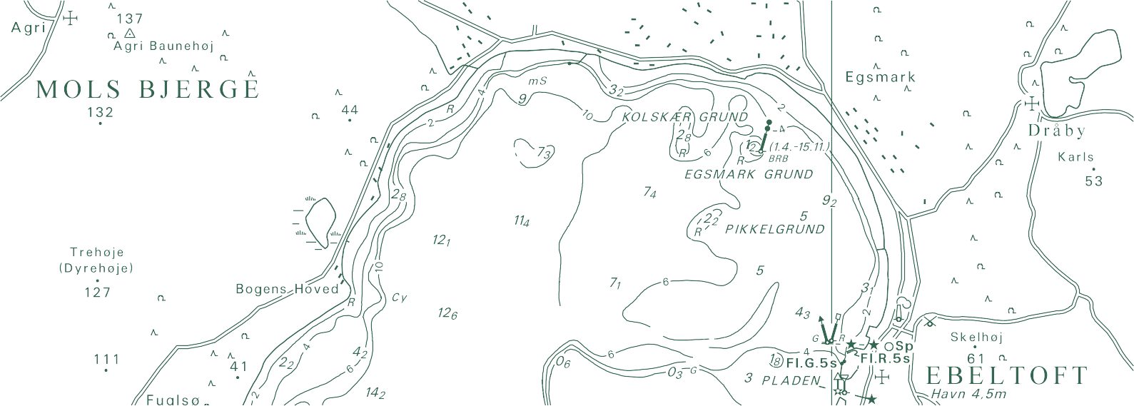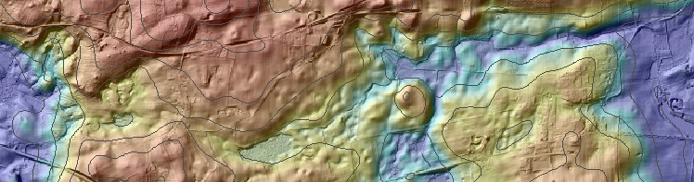

TECHNICAL REPORT NO. 12

Quality assessment of the Danish Elevation Model (DK-DEM)
Brigitte Rosenkranz, Poul Frederiksen

Brigitte Rosenkranz, Poul Frederiksen
Quality assessment of the Danish Elevation Model (DK-DEM)

National Survey and Cadastre—Denmark, technical report series number 12 ISBN 978-78-92107-38-1
Technical Report Published 2011-08
This report is available from http://www.kms.dk

Preface

This report deals with the quality of the new Danish Elevation Models consisting of five different products. They were produced by KMS in cooperation with two private firms. The applied technology was airborne laserscanning. The original point cloud was to a large extent processed automatically. The original data were refined by automated filtering, manual editing and supplementing with existing and new data. The refinement work is described, the quality of the DEM_DK’s is assessed, and the results are presented.

The applications of the DEM-DK’s are multiple. The user of the data should be aware of the characteristics of the applied data including their shortcomings.

Information about the producer, the applied systems, flight lines, point density and other features are contained in the metadata, which are available to the user. Inaccuracies and shortcomings in the completeness of the data may be discovered by means of these additional data. The geo-referencing of the DEM includes the vertical and the horizontal accuracy. The assessment carried out proves that the specified accuracies (Mean=0.10m, σ_{elevation}=0.10m, and RMSE_{plane}=1m for DTM_{grid}) are achieved at almost all of the tested samples.

A large part of the report deals with the improvement of the elevation models. Many good figures document the efforts of KMS and the producers to make the product ‘fit for purpose’. In areas of low density or lack of data photogrammetric correlation is used to complete the DEM. The report concludes that the work with the DEM is not finished and the updating is identified as the “highest prioritized upcoming challenge for DEM-DK”.

In general, the production of DEM-DK’s is a fine example of a good cooperation between private firms and KMS. Also universities from abroad and from Denmark have contributed to the new products.

This report as well as other DEM related technical reports of KMS are highly recommended to the users of the DEM-DK. There will be a time where new applications and new requirements will come up and when new DEM products have to be generated.

Aalborg, May 2011 Joachim Höhle

Contents

- Description of the Products 5
  - DK-DEM/terrain model 6
  - DK-DEM/surface 6
  - DK-DEM/contours 9
  - DTM_bridge 9
  - 10m terrain model 9
- Physical Data Quality 13
  - Point Density 13
  - Point Distance 13
  - Strip Adjustment 14
    - Method 14
  - Results 15
- Absolute geo-referencing 20
  - Vertical accuracy 20
    - Reference data 20
    - Method 22
    - Results 24
    - Municipality technical mapping data 24
    - Coastal Directorate 24
    - Actuality 33
  - Horizontal accuracy 33
- Improvement of the Models 35
  - Lake Improvement (lakefix) 35
  - Bridge Correction (bridge fix) 35
  - Clipping of Ports and Piers (coast fix) 37
  - Photogrammetric Corrections 38
  - Classification Errors 39
  - Surface Model DK-DEM/surface 41
- Conclusion 50
List of Figures 51

Chapter 1

Description of the Products

The Danish elevation model DK-DEM was established in a co-financed corporation between the ministry of environment, ministry of transportation, ministry of climate and energy and ministry of defense. The DK-DEM product suite contains the following 3 products:

- DK-DEM/terrain
- DK-DEM/surface
- DK-DEM/contours
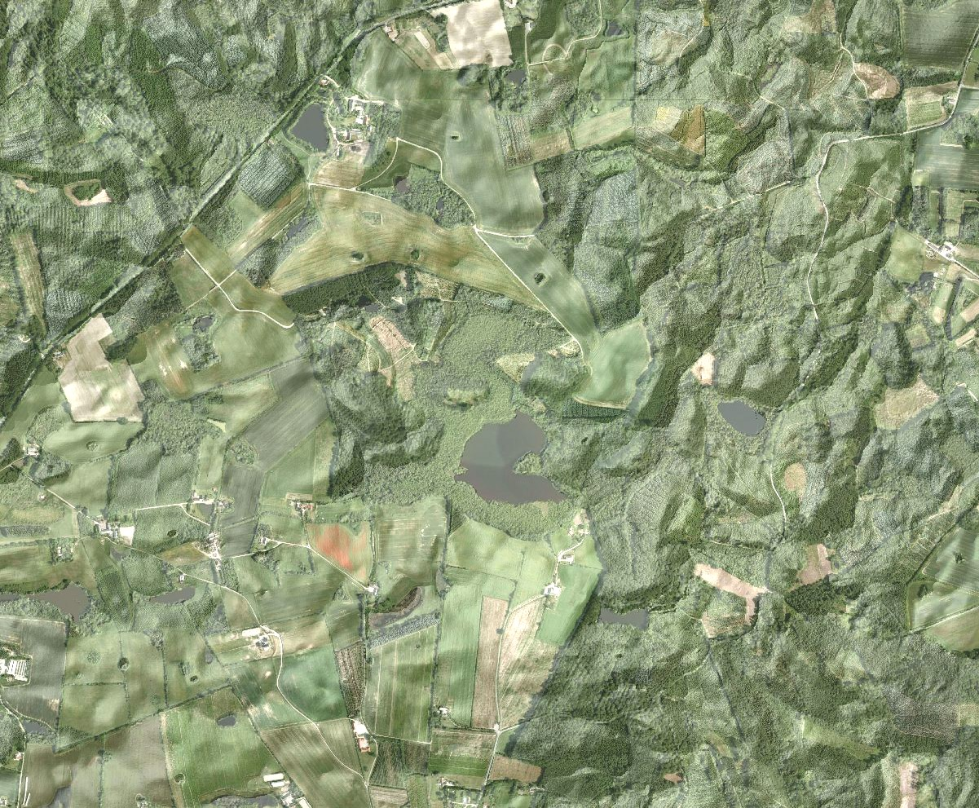
Figure 1.1: DEM/terrain visualized by using hillshading and by draping an orthophoto on the terrain data.

The data was surveyed in the period between 2005 and 2007 by a consortium of two Danish companies Blominfo and Scankort A/S (lateron Fugro). Figure 1.3 shows the year of data collection, figure 1.4 the scannertype and responsible data supplier for all flight lines. DK-DEM is purchased with user rights for all state institutions in Denmark and most Danish municipalities bought DK-DEM directly from the data suppliers. DK-DEM was quality controlled by the Danish National Survey (KMS) between 2007 and 2009. The control processes were developed on the background of the tech- nical report from the Vienna University of Technology, Institute of Photogrammetry and Remote Sensing. Within this report 2 selected test areas were analyzed and the resulst was published in (Briese et al., 2008), which is appended.

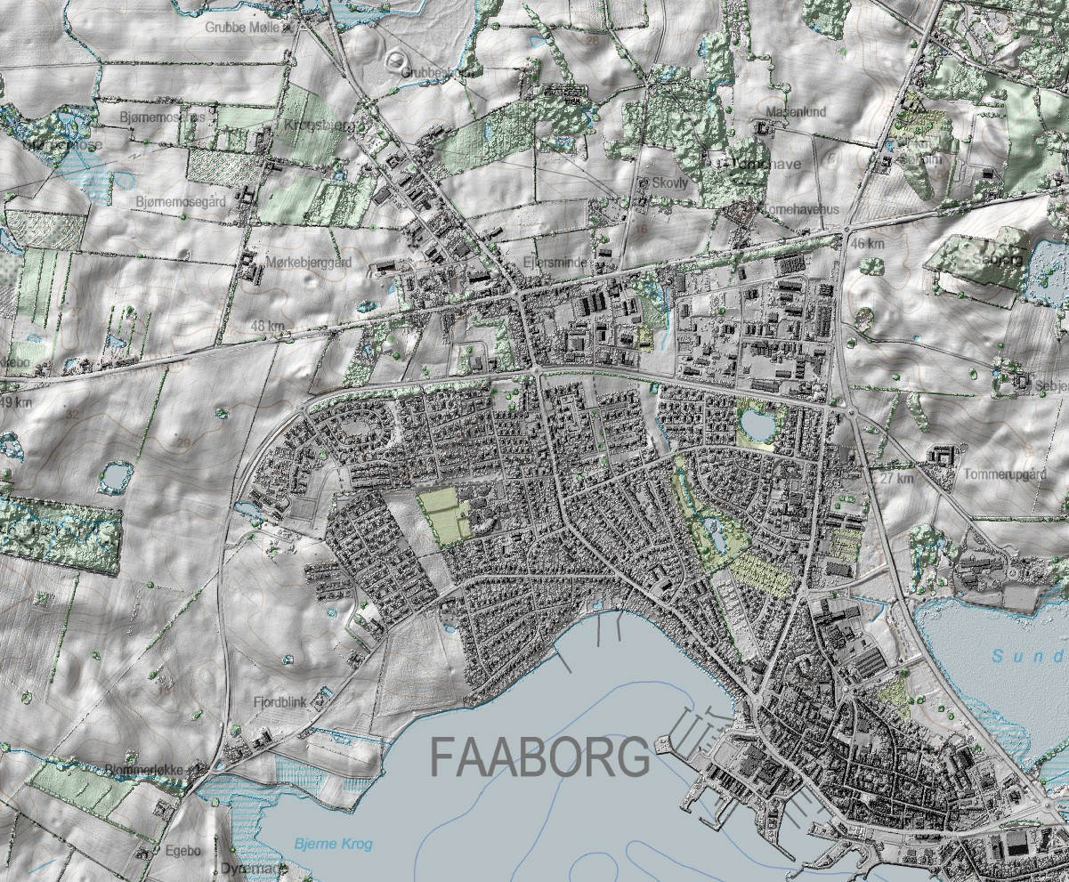

Figure 1.2: Visualization of DK-DEM/surface in combination with a topographic map.

The raw-data (point cloud) for DK-DEM was collected by airborne LIDAR technique and the collected points were clas- sified to ground, surface, outlier and overlap classes. The classification was mostly done automatically, but if necessary corrected manually. From the classified point cloud DK-DEM (DK-DEM/terrain, DK-DEM/surface and DK-DEM/contours) was derived by the data vendors. Besides DK-DEM KMS gained or generated the following products:
- DTM_bridge, DK-DEM/terrain including bridges and purchased separately by KMS from the data vendors
- 10m-grid terrain model, generalized from DK-DEM/terrain by KMS
- Various sets of contour lines for different mapping scales, calculated by KMS
DK-DEM is localized in the horizontal reference system UTM32N/ETRS89 and vertical reference system DVR90. The models are distributed as ESRI ascii-grid files and have a cell size of 1.6m. The data are grouped in 10km x 10km blocks, zipped and named after the Danish gridding naming convention (See specification - Det danske Kvadratnet (National Survey & Cadastre, 2003)

DK-DEM/terrain model

DK-DEM/terrain is a digital terrain model, showing the terrain’s height in relation to the average sea level (in m). Terrain objects are defined as pure terrain in ground level. Permanent objects above ground level (trees, houses, etc.) are part of the surface model, while non permanent objects are classified as outliers (cars, birds, etc.). Figure 1.1 shows DK-DEM/terrain visualized in combination with an orthophoto. (See specifications - DK-DEM/terrain (National Survey & Cadastre, 2011b) and DK-DEM/surface (National Survey & Cadastre, 2011a).

DK-DEM/surface

DK-DEM/surface is a digital surface model, that besides the terrain also includes permanent objects above ground level(high vegetation, houses, bridges, etc.). Figure 1.2 shows DK-DEM/terrain combined with KMS’ topographic map. In urban areas the biggest differences between DK-DEM/surface and DK-DEM/terrain are caused by buildings while in open land hight vegetation will be the cause of most differences. The differences between these two models can be studied in detail in figures 1.5 and 1.6.

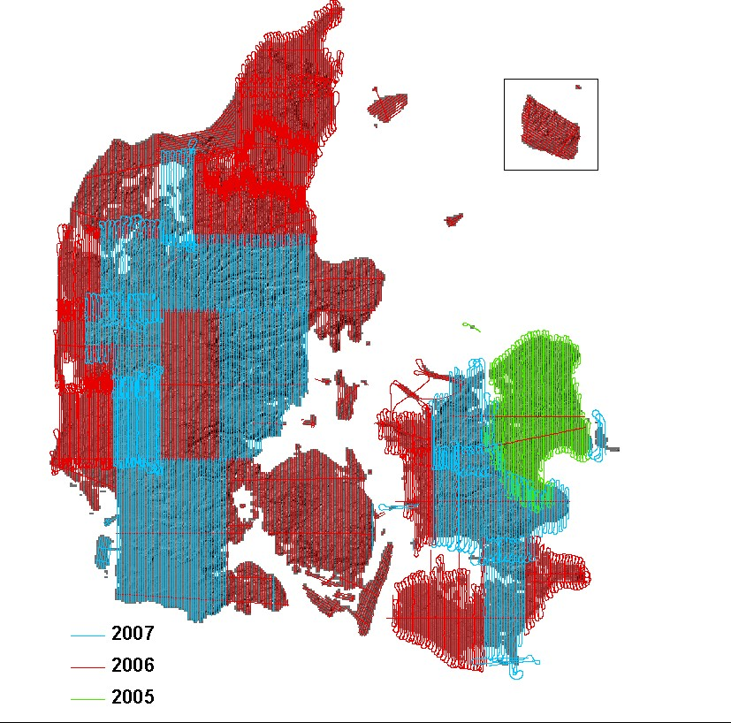

Figure 1.3: Scanlines with the year of data collection.

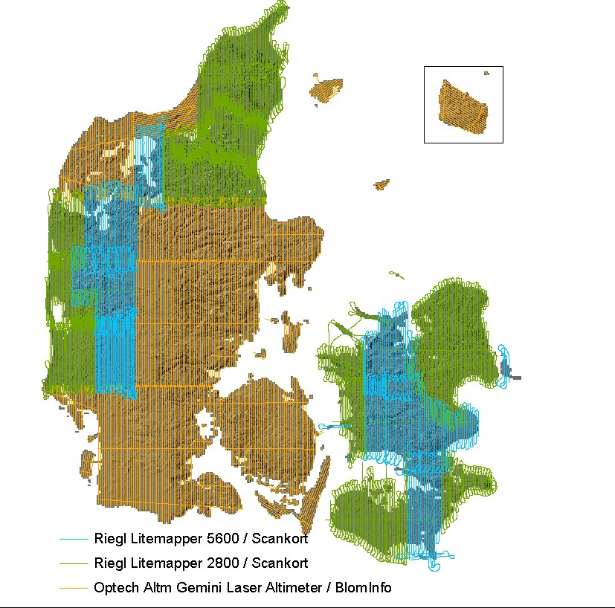

Figure 1.4: Scanlines with the scannertype and responsible data supplier

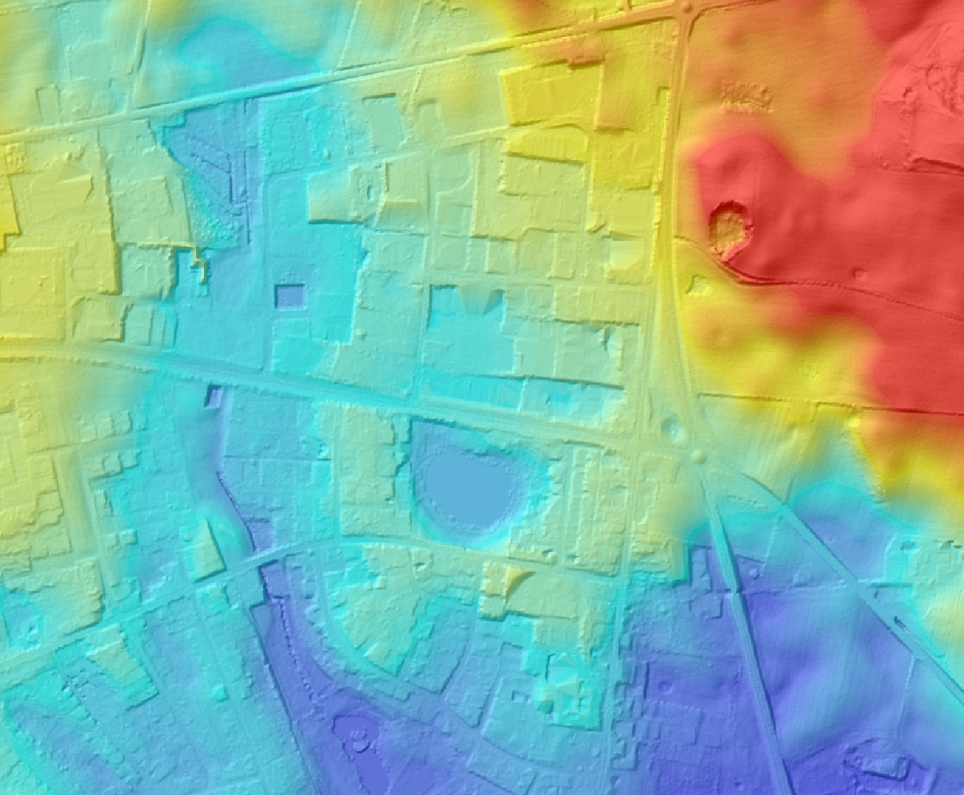

Figure 1.5: DK-DEM/terrain visualized with hillshading.

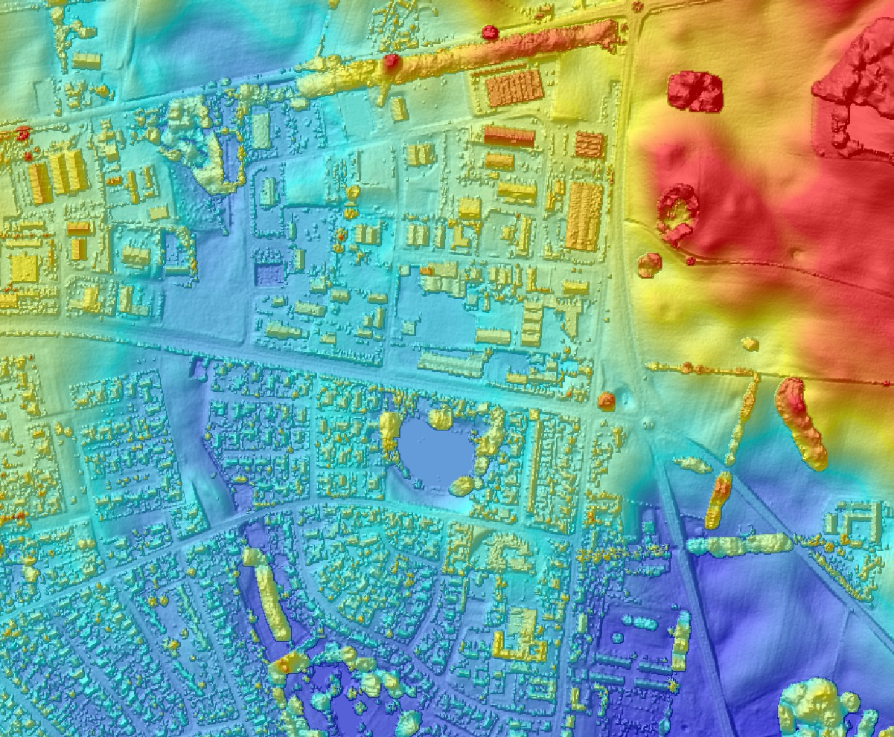

Figure 1.6: DK-DEM/surface, visualized with hillshading. The differences between surface and terrain model can clearly be seen as buildings and vegatation.

DK-DEM/contours

The DK-DEM/contours are specified as contour lines with an equidistance of 0.5m. They are based on the filtered DK- DEM/terrain model. For eliminating noise and insignificant details a Gaussian filter was used. The filtering is necessary to achieve the main requirement for cartographic contours, the interpretability of terrain for human users. Even after this filtering the contour lines are very detailed and can not directly be used for mapping purposes. For generating contour lines from DK-DEM for different map scales, KMS developed an efficient filtering method, that also uses "a priori information" of the terrain. The result of this work is published in a separate technical report (Rosenkranz et al., 2011b). Figure 1.7 illustrates an example of DK-DEM/contours in different types of terrain. To ensure a sea level of 0m DVR90, a polygon with a distance of 25m to Top10-DK’s coast line was introduced. Elevations outside this polygon were not used for the calculation of the contours lines.

DTM_bridge

While a terrain model without bridges is useful for hydrological modeling, a terrain model with bridges is necessary for orthophoto generation. As it was decided, that bridges should not be part of the terrain model they were removed from DK-DEM/terrain. Since they are very important for the generation of ortophoto, KMS decided to invest in a elevation model including bridges (DTM_bridge). DTM_bridge is identical to DK-DEM/terrain, except for the areas, that include bridges. DTM_bridge is used by KMS for generating orthophotos. In figures 1.9 and 1.10 the difference between DK-DEM/terrain and DTM_bridge is shown.

10m terrain model
From the 1.6m grid (DK-DEM/terrain), KMS generalized a 10m grid. The generalization was done by using a simple “nearest neighbour interpolation”. Also this grid is distributed in 10km x 10km tiles with full user rights for the entire state and the municipalities. Figures 1.11 and 1.12 illustrates the difference between the 1.6m and the 10m grid.

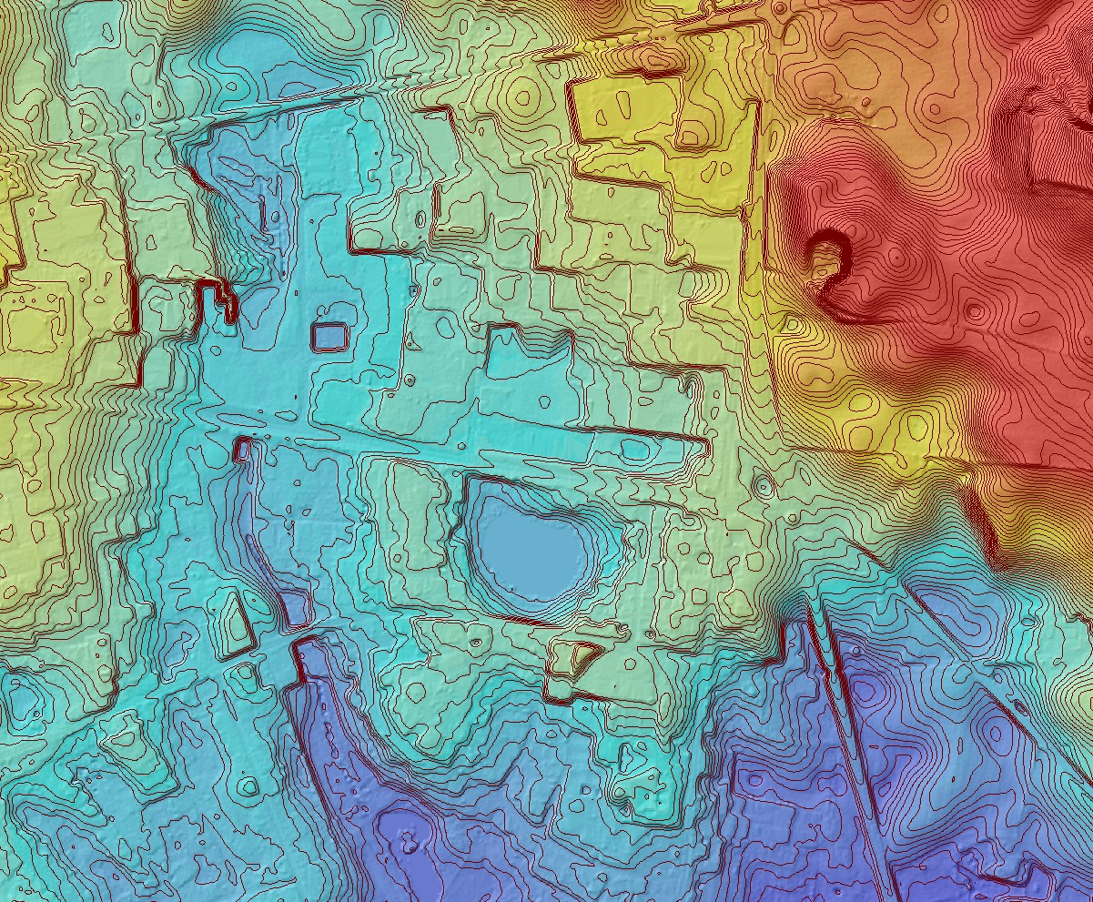

Figure 1.7: Example of the 0.5m contour lines visualized together with the colored DK-DEM/terrain model.

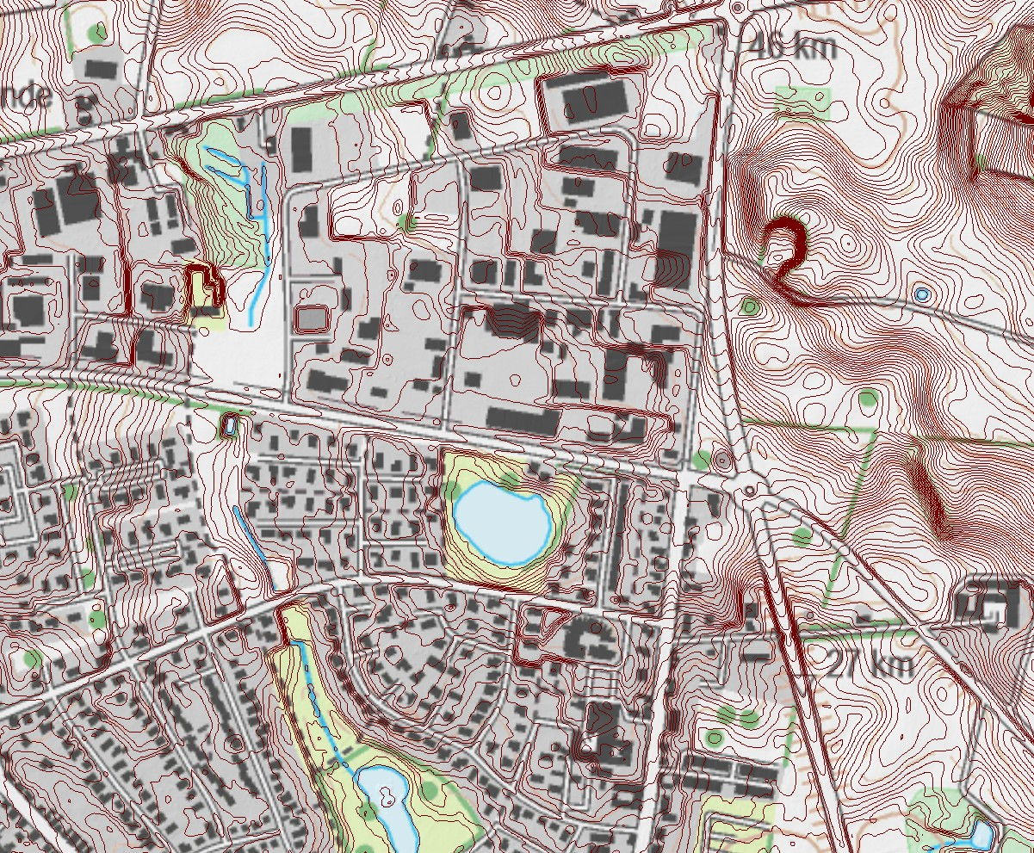
Figure 1.8: Example of the same 0.5m contour lines as in figure 1.7 visualized in combination with KMS’ topographic map.

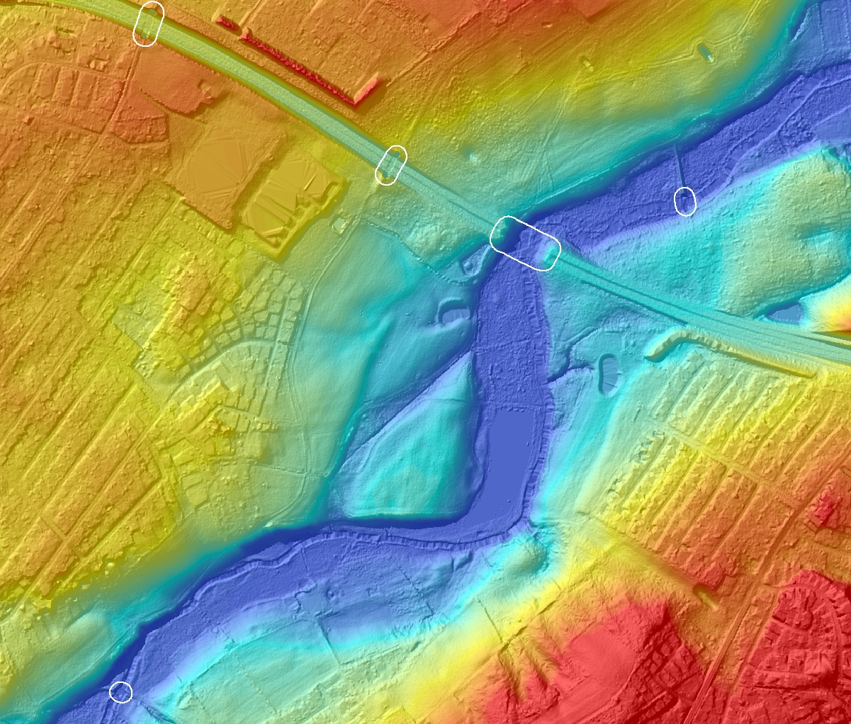

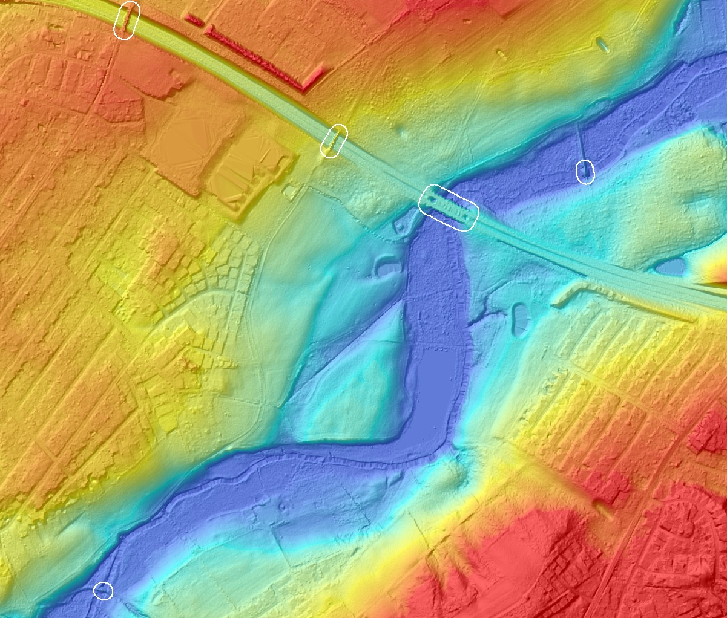
Figure 1.9: Visualization of DK-DEM/terrain, where the bridges are removed. The polygons where bridges have been removed are marked in white.

Figure 1.10: Visualization of DTM_bridge of the same area as in figure 1.9. Also here the bridge polygons are marked in white.

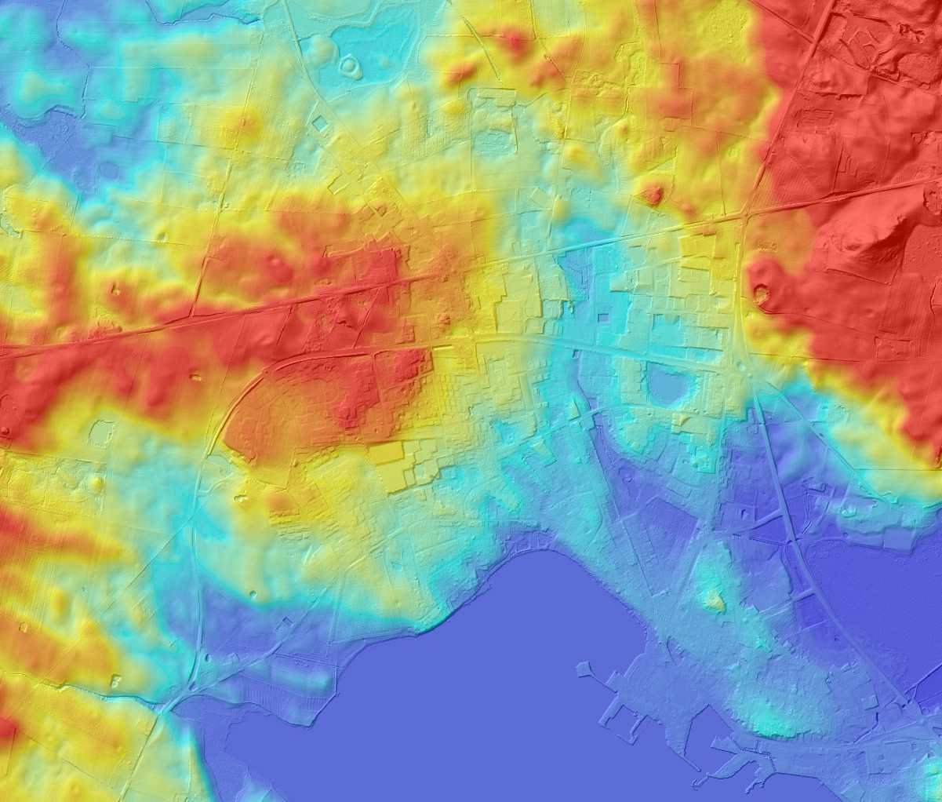

Figure 1.11: DK-DEM/terrain with the cellsize of 1.6m. A lot of small details can be seen.
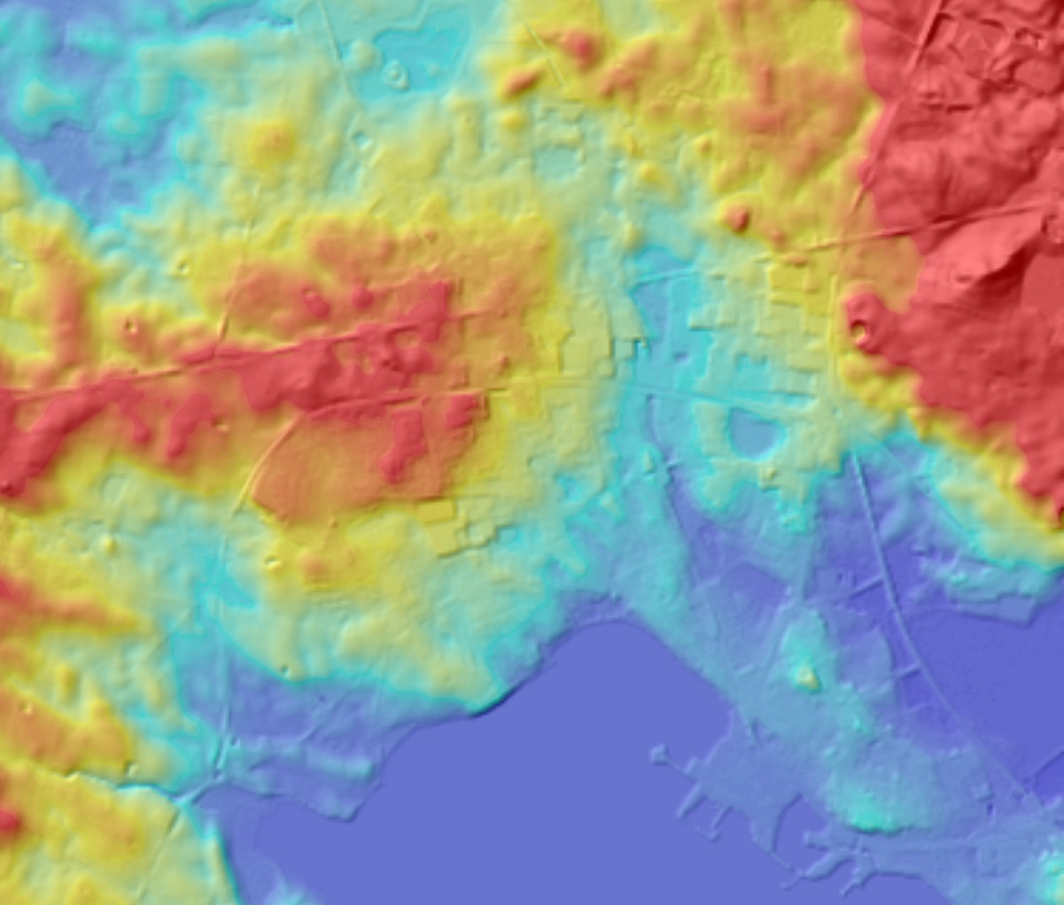
Figure 1.12: Terrain model with a cellsize of 10m. The level of detail is much less than in figure 1.11.

Chapter 2

Physical Data Quality

The quality of the point cloud has a big influence on the quality of the final model and its credibility. For that reason KMS developed methods for verifying the physical quality of the point cloud, even though KMS does not possess user rights for the point cloud. Using the point cloud for control was permitted by the producers. The control procedures were carried out on the geo-referenced and classified point cloud. KMS did not invest in expensive commercial programs for editing, classifying and calculating statistics of the point cloud, but developed programs which calculate a grid with inverse distance weighting interpolation and calculate statistics on the point cloud. This program is called PINGPONG and was described in detail earlier in (Knudsen, 2008).

Point Density

A nationwide point density grid was computed with PINGPONG. These grids are available as metadata to DK-DEM. The point density is computed as the number of points n that are returned within the search radius of R₀ from the grid node
( D = n/πR2 ). A visual description is shown in figure 2.1. We calculated a point density grid with a search radius of
0
R₀ = 4m. The point density maps give a very good estimate of the average point density. Figure 2.2 and figure 2.3 are examples of the point density control investigation. Spots with a low data density are unavoidable in areas where the surface does not reflect laser light. Eye-catching are water covered areas and buildings, that do not reflect laser light because of their black and light absorbing roof. These physical restrictions of laserscanning-technology has to be taken into consideration when working with laser-scanned elevation data.
Other objects that challenge laserscanning-technology are trees and vegetation. Laser light is spread by the leaves and the light is neither reaching the ground, nor reflected back. This results in low point density for both the surface and the terrain model. An example of the point cloud is outlined in figure 2.5.
When carrying out the quality control the point density was verified for:

    - The complete point cloud, where ground points, surface points and overlap points were included in the calculation.

Terrain classified point cloud, where only points are included that are terrain classified. In this interpolation also overlap points are excluded.
•

Point Distance

The point distance, defines a similar statistical value. While the point density is measuring the amount of laser returns in a grid cell, the point distance measures the distance from a grid node to the nearest laser return. Both are outlined in figure 2.1. Point distance is a good estimate to point out areas with very few laser points.
KMS calculated a nationwide point distance grid which was used intensely for an automated localization of areas with very few laser return points. Most of the unexpected low-density areas showed out to be water covered agricultural fields, but also areas where the measurement equipment had been turned off too early. An example of a point denstance map can be seen in figure 2.4.

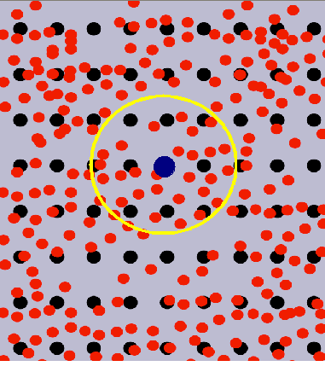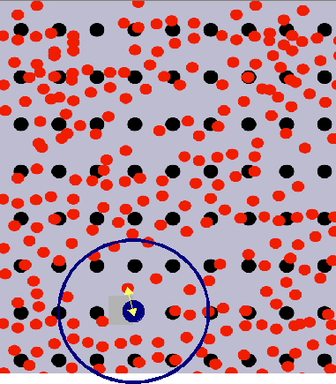

Figure 2.1: Left side: Point density; where all points within the search radius R₀ are counted. The red dots visualize the laserpoints while the black dots are showing the grid nodes. The point density within the search radius R₀ is normalized to points/m2. Right side: Point distance; distance of the grid node to its nearest observation.

Strip Adjustment

One of the first steps in the generation of an elevation model is the adjustment of the flying strips. Connecting the strips can be done in different ways.

All points in the overlap zone can be used for calculating the model. This will increase the variance in the overlap zone. The height within the overlap zone could either be interpolated from the individual values or by using the mean value of the two measurements. The first method would result in higher frequent noise within the overlap zone, while both methods can not determine explicitly how and when the single hight value was measured. Nevertheless, these methods would not result in steps at the border between the flight lines.
•
The overlap points are cut off at the center of the overlap. The interpolated height can clearly be assigned to a particular flight, but there is a likelihood of steps at the strip edges. This method was used by the contractors when calculating DK-DEM. Unfortunately, the mentioned steps could clearly be seen in the first delivery.
•

The first data KMS received was measured with older equipment. The roll parameter ω for a whole flight line was designed as a rigid parameter. Since a flight line could be up to hundred km this rigid parameter strategy did not always turn out to be useful. To improve the flight line adjustment, the roll parameters were in problematic lines allowed to change (twist) over time. This resulted in a slightly worse accuracy at the control points, but the values inside the overlap zone got identical observation values. It has to be pointed out, that the parameters for each adjustment were considered thoroughly. Floating parameters are not always desired. Less tight control parameters may lead to point wise correct, but entirely wrong flight line parameters. This means, that minor discrepancies along seam lines can still occur between the flight strips in DK-DEM, but the height of the possible steps were reduced from 30cm on a length of more than 10km to steps below 20cm and a maximum length of 5km.

2.3.1 Method

A method for finding strip adjustment that does not fulfill our requirement, was developed and described earlier in (Rosenkranz and Knudsen, 2008). Here only a short summary of the paper is given.
In open land, where surface and terrain points are identical, this method can point out strips that are not adjusted thoroughly. For localizing the strips of imperfect adjustment the program PINGPONG, that interpolates a grid, is used twice. In the first execution a grid is calculated from the complete point cloud. As the points from overlap zone from both flight lines are included, the model can be regarded as a surface model KMS_DSM++ (++ stands for the usage of the additional overlap points). The second grid is calculated from the terrain classified point cloud (KMS_DTM). In

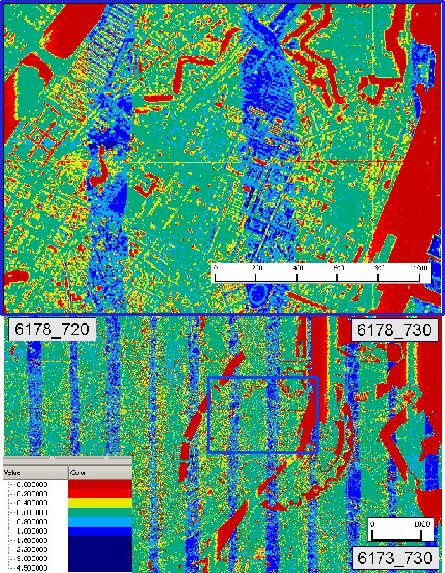

Figure 2.2: Point density calculated with all laser points. It can be noted, that there are areas of low density (red spots) at water covered areas and buildings with black roofs. Moreover, it can bee seen that the strip overlap has a double density (blue lines).

cases where one strip, due to adjustment imperfections, systematically is lower than the other, KMS_DTM will have a step at the breaking line. In the overlap area KMS_DTM will differ from KMS_DSM++ by an amount of approximately half the adjustment residual, since approximately half of the points will come from either strip. The resulting height value of KMS_DSM++ will be the mean height of both strip observations.
Calculating the normalized KMS_DSM++ (subtracting KMS_DTM from KMS_DSM++) will result in zero where both models are equal but plus or minus ∆h where they differ. The method is outlined in figure 2.6 and an example of the strip adjustment grid before and after the correction is shown in figure 2.7.

2.4 Results

A spot check calculation of representative tiles showed that DK-DEM’s point cloud reached the required average point density of about 0.45 points/m2. It has to be pointed out, that a nation wide point density grid can be downloaded as metadata.
By investigating the point distance, we were able to localize unexpected areas of very low point density. As the contract

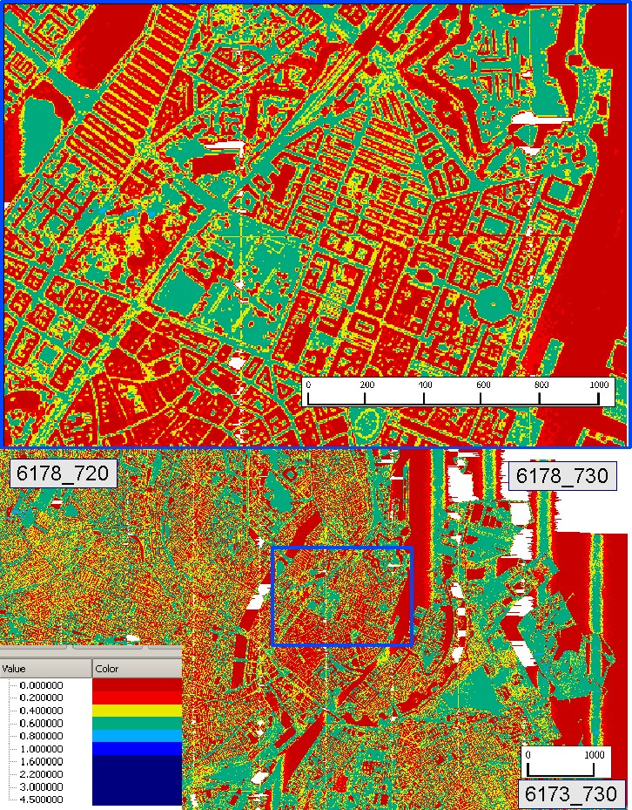

Figure 2.3: Point density calculated with the terrain classified points. The buildings are areas of low density, as these points are not included in the calculation. The white areas are no data areas, as the density is very low here.

not allow water covered agricultural fields, these areas had to be surveyed again. The contractors chose photogrammet- ric methods for fulfilling the requirements. The method is outlined in chapter 4.4. Unfortunately, the point distance grid can just be shown as an example in this report since KMS did not get the rights to publish this data set.
Besides the unexpected areas, there are always areas of expected low point density like lakes, buildings and forrested areas. For getting the best possible DK-DEM, KMS and the contractors cooperated on developing a method that uses a priori land use information for a fine grained selection of the surface gridding parameters. This method is described in detail in (Knudsen et al., 2008).
The fact that we did not have access to position and attitude (i.e. GPS and INS) data, explains the necessity of this extensive procedure of calculating two grids for controlling one.

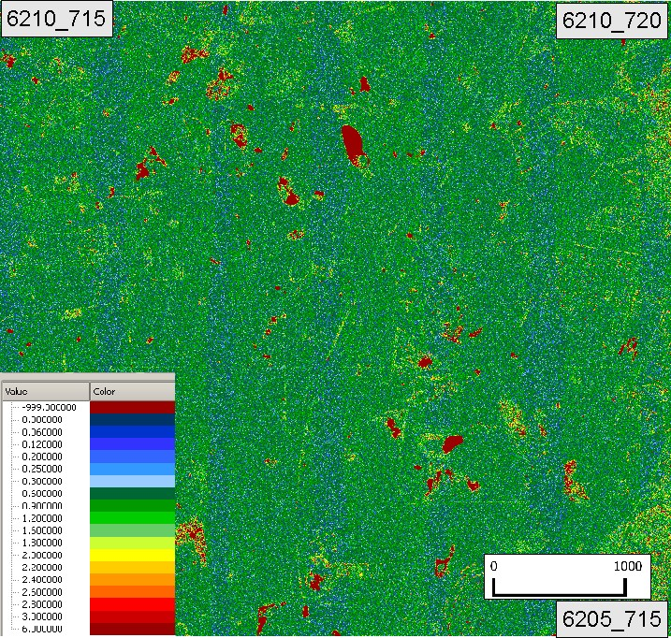

Figure 2.4: Point distance of the terrain classified points. Problematic areas with a large distance between the laserpoints can easily be seen.

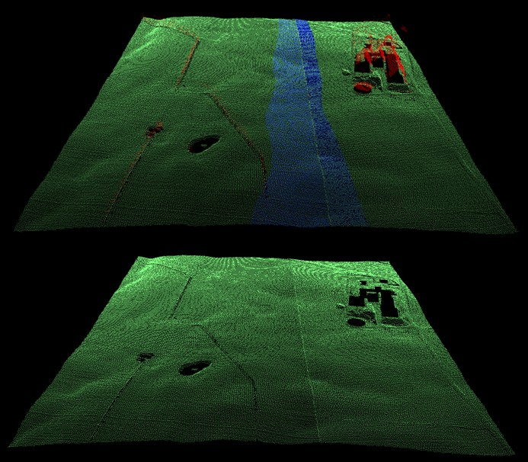

Figure 2.5: Upper panel: Classified point cloud with all points included. This point cloud is used for interpolating KMS_DSM++, used for finding imperfect strip adjustment. The points classified as surface points are shown in red and the terrain points in green. Points of the overlap zone are shown in blue. Lower panel: Corresponding digital terrain model, with the terrain points shown in green. The overlap points are excluded.
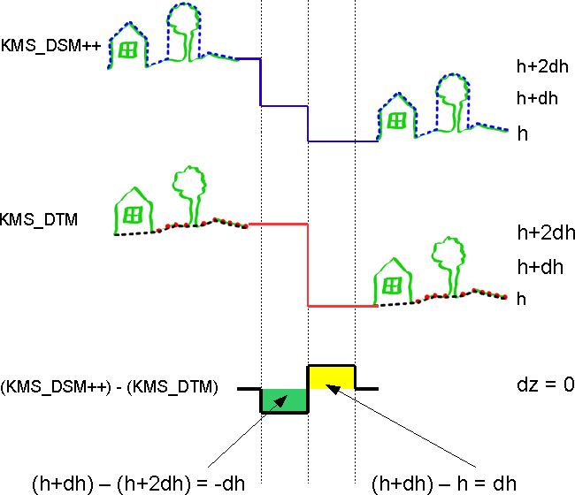

Figure 2.6: The mechanism for detecting strip adjustment residuals.
KMS_DTM is generated from points classified as terrain. Overlap points from the neighbouring line will not be included. In cases where one strip is systematically lower than the other (due to adjustment imperfections) the terrain model will have a step at the border.
In the cross over regime, the model including all points KMS_DSM++ will also include the overlap points from the neighbour line. In the overlap area KMS_DTM will differ from KMS_DSM++ by an amount of approximately half the adjustment residual, since approximately half of the points used will come from either strip. The result will be the mean value of both strips.
Subtracting the KMS_DTM (half of the terrain points) from the KMS_DSM++ (all points) will result in zero where they are equal and plus or minus ∆h where they differ.

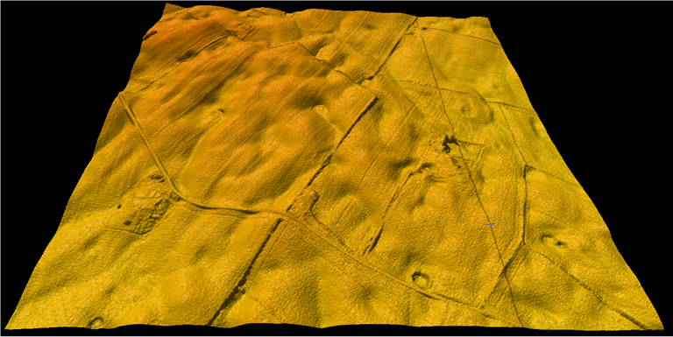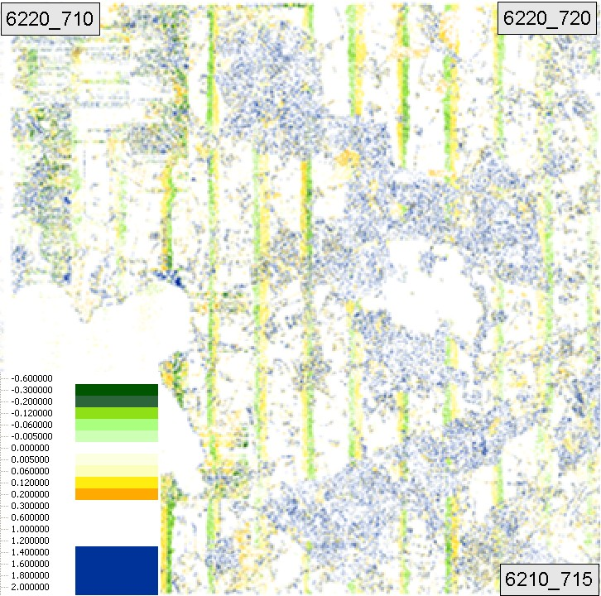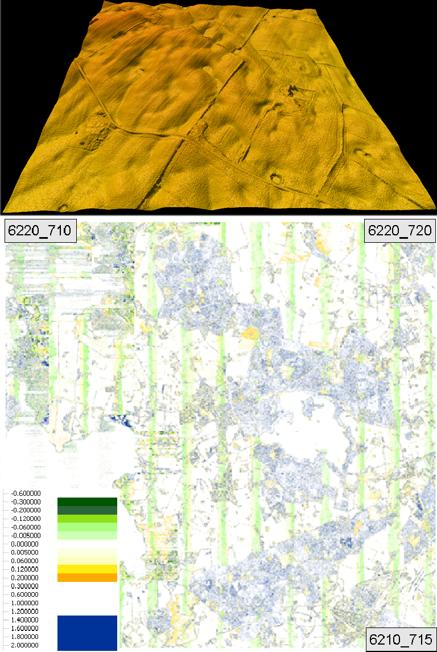

Figure 2.7: Upper images: Strip adjustment before (left hand side) and after (right hand side) the correction, visualized within the 3d-program "Fledermaus". There is a clear N-S step at the block border in the left hand side image, while this step is corrected in the right hand side image. Lower images: Illustrating the strip adjustment by showing the normalized DSM (nDSM=DSM-DTM) before (left hand side) and after (right hand side) the correction. The dual range ( 0.6m and above 1.5m) ensures that building outlines are included as blue patterns in the image as a visual guidance for the human interpreter.
±

Chapter 3

Absolute geo-referencing

High precision absolute geo-referencing is often very important to users of geographical data. Especially when combin- ing different sets of data, it is important to know the data accuracy. For documenting DHM’s geo-referencing quality, we thoroughly analyzed both the vertical and the horizontal accuracy. For most users of elevation models, a precise vertical accuracy seems to be most important. Having in mind, that the vertical accuracy in steep areas depends very much on the horizontal accuracy, the importance of analyzing both is obvious. In chapter 3.1 our investigation of analyzing the vertical accuracy and its results is described in detail. The description of the horizontal accuracy has been published earlier in (Hawa et al., 2011). In chapter 3.2 a short summary of this analysis is given.

Vertical accuracy

Reference data

For testing the vertical accuracy we carried out control measurements for getting independent elevation data. KMS measured 162 control patches, each including about 100 single measurements with an area of 20mx20m. The mea- surements were carried out using high accuracy RTK-GPS equipment, which is shown in figure 3.1. For reaching an accuracy that fulfills the requirements for control data, of at least 3 times better than the data to be controlled, the mea- surements were mainly carried out on well defined surfaces like football fields, parking lots and level agricultural fields. Some examples of the control patches are shown in figure 3.2, where it can be seen that the surface characteristics of the control patches varies. This has evidently influence on the accuracy of the reference measurement and on the statistical result.
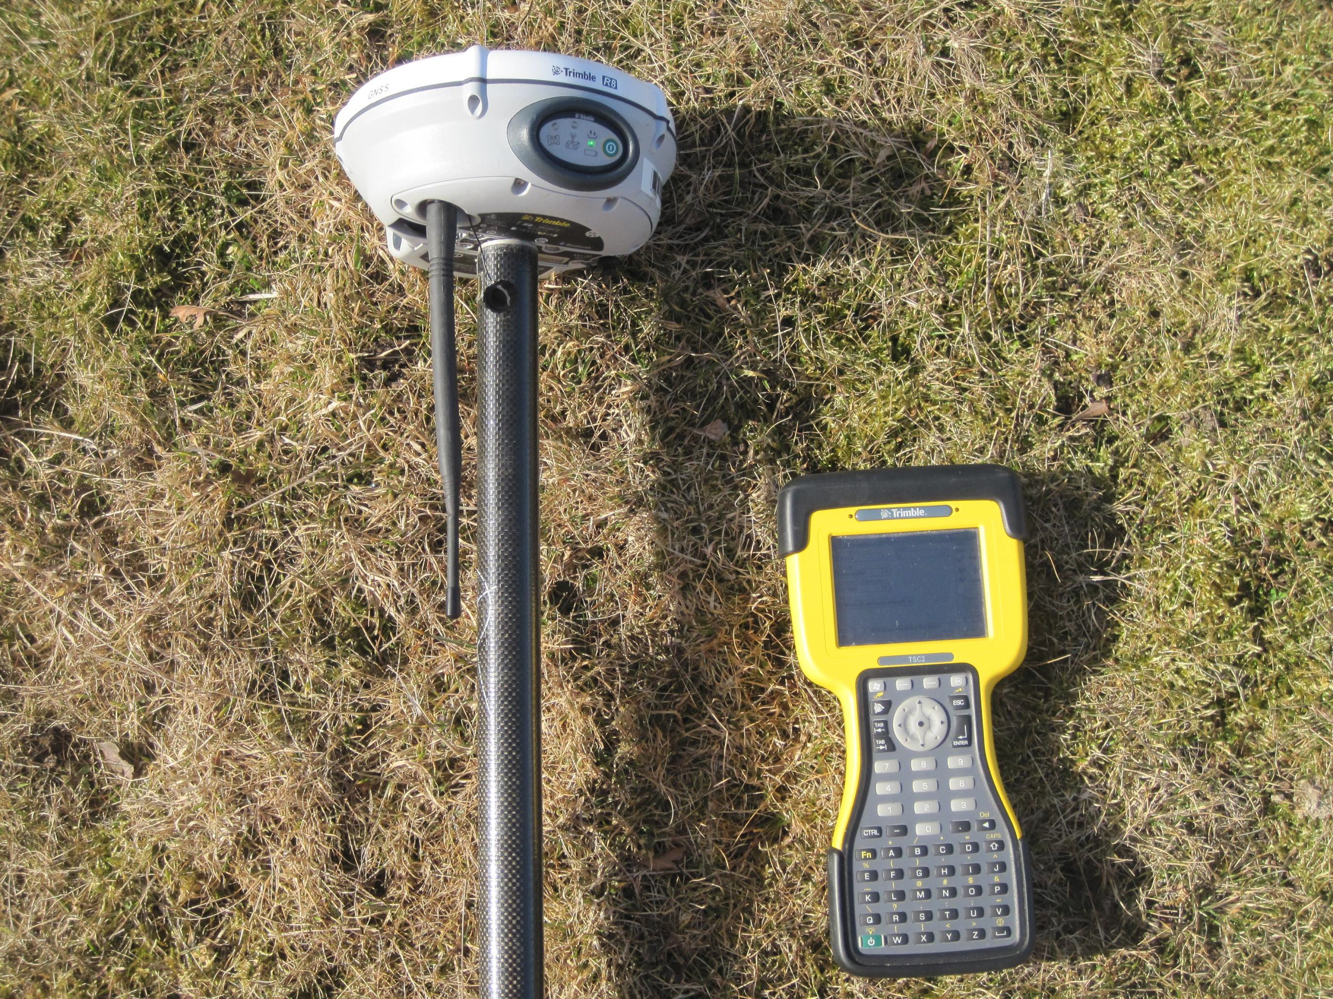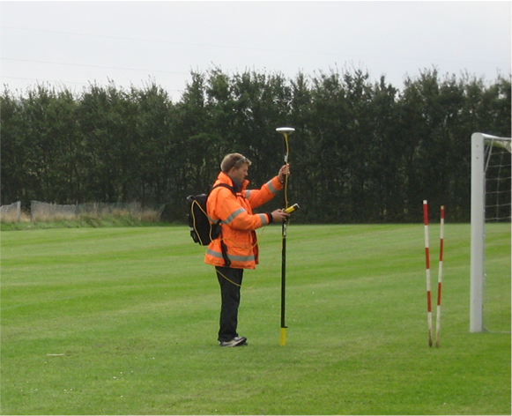

Figure 3.1: Measuring with RTK-GPS equipment

Also the absolute accuracy of RTK-GPS depends on various parameters like the geometry of the satellite constelation and the amount of “visible” satellites. However, in worst case the accuracy is still better than 5cm.
For getting a reliable result, control patches should be distributed geographically homogeneous within the data area. In our case this means a country wide distribution where the control patches were located in a grid of around 20kmx20km.

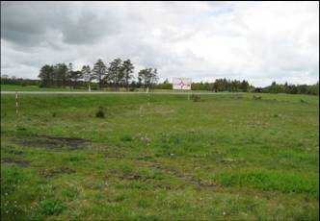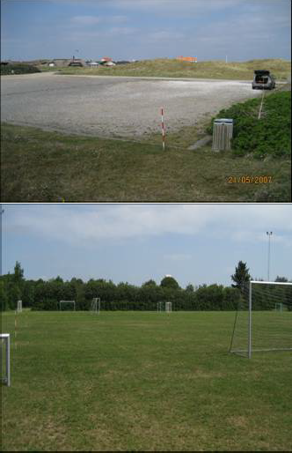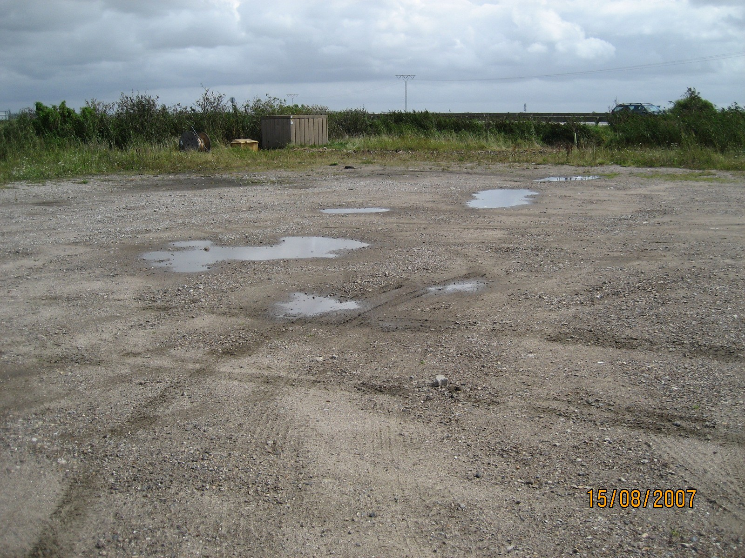

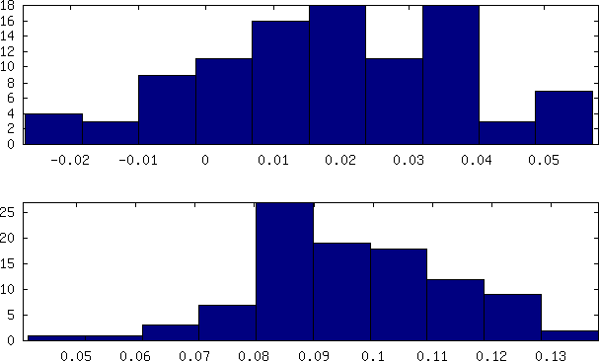
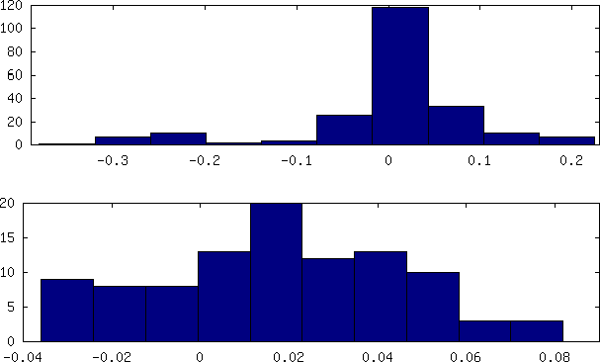
Figure 3.2: Examples of control patch areas A12, D10, B13 and C17

Figure 3.3: Control patch A12 D10, B13 and C17 The geographical distribution of the control patches can bee seen in figure 3.4.

The control patches were measured in:

      - Projection - Cartesian 3-d coordinates
      - Datum - EUREF89
The data was transfered with KMSTrans to:

      - Projection - UTM32N
      - Datum - EUREF89

      - Elipsoid - GRS80
      - Height System - DVR90
The transformation resulted in text files with easting, northing and height and were used for comparing the height of the control patches to DTM. These files were also transferred to ESRI shape files.

Method

KMS developed a program, called “DHMSuite”, for comparing reference data to DEM/terrain. “DHMSuite” is a Python program published under the GNU distribution license.
The program reads the control data and divides them into smaller clusters, where each cluster contained one control patch. For each cluster it compares the height of the control points to the height in DEM/terrain. For each control point, the difference ∆z to DEM/terrain was calculated
∆z = z_re f erence−z_dtm
where z_dtm for the exact xy-position was interpolated from the 4 closest grid values. This resulted in the following statistical key values for each control patch.

Mean error (µ) | µ = ¹ ∑n ∆z_{i}  n i=1
RMS error (RMSE) | RMSE = ¹ ∑^{n} ∆z²  n i=1 i
Standard devation σ | σ = ¹ ∑n (∆z_{i} − µ)2  (n−1) i=1
Median error | ∆z value, separating the  higher half of the measure-  ments from the lower half

“DHMSuite” has the option of eliminating blunders by choosing an error threshold value. For testing a threshold value of 0.5m was chosen. However, no blunders were eliminated when calculating the statics of the control patches because of good data quality. The program results in a report with the statistical values (see an example in listing 3.1) and a histogram for each cluster (see examples in figure 3.3).

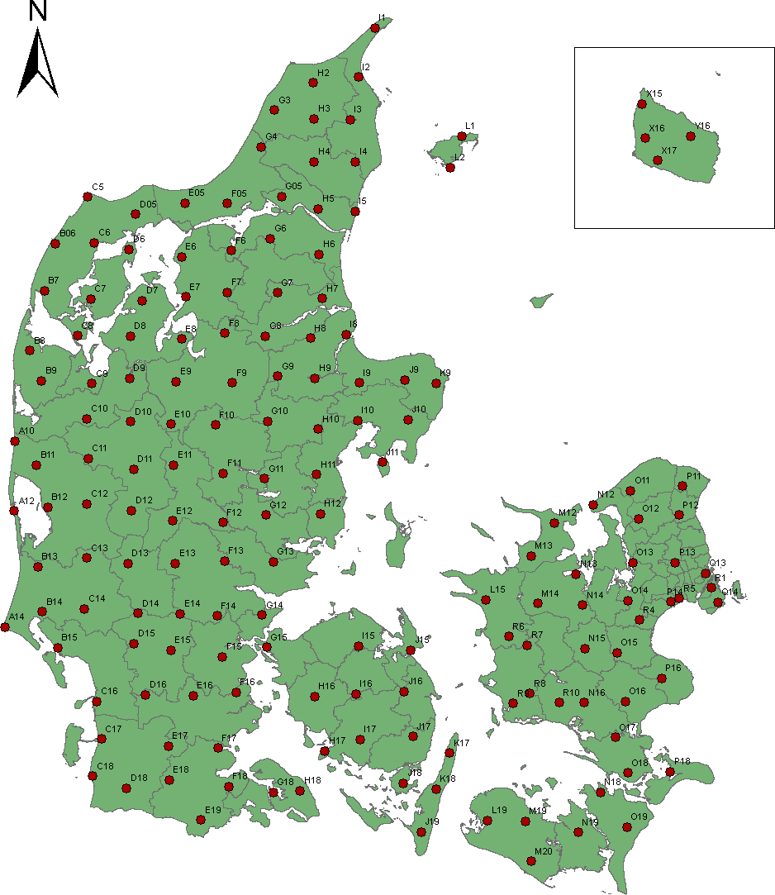

Figure 3.4: Geographical distribution of the control patches

Results

The statistics for the entire control patches is shown in the figures 3.5 to 3.7, where figure 3.5 shows all RMS errors, figure 3.6 all median errors and figure 3.7 all standard deviations. The nationwide RMS error result (figure 3.5) and standard deviation (figure 3.7) shows that DK-DEM has a very satisfyingly average RMS error of 5.9cm and standard error of 3.44cm. Nevertheless, some control patches are conspicuous. The results of these control patches need an underlying explanation.
E8: Figure 3.10 shows both a photography and a histogram of E8. It can be seen that the measured reference points are 16cm below DEM/terrain. Unfortunately, we were not able to explain these big errors for that location. The surface of this control patch is perfectly flat and there are no shadowing buildings. However, it has to be kept in mind, that the requirement for the average error was 10cm, while the maximum error was allowed to be 40cm. As the reference points were measured on a small area of 20m x 20m and within a short period of time, the external conditions (eg. vegetation, satelite constellation) for the whole area assumed to be identical.
•
M14: Figure 3.9 shows a photography and the histogram of M14. The reference points of this control patch are about 12cm over DEM/terrain. In the photography can also be seen, that the measurement is carried out both in steep and uneven terrain. The dependency of the vertical accuracy to the horizontal accuracy is much bigger in steep than in flat terrain, which may explain this relative high error value.
•
O13: Figure 3.11 shows photography and histogram of O13. It illustrates that the reference points are about 18cm below DEM/terrain. In this case an explanation for the difference may be explained by the short distance to the building which could result in a reflection effect of the satellite signal.
•
D10: The histogram to D10 is illustrated in figure 3.8. It does not show a large median error, even when figure
•
3.7 shows a relative large standard deviation. This can be explained by the surface characteristics of the control area. It can be seen that the surface of the control patch varies from being asphalt to low vegetation. This results in poor accuracies of both the reference and the DK-DEM data and in a large standard deviation.

Municipality technical mapping data

Our intention in the beginning of the Quality Control project was to also compare technical data from the Danish mu- nicipalities with DEM/terrain. Unfortunately it turned out, that a large part of the data we received from the various municipalities did not meet the quality and homogeneity requirement necessary for computing reliable statistics. Re- liable reference data should at least be 3 times better than the data to be checked and it should be homogeneous distributed within the data area. As the technical mapping data did not satisfy the conditions homogenity and quality, we refrained from using any of the technical mapping data, even those that fulfilled our quality requirements.

Coastal Directorate

During our investigation it became more and more clear that a main application of the DHM is the simulation of water- level rising. In this context it also showed out that dikes were a major challenge for DK-DEM. Our attention was drawn to erroneous classification especially on dikes. For further investigation we received a reference data set with 57000 points from the Danish National Coastal Directorate and carried out statistical computation with these data. These measurements were carried out throughout a period of 20 years. As dikes are constantly maintained, they will in many cases have changed their height since the measurements were carried out. Moreover, these measurement include points on bridges. As our DEM/terrain does not include bridges, these points are generally not suitable for the control measurements. Nevertheless, we have used all points for calculating the statistics. The huge amount of points compared to the few bridge points refrained us from undertaking the sorting out of the unsuitable points. Even though we included these known outliers, we got this very satisfyingly result:
      - Median error -0.02m
      - Mean error -0.023m
      - Variance 0.0234m
      - Standard deviation 0.15m
      - RSM error 0.15
Apart from the known errors we identified in dikes of DEM/terrain (see chapter 4.5), we can conclude that the reference measurements showed a overall satisfyingly result.

Report created by DHMtune v.1.1 Thu Jul 30 11:44:34 2009
∗S∗c∗a∗n∗n∗in∗g∗t∗h∗e∗r∗e∗fe∗r∗e∗n∗c∗e∗fi∗l∗e∗: ∗m∗1∗4∗_∗U∗∗T∗M∗.ref
Geographic span:
Emin: 656738 Emax: 656774
Nmin: 6166523 Nmax: 6166556
Minimum altitude: 66.4
Maximum altitude: 72.3
∗O∗p∗ti∗m∗i∗z∗a∗tio∗n∗∗tu∗r∗n∗e∗d∗:∗O∗N∗∗∗∗∗∗∗∗∗∗∗∗∗
Optimization parameter: 2.0
Bounce parameter: 10.00 Helmert optimization : No Scale optimization: No Maximum cluster size: 100
Pass parameter for large errors: 0.500

∗R∗e∗fe∗r∗e∗n∗c∗e∗∗d∗a∗t∗a∗f∗ro∗∗m∗:∗.∗/d∗a∗t∗a∗/t∗m∗p∗r∗e∗f/∗6∗166555−656743−100.ref Message from stacking program: File(s) found.
−
Reading 1−DTM−block(s)
Last block: DTM_1km_6166_656.asc All OK.
Number of reference points: 100 Statistics:
0.164 0.200 0.114 0.129 0.164 0.50
Large error, doing spatial optimization.
dx: −0.15 dy: 1.48 dz: −0.04 E1_min: 0.037
Saving filename in fishy−list.
∗R∗e∗fe∗r∗e∗n∗c∗e∗∗d∗a∗t∗a∗f∗ro∗∗m∗:∗.∗/d∗a∗t∗a∗/t∗m∗p∗r∗e∗f/∗6∗166524−656758−2.ref Message from stacking program: File(s) found.
−
Reading 1−DTM−block(s)
Last block: DTM_1km_6166_656.asc
All OK.
Number of reference points: 2 Statistics:
0.109 0.110 0.027 0.109 0.109 0.13
Large error, doing spatial optimization. dx: 0.15 dy: 1.27 dz: 0.00 E1_min: 0.000
∗To∗t∗a∗l ∗n∗u∗m∗b∗e∗r∗o∗f∗r∗e∗fe∗r∗e∗n∗c∗e∗fi∗l∗e∗s:∗2∗∗∗∗∗∗∗∗∗∗∗∗∗∗∗∗∗∗
Number of I/O or bad header errors: 0
Number of DTM files containing no data cells or large downspikes: 0 Number of files included in analysis: 2
− −
Number of coordinate errors: 0 Fraction of large errors: 0.0%
∗O∗v∗e∗ra∗l∗l ∗S∗ta∗t∗is∗t∗ic∗s∗(∗a∗ft∗e∗r∗r∗e∗m∗o∗v∗a∗l ∗o∗f ∗la∗r∗g∗e∗e∗r∗ro∗r∗s∗).∗∗∗∗∗∗
Number of files with large error versus reference data: 2 Number of files with error less than 10 cm: 0
Number of reference points: 102
- power mean error: 0.163
−
- power mean error (RMS): 0.198 Mean error: 0.163
−
Median: 0.128
Standard deviation: 0.113 Average Shifts:
dx: 0.003 dy: 1.372 dz: 0.021
− −
Number of files with significant error reduction due to spatial optimization: 2 Run fine tuning program on questionable files...
−
Created list of files to fine tune: ./results/m14_UTM_fishy.lst Sending questionable files to FineTune...
∗P∗ro∗g∗r∗a∗m∗∗T∗e∗rm∗∗in∗a∗t∗e∗d∗:∗T∗h∗u∗∗J∗u∗l ∗3∗0∗1∗1∗:∗4∗4∗:5∗2∗2∗0∗0∗9∗∗∗∗∗∗
Listing 3.1: Example of a report (control patch M14)

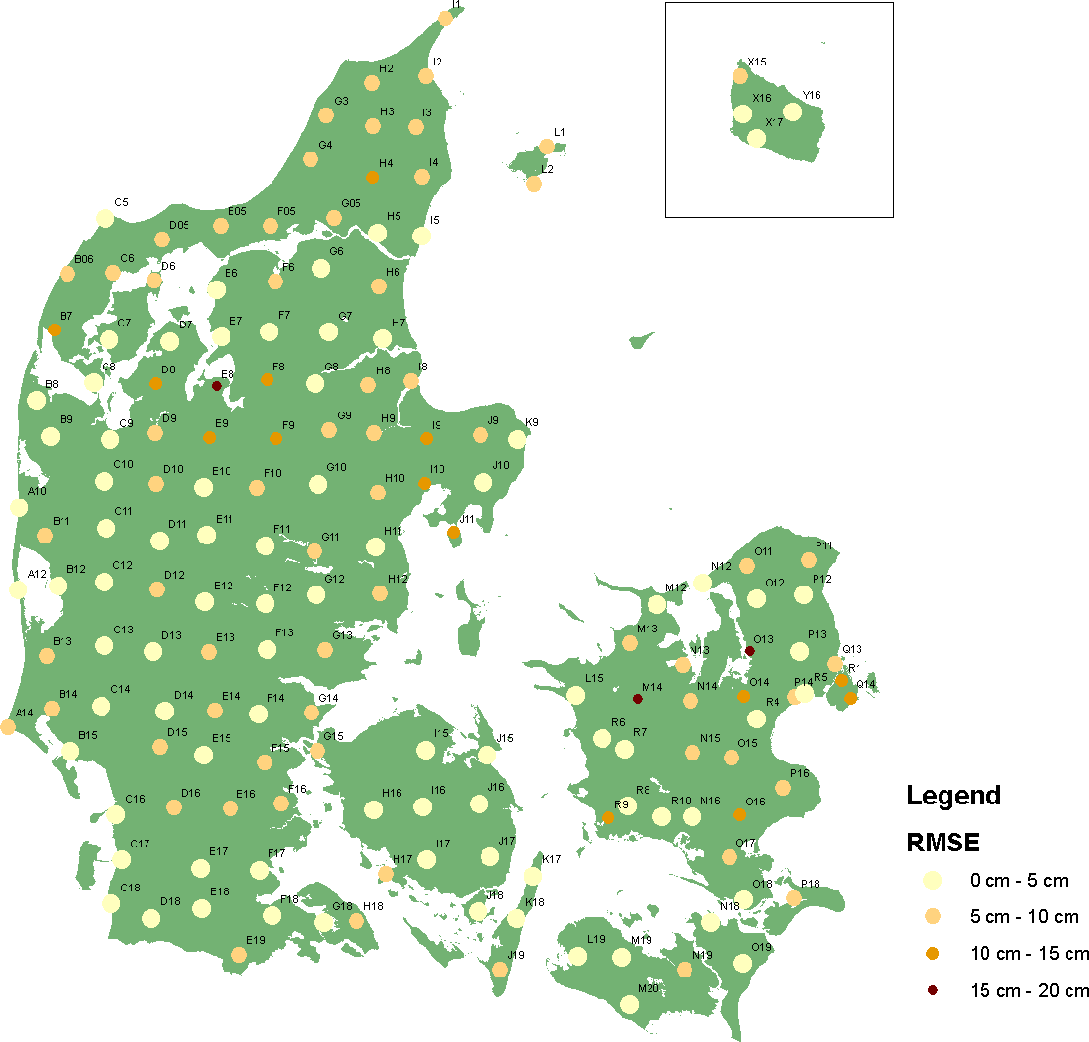

Figure 3.5: RMS errors of all control patches. Three control patches with an error larger than 15cm are illustrated in figure 3.10, figure 3.9 and figure 3.11

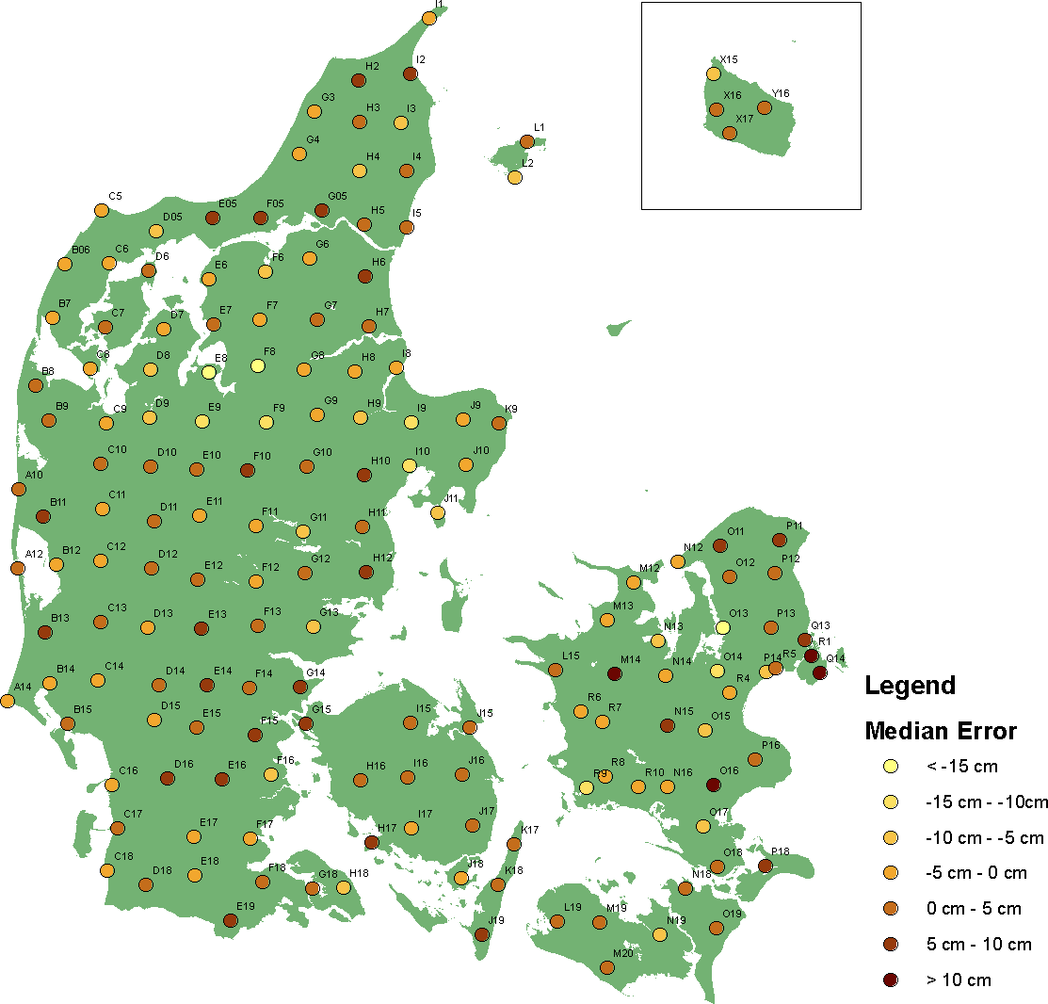

Figure 3.6: Median error of all control patches, where minimum median error is -18.5cm and maximum median error
+13.5cm

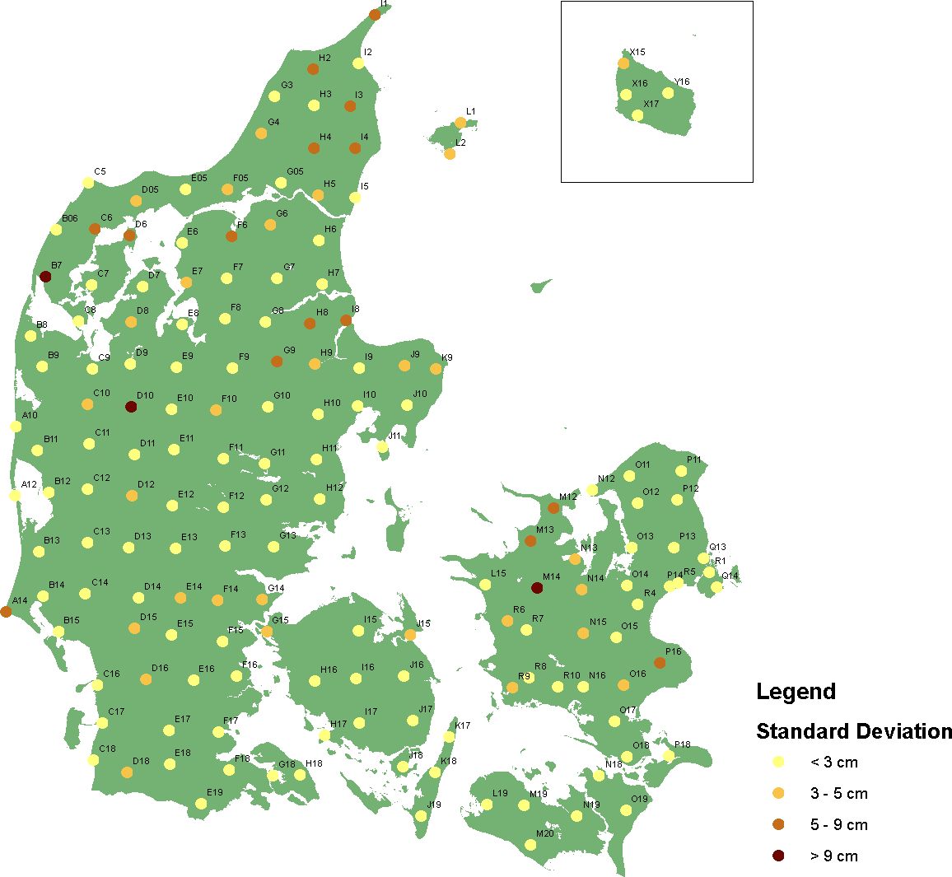

Figure 3.7: Standard deviation of all control patches. All control patches with a standard deviation higher than 9cm (M14, D10, B7) have been measured on steep or not well defined areas, which can be seen in figure 3.9, figure 3.8 and figure 3.12.

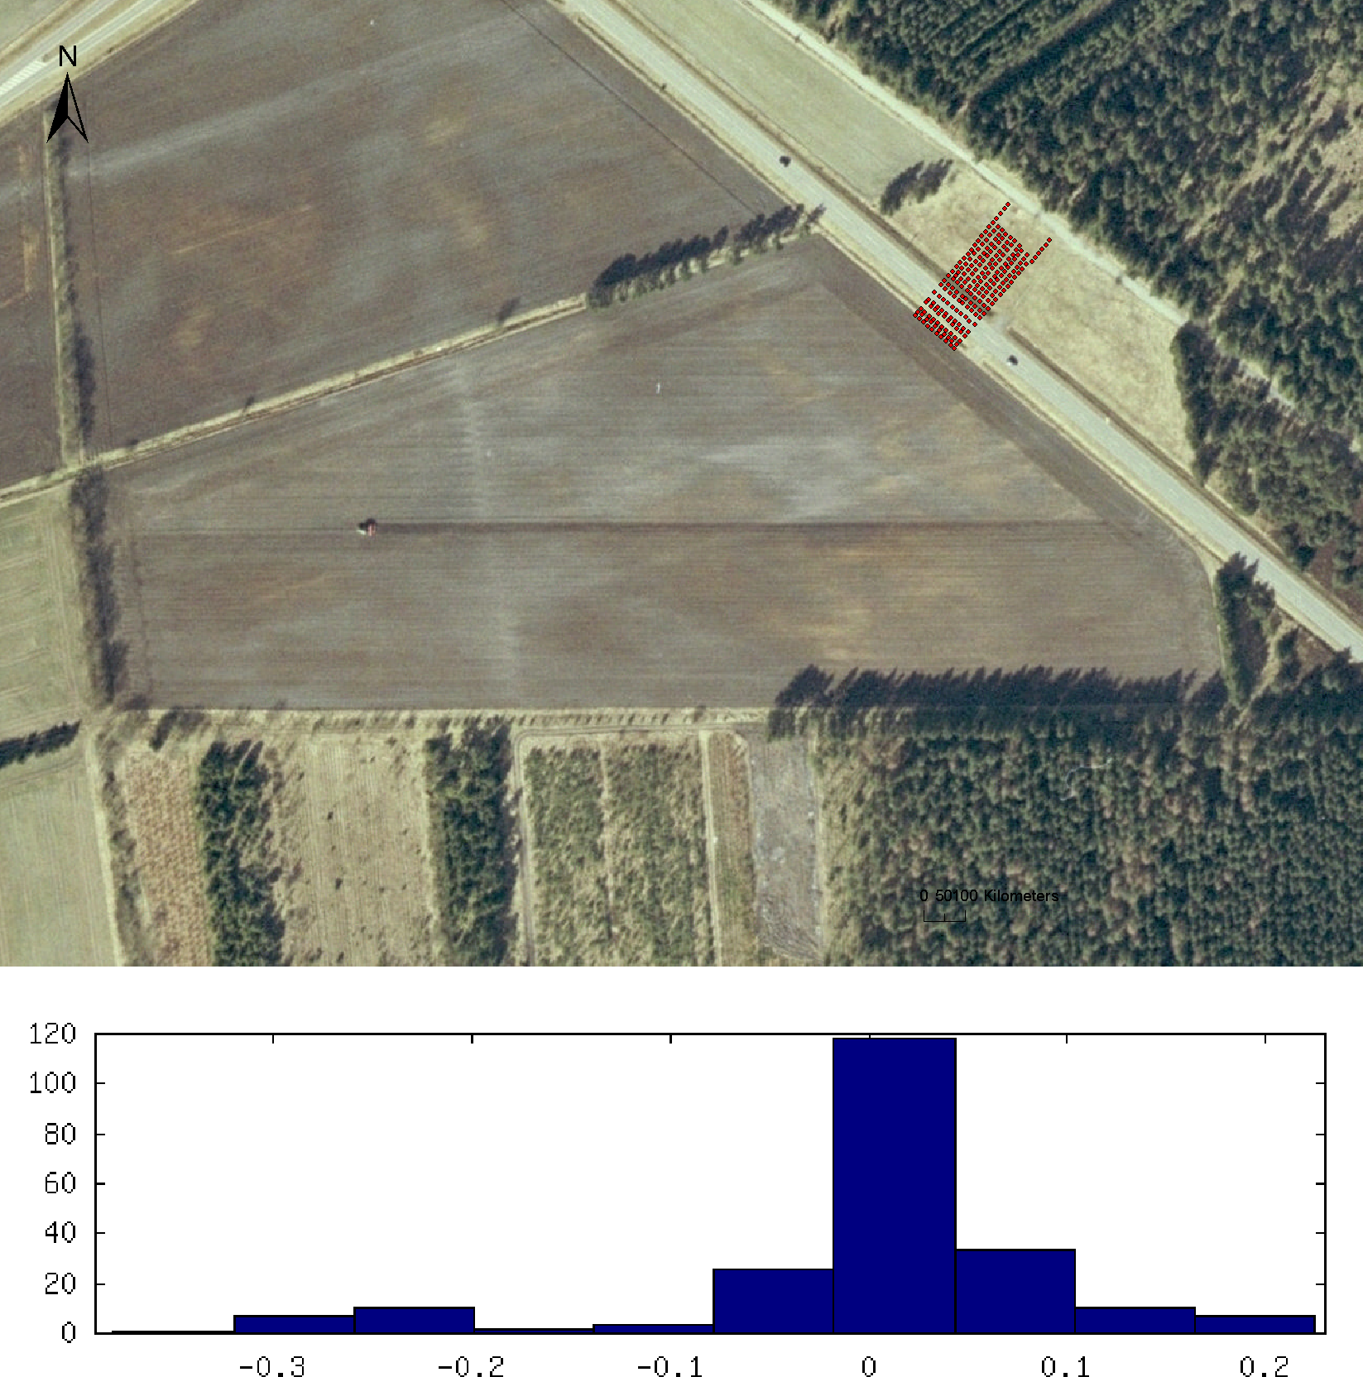

Figure 3.8: Location and histogram plot of control patch D10. The surface of the control patch varies from being asphalt to low vegetation, which can result in poor accuracies of both reference data and DEM/terrain.

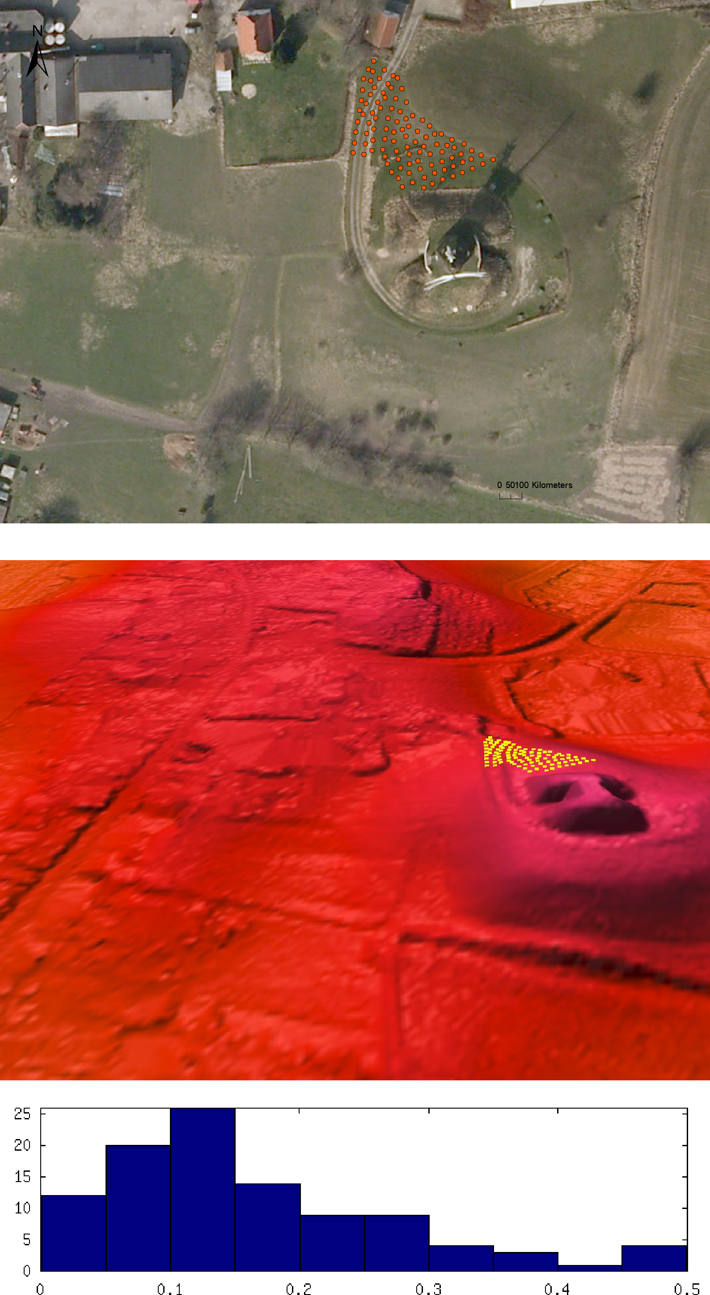

Figure 3.9: Location and histogram plot of control patch M14. The reference points are measured in a steep area, where the vertical accuracy depends more on the horizontal accuracy. The steepness of M14 can be seen in the 3d-DTM model.

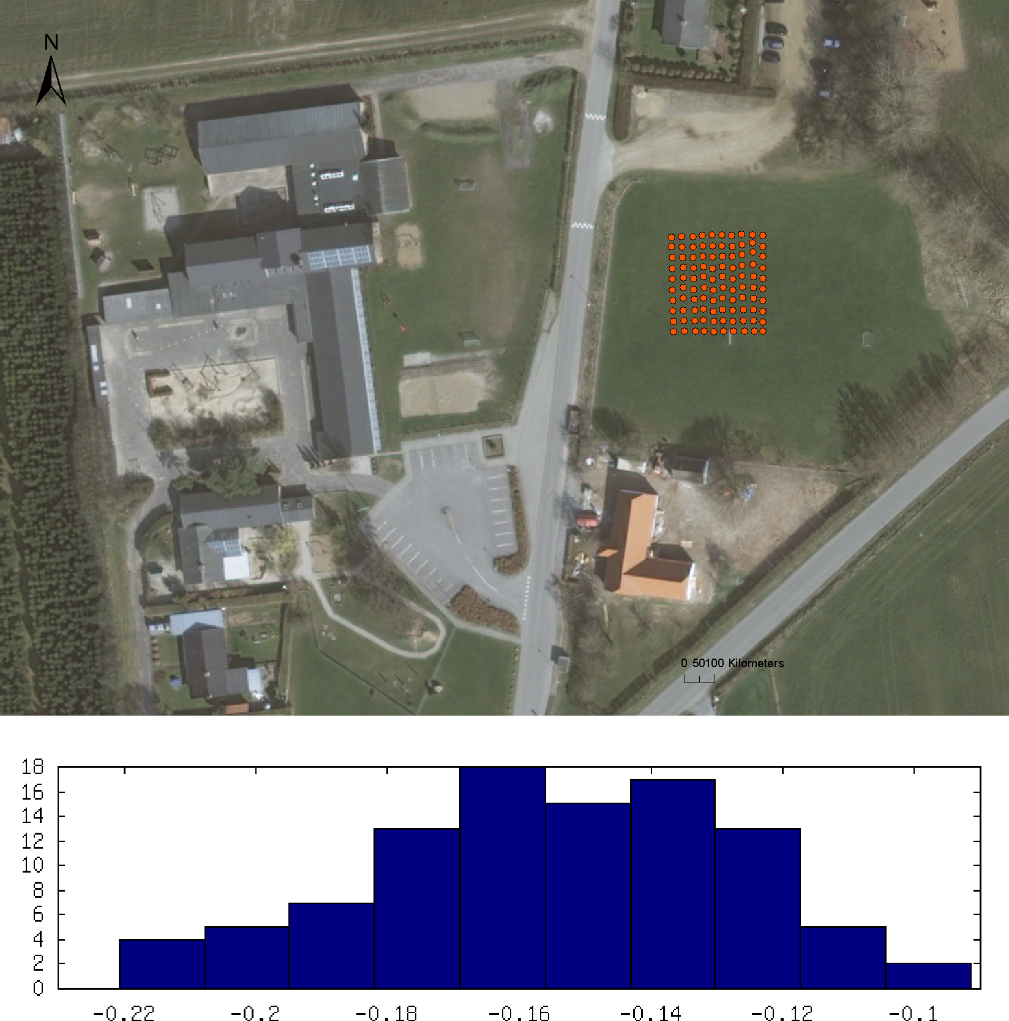

Figure 3.10: Location and histogram plot of control patch E8. It can be seen that the average of the measured reference points are 16cm below DEM/terrain points.
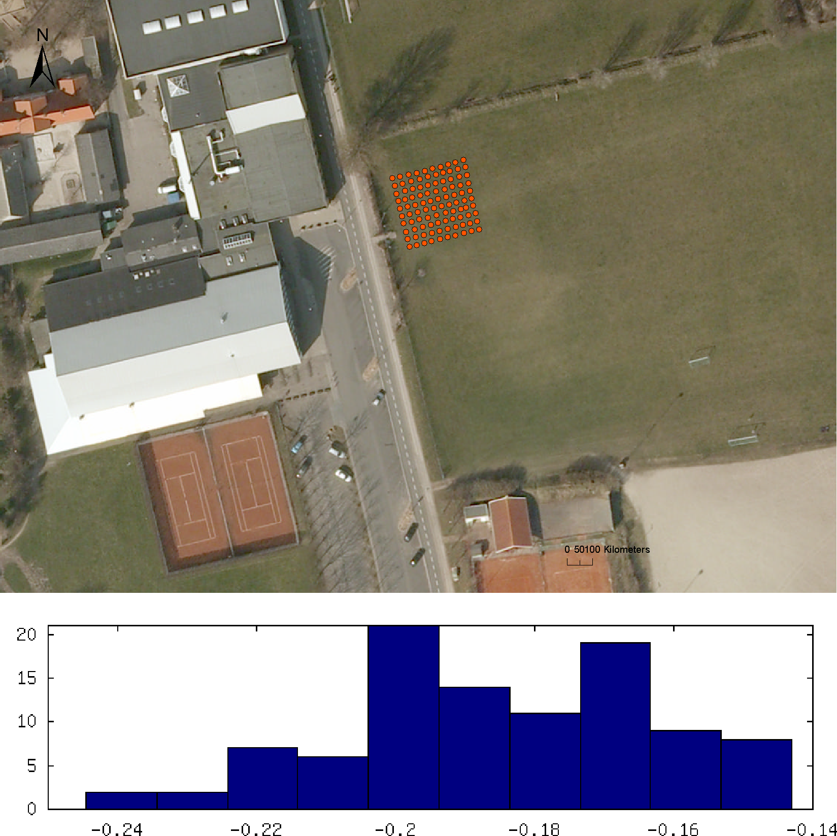

Figure 3.11: Location and histogram plot of control patch O13. The reference points are about 18cm below DEM/terrain. The short distance to the building could be an explantion.

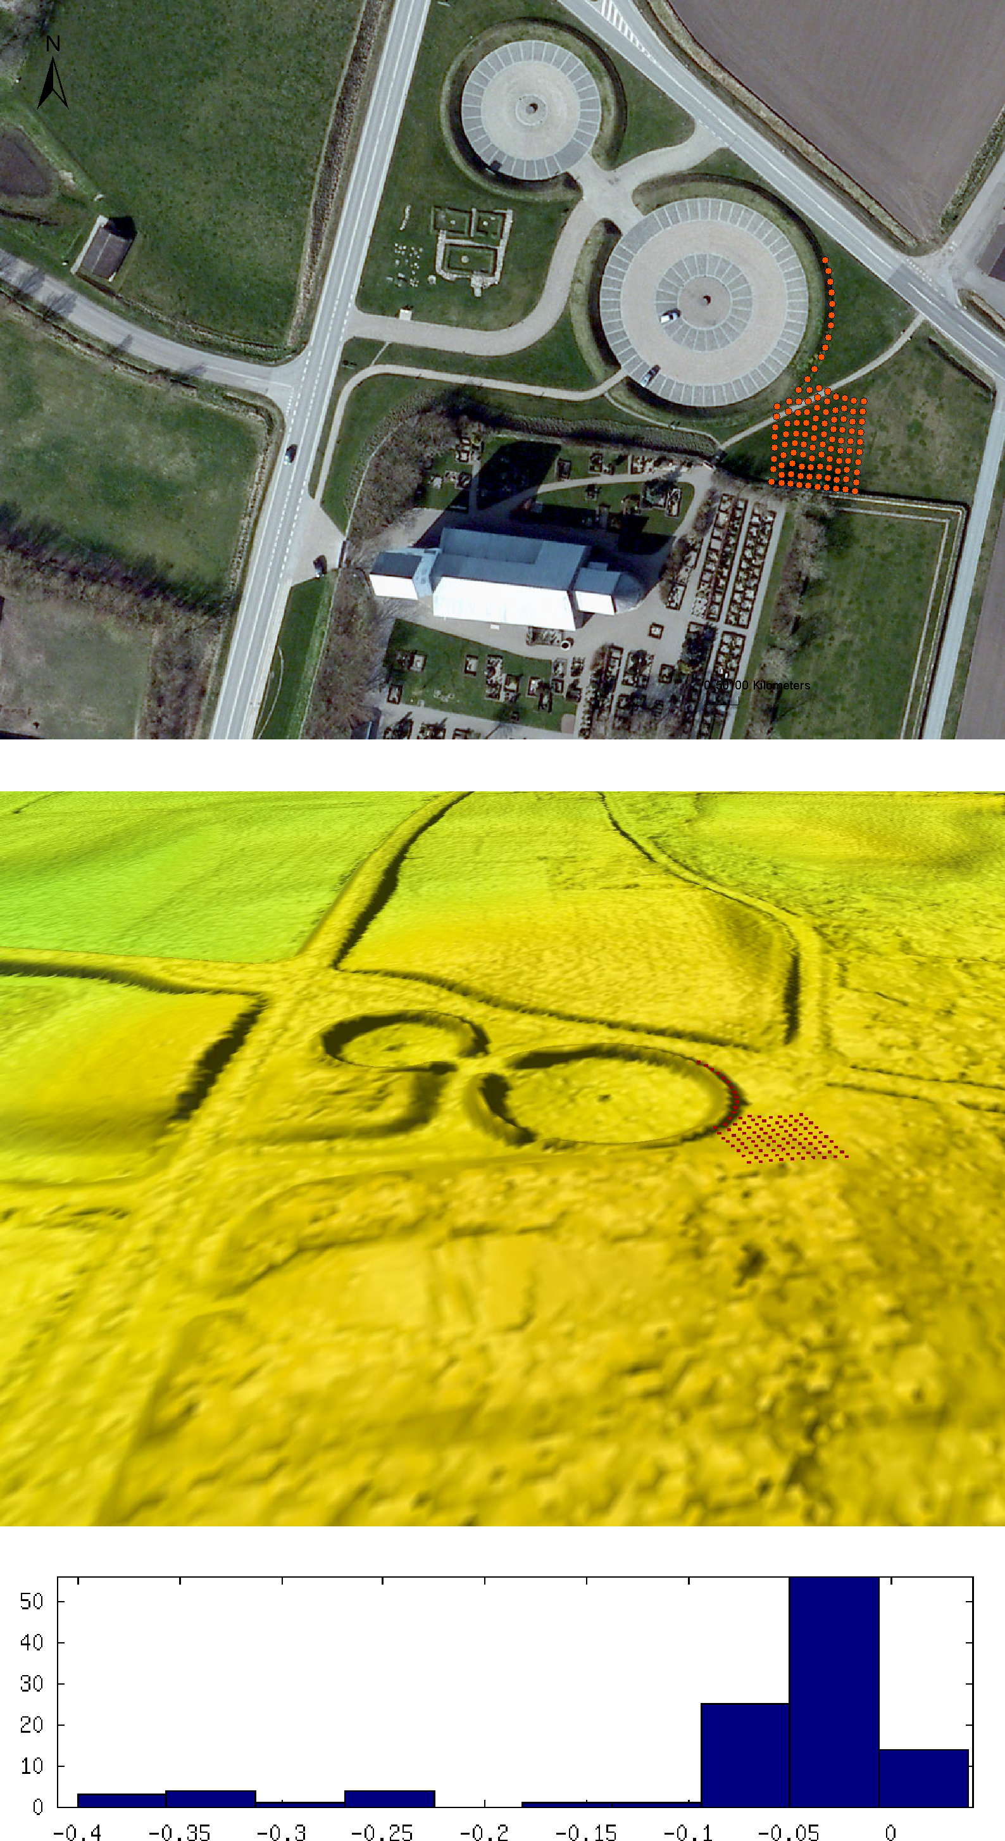

Figure 3.12: Control patch B7 is measured in a steep area, where the vertical accuracy depends on the horizontal accuracy also. The steepness of B7 in the 3d-DTM model.

Actuality

While the DEM laser measurements were carried out in the period from 2005 to 2007, the control measurements were carried out from 2007 to 2009. The difference in time has to be considered when interpreting the results. Thus, a large error may not be due to poor quality of the DK-DEM, but could be caused by events that took place between times of measurements of DEM data and reference data. Within this report we did not investigate into the challenge of actuality, but in the quality of the delivered data for the time of data recording.

3.2 Horizontal accuracy

The Danish National Survey (KMS) developed a method for determining the horizontal accuracy of the DK-DEM. As KMS does not own the point cloud but the raster models our verification has been carried out on the DK-DEM model. In this chapter a short summary of the method and results of our control of the horizontal accuracy is given. A more detailed description can be read in a separate technical report (Hawa et al., 2011) that has been published earlier.
As buildings typically have a recognizable geometry and reasonable resolution they are often used for verifying the horizontal accuracy. Even though we did not have an exact building position, as it can be seen within a point cloud, we were using buildings from in the normalized DEM/surface (DEM/surface - DEM/terrain = normalized DSM) as our target objects. The measurements of the buildings in nDSM (normalized DSM) were carried out by visual inspection. This could be done with an satisfyingly quality, because of the well known fact from photogrammetry that even an unskilled stereo operator is able to estimate the position of rectangular crossing lines with an accuracy that is 3 times better than the resolution of the imagery. All in all, 568 building corners were measured for 142 buildings in 4 different test sites. The average RMS error for the entire horizontal errors showed out to be 67cm, which was well below the original requirement of 1.0m.

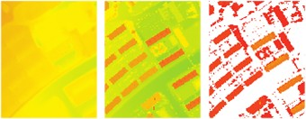

Figure 3.13: DEM/terrain, DEM/surface, normalized DSM with a threshold height of 1.5m; where the nDSM is used for verifying the buildings within the model. The result is compared to registered vector data.
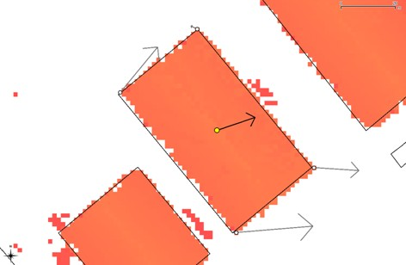

Figure 3.14: Selected corners with the resulting vector in the center of gravity
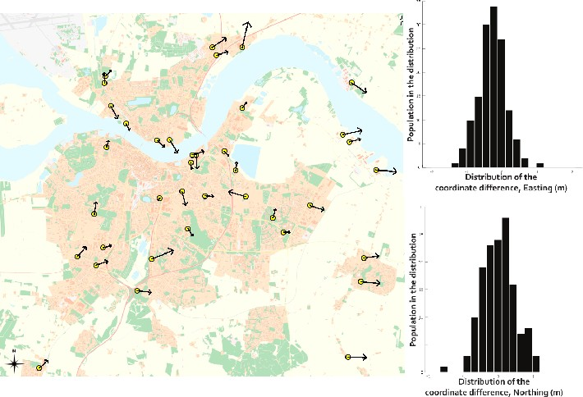

Figure 3.15: The yellow points represent the measured buildings around the Aalborg area. The arrows show the direc- tions and RMSE values, of the coordinate differences. Arrows are exaggerated by a factor 500. As also reflected by the results table on the right hand side, the DEM appears to be shifted approximately 50cm eastwards.

Chapter 4

Improvement of the Models

Generally, the DK-DEM is interpolated from the point cloud. As there are some physical restrictions concerning the reflection of laser light (water deflects the laser, black roofs absorb light and no laser reflections from below a bridge), methods for improving DK-DEM have been developed in cooperation between KMS and the contractors. These improve- ments have been carried out on the DEM/surface and DEM/terrain grid.

Lake Improvement (lakefix)

The most important restriction of laser light measurements is the light deflecting property of water. This means that the elevation of lakes and streams can not be measured sufficiently. This could be solved either by using a no-data value or by interpolating the affected areas with an alternative method. We decided together with our co-financing partners, that a homogeneous model (no no-data values) with interpolated values is preferable.
Our investigation resulted in the “lakefix ” routine that improves the DEM/surface and DEM/terrain grid. A big effort was carried out to determine in which areas lakefix should run (definition of a lake). We decided that it is important that a lake is permanent. As our laser scanning was carried out between 2005 and 2007, we were running lakefix on intersection areas (association volume) where lakes were registered both in the years 2005 and 2008. Besides the area where a lake fulfills this definition, also the laser measurement was used for computing the lakes height value. If an area has a low data density lakefix will firstly calculate a lake covering the area with no-data. After this lakefix will grow the “lake” to all laserpoints within a variance of 10cm. Lakefix starts seeking a height value within this identified area. The lowest measured value, that either was measured directly under the airplane (laser light hitting water right angled will be reflected) or at the lake boundaries, is used as the height value for a horizontal lake. These conditions imply, that lakefix was calculating flat areas for sites, where

    - a lake had been registered both in 2005 and 2008.
    - a low laser point density occures.
    - variance between the laser measurements is less than 10cm.
This strict definition of areas where lakefix were applied leads inevitable to sites where real lakes are not made com- pletely horizontal, as they did not fulfill all these theoretical requirements. Moreover, there is a risk when working over tile boundaries with differences in point density in either tiles. In this case lakefix will automatically run in the tile with an average low point density. This possible error is outlined in figure 4.4.
The developed lakefix -method removes the no-data value in nearly all lakes. It does neither result in data stripes from reflections directly under the airplane, nor in huge triangulations in areas with a low data coverage. The searching algo- ritm of lakefix ensures that the flattened areas are real, meaning not too small or large lakes. Moreover, it searches over the registered area which avoids data stripes and huge triangulations outside the 2005-2008 area.
Examples of lake that is improved by lakefix can be seen in figure 4.3.

Bridge Correction (bridge fix)

Another important challenge of a terrain model that excludes bridges, is the shielding of the laser light by bridges and thus giving no information under the bridge. As also DEM/terrain excludes bridges, a value bellow the bridge has to be interpolated. When the bridge is over water, no laser light will be reflected from the area under the bridge (neither

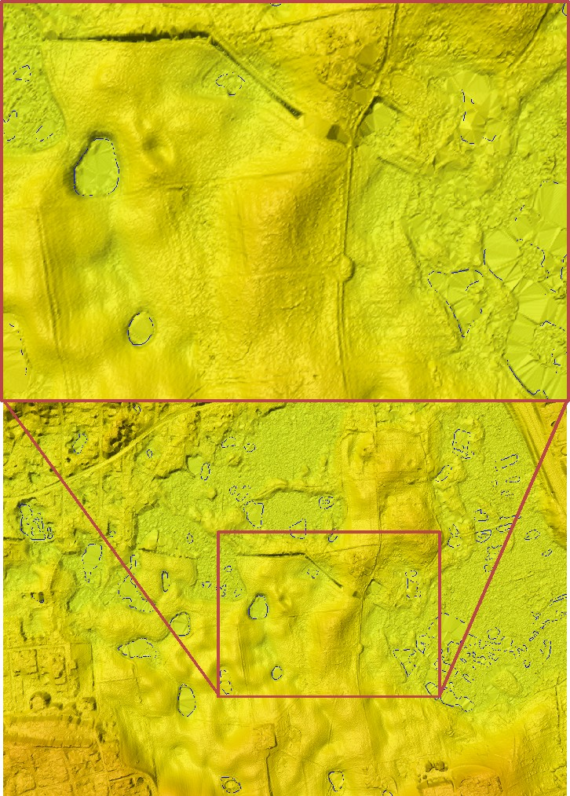

Figure 4.1: Area with small lakes, where no lakefix was carried out (Tile: 6180_715).

from the neighbour flight ). If, like in our case, no break lines were included and a simple triangulation method was used for the model generation, there is a big possibility that the nearest reflection point is measured from the other side of the terrain gap. This gapping effect can be seen in figure 4.5. This means that even if a bridge is treated correctly by classification, it is often recreated during the triangulation process (gapping effect ). To avoid these re-created bridges, DEM/terrain was corrected inside polygons around the bridges.
For this purpose the DK-DEM contractors developed a method that uses a bridge mask (new grid, only including values for bridges of less than 2000m2) to find the cells which should be interpolated in a different way than triangulation. Every cell of this bridge mask was compared to the corresponding cell of the DEM/terrain. All cells where the value inside the bridge mask differs less than 2m from DEM/terrain were accepted as valid terrain value. Furthermore, all neighbour cells were checked within a search radius of 20 cells if their value was lower than the bridge mask. The lowest value was ascribed as the valid terrain for the whole site under the bridge. For minimizing edges these calculated values were smoothened.
As it can be seen in the figures 4.6 and 4.8 the bridge correction does not work as perfect as one could hope. The calculation method, where the lowest point within a search radius of 20m to bridge values is used, results unfortunately

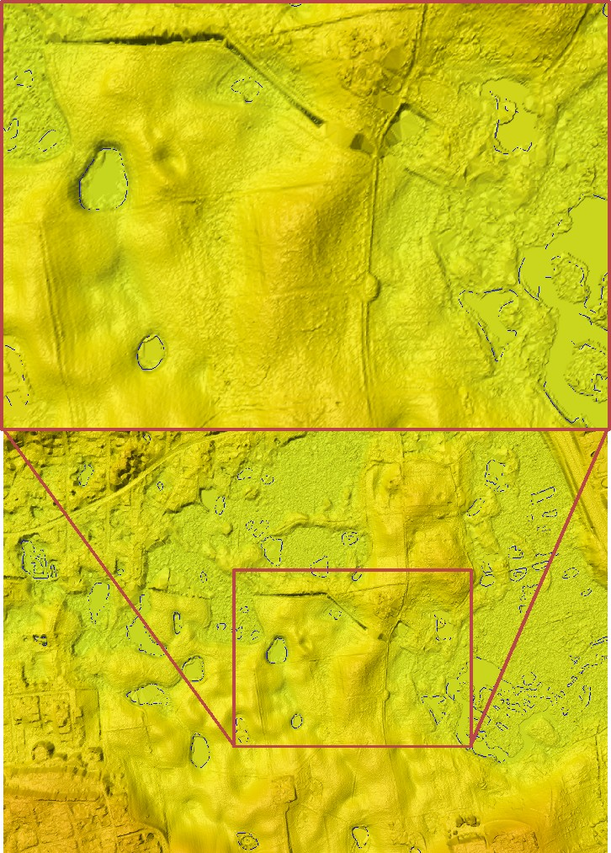

Figure 4.2: The same area as in figure 4.1 after lakefix was carried out (Tile: 6180_715).

in holes that can reach down to 1m in DEM/terrain. Moreover, the bridge fix has been applied to small bridges only (< 2000m2) for avoiding bigger odd artifacts and because the gapping effect occurres most likely at small bridges. Un- fortunately, there is still a possibility that also larger bridges were re-created by the triangulation process. Nevertheless, this was accepted as the best achievable solution within the available time and resources.

Clipping of Ports and Piers (coast fix)

To ensure a flat and homogeneous sea surface all sea bodies were clipped and set to an elevation of 0.00m. Many piers and ports have a narrow width compared to the point density of the DK-DEM point cloud. If the laser does not hit the maximum point, the model will not describe the correct height. Moreover, if the model in these areas would be generated uncritical many of these points would either be filtered away as blunder points or by the sea leveling process.
For avoiding the sorting out of these important points, special attention was given to the clipping of ports and piers. Information about the coast was taken from the KMS vector data set, where both coast and harbor themes were used.

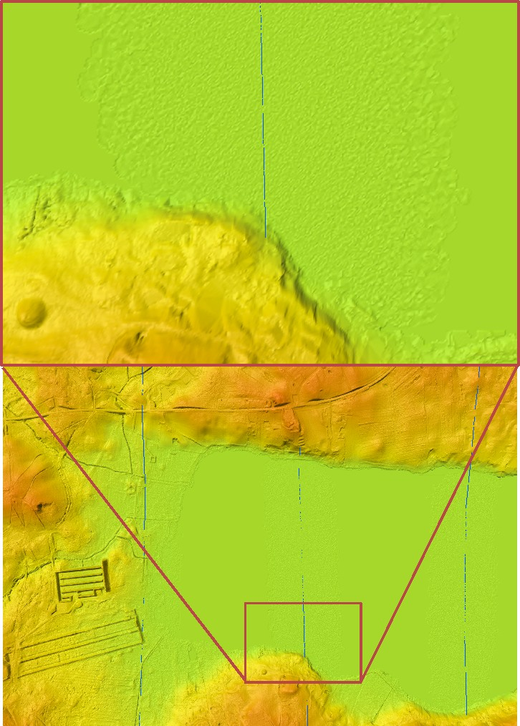

Figure 4.3: Lake where lakefix was executed. A value is interpolated for the parts of the lake where no return signal was measured. The blue lines show the flight lines and as it can be seen in the zoom, there are reflections from directly under the airplane, but not from beside the flight line. Hence, it was possible to calculate the surface directly under the flight line while it was necessary to run lakefix besides the flight line (Tile: 6196_715).

A new coast polygon was edited using this information and the newest ortophotos that ensured that all piers harbor constructions were included in the model.

Photogrammetric Corrections

In the lidar data there have been a number of large areas with very low data density resulting in huge triangulations in the grid. While most of these areas had suitable explanations, like actual lakes or huge buildings, some of the reasons for low density could not by accepted. Most of the unaccepted sites were due to

    - flooded agricultural fields.

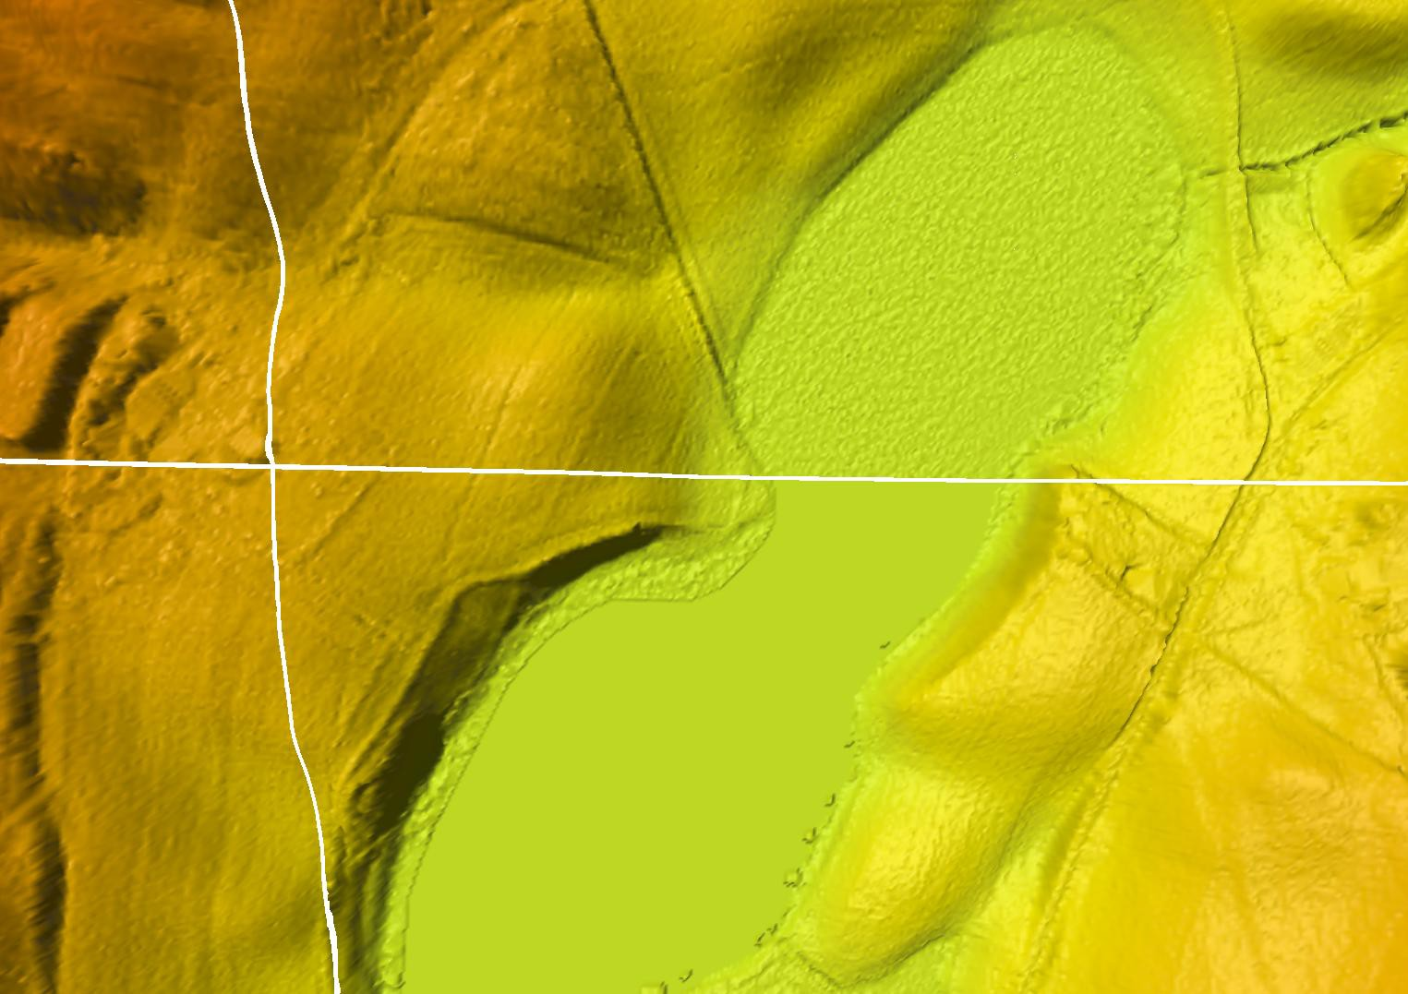

Figure 4.4: Area where lakefix was run in the southern, but not in the northern tile, where the average amount of return points just were sufficient in northern, but not the southern tile (Tile: 6259_531). Note, this example has been corrected in DK-DEM.

As the contract with the data supplier included the requirement, that data must not be collected while agricultural fields are flooded, these areas had to be re-measured. Furthermore, there had been some areas where the low data density was caused by
    - missing overlap between flight lines.
    - equipment that was turned off to early.
    - shadowing clouds in the atmosphere.
The sites where the data density was not acceptable were pointed out by KMS and the contractors re-measured them. The re-measurement was mainly done by photogrammetric correlation. In figure 4.11 the location of newly measured sites are shown. In figure 4.12 a faulty and in figure 4.13 a corrected grid of the same area is shown. Moreover, figure
4.14 to figure 4.16 shows examples of before and after correction of the grid. The photogrammetric correlation was carried out with RGB stereo recordings from summer 2008 with a ground sampling distance (GSD) of 20cm. The data assimilation was carried out directly in the point cloud, after which a new DEM/terrain model was calculated. For that purpose the original laser scanned point cloud of the affected areas was generalized to a point cloud with node distance of 5m. These point cloud values were compared to the elevation values calculated by autocorrelation. In areas with no- data values in the laser scanning, or a difference between the laser and autocorrelation grid larger than 10cm, entirely the autocorrelated points were used for model calculation (DEM/terrain). The autocorrelation area was chosen larger than the area of low density, so as to use the overlapping region, to transform the photogrammetric measurements to the DEM/terrain.

Classification Errors

DK-DEM is generated from approximately 20 billion laser points. These points are mostly classified automatically, but to some extend post treated manually. When working with this amout of points, a completely faultless point cloud is desirable but statistically impossible. We found 2 types of classification errors:
    - Spikes, that are caused by either single points, that are reflected from the surface eg. tree top or bird but faultily classified as terrain points (results in +∆z), or by multi reflection of the laser beam (results in −∆z). These errors

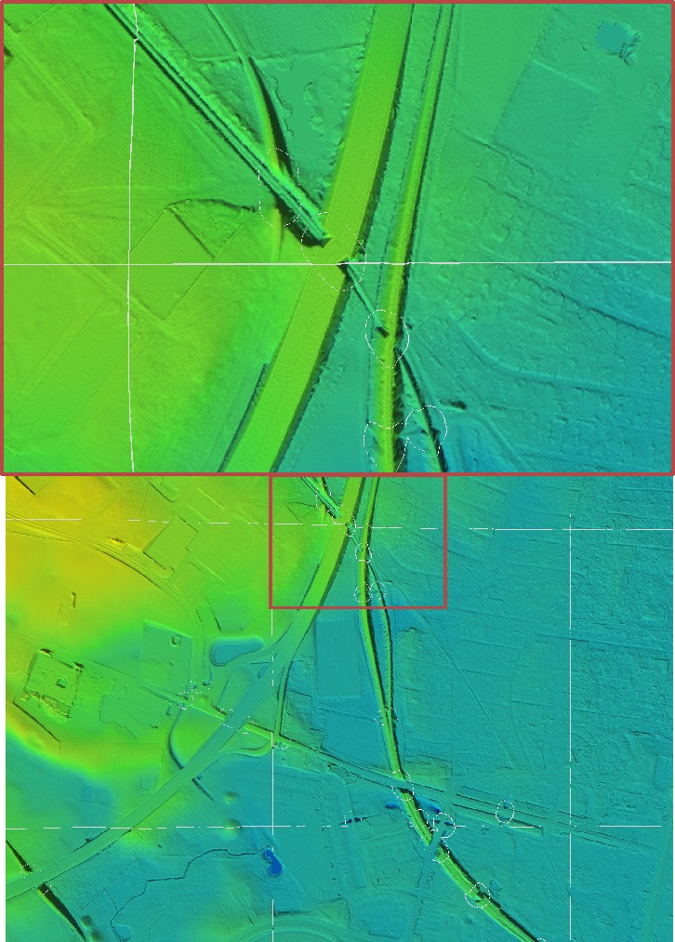

Figure 4.5: Example of briges without bridge correction (Tile: 6153_700).

have especially be seen at tile boundaries, which may be caused by the diminished focus on the edges compared to the center focus of the human editors. The most effective way of finding these edge spikes turned out to be human visual control.
Holes in dikes which have been found while using DEM/terrain for water level simulations, are another serious example of errors in classification. Most of the classification was done automatically, where the angle from one point to its neighbouring point determines the point’s class (terrain, surface, blunder, photogrammetric point ). As dikes have a very steep terrain form, the automatic classification can fail. This failure was supposed to be found by the human manual editors that rechecked the whole DK-DEM. With approximately 80,000 registered dikes this was a huge task. Unfortunately, many of the wrong surface classified points were not found by this control due to small spatial extensions they were difficult to distinguish from the surroundings. This resulted in holes in dikes in the DEM/terrain. As the consequence of these classification errors is very serious for water level simulation applications (water will break through the dike in a simulation scenario), KMS decided to particularly investigate in the correction of these errors. The method and results of this investigation is described earlier in a separate technical report (Rosenkranz et al., 2011a).
•

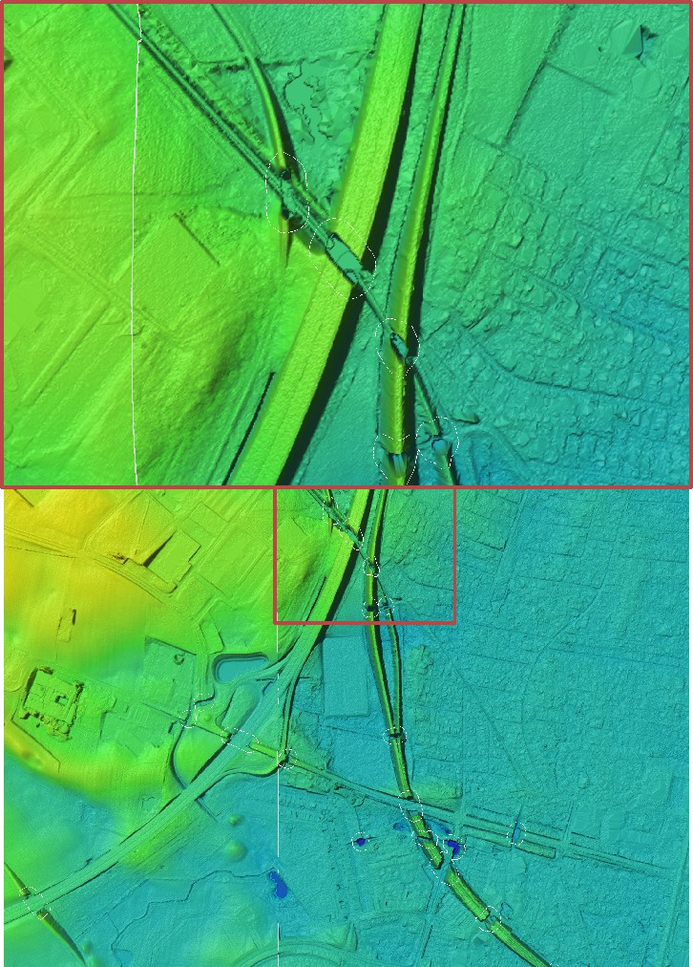

Figure 4.6: Example of bridges after bridge correction, where bridge values were calculated within the white polygons (Tile: 6153_700).

Surface Model DK-DEM/surface

The DEM/surface model has been generated by use of “a priori information masks”. For this purpose forests, roads, urban areas and building have been rasterized from the Danish vector data Top10-DK and were used for a differentiated generation of DEM/surface. The used method is described in (Knudsen et al., 2008).

In forested areas, where the height value depends on from which part of the tree the laser light was reflected, only the points reflected from the tops of the trees were used for model generation. With this method the surface of forestry areas exemplify the unbroken tree crowns.

When scanning roads, it is unavoidable to also scan cars. As cars should not be included in DEM/surface, they have to be removed. This has be done by using the a priori information of the road system and by generally not allowing objects in the road model between 1.5m and 4m.

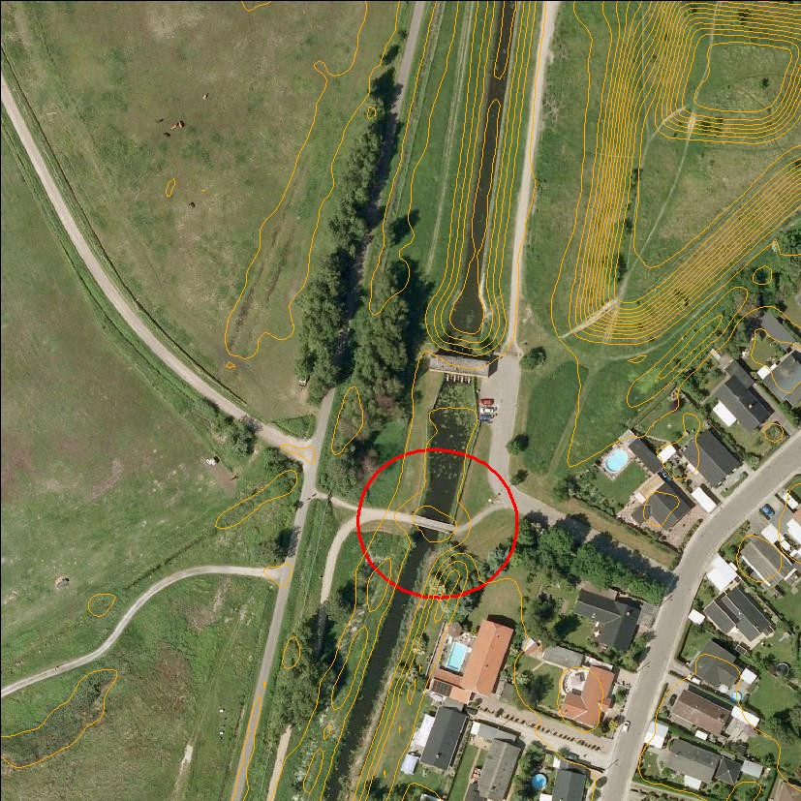

Figure 4.7: Orthophoto and contour lines of a bridge where the bridge in DEM/terrain is removed by bridge_fix (Tile: 6160_720).

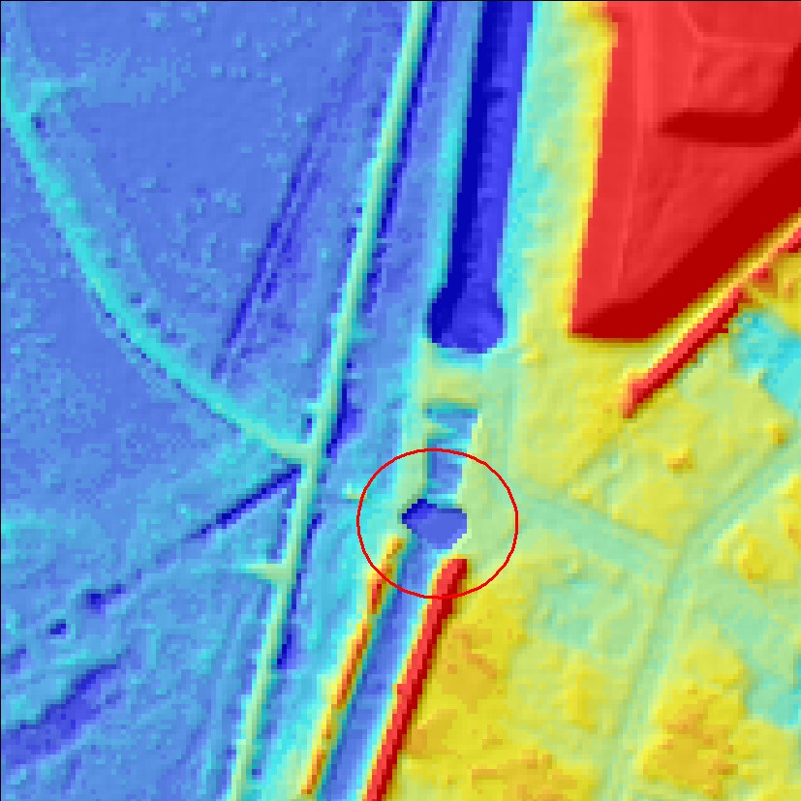

Figure 4.8: Close-up zoom example of a bridge with the bridge correction (Tile: 6160_720).

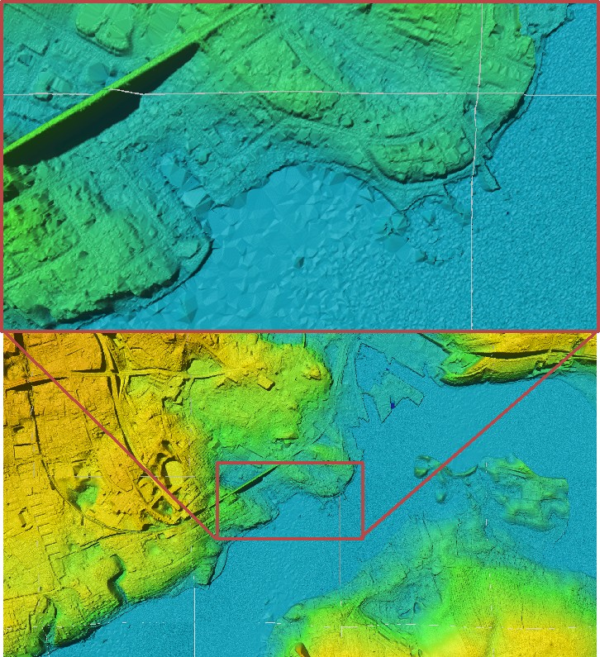

Figure 4.9: Examples of harbor problems at Silkeborg harbor before the habor fix. As it can be seen in the zoom, parts of the harbor are disappearing the triangulation process (Tile: 6101_602).

Dark roofs of buildings are poor reflectors of laser light. Using an uncritical model generation, the sparse reflections of roofs, would be sorted out within the standard blunder detection process and terrain elevation being interpolated where the building should be. As this is not desirable for roofs, the reflection points are not sorted out within building masks where lidar returns are scarce.

The fourth a priori information class was the miscellaneous object class, which includes all other objects. The mis- cellaneous objects are filtered with standard methods.

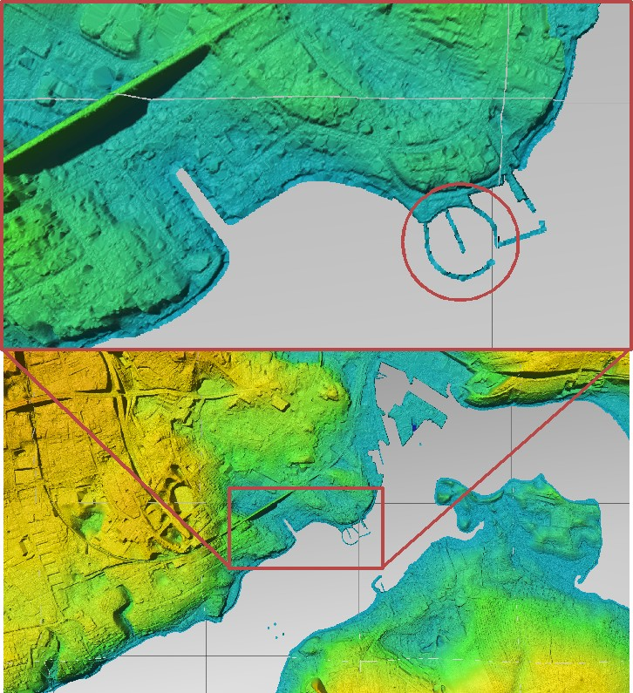

Figure 4.10: Example of a clipped coast line at the same area as in figure 4.9, where the sea level is shown in grey. The sea level is lateron set to 0.00m (Tile: 6101_602).

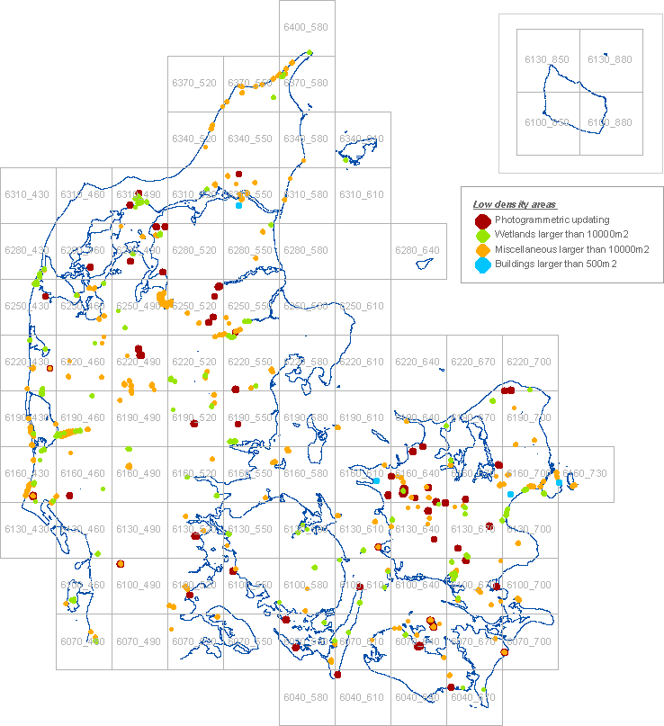

Figure 4.11: Map of the stites with low data density shown together with the 30km x 30km tile names. The areas are enlarged for visualization purposes. The red areas Photogrammetric updating are the only sites that have been corrected. The wetlands, the miscellaneous and the buildings have been accepted and left as-is in the final model.

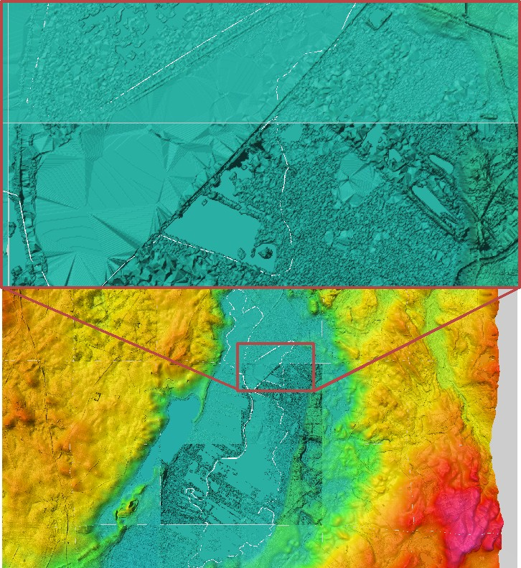

Figure 4.12: Example of an area with low laser data density. Huge triangulations can be seen in the low density area. Figure 4.13 shows the same area after photogrammetric correction (Tile: 6167_649).

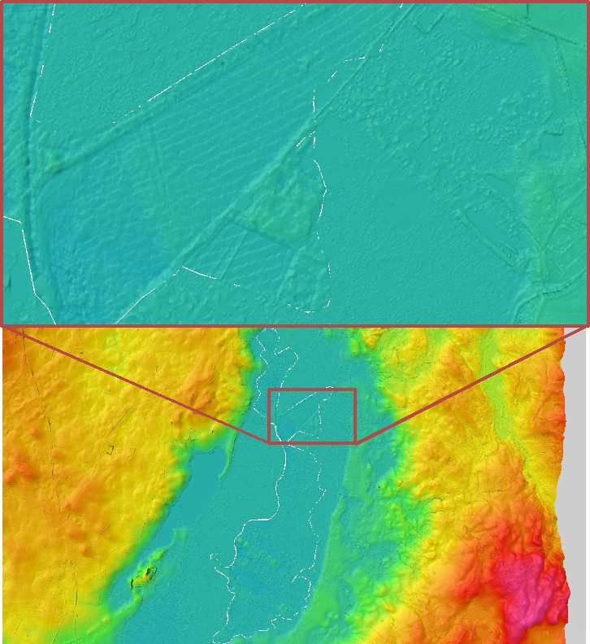

Figure 4.13: Example of the same area as in figure 4.12 after the photogrammetric correction (Tile: 6167_649).

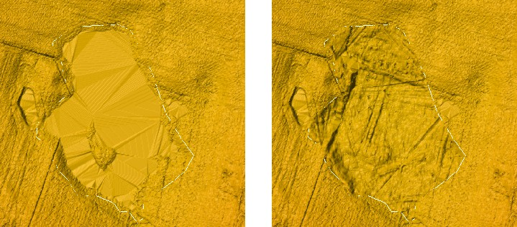

Figure 4.14: Left hand side: Example of an uncorrected low density area. Right hand side: Photogrammetric corrected area. (Tile: 6160_664).

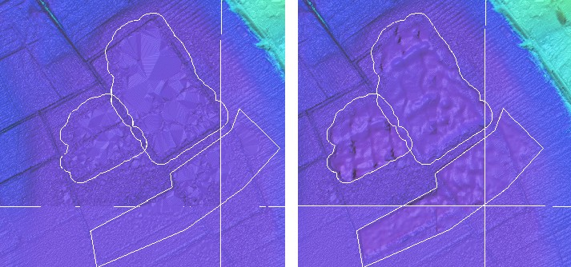

Figure 4.15: Left hand side: Example of an uncorrected low density area. Right hand side: Photogrammetric corrected area.(Tile: 6082_588).

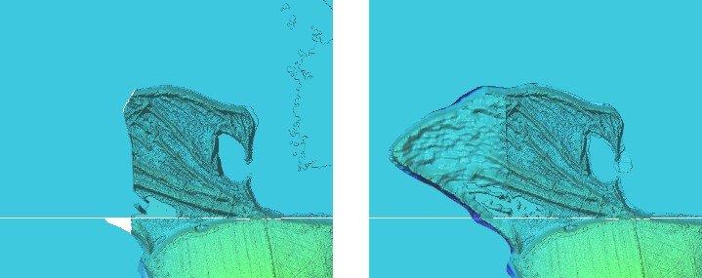

Figure 4.16: Left hand side: Example of an uncorrected low density area. Right habnd side: Photogrammetric corrected area. This example shows an area where the laser equipment had been turned off too early (Tile: 6123_555).

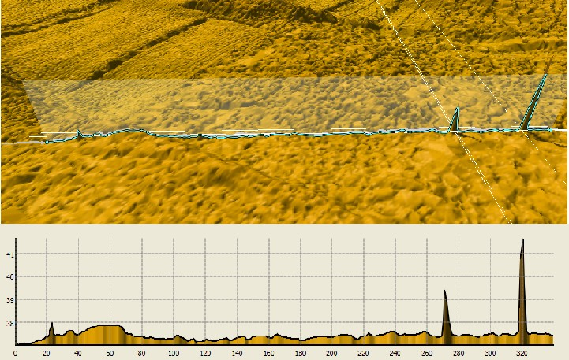

Figure 4.17: Example of edge spikes, where the z-value is inflated by six. These “small” spikes were mostly found by the human visual control in a hillshaded model (Tile: 6235_497 ).

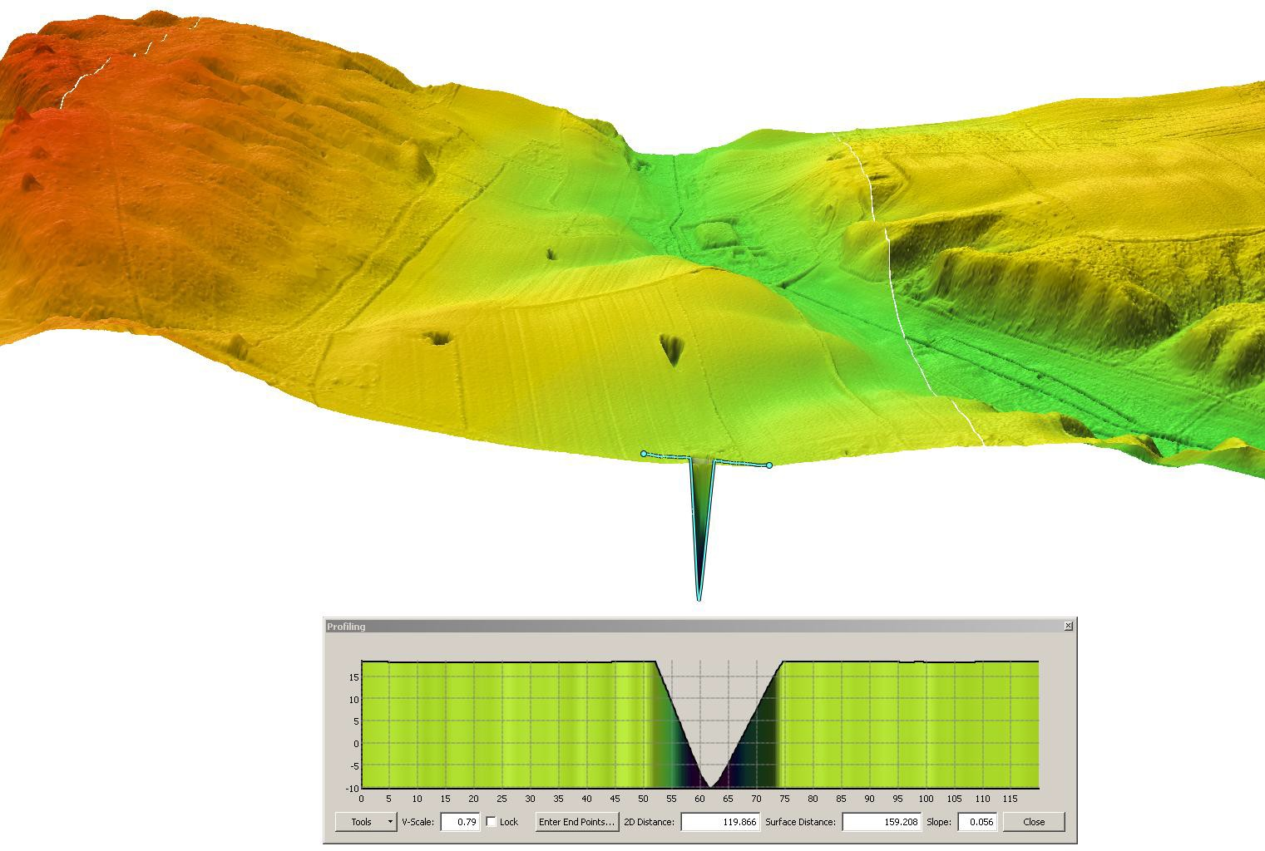

Figure 4.18: Example of a negative spike, where the z-value is inflated by six. (Tile: 6255_607 ).

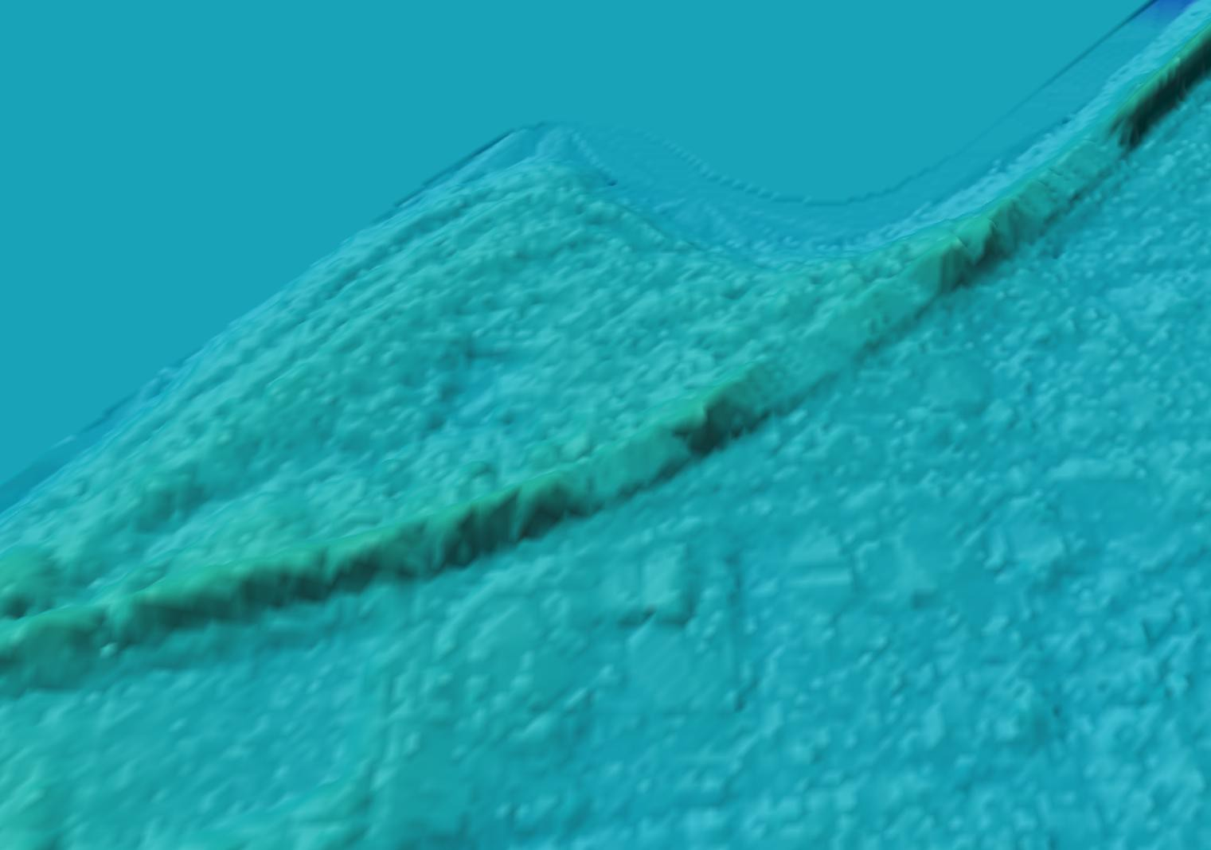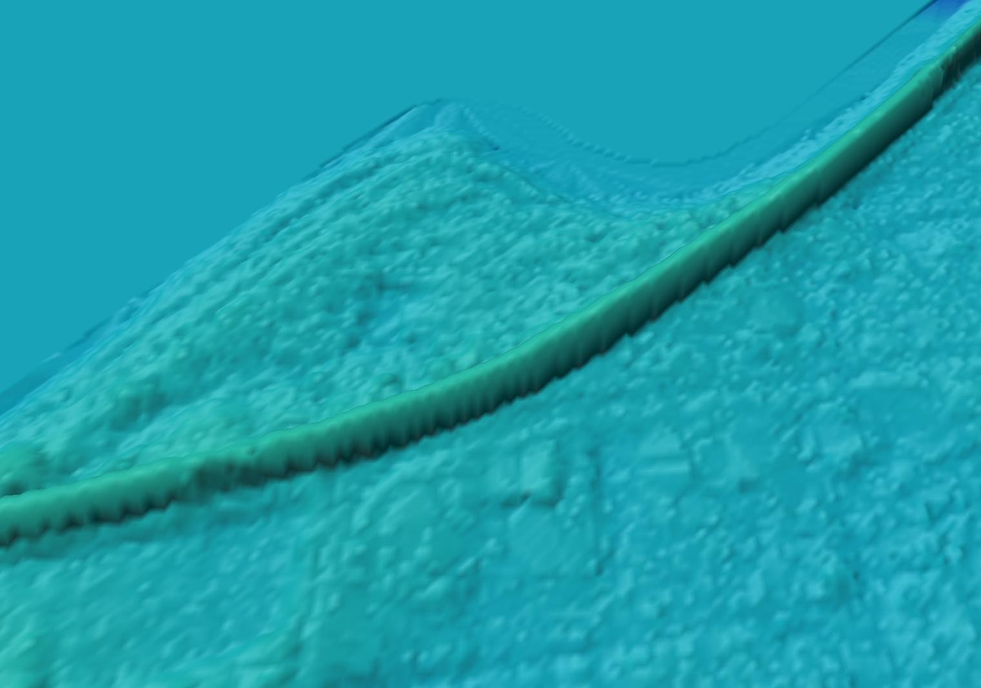

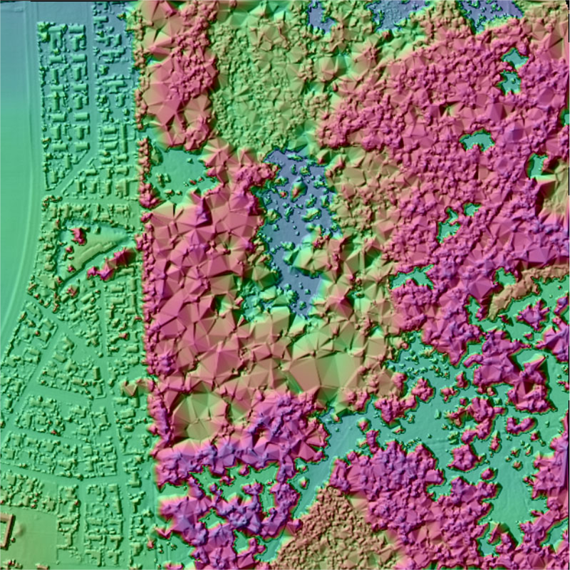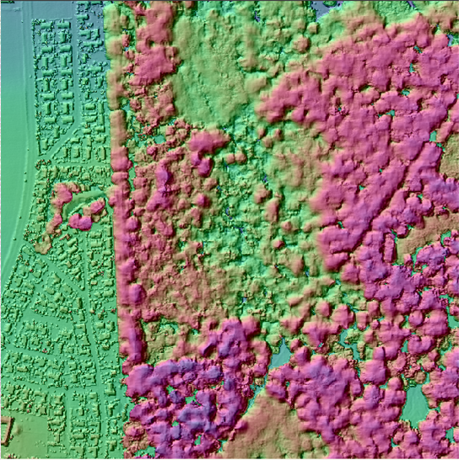Figure 4.19: Left hand side: Example of a faulty dike without correction. Right hand side: Example of the corrected dike (Tile: 6158_569).

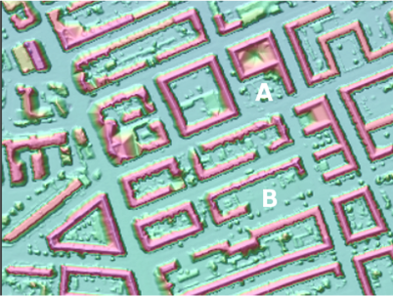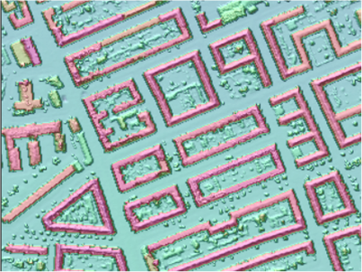Figure 4.20: Left hand side: Example of forestry area where the surface model is generated without using "a priori" information based filtering. Right hand side: Surface model of forestry area, generated by use of "a priori" information.

Figure 4.21: Left hand side: Example of an urban area with many buildings, where the filtering was carried out without “a priori information”. Right hand side: The same area with a priori information based filtering. While the noise in A is treated correctly in both cases, the building in B is removed when using standard filtering procedures, but not when using the a priori information.

Chapter 5

Conclusion

This report describes the various quality control processes, that KMS had carried out and their results. The report is directed to users of DK-DEM to increase the understanding for the data and to enhance the usage of the metadata (which can be downloaded for state users at ftp://ftp.kms.dk). Furthermore, it should enable the users to explain results (possibly unexpected results) of their data analyses. Even though a huge effort has been carried out to visually control the data, this report deals mostly with the highly automated processes. As a human visual control is subjective and depends on the controllers local and cartographic knowledge, it is difficult to report. Within a period of 2 years, KMS was working very close together with the data vendors to understand and improve the processing methods. The quality control project was very rich of experiences for both KMS and the data suppliers. As KMS required a better data quality than it was delivered in the initial version, KMS received one nationwide and many new local redeliveries. Nevertheless, it has to be kept in mind, that DK-DEM was modeled of 20 mia. laser points, which were partly edited by hand. A completely error-free model is statistically impossible. After 2 years of hard work for both KMS and the producers, the result is a high quality digital elevation model. Some technical limitations caused unintended artifacts which are described in this report and which were accepted by KMS.
Finally, it has to be pointed out that by finishing the quality control, the work with DK-DEM is not finished. In some areas the model is already outdated as it was surveyed back in 2005. Therefore, KMS and the governmental cooperation partners identified the updating of DK-DEM as the highest prioritized upcoming challenge for DK-DEM.

Bibliography

Christian Briese, Bernhard Hoefle, and Hubert Lehner. Technical report, als - denmark,. Technical report, Vienna University of Technology Institute of Photogrammetry and Remote Sensing, 2008. 1
M. Nour Hawa, Thomas Knudsen, Simon L. Køkkendorff, Brian P. Olsen, and Brigitt Rosenkranz. Horizontal accuracy of digital elevation models. Technical Report 10 (ISBN 978-78-92107-36-7), National Survey and Cadastre, 2011. 3, 3.2
Thomas Knudsen. PINGPONG: a program for height model gridding and quality control. In Knudsen and Olsen (2008). 2
Thomas Knudsen and Brian Pilemann Olsen, editors. Proceedings of the 2nd workshop of the NKG height model task force, Copenhagen, Denmark, 2008. Technical Report 4 (ISBN 978-87-92107-26-8), National Survey and Cadastre. 5
Thomas Knudsen, Brian Pilemann Olsen, and Rune Carbuhn Andersen. A priori land use information for fine grained se- lection of surface model gridding parameters: definition and implementation of the FLATMAN procedure. In Knudsen and Olsen (2008). 2.4, 4.6
National Survey & Cadastre. Det danske Kvadratnet, 2003. 1 National Survey & Cadastre. DEM/surface, 2011a. 1.1 National Survey & Cadastre. DEM/terrain, 2011b. 1.1
Brigitte Rosenkranz, Simon Lyngby Køkkendorff, and Steffen Svinth Thommessen. Rettelse af typefejl på diger i dan- marks højdemodel. Technical Report 11 (ISBN 978-78-92107-37-4), institution = National Survey and Cadastre, 2011a. 4.5
Brigitte Rosenkranz, Thomas Knudsen, and Hanne Mortensen. Automated generation of cartographic decent contour lines. Technical Report 13 (ISBN 978-78-92107-39-8), institution = National Survey and Cadastre, 2011b. 1.3
Brigitte Christine Rosenkranz and Thomas Knudsen. Checking strip adjustment without access to navigation records. In Knudsen and Olsen (2008). 2.3.1

Technical Report

ALS – Denmark

SAP D12273070002 / GZ 607028

Christian Briese, Bernhard Höfle, Hubert Lehner

Date: 13. February 2008

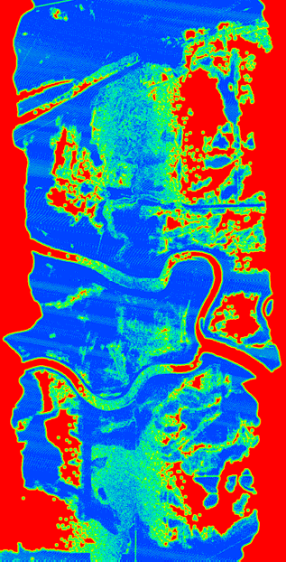

Contents:

Project definition 3

Investigated project area 3

Project execution 4

General workflow 4

Data management 4

TopDM import 4

TopDM project description 5

Data preparation 5

Flight line data 5

Tiled data 6

ALS data quality checks 6

Point density maps for the whole project area 7

Point distance maps for the whole project area 9

Strip differences for the whole project area 11

Absolute geo-referencing 15

ALS DTM quality checks 17

DTM Interpolation test for a small test area 17

Root Mean Square Error (RMSE) for the whole project area 20

Shadings of whole project area 21

Filter check for whole project area 24

Comparison with existing 10m DTM 26

Conclusions 28

Literature 29

Data delivery 30

- Project definition

The project aims to analyze the quality of the Airborne Laser Scanning (ALS) data of two represen- tative test areas in Denmark. The analysis covers both, quality checks of the point cloud (last ech- oes and classified ground/terrain points) and the delivered Digital Terrain Models (DTMs). Signifi- cant parameters describing the ALS data quality will be derived, which accord to the state-of-the- art knowledge in ALS research. A comparison will be drawn between the delivered DTM filtering and interpolation results and the outcome of the in-house DTM filtering and interpolation strategy of the Institute of Photogrammetry and Remote Sensing (I.P.F., TU Vienna) implemented into the software package SCOP++ (Inpho, 2007, I.P.F., 2007). Additionally to the derived data quality lay- ers, an extensive visual inspection of the ALS data (e.g. using DTM shadings and difference maps) will give complementary information on the quality of the checked datasets.

- Investigated project area

Two test areas were investigated (Table 1). The data to be checked consist of LAS files (LAS Specification, 2005) of the point cloud organized in flight strips and 1km x 1km tiles, as well as Digital Surface Models (DSMs) and DTMs organized in 1km x 1km ESRI ASCII grid files with 1.6m grid size.

 | Area 1 | Area 2
Northing [km] | 6195000 – 6210000 | 6203000 – 6213000
Easting [km] | 460000 – 470000 | 499000 – 501000
Extend Northing [km] | 15 | 10
Extend Easting [km] | 10 | 2
Flight lines | 31 | 2
No. last echoes* | 84573343 | 9660526
Mean Density  Last echoes* [points/m²] | 0.56 | 0.48
No. of ground points* | 64106663 | 6456699
Mean Density  Ground points* [points /m²] | 0.43 | 0.32
Remark |  | Border line between the acqui- sition areas of the two ALS companies
* of tiled point cloud
Table 1: Description of the project area.

- Project execution

  - General workflow

The ALS quality analysis consists of two major tasks: 1) quality check of ALS data (point cloud) and 2) quality check of ALS DTMs including the filtering and interpolation of the point cloud.

The following check procedures were carried out:

ALS data quality checks:

Point density ➔ point density maps

Point distance ➔ point distance maps

Strip differences ➔ strip difference maps

Absolute geo-referencing ➔ histograms

ALS DTM quality checks:

Root mean square (RMS) error of classified terrain points ➔ RMS error maps

Interpolation check of classified terrain points ➔ difference maps

Filter check of last echo points ➔ difference maps

Shadings for visual inspection of DTM ➔ shaded relief maps

Comparison of ALS DTM with existing 10m DTM ➔ difference maps

  - Data management

The analysis of large ALS datasets requires an efficient data management of the point cloud data as well as the raster data. For this purpose the software package TopDM (Topographic Data Man- agement, I.P.F, 2007) was employed.

    - TopDM import

The following datasets were imported and managed with TopDM:

Ground points and last echoes for both test areas originating from 1km x 1km tiles

Ground points and last echoes for each flight strip (of both test areas)

DTM ASCII rasters (1km x 1km)

DSM ASCII rasters (1km x 1km)

The provided LAS point cloud files do have a coding for ground points (class no. 5), which does not conform with the standard LIDAR point class for ground (class no. 2) in the ASPRS LAS Specifica- tion (v. 1.1 and v. 2.0). Hence, to be able to import the ground points into the TopDM database (TOPDB), a modification of the common LAS reading procedure was necessary. The ground points were extracted from the LAS files, saved as binary XYZ files (*.bxyz) and finally imported into TopDM. The extraction of the last echoes was not explicitly necessary because the last echoes could be extracted using the standard TopDM LAS import filter settings.

    - TopDM project description

A placeholder for the coordinate system (i.e. UTM-undef) was used, which can be easily replaced in the future by a detailed coordinate system definition. This would allow exporting the ALS data in various target coordinate systems.

The following metadata definition was used for TopDM:
- Owners: KMS
- Coordinate system: UTM-undef
- Compile Modes: Laserscanning

Properties:
  - ground: for ground points
  - last_pulse: for last echoes
  - DTM: for DTMs
  - DSM: for DSMs

Aggregates (aggregate name convention):

Prefix “FL_” for ground points imported from flight lines

Prefix “FL_l_” for last echoes imported from flight lines

Prefix “T1l_” for last echoes of test area 1 imported from tiles (1km x 1km)

Prefix “T2l_” for last echoes of test area 2 imported from tiles (1km x 1km)

Prefix “T1g_” for ground points of test area 1 imported from tiles (1km x 1km)

Prefix “T2g_” for ground points of test area 2 imported from tiles (1km x 1km)
- Projects: DK_quality_analysis

Models:

Area_1_tiles: attribute for point cloud and raster data (DTM, DSM) of test area 1 im- ported from tiles

Area_2_tiles: attribute for point cloud and raster data (DTM, DSM) of test area 2 im- ported from tiles

Flightlines: attribute for point cloud imported from flight lines

  - Data preparation

Before executing the quality checks, data preparation was performed, producing adequate input files for the respective quality check programs.

    - Flight line data

The flight line data was reorganized by generating binary XYZ files of ground points for each flight line (already done before importing into TopDM, see above), and by the retrieval of last echo XYZ ASCII files for each flight line by querying and exporting from TopDM.

    - Tiled data

To reduce the number of output files of the quality checks, due to the high number of 1km x 1km point cloud tiles, larger units (tiles) were defined. A tile size of 3.2km x 3.2km was chosen, which results in an integer number of cells when calculating output images/rasters with grid sizes as mul- tiples of 1.6m (aimed final grid size defined by KMS, cf. Figure 1). The larger tiles organization was applied to the point cloud by exporting last echoes and ground points for each tile in the XYZ ASCII format. The file names are assigned as following:

a<test_area_number>t<tile_number>_<point_class[lp,grd]>.xyz

examples:
a1t1_lp.xyz ➔ Test area 1, tile 1, last pulses
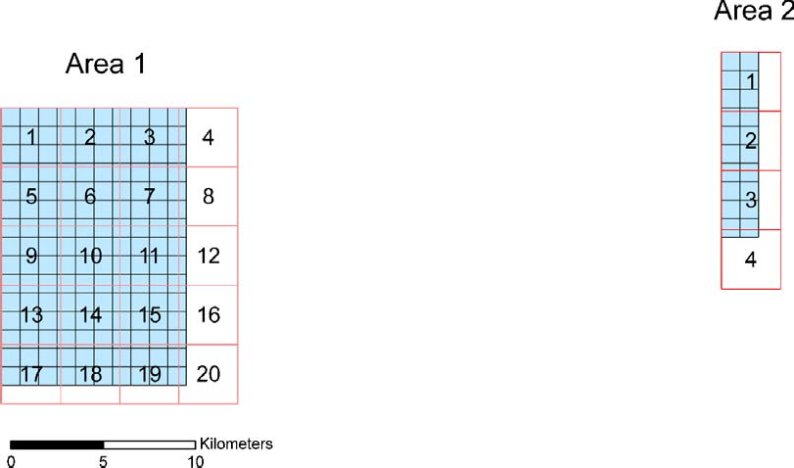
a2t1_grd.xyz ➔ Test area 2, tile 1, ground points
Figure 1: Point cloud tile organization for the two test areas. The small tiles (blue – 1km x 1km) represent the provided tile organization. The larger tiles (red – 3.2km x 3.2km) represent the chosen target tile organization for all quality check data layers.

  - ALS data quality checks

In the following, several checking procedures based on the ALS point cloud data are presented. The aim of these procedures are on one hand to get a detailed description of the data distribution and availability, whereas on the other hand further procedures are applied in order to analyse the precision (inner accuracy) as well as the absolute geo-referencing of the data by external reference data.

ALS Data Quality
 | flight lines |  | tiled (3.2km² 80m overlap)
 | last echoes | ground points | last echoes | ground points
Export tiles | - | -
Point density maps
Point distance maps
Strip differences
models per strip |  | - | - | -
difference models |  | - | - | -
visualization |  | - | - | -
Absolute
Geo-referencing
Table 2: Overview of ALS data quality checks.

    - Point density maps for the whole project area

The point density was calculated for both point clouds per flight line and tiled point clouds (Table 1) for the whole project area. Furthermore, the point density was calculated for ground points and last echoes with two different analysis units (3.2m and 8.0m raster size). The resulting point density data layers were then written in two export formats; as GeoTiff with fixed colour palette (see Figure 2, Figure 3) and as grid model (format: SCOP RDH) that still allows applying an individual colour palette using SCOP++ (I.P.F., 2007).

1flight lines |  |  |  |  |  |  |  | tiles (3.2km x 3.2km)
2ground points |  |  |  | last echoes |  |  |  | ground points |  |  |  | last echoes
33.2m |  | 8.0m |  | 3.2m |  | 8.0m |  | 3.2m |  | 8.0m |  | 3.2m |  | 8.0m
4TIFF | RDH | TIFF | RDH | TIFF | RDH | TIFF | RDH | TIFF | RDH | TIFF | RDH | TIFF | RDH | TIFF | RDH
Table 3: Resulting combination of point density data layers: ¹…point cloud organization, ²…point class, ³…size of the analysis unit and raster size of the output, ⁴…output format.

The file names for the point density layers are assigned as following:

<input_file_name>_<resolution>.<format>

examples:

a1t1_lp.xyz_3_2m.tif ➔ point density of test area 1, tile 1, last pulses and analysis unit 3.2m as GeoTiff

a2t1_grd.xyz_8_0m.rdh ➔ point density of test area 2, tile 1, ground points and analysis unit 8.0m as SCOP RDH model.

In the following figures the variable point density within the project area can be inspected. Areas with overlapping ALS strips as well as areas with a rather low point density (e.g. caused by bad reflectivity, too high flying speed, flying height, etc.) can clearly be recognised. Furthermore, when comparing both point density figures, one can see the reduction in point density caused by the classification (filtering) of the ALS points into terrain (resp. ground) and off-terrain points. It is im- portant to consider this reduction in the point density of the classified ground points in vegetated areas as well as in built-up areas due to the fact that this point cloud is the input for the final deter- mination of the DTM. Additionally, it can be seen that the point density map of the ground points does not show an increase of the point density in areas with strip overlap. This fact indicates that a reduction in point density was applied by the company in these areas. Further remarks concerning this topic of data removal can be found in section 3.4.3.

a) b)

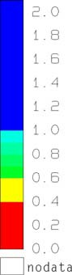
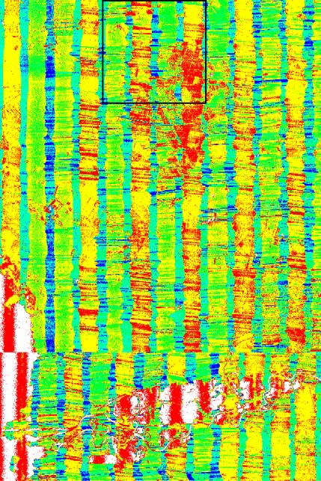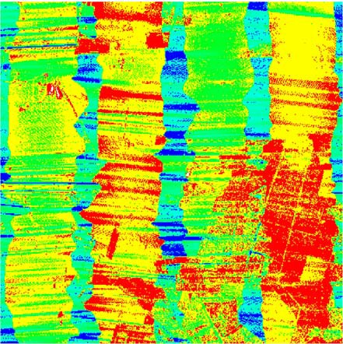pts/m²

3.2 km

10 km

Figure 2: Point density images (analysis unit: 8.0m) of all last echo points: a) complete test area 1 and b) 2nd tile of area 1.

a) b)

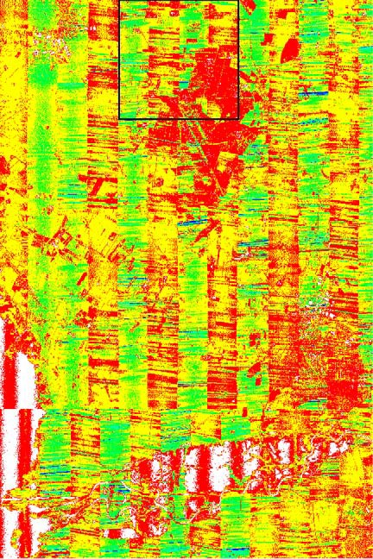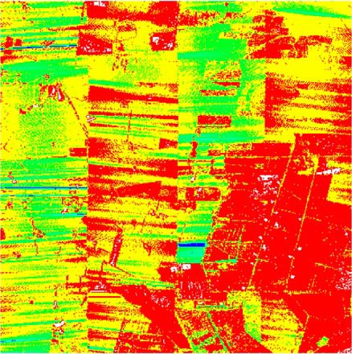pts/m²

3.2 km

10 km

Figure 3: Point density images (analysis unit: 8.0m) of all ground points: a) complete test area 1 and b) 2nd tile of area 1.

    - Point distance maps for the whole project area

The point distance parameter is defined as distance from a grid cell to the nearest given point. Therefore, the distance of a cell that contains a point is zero.

The point distance data layers were calculated according to the procedure of the point density cal- culation (see Table 1). Just the size of the analysis unit (identical to the raster size of the output) was set to 1.6m and 3.2m, respectively. Examples of point distance images can be seen in Figure 4 and Figure 5. In a similar way like in the point density maps the reduction of data caused by the filtering and the data removal in the overlapping zones of the strips can be observed.

a) b)

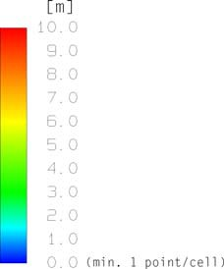
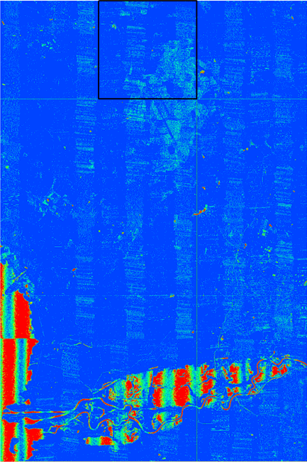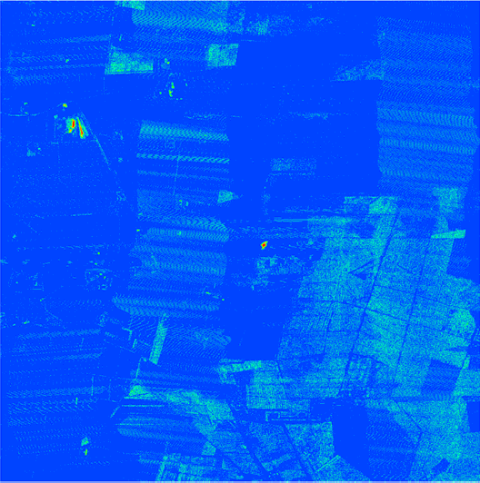3.2 km

10 km

Figure 4: Point distance images (analysis unit: 1.6m): a) last echoes of whole test area 1 and b) last echoes of tile 2 (area 1).

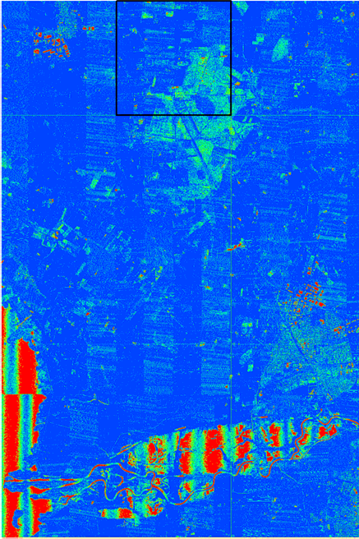
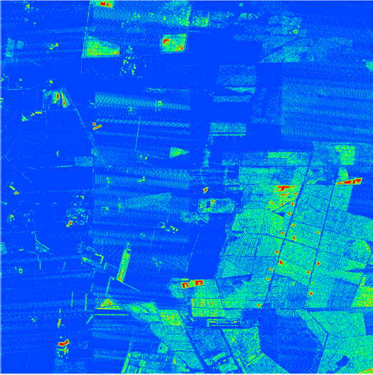a) b)

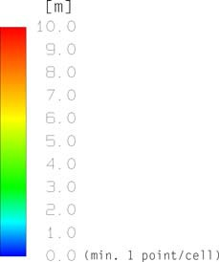
3.2 km

10 km

Figure 5: Point distance images (analysis unit: 1.6m): a) ground points of whole test area 1 and b) ground points of tile 2 (area 1).

    - Strip differences for the whole project area

The precision (inner accuracy) of the individual ALS strips can be analysed by the calculation and visualisation of height difference models of the individual overlapping flight strips.

To enable the investigation of differences between flight strips, digital surface models (DSMs with 1.6m grid size) were determined by using a simple moving plane interpolation (program: xyz2rdh) resulting in one surface model (RDH file) for the last echoes per flight strip. Subsequently, the cal- culated surface models of overlapping flight strips were imported pair wise into SCOP++. In SCOP++ a visualisation (shading) of the strip wise models was calculated (useful for the analysis of the strip differences) and exported for every flight strip. Afterwards the difference model (with 1.0m grid size) and z-coded visualizations of it (with 1.0m resolution) for every pair of overlapping flight strips were determined.

For the z-coded visualizations of the difference models three different palettes, which differ in the size of the classes, were used (cf. Table 4). They have in common that the differences are shown

from green for small positive till blue for large positive differences and from yellow for small nega- tive till red for large negative differences.

Palette 1 | Classes of the | Palette 2 | Classes of the | Palette 3 | Classes of the
(pal02) | differences [m] | (pal3cm) | differences [m] | (pal6cm) | differences [m]
 | 0,30 |  | 0,135 |  | 0,27
 | 0,20 |  | 0,105 |  | 0,21
 |  |  | 0,075 |  | 0,15
 | 0,12
 |  |  | 0,045 |  | 0,09
 | 0,06 |  | 0,015 |  | 0,03
 | 0,005 |  | 0,001 |  | 0,001
 | -0,005 |  | -0,001 |  | -0,001
 | -0,06 |  | -0,015 |  | -0,03
 |  |  | -0,045 |  | -0,09
 | -0,12
 |  |  | -0,075 |  | -0,15
 | -0,20 |  | -0,105 |  | -0,21
 | -0,30 |  | -0,135 |  | -0,27
Table 4: Different colour palettes that were used for the z-coded visualization of the difference models.

The file names for the shadings and strip differences are assigned as following:

<name_of_flight_strip>.tif
example: FL_l_A3_152.tif ➔ shading of one flight strip

<name_of_flight_strip_1>_< name_of_flight_strip_2>.dtm
example: FL_l_A3_152_FL_l_A3_156.dtm ➔ difference model of two overlapping flight strips

<name_of_flight_strip_1>_< name_of_flight_strip_2>_<name_of_the_palette>.tif
example: FL_l_A3_152_FL_l_A3_156_pal02.tif ➔ visualization of a difference model using Palette 1 (pal02)

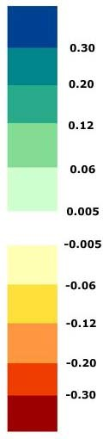
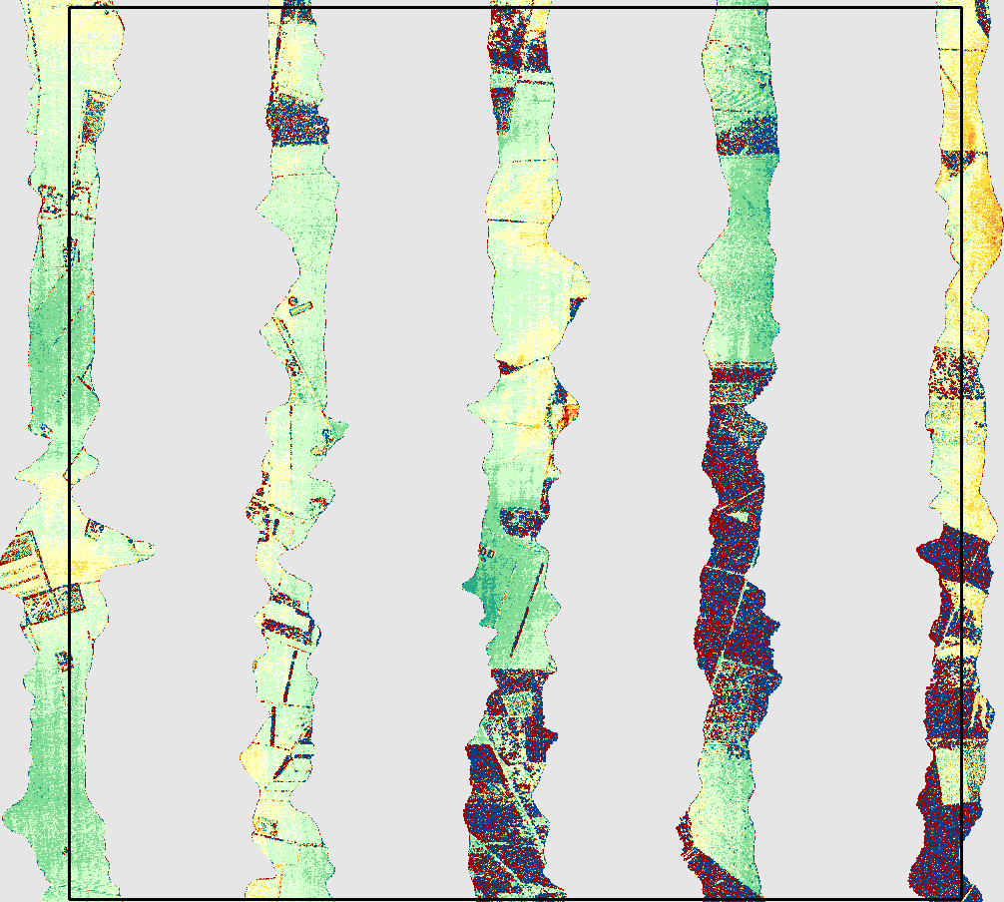
m

3.2 km

Figure 6: Strip differences in overlapping areas of flight lines crossing tile 2 in test area 1.

In Figure 6 the strip differences calculated in one of the tiles in test area 1 can be inspected. Very big differences can be found in areas with high vegetation. This is caused due to the different angle of incidence of the two strips and does not indicate a relative strip offset. For the analysis of the relative precision of two strips one has to inspect smooth open terrain, where the DSM from both strips should be identical. In certain areas of Figure 6 the strip differences are rather small (< ± 6cm), but in other areas height differences between the two models bigger than ±12cm to ±30cm can be found. These differences can be caused by several causes (e.g. local height offset due to GPS/IMU processing, calibration errors, etc.). Bigger differences that have a bad impact to the final model should be removed resp. reduced by strip adjustment.

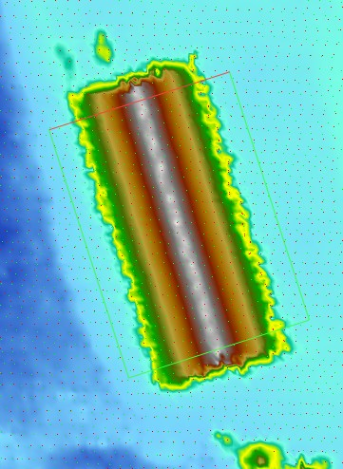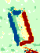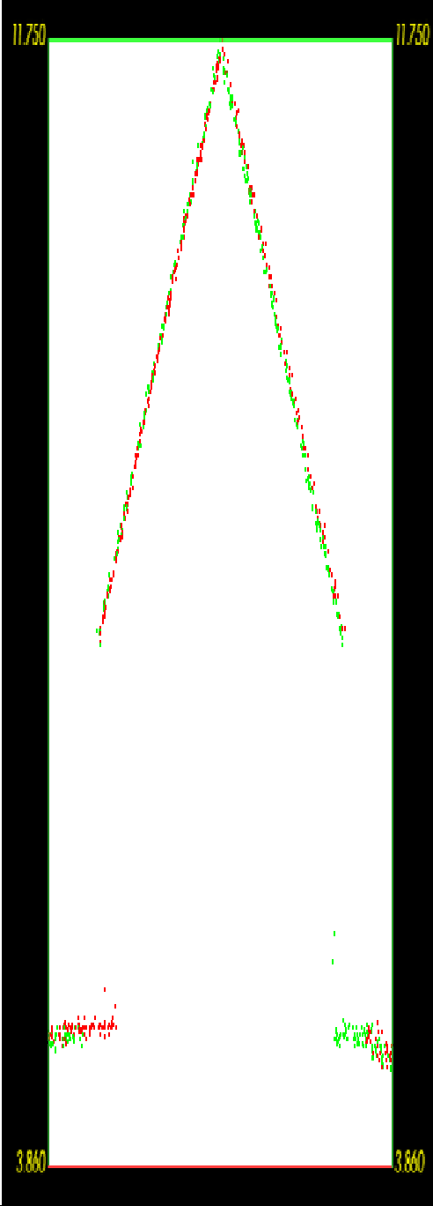
Figure 7: Left: Height z-coding; Middle: Z-coding of the difference of two flight strips; Right: Profile through the point cloud of one building.
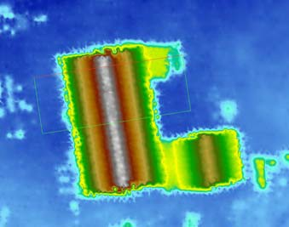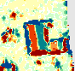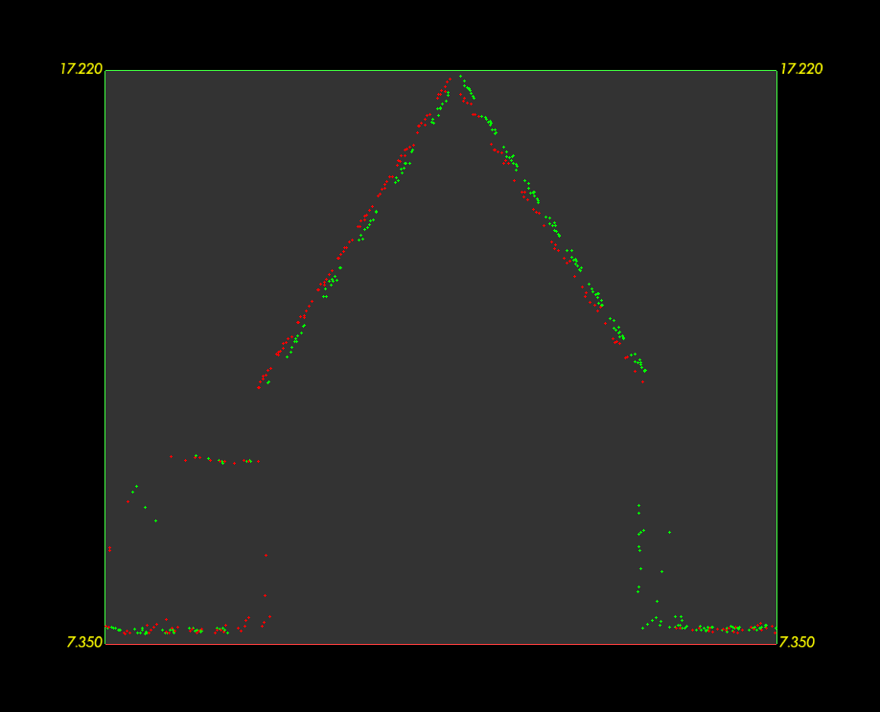
Figure 8: Upper left: Height z-coding; Upper right: Z-coding of the difference of two flight strips; Bottom: Profile through the point cloud of one building.

Within the analysis it is important to consider that the height differences that can be seen in the visualisation of the difference models can also be caused due to planimetric errors. Therefore, we recommend to check the differences on inclined surfaces such as building roofs (cf. Figure 7 and Figure 8). In the case of a planimetric error you can typically find positive height differences on one side of the building, whereas you can find negative differences on the other side. This fact can be seen in both figures, but the error is especially large (±20cm - 30cm) in Figure 8.These pairwise

differences – depending on the local slope of the surface – indicate a planimatic error. However, big differences on the boundary of a house can also be caused due to the shadow caused by a building (cf. Figure 7): The area around a house might be visible from one view position (from one strip) while it might be invisible from another view (e.g. the neighbouring strip).

Higher differences can often be observed in areas with higher movements of the aircraft (in the case of an unstabilised platform (as it is typically the case in ALS). These movements are visible on the strip boundary.

Currently, we do not have an automated tool in order to check the quality of the strip differences (we are currently in the development phase). Therefore, it is at least necessary to check the strip differences manually on a representative amount of areas distributed over the whole project area. Especially important are cross strips, which allow controlling the stability of the whole ALS block.

    - Absolute geo-referencing

For the quality check of the absolute geo-referencing of the ALS data independently acquired con- trol data is essential. Due to the fact that the acquired ALS points can not be identified in field ac- curately, a surface based checking is essential.

In order to check the height as well as the planimetric accuracy of the data, we recommend to pro- vide well distributed points on so-called control patches. These control patches should be small flat surface areas with a significant slope in order to check next to the height accuracy the planimetric error (we recommend to use building roofs). Furthermore, the control patches should be situated over the whole project area (especially in the corners), and within each check area control patches with a different orientation and slope should be available.

Unfortunately, within this project such detailed control information was not available. In order to check the absolute geo-referencing only height control points in three horizontal areas were avail- able. Therefore, we were only able to analyse the local height differences per test area. For a de- tailed analysis we recommend the usage of inclined control patches (e.g. building roofs) distributed all over the project area in order to check the planimetric as well as the height accuracy.

This analysis was done with the programme RDHacc (developed at the I.P.F., TU Vienna) . This program determines the difference of each input point in respect to a provided DTM. These residu- als were statistically analysed and histogram plots were generated (units: meter; cf. Table 5).

.
 | SkjernTest1 | SkjernTest2 | SkjernTest3
check points: | 59 | 66 | 54
minimum: | -0.105 | -0.118 | 0.05
mean: | -0.018 | -0.065 | 0.108
mean of absolute value: | 0.031 | 0.065 | 0.108
RMS error: | 0.04 | 0.069 | 0.111
median: | -0.01 | -0.065 | 0.111
maximum: | 0.037 | -0.027 | 0.16
sigma: | 0.036 | 0.022 | 0.024
+/- 1.0 sigma [%]: | 64.41 | 68.18 | 68.52
+/- 1.5 sigma [%]: | 88.14 | 86.36 | 85.19
+/- 2.0 sigma [%]: | 96.61 | 96.97 | 94.44
+/- 3.0 sigma [%]: | 100.0 | 100.0 | 100.0
Table 5: Statistics of absolute geo-referencing check for the 3 test areas (units: meter).

By the analysis of the median of the residuals of each test area (Table 5), one can see that the systematic height off-set in the test area “SkjernTest1” is quite low (-0.01m), whereas in the area “SkjernTest2” and “SkjernTest3” an offset of -0.07m resp. +0.11m can be found. This fact can also be seen in the histograms: They show just negative values for SkjernTest2 and just positive values for SkjernTest3. The root mean square error (RMS) in the teat area 1 is quite low (0.04m), whereas the RMS increases to 0.07m in area 2 and even to 0.11m in area 3. The bigger systematic offsets (indicated by the median) and the higher RMS values should be analysed further. However, for this aim further knowledge about the test area (low grass?, different acquisition time in respect to the ALS data acquisition, etc.) is essential.

In order to get a better impression about the accuracy further control areas (also on inclined sur- faces) distributed over the whole project area would be necessary.

a) b)
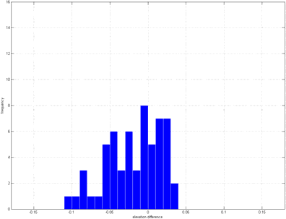
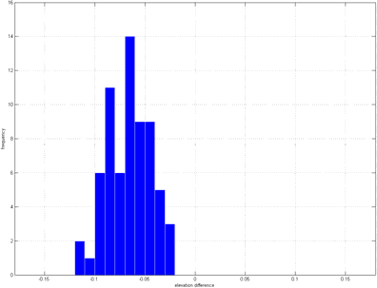

c) d)
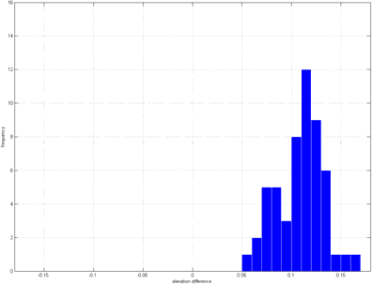
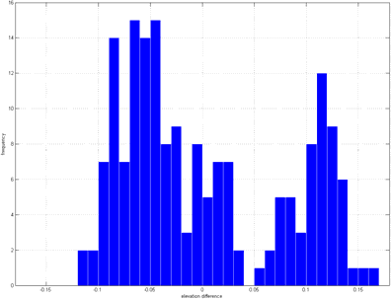

Figure 9: Histogram plots of a) SkjernTest1, b) SkjernTest2, c) SkjernTest3 and d) all residuals together.

  - ALS DTM quality checks

The following checking procedures are applied in order to analyse the quality of the delivered DTMs. Next to the analysis of the interpolation quality, the quality of the classification (filtering) of the last echo points done by the companies is analysed. This is done by independent procedures available in the software package SCOP++. An overview of the checking procedures can be found in Table 6.

ALS DTM Quality
DTM Interpolation for small test area | ground points
Linear prediction with different filter values
Triangulation
Difference models to delivered ALS DTM
RMS error map | ground points
Shadings of whole project area | last echoes | ground
Models per tile
Shading per tile
Filter check for whole project area | last echoes | ground
Filtered ground points per tile |  | -
Models per tile (classic prediction filter value 0,10m)
Difference models
Comparison with existing 10m DTM
Difference Models
Table 6: Overview of ALS DTM quality checks.

    - DTM Interpolation test for a small test area

The aim of this test is to analyse the influence of different interpolation methods to the finally stored DTMs. For this aim different DTMs (with the same grid width) based on the delivered ground points were computed with SCOP++. Tile number 2 of test area 1 (“a1t2”) was chosen as test area. All in all three DTMs were determined: two models are computed using the interpolation method “classic prediction” (kriging that allows the reduction (smoothing) of random measurement errors), whereas the third model is generated using the triangulation method that is available in SCOP++. For the models generated by “classic prediction” different filter (smoothing) parameters were chosen. One model was calculated with low smoothing (filter value: 0.05m), while the other model was deter- mined with a smoothing of 0.1m.

Subsequently, these three models were compared to the ALS DTM delivered by the companies (1.6mx1.6m Arcinfo ASCII grid) by computing difference models. All models were calculated with a grid width of 1.6m. Finally, the difference models were visualised with the Palette 1 (pal02, cf. Table 4). In the following figures these visualisations are provided within one test area. Differences higher than ±6cm can be found only in areas with discontinuities. In the first two visualisations higher differences can be found in the south-eastern part. This might be due to a different surface

characteristic. In the third visualisation the differences are more homogeneous.

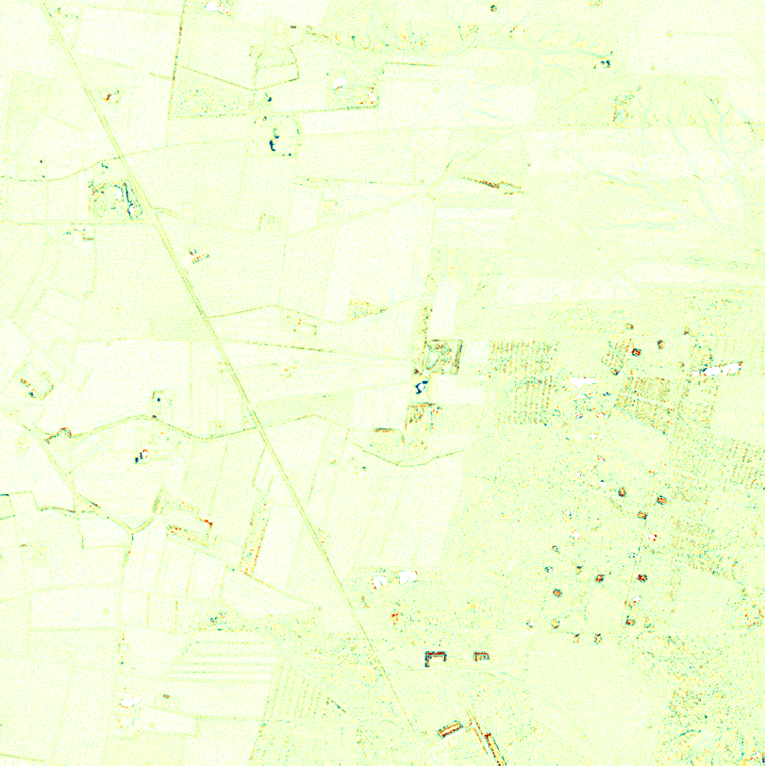m

3.2 km

Figure 10: Visualization of the difference model: delivered ALS DTM minus model interpolated with SCOP++ (classic prediction with a filter value of 0.05m for bulk data).

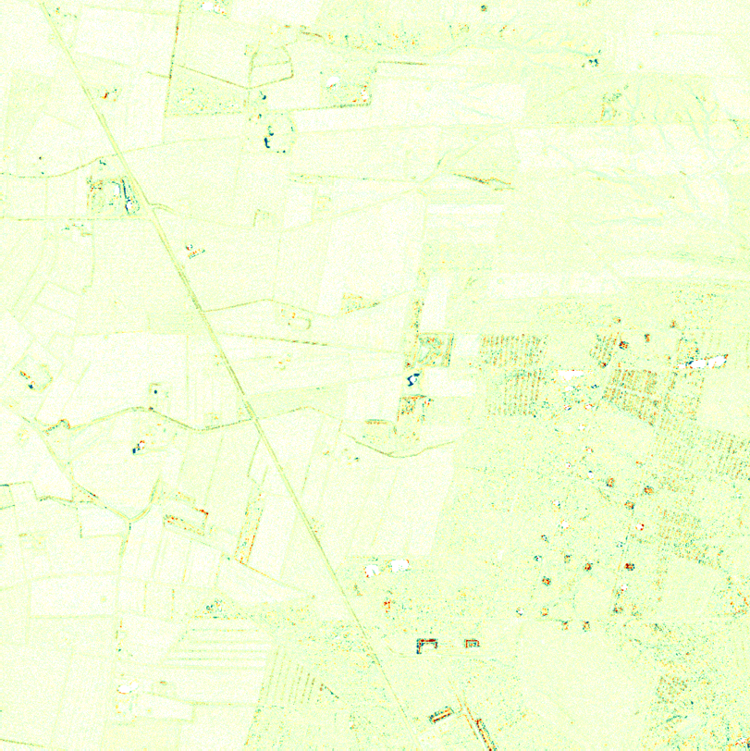
m

3.2 km

Figure 11: Visualization of the difference model: delivered ALS DTM minus model interpolated with SCOP++ (classic prediction with a filter value of 0.10m for bulk data).

m

3.2 km

Figure 12: Visualization of the difference model: delivered ALS DTM minus model interpolated with SCOP++ (triangula- tion).

    - Root Mean Square Error (RMSE) for the whole project area

The root mean square error is used as measure of the differences between the provided classified ground points and the DTM.

Before calculating the RMSE image, all ground points for test area 1 as well as for test area 2 had to be exported from TopDM. The provided 1km x 1km DTMs have also been imported into TopDM and therefore it was easily possible to merge and export the single 1km tiles in one large RDH file that is used for the RMSE estimation for each test area.

Both, the XYZ ASCII file of the ground points and the DTM (RDH file) are used as input for the RMSE calculation (I.P.F. utility program: RDHacc). The resulting model quality layers are one RDH file and one GeoTiff image with grid size 1.6m for each test area.

m
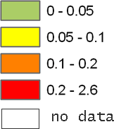

3.2 km

Figure 13: RMSE map of the residuals between the delivered ground points and the provided ALS DTM for tile 2 in test area 1.

Bigger differences can be found in areas with surface discontinuities and lower point density caused by the removal of off-terrain points.

    - Shadings of whole project area

Digital surface models (with 1.6m grid size) were produced for the 3.2km x 3.2 km tiles with an overlap of 80m by using a moving plane interpolation (I.P.F. utility program: xyz2rdh) resulting in one surface model (RDH file) for the ground points and one for the last echoes per tile. These sur- face models were imported into SCOP++ and shadings of 1.6m resolution were derived and ex- ported without the overlap of 80m.

1tiles (3.2km x 3.2km)
2ground points |  | last echoes
31.6m |  | 1.6m
4TIFF | RDH | TIFF | RDH
Table 7: Resulting combination of data layers: ¹…point cloud organization, ²…point class, ³…output resolution,
4…output format.

The file names for the layers are assigned as following:

<input_file_name>.<format>

examples:

a1t2_grd.dtm ➔ model of test area 1, tile 2, ground points as SCOP RDH model

a1t2_lp.tif ➔ shading of test area 1, tile 2, last pulses as GeoTiff

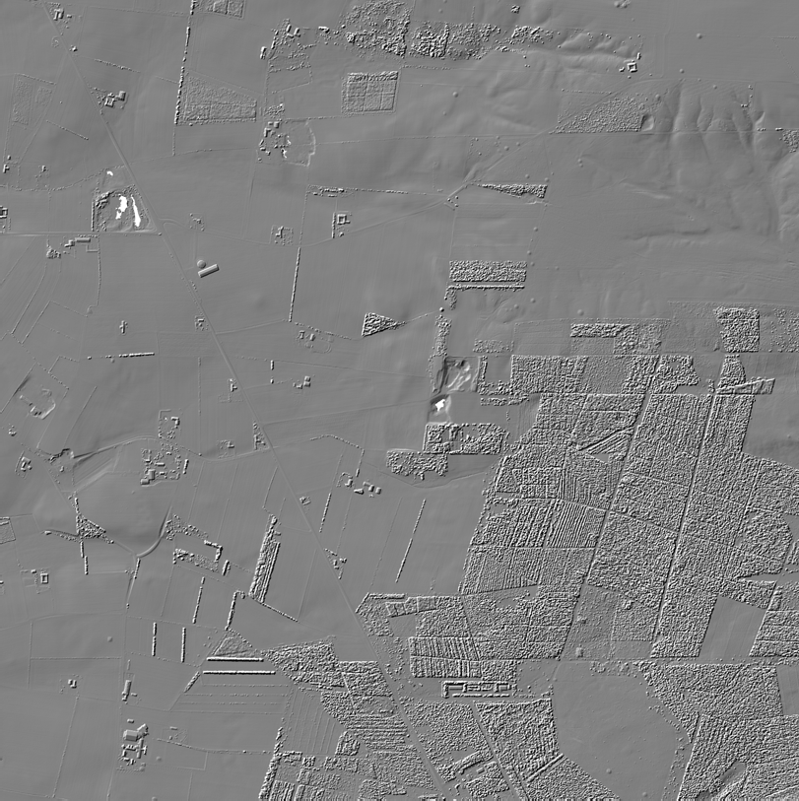3.2 km

Figure 14: Shading (illumination from NW) of a DSM determined based on the last echo points with resolution of 1.6m for tile 2 in test area 1.

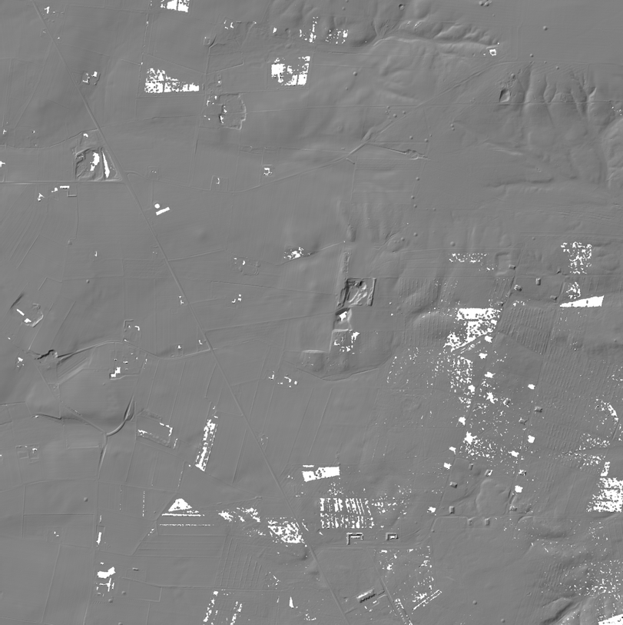3.2 km

Figure 15: Shading (illumination from NW) of the DTM calculated from the delivered ground points with resolution of 1.6m for tile 2 in test area 1.

In Figure 14 and Figure 15, one supposed building in the two shadings is highlighted with a red circle. By looking closer at this “building” it can be seen that it is seams to be artificially made but there is a smooth change in the terrain instead of vertical walls (for further details cf. Figure 16). Due to that fact, it is quite difficult to eliminate these structures automatically by filtering the last echoes but also not really necessary because this structure can be seen as part of the terrain (de- fends on the definition of the terrain surface).

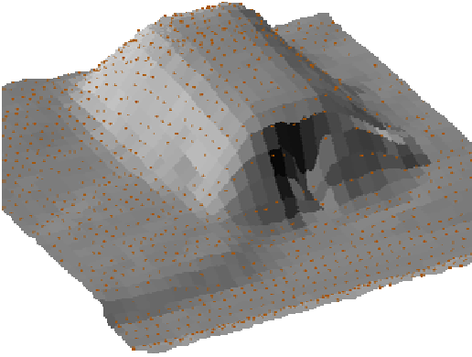

Figure 16: Left: Orthophoto; Middle: Ground view; Right: Parallel projection of the supposed building (ground points with shading in the background). The parallel projection was created with a height factor of 2.

    - Filter check for whole project area

The filter check is performed by an independent classification (filtering) of the last echo points with the software package SCOP++.

The processing is done in the following way: The 3.2km x 3.2 km tiles of the last echoes were im- ported with the 80m overlap one after the other into SCOP++ and filtered with the “Lidar DTM De- fault” strategy (developed by I.P.F., TU Vienna). In the last step of this procedure the points are classified into different vegetation classes, buildings, ground points and points that are below the ground due to measurement errors. The ground points, which were derived through this process, were used to calculate a new model using the interpolation method classic prediction with a filter value of 0.10m for bulk data. For the delivered ground points (classified by the companies) models were computed using the same interpolation method and settings. The resulting DTMs were com- pared with each other by the calculation of difference models.

data | ground points classified by SCOP++ | ground points classified by the companies
model | classic prediction filter value:  0.10m for bulk data | classic prediction filter value:  0.10m for bulk data
differences | difference 1
Table 8: Overview of the calculated difference models.

The file names for the layers are assigned as following:

<input_file_name>_<interpolation_mode>.<format>

examples:

a1t2_lp_classic10.dtm ➔ model of test area 1, tile 2, from last pulses filtered ground points interpolated using a classic prediction and a filter value of 0.10m for bulk data as SCOP RDH model

a1t2_grd_classic10.tif ➔ shading of test area 1, tile 2, ground points interpolated using a classic prediction and a filter value of 0.10m for bulk data as GeoTiff

<input_tile_name>_< points&interpolation_mode_model1>_< points&interpola- tion_mode_model2>.<format>

examples:

a1t2_ LPcl10_GRDcl10.dtm ➔ difference model of test area 1, tile 2, from last pulses fil- tered ground points (classic prediction, filter value of 0.10m for bulk data) minus delivered ground points (classic prediction, filter value of 0.10m for bulk data) as SCOP RDH model

a1t2_LPcl10_GRDcl10.tif ➔ shading of test area 1, tile 2, from last pulses filtered ground points (classic prediction, filter value of 0.10m for bulk data) minus delivered ground points (classic prediction, filter value of 0.10m for bulk data) as GeoTiff

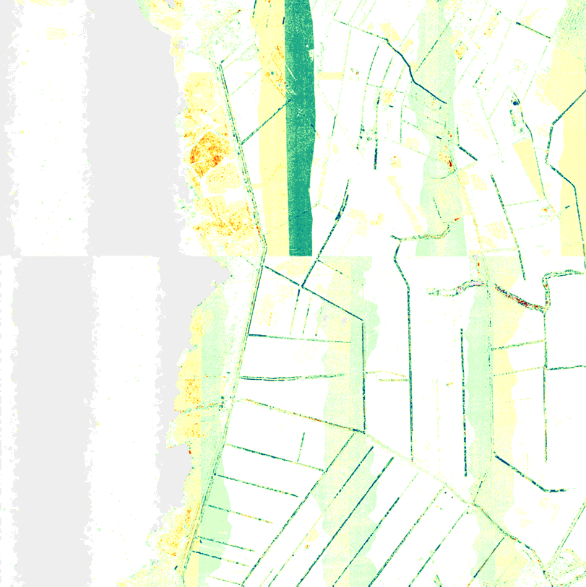m

3.2 km

Figure 17: Visualization of the difference model: filtered ground points (classic prediction, filter value 0.10m) minus deliv- ered ground points (classic prediction, filter value 0.10m).

In Figure 17 bigger differences can be found in overlapping strip areas. We suggest that these dif- ferences are caused by a data reduction procedure applied by the companies. It seams that the companies have divided the overlapping region into two parts and removed the data of one of the two overlapping ALS strips. Due to even small errors in the geo-referencing of the individual strips this procedure leads to a surface discontinuity in the final DTM. Especially in the northern part of Figure 17 bigger differences (> 0.12m) can be found. In this area a fine-georeferencing of the data and the usage of the data from both strips (in order to avoid a discontinuity and in order to use the redundant information for the removal of random measurement errors) is essential.

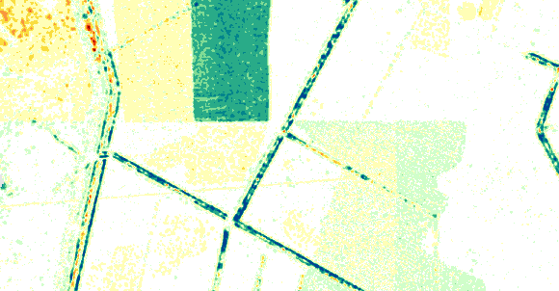
Figure 18: Enlargement of the area in the red square in Figure 10 with the lines where the overlapping points were cut off.

In general, we do not recommend this way of data reduction and removal of discrepancies, be- cause this step leads to discontinuities in the final surface models which might be problematic for further applications (e.g. water flow analysis). Instead of the removal of data an adequate fine-geo- referrencing of the ALS strips is essential. The interpolation of the whole data from all the strip has to be favoured, because it is not known which ALS strip is more correct than the other. The interpo- lation of all the strips allows smoothing the errors and generates a model which fits to the whole amount of data.

    - Comparison with existing 10m DTM

Next to the other quality checking procedures of the DTM a comparison with the existing 10m DTM was performed. The processing of this procedure is performed in the following way:

Both DTMs (coarse 10mx10m ArcInfo ASCII grid and the new 1.6mx1.6m Arcinfo ASCII grid) are imported into SCOP++. Then, the difference model was calculated (coarse minus fine terrain model) and finally, the resulting difference model is visualized with the help of a z-coding using an appropriate colour palette.

The visualisation of the difference models of both test areas is presented in Figure 19. When ana- lysing these visualisations, differences can be found in areas of small surface features better de- scribed in the new higher resolution DTM, e.g. the supposed buildings in tile2 (area1), which were introduced in section 3.5.3 can be clearly seen as differences greater than 3m (Figure 19). How- ever, next to small features that are not included in the 10m grid, unexpected big systematic differ- ences (both positive and negative) can be found in larger regions. These differences need to be further analysed with local knowledge of the area and the individual data acquisition and process- ing steps. For this analysis, a detailed knowledge about the accuracy and reliability of the 10m DTM is essential.

a) b)

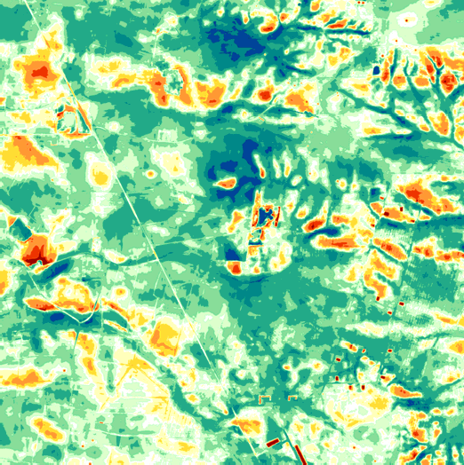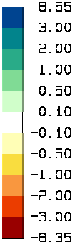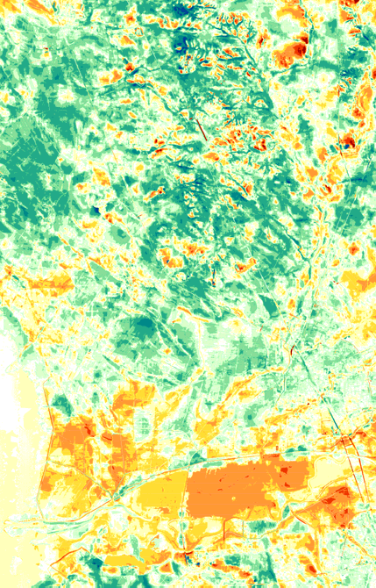10 km
3.2 km
c)

Figure 19: Visualization (grid size 1.6m) of the difference model of the new 1.6mx1.6m ArcInfo ASCII grid and the pro- vided 10mx10m ArcInfo ASCII grid DTM: a) whole test area 1, b) tile 2 (of test area 1) and c) supposed building intro- duced in section 3.5.3.

Furthermore, based on the difference model statistical measures and histograms are produced (cf. Figure 20 and Table 9). The RMS error is 0.81m in area 1 whereas the RMS is 0.91m in area 2. The systematic height offset expressed by the median is 0.11m for area 1 and 0.15m in area 2. As mentioned before, the result of this quality checking procedure needs further analysis. Further- more, when looking at the left histogram displayed in Figure 20 one can recognise two significant peaks. One of the peaks is near zero (maybe this peak is caused by a different water level) and the other peak is situates at a value of approx. -1.6m. It seams that the second peak is caused by the big area with a height difference value in the range of -2m and -1m (also seems to be a water area) visible in the south part of the left z-coding image visualised in Figure 19. This area and also the other big green areas in the northern part need further inspection.

 | Area 1 | Area 2
values | 58593750 | 7767536
minimum | -8.352 | -8.81
mean | 0.116 | 0.054
mean of absolute values | 0.624 | 0.658
RMS error | 0.813 | 0.909
median | 0.113 | 0.145
maximum | 8.549 | 5.878
std. deviation | 0.804 | 0.907
+/- 1.0 std. dev. [%] | 71.14 | 76.49
+/- 1.5 std. dev. [%] | 87.87 | 89.45
+/- 2.0 std. dev. [%] | 94.4 | 95.09
+/- 3.0 std. dev. [%] | 99.31 | 98.55
Table 9: Descriptive statistics of elevation difference models for both test areas.

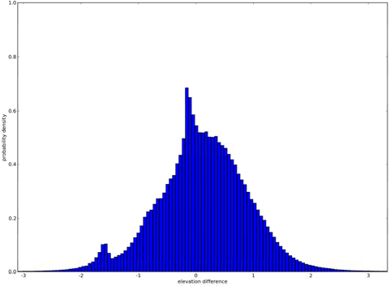
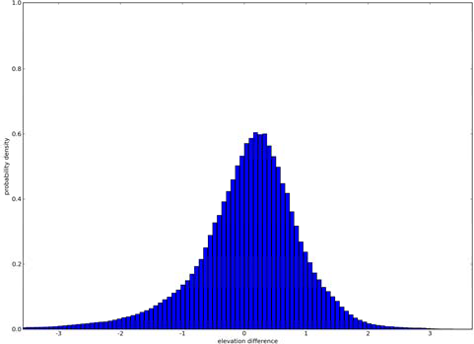
b)
Figure 20: Histograms of elevation difference models for a) test area 1 and b) test area 2.

The 10mx10m ArcInfo ASCII grid files were delivered with the following names: Agrid.asc (which covers the test area 2) and Bgrid.asc (which covers test area 1).

The file names for the comparison of the DTMs are assigned as following:

<new_ASCII_grid>_<old_ASCII_grid>.<format>

examples:

A1_B.dtm ➔ difference model of test area 1 as SCOP RDH model

A2_A.tif ➔ visualization of the difference model of test area 2 as GeoTiff

- Conclusions

Within this project a lot of different quality checking procedures for the delivered ALS point cloud data as well as for the derived models were carried out. On the one hand the checking procedures provide a detailed inside into the delivered data and models (e.g. due to the documentation of the

point density, documentation of the relative precision of the ALS strips, etc.) and can help to control the processing steps that were performed by the data providers, but on the other hand the result of the checking procedures can be seen as a data quality layer which can be provided next to the DTM to further institutes or companies which use the DTM for further analysis. The data and model quality layers can be very important for the further usage of the data and can help to explain the results of further DTM analysis methods.

Finally, it has to be stressed that next to the computation of the quality layers the interpretation of the results of the quality analysis is very important. Sometimes this analysis can be automated to a high degree (e.g. by using same statistical analysis), but often a human interpretation is necessary. Within this process local knowledge about the data acquisition, the processing and the local terrain surface characteristic is essential. Therefore, we recommend to use the set of data quality layers presented within this report (or at least a sub-set of them) within the discussion about the accep- tance of the data in-between the data deliverers and data applicants and for the internal and exter- nal documentation of the quality of the ALS models.

- Literature

Karel W., Pfeifer, N., Briese, C. (2006): DTM QUALITY ASSESSMENT, ISPRS Technical Com- mission Symposium, Vienna; 07-12-2006 - 07-14-2006; in: "ISPRS Technical Commission II Symposium 2006", International Archives of the ISPRS, XXXVI/2 (2006), 1682-1750, http://www.ipf.tuwien.ac.at/cb/publications/2006/Karel,Pfeifer,Briese- DTM_Quality_Assessment.pdf.

Inpho (2007): Homepage of the company Inpho, Product SCOP++: http://www.inpho.de/index.php?seite=index_scope&navigation=185&root=165&kanal=html, accessed: 12.10.2007.

I.P.F. (2007): Homepage of the Institute of Photogrammetry und Remote Sensing, TU Vienna, Product SCOP++: http://www.ipf.tuwien.ac.at/products/produktinfo/scop/scop_dtm_sheet.htm, accessed: 12.10.2007.

LAS Specification (2005): ASPRS LIDAR Data Exchange Format Standard Version 1.1. http://www.lasformat.org, , accessed: 12.10.2007.

- Data delivery

The data delivered on the external hard drive are organized as following:

├───ALS_data_quality
│ │
│ ├───1_point_density Point density maps for whole project area
│ | │ | ├───flightlines per flightline
│ | │ | │ ├───ground using classified ground points
│ │ │ └───last_pulse using all last pulse points
│ │ └───tiles_3.2km per tile
│ | │ | ├───Area_1 for test area 1
│ | │ | │ ├───ground using classified ground points
│ │ │ └───last_pulse using all last pulse points
│ │ └───Area_2 for test area 2
│ | │ | ├───ground | using classified ground points
│ | │ | └───last_pulse | using all last pulse points
│ ├───2_point_distance Point distance maps for whole project area
│ | │ | ├───flightlines per flightline
│ | │ | │ ├───ground using classified ground points
│  │ | │  │ | │ └───last_pulse  └───tiles_3.2km | using all last pulse points  per tile
│ | │ | ├───Area_1 for test area 1
│ | │ | │ ├───ground using classified ground points
│  │ | │  │ | │ └───last_pulse  └───Area_2 | using all last pulse points  for test area 2
│ | │ ├───ground |  | using classified ground points
│ | │ └───last_pulse |  | using all last pulse points
│ | ├───3_strip_difference |  | Flight strip difference maps
│ | │ ├───difference_models |  | for all overlapping areas
│ | │ ├───shadings_per_strip |  | per flightline
│ | │ └───visualizations |  | for all overlapping areas using different colour palettes
│ | │ ├───p02
│ | │ ├───p3cm
│ | │ └───p6cm
│ └───4_absolute_georeferencing Absolute geo-referencing check
│
│
├───ALS_DTM_quality
│ │
│ ├───1_interpolation_comparison DTM Interpolation test for small test area (tile 2 of test area 1)
│ │ ├───differences_a1t2 difference maps
│ │ └───shadings_a1t2 shadings
│ ├───2_RMSerror Root Mean Square Error for whole project area
│ │ ├───Area_1 for test area 1
│ │ └───Area_2 for test area 2
│ ├───3_shadings Shadings of whole project area
│ │ ├───Area_1 for test area 1
│ │ │ ├───ground using classified ground points
│ │ │ └───last_pulse using all last pulse points
│ │ └───Area_2 for test area 2
│ │ ├───ground using classified ground points
│ │ └───last_pulse using all last pulse points
│ ├───4_filter_check Filter check for whole project area
│ │ ├───Area_1 for test area 1
│ │ │ ├───differences difference maps
│ │ │ ├───RDH_grd_classic10
│ │ │ └───RDH_lp_classic10
│ │ └───Area_2 for test area 2
│ │ ├───differences difference maps
│ │ ├───RDH_grd_classic10
│ │ └───RDH_lp_classic10
│ └───5_comparison_with_10m_DEM Comparison with existing 10m DTM
├───Palettes Used colour palettes
└───Report Technical Report, Figures and PowerPoint Presentation

82

:æ
n. n.
A. n.

A.
A. n.
- I,

I ,
n.
n. n.

132
n.
n.

n. A. A.
A. n.
n. 44

Dråby

A. n. n.
n. A.
Karls

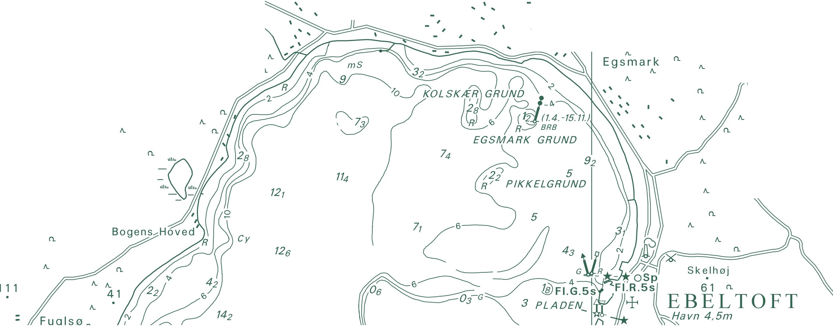n. n.
National Survey and Cadastre Rentemestervej 8
2400 Copenhagen NV Denmark
http://www.kms.dk
53
A.
A.
A. n.
A.
A.
- n. n.
  - A.
A. n.
A. Trehøje n.
(Dyrehøje) _{A.}
n.
127

