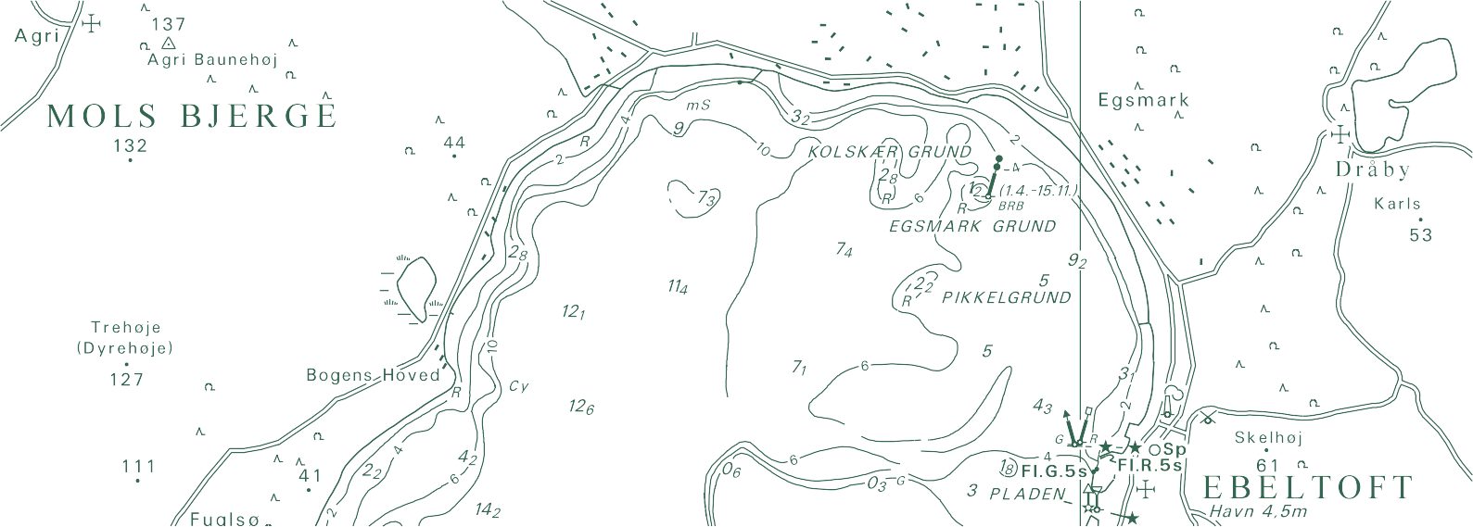

TECHNICAL REPORT NO. 19

Interpolation in laser scanned height data
Allan Aasbjerg Nielsen (Technical University of Denmark)

Allan Aasbjerg Nielsen (Technical University of Denmark) Interpolation in laser scanned height data

Danish Geodata Agency, Technical Report Series Volume 19 ISBN 978-87-92107-65-7
Technical Report Published 2013-12-16
This report is available from http://www.gst.dk
Note: The first 15 volumes of this series were published under the series title “Technical Reports of the National Survey and Cadastre”.

Interpolation in laser scanned height data

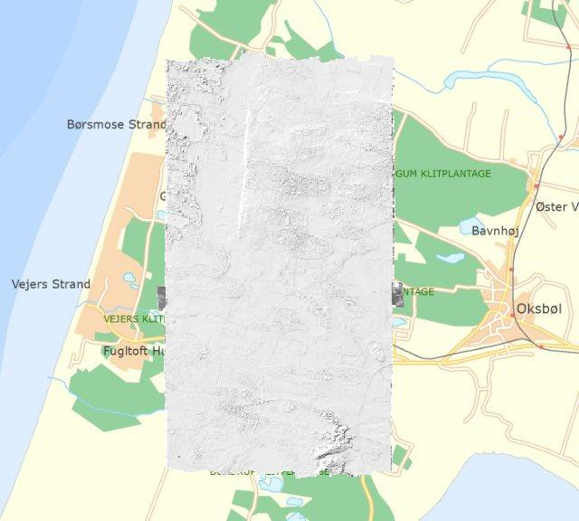
Allan Aasbjerg Nielsen Technical University of Denmark

Contents

Interpolation in laser scanned height data 5
Data 5
Interpolation methods 6
Cross validation (leave one out – LOO) 7
Joint semivariograms for all data 7

Conclusions 7

Literature 8

Appendix: Results from 2007 data 11
Test site A 2007 12
Test site B 2007 17
Test site C 2007 22
Test site D 2007 27
Test site E 2007 32
Test site F 2007 37
Test site G 2007 42
Test site H 2007 47
Test site X 2007 52
Test site Y 2007 57

Appendix: Results from 2013 data 62
Test site A 2013 62
Test site B 2013 67
Test site C 2013 72
Test site D 2013 77
Test site E 2013 82
Test site F 2013 87
Test site G 2013 92
Test site H 2013 97
Test site X 2013 102
Test site Y 2013 107

Interpolation in laser scanned height data

This report is in fulfillment for 2013 of “Ydelsesaftale mellem Geodatastyrelsen og Institut for Rumforskning og –teknologi, DTU om myndighedsbetjening af Geodatastyrelsen (tidligere Kort og Matrikelstyrelsen) i form af forskningsbaseret rådgivning og forskning i relation til geodæsi og kortlægning i 2013‐2016”, ”Resultatmål 3: Metodeudvikling til dataindsamling og topografisk kortlægning, Krav 2”.

Data
The data received from GST consist of laser scanned height data. The twenty data sets delivered cover ten sub‐areas sized 100 m by 100 m near Oksbøl (covering part of the military training area there). The figure on the title page shows the area in question.

The lidar reflections are classified and only the ones classified as “terrain” are worked with below.

For each sub‐area there is one data set from 2007 and one from 2013. The sampling density for the 2007 data is around 0.5‐1.0 points per m² and for 2013 it is 3‐4 points per m². Hence a typical distance between observations for the 2007 data is 1 m; for 2013 it is 0.5 m. Also, the average number of neighbours within a
  - m search radius is 3‐4 for 2007 and around 12 for 2013. Within a 2.0 m search radius the number is around 12 for 2007 and around 50 for 2013.

The following table shows basic statistics including measures of variability for the heights in the twenty areas, namely standard deviation in m and coefficient of variation (the ratio of standard deviation and mean which has no unit). There is little variation in heights in this region (except maybe for region OKSx).

Area | Number of observations | Mean  [m] | Min [m] | Max [m] | Standard deviation  [m] | Coefficient of variation [‐]
OKSa_2007 | 2,405 | 10.0270 | 9.58 | 11.47 | 0.32496 | 0.032407
OKSb_2007 | 2,031 | 9.2259 | 8.39 | 9.86 | 0.25584 | 0.027731
OKSc_2007 | 3,609 | 9.0515 | 8.10 | 10.67 | 0.42815 | 0.047302
OKSd_2007 | 2,357 | 9.9004 | 9.29 | 10.64 | 0.21435 | 0.021651
OKSe_2007 | 2,719 | 9.8319 | 9.43 | 11.25 | 0.24181 | 0.024595
OKSf_2007 | 4,697 | 9.9447 | 9.04 | 13.49 | 0.43911 | 0.044155
OKSg_2007 | 3,698 | 9.9299 | 9.51 | 10.34 | 0.12042 | 0.012127
OKSh_2007 | 3,946 | 9.9344 | 9.49 | 11.25 | 0.21794 | 0.021938
OKSx_2007 | 2,034 | 12.3984 | 9.90 | 21.22 | 2.75357 | 0.222084
OKSy_2007 | 1,074 | 23.8013 | 21.02 | 26.77 | 0.99539 | 0.041821

Area | Number of observations | Mean  [m] | Min [m] | Max [m] | Standard deviation  [m] | Coefficient of variation [‐]
OKSa_2013 | 36,861 | 10.0071 | 9.65 | 11.48 | 0.29150 | 0.029129
OKSb_2013 | 22,614 | 9.1945 | 8.37 | 10.03 | 0.25237 | 0.027448
OKSc_2013 | 36,560 | 8.9057 | 8.13 | 10.54 | 0.43624 | 0.048984
OKSd_2013 | 13,622 | 9.9237 | 9.38 | 10.50 | 0.20149 | 0.020303
OKSe_2013 | 17,138 | 9.8593 | 8.91 | 11.24 | 0.24678 | 0.025030
OKSf_2013 | 20,915 | 10.1106 | 9.06 | 13.39 | 0.58424 | 0.057785
OKSg_2013 | 21,953 | 9.9581 | 9.64 | 10.50 | 0.10661 | 0.010706
OKSh_2013 | 19,410 | 9.9144 | 9.46 | 10.89 | 0.18793 | 0.018956
OKSx_2013 | 24,606 | 12.7075 | 9.90 | 21.47 | 3.09036 | 0.243191
OKSy_2013 | 11,691 | 23.5409 | 21.06 | 26.83 | 1.14271 | 0.048542

In OKSb_2013 observations 22,440, 21,254 and 17,721 were removed manually.

In OKSc_2013 observations 35,247, 30,306, 29,226, 28,191 and 24,919 were removed manually.

Interpolation methods
In this work the following spatial interpolation methods are used

    - Local mean value (LM).
    - Inverse distance (ID).
    - Inverse distance squared (ID2).
    - Ordinary kriging (OK).

The four above methods are performed using 3, 5, 10, 20, 30, 40, 50, 60, 70 and 80 nearest neighbours, respectively. LM corresponds to OK with a full nugget effect semivariogram model.

Also

    - Nearest neighbour interpolation (NN) is used, and
    - Delaunay triangulation followed by bilinear interpolation always based on three nearest neighbours (TIN, triangulated irregular network) is carried out.

The TIN method is often used in GIS based work.

2‐D semivariograms (also known as semivariogram maps) estimated individually for each of the ten sub‐ areas in both years are calculated based on a lag distance of 1.6 m for 2007 and 1.0 m for 2013. These semivariograms mostly exhibit isotropy for small lag distances. Hence also individually (1‐D) isotropic (also known as omnidirectional) semivariograms are calculated (based on lag distances of 1.6 m for 2007 and 0.4 m for 2013), modelled and used in OK.

The semivariogram models applied are either spherical (some with the range so large that they appear linear), or modified Gaussian (or modified exponential). The modification consists of using exp(-3(h/R)p)

the range (of influence).

Cross‐validation (leave‐one‐out, LOO)
The quality of the above methods is quantified by a number of measures calculated from leave‐one‐out (LOO) cross‐validation. In LOO cross‐validation we exclude one observation x_{i} at a time (and retain all the other observations), and we then compare the estimated value x�_{i} with x_{i} in a number of fashions, see below. Important measures are bias and root‐mean‐squared error (RMSE). Bias is defined as

1 ∑n
(x_{i} - x�_{i}), where n is the number of observations. RMSE is defined as the square root of

n i=1

1 ∑n
(x_{i} - x�_{i})2. Values for bias and RMSE close to zero are best. Results for the ten sub‐areas and both

n i=1
years are shown in the appendix.

Joint semivariograms for all data
It is tempting to estimate joint semivariograms for all the data and use a joint model in all OK estimations. These are shown after the literature list. OK is performed based on individual semivariogram models.

Conclusions
The bias and the RMSE plots consistently show OK as the best or among the best interpolation methods followed by ID2, ID and LM.

The supremacy of OK is confirmed by the histograms and the scatterplots of LOO estimates vs
measurements.

The scatter plots show that some of the interpolation methods (sometimes also OK) tend to overestimate low values and underestimate high values.

Runs with different numbers of neighbours used in the interpolations show that generally bias and RMSE do not improve beyond 20‐30 neighbours.

Literature
A. G. Journel and C. J. Huijbregts (1978). Mining Geostatistics. Academic Press.

E. Isaaks and R. M. Srivastava (1989). An Introduction to Applied Geostatistics. Oxford University Press.

C. V. Deutsch and A. G. Journel (1998). GSLIB: Geostatistical Software Library and User’s Guide, 2nd edition. Oxford University Press.

A. A. Nielsen (2009). Geostatistics and Analysis of Spatial Data. Lecture note.

A. A. Nielsen (2012). Interpolation in laser scanned height data. Technical report.

papers from the annual Photogrammetrische Woche and the European LiDAR Mapping Forum.

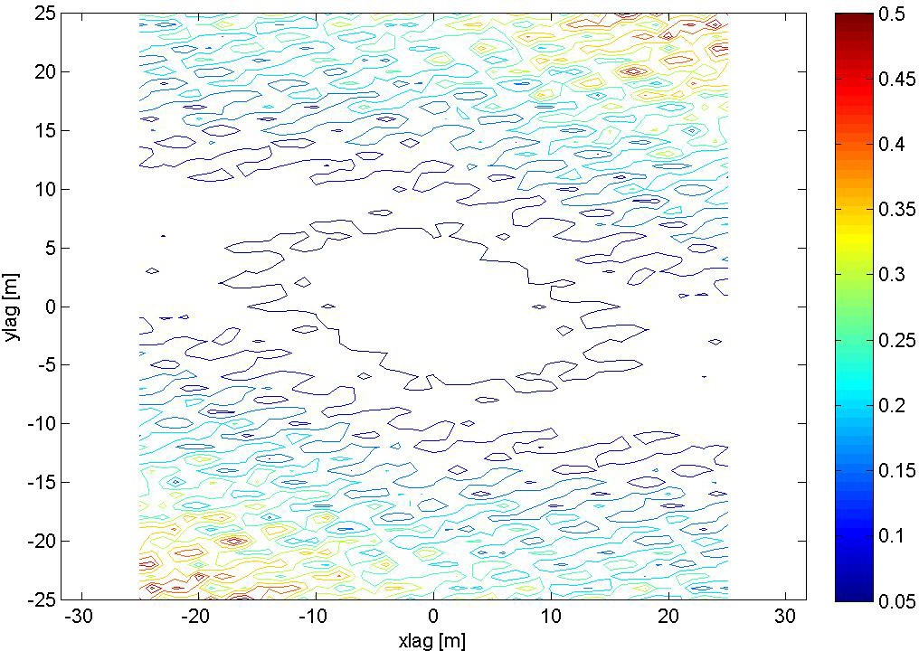

Figure 1: 2‐D semivariogram for all 2007 data.

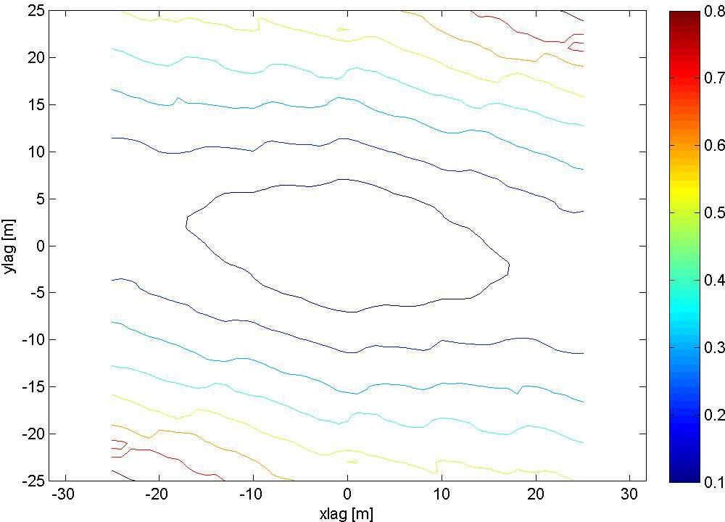

Figure 2: 2‐D semivariogram for all 2013 data.

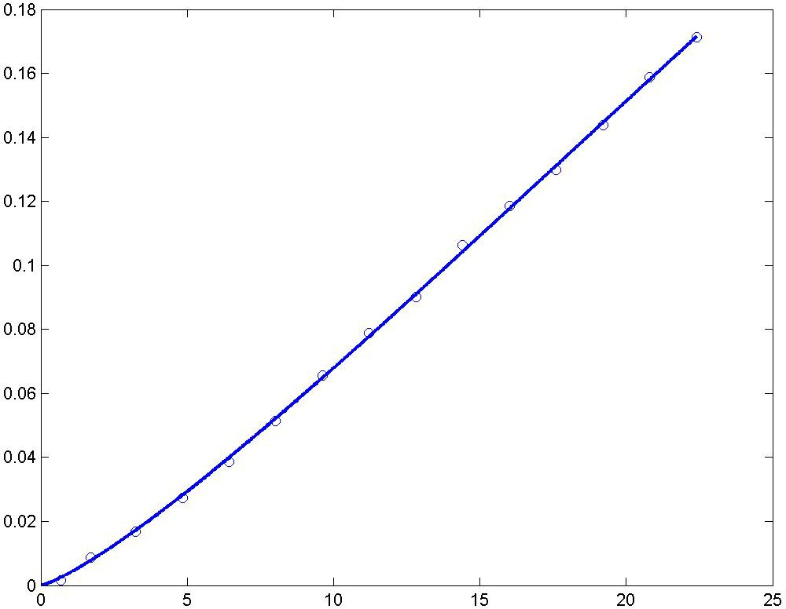

Figure 3: Isotropic semivariogram for all 2007 data and model (modified Gaussian, p = 1. 25, no nugget).

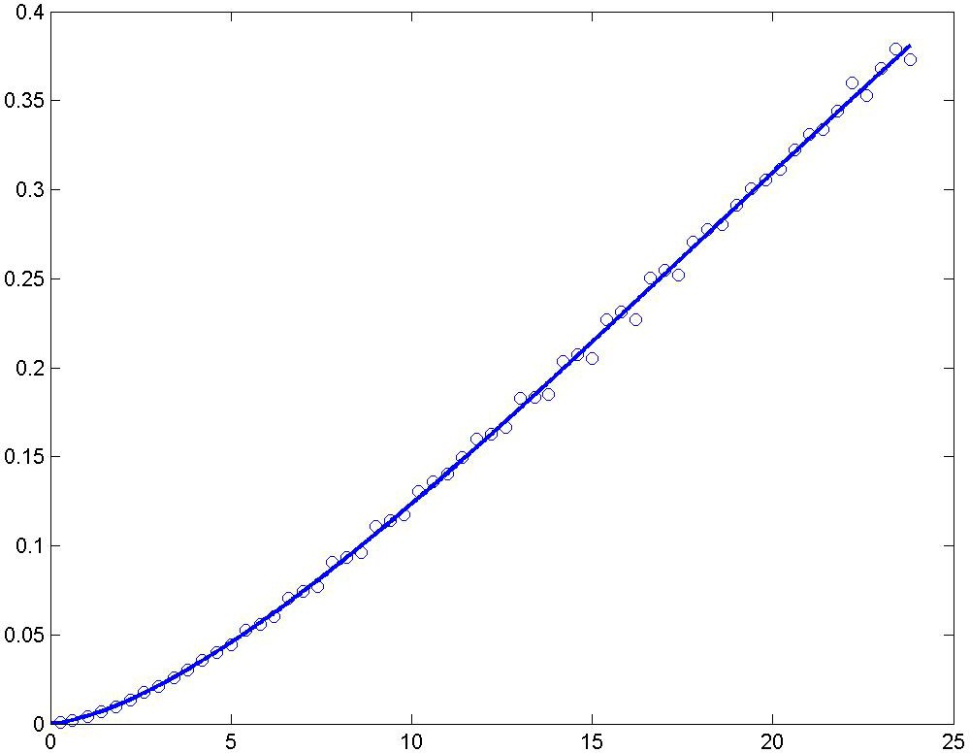

Figure 4: Isotropic semivariogram for all 2013 data and model (modified Gaussian, p = 1. 50, no nugget).

Appendix
The following 100 pages show results from leave‐one‐out (LOO) cross‐validations for the different interpolation methods, namely NN, TIN, ID, ID2, LM and OK.

For each of the ten sub‐areas in both 2007 and 2013 five pages with results are shown:

- The first page shows 1) a posting plot of the heights; and 2) a posting plot of the differences between the heights and their LOO estimates from OK based on 30 nearest neighbours.
- The second page shows 1) contours of a 2‐D semivariogram also known as a semivariogram map to check for possible anisoptropy; and 2) a (1‐D) isotropic also known as an omni‐directional semivariogram including a semivariogram model.
- The third page shows histograms of the differences between the heights and their LOO estimates (based on 30 nearest neighbours for ID, ID2, LM and OK).
- The fourth page shows bias and RMSE for LM, ID, ID2 and OK as functions of number of nearest neighbours.
- Finally, the fifth page shows a plot of the heights (x‐axis) and their LOO estimates (y‐axis) from all six methods (based on 30 nearest neighbours for ID, ID2, LM and OK).

When six figures are presented on one page, the order of the figures is

NN | TIN
ID | ID2
LM | OK

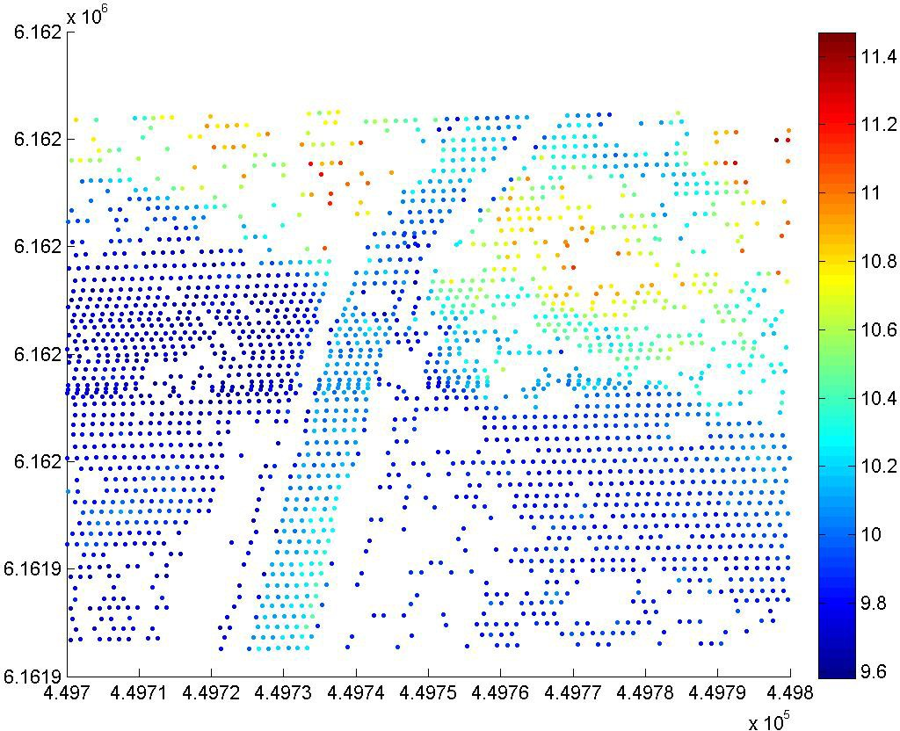

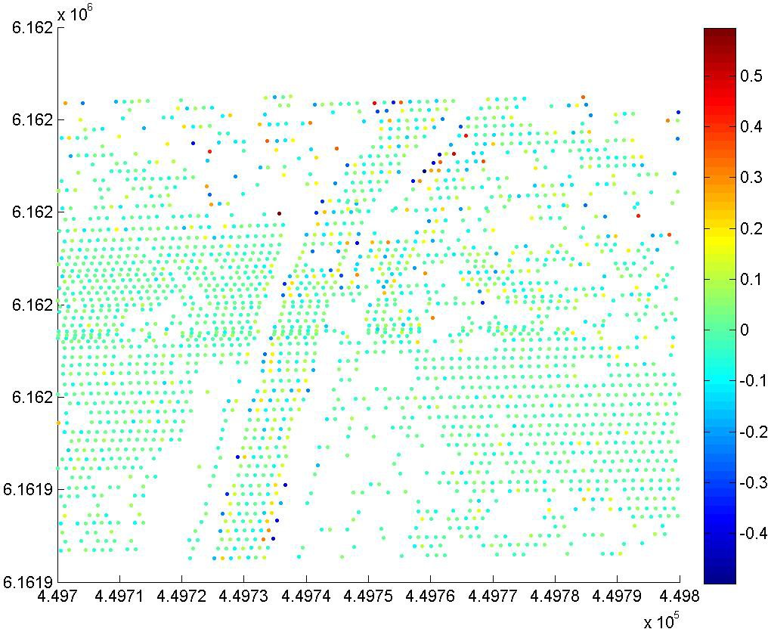

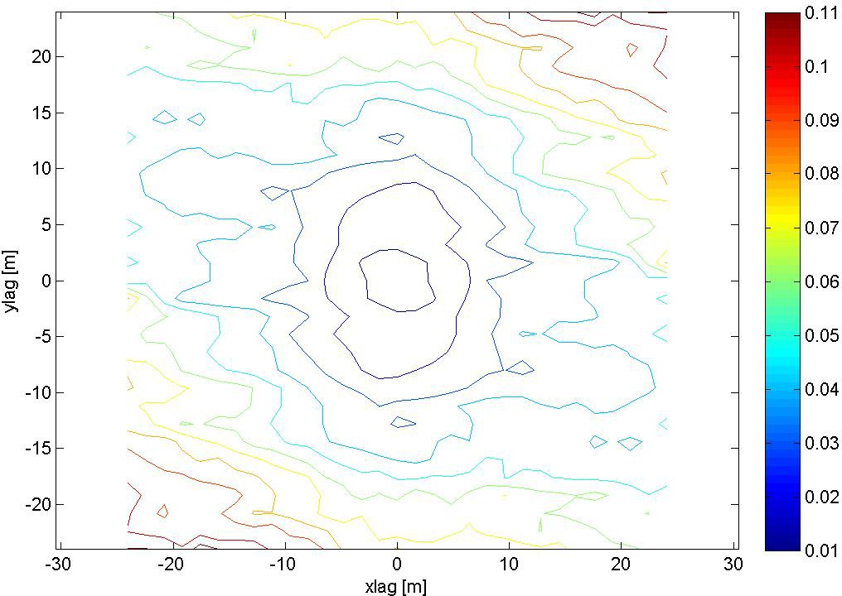

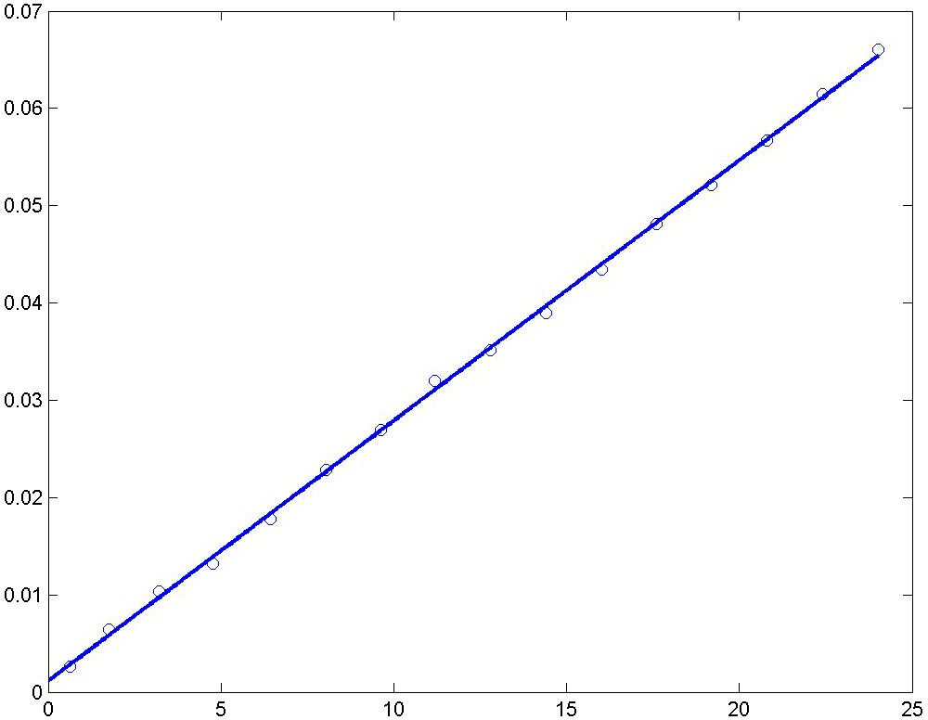

A spherical (linear) semivariogram model is used.

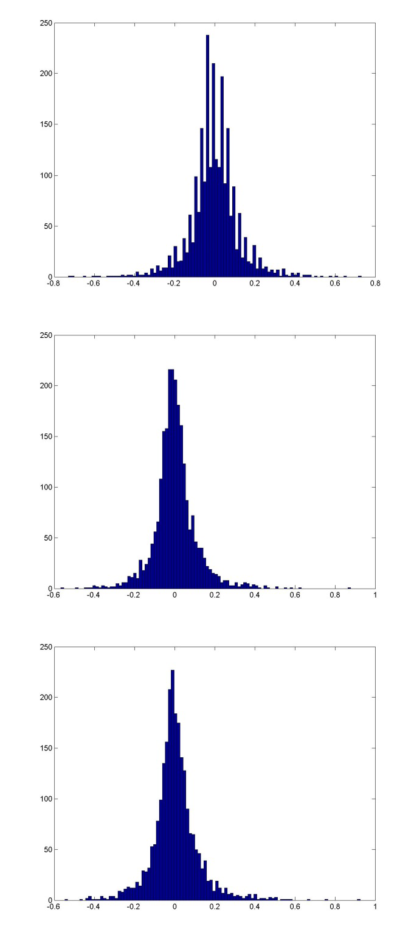
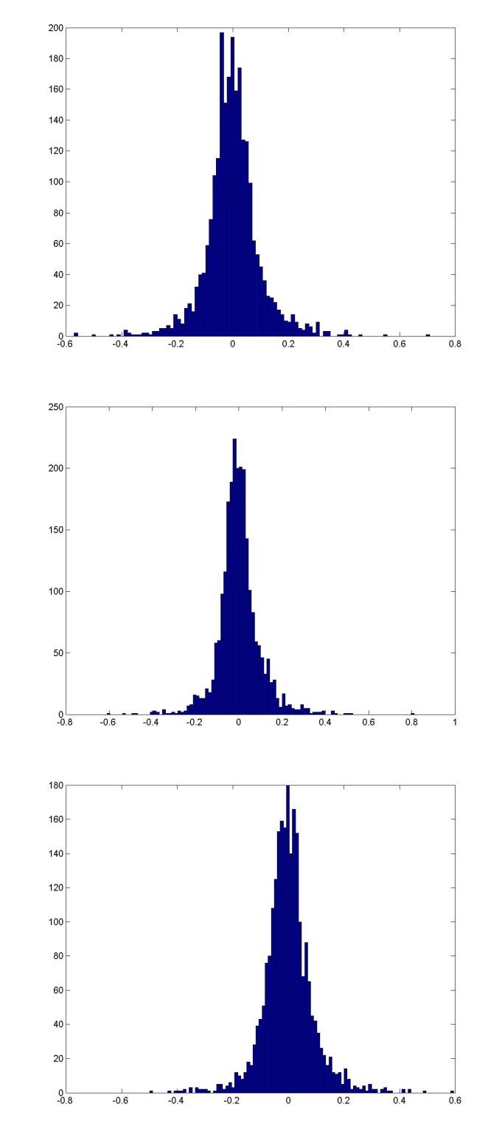

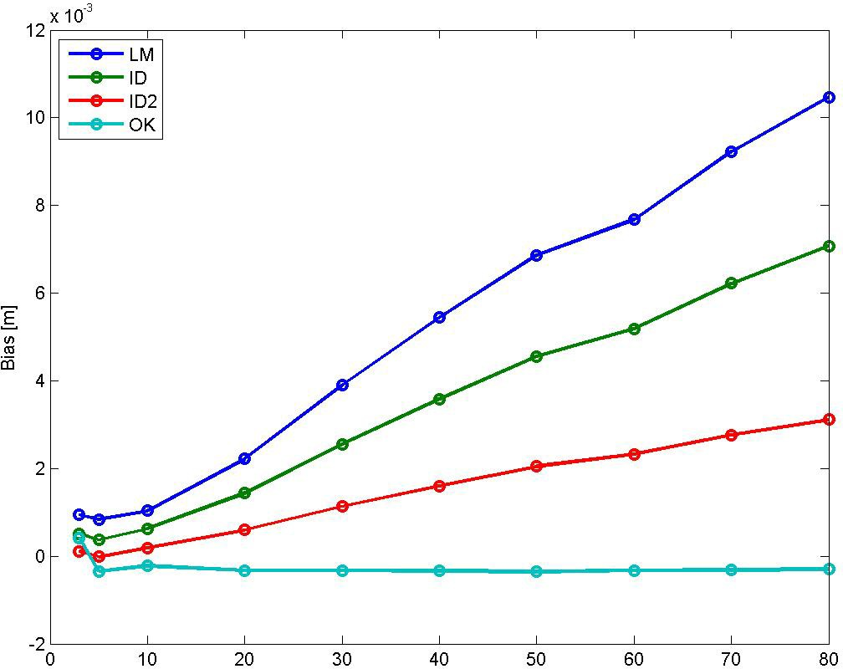

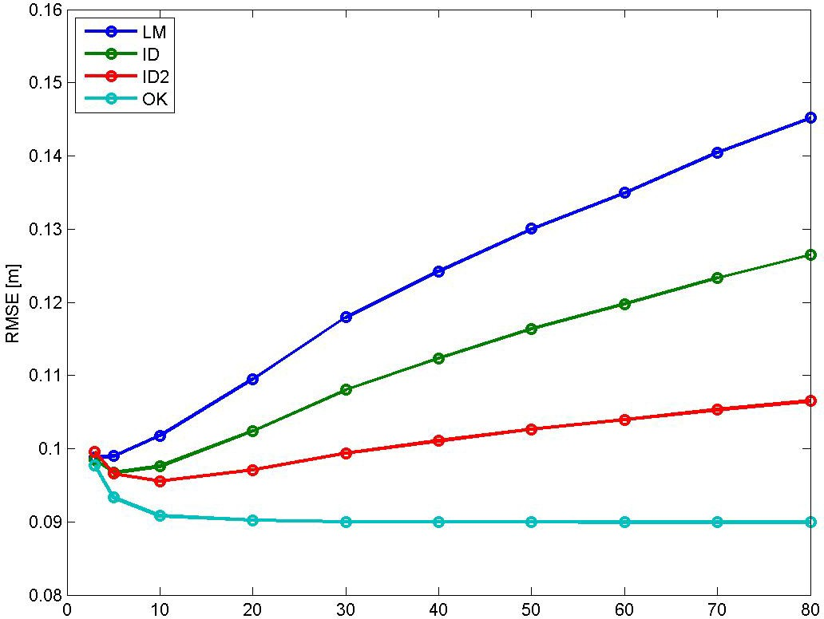

Bias for NN is ‐0.0029896 m, and for TIN 0.0003281 m. RMSE for NN is 0.12486 m, and for TIN 0.09863 m.

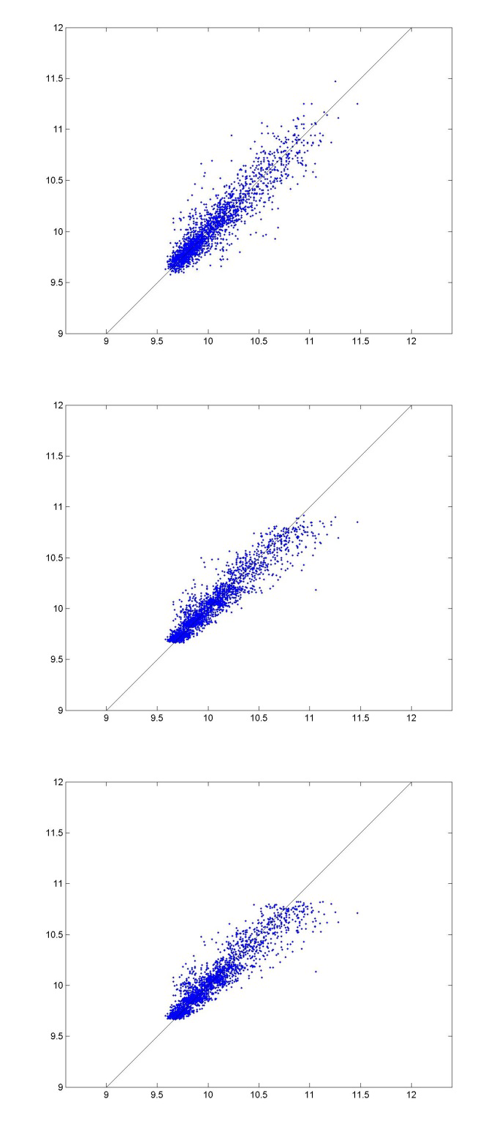
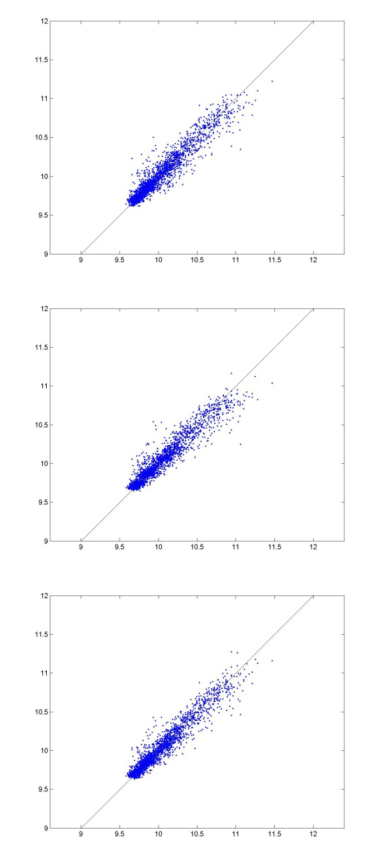

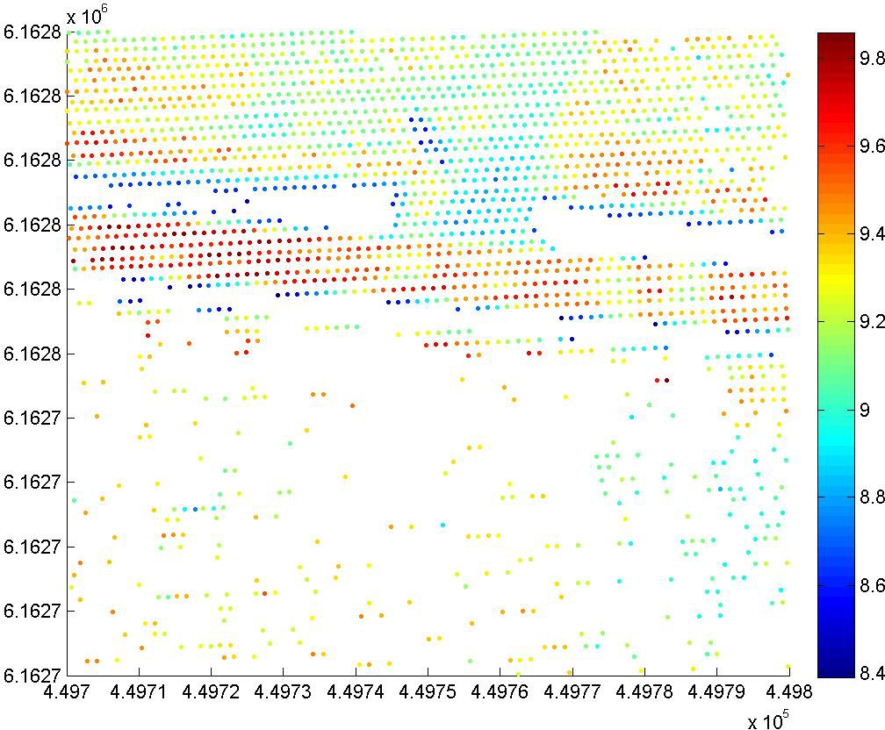

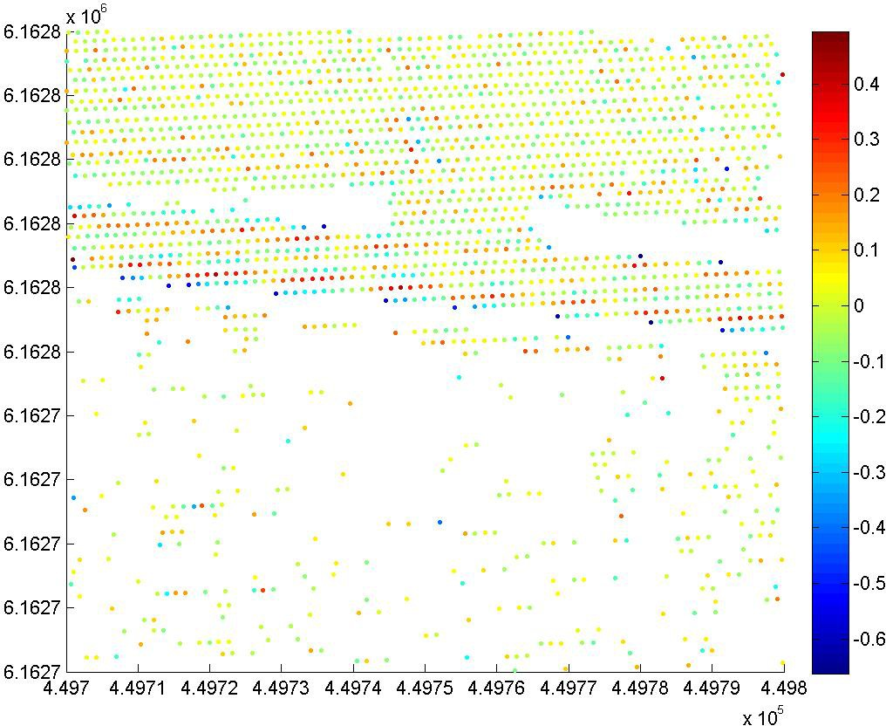

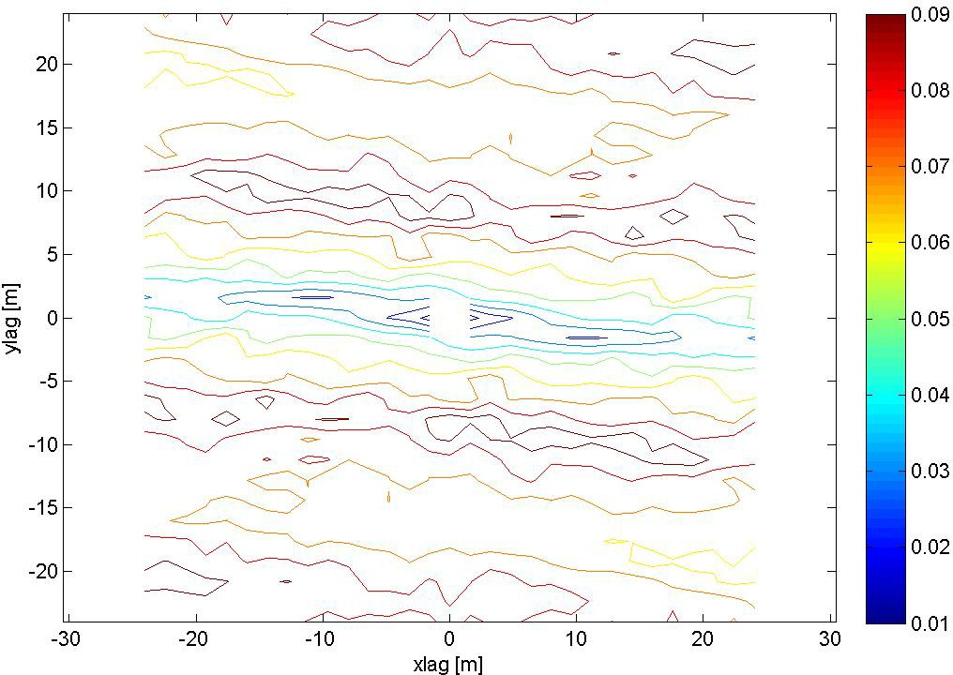

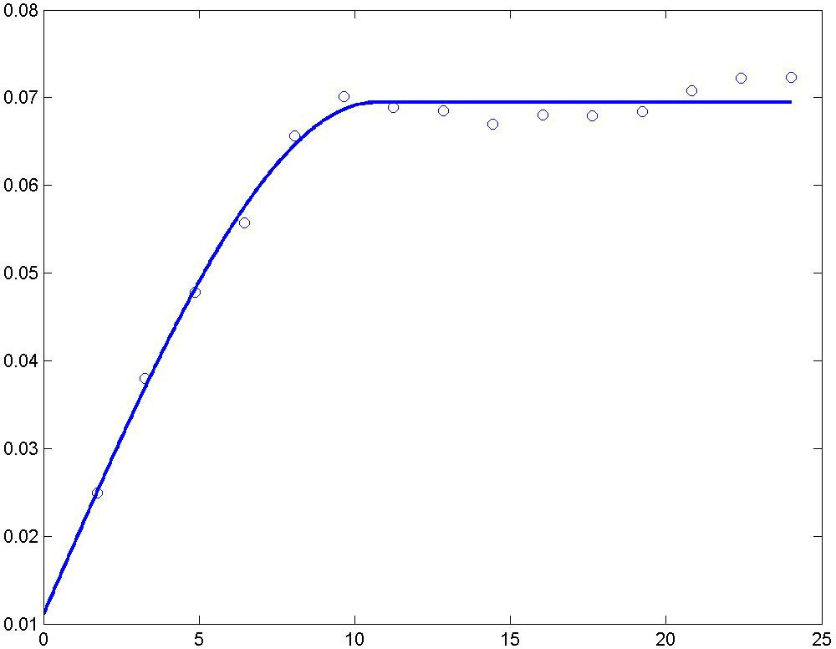

A spherical semivariogram model is used.

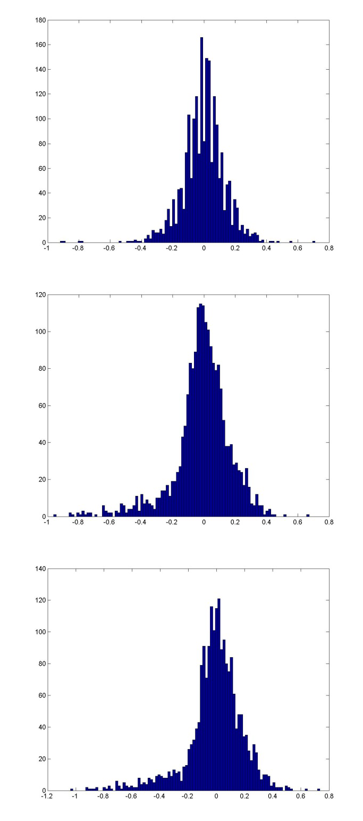
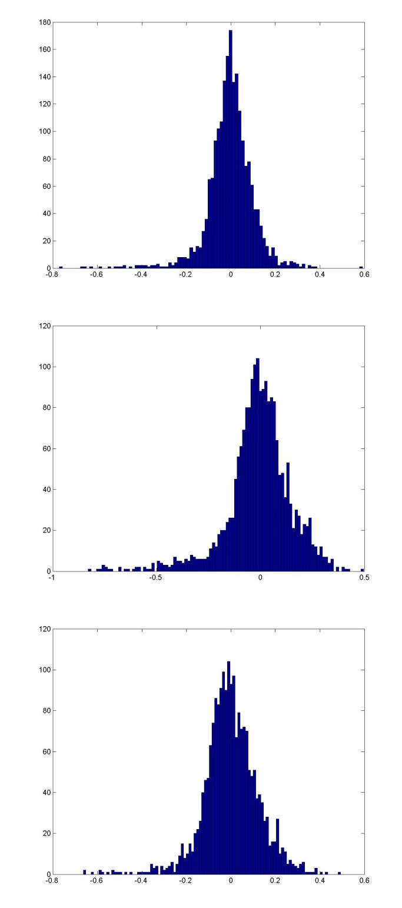

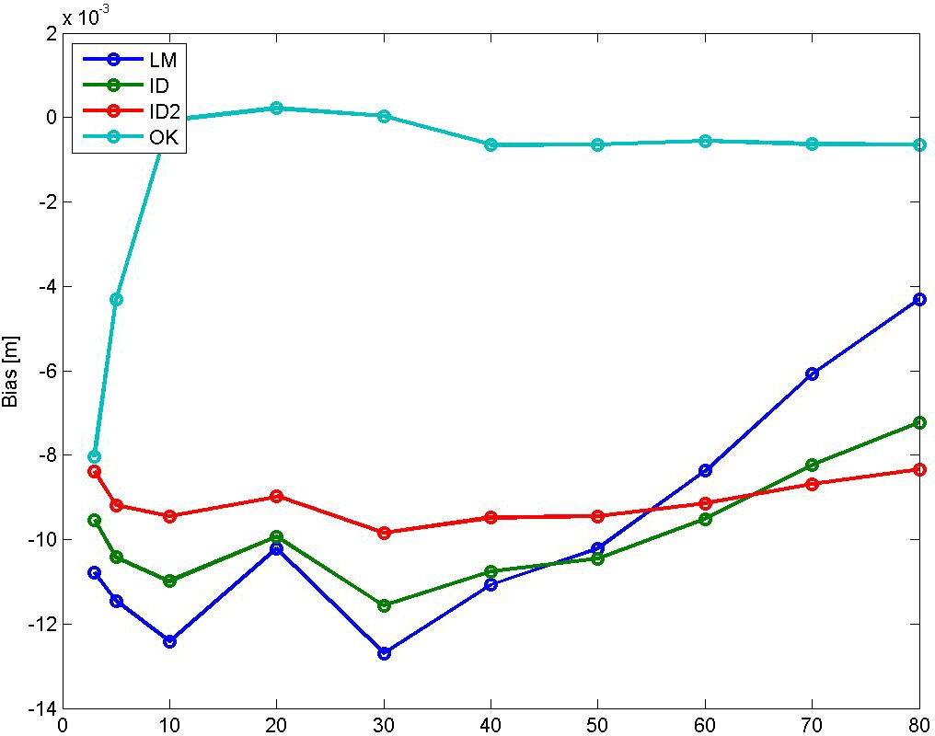

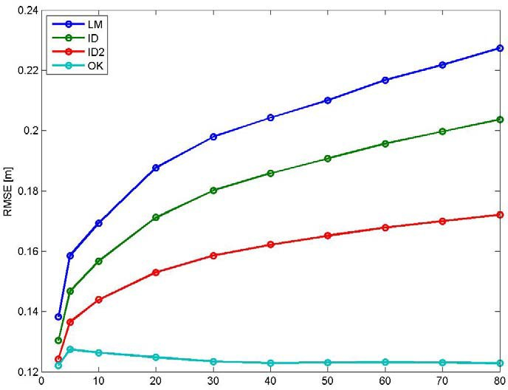

Bias for NN is ‐0.0031856 m, and for TIN ‐0.0028933 m. RMSE for NN is 0.13378 m, and for TIN 0.10383 m.

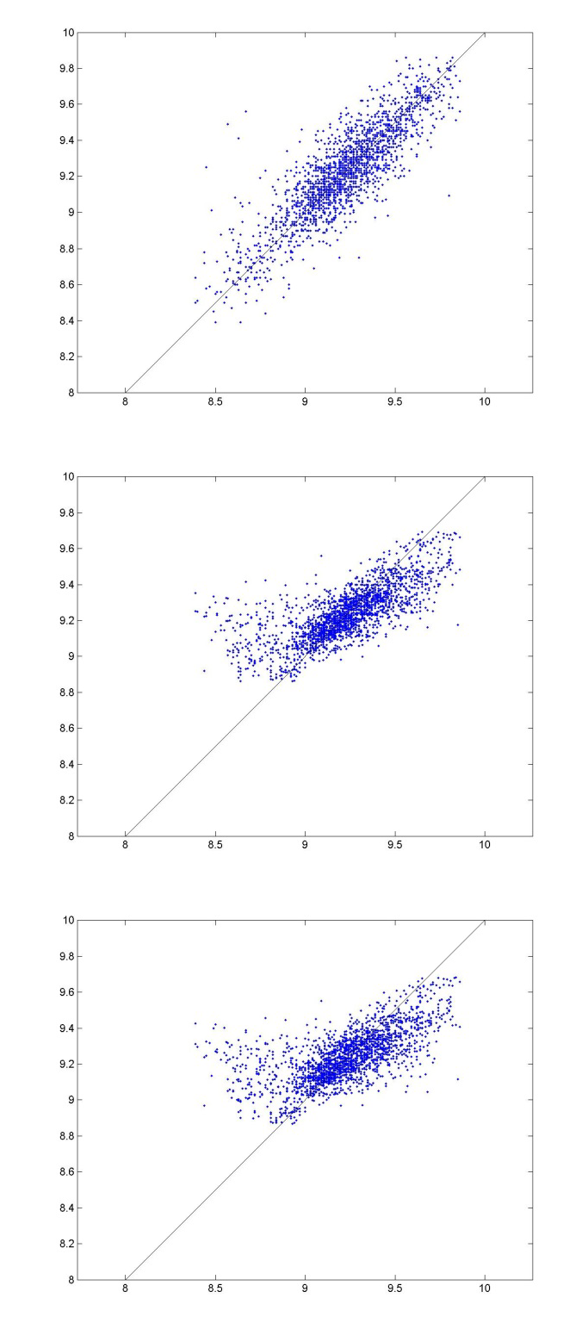
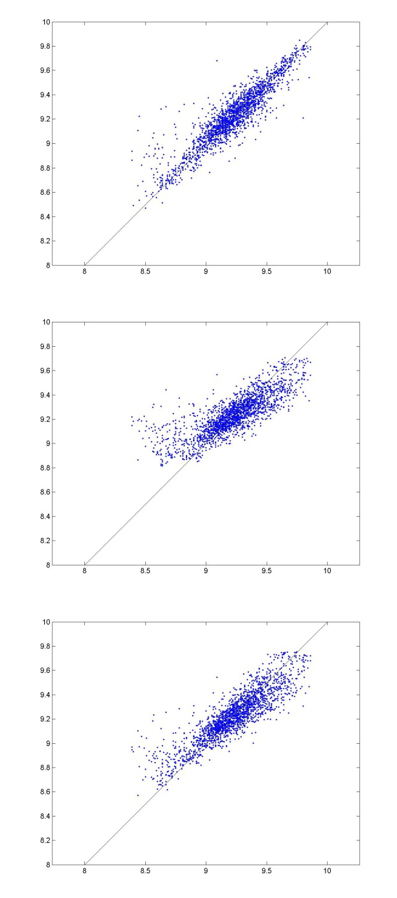

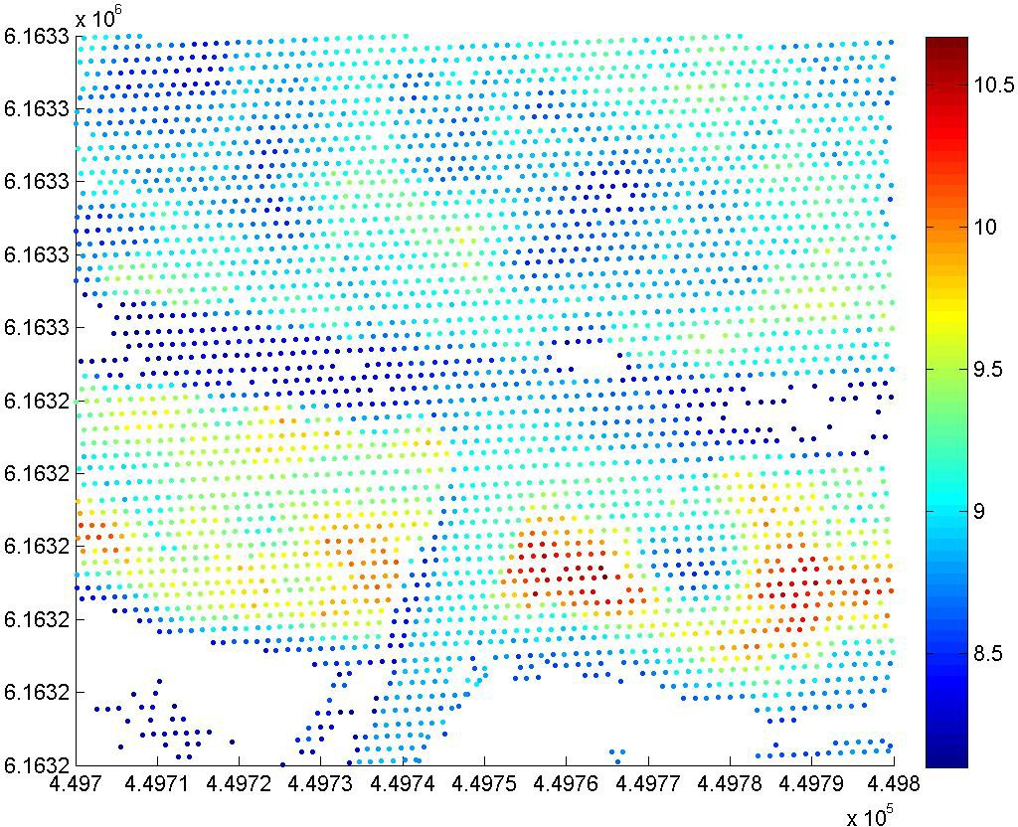

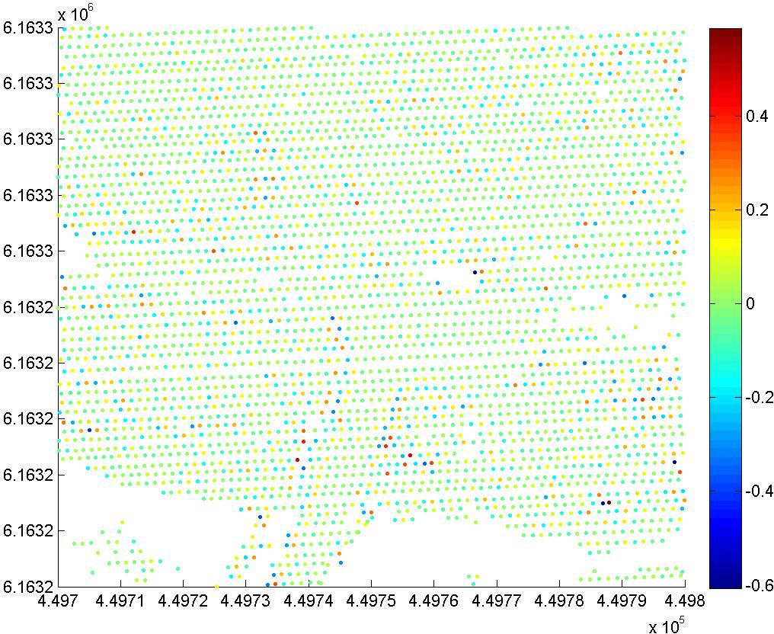

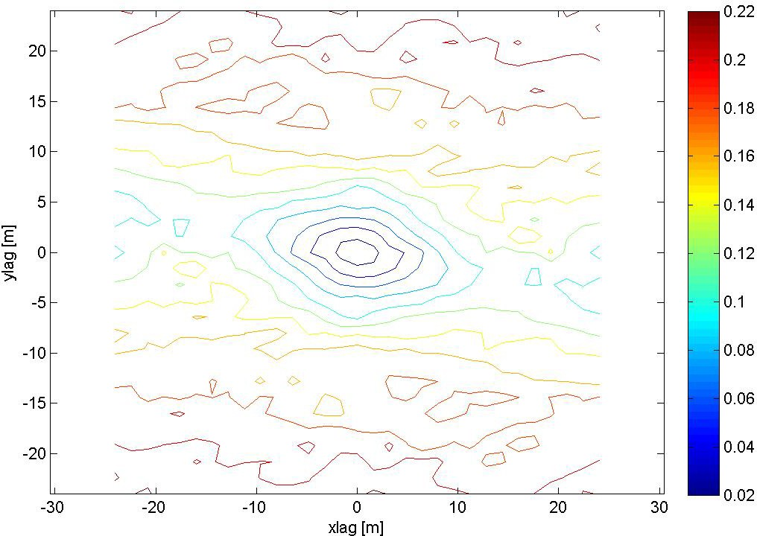

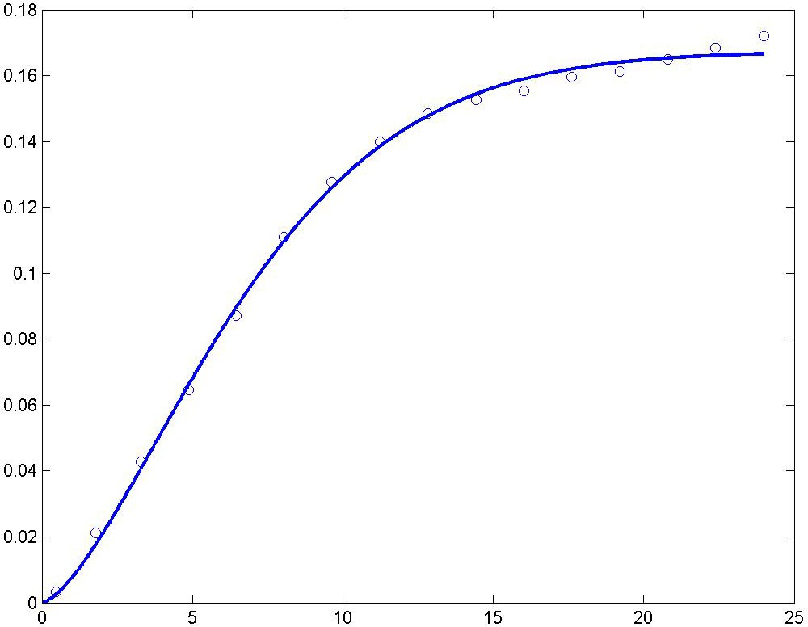

A modified Gaussian semivariogram model is used (power is 1.5 and not 2), no nugget effect.

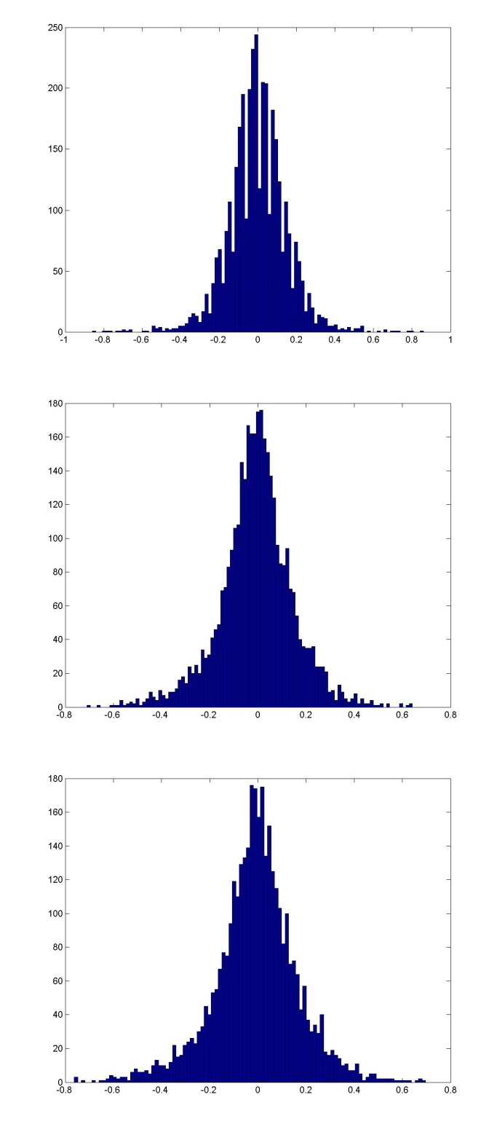
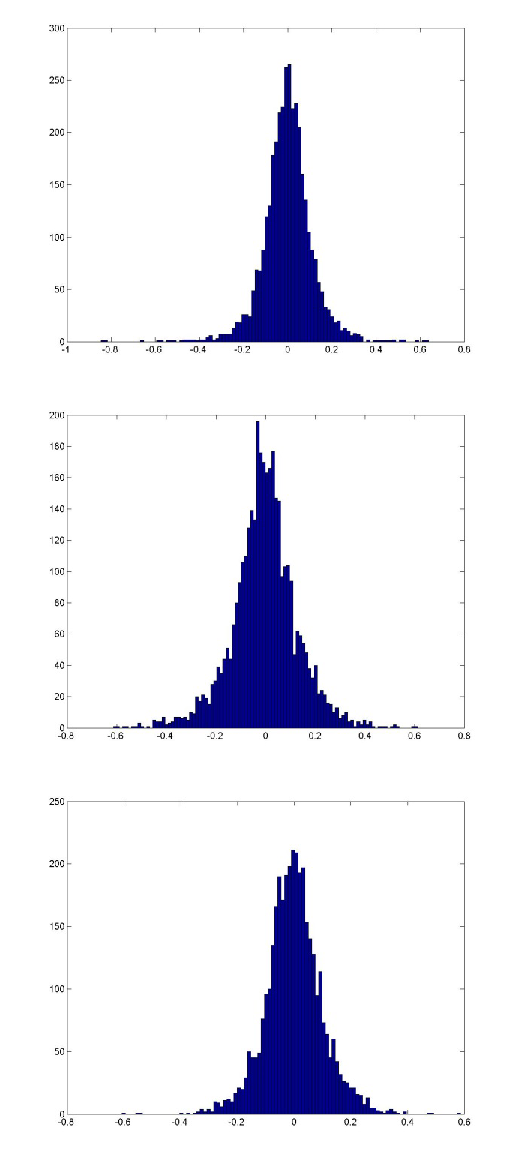

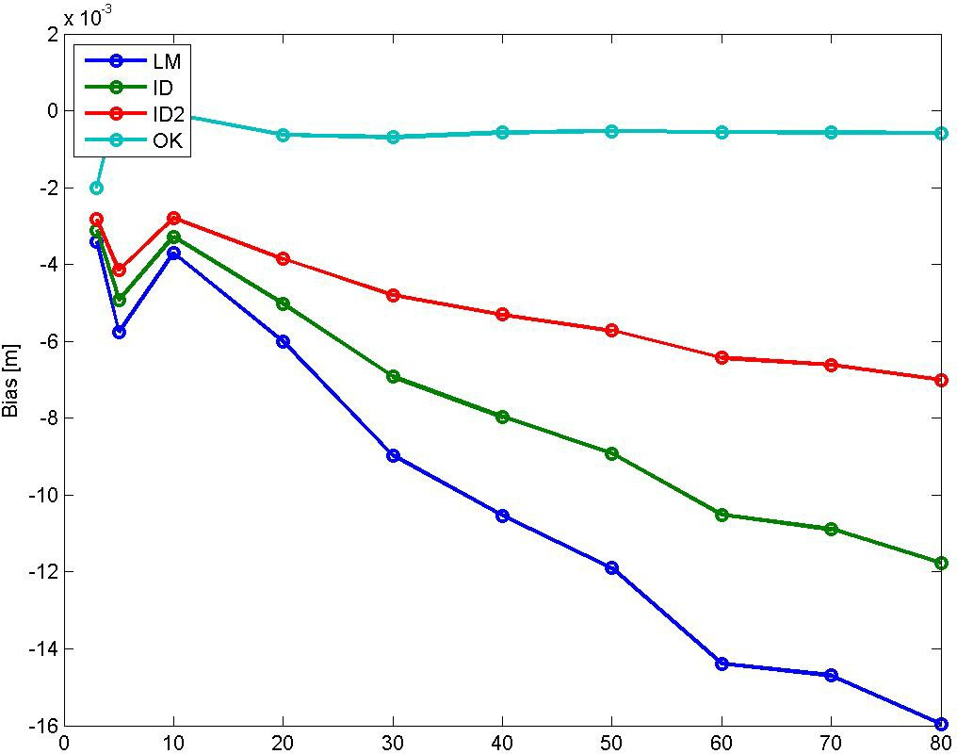

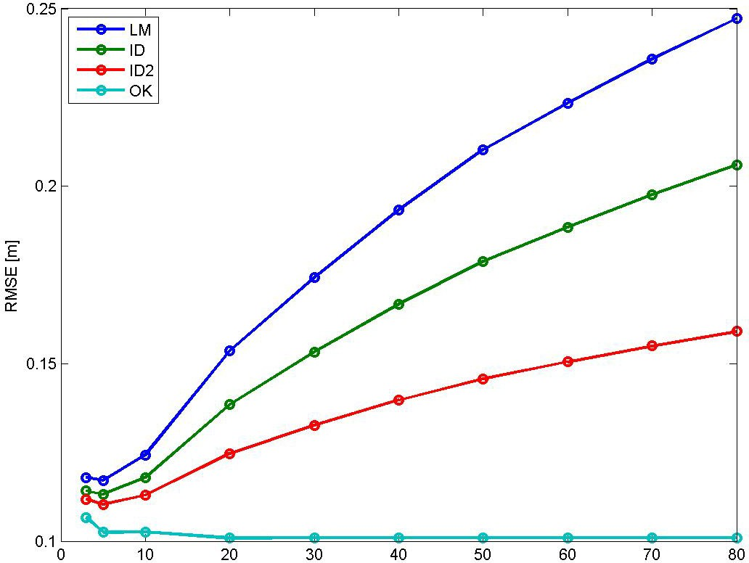

Bias for NN is ‐0.00179 m, and for TIN ‐0.00088283 m. RMSE for NN is 0.15491 m, and for TIN 0.11269 m.

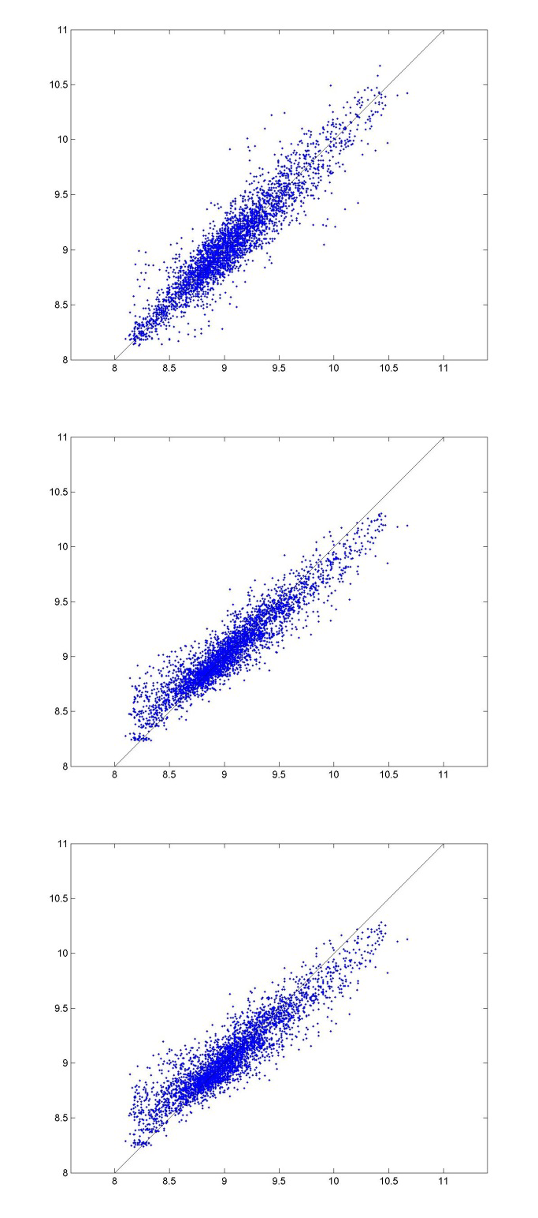
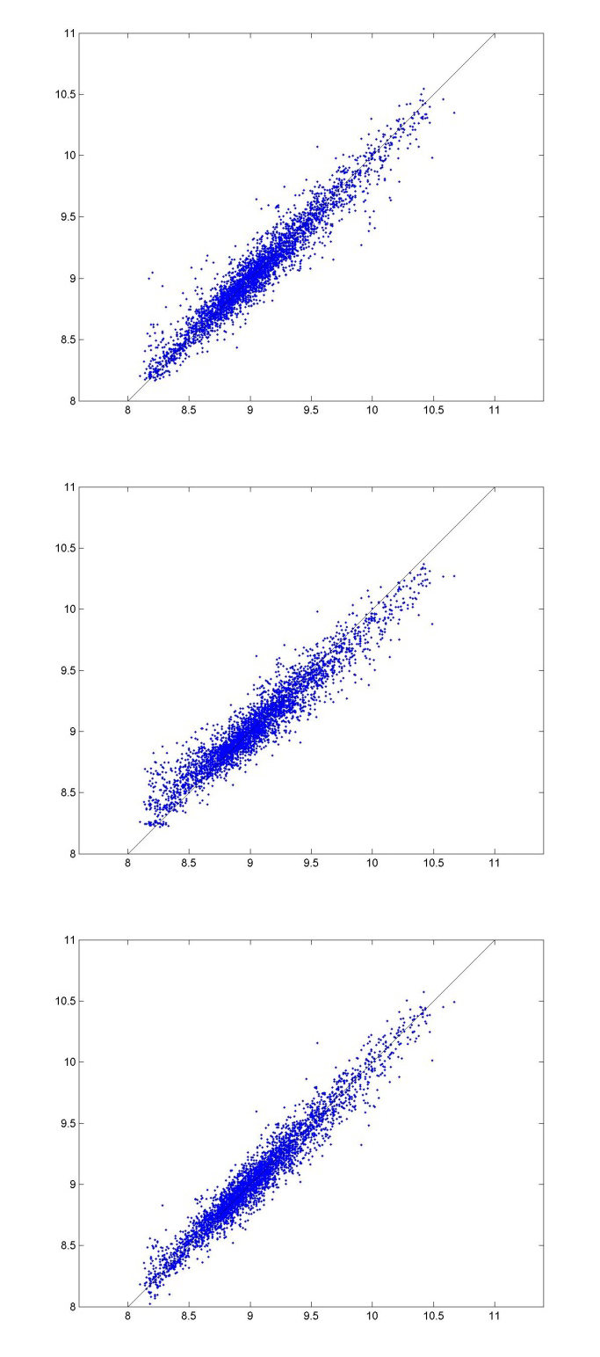

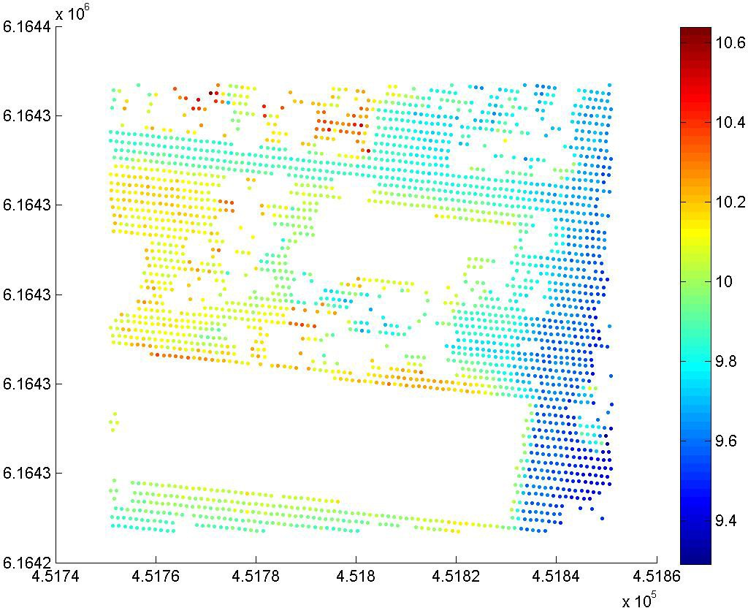

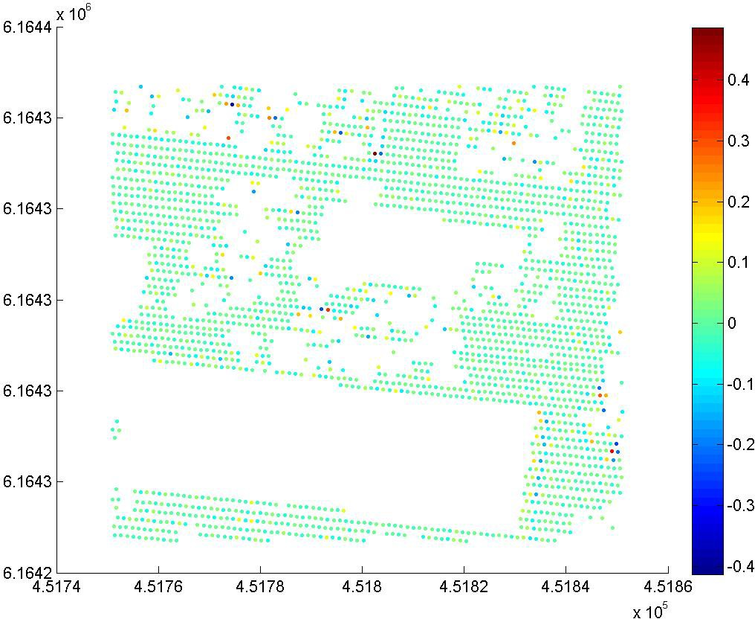

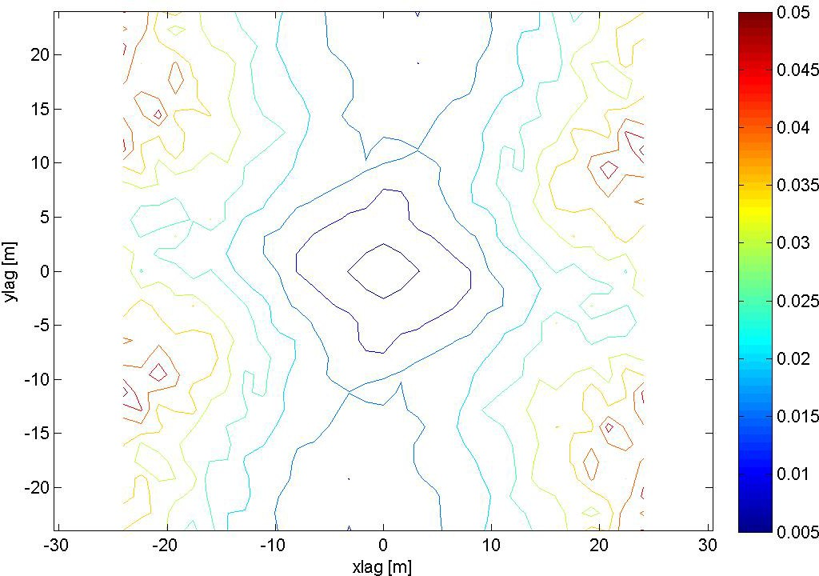

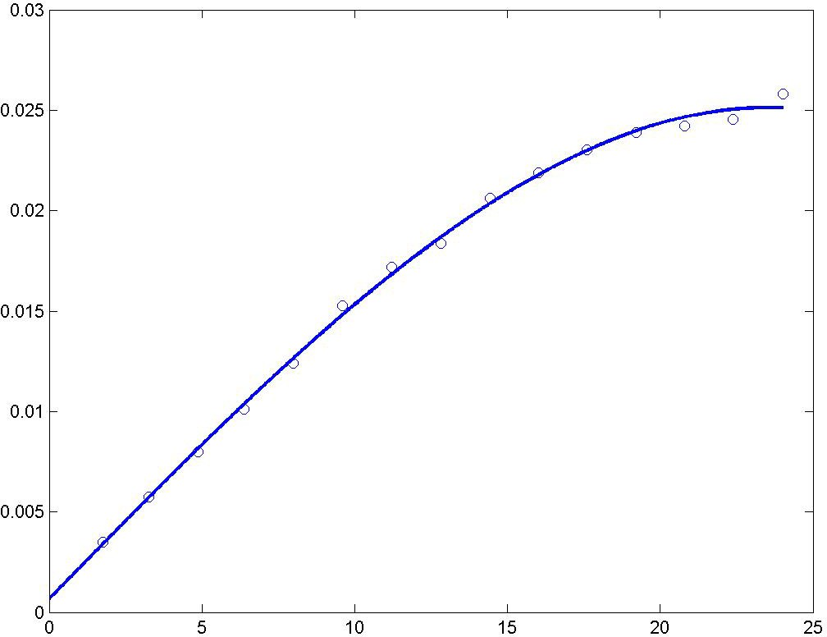

A spherical semivariogram model is used.

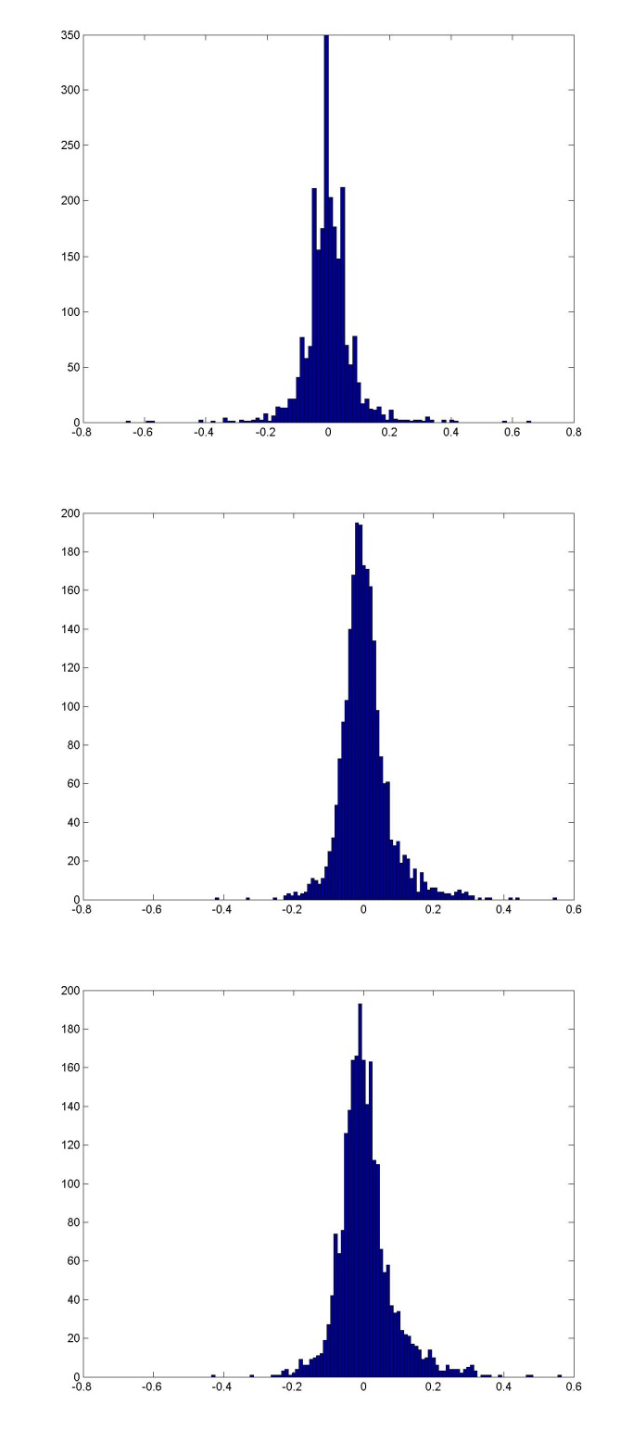
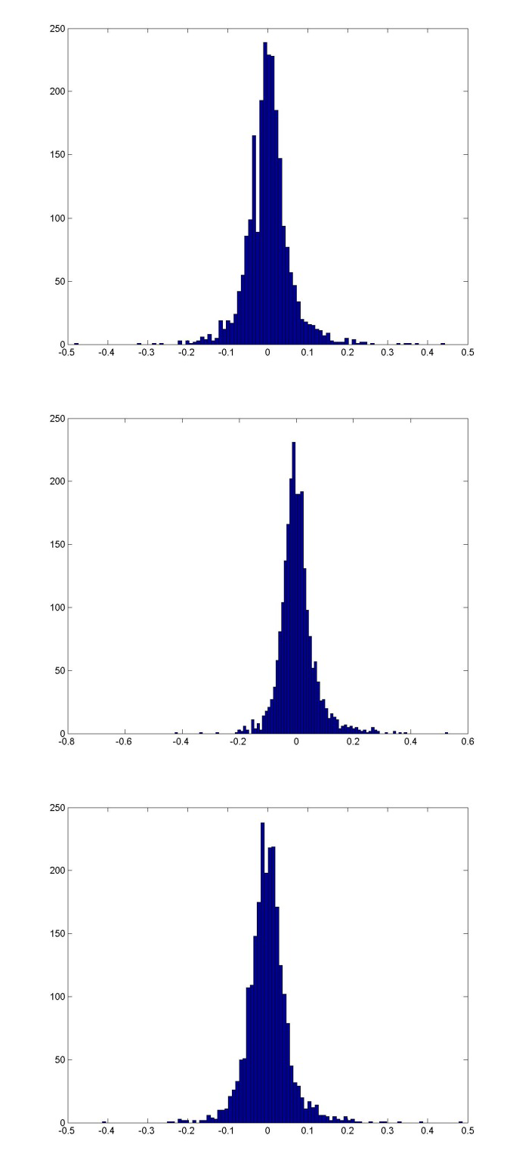

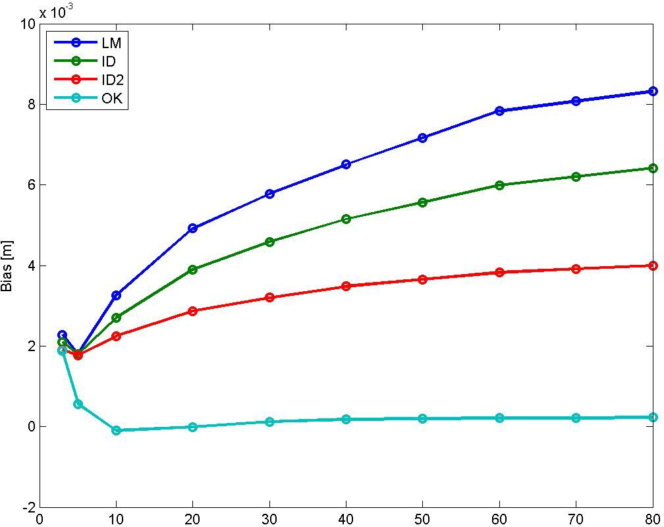

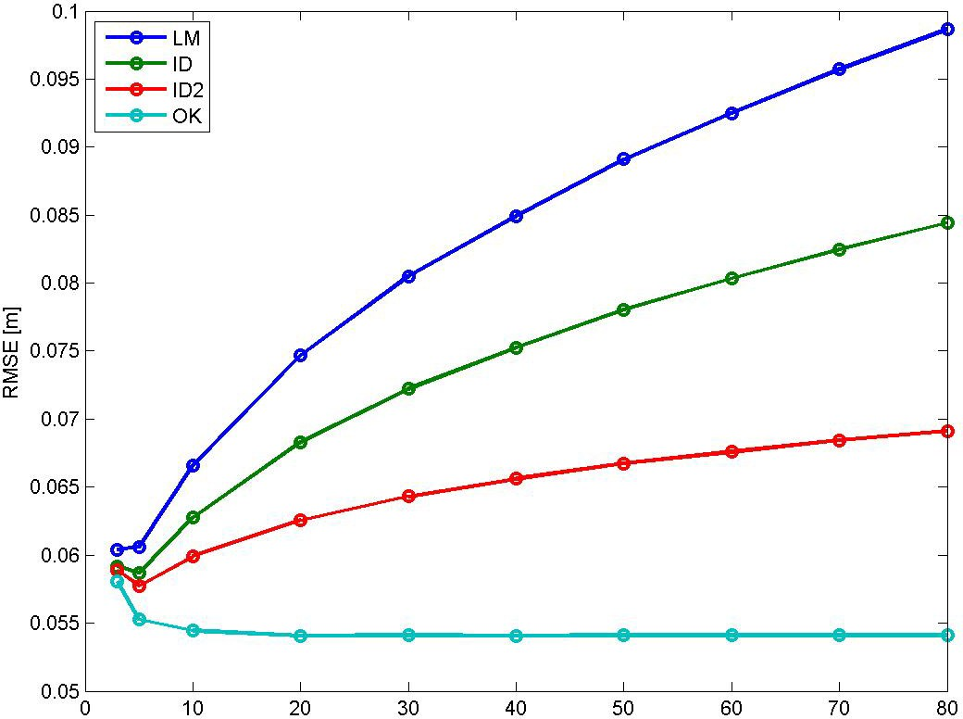

Bias for NN is 0.0002800 m, and for TIN 0.0012231 m. RMSE for NN is 0.079079 m, and for TIN 0.057797 m.

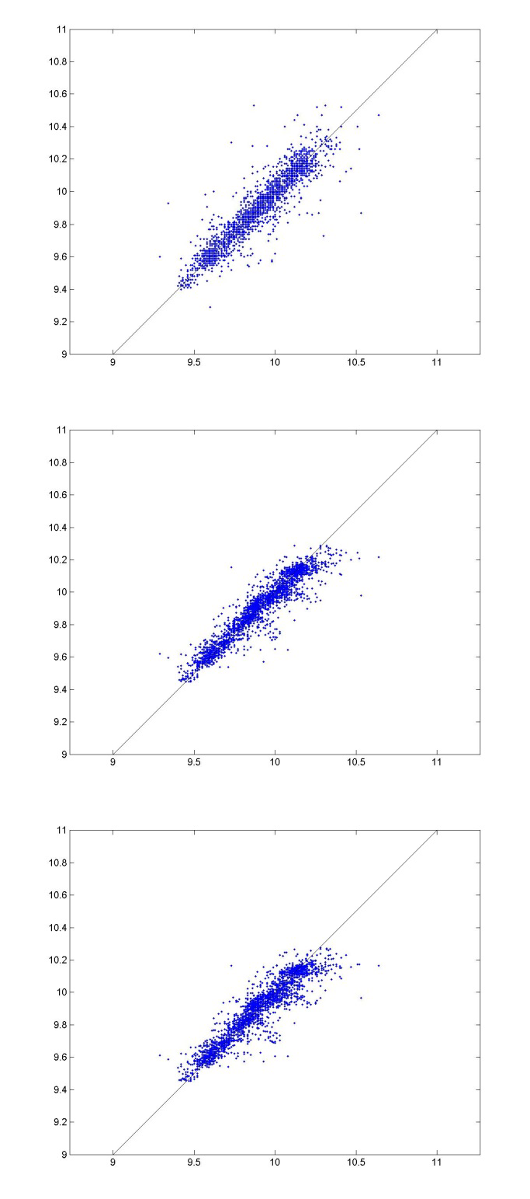
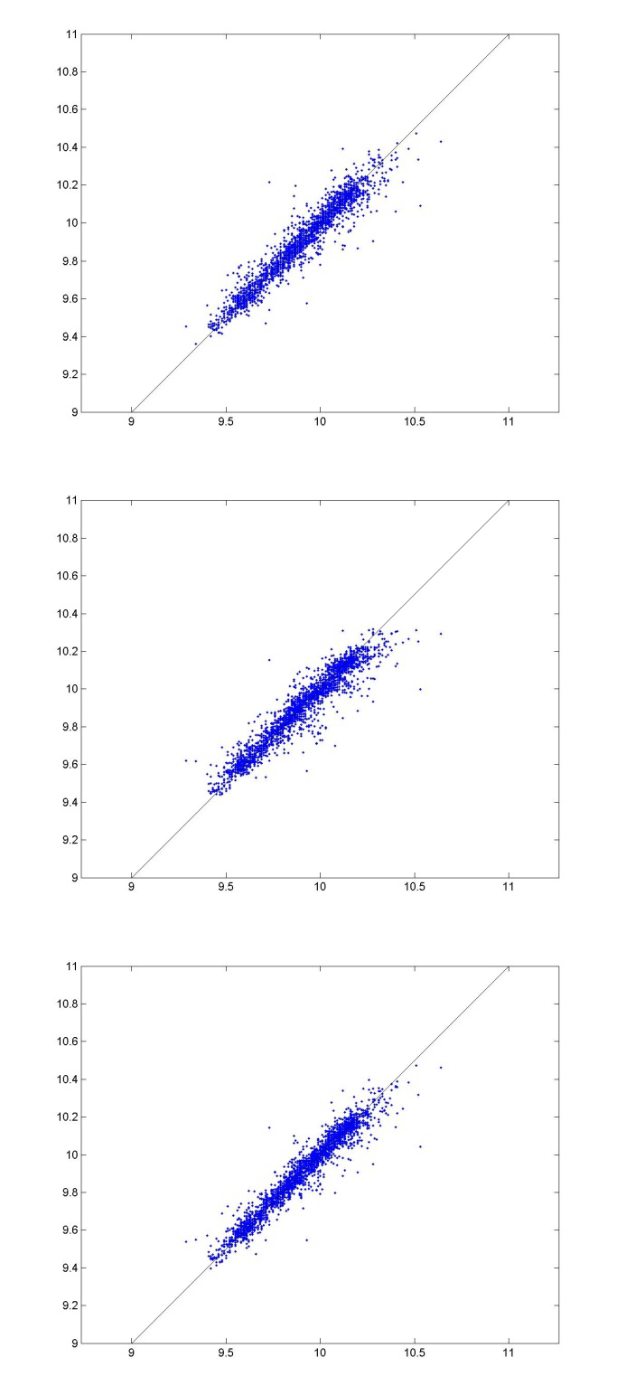

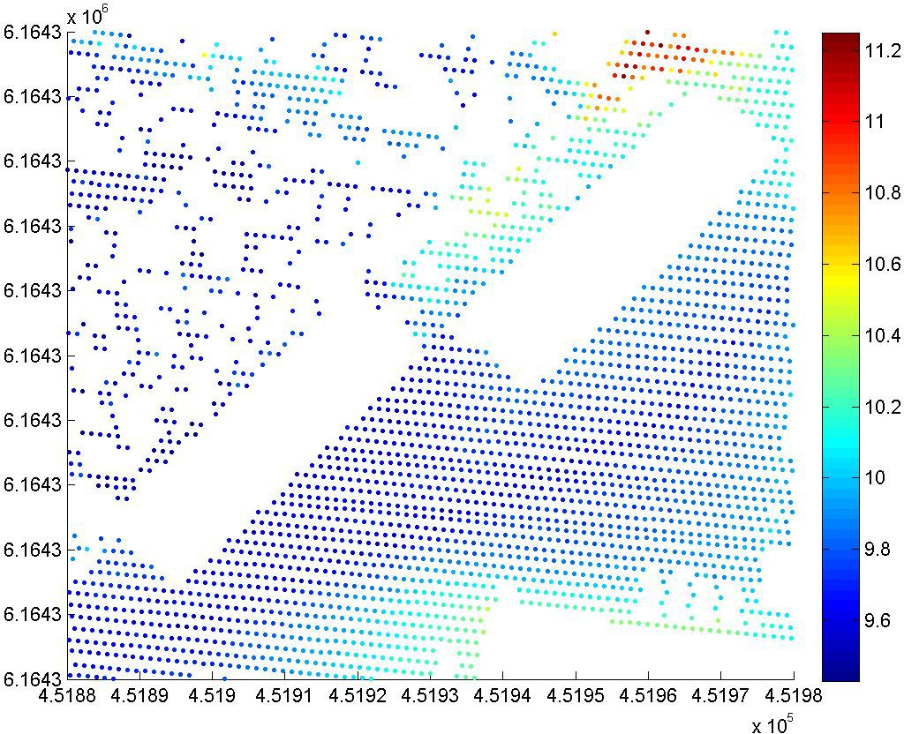

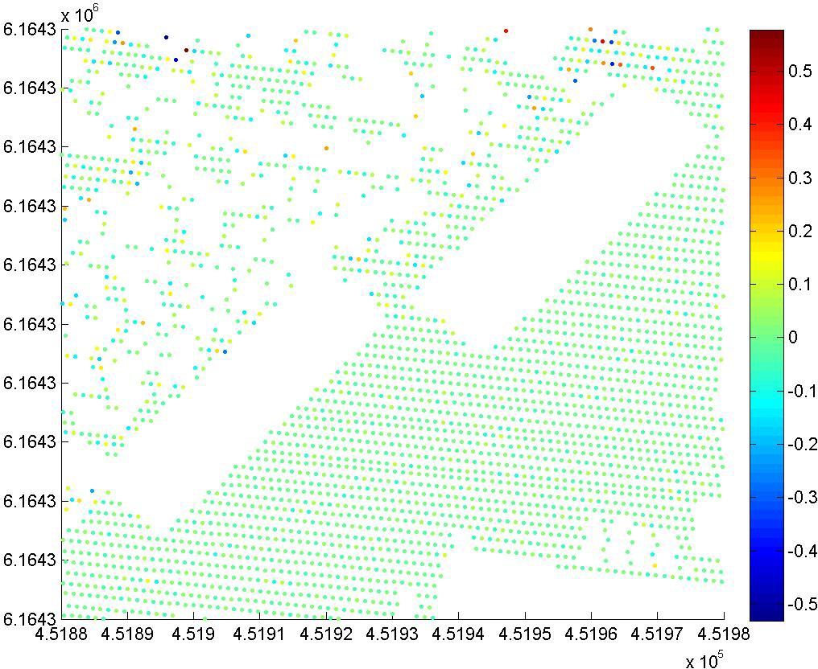

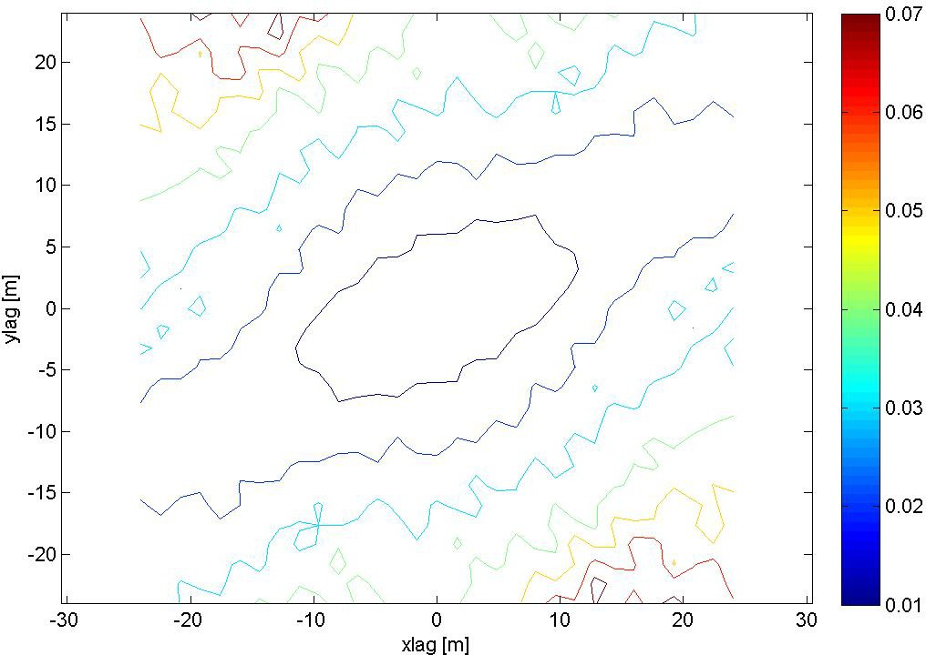

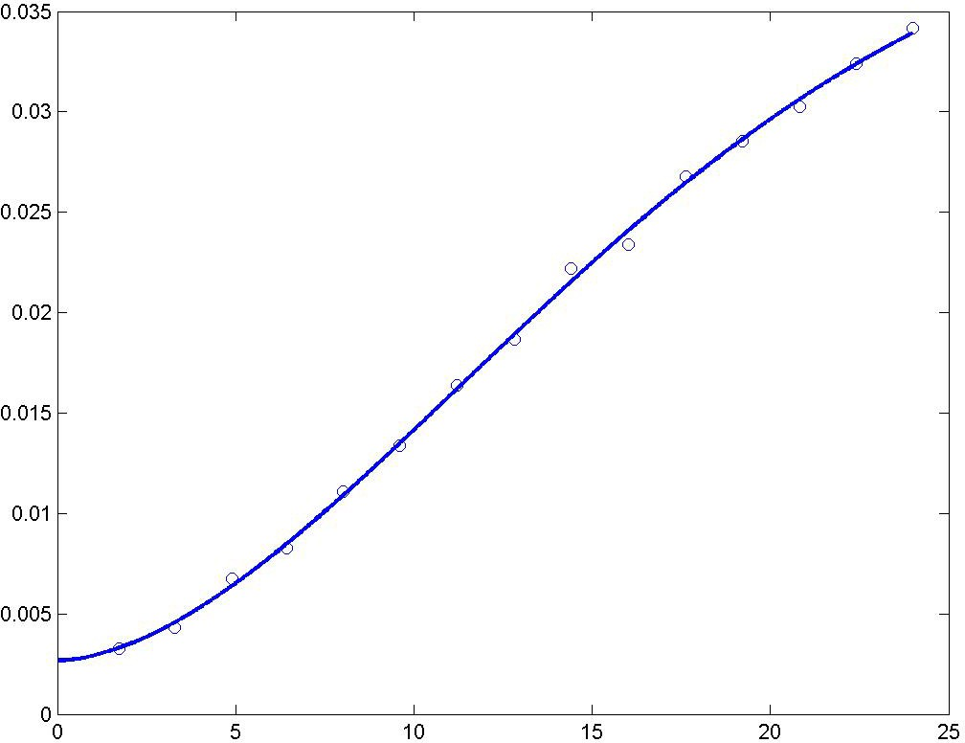

A modified Gaussian semivariogram model is used (power is 1.75 and not 2).

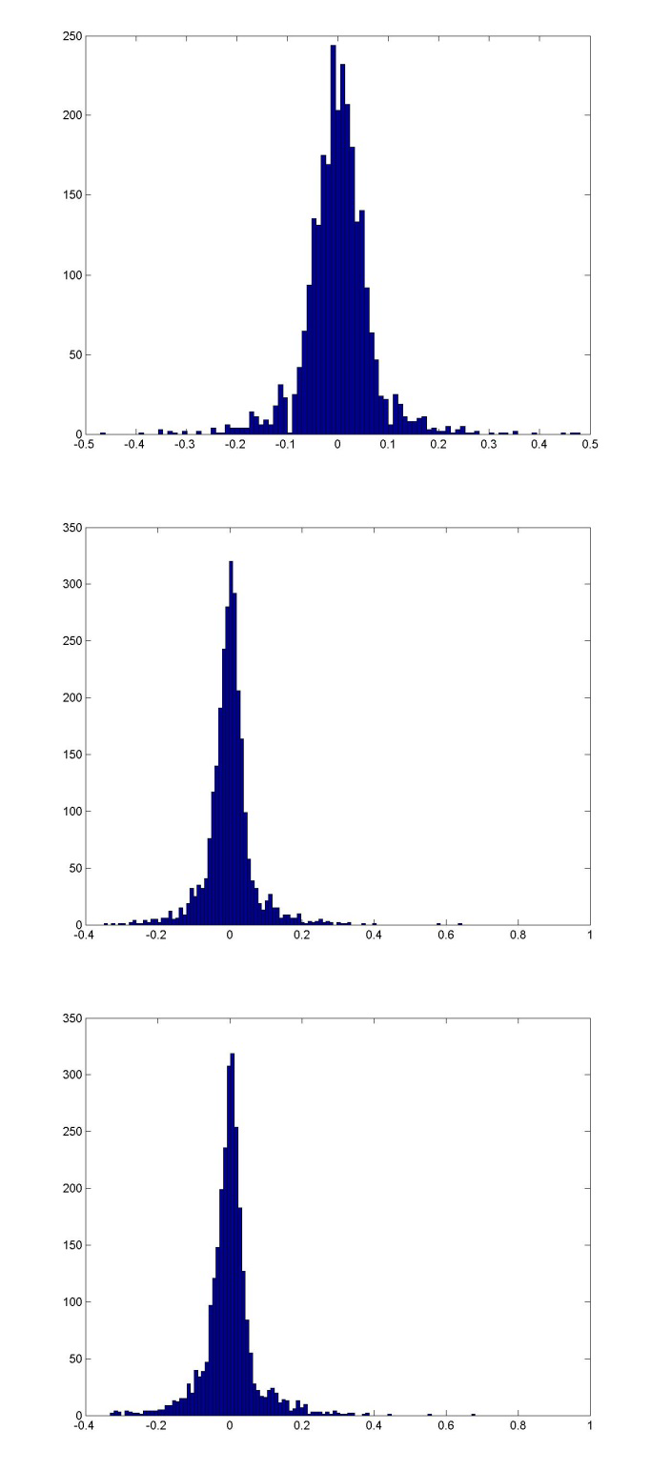
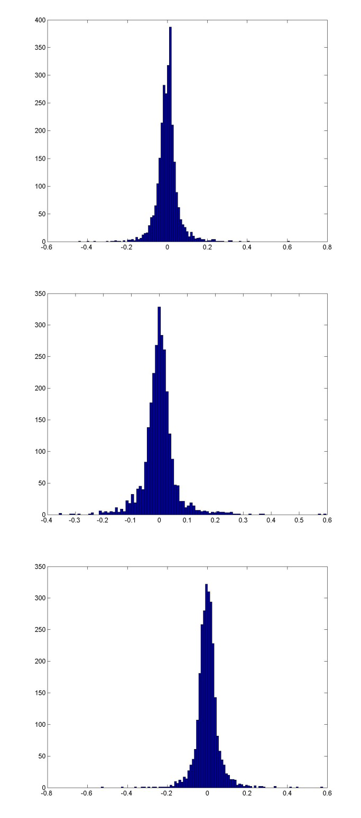

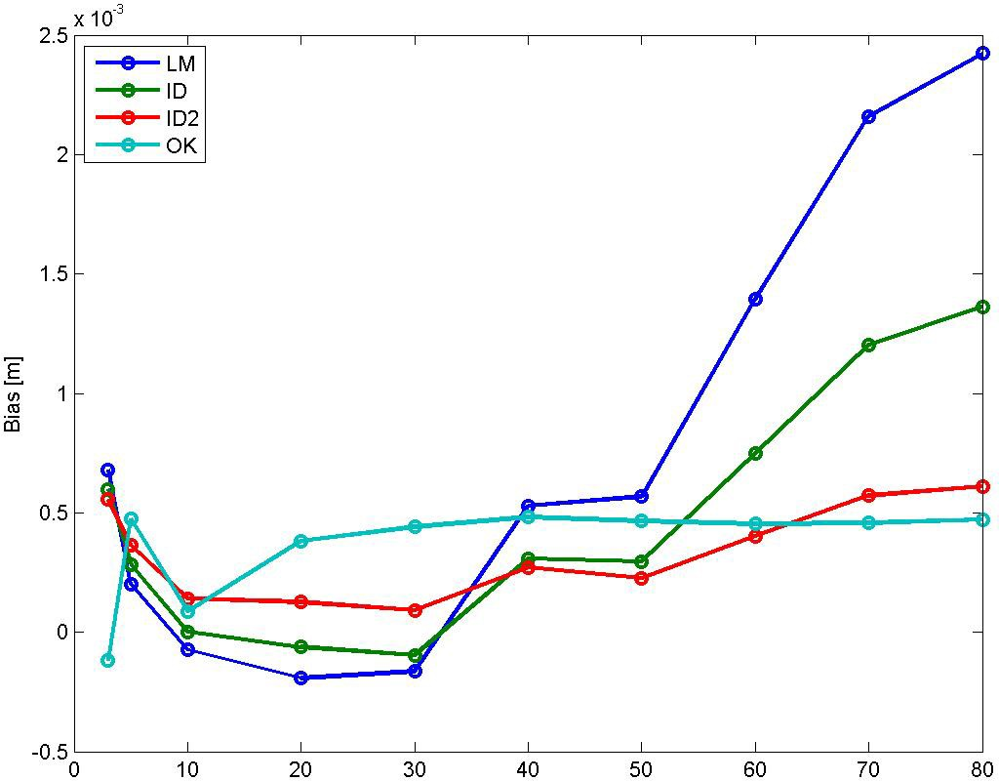

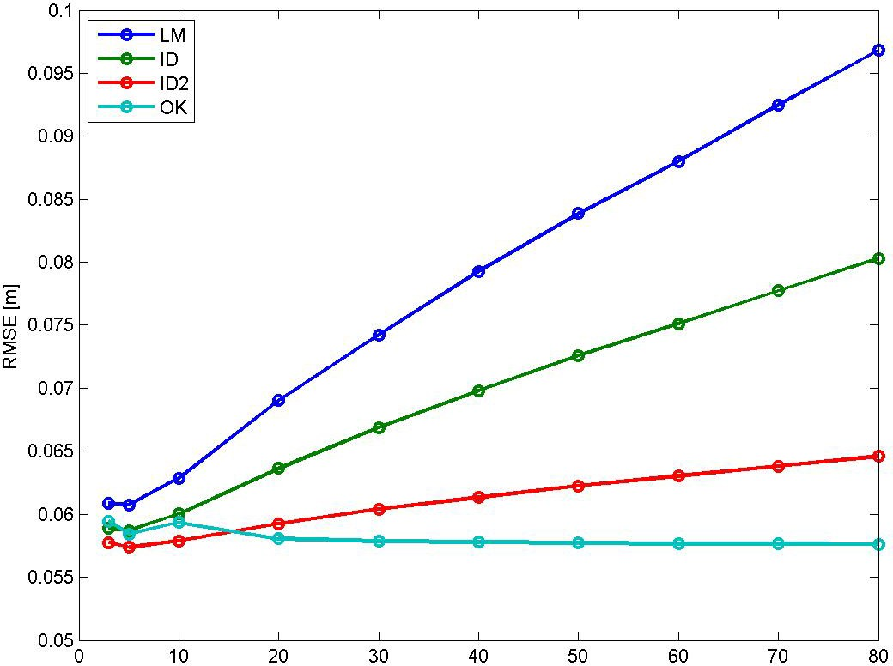

Bias for NN is ‐0.00179 m, and for TIN ‐0.00088283 m. RMSE for NN is 0.15491 m, and for TIN 0.11269 m.

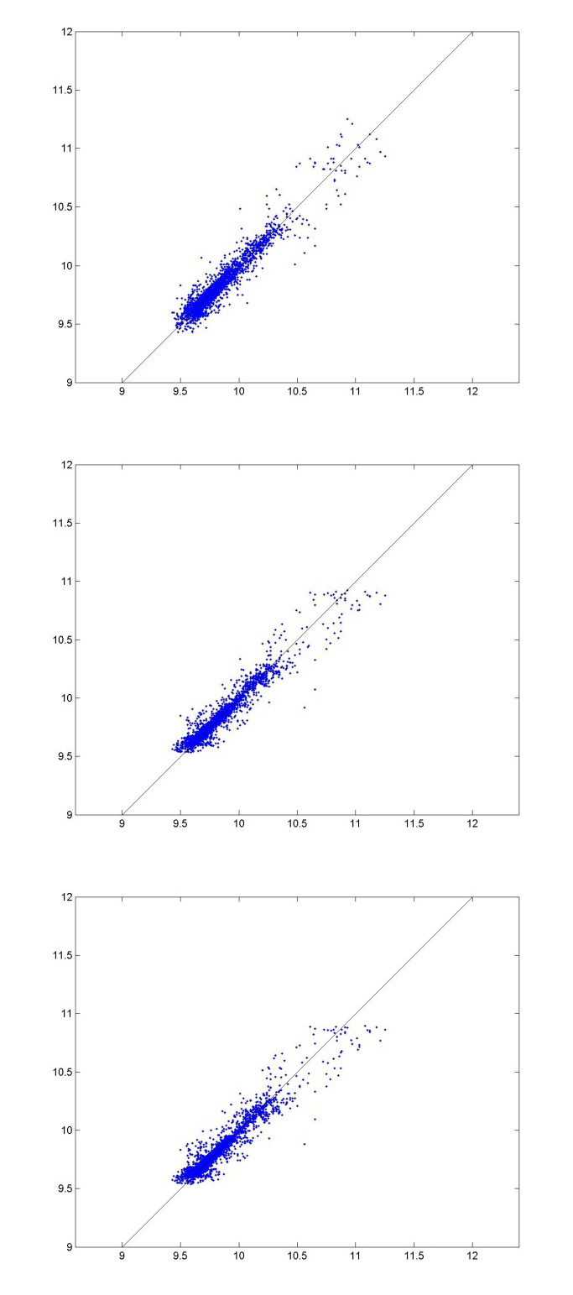
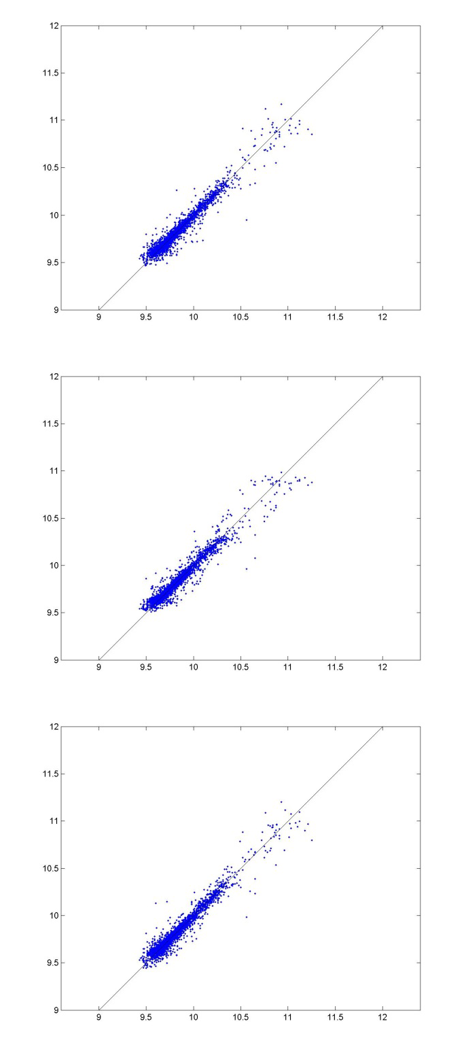

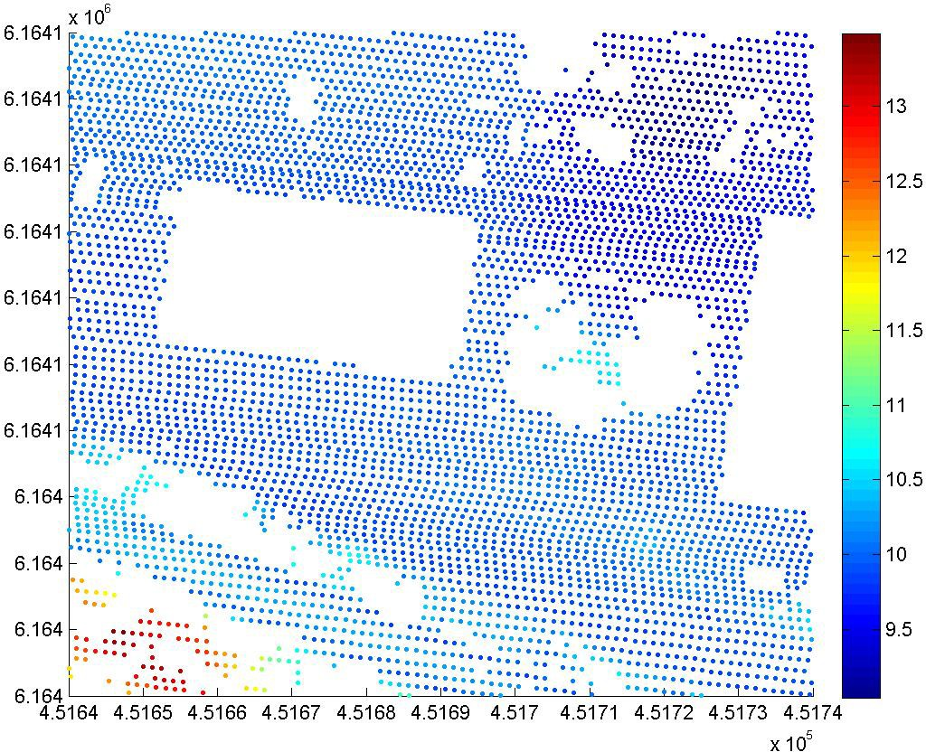

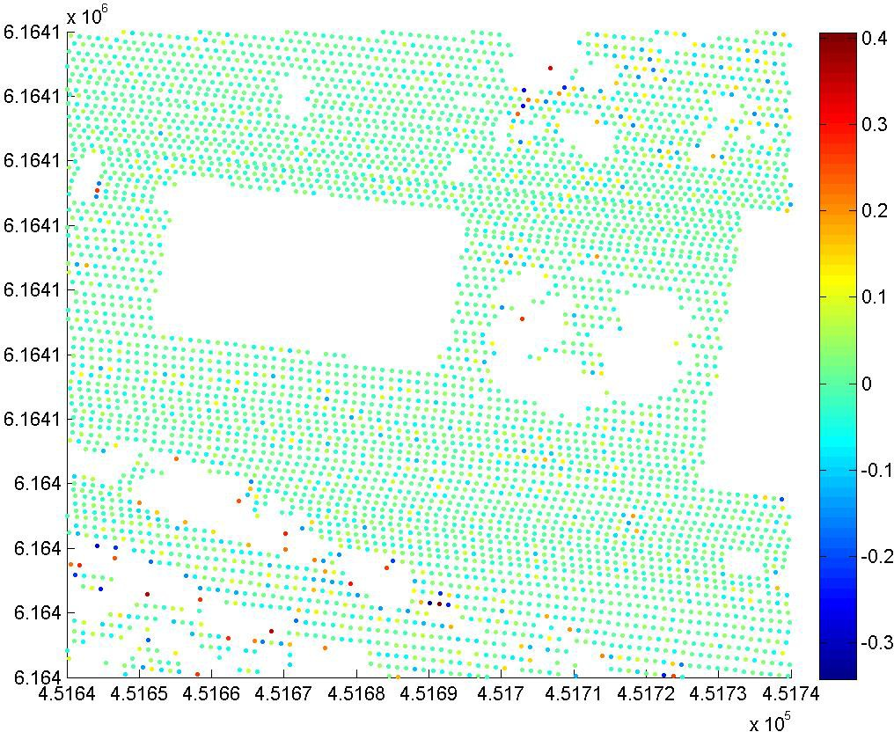

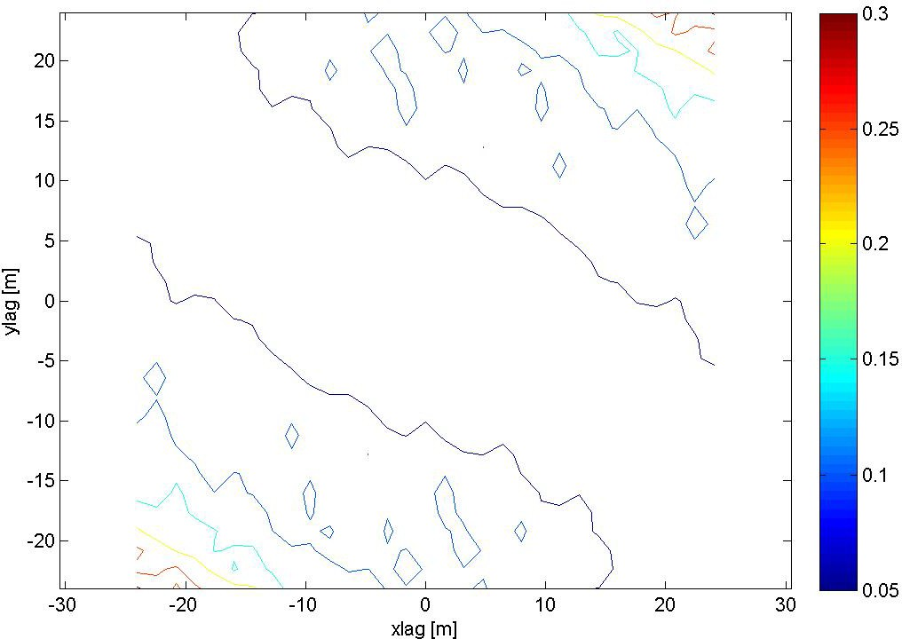

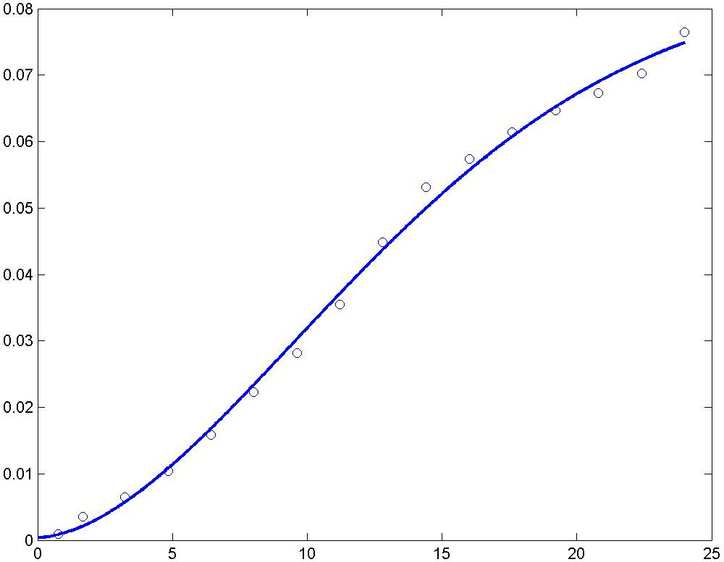

A modified Gaussian semivariogram model is used (power is 1.75 and not 2).

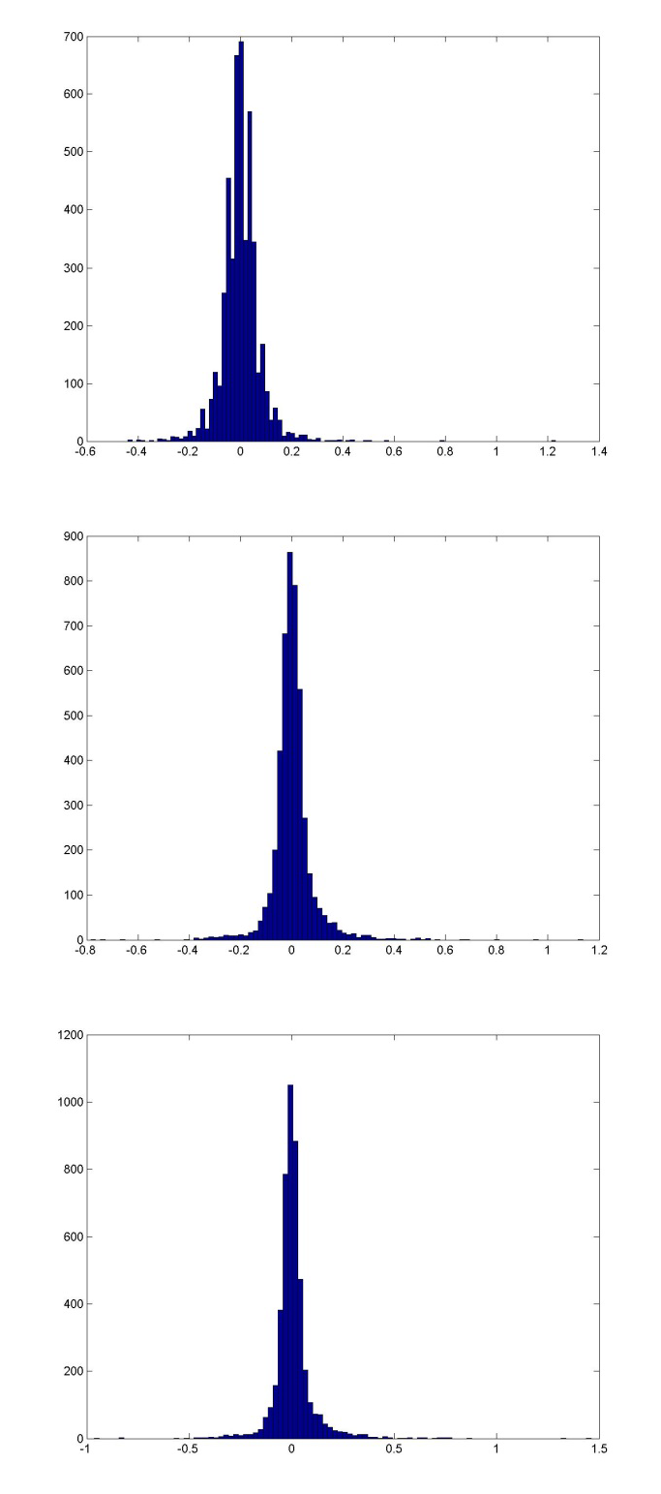
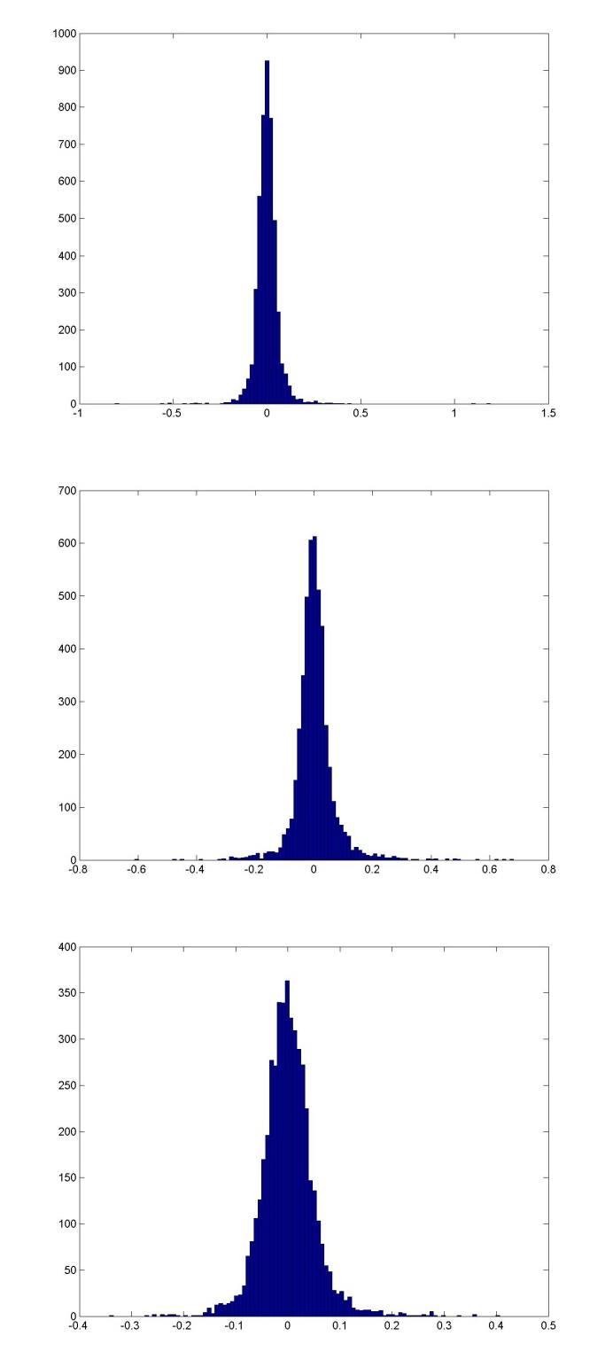

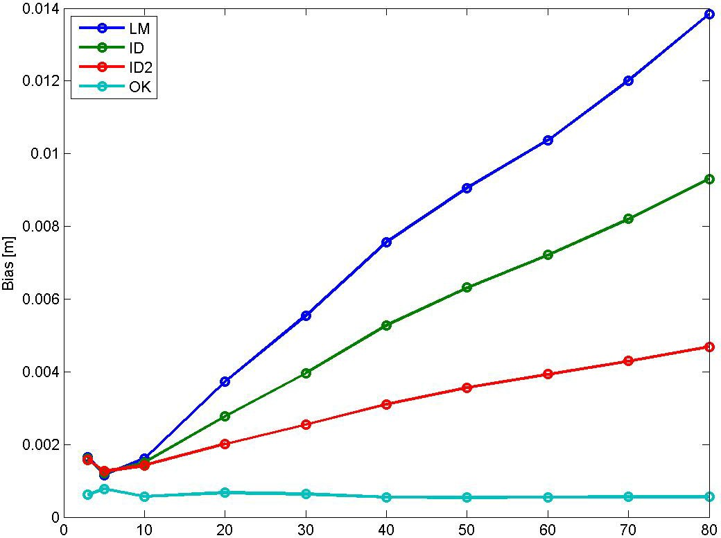

Bias for NN is 0.001618 m, and for TIN ‐9.9869e‐05 m. RMSE for NN is 0.075206 m, and for TIN 0.06266 m.

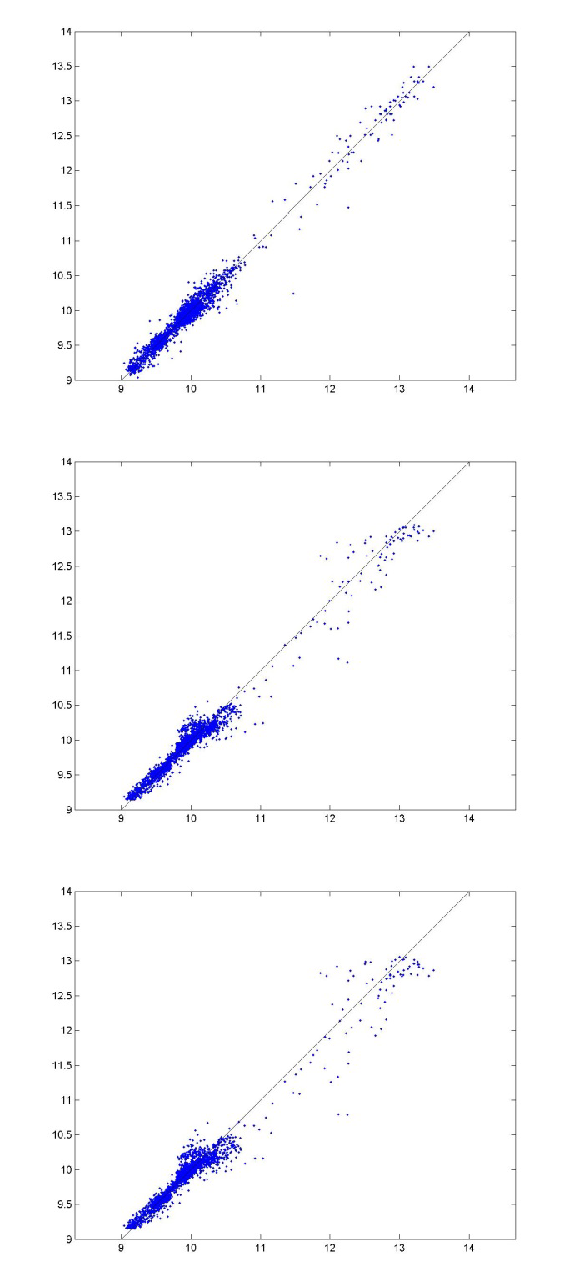
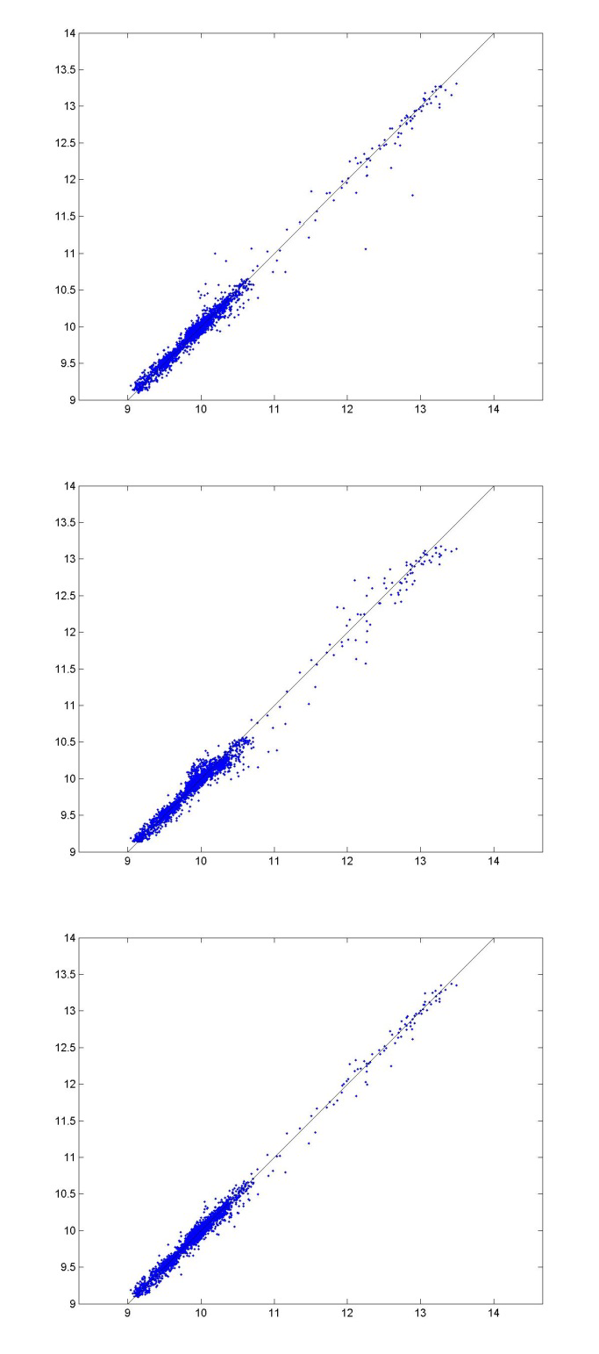

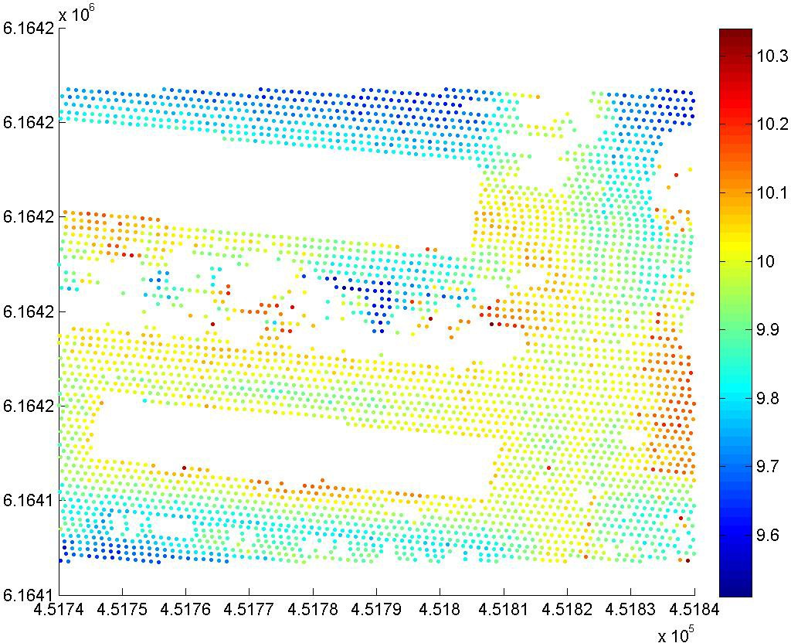

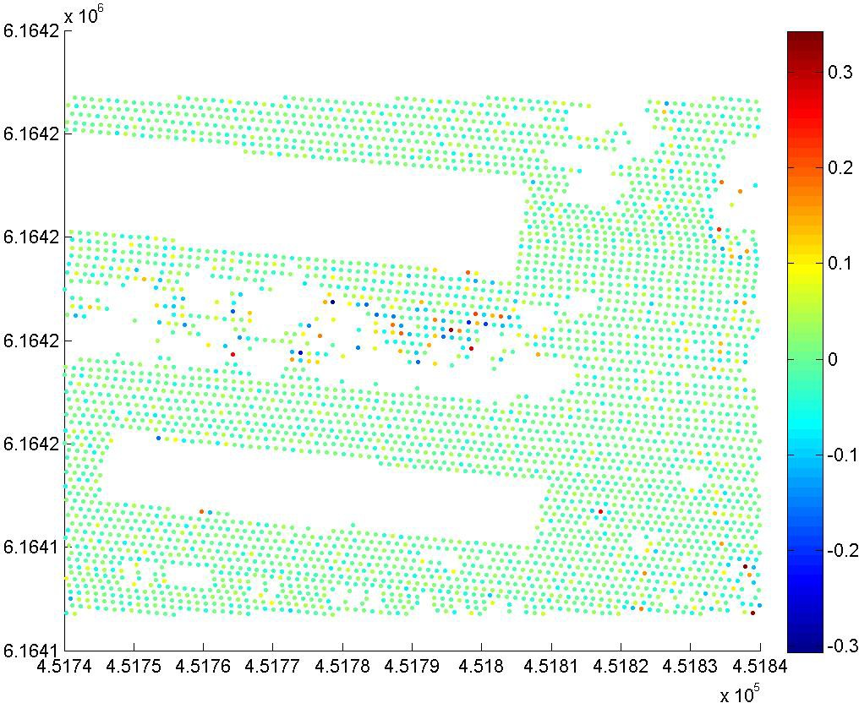

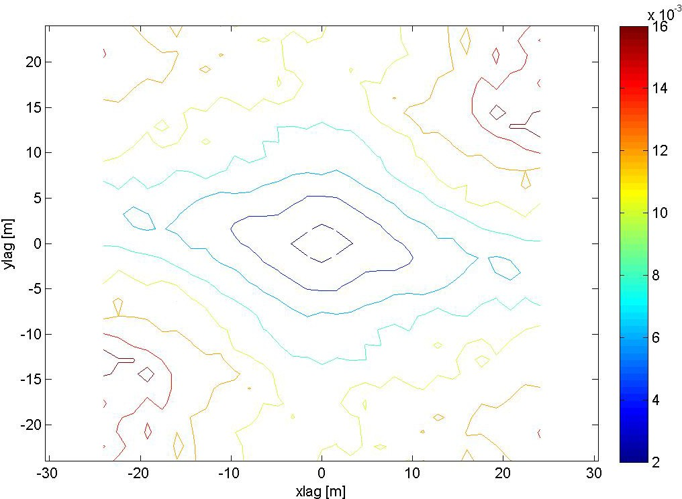

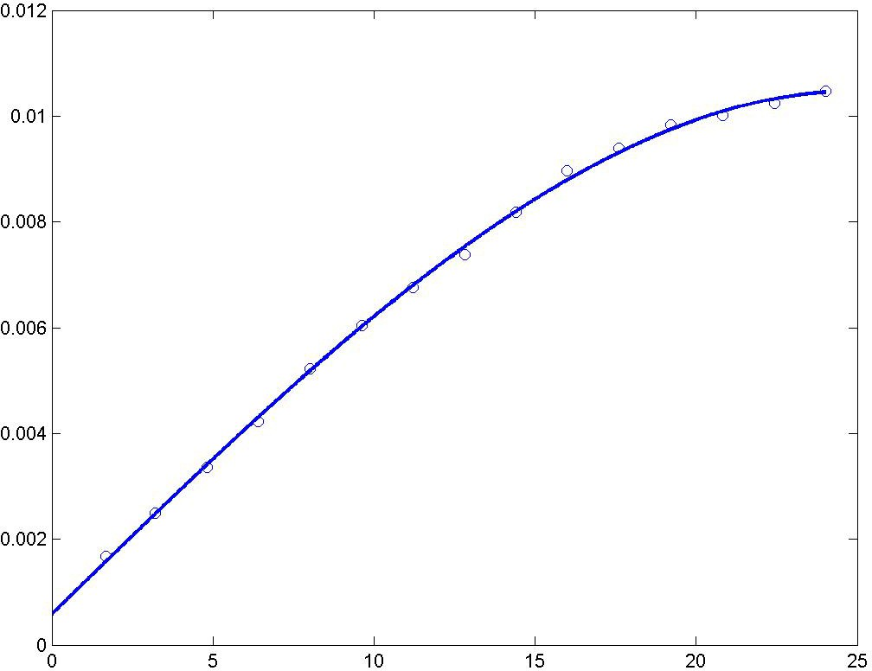

A spherical semivariogram model is used.

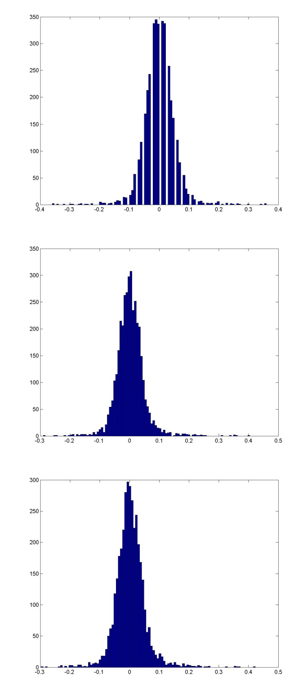
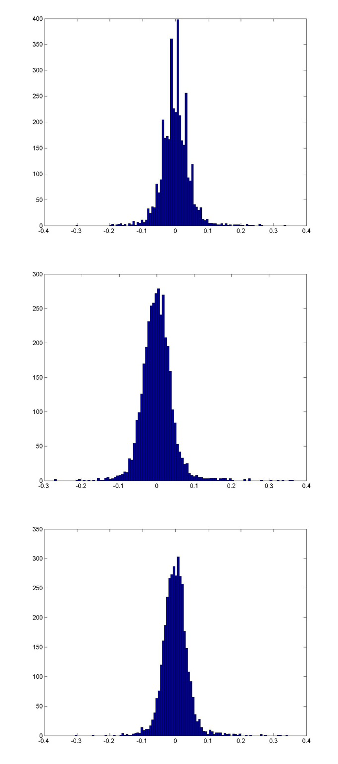

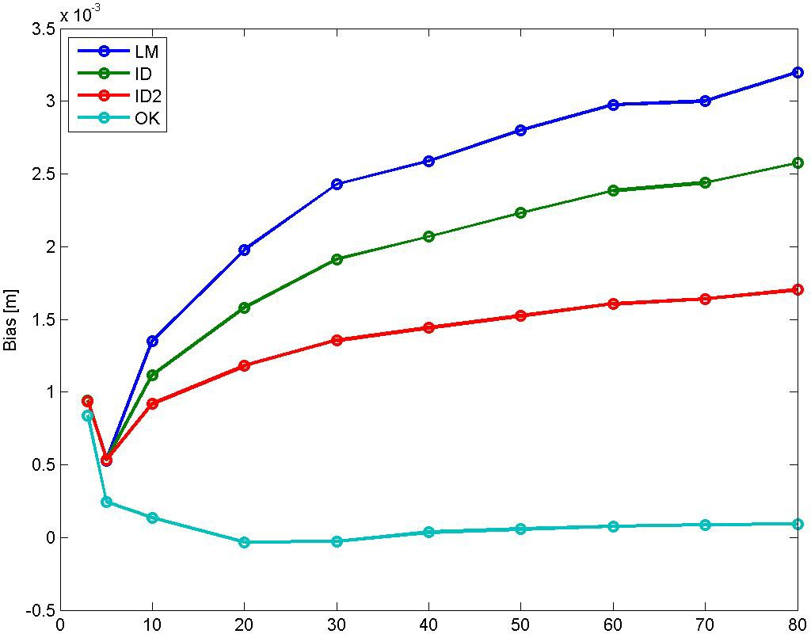

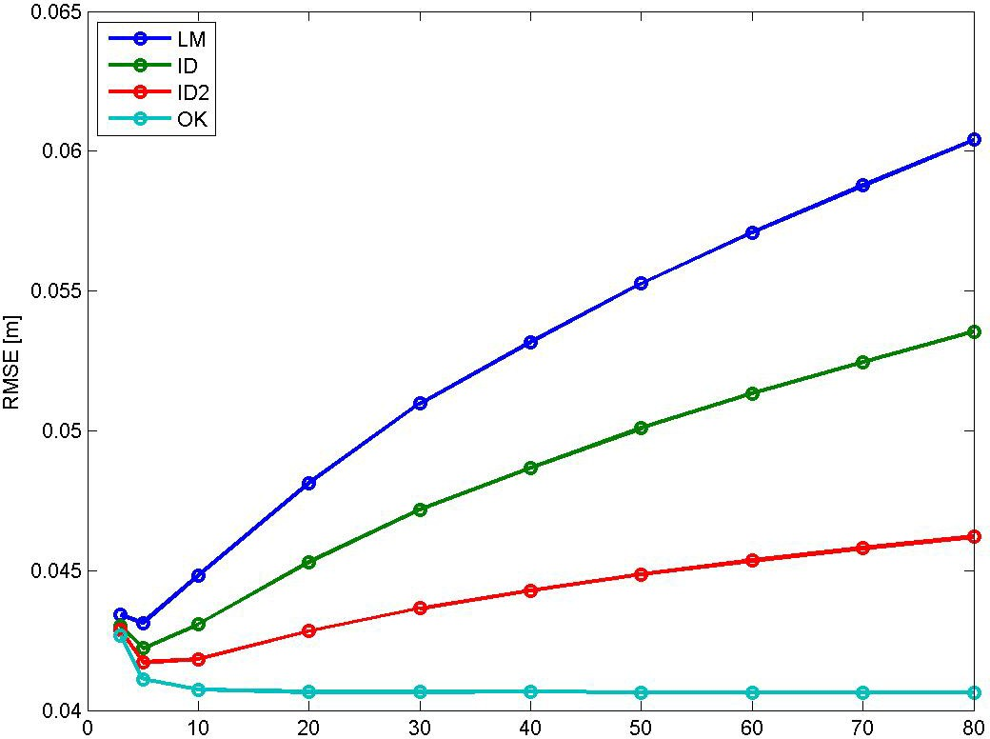

Bias for NN is ‐0.0001947 m, and for TIN 7.7836e‐05 m. RMSE for NN is 0.05241 m, and for TIN 0.04339 m.

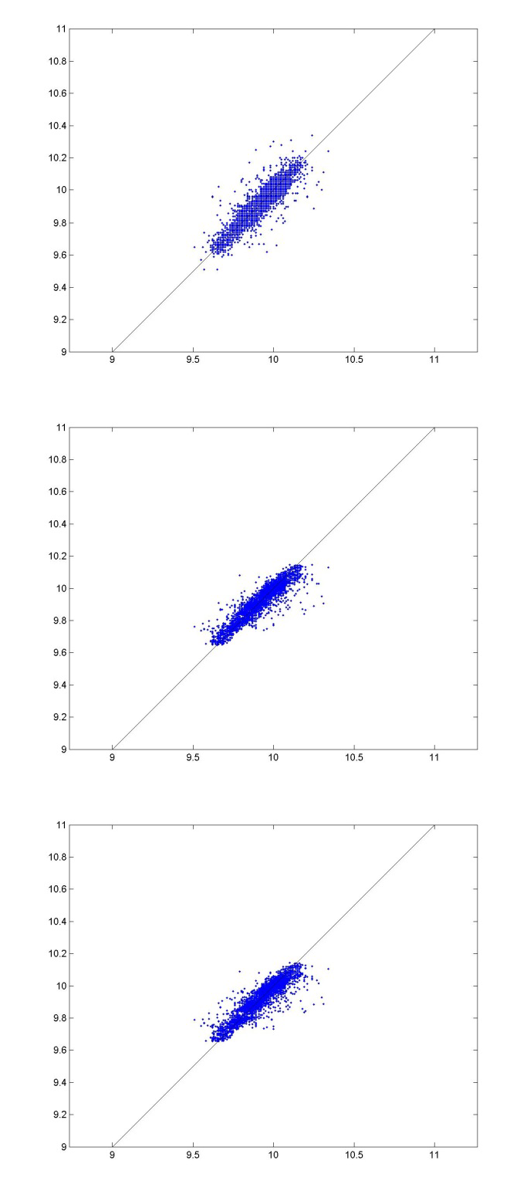
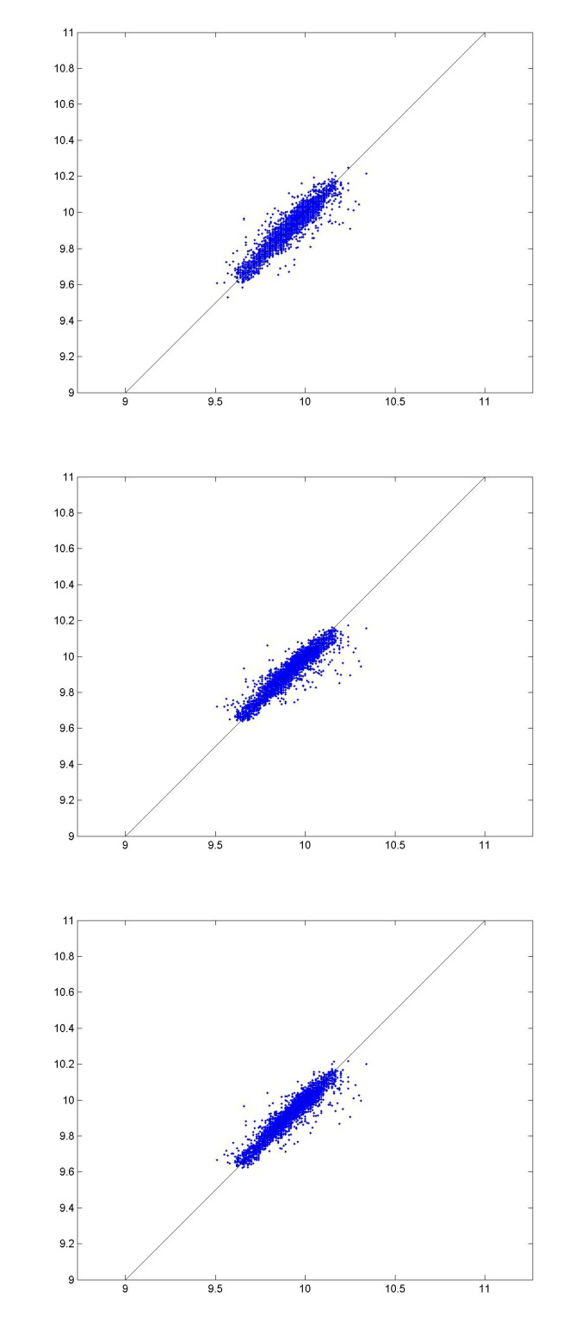

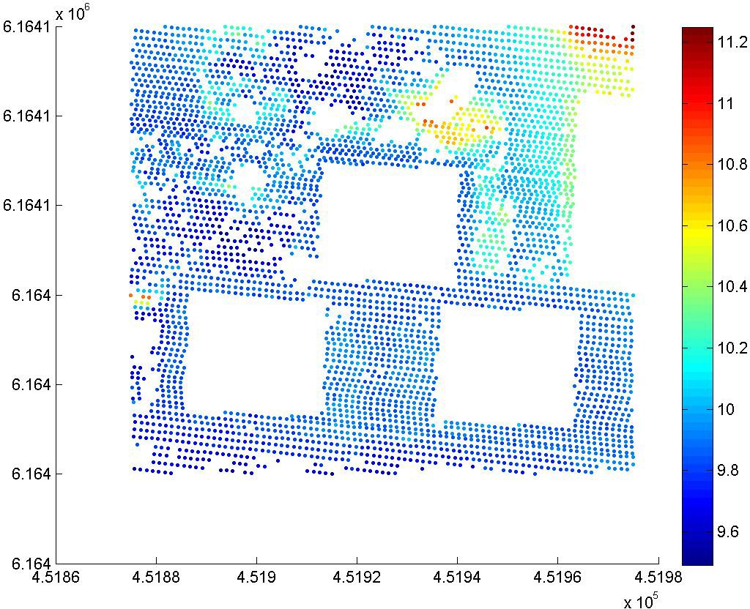

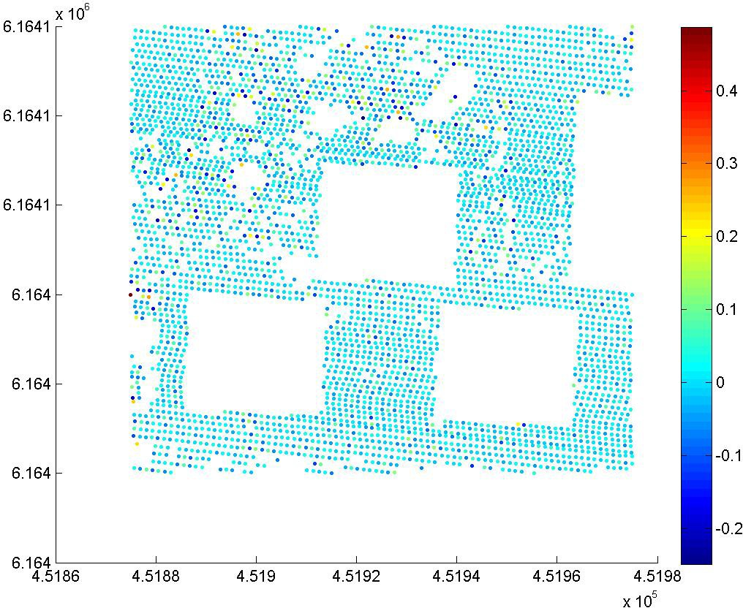

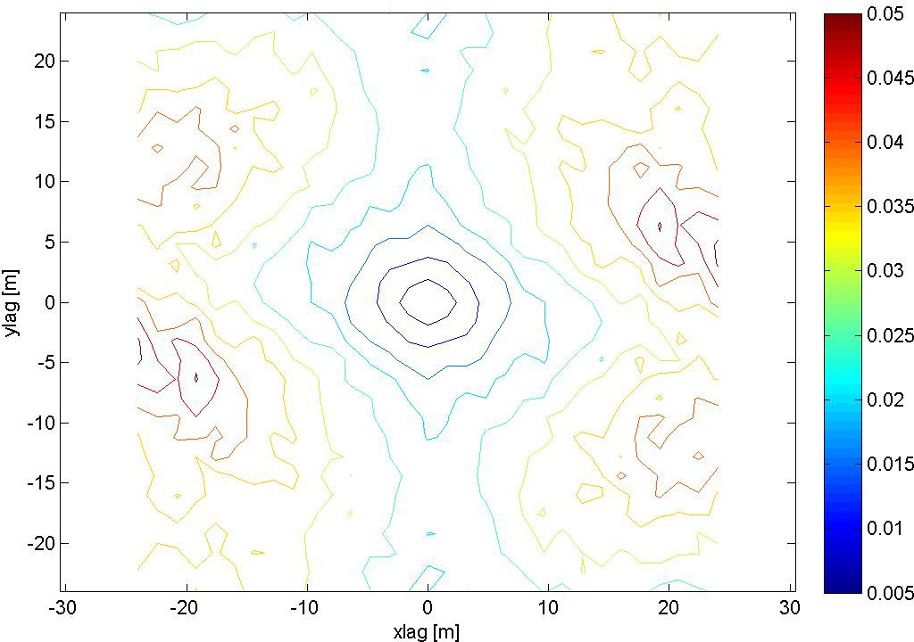

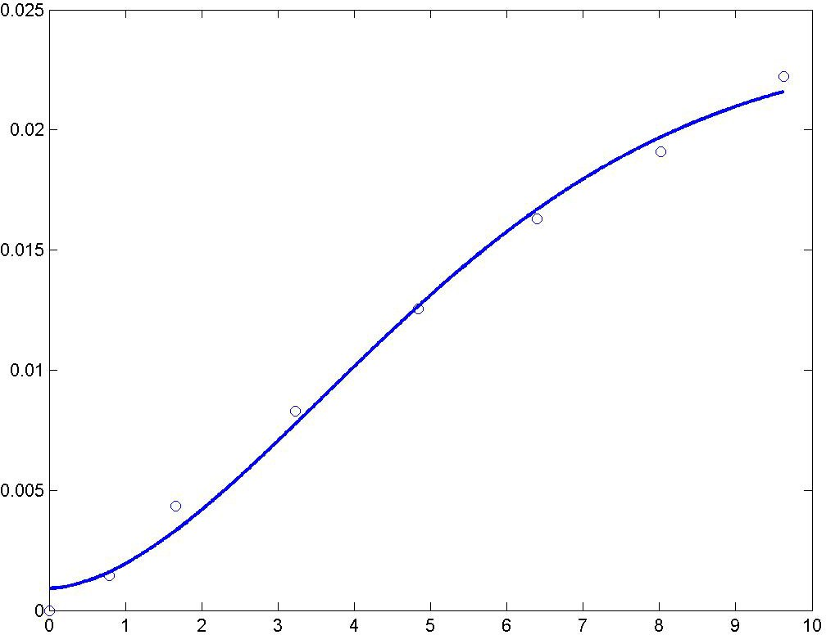

A modified Gaussian semivariogram model is used (power is 1.75 and not 2).

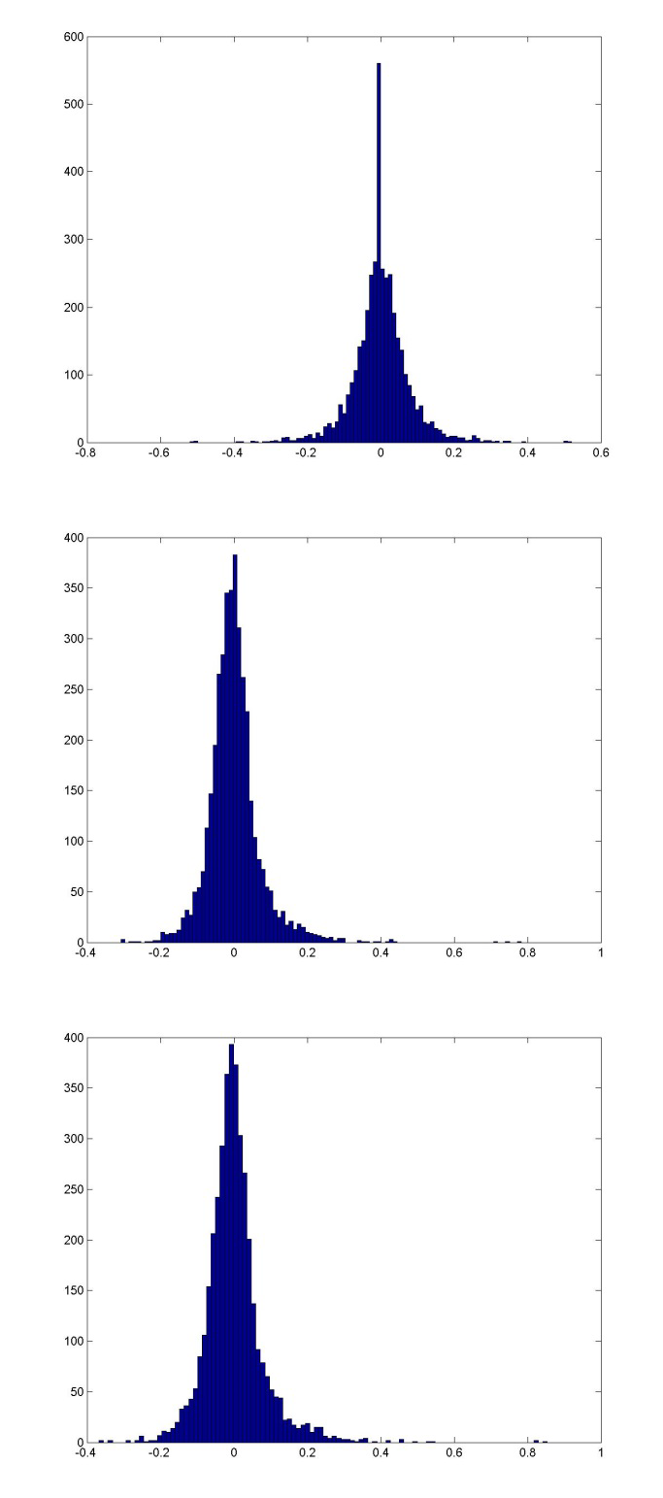
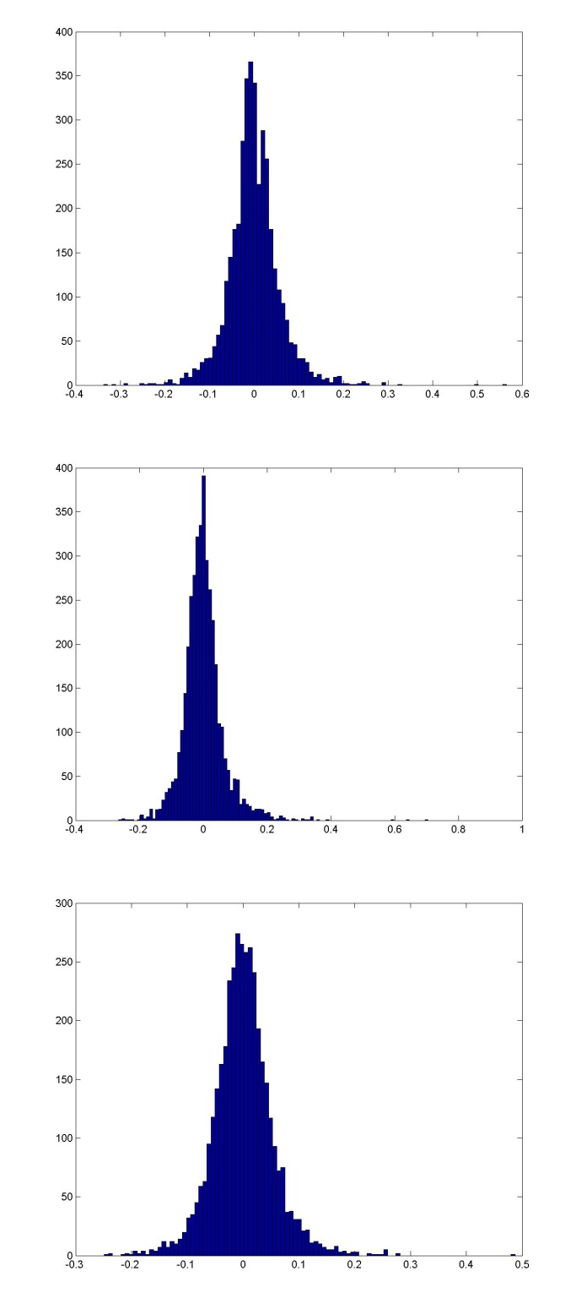

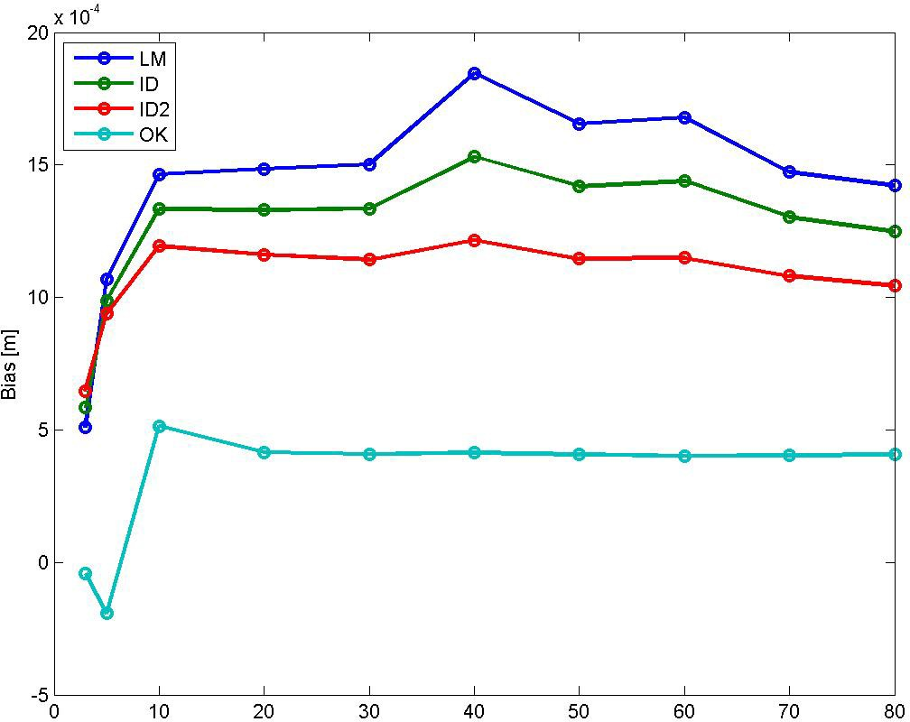

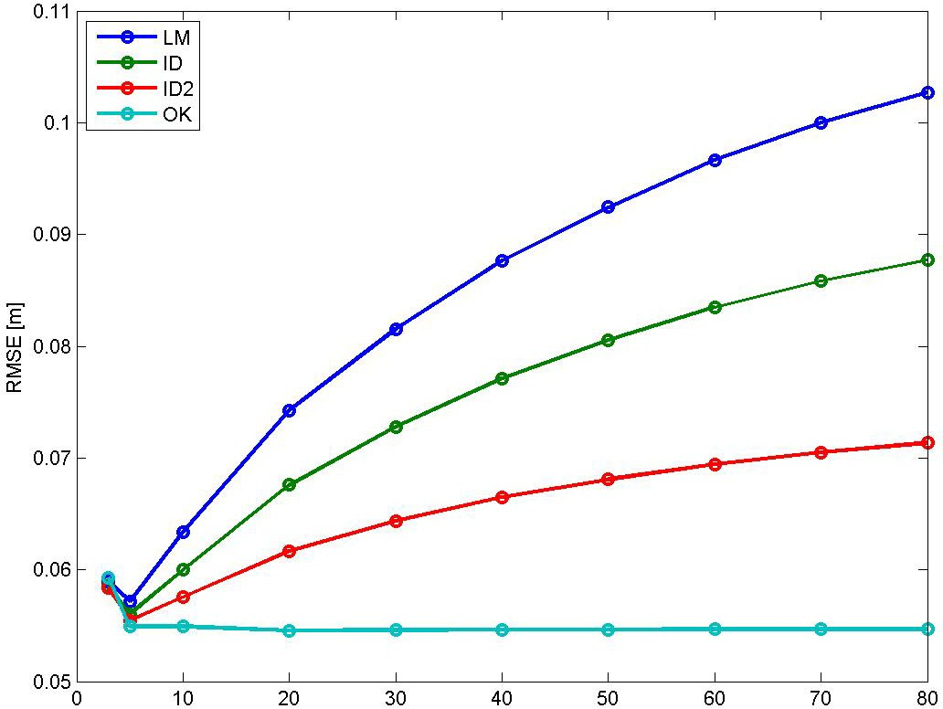

Bias for NN is 0.0006564 m, and for TIN ‐0.0008640 m. RMSE for NN is 0.078595 m, and for TIN 0.05876 m.

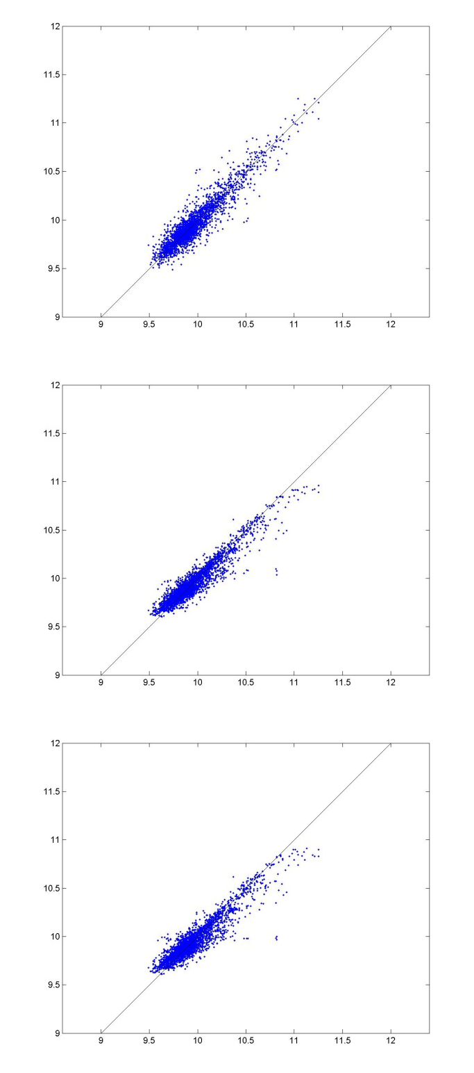
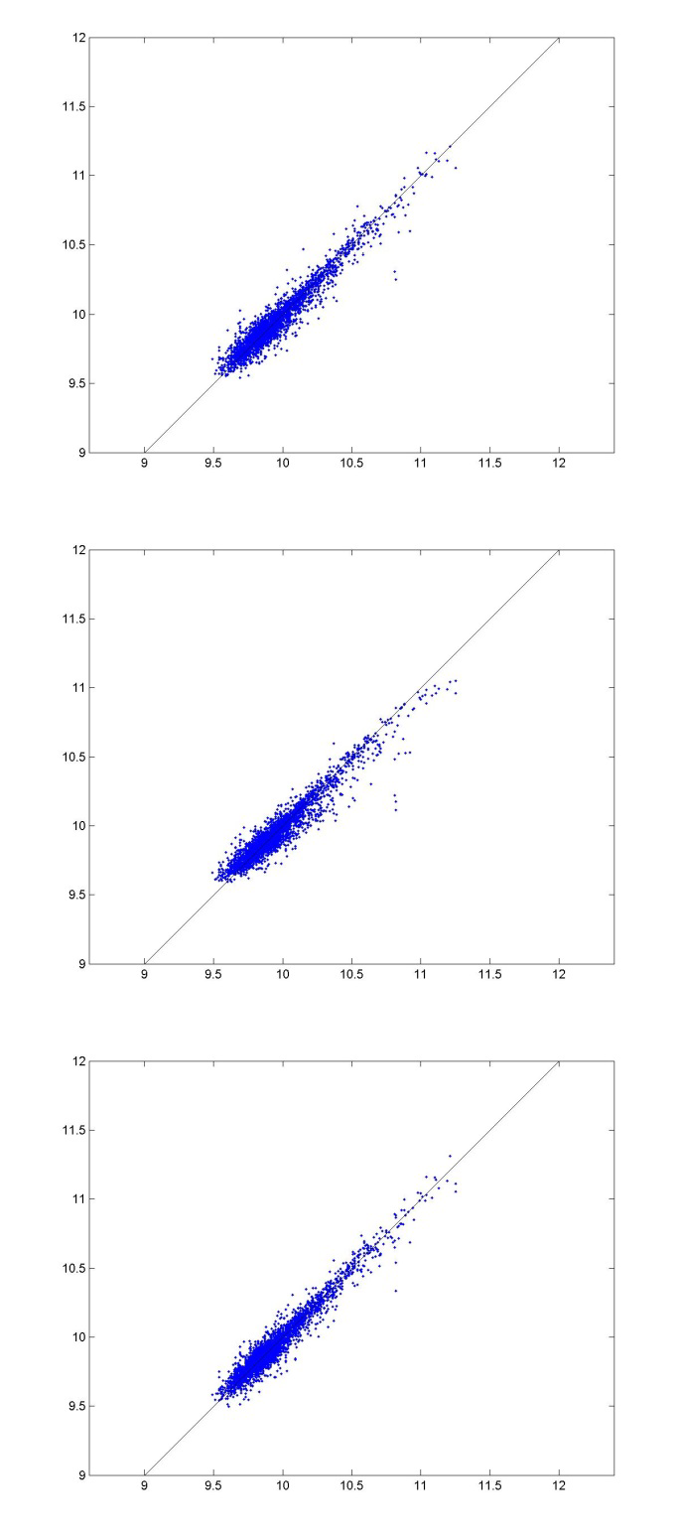

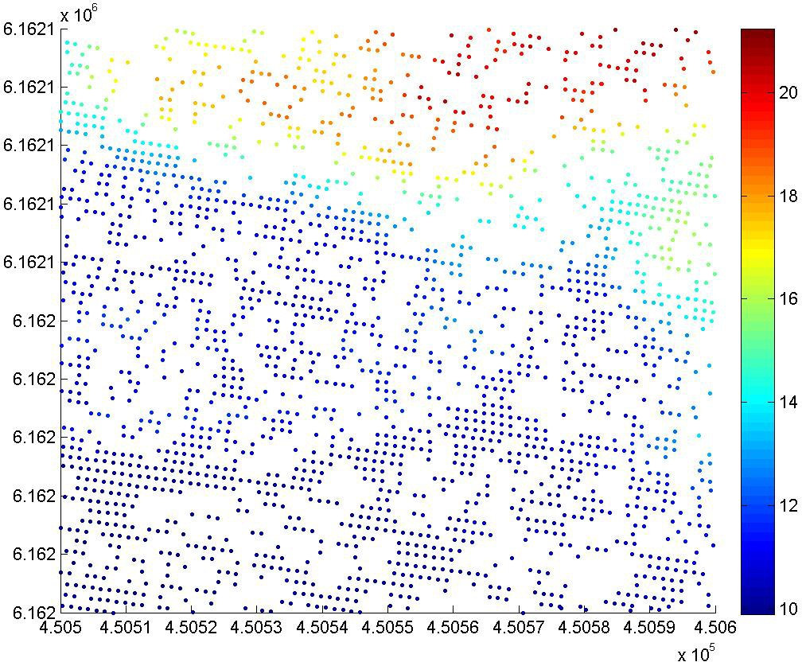

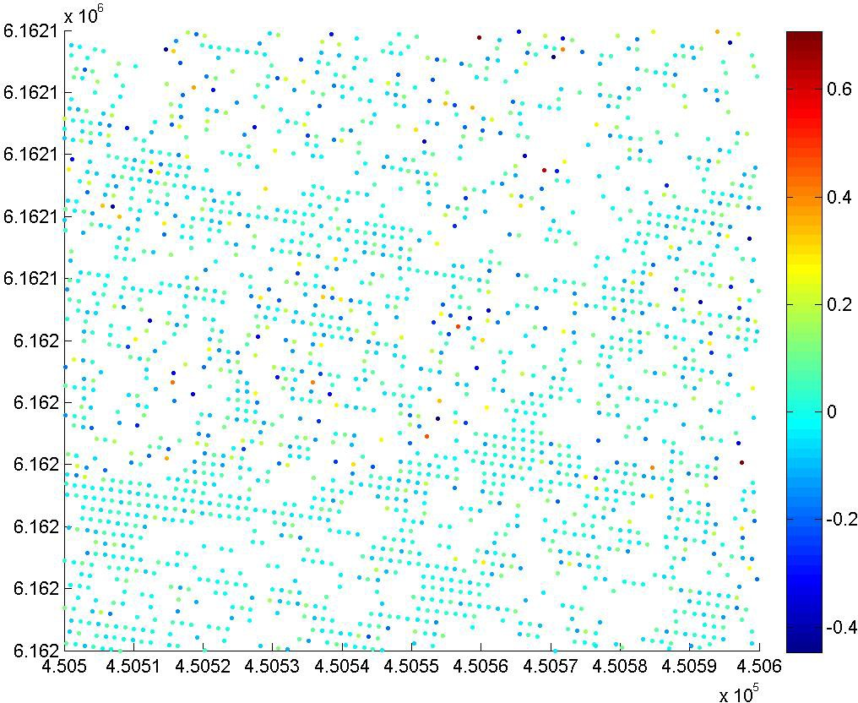

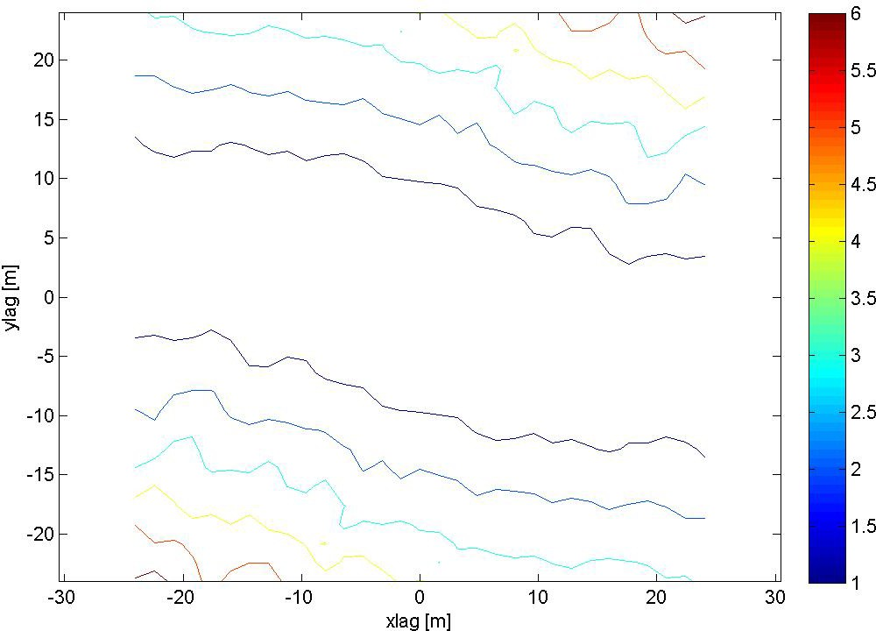

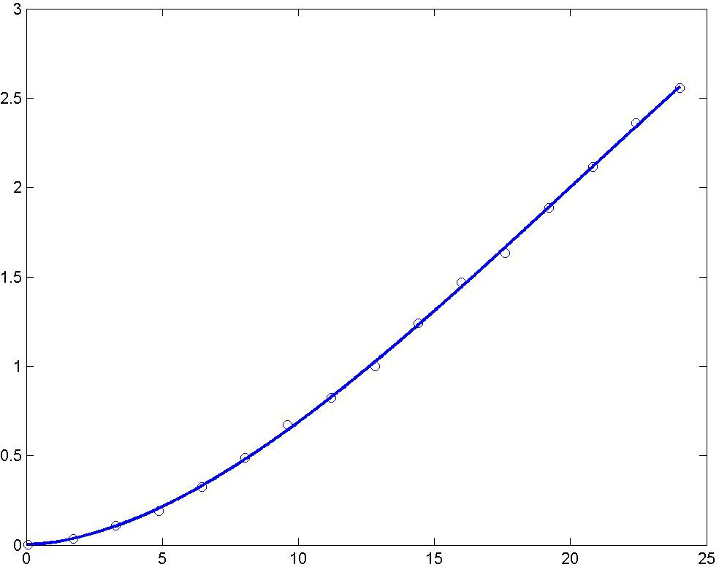

A modified Gaussian semivariogram model is used (power is 1.75 and not 2).

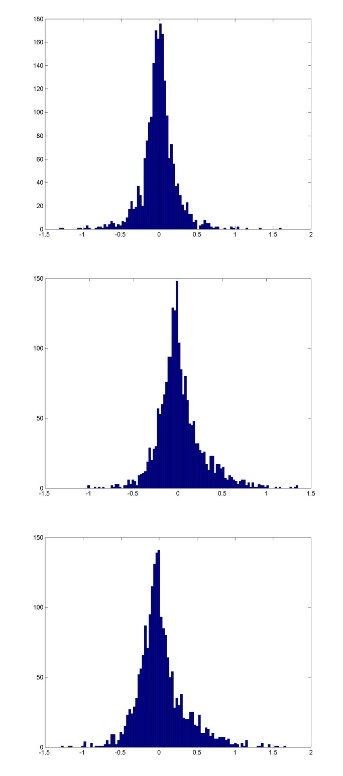
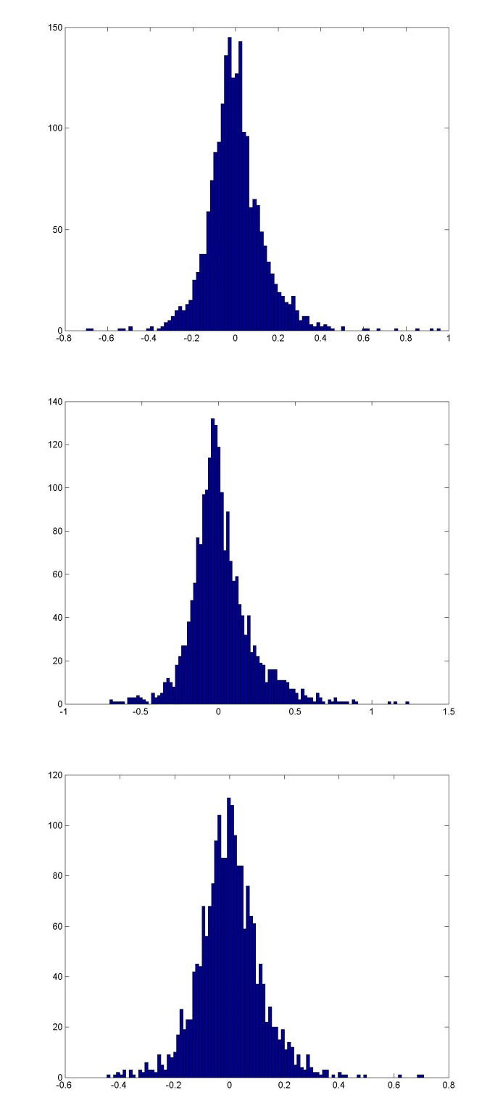

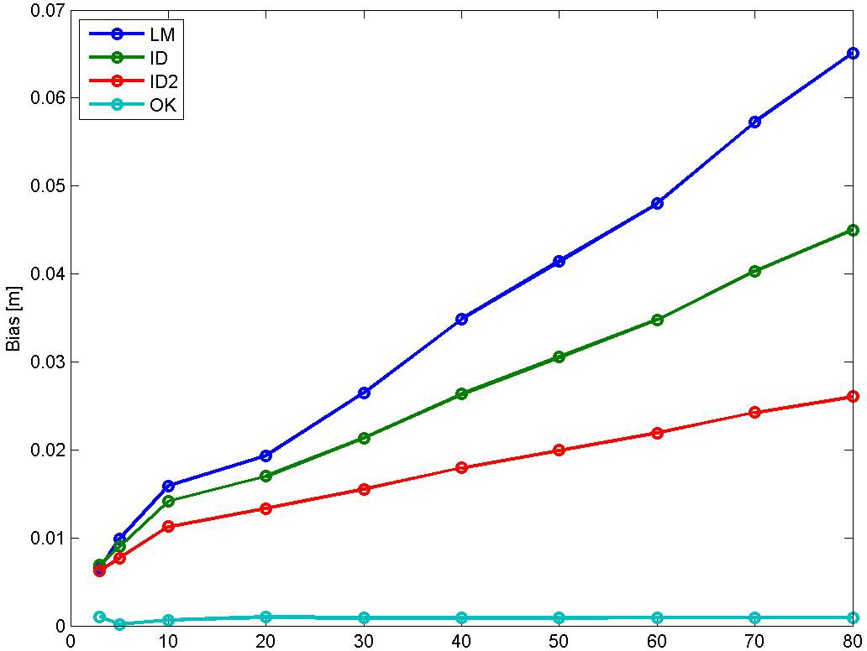

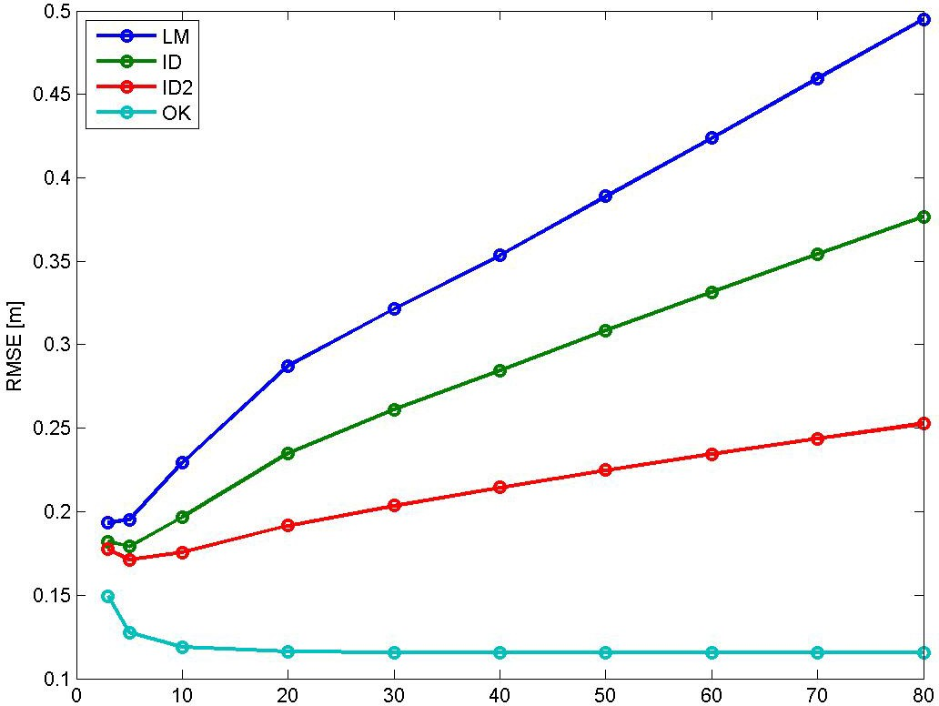

Bias for NN is 0.0014258 m, and for TIN 0.00068106 m. RMSE for NN is 0.2273 m, and for TIN 0.13433 m.

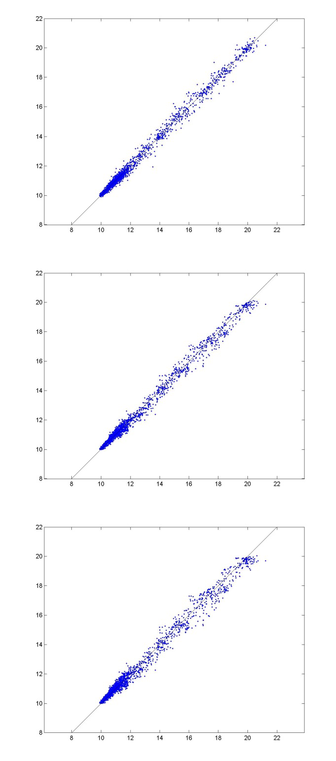
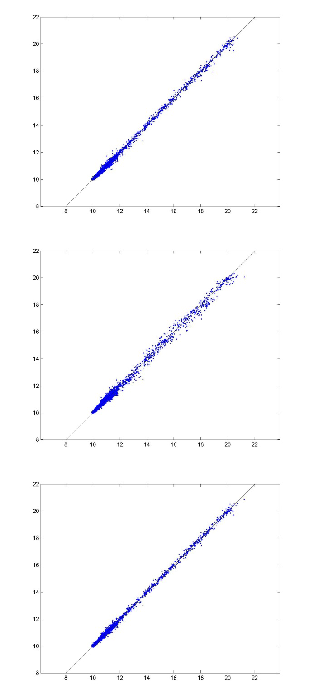

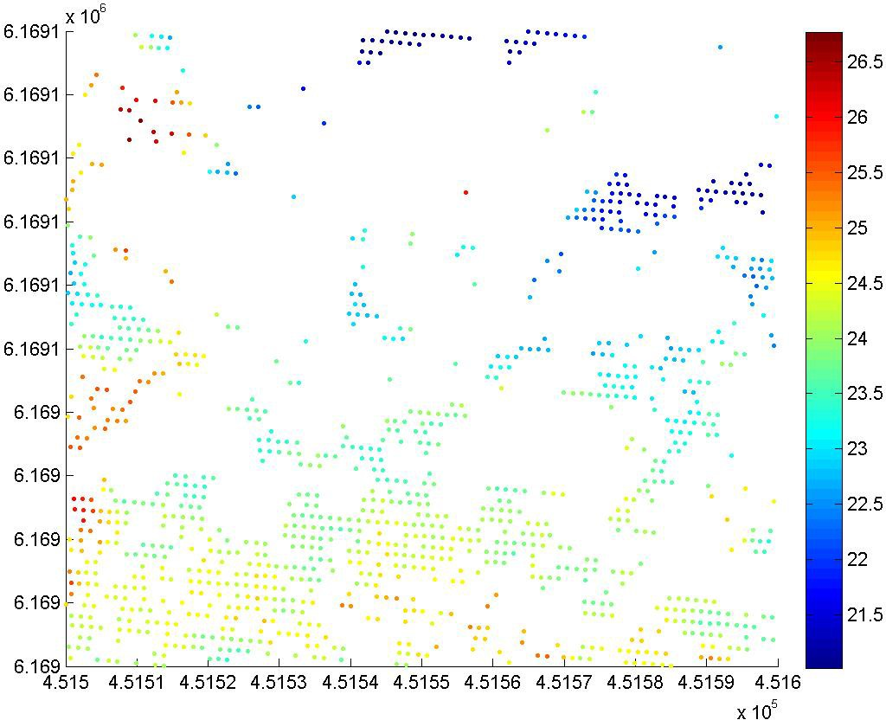

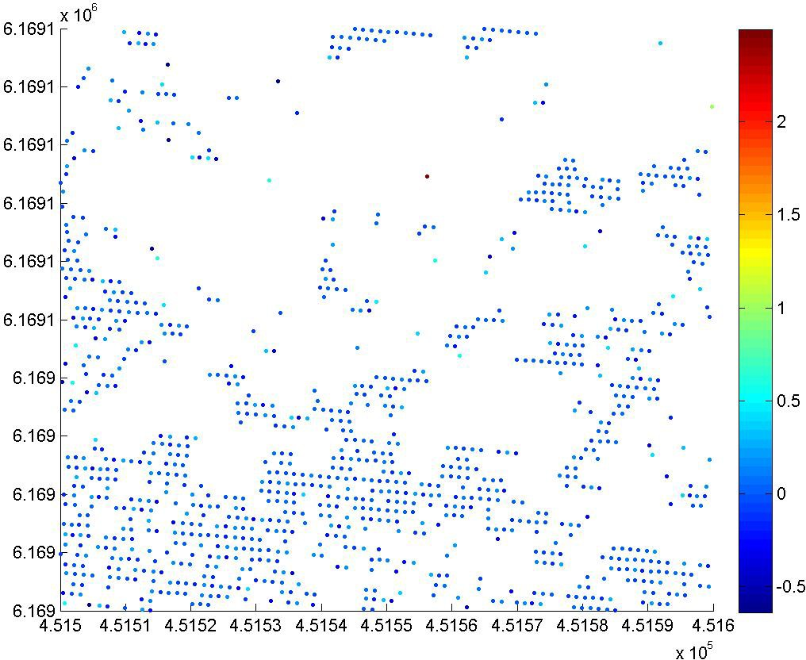

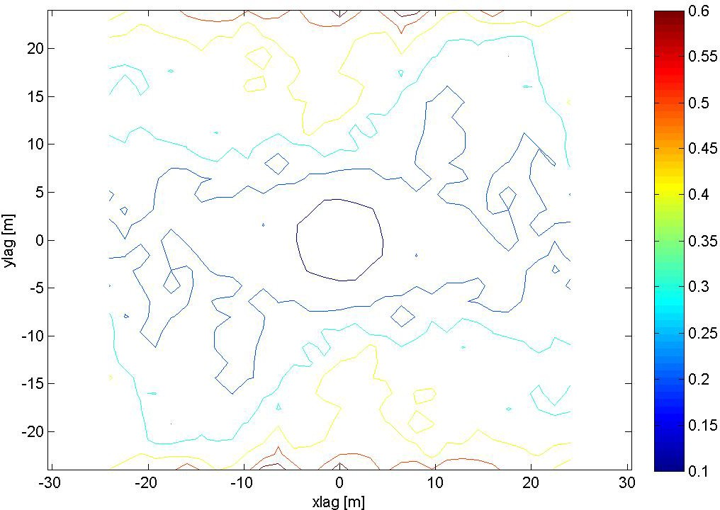

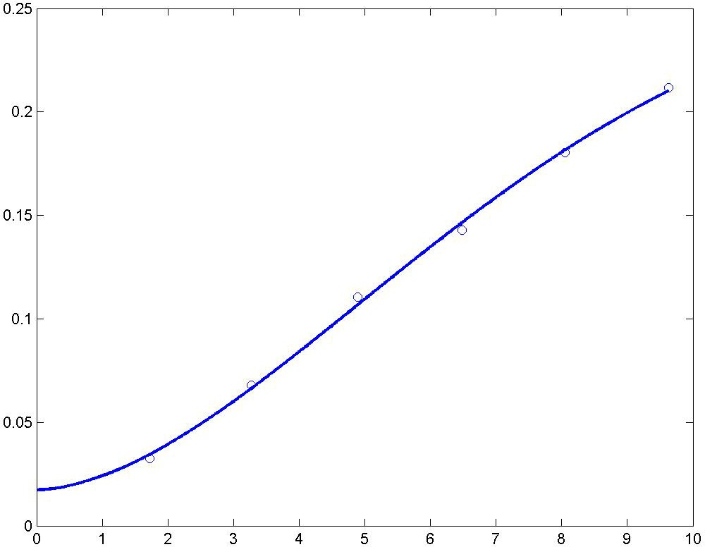

A modified Gaussian semivariogram model is used (power is 1.75 and not 2).

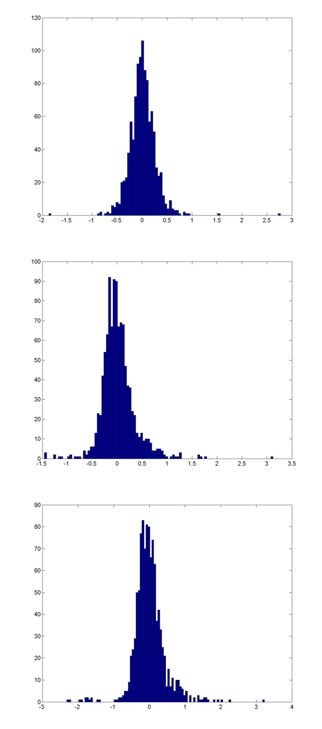
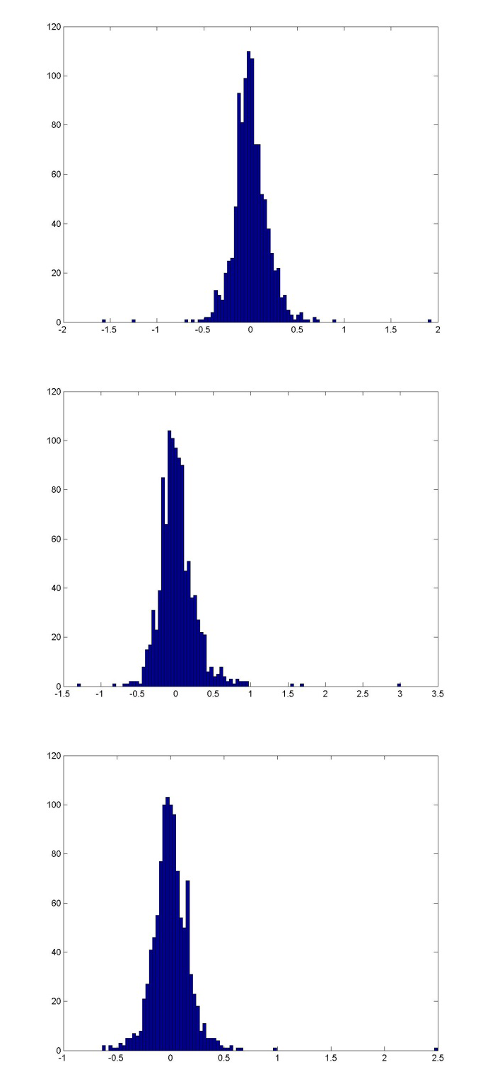

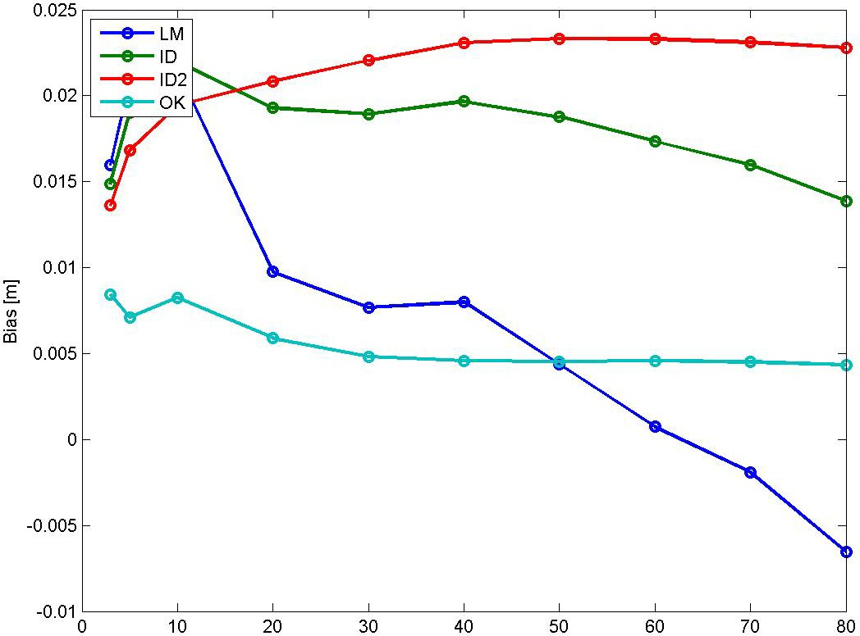

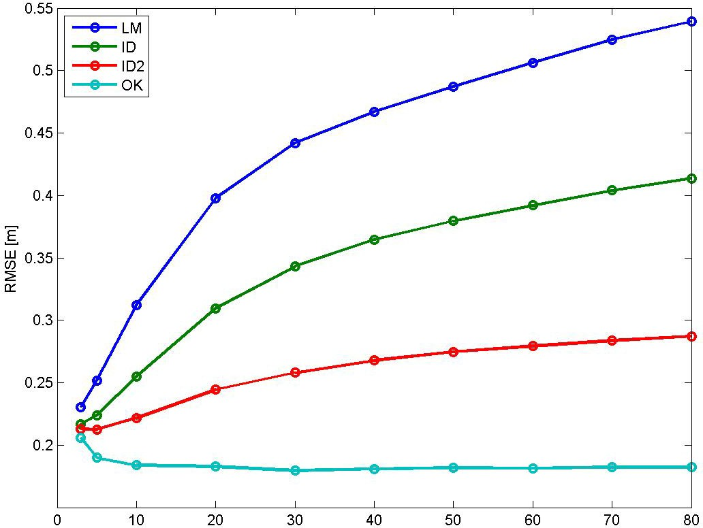

Bias for NN is 0.0069553 m, and for TIN 0.0019139 m. RMSE for NN is 0.26282 m, and for TIN 0.19465 m.

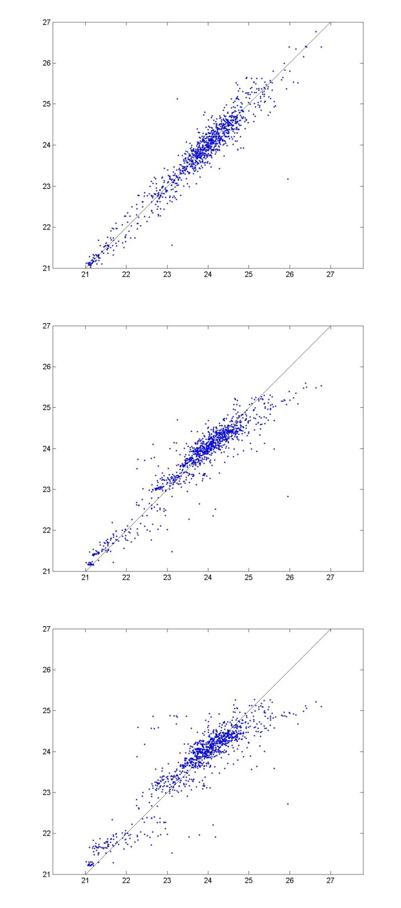
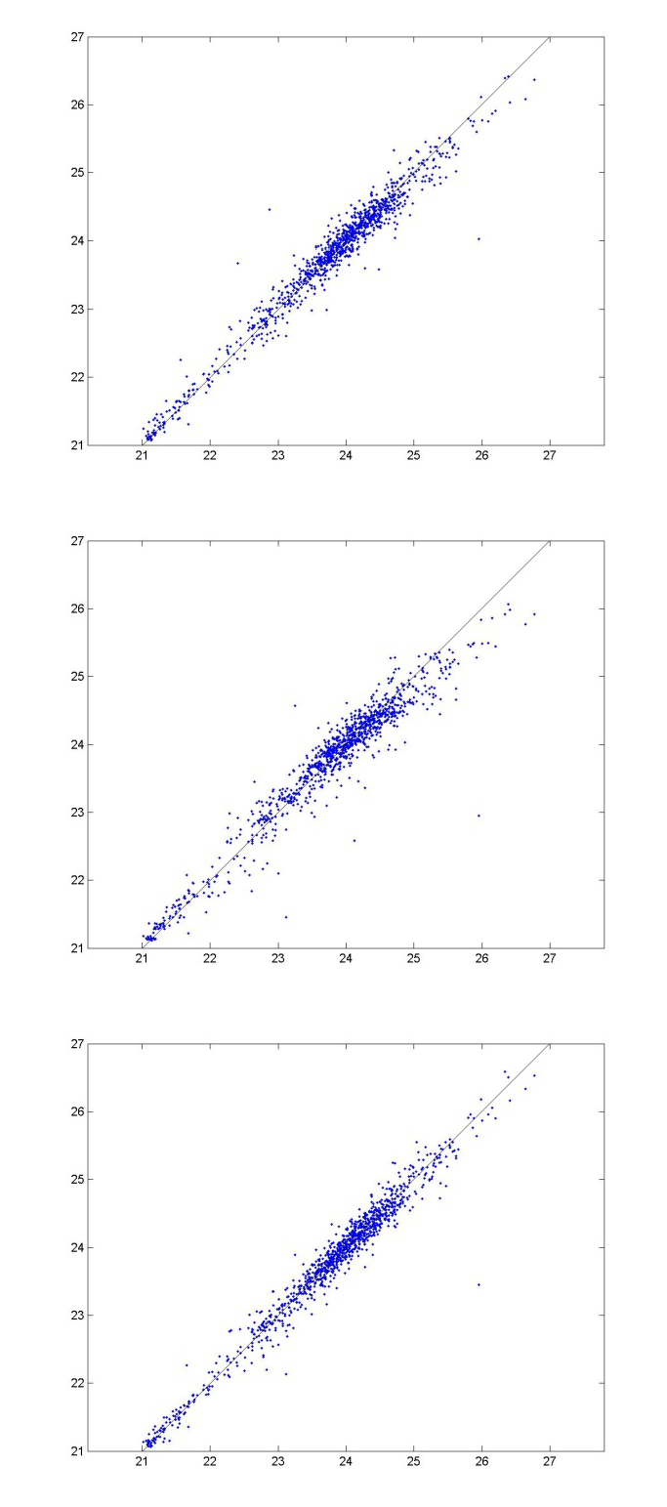

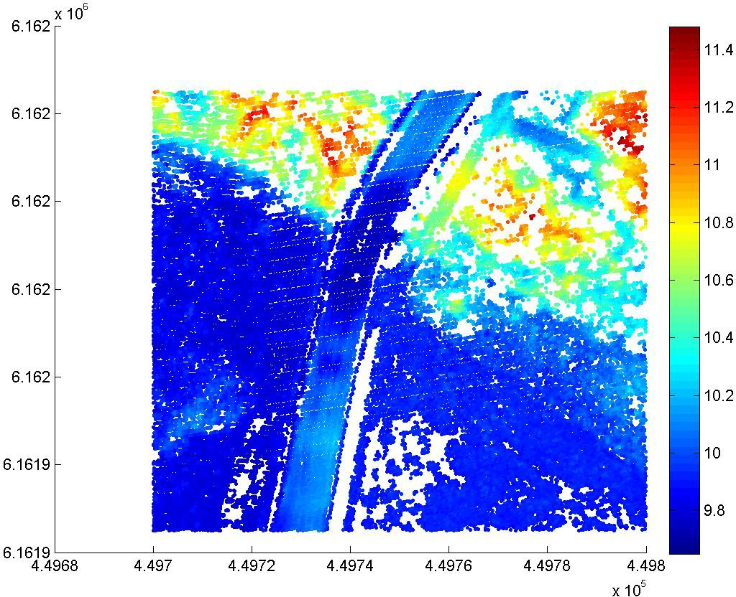

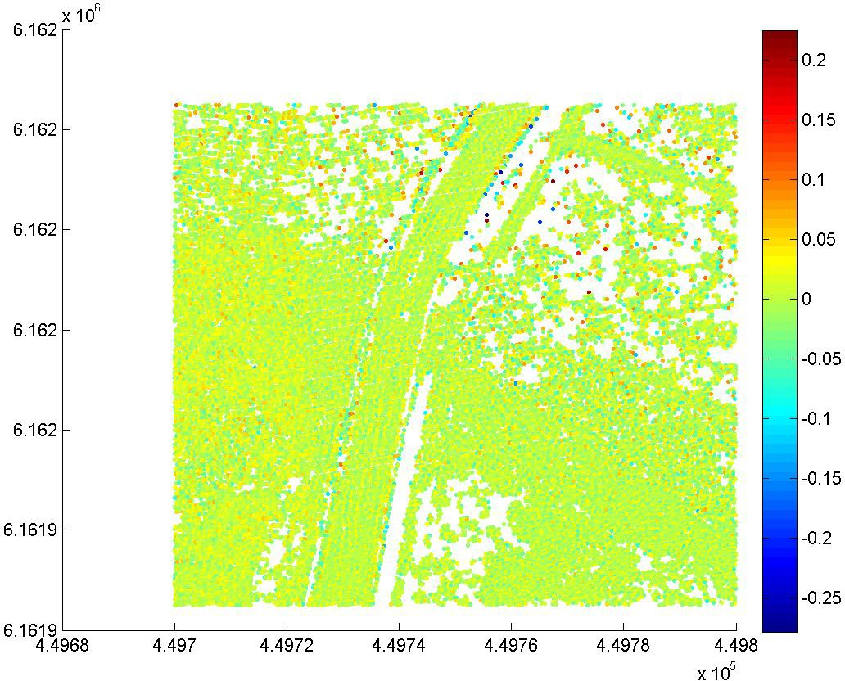

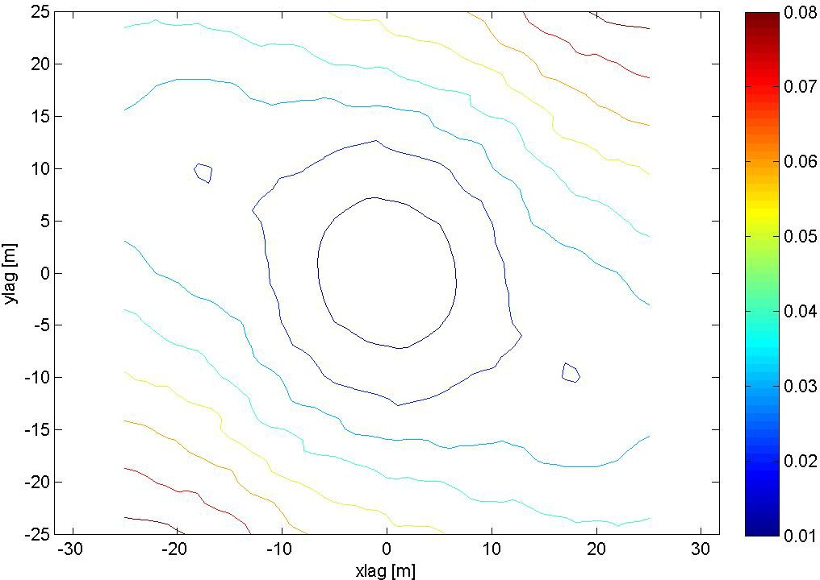

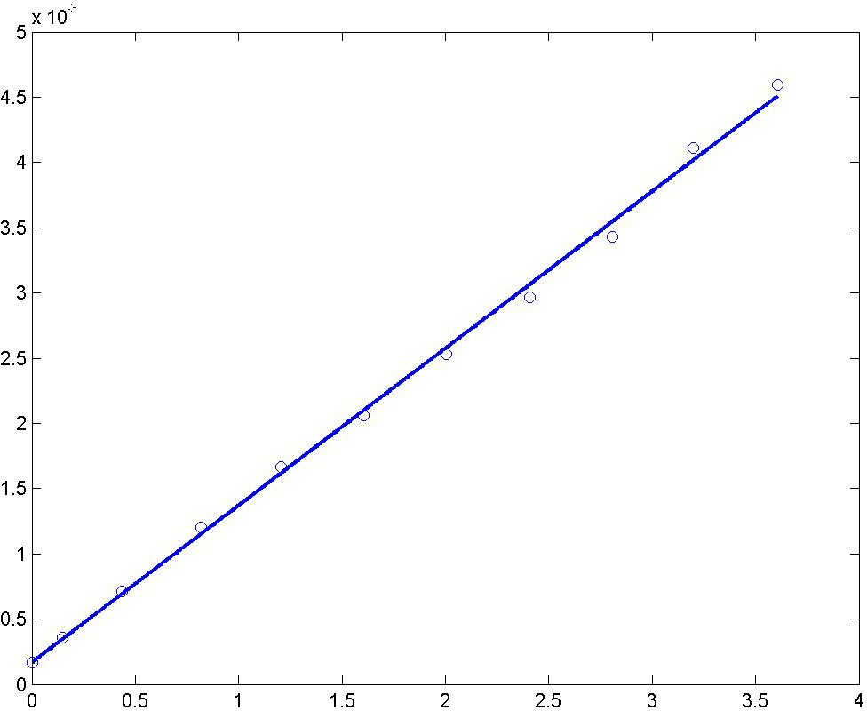

A spherical (linear) semivariogram model is used.

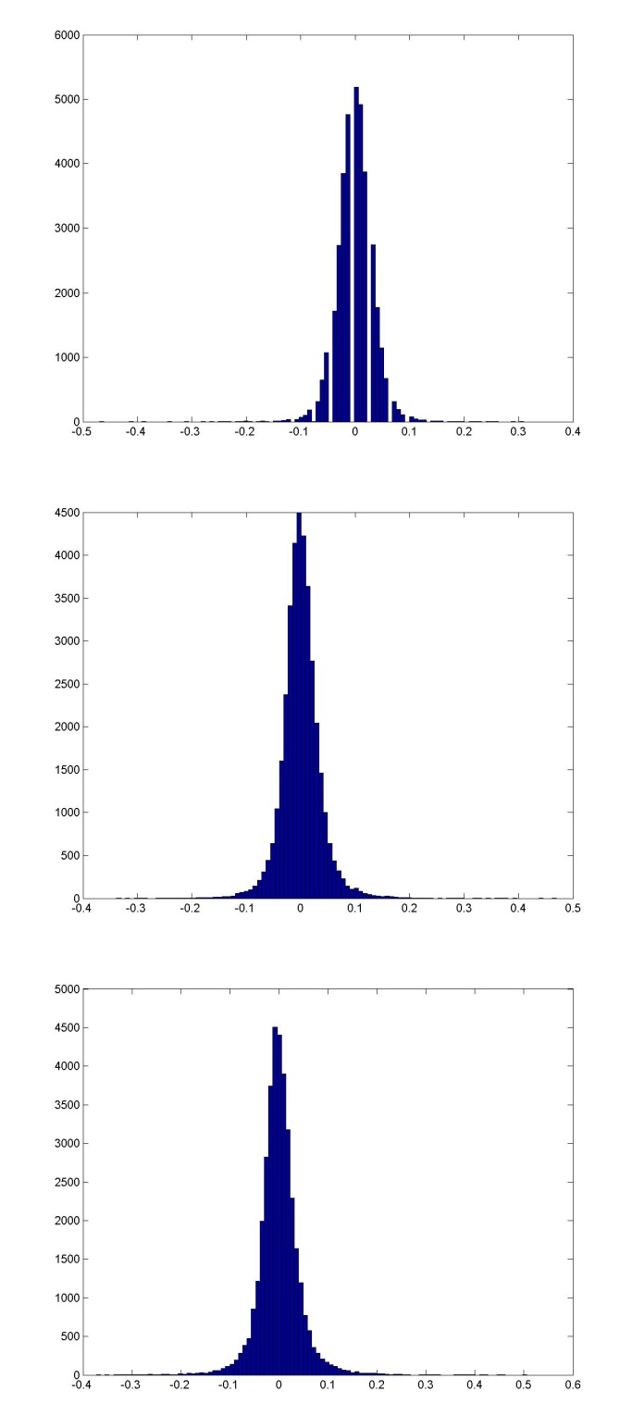
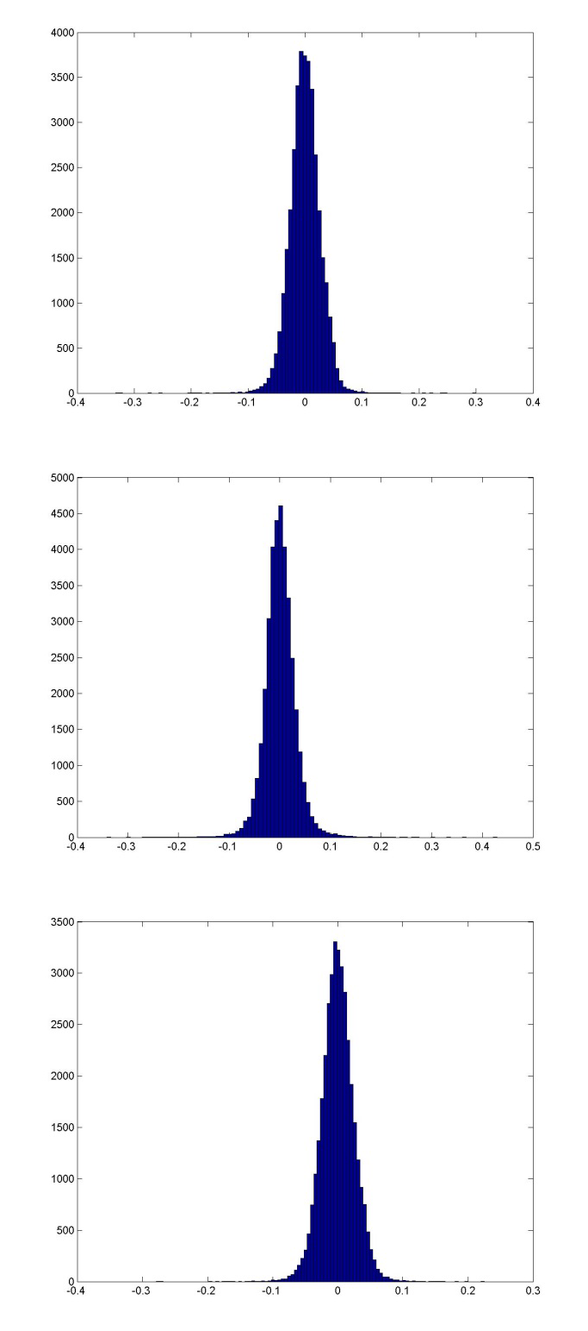

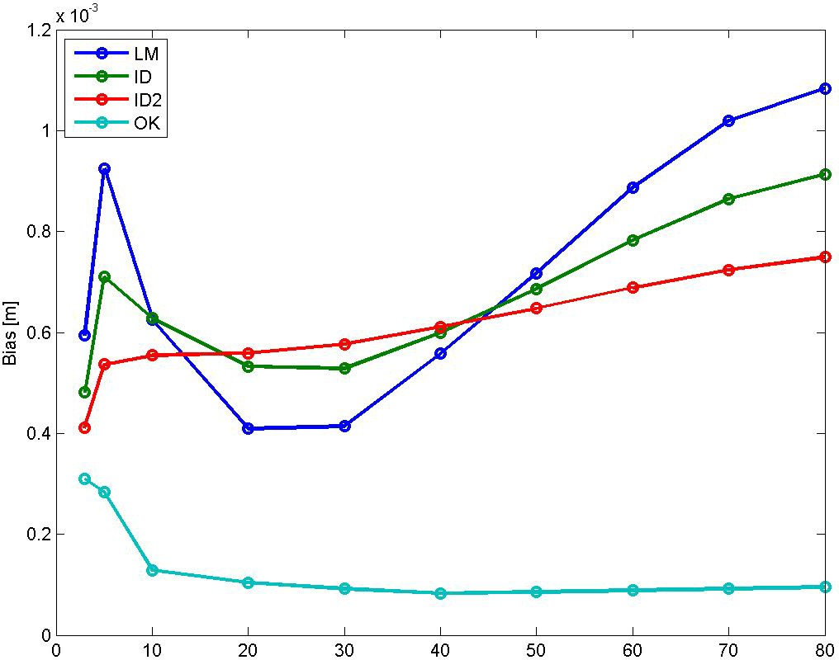

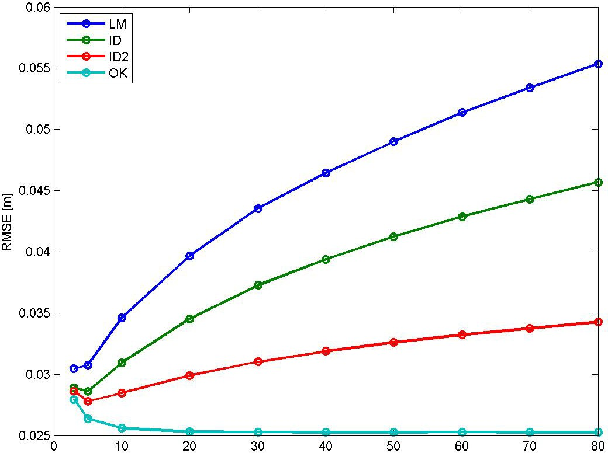

Bias for NN is 0.0003076 m, and for TIN ‐0.0004442 m. RMSE for NN is 0.03398 m, and for TIN 0.026897 m.

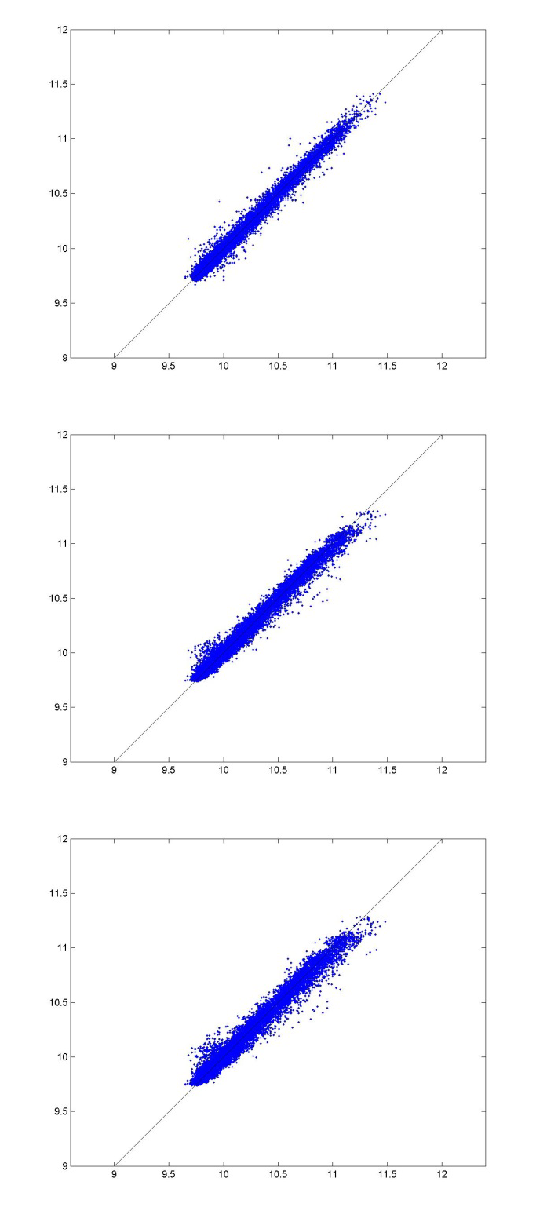
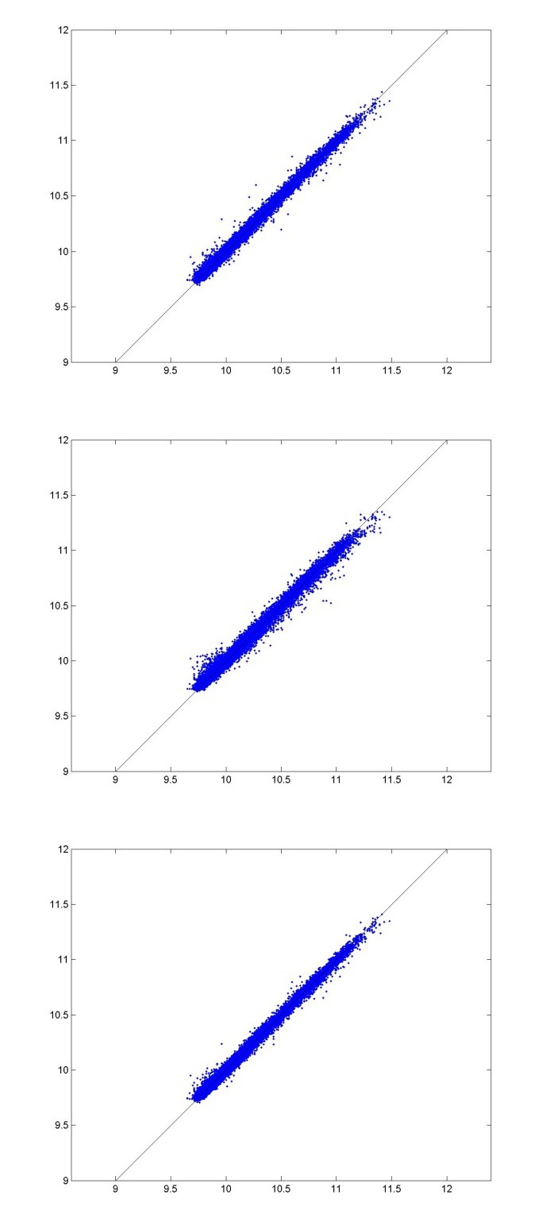

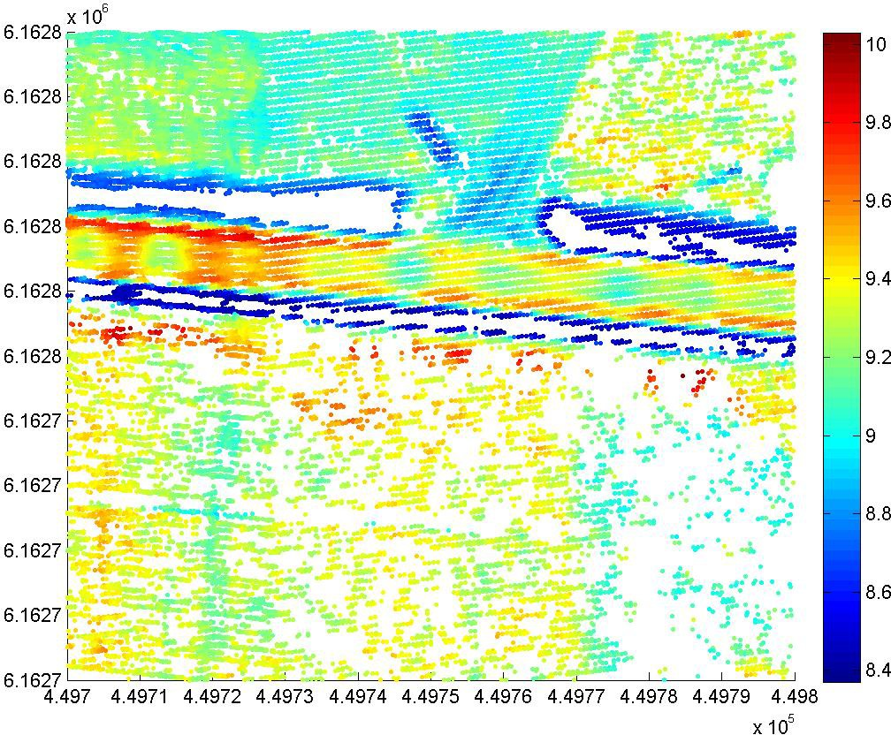

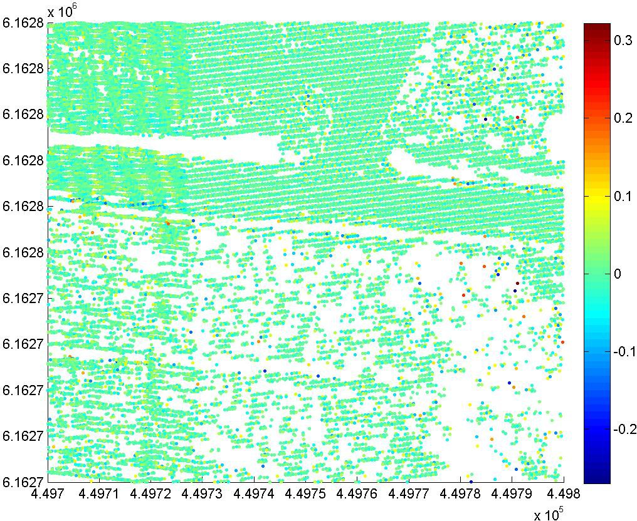

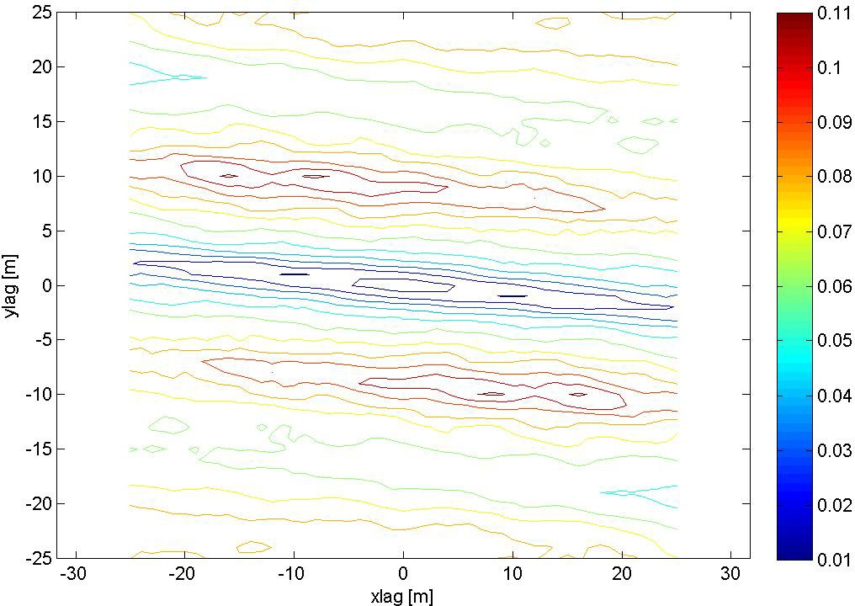

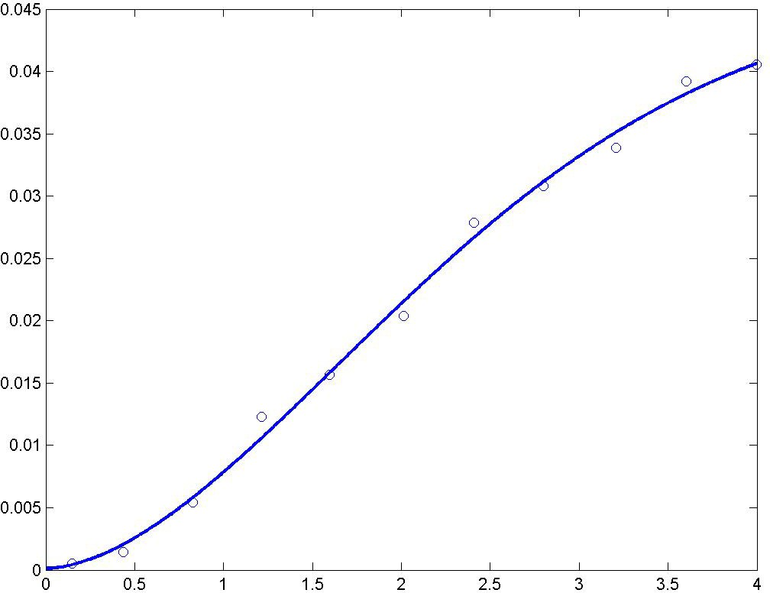

A modified Gaussian semivariogram model is used (power is 1.75 and not 2).

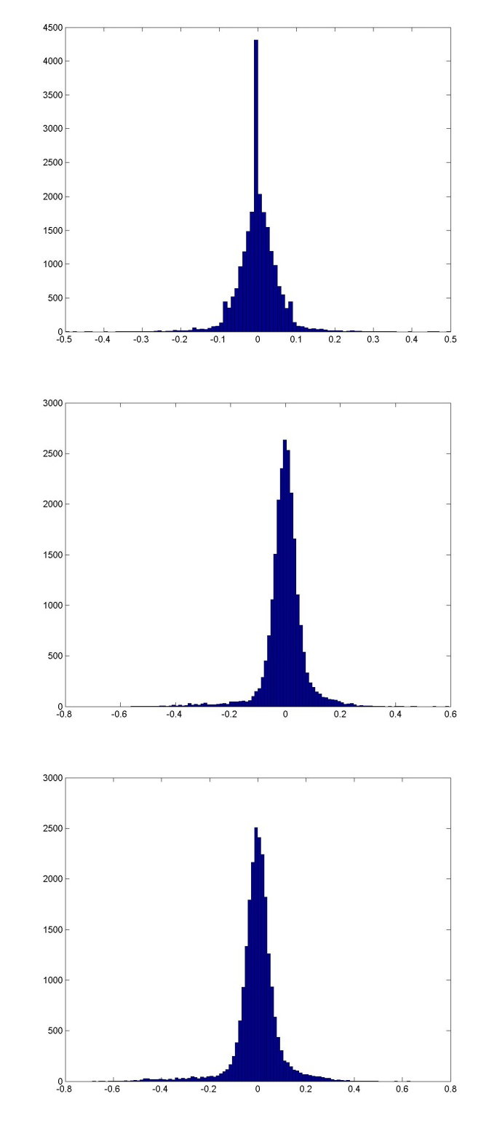
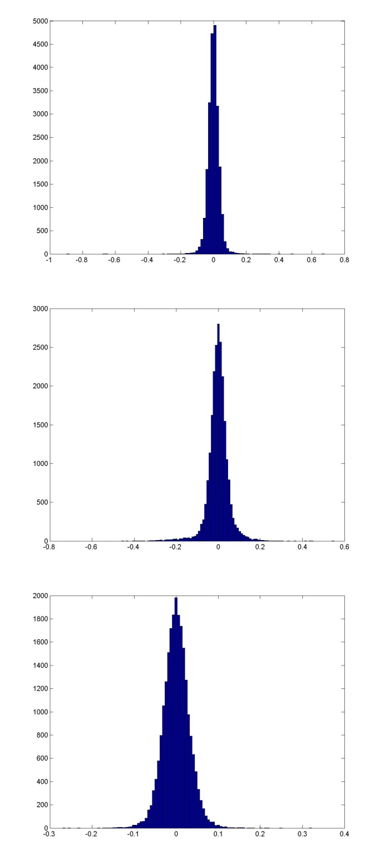

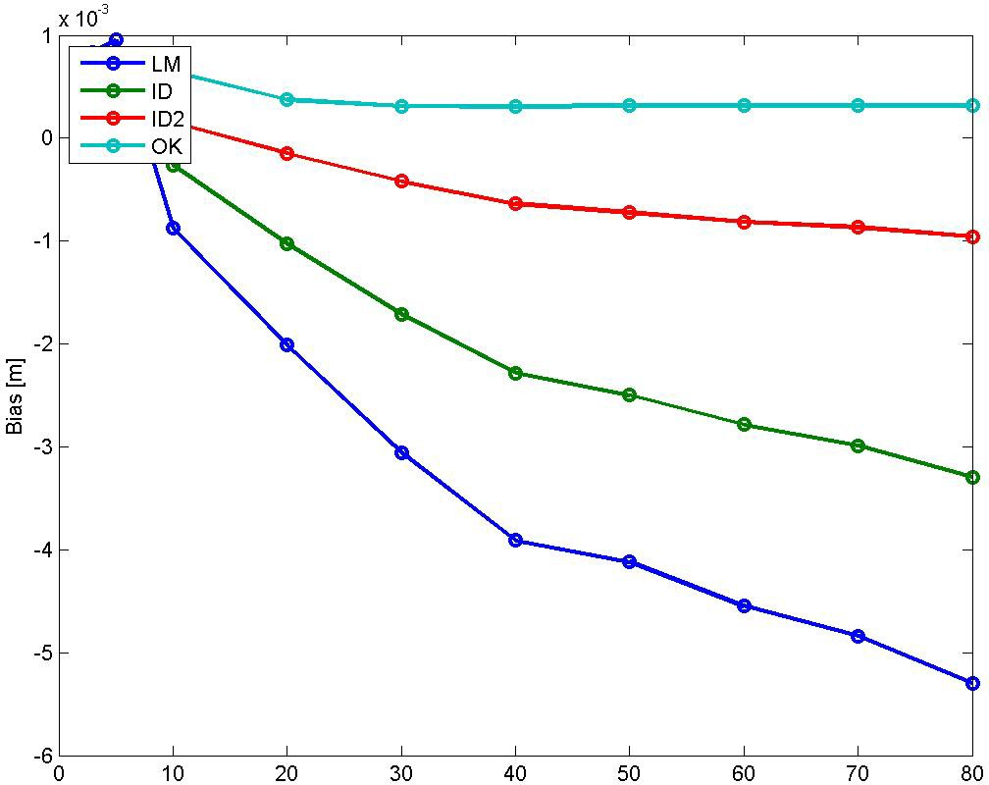

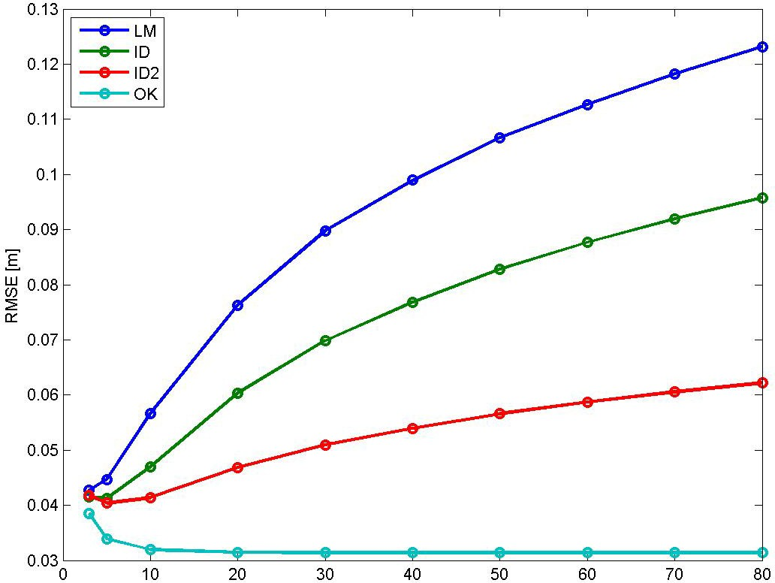

Bias for NN is 0.00029805 m, and for TIN ‐0.0003113 m. RMSE for NN is 0.05375 m, and for TIN 0.03583 m.

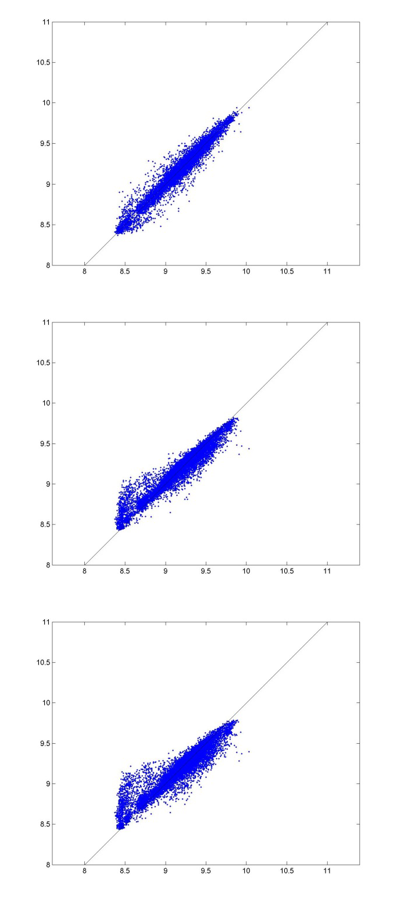
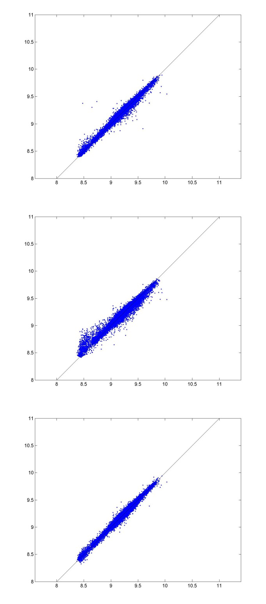

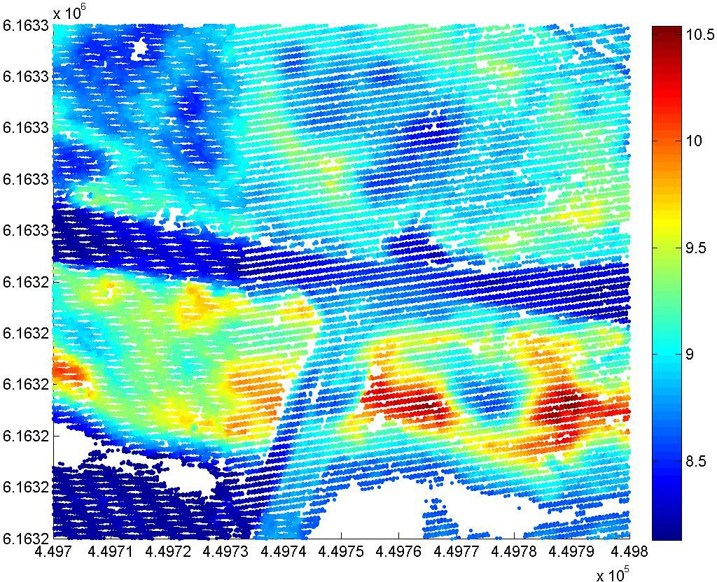

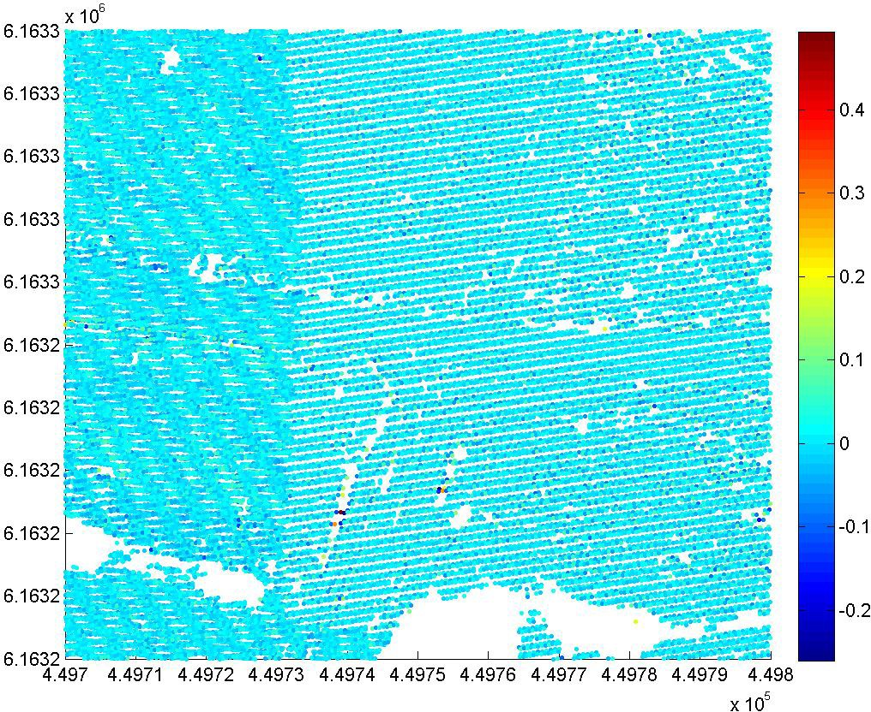

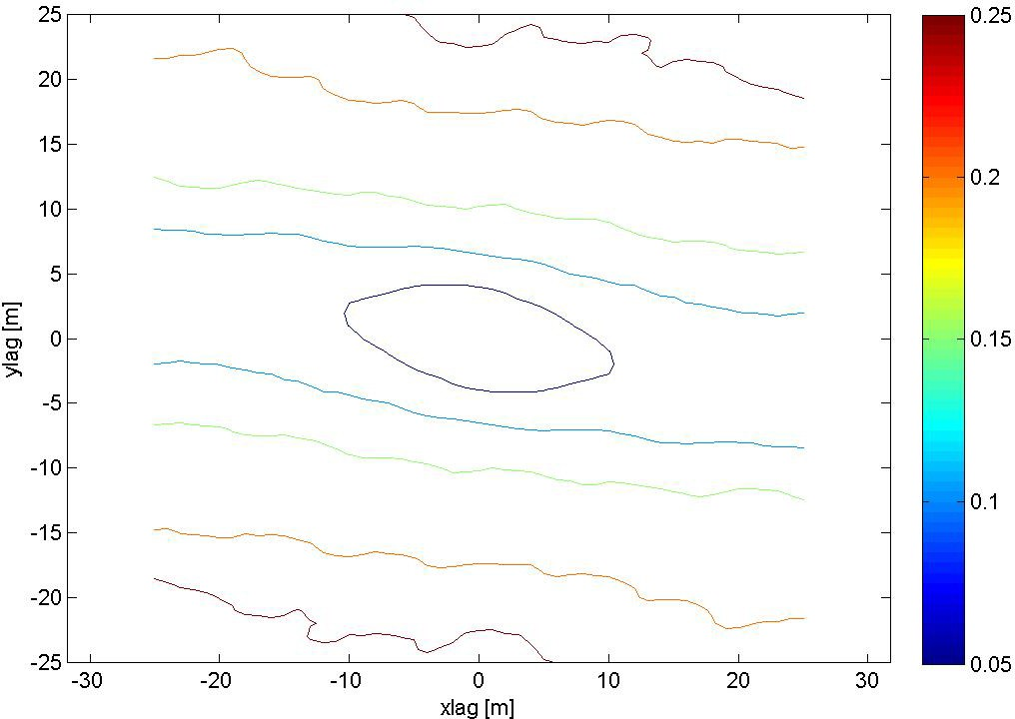

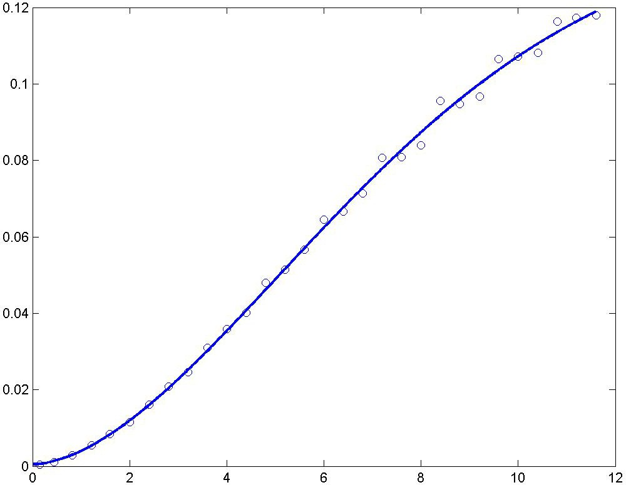

A modified Gaussian semivariogram model is used (power is 1.75 and not 2).

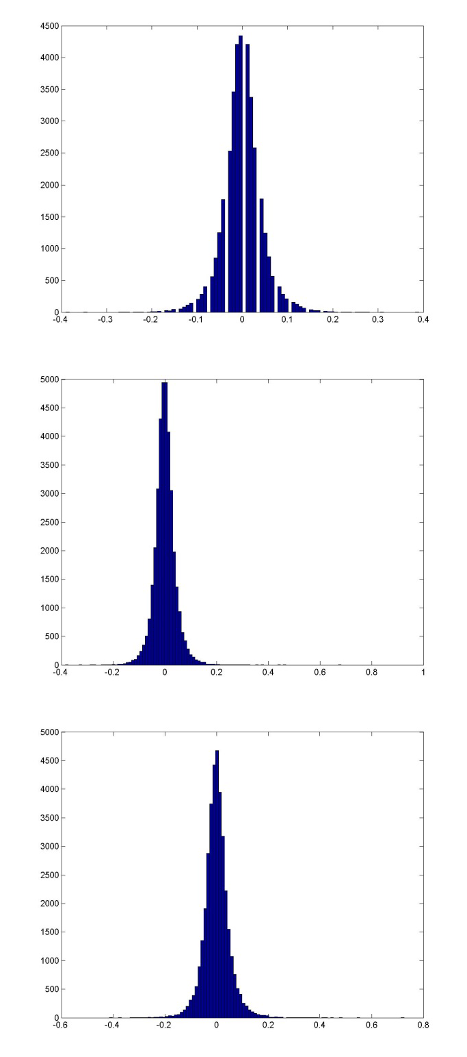
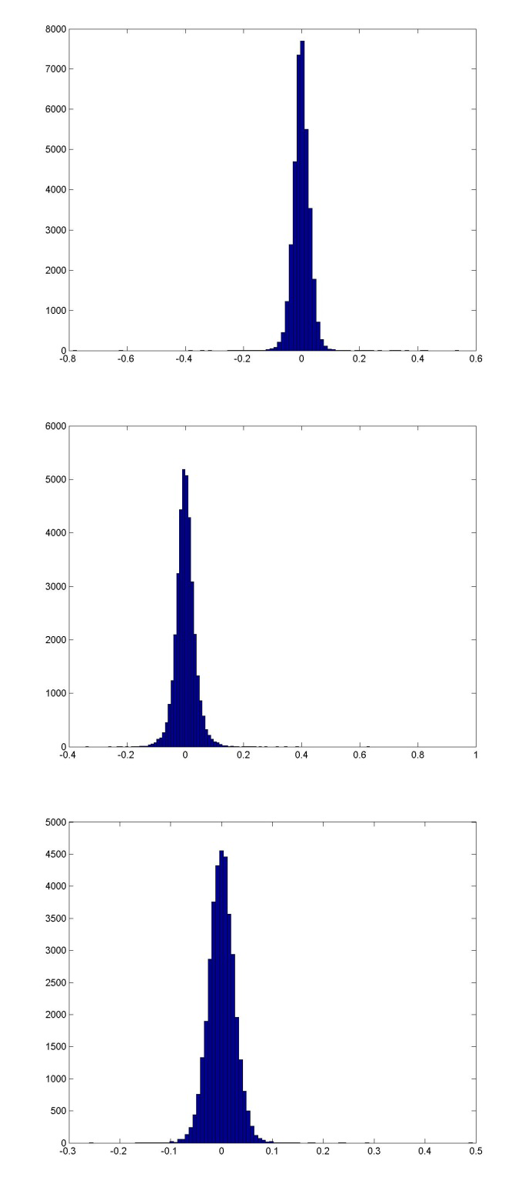

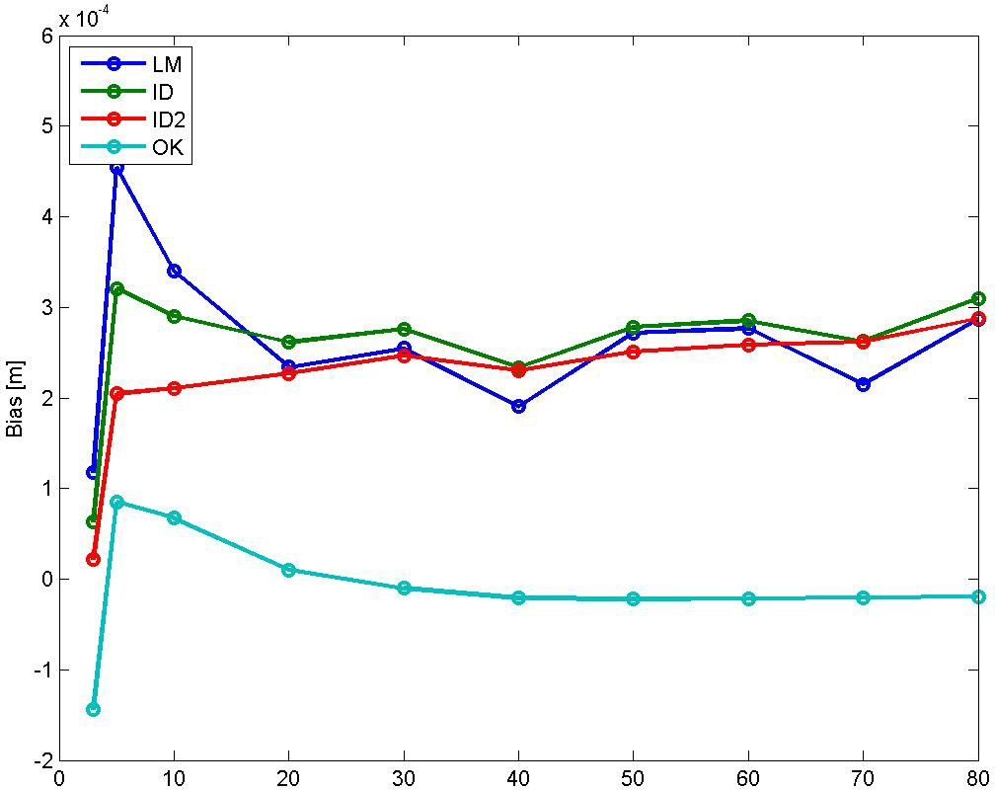

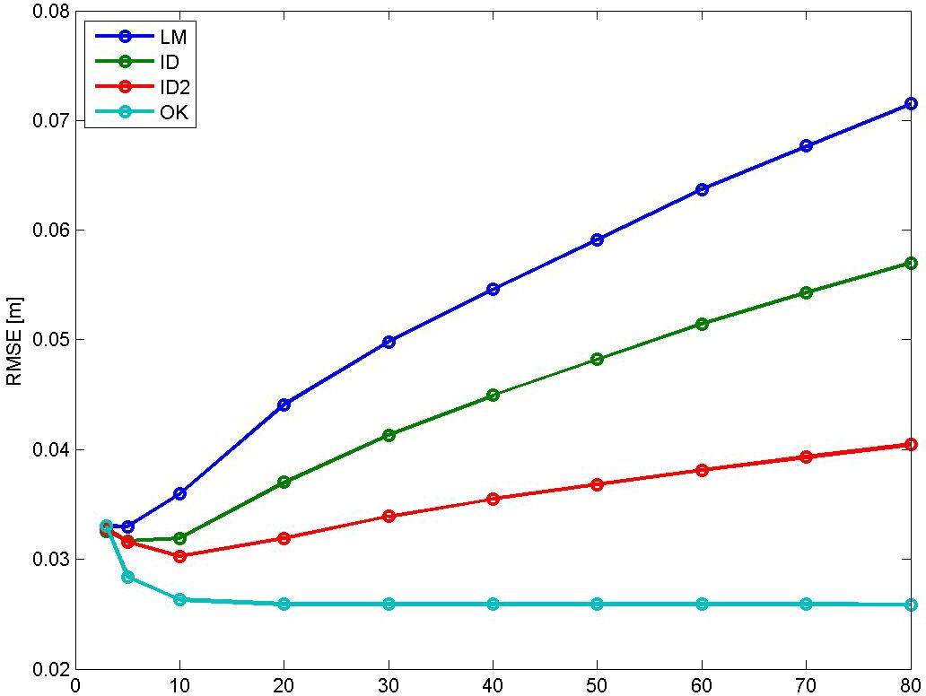

Bias for NN is 0.000143 m, and for TIN ‐0.0003364 m. RMSE for NN is 0.043426 m, and for TIN 0.029595 m.

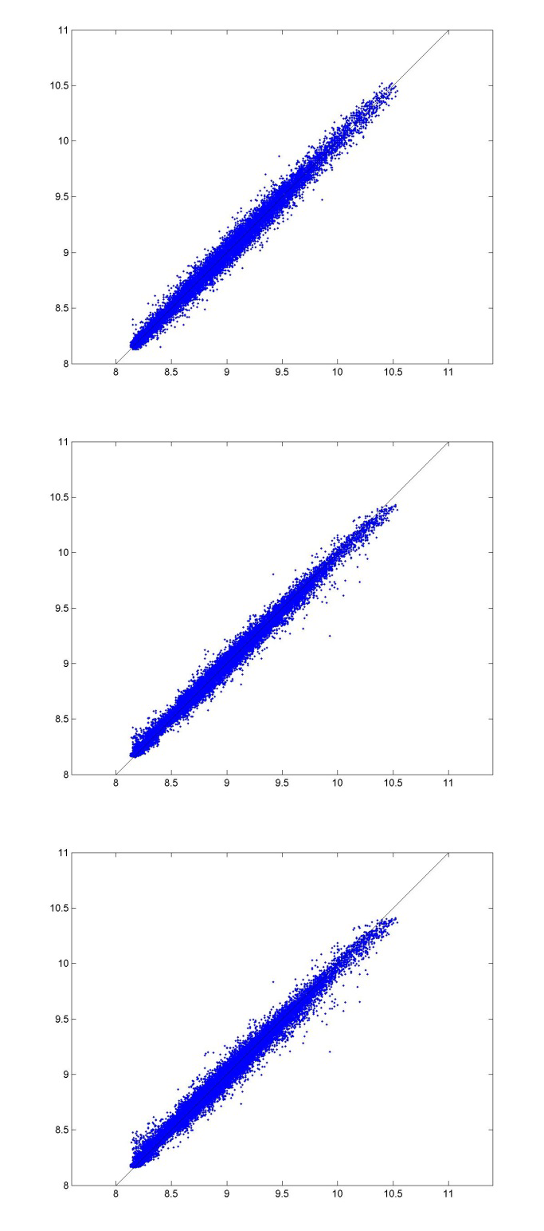
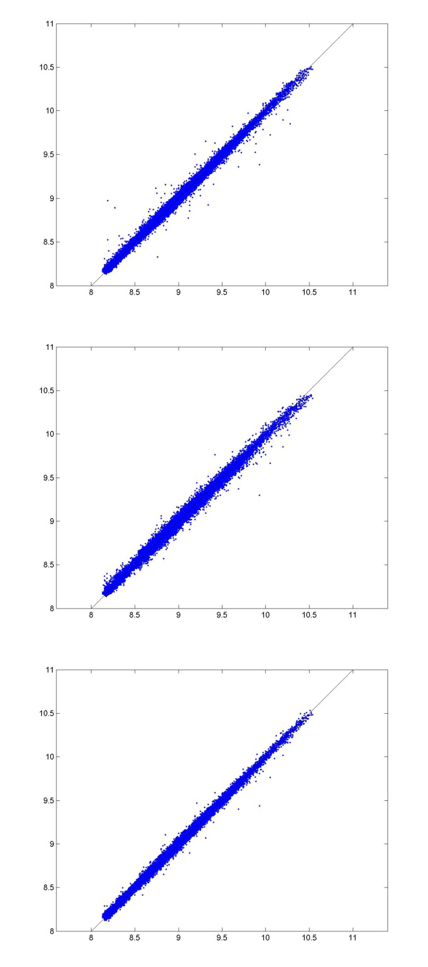

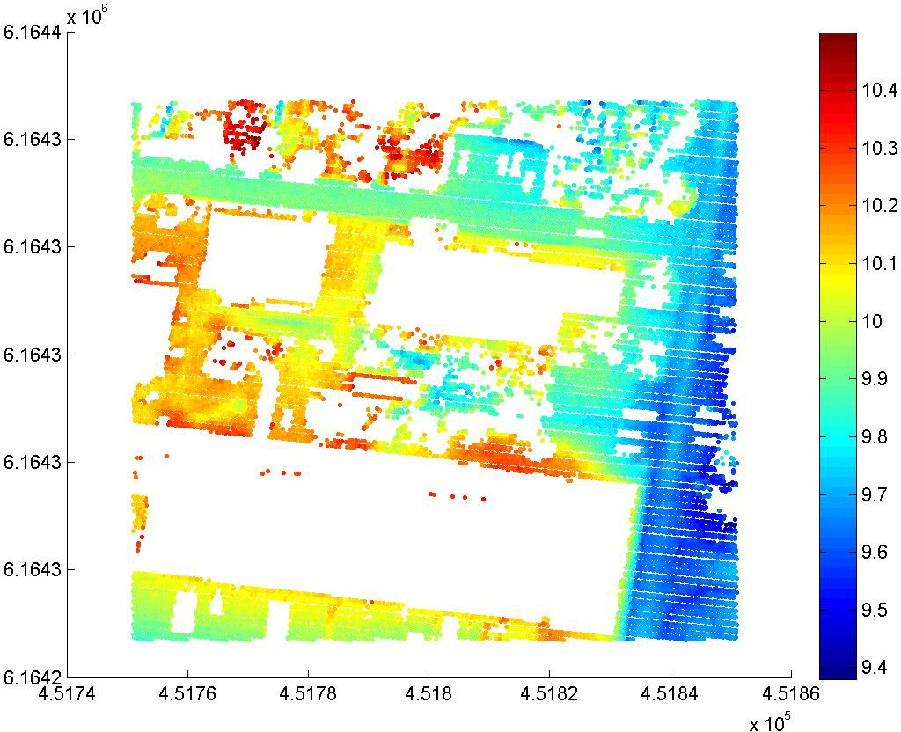

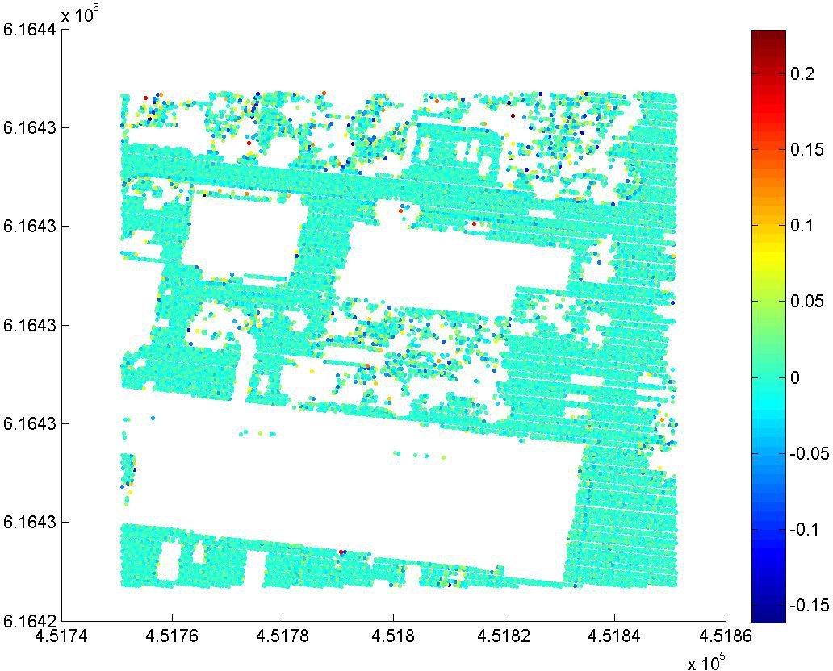

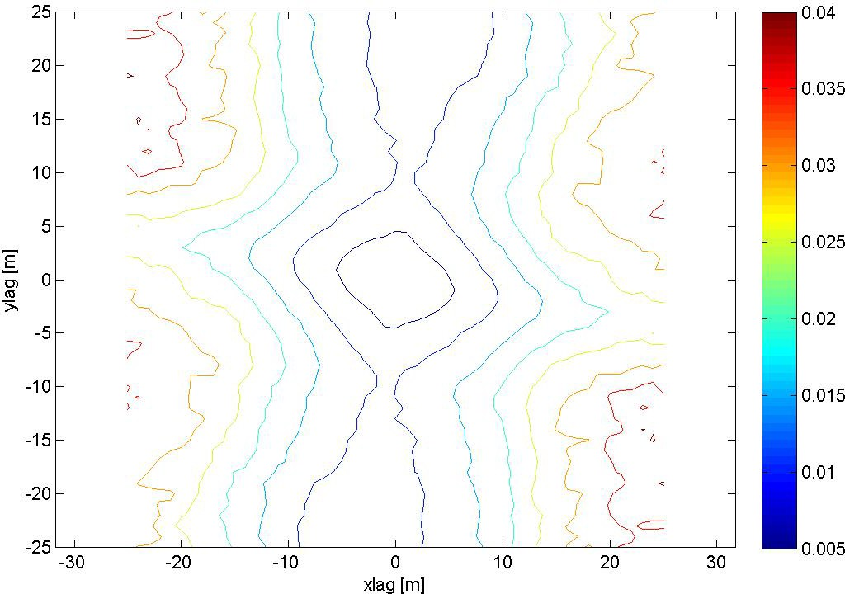

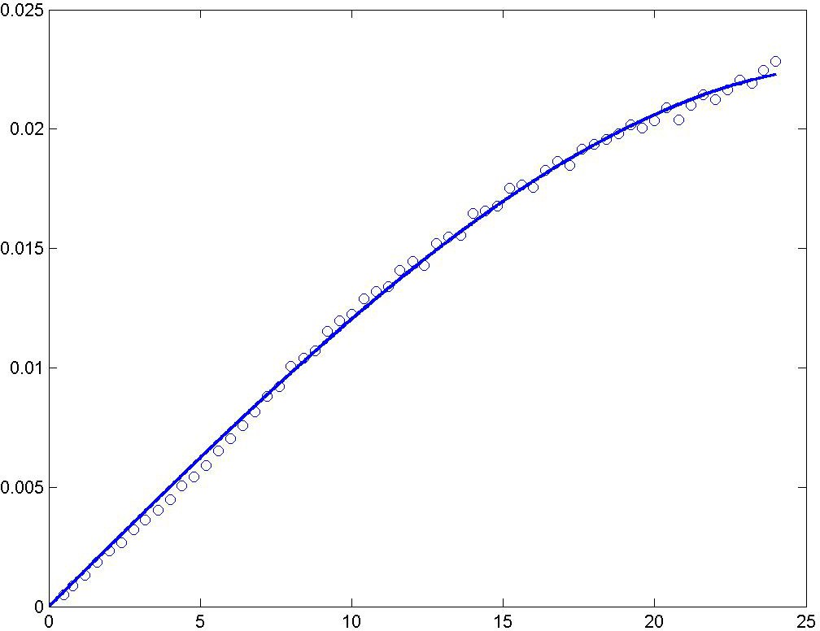

A spherical semivariogram model is used, no nugget effect.

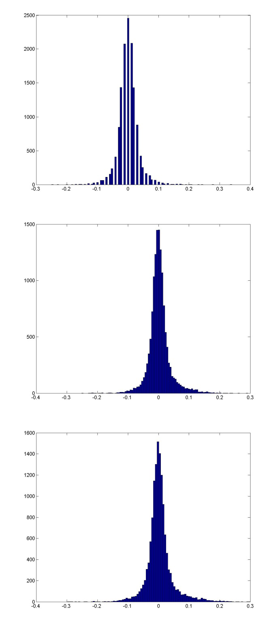
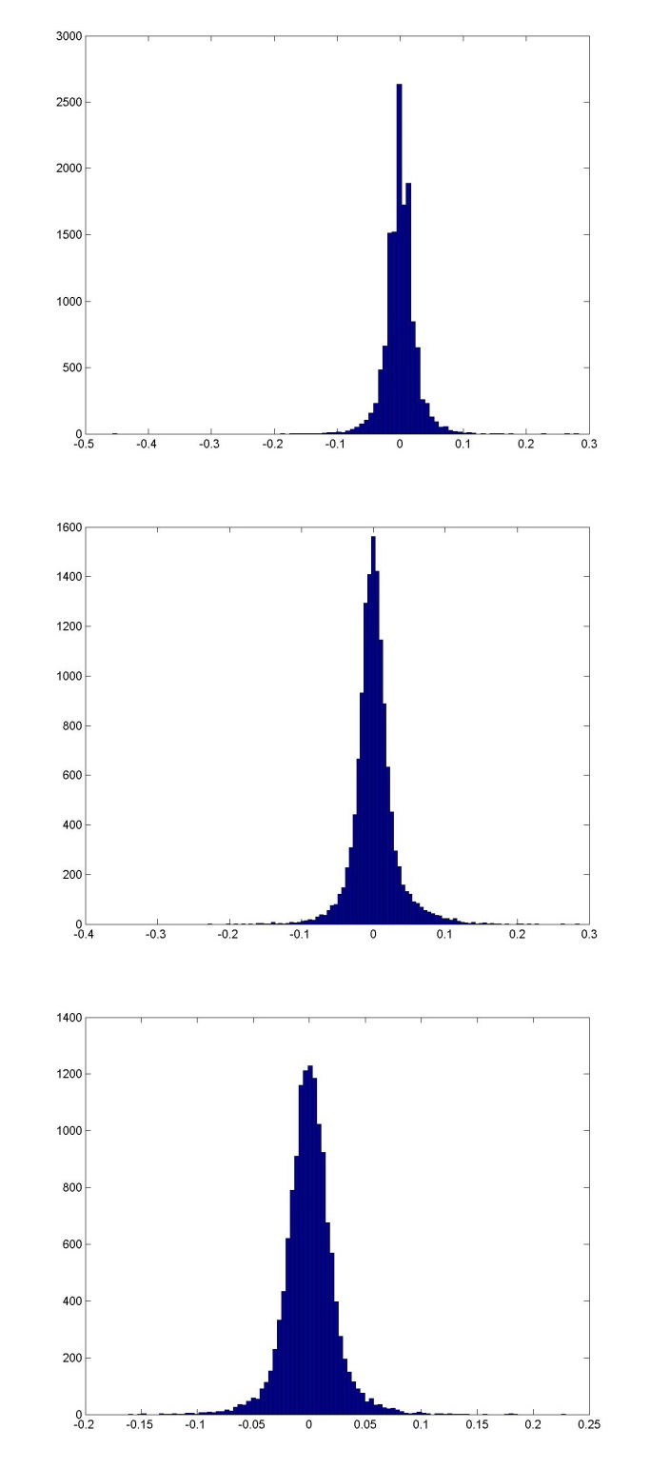

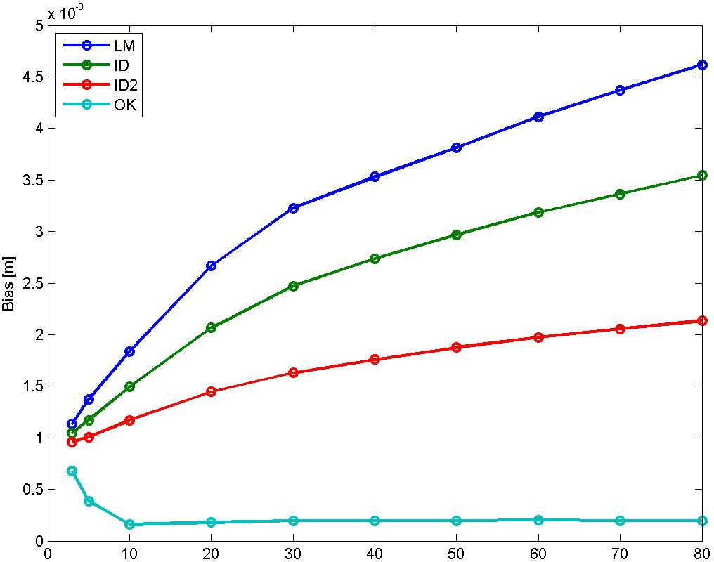

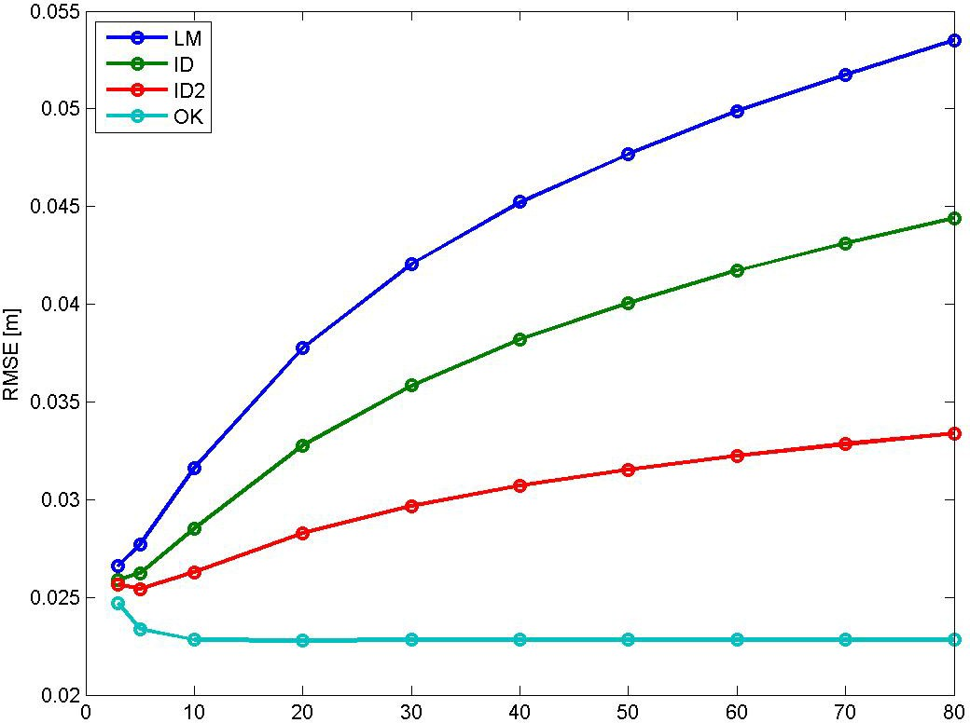

Bias for NN is 0.0007297 m, and for TIN ‐0.0002848 m. RMSE for NN is 0.03236 m, and for TIN 0.025345 m.

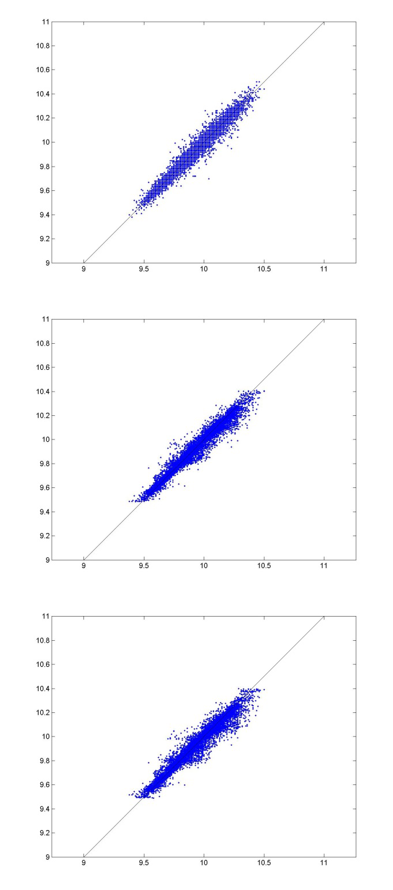
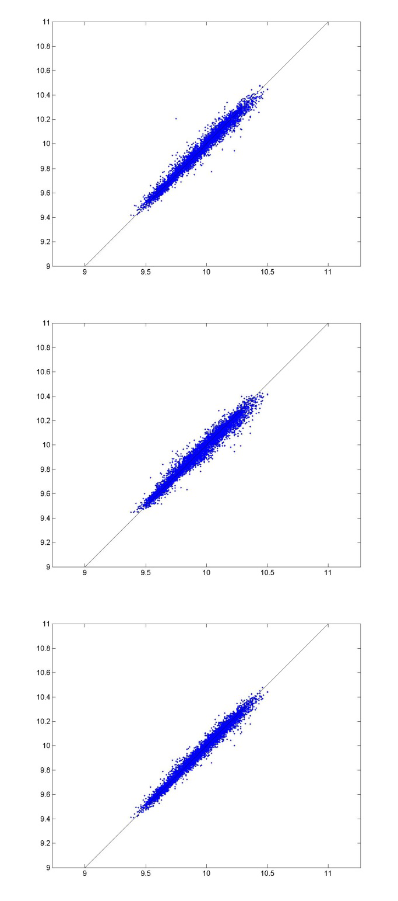

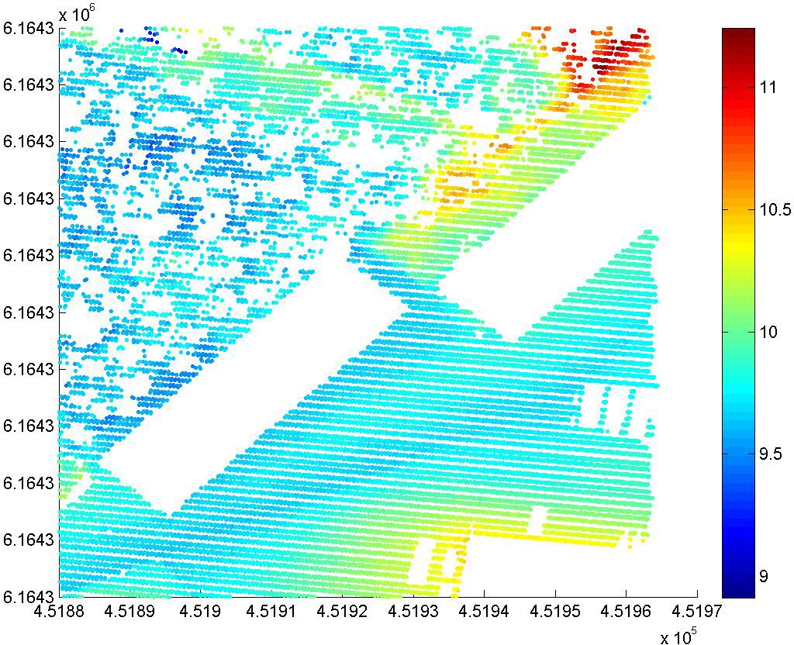

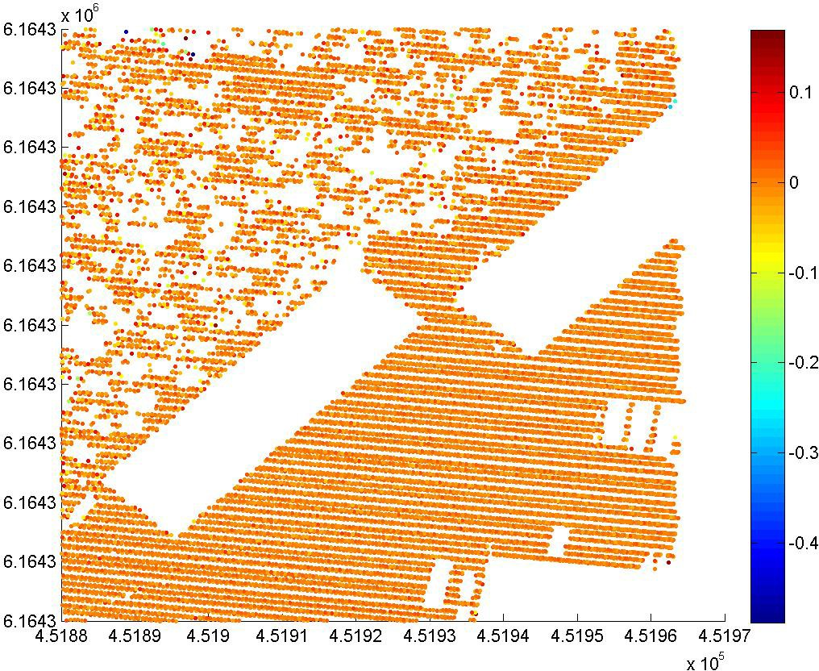

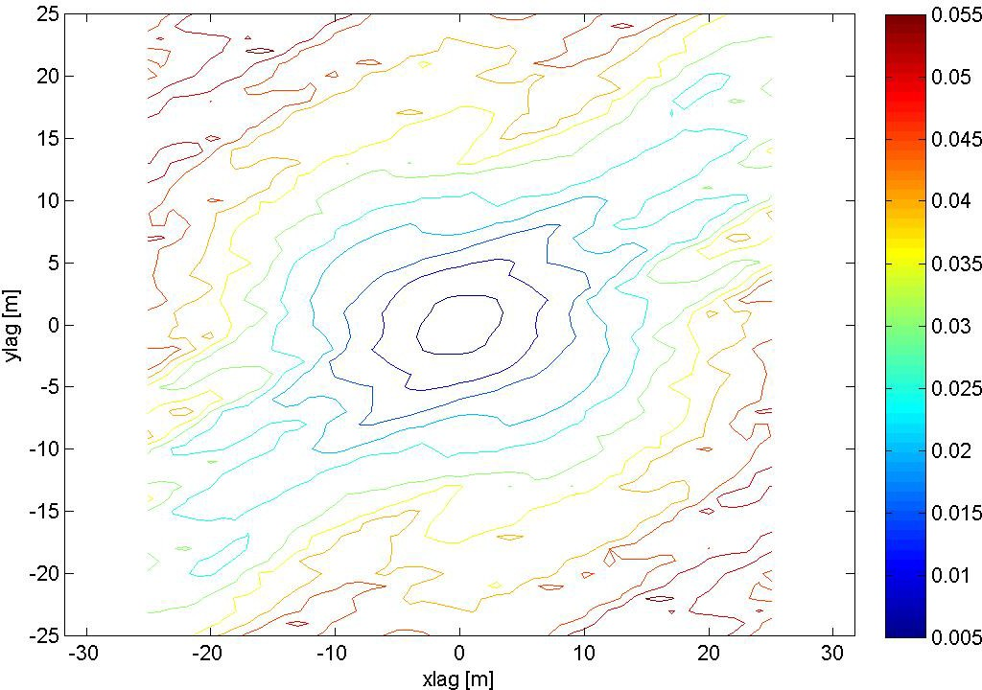

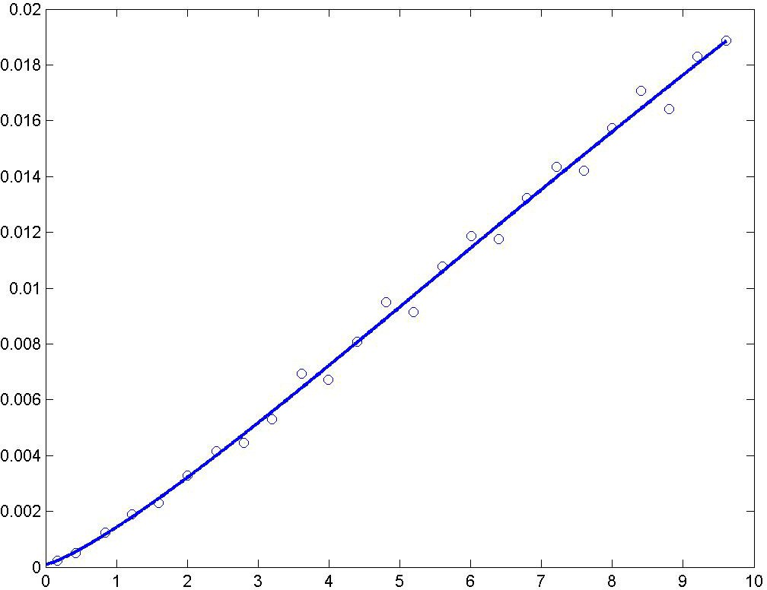

A modified Gaussian semivariogram model is used (power is 1.25 and not 2).

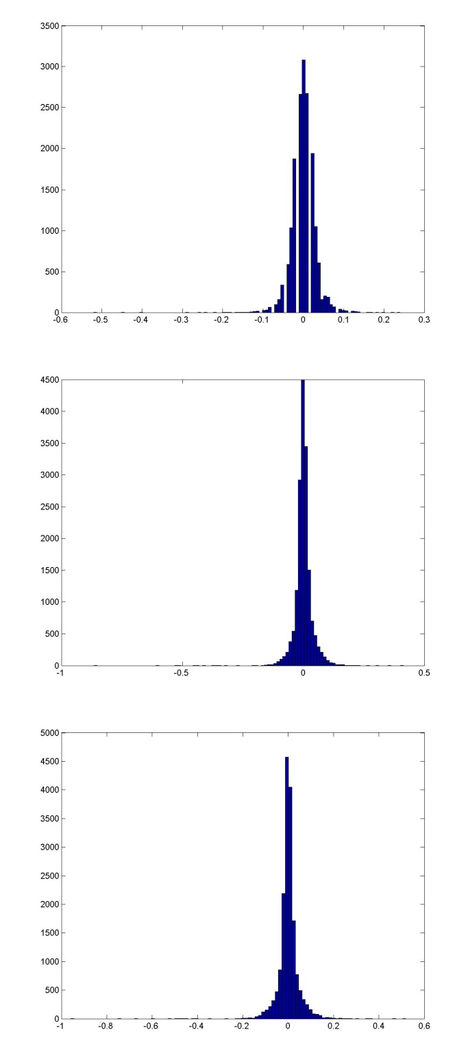
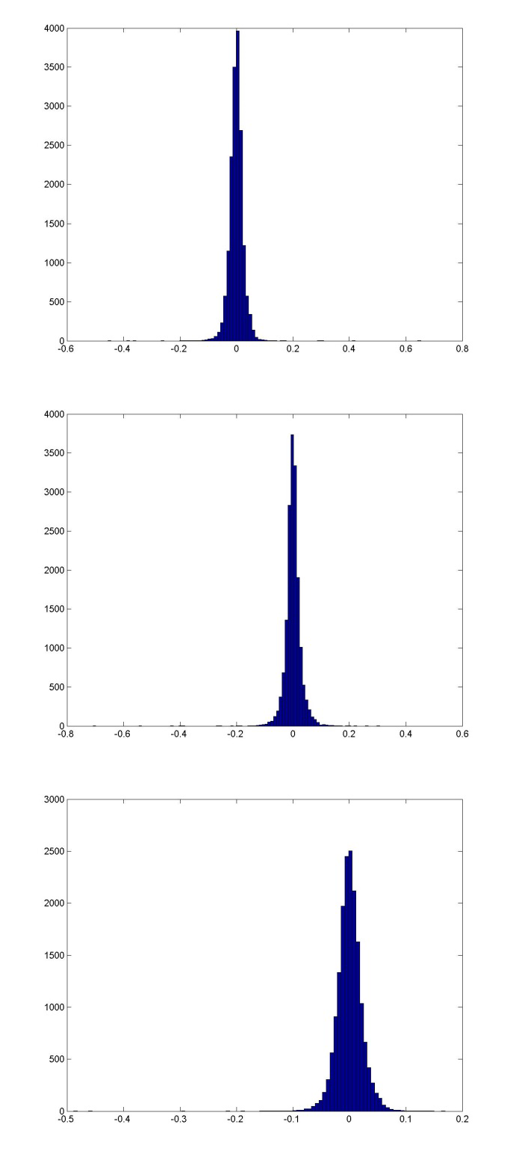

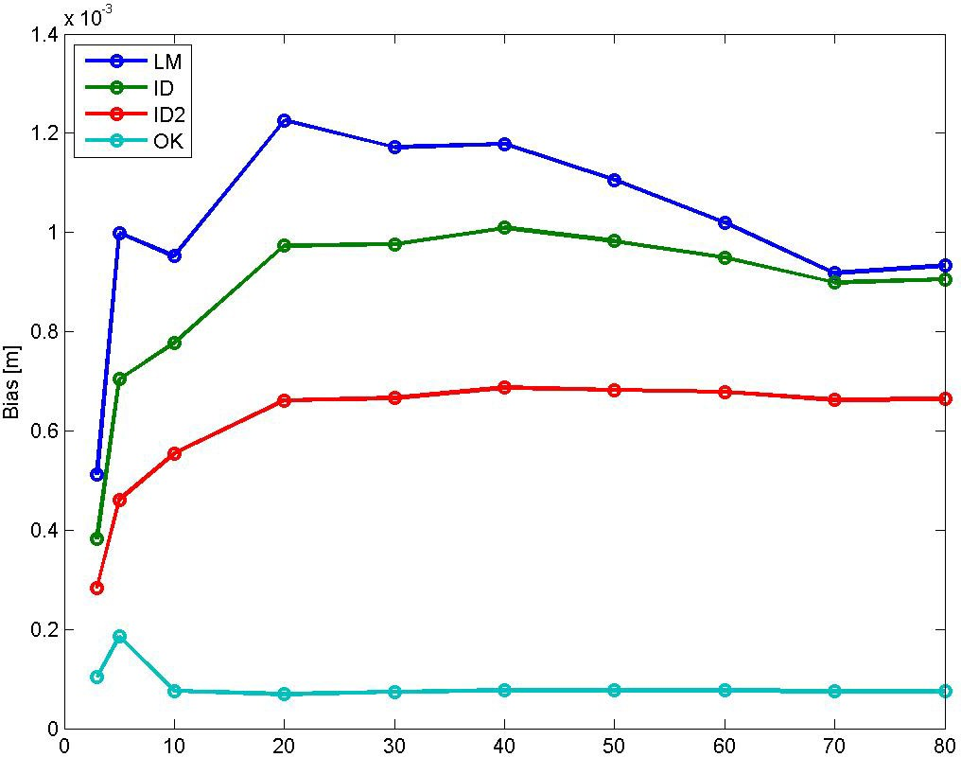

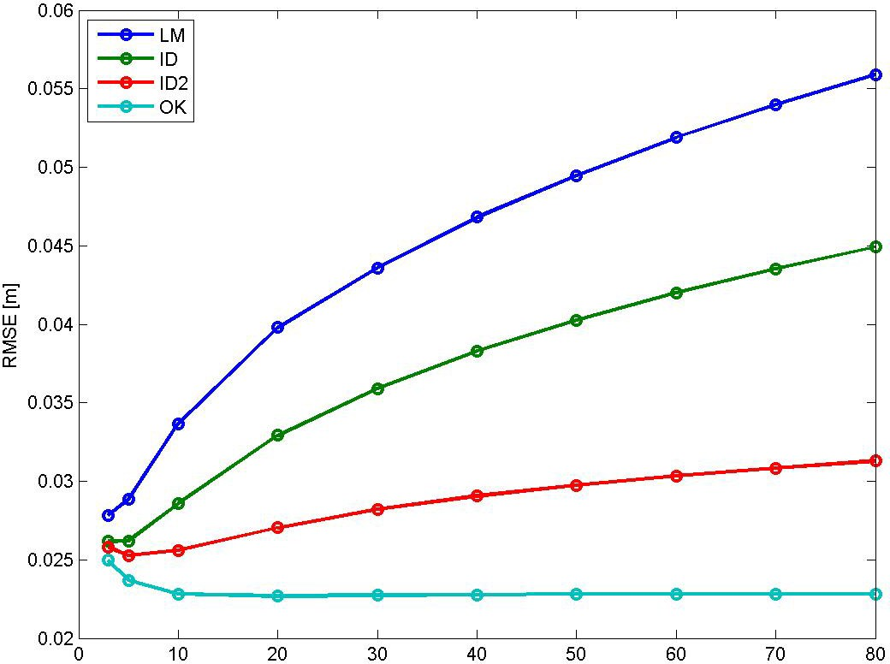

Bias for NN is 0.0002760 m, and for TIN ‐0.0005435 m. RMSE for NN is 0.02933 m, and for TIN 0.025123 m.

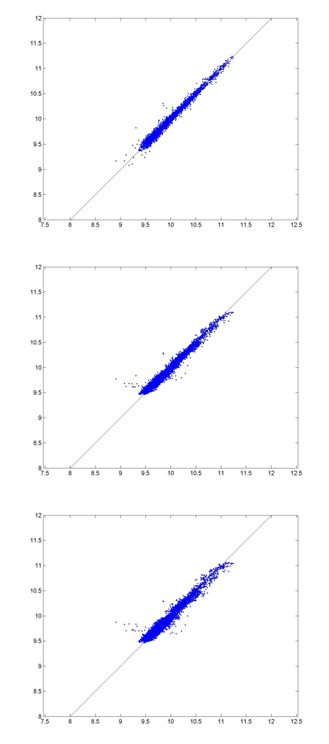
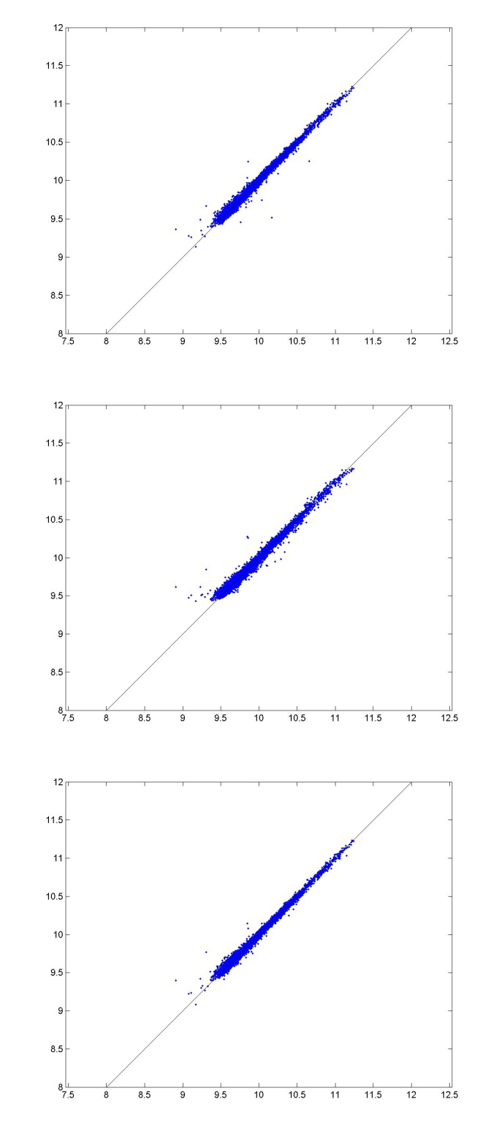

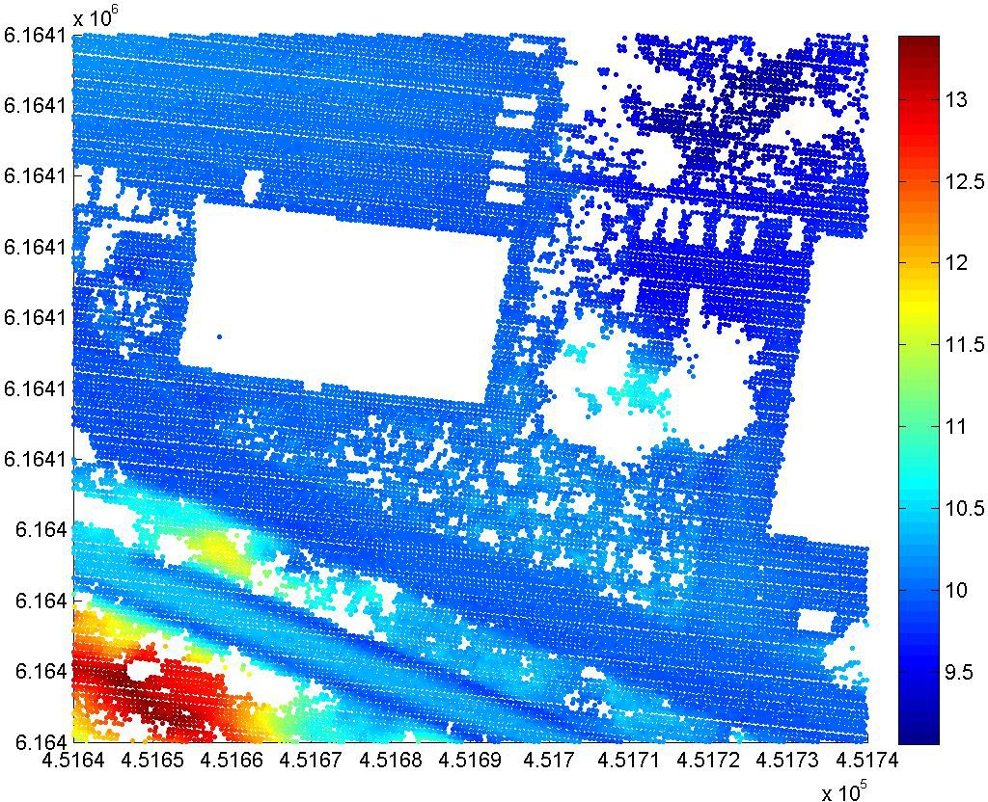

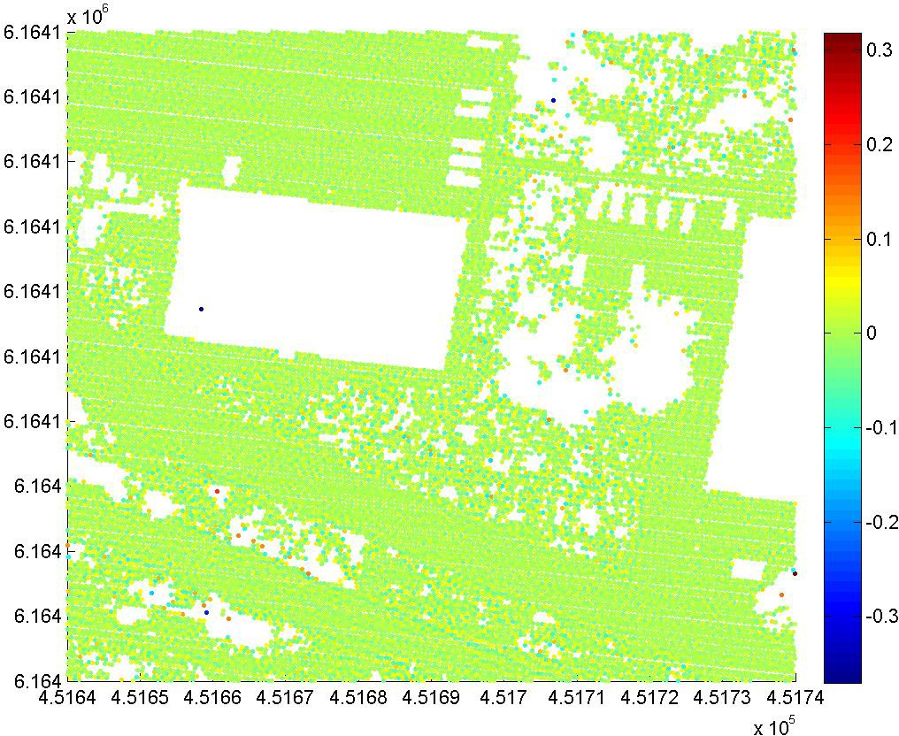

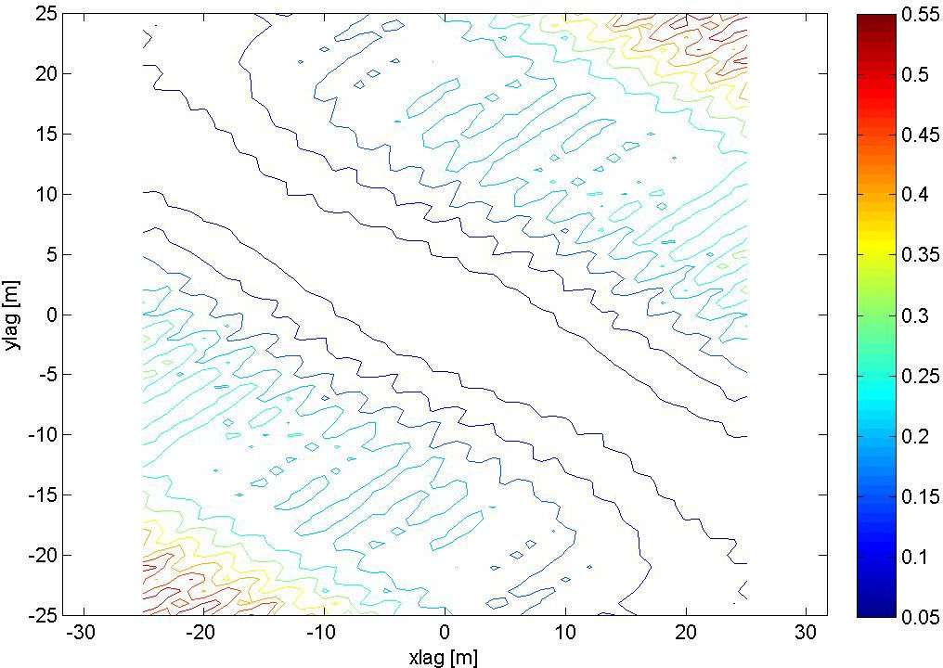

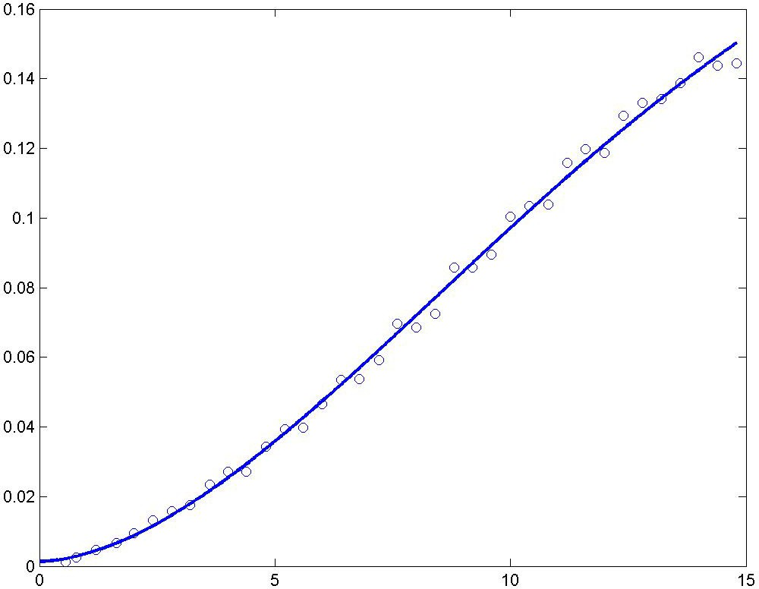

A modified Gaussian semivariogram model is used (power is 1.75 and not 2).

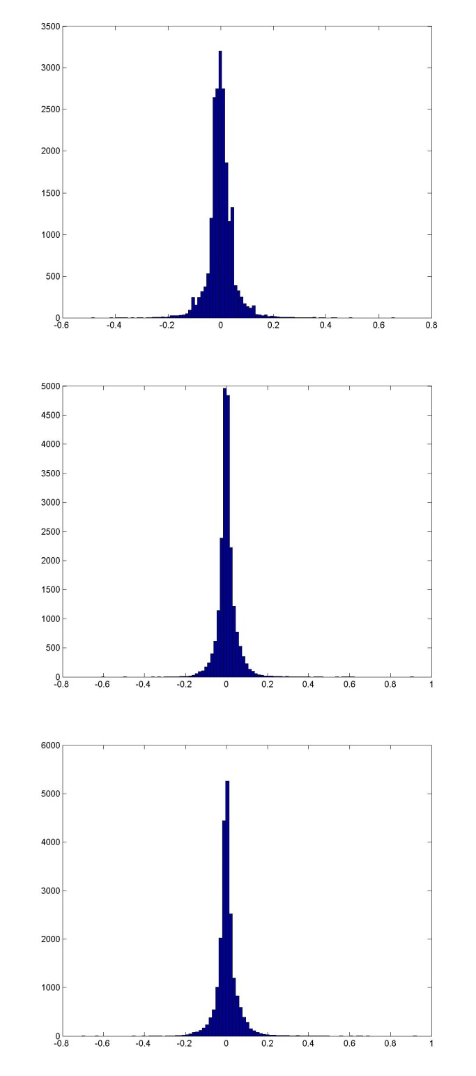
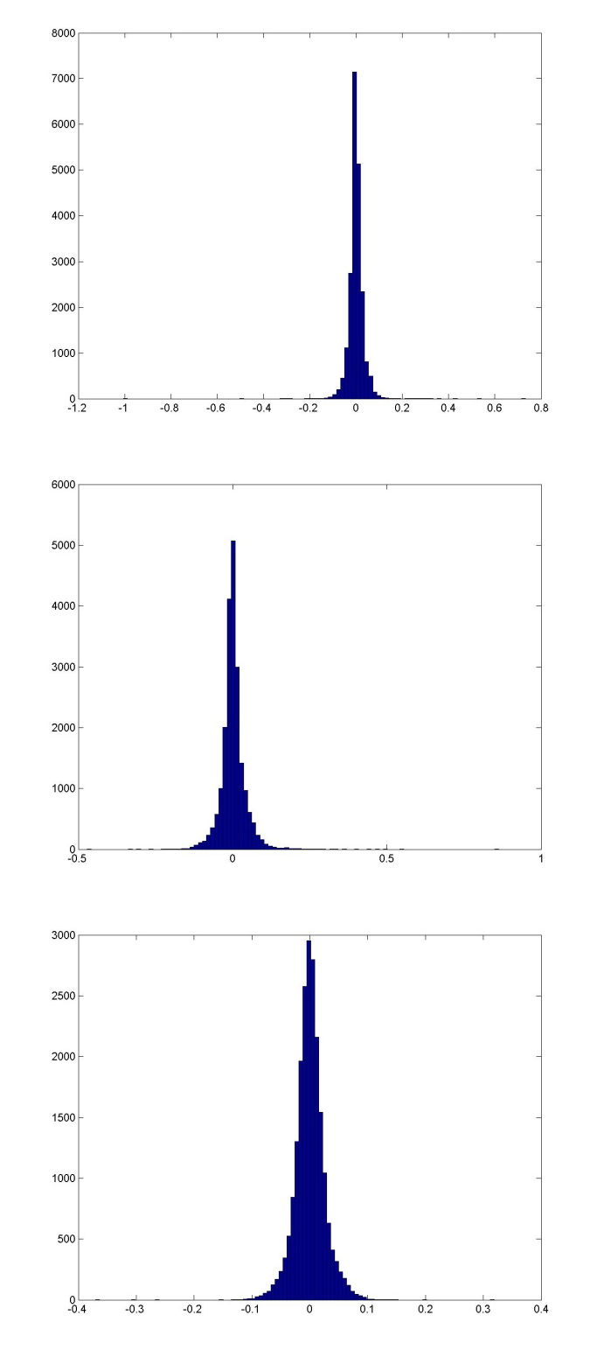

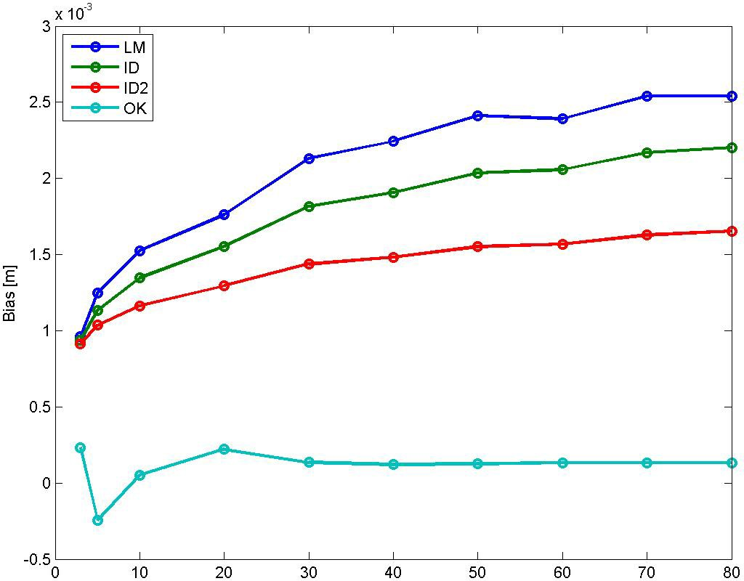

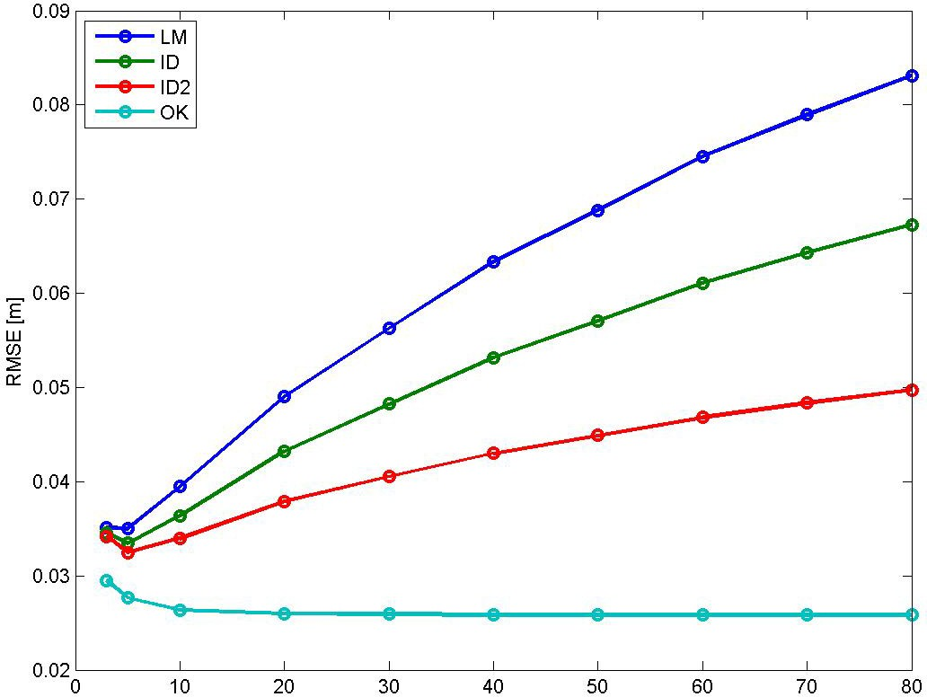

Bias for NN is 0.000717 m, and for TIN ‐0.000118 m. RMSE for NN is 0.049237 m, and for TIN 0.030853 m.

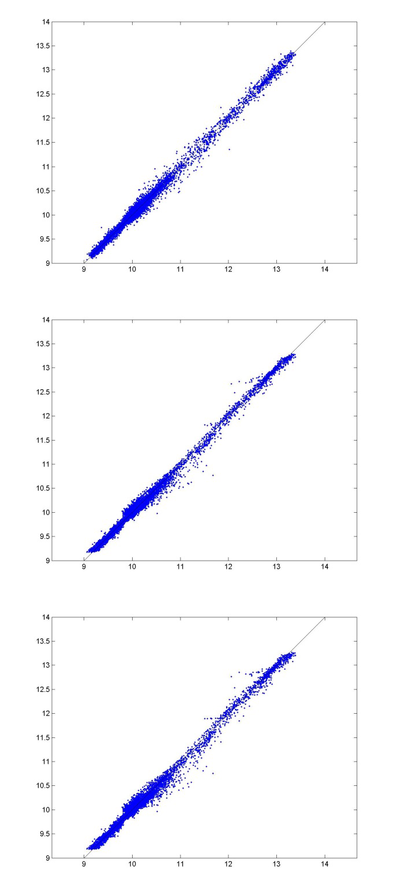
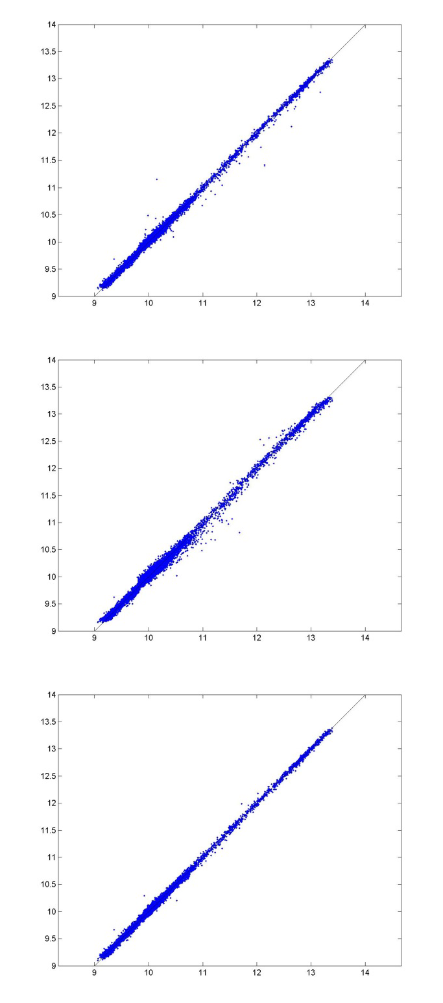

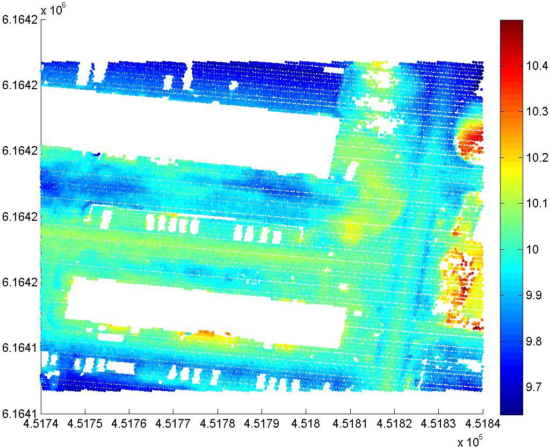

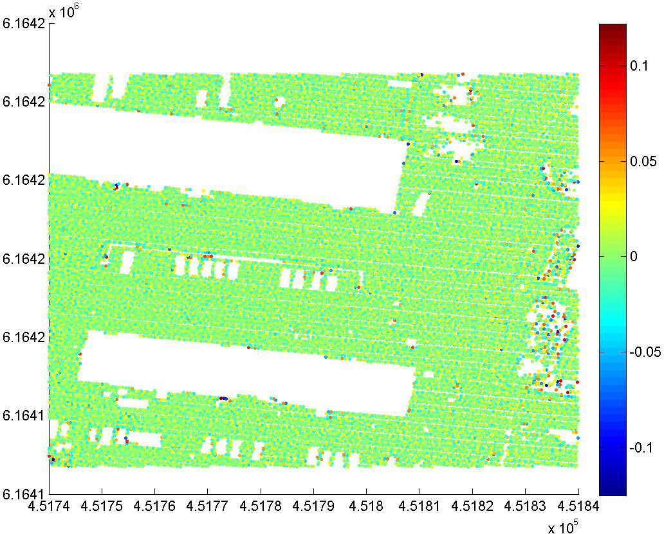

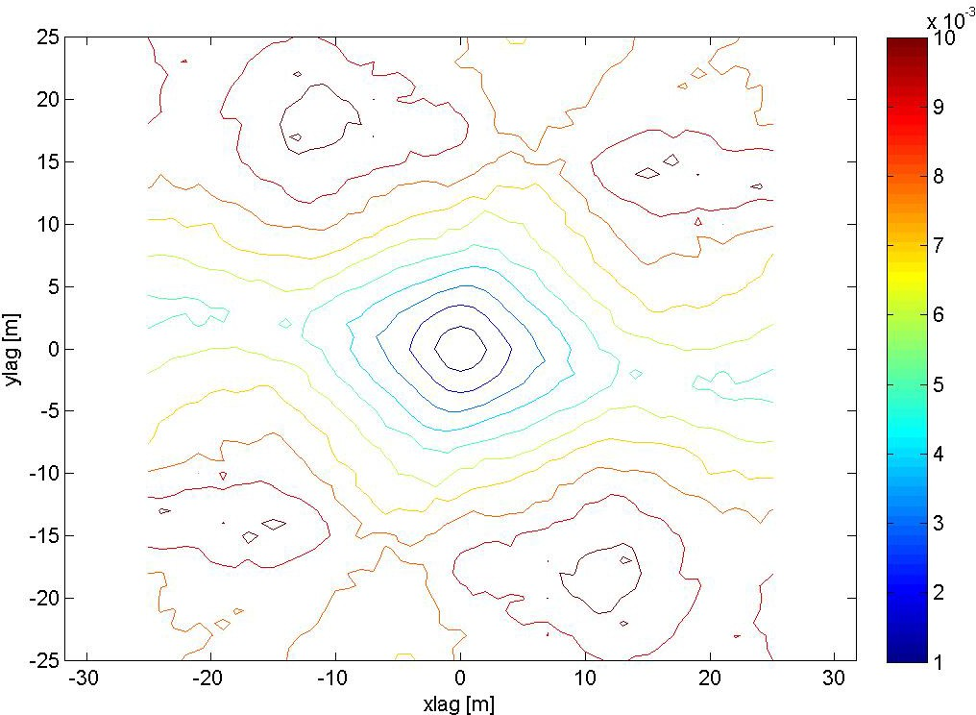

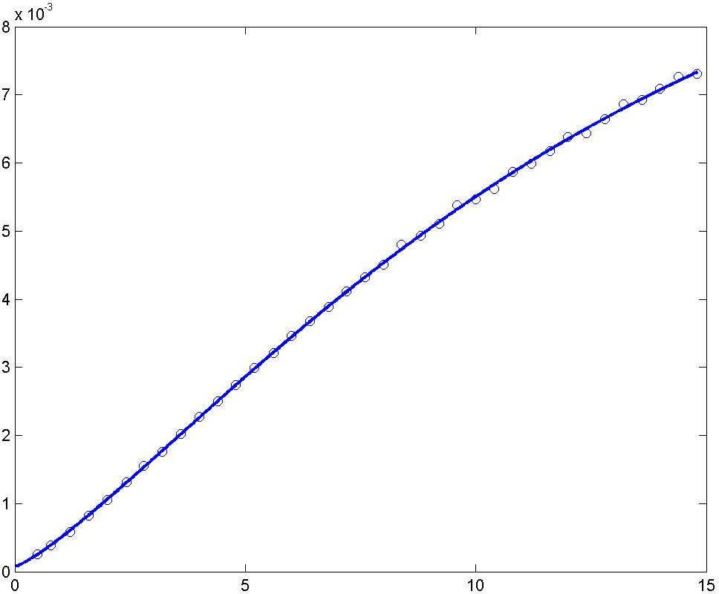

A modified Gaussian semivariogram model is used (power is 1.25 and not 2).

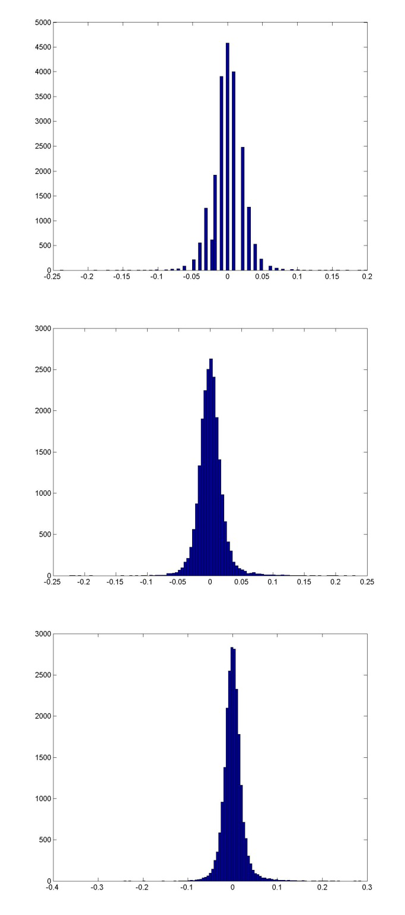
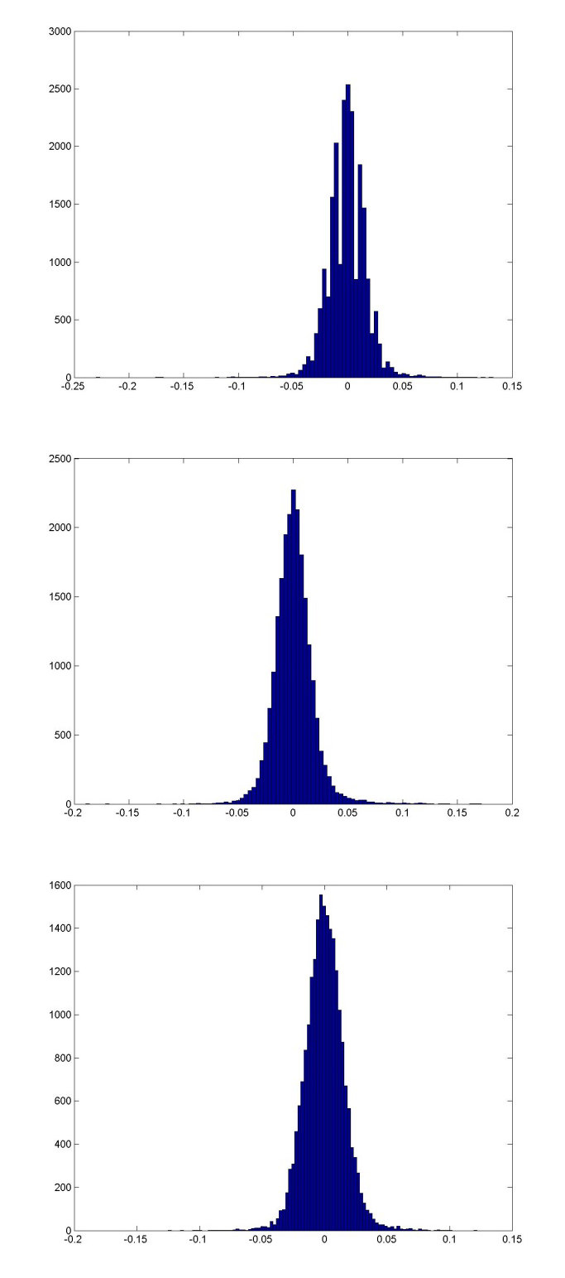

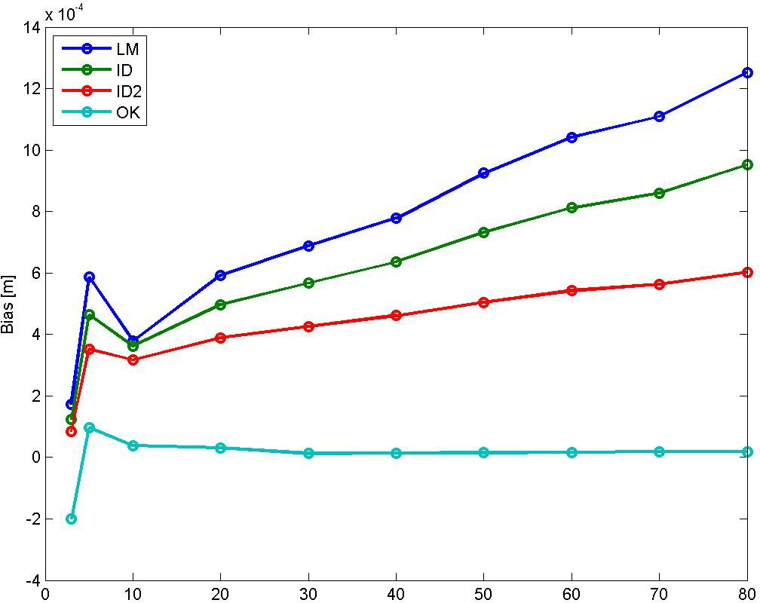

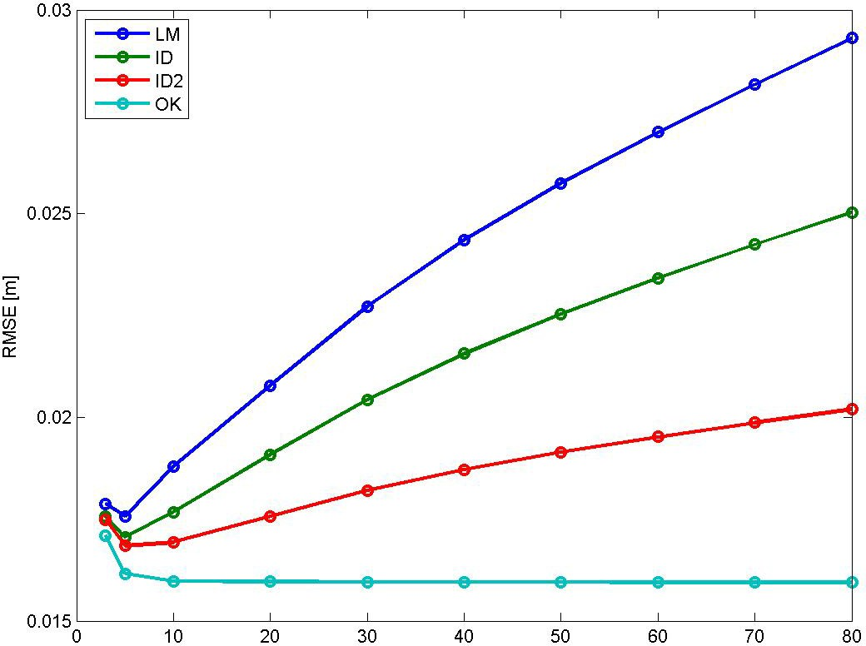

Bias for NN is 7.425e‐05 m, and for TIN ‐0.0008217 m. RMSE for NN is 0.02177 m, and for TIN 0.01730 m.

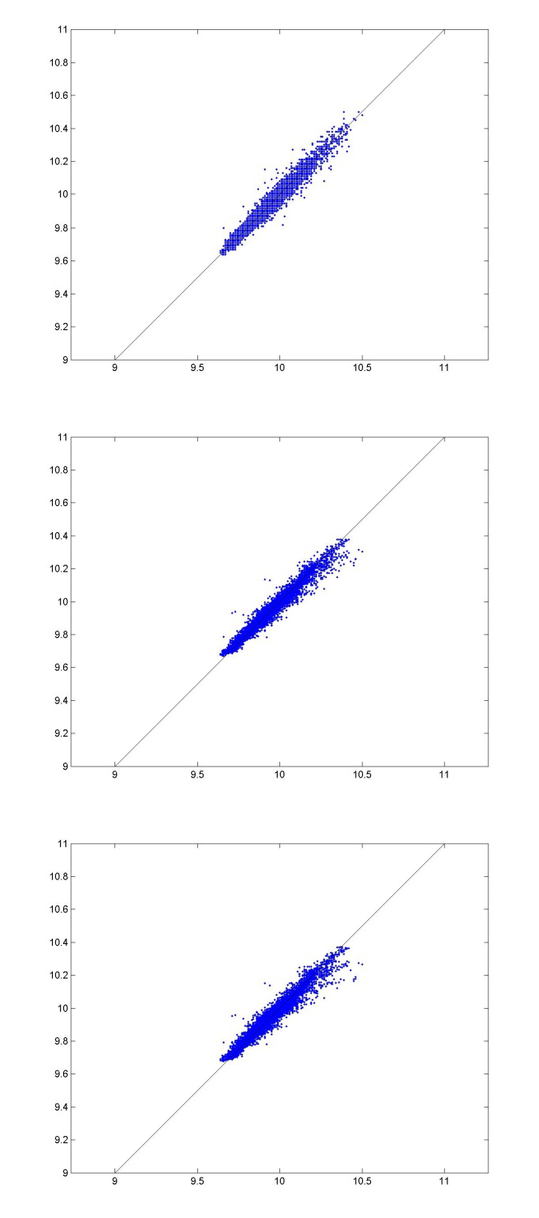
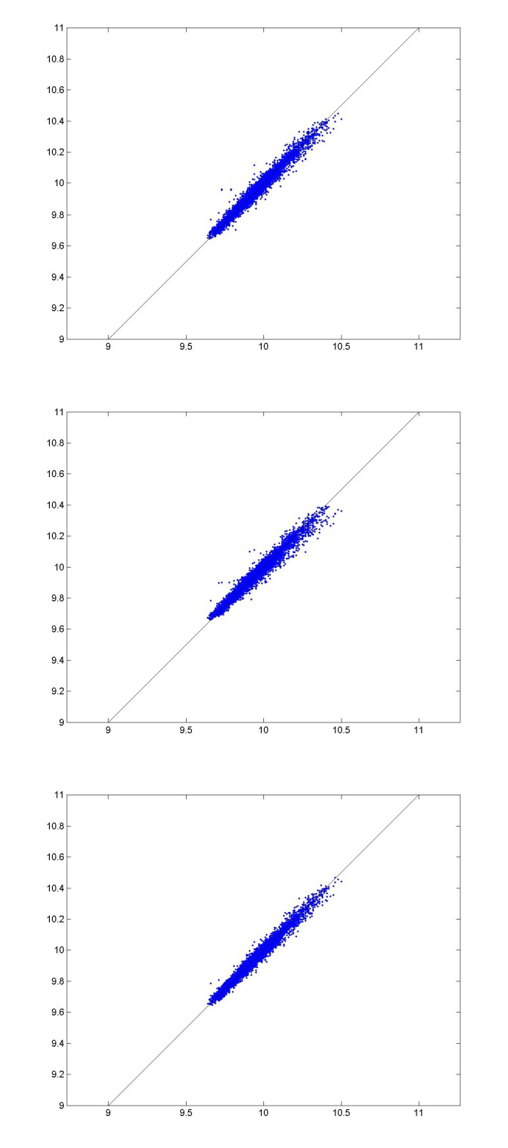

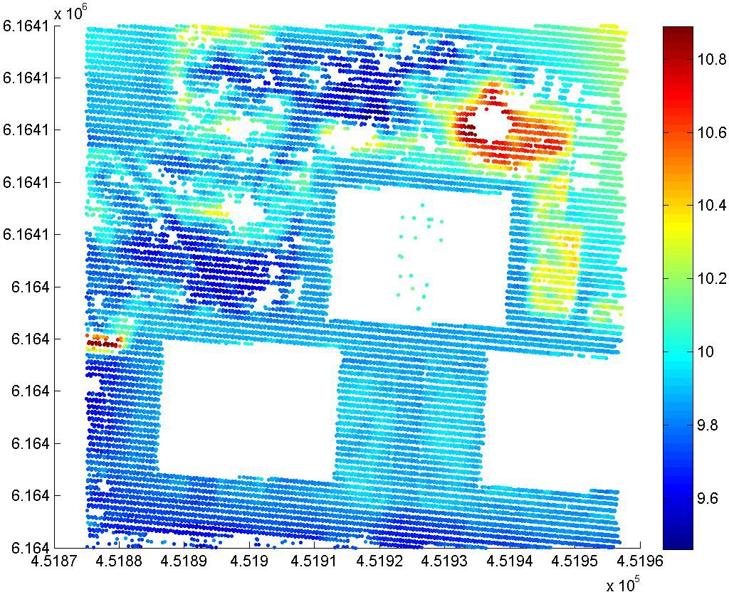

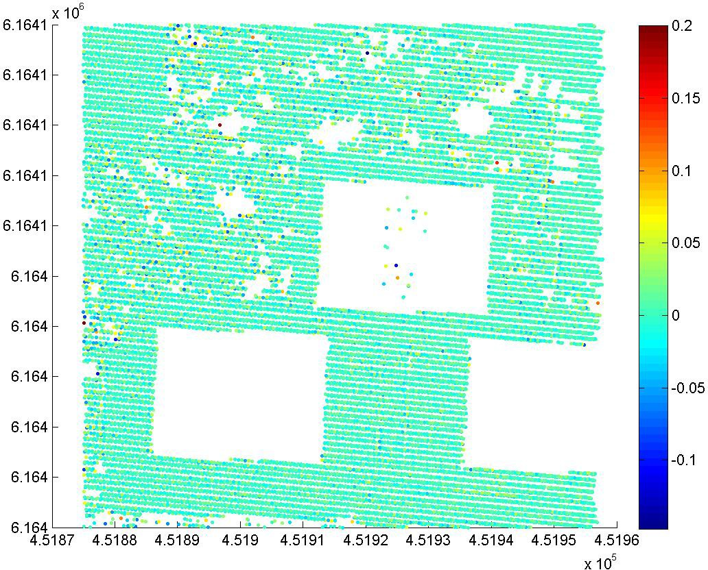

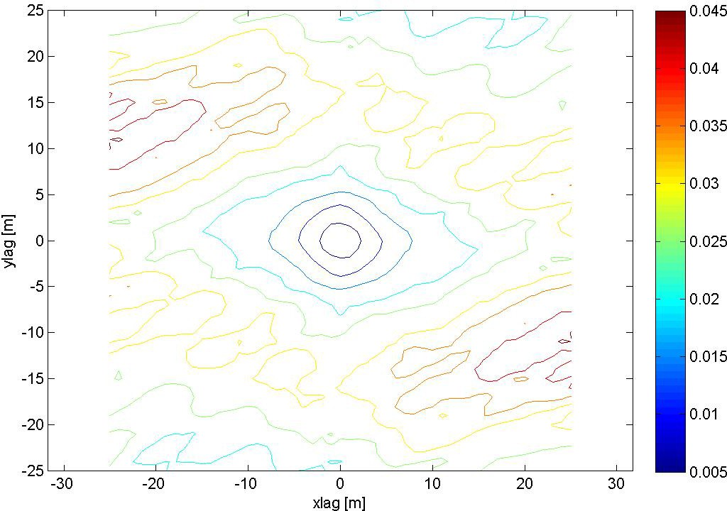

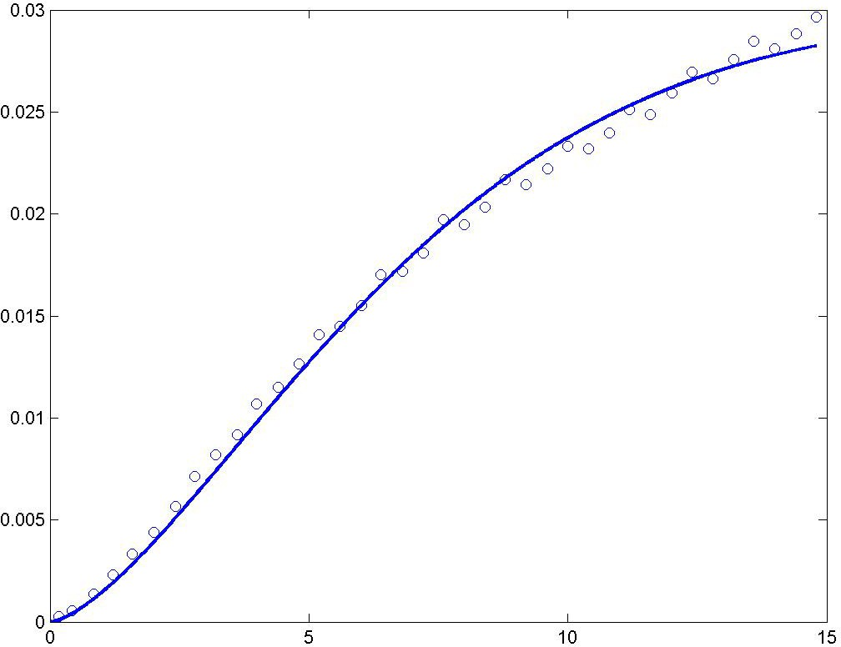

A modified Gaussian semivariogram model is used (power is 1.25 and not 2), no nugget effect.

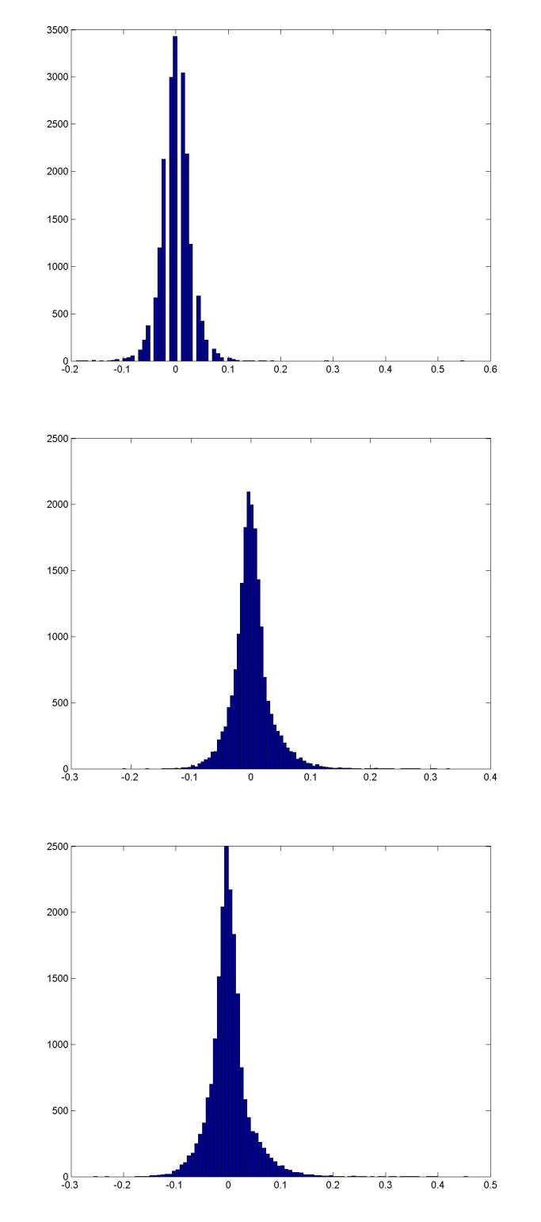
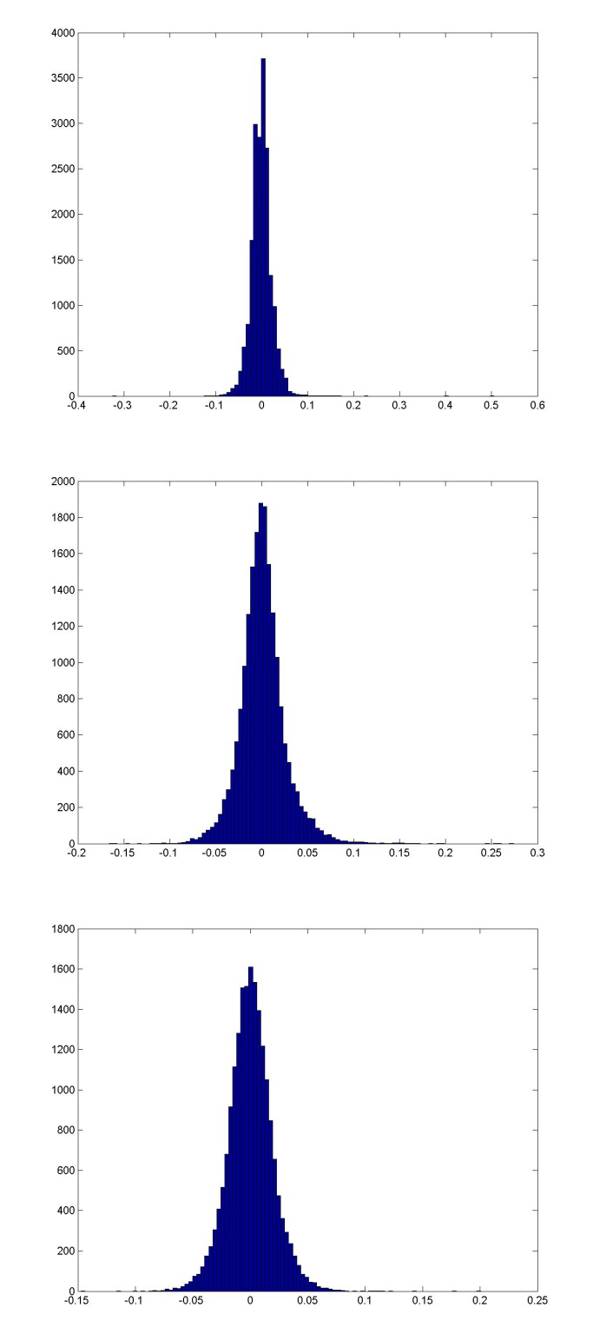

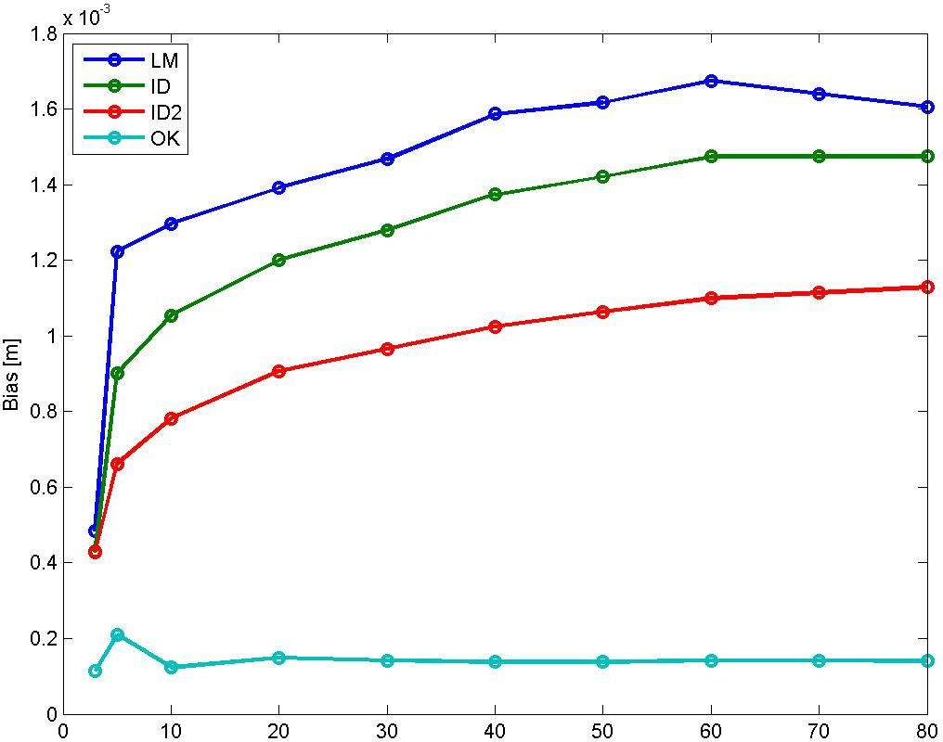

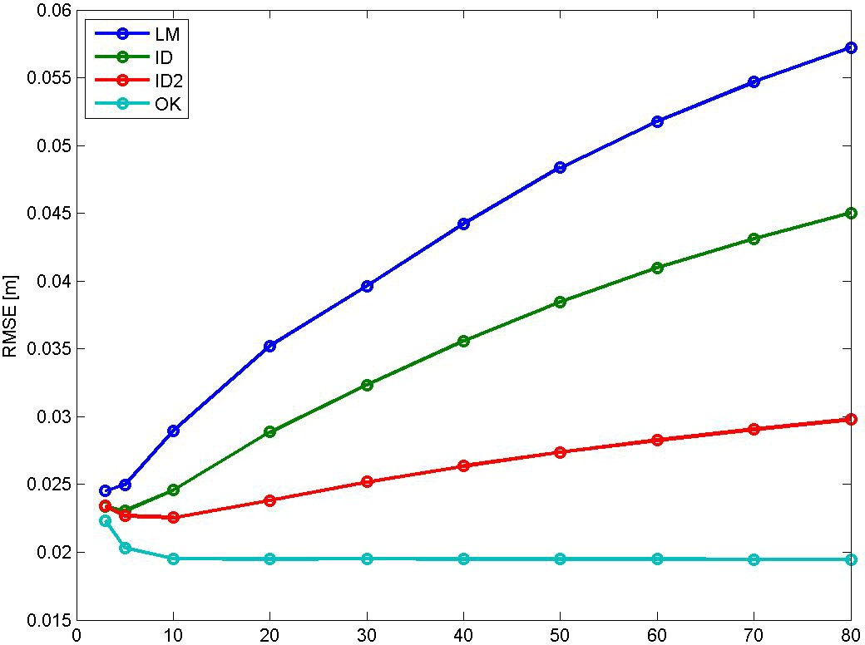

Bias for NN is 0.0005214 m, and for TIN ‐0.000865 m. RMSE for NN is 0.028123 m, and for TIN 0.022446 m.

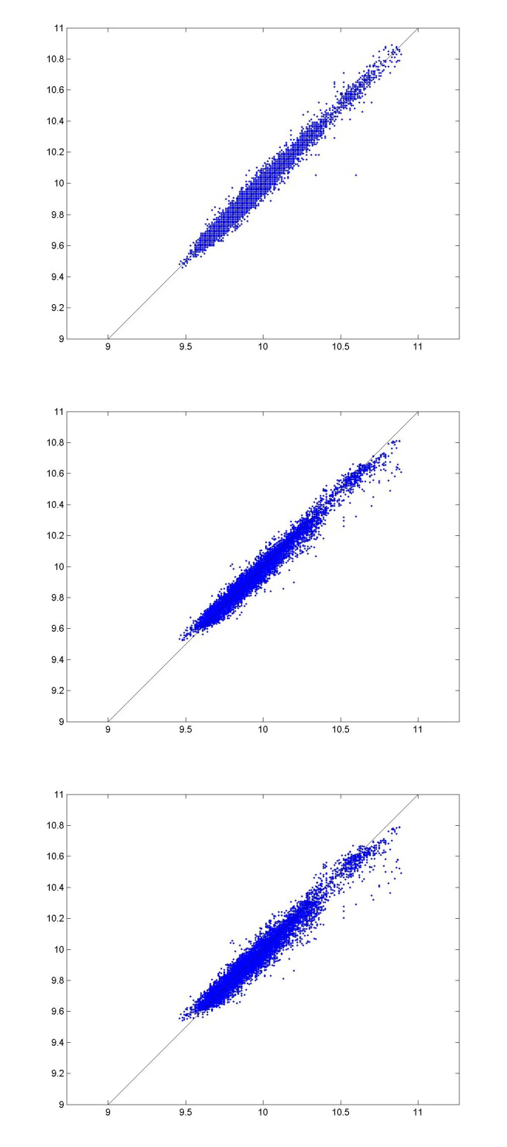
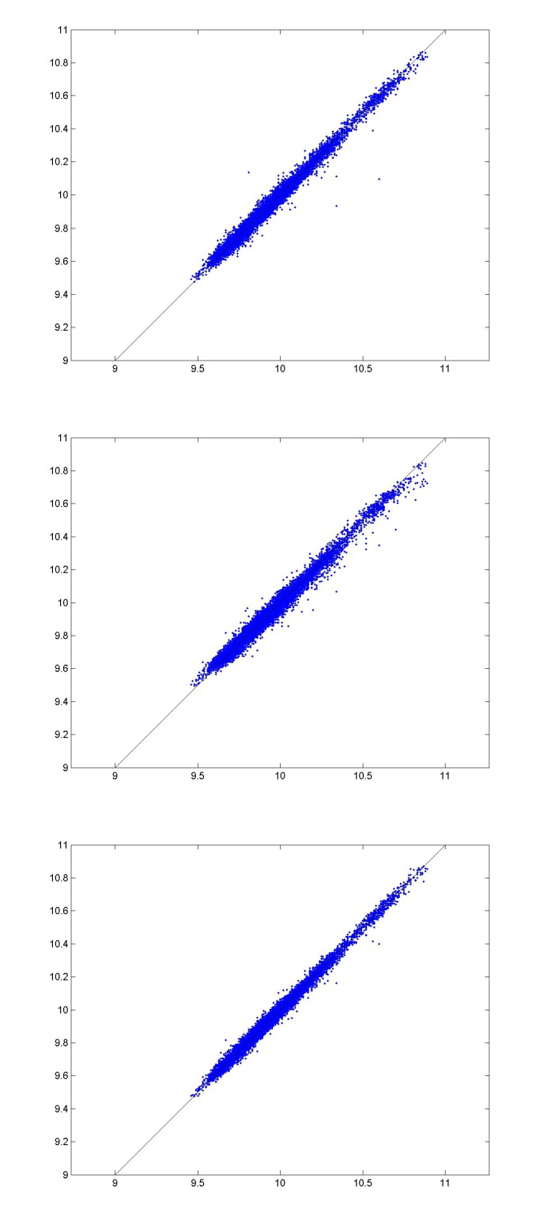

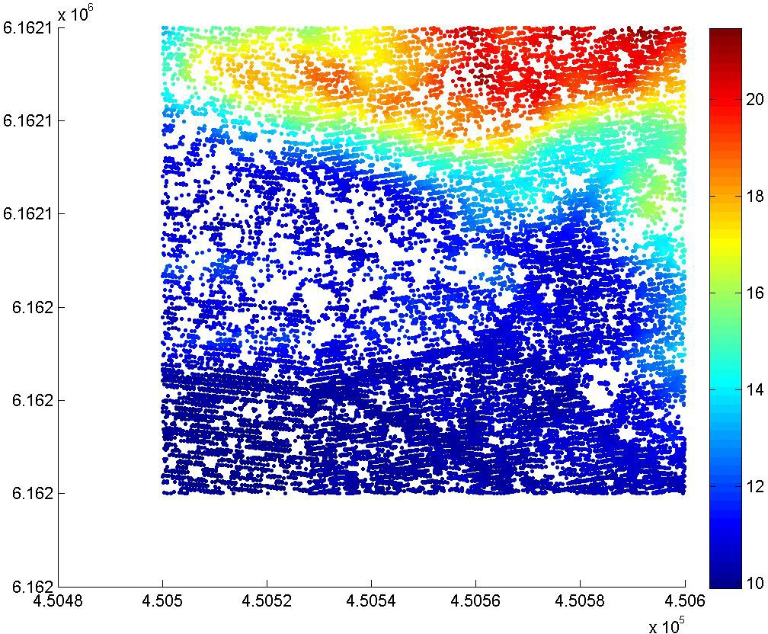

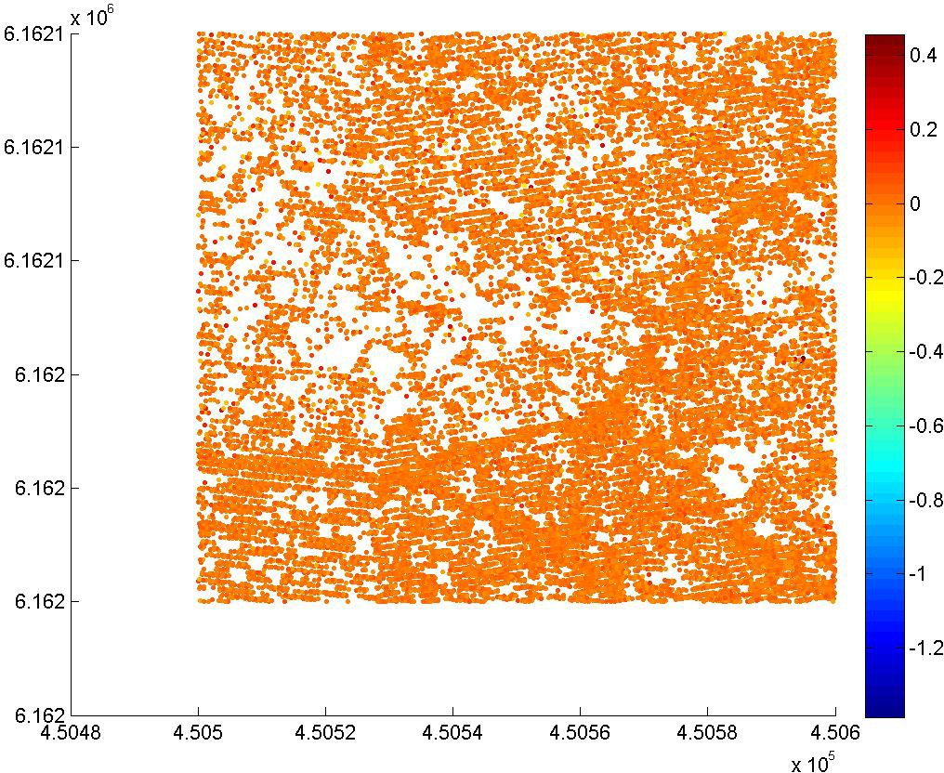

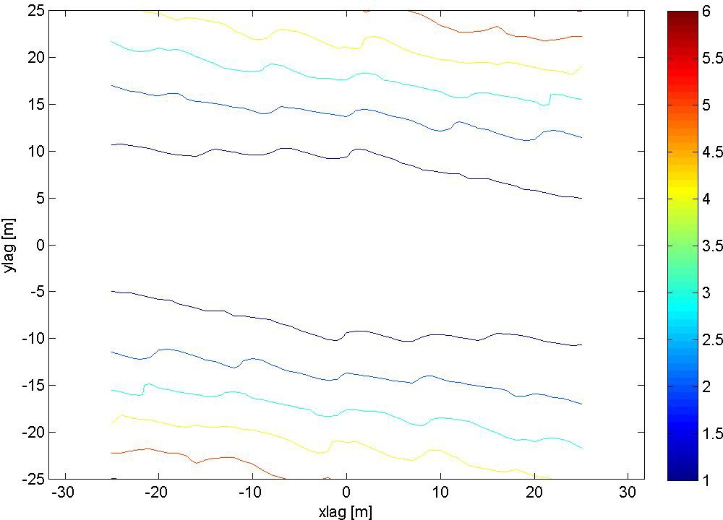

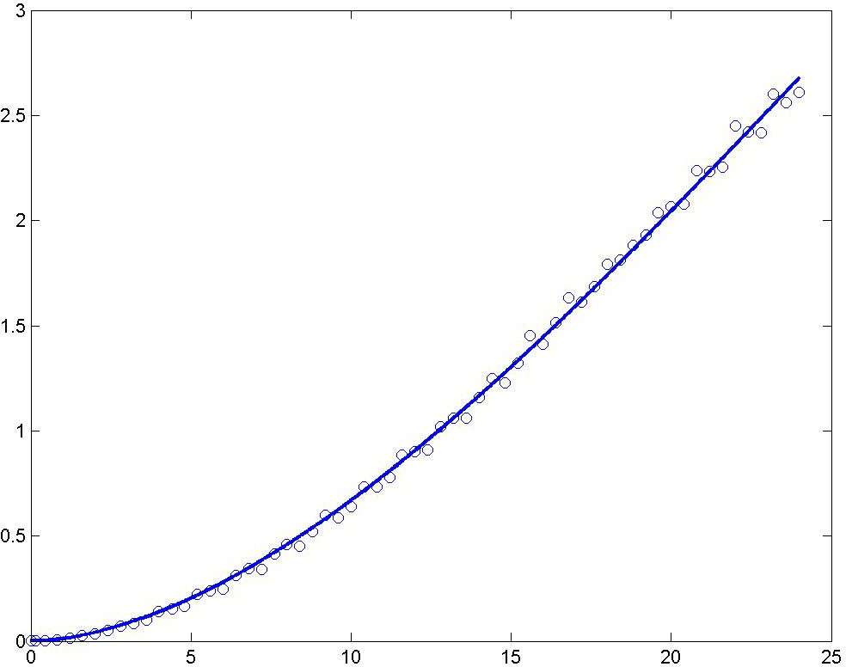

A modified Gaussian semivariogram model is used (power is 1.75 and not 2), no nugget effect.

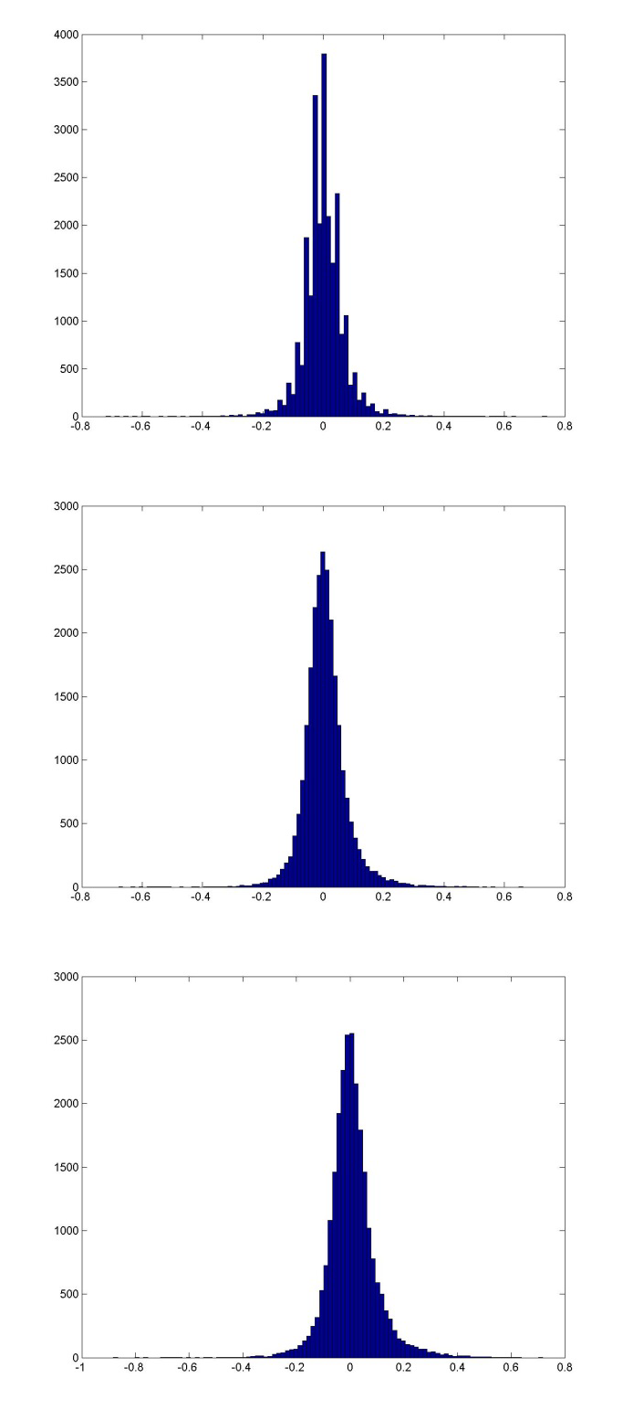
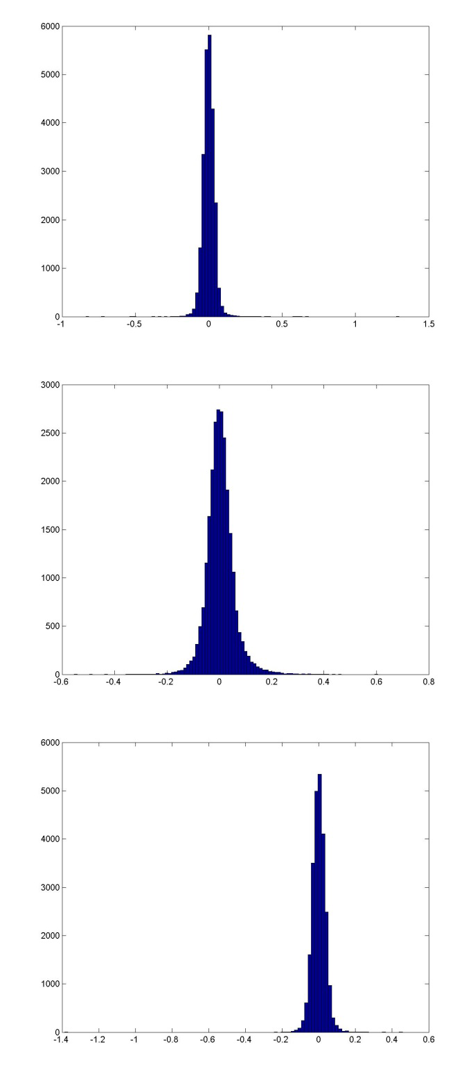

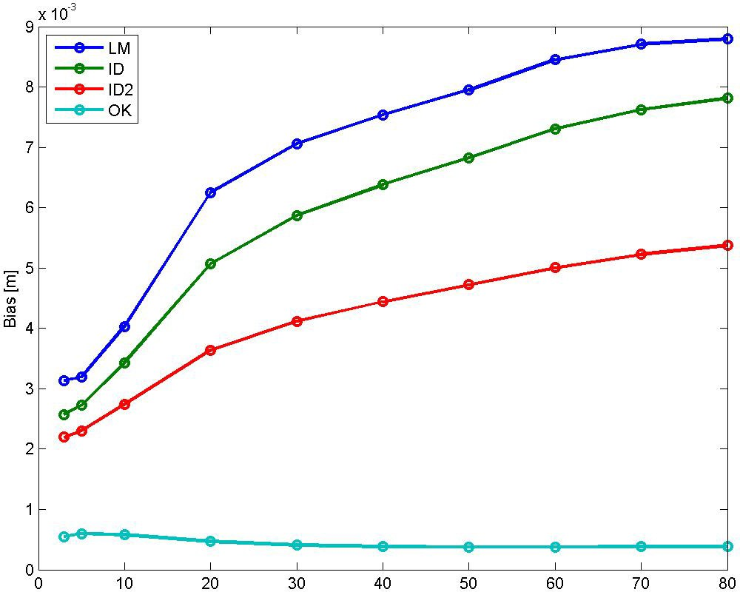

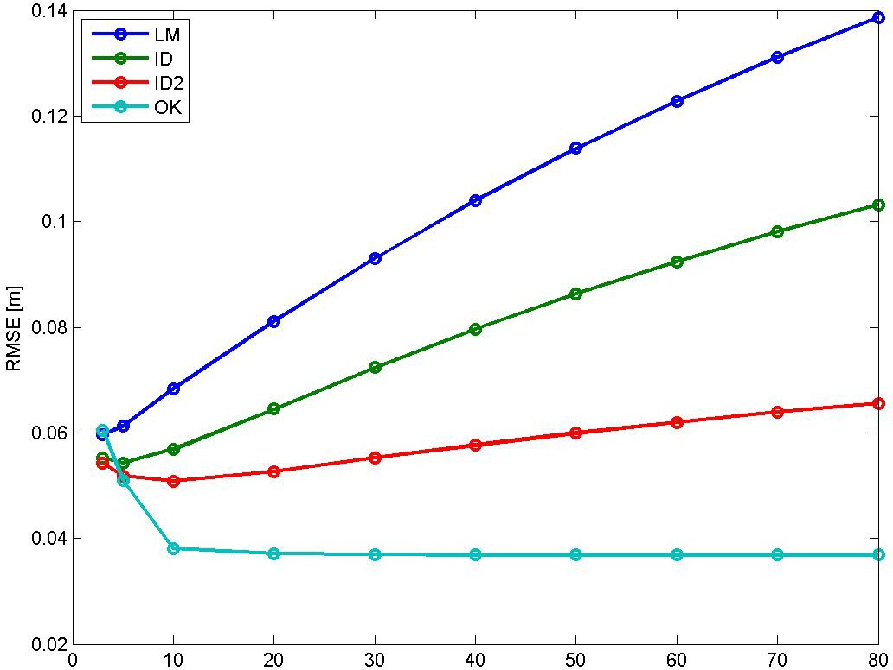

Bias for NN is 0.001561 m, and for TIN ‐0.0007537 m. RMSE for NN is 0.067633 m, and for TIN 0.041353 m.

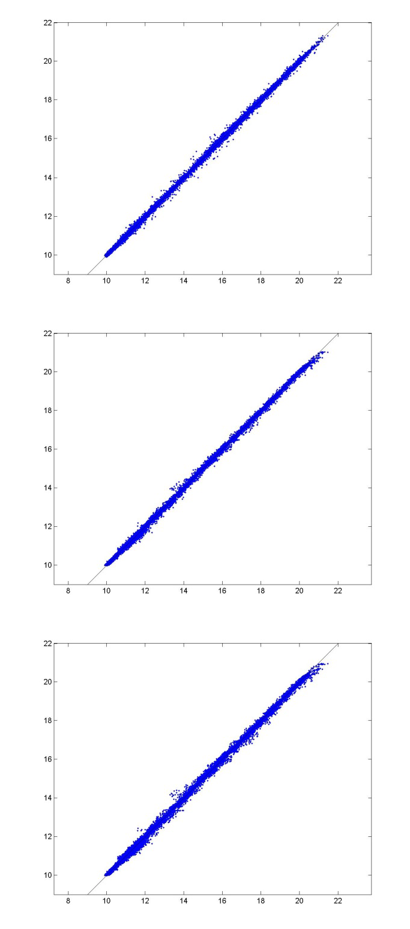
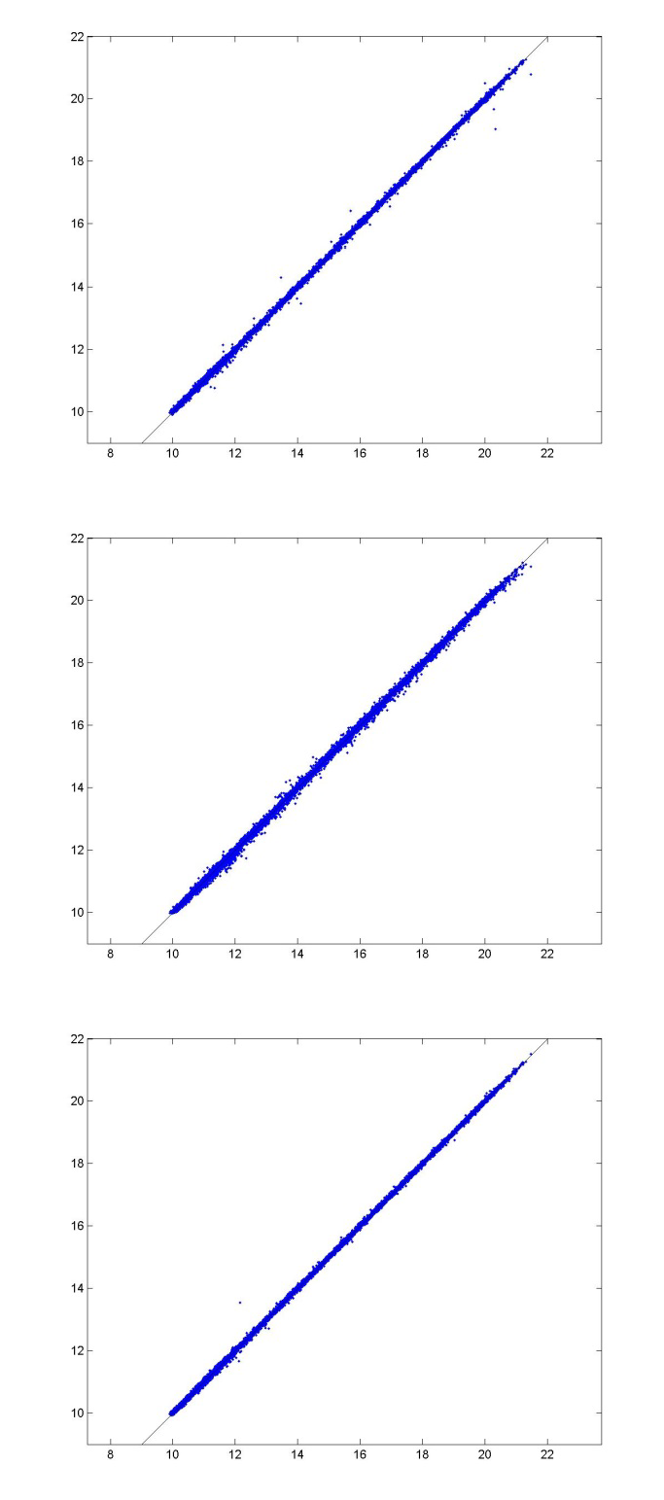

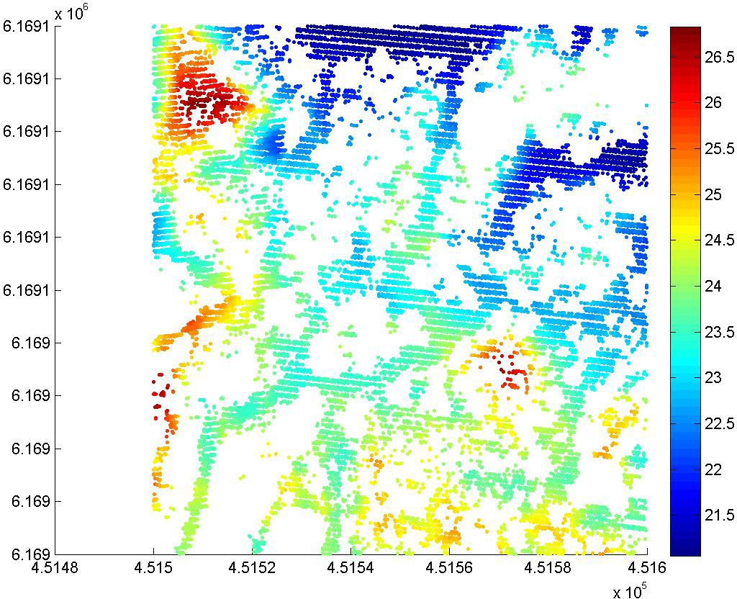

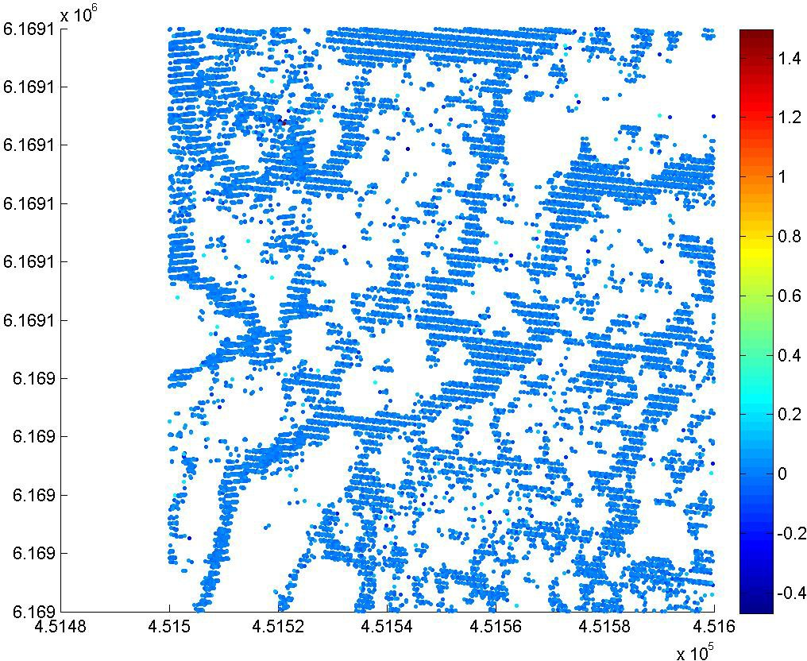

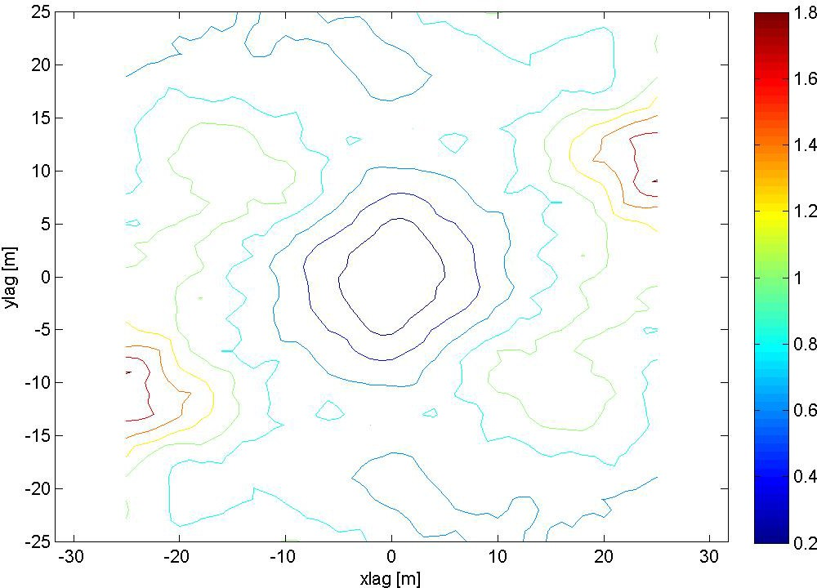

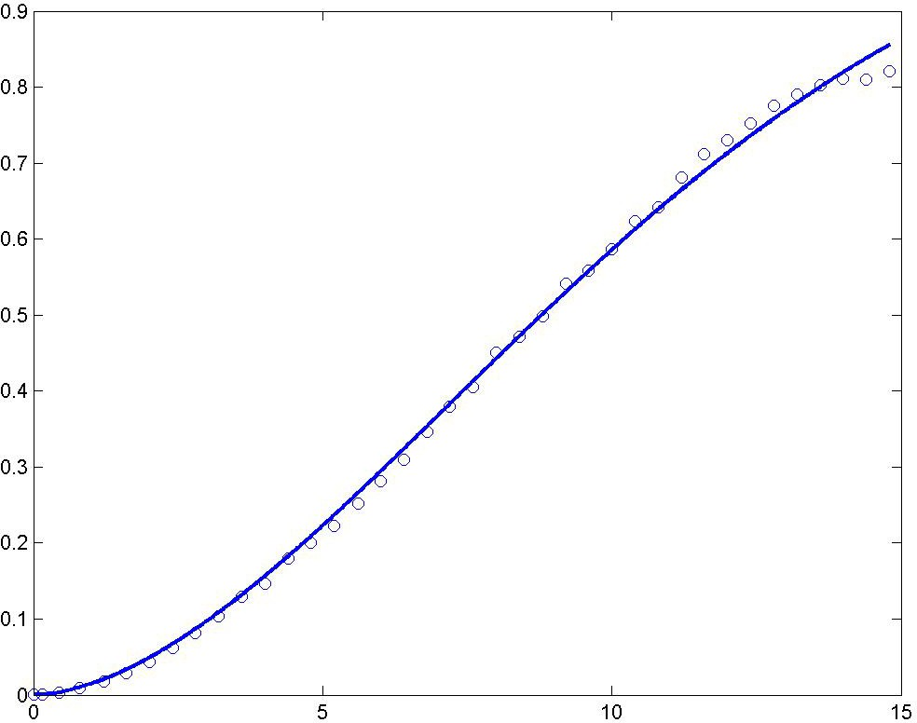

A modified Gaussian semivariogram model is used (power is 1.75 and not 2), no nugget effect.

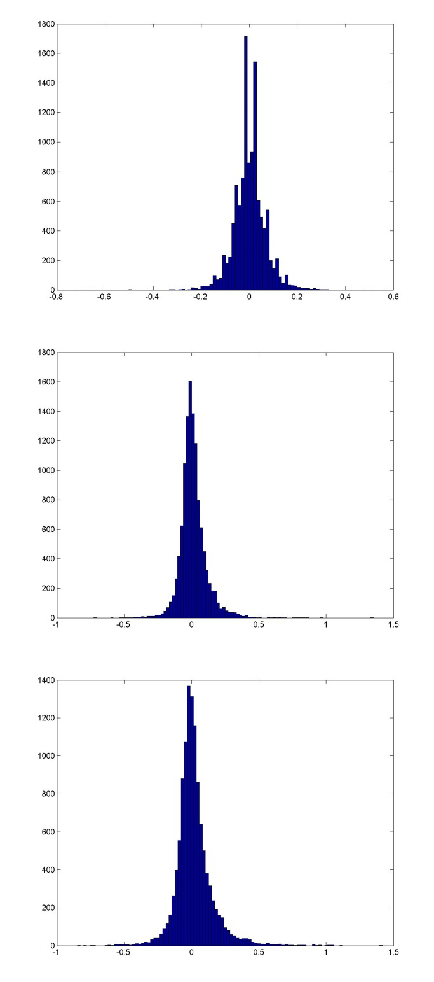
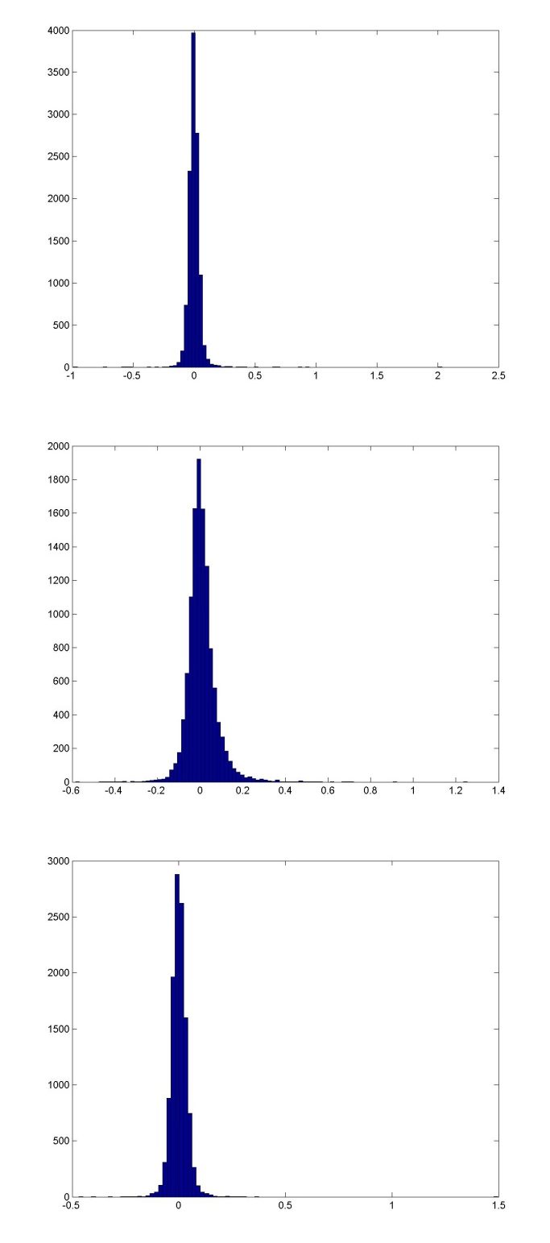

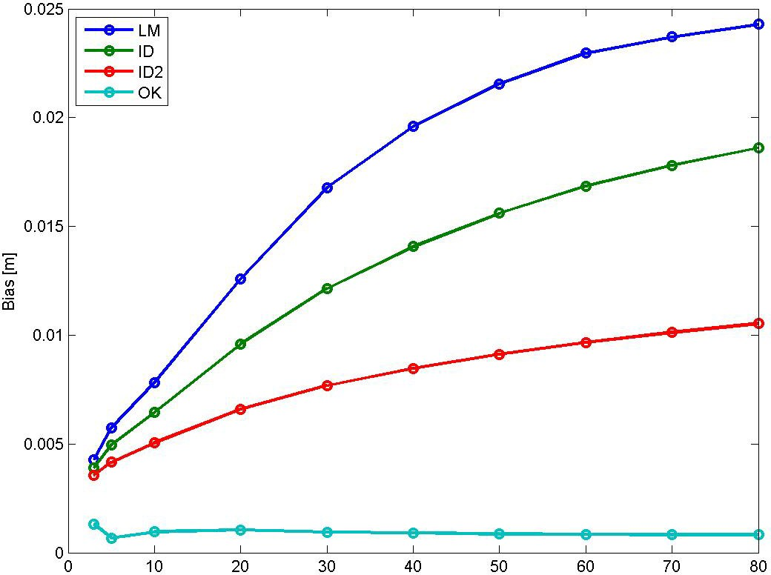

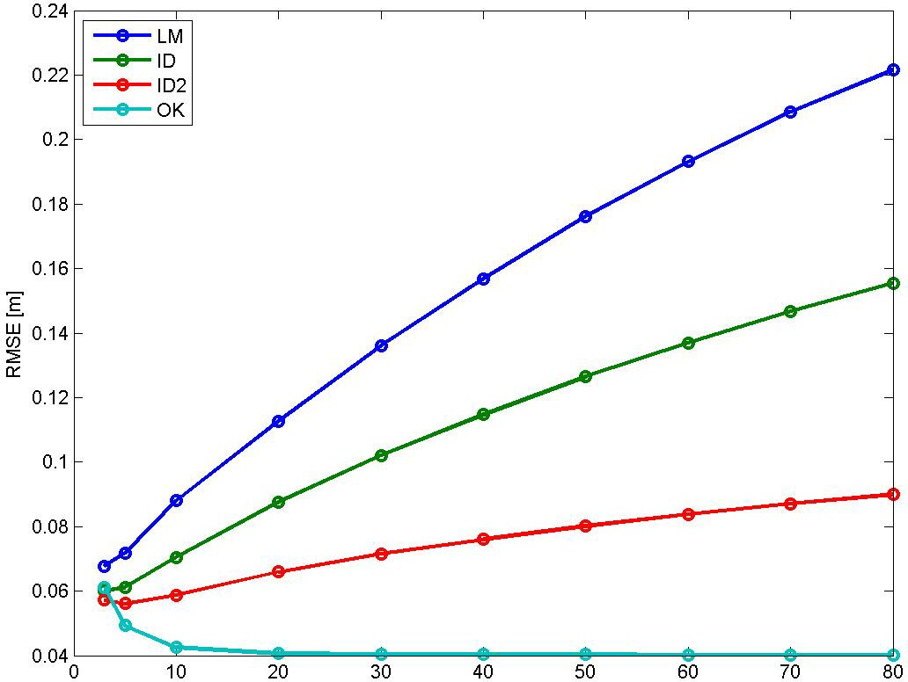

Bias for NN is 0.002464 m, and for TIN ‐0.0006516 m. RMSE for NN is 0.070317 m, and for TIN 0.052671 m.

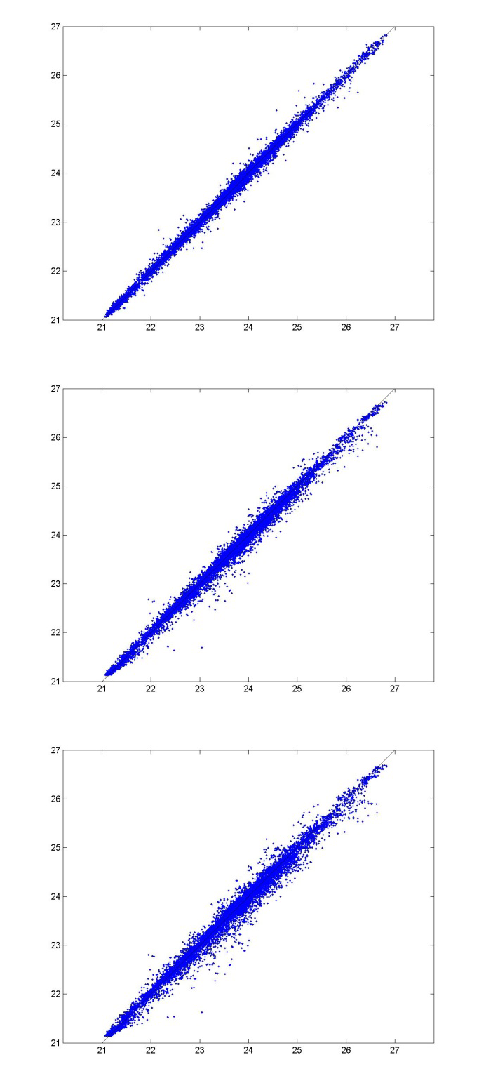
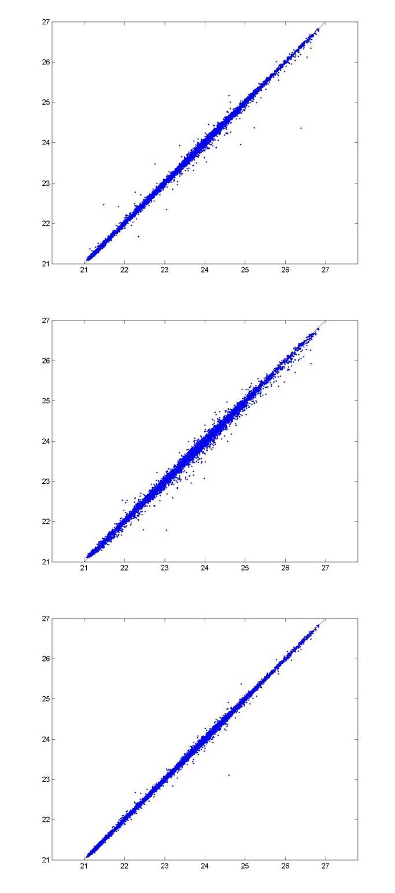

:æ
n. n.
A. n.

A.
A. n.
- I,

I ,
n.
n. n.

132
n.
n.

n. A. A.
A. n.
n. 44

Dråby

A. n. n.
n. A.
Karls

n. n.
53
A.
A.
A. n.
A.
A.
- n. n.
  - A.
A. n.
A. Trehøje n.
(Dyrehøje) _{A.}
n.
127

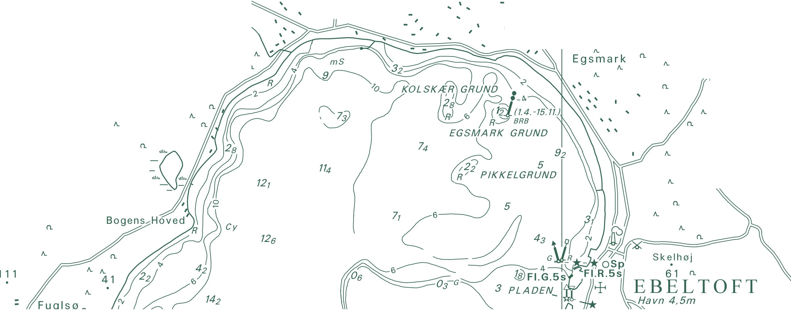Danish Geodata Agency Rentemestervej 8
2400 Copenhagen NV, Denmark http://www.gst.dk

