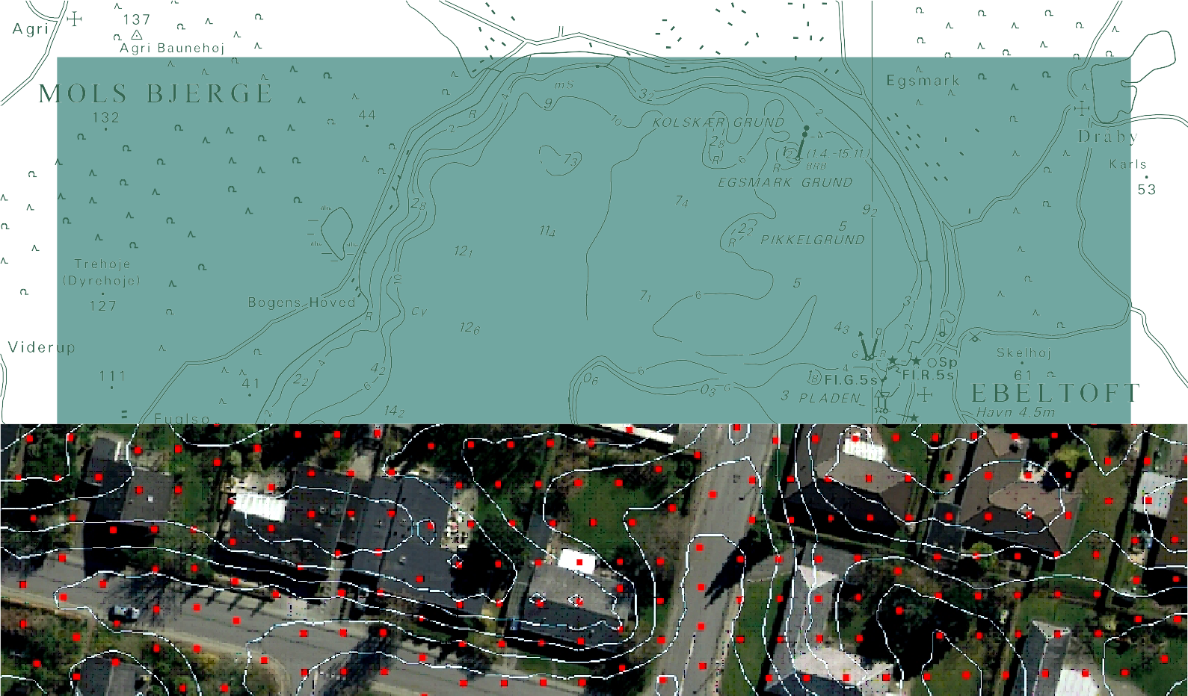

TECHNICAL REPORT NO. 03

Updating of the Danish Elevation Model by means of photogrammetric methods
Professor Joachim Höhle, Aalborg University

2

Updating of the Danish Elevation Model by means of photogrammetric methods
Professor Joachim Höhle, Aalborg University

National Survey and Cadastre – Denmark 8 Rentemestervej
DK-2400 Copenhagen NV Denmark

thokn@kms.dk bpo@kms.dk http://www.kms.dk

Professor Joachim Höhle, Aalborg University :
Updating of the Danish Elevation Model by means of photogrammetric methods

National Survey and Cadastre—Denmark, technical report series number 03 ISBN 87-92107-25-7
Technical Report Published 2009-06
This report is available from www.kms.dk

Prepared using pdfTeX and the LATEXtypesetting system. Parts of the main text typeset using Microsoft Word.

Forord
Danmark har fået en ny højdemodel med en hidtil uset nøjagtighed og punkttæthed. Modellen bygger på laserskannede data, der efterfølgende har gennemgået omfattende beregninger og kvalitetssikringsprocedurer. Datagrundlaget er op- samlet i perioden 2005 - 2007, hvorfor der allerede ved modellens ibrugtagning i starten af 2009 var behov for ajourføring, især omkring de store byer.

Ajourføring af modellen kan foretages ved forskellige registreringsmetoder, og nye data kan tilføjes den eksisterende model ud fra forskellige strategier og metoder.

Skal et større område ajourføres er det mest nærliggende at foretage en ny laserskanning af det berørte område og efterfølgende integrere de nye data i den eksisterende model. En anden metode kan være den digitale fotogrammetri, hvor to eller flere overlappende digitale flyfoto anvendes til automatisk eller semi-automatisk at bestemme højden i et tæt mønster af punkter - den såkaldte billedmatchning.

Set i en større sammenhæng er den fotogrammetriske metode økonomisk attraktiv, idet grundmaterialet i form af digitale flyfoto eksisterer eller vil være til rådighed inden for få år. Efterhånden som samarbejdet mellem stat og kommuner om den topografisk/tekniske kortlægning bliver landsdækkende i FOT samarbejdet, vil der være digitale flyfoto til rådighed, som er mindre end 3 år gamle - typisk helt nye eller 1-2 år gamle.

Nærværende rapport belyser mulighederne i den fotogrammetriske metode baseret på flyfoto. Fotos som er optaget i henhold til kravene i FOT specifikationen.

Arbejdet er udført ved Aalborg Universitet, Institut for Samfundsudvikling og Planlægning af Professor Joachim Höhle som et bestillingsarbejde fra KMS. Rapportens hovedmål at kunne medvirke som beslutningsgrundlag, når strategi og metoder for ajourføring af højdemodellen skal fastlægges. Rapporten indeholder en række spændende og til dels over- raskende resultater og konklusioner.

Poul Frederiksen Landkortområdet
Kort og Matrikelstyrelsen

CONTENTS

1. Introduction…………………………………………………………………. 9
- Extent of the investigation………………………………………………….. 9
- General strategy for solving the task 10
- Preparation of the investigation 10
- Selection of the test areas 11
- Flight planning and flights 12
- Determination of the reference data 14
  - Fix points 14
  - Ground control points 14
  - Checkpoints 14
  - DK-DEM/Terrain 15
- Software for the test 15
  - Software of Inpho GmbH 15
  - Other software 16
- Orientation of images 18
- DEM generation 19
- Filtering of the DEM 19
- Completion of the DTM 21
- Assessment of the accuracy 21
- Results of the DTM tests 22
Test A 22
Test B 30
Test C 32
Test D 43
Test E 50
Test F 52
Test G 57
- Economic considerations 58
- Summary and conclusions 59
- Recommendations 61
Acknowledgement 61
References used in this report 62
References relevant for the topic 62

Introduction

This report deals with the task of updating the DTM 2007 (DK-DEM/Terrain) which was produced by means of airborne laserscanning (Lidar). Most of the DTM applications require updated elevations, and accurate, economic and practical procedures have to be applied in the updating of areas of change. In order to specify the methodology and procedures for the updating of the DTM 2007 practical tests have to be carried out. The photogrammetric method comes into focus because new images of high resolution are available for the whole territory of Denmark every third year. Furthermore, the photogrammetric method has recently received new tools which may solve the updating of the DTM for areas of change. Images play already a role in the quality control of the DTM 2007 and in the updating of the topographic vector database. Both technologies can be combined in order to solve the updating of the DTM 2007 including an efficient quality control of the DTM. KMS has initiated the study on the updating of the DTM 2007 already in 2007 and a first study (called phase 1) has been carried out by Aalborg University and the author. This project (called phase 2) deals now with practical tests and, based on the gained experiences and results, proposals and suggestions will be made for the upcoming task of revising and updating of the DK-DEM/Terrain.

Extent of the investigation

The task of updating a DTM can be separated into several steps. First, the areas of changes have be found, new elevations have then to be determined, the old and new data have to be merged and quality control has to be carried out at the end. The photogrammetric method can be useful in each of the steps. This project will concentrate on the generation of the new elevations in the areas of change. The photogrammetric approach to automatic generation of DTMs can also be divided into various steps: Orientation of the images, generation of a course surface model (DSM) and filtering of the data with the purpose of obtaining a Digital Terrain Model (DTM), closing the gaps by interpolation, and finally the accuracy assessment. As mentioned before, there are new tools available for the photogrammetric approach and they will be applied. Images are available with different ground resolution (GSD=10 cm and GSD=20cm) as well as a DTM derived by laserscanning including filtering to bare earth (DTM). The assessment of the accuracy has to be done by reference data of superior accuracy. The accuracy and completeness differ for

different types of terrain and the checking of the DTM has to be carried out for each type of terrain separately. Economic considerations are also of interest. The extent of this work has to match the available resources and the specified dead line. The test of the DSM (DK- DEM/Surface) and applications of DTMs (e.g. contour lines, modelling of bridges and houses) is not part of this project. The DTM is represented as a regular grid of elevations; the original point cloud will not be investigated in this project either.

General strategy for solving the task

The accuracy of DTMs differs in various types of terrain. Three terrain classes (open terrain, built-up terrain, and forested areas) are chosen and the accuracy of generated DTMs will be determined for each class. Checkpoints have to be determined by ground surveying in order to achieve a superior accuracy of the checkpoints. The amount of points should be relatively large in order to obtain reliable results. The orientation of the images should be very accurate and
will therefore be based on accurate ground control points (GCPs). The camera parameters should be used as they are given by the calibration report of the manufacturer.

A set of experiments will be carried out step by step in order to find a solution to the given tasks. The used data, programs and procedures will be described shortly.

Preparation of the investigation
Several innovations in DTM generation by photogrammetry were announced in the last year and various papers were published on the topic (Inpho 2008a-d), (Goa 2008), (Wind 2008) and (Overbye 2008). This and other literature has been studied. Practical experience with new tools has been gained as well. The topic is also of interest to European National Mapping Agencies and others. The European Organization of Spatial Data Research (EuroSDR) deals with it and representatives of the member countries discussed the topic at their last meeting (EuroSDR 2008). The impact of laserscanning in the production of topographic databases, DTMs and other geodata is not clear to the European mapping community and guidelines have to be derived.
KMS organized seminars for the Danish users of the DK-DEM products and exchanged ideas between Nordic countries (KMS 2008). The preparation of the investigation included the study of laser scanning as well as of the photogrammetric approach using digital images and advanced correlation techniques.

Selection of the test areas

Test areas were selected near AAU in order to keep costs for ground surveying small. The selected area has the required terrain types: open area, built-up area and forested area. It should be the same area for the two types of images. The area is partially flat and partially hilly. The elevations reach from 5m to 70m. The built-up area consists of one level houses. Each type of landscape should be checked by reference data. Ground control points (GCPs) were necessary in order to obtain an accurate orientation of the images. The distribution of ground control points (GCPs) and checkpoints (CPs) can be seen in Figure 1 and Figure 2 respectively.

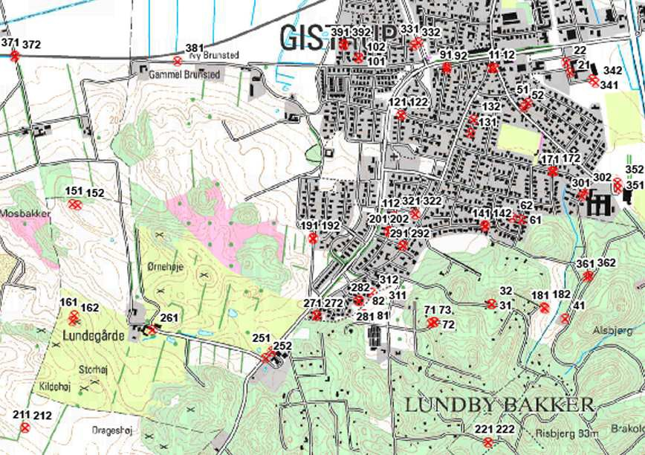

Figure 1. Distribution of used ground control points

The checkpoints of a terrain type are distributed in three sub-areas. They are arranged in profiles at the open area. In the built-up area they are placed between houses, and in the forested area on paths and beside the paths.

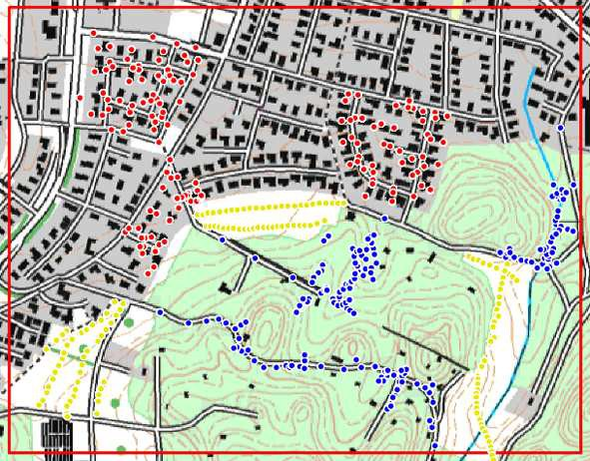

Figure 2. Distribution of checkpoints. The checkpoints are plotted in yellow colour for open terrain, in red colour for the built-up area and in blue for the forested area.

Flight planning and flights
The images were taken by two DMC cameras of Intergraph (c=120 mm, geometric resolution pel=12 µm). The distortion-free virtual image of the DMC has a format of 13824 pixels x 7680 pixels or 165.9 mm x 92.2 mm. Flying height above ground were 1000m and 2000m respectively resulting in GSDs of 10cm and 20cm. The DMC01_0049 of Scankort was used for GSD=20cm imagery and their DMC01-118 for GSD=10 cm imagery. The width of the single flight lines is 1382m at flying height of 1000m and 2765m at 2000 m for the applied camera. The overlap has been 60% in flight direction and 20 % between the stripes. Figure 3 shows the flight lines of the GSD=10cm images and Figure 4 the flight line of the GSD=20cm images.

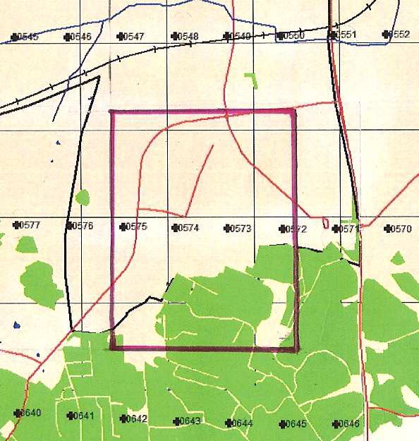

Figure 3. Flight lines of the GSD=10cm images (east/west flight). The red frame depicts the area for which a DTM is generated.

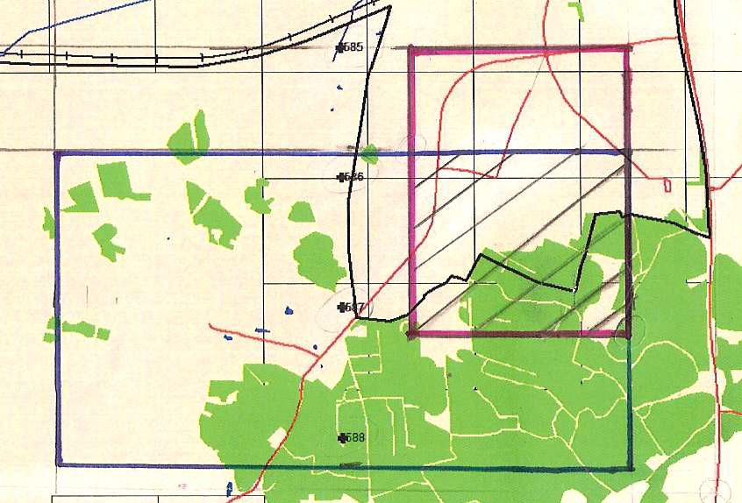

Figure 4. Flight line with the GSD=20cm images (north/south flight). The hedged area is the test area.

The photography took place in spring 2008. This all is according to the specifications for the FOT program of KMS. The images were delivered in tif- and ecw-format. The radiometric resolution of the delivered images was 8bit or 256 levels of intensity for each of the four colour channels. Only the red, green and blue (RGB) channels were used in the investigation. The

colour images are derived by pan-sharpening, which means that the low resolution colour bands are fused together with high resolution panchromatic images. The use of such synthetic colour images gives good possibilities in the interpretation of the content (e.g. identifying the control points), but the conditions for DTM generation are not optimal.

Determination of reference data
Reference points are needed for the orientation of images and for the checking of the DTMs. Some fix points (GI points) were measured additionally in order to ensure that all measurements had the same reference. All of these points (ground control points, checkpoints and fix points) were determined by field measurements using GPS/RTK. Furthermore, the DTM derived by laser scanning has to be checked whether it can qualify as a reference of superior accuracy.

  - Fix points
Three fix points for planimetry and five fix points in height within and around the test area have been measured. The mean squared differences (RMSD) between the two coordinate sets were RMSE=3.4cm in Easting and RMSE=2.7 cm in Northing, and 0.6 cm in Elevation. The differences are small and no correction had to be used for GPS/RTK measurements.

  - Ground control points
78 ground control points (GCPs) were determined by field measurements using GPS/RTK. In built-up areas mainly manhole covers were used, in the open areas other well-defined objects (stones, circular water container, etc.) with contrast to the surroundings were selected and marked in prints of the images. All GCPs were measured twice within a few hours in between the measurements. The precision derived from double measurements were σ _{X,Y} = 1.2 cm and σ _{Z}
= 1.9 cm. Pairs of GCPs were well distributed over the whole image so that each image could be oriented with a high redundancy.

  - Checkpoints
455 checkpoints were determined for the three types of terrain types: open land, built-up and forested area (cf. Figure 2). The measurements in the built-up and the open areas were carried

out again by means of GPS/RTK, but in the forested areas by a total station. The number of checkpoints has to be relative high in order to obtain small confidence intervals.

  - The DK-DEM/Terrain
The DK-DEM/Terrain is determined by airborne laserscanning using GPS/IMU measurements for georeferencing. Data collection occurred in 2007. The raw data are filtered and the elevations should represent the terrain. Delivery of the data by KMS occurred in the ESRI format where the origo is defined as the lower left corner of the lower left cell and the elevation data start at the upper left cell. According to the specification of KMS the vertical accuracy of interpolated points should be σ= 0.15 m (standard deviation) and the maximum errors should not be higher than 0.4 m (KMS2007). Such accuracy would be sufficient as reference data. In order to make sure that the delivered data keep the specified accuracy, the DK-DEM/Terrain (DTM 2007) was checked by the help of the reference data described in chapter 7.3.

Software for the tasks
Over the years various manufacturers have produced software packages to generate DTMs from images. In 2007 progress in packages for DTM generation and for DTM editing was announced by Inpho GmbH and BAE Inc. It was the goal to use the new software packages from one of the two manufacturers for the tasks. One stereo-work station of the laboratory for Geoinformatics of AAU was then used to work with this new software. Furthermore, software in “MatLab” and “R” has been used to derive accuracy measures of the generated DTMs. In the following the used software is shortly explained.

  - Software of Inpho GmbH
The software of Inpho GmbH for DTM generation and DTM editing comprises the following program modules: ApplicationsMaster, Exterior Orientation, Match-T DSM, DTMaster, and DTM toolkit. The version 5.1.0 was used at the start of the investigations and later updated to version 5.1.3.

ApplicationsMaster
ApplicationsMaster is the core component of Inpho’s photogrammetric system. It integrates project generation, handling tools and application programs into one environment.

Exterior Orientation
By means of this program the exterior orientation of single images can be determined using monoscopic measurements of GCPs. The mathematical model is ‘resection’ using least squares adjustment.

Match-T DSM
DSMs and DTMs can be calculated from a block of images. A very dense point cloud is calculated first from which a grid of elevations is derived by means of robust finite elements interpolation. The DEM is seamless and small buildings and trees can be filtered away. Some of the parameters are optimized automatically. Morphological data like spot heights and breaklines can also be input. The output is a regular grid with one common grid spacing together with morphological data in a hybrid data structure.

DTMaster
DTMaster is a DEM editor. There are two versions of the program, DTMaster Stereo and DTMaster for monoscopic measurements. The use of the stereo vision enables efficient editing of the DEMs as well as 3D data collection. The program integrates photogrammetry and handling of DEMs and map data for the tasks of editing, supplementing and quality control.

DTM toolkit
By means of this tool box Digital Elevation Models can be merged, splitted and converted into different formats.

  - Other software
In order to derive accuracy measures for the derived DTMs software had to be created and modified.

DEM quality control - part 1 (search and interpolation)
In the generated DTM the program searches the adjacent points to the position of the checkpoints. Elevations at the position of checkpoints are derived by means of interpolation. The

type of interpolation can be selected according to the characteristics of the DTM (density, data structure). The outputs are the list of the checkpoint coordinates and their vertical error.

DEM quality control 2 – part 2 (standard and robust accuracy measures)
The standard accuracy measures are derived by the formulae of Table 1. A normal distribution of the errors is assumed.
Vertical error | Δh = h _{DTM} – reference height
Root Mean Square Error | ∧ 1 n  RMSE = ∑ Δh2  n i  i=1
Mean error | μˆ = 1 ∑n Δ  hi  n i=1
Standard deviation | n  σˆ = 1 ∑(Δh − μˆ)2  (n − 1) i  i=1
Threshold for outliers | |Δh | ≥ 3 · RMSE
Number of outliers | N

Table 1. Accuracy measures for DEMs presenting a normal distribution of errors

The important accuracy measures of DEMs (systematic shift of reference and standard deviation) should not be influenced from outliers and non-normality of the error distribution. DEMs derived by digital photogrammetry and laser scanning very often have outliers and a non-normal distribution of errors. A histogram or QQ-plot will reveal this. Therefore, the robust statistical measures of Table 2 are calculated by this program in addition.

The Median is the middle of all elevations errors, if the values are arranged from the lowest to the highest value. The Median Absolute Deviation (MAD) is the median of the absolute differences between the elevation errors and their median. Multiplying the MAD value with the constant (1.4826), the Normalized Median Absolute Deviation (NMAD) is obtained. The NMAD value corresponds approximately to the standard deviation (σ) of the normal distribution.

The Median and the NMAD are more resilient to outliers. The 95% quantile is the absolute value of this elevation error which divides the dataset into two parts: one with 95% and the other with 5% probability. Quantiles are less susceptible to long-tailed distributions and outliers.

Accuracy measure | error  type | Notational expression
Median(50% quantile) | Δh | Qˆ Δh(0.5) = m_{Δh}
Normalized Median Absolute Deviation | Δh | NMAD = 1.4826⋅ median_{j}( |Δh_{j} - m_{Δh}|)
68.3% quantile | |Δh | | Qˆ |Δh|(0.683)
95% quantile | |Δh | | Qˆ |Δh|(0.95)

Table 2. Robust accuracy measures for DEM derivation

More information on robust statistical methods in the assessment of DEMs can be taken from the references, for example (Höhle&Höhle 2008). In the following chapters the steps in the DTM generation are explained and details about used parameters will be given.

Orientation of images
Before the photogrammetric procedures can start, each image has to be converted into a set of images of different geometric resolution (pixel size). The resulting ‘image pyramids’ enable a better handling (e.g. zooming) and a processing from coarse to fine DEMs. The resampling of the images used a Gaussian interpolation and nine levels of resolution were derived. The camera parameters of the manufacturers’ calibration report were used. Earth curvature and refraction were corrected.

The orientation of images is done by measurement of the ground control points in each image. The GCPs have to be well distributed over the whole image in order to receive accurate results. The coordinates of the GCPs were supplemented with weights (σ _{E,N} = 2 cm, σ _{Z} = 3 cm). The standard deviation of the residuals in the images and the precision of the orientation parameters were monitored. Basically the DTM generation requires a high accuracy of the orientation data. Therefore, the orientation data of this investigation could be calculated with a large number of accurate GCPs resulting in a high redundancy.

DEM generation
The generation of DEMs requires manual setting of about 40 parameters. These parameters have influence on the results and some experiments were necessary in order to select the proper settings.

Different settings were done for the following parameters:

DEM type: DSM or DTM Grid width: 10m, 3m, 1.6m
Use of morphological data: no, GCPs, DTM 2007 Fixed settings in the control parameters were:
Type of terrain: Undulating Parallax bound: 16 pixels Epipolar line distance: 1 pixel
Threshold for the correlation coefficient: 0.8 Window size for correlation coefficient: 5 x 5 [pixel] Resampling: on
Adaptive matching: on

The weighting of the finite element interpolation used always the default values.
The size of the area was specified by the given overlap area. The tests used two, three and four images for the block. Borderline correction was chosen always with ‘on’. (This possibility is an improvement to the previous version of the program which produced big errors at the edges of the model). All selected parameters are stored in a log file.

Filtering of the DEM
The objective of this investigation is to derive a DTM from the Match-T output data. All elevations above the terrain (on top of houses, trees, vehicles, etc.) have to be removed. Such a filtering occurs already when the proper parameters in Match-T are set (parallax bound, weights for the finite element interpolation). But corrections and other editing of the Match-T output data

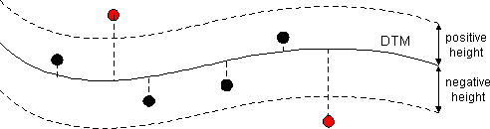
are still necessary. This task was carried out by the 3D editor program “DTMaster”. A classification of the DSM data into terrain, buildings, vegetation and other object classes could also be a request. Such a task is more difficult to solve and not necessary for a DTM generation. Filtering of the DTM can automatically be carried out for large areas. The parameters of filters have to be found by some manual operations using the “brush” function of DTMaster. The size of the area, where filtering will be carried out, can be selected. Certain values have to be defined for each filter (cf. Figure 5). The ‘gross error filter’ defines a threshold. The ‘building filter’ uses

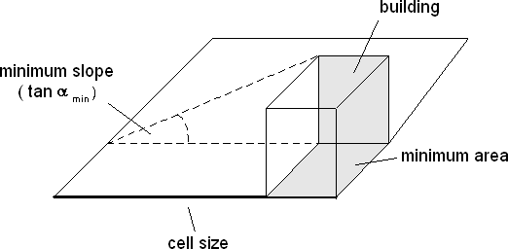
gross error filter

building filter

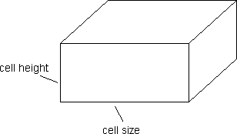
vegetation filter

Figure 5. Applied filters (gross error, buildings, and vegetation) and their parameters

cell size (=2 x point density), minimum area of the building (s²) and a minimum slope (tan α _{min}) as parameters for detection of buildings. The vegetation filter uses four parameters: Cell size 1, cell size 2, cell height 1 (≈cell size) and cell height 2 (<cell size) to eliminate vegetation. The

program derives an internal DTM with a new grid size equal to the specified cell size. This interpolated DTM is then used to analyze the original DTM. Filters for gross errors, buildings and vegetation can be applied separately or combined in a “strategy”. The effect of the applied filter strategy can be visualized by means of profile views, perspective views and/or under stereo vision. This 3D viewing of the DEM together with the image pair is the most effective editing.
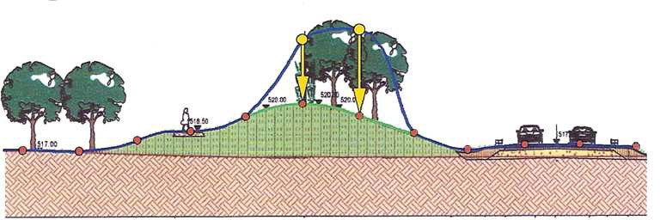
Other editing functions of DTMaster concern the shift of the height reference, setting of absolute heights for selected points, deleting of points, re-interpolating points (cf. Figure 6), and interpolating of gaps, etc. Elevations can also be measured by means of a 3D-cursor. These functions are carried out manually before and after the automated filtering.

Figure 6. Editing function “Re- Interpolation of points” (taken from Inpho 2008b)

Completion of the DTM
The DTM should have a complete regular grid which means that the removed elevations in the filtering have to be replaced by new ones using interpolation with the adjacent terrain points. The interpolation is carried out by different methods which the program selects. A maximum ‘gap distance’ was specified using three times the grid width. Other tasks to be carried out concern the merging of different DTMs and the conversion of DTMs (e.g. from ‘Binary SCOP format’ to ‘ASCII format’).

Assessment of the accuracy
It was already pointed out that DTMs derived by digital photogrammetry (or by laserscanning) may have gross errors and a non-normality in the distribution of errors. The standard accuracy measures and the robust accuracy measures should therefore be derived. The number of checkpoints should be large enough to ensure small confidence intervals. Three classes of terrain will be tested and there should be about 150 points per class. The inherent accuracy will be an important part of the DTM characteristics.

In the following various tests will be done in order to come up with recommendations how the updating of the DTM 2007 could be carried out by photogrammetry. The tests start with one model of the 10 cm imagery and the methodology of the DTM generation and editing will be derived step by step and then used for all of the images. The final results are then discussed.

Results of DTM tests

Test A
The DTM derived by digital photogrammetry comprises one model of the 10 cm imagery. Details in the various steps of the DTM generation are the following:

Orientation of the model:
The model consists of two images with GSD=10cm. DEM generation:
A DTM is derived. Spacing of the grid posts is 10m. Filtering:
Filtering is used by means of the default Match-T functions. Assessment of the accuracy:
Because the number of checkpoints has influence on the reliability of the accuracy measures (size of the confidence interval) various combinations of checkpoints have been used. The checkpoints are either distributed over the whole area with a low density or with a high density.

The results of the DTM evaluation using Ground Control Points (GCPs) as reference data assuming a normal distribution of the errors are summarized in Table 3a. The achieved standard deviation of the DTM is calculated with RMSE = 46 cm. A relatively high systematic error is present (µ=22 cm). The robust accuracy measures (cf. Table 3b) are somewhat less (Median = 20 cm and the 68.3% quantile = 37 cm). The errors are distributed normally and there are no outliers. Therefore, the results are nearly the same by both methods of assessment. The achieved accuracy is, however, relatively low. The number of check points (n=13) is too small which results in relatively large confidence intervals (cf. Table 3b).

Accuracy measures | value  [cm]
RMSE | 46
Mean ( μˆ ) | 22
Standard deviation (σˆ ) | 41
Mean (after removal of outliers) ( μˆ *) | 22
Standard deviation (after removal of outliers) (σˆ * ) | 41

Table3a. Results of a photogrammetrically derived and filtered DTM. Evaluation is done with the assumption of normal distribution by means of n=13 checkpoints (GCPs) of which none is classified as outlier by the 3⋅RMSE threshold.

Robust accuracy measures | error  type | value  [cm] | 95% confidence interval  [cm]
Median(50% quantile) | Δh | 20 | [14 , 38]
NMAD | Δh | 21 | [18, 63]
68.3% quantile | |Δh | | 37 | [33 , 72]
95% quantile | |Δh | | 87 | [61 , 110 ]

Table3b. Accuracy measures of the robust method for a sample size of n=13 GCPs

When checkpoints and ground control points are used as reference, the number of points is considerably higher (n=231). The results of the assessment are presented by Tables 4a and 4b.

Accuracy measures | value  [cm]
RMSE | 114
Mean ( μˆ ) | 49
Standard deviation (σˆ ) | 104
Mean (after removal of outliers) ( μˆ *) | 41
Standard deviation (after removal of outliers) (σˆ * ) | 77

Table 4a. Accuracy measures of a DEM derived by digital photogrammetry and checked by GPS measurements (n=231 checkpoints of which 3 are classified as outliers by the 3⋅RMSE threshold).

Accuracy measure | error  type | value  [cm] | 95% confidence interval  [cm]
50% quantile (median) | Δh | 36 | [33,48]
NMAD | Δh | 65 | [61,77]
68.3% quantile | |Δh| | 72 | [72,86]
95% quantile | |Δh| | 197 | [176,270]

Table 4b. Accuracy measures of the robust methods for the sample size of n=231

There are three blunders present. The non-normality of the error distribution can also be detected by calculating two values, skewness and kurtosis. Both values are high (3.7 and 29.0 respectively). Viewing the histogram or a so-called QQ-plot reveals the non-normality of the error distribution. The standard accuracy measures (RMSE, µ, σ) differ very much from the robust accuracy measures (68.3% quantile, median, NMAD). The latter values are not so much influenced by the outliers and the non-normality of the error distribution. The relative large number of the sample size leads to a narrower confidence interval compared to the one with a much smaller number of checkpoints. This example stresses the need for application of the robust methods in the accuracy assessment and the use of a large number of checkpoints.

The availability of the very dense DTM derived by airborne laser scanning (ALS) and automatic labelling of ground points gives the possibility of checking the elevations of automated photogrammetry thoroughly. The DTMs have different grid spacing: 10m for the photogrammetric DTM and 1.6 m for the laser DTM. Elevation values for the posts of the photogrammetric DTM were derived by nearest neighbour interpolation. The tolerated coordinate difference was set to 0.8 m. The differences between the two elevations were then first evaluated with the accuracy measures assuming a normal distribution (cf. Table 5a).

Accuracy measures | value  [cm]
RMSE | 139
Mean ( μˆ ) | 29
Standard deviation (σˆ ) | 136
Mean (after removal of outliers) ( μˆ *) | 22
Standard deviation (after removal of outliers) (σˆ * ) | 92

Table 5a. Accuracy measures of a DEM derived by digital photogrammetry and checked by a dense grid derived from laser scanning (259446 checkpoints of which 5754 are classified as outliers by the 3⋅RMSE threshold).

Accuracy measure | error  type | value  [cm] | 95% confidence interval  [cm]
50% quantile (median) | Δh | 10 | [10 , 12]
NMAD | Δh | 55 | [53 , 56]
68.3% quantile | |Δh| | 70 | [69 , 73 ]
95% quantile | |Δh| | 256 | [251 , 272 ]

Table 5b. Accuracy measures of the robust methods for the sample of size n=259446.

2.2 % of the differences are outliers. They reach from -15.8 m to +11.2 m. After removal of outliers (using a threshold of three times RMSE) the resulting standard deviation is considerably reduced (from 136 cm to 92 cm). But outliers are still present and the thresholding could be repeated several times and better results will be obtained. But this is not a good approach.

The histogram shown in Figure 7 reveals that a robust approach must be taken in order to obtain reliable accuracy measures for the DEM.

The median of the differences between the two DTMs is 10 cm which is a value for the systematic shift between the two DEMs. The robust estimator (NMAD) of the standard deviation is 55 cm and the 68.3% quantile of the distribution of absolute differences (|Δh|) is 70 cm (cf.
Table 5b). Again, the robust accuracy measures (68.3% quantile, median, NMAD) are not so much influenced by outliers and the non-normality of the error distribution. The derived values are very much lower than the standard accuracy measures. Of interest is the spatial distribution of the differences (cf. Figure 8).

From Figure 8 it is obvious that outliers have especially occurred in the southern (wooded) part of the test area. The use of accuracy classes for different type of landscape is therefore justified. The reason for the large differences is not clear. The DTM derived by laser scanning data has to be tested in order to make sure that it can be used as reference with superior accuracy.

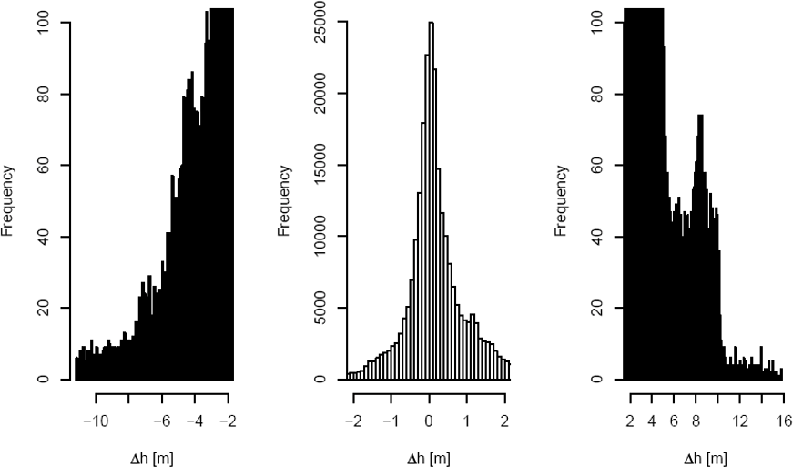

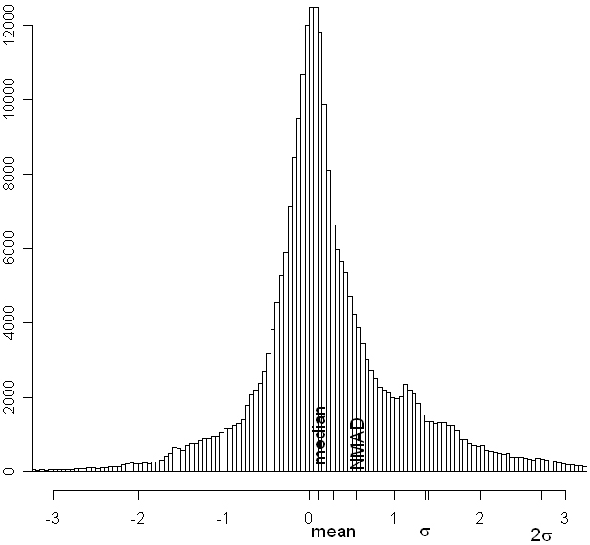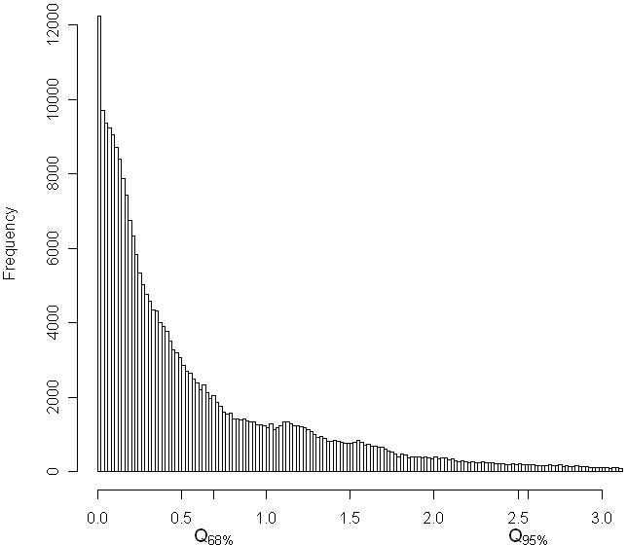
RMSE
Δh [m]
|Δh| _{[m]}

Figure 7. Histograms of the differences in elevation between the DTM derived by laser scanning and the DTM derived in test A. In the lower part of the figure the robust accuracy measures (median, NMAD and 68.3% and 95% quantiles) are plotted together with the standard accuracy measures (RMSE, mean, standard deviation). Note the difference in scales and ranges on the axes. The number of classes is selected differently therefore the number of errors per class varies also.

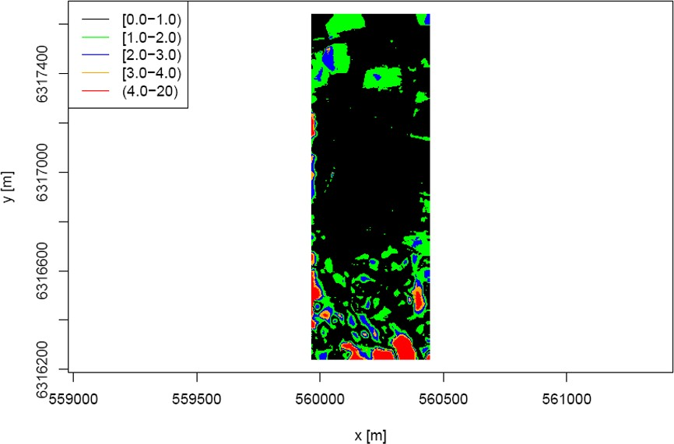
The results of the evaluation of the DTM derived by laser scanning (part of DK DEM/Terrain) are summarized in Table 6a and 6b. 257 checkpoints are used.

Figure 8. Spatial distribution of the differences between the DTM derived by laser scanning and the DTM derived in test A.

Accuracy measures | value  [cm]
RMSE | 11
Mean ( μˆ ) | 0
Standard deviation (σˆ ) | 11
Mean (after removal of outliers) ( μˆ *) | 0
Standard deviation (after removal of outliers) (σˆ * ) | 9

Table 6a. Accuracy measures of a DTM derived by laser scanning by means of n=257 checkpoints (incl. GCPs) of which 6 are classified as outlier by the 3⋅RMSE-threshold.

Accuracy measure | error  type | value  [cm] | 95% confidence interval  [cm]
50% quantile (median) | Δh | -1 | [-1 , 0]
NMAD | Δh | 6 | [6 , 7]
68.3% quantile | |Δh| | 7 | [6 , 9 ]
95% quantile | |Δh| | 24 | [21 , 38]

Table 6b. Accuracy measures of the robust methods for the sample size of n=257

The standard deviation after removal of six outliers is σ=9cm only. The robust NMAD value is 6 cm only. The comparison with the results of the DTM derived in test A (σ=77cm and NMAD=65 cm) reveals that this DTM derived by laser scanning has a much higher accuracy at the positions of checkpoints. The use of terrain classes must reveal if this generally is the case or due to problems in the wooded and built up areas only.

The Figures 9 and 10 summarize the results of the test A. The accuracy measures assuming the normal distribution of errors are higher than the robust measures.

The test A revealed that DTMs derived by photogrammetry and by laser scanning have blunders and a non-normality of the error distribution. A robust approach in determination of the error assessment has therefore to be applied. The robust accuracy measures (Median, NMAD, and the 68.3% quantile) are, therefore, determined in the following tests. The number of checkpoints has to be large so that small confidence intervals can be achieved.

The use of the terrain classes seems to be necessary because areas with trees or building coverage need filtering for the removal of the non-ground points. This may be a big source of errors and the results will be less accurate than at the areas without coverage. The derived DTMs should therefore be tested for different terrain classes. The following classes will be used: Open terrain, built-up terrain and forested terrain.

The DTM derived by photogrammetry in test A has not the accuracy of the DTM derived by laser scanning. Various reasons have contributed. The filtering was restricted to Match-T filtering only.

The photogrammetric DTM should have a smaller spacing of the grid posts. According to (Intergraph, 2008) it can be determined by the following formula:

∆ = 30 * pixel size * image scale= 30 * GSD (1)

Accuracy measures at normal distribution of errors

160

140

120

100
RMSE MEAN
Std.dev.
Errors [cm]

80

60

40

20

0
1 2 3 4

Figure 9. Results of test with 10 cm images (test A), standard measures. It means 1: Laser/GPS, n= 257, N=6; 2: foto_filtr/GPS_GCP (n=13, N=0); 3: foto_filtr//GPS/CP (n=231, N=3); 4: foto_filtr/Laser (n=259446, N=5734)

Robust measures

80
4
3
2
1

70

60

50

40
68.3% quantile Median
NMAD
Errors [cm]
30

20

10

0

-10

Figure 10. Results of test with 10 cm images (test A), robust measures.
It means 1: Laser/GPS, n= 257, N=6; 2: foto_filtr/GPS_GCP (n=13, N=0); 3: foto_filtr//GPS/CP (n=231, N=3); 4: foto_filtr/Laser (n=259446, N=5734)

For the applied images the grid spacing can be selected with

∆ = 30 * 12 µm * 8 333 = 30 * 10 cm = 3m.

(For the generation of digital surface models the user guide of “Match-T DSM” recommends a smaller spacing between the grid posts: ∆ = 5 * GSD ).

The accuracy of orientation should be improved in order to avoid a big systematic shift of the elevations. The number of GCPs will be increased in the next tests. Bilinear interpolation should be applied for the derivation of the elevations at the position of the reference data. All of these changes will very likely improve the photogrammetric approach. Blunders and systematic shifts in elevation and especially in planimetry can also happen at laser scanning and the following filtering/classification. The huge differences experienced in test A using the DTM 2007 as reference may also partially be caused by this DTM. However, it is not the objective of this investigation to thoroughly test the DK-DEM/Terrain.

Test B
The checkpoints were now separated into three classes. The area comprises the whole test area. From Table 7 it can be seen that the results are different for the
three classes. Forested area has the highest errors (σ=15 cm, NMAD = 9 cm, N=3 (=2.9%)). The maximum error in the forested area is 54 cm. The quality of the DTM derived by laser scanning is nevertheless high.

The results of the photogrammetically derived DTM with a 10 m grid are shown in Table 8.

Terrain type | n | RMSE  [cm] | µ  [cm] | σ  [cm] | N | ∆h_max  [cm] | Q (0.683)  [cm] | Median  [cm] | NMAD  [cm]
Open | 48 | 6 | 2 | 6 | 0 | +16 | 5 | 3 | 5
Built-up | 83 | 7 | -3 | 6 | 1 | -37 | 5 | -2 | 3
Forested | 105 | 15 | 2 | 15 | 3 | +54 | 11 | 0 | 9

Table 7. Accuracy of the DTM determined by laser scanning at different terrain classes.

Terrain type | n | RMSE  [cm] | µ  [cm] | σ  [cm] | N | ∆h_max  [cm] | Q (0.683)  [cm] | Median  [cm] | NMAD  [cm]
Open | 50 | 55 | 42 | 36 | 0 | 126 | 52 | 38 | 32
Built-up | 84 | 119 | 52 | 107 | 1 | 377 | 78 | 15 | 64
Forested | 108 | 140 | 58 | 128 | 1 | 995 | 103 | 48 | 84

Table 8. Accuracy of the 10 m DTM determined by digital photogrammetry at different terrain classes.

There are considerable differences between the three categories of terrain. The open terrain area is determined with σ=36 cm and NMAD=32 cm. These values are higher by a factor 6 (resp. 6.4) than the one of the DTM derived by laser scanning. The accuracy at the other terrain classes is lower than in open terrain. As expected, the accuracy at forested areas is poorer than in the other two classes. Maximum error is 9.95 m which has a big effect on the standard accuracy measures. The robust accuracy measures (68% quantile, Median, NMAD) show again lower values because the outliers have no influence. Bilinear interpolation was implemented but the differences to NN interpolation (only using checkpoints not more than 0.8 m away from a grid post) were very small. The number of checkpoints can be increased if bilinear interpolation is used and this interpolation will therefore be used in the forthcoming tests.

Test C
The area is extended to four images which are oriented by means of well defined GCPs. Three models are used to derive a DTM. The grid size is selected with ∆E=∆N=3 m. Some editing can be done by means of the Match-T program by which points of low redundancy and poor accuracy can be suppressed. The results without editing are also given in order to see the effect. The checking occurs separately for the three classes (open terrain, built-up, and forest).

The georeferencing of the images were carried out by the program “Exterior Orientation”. Each image is orientated by resection by means of ground control points. Most of the GCPs are well- defined points like manhole covers and drain gratings. There are used about 25 well distributed points per image and all GCPs have XYZ coordinates. The residuals after orientation are between three to six microns at the image coordinates. The computed standard deviation of the orientation elements are small (7 cm for X0 and Y0, 2 cm for Z0, and 4 mgon for omega and phi and 1.2 mgon for kappa). This means that the orientation of the images is of a high accuracy.

The DTM generation used all ground control points as morphological data. The parameters to be set in the Match-T program were the following:
grid size: 3m
terrain type: Undulating smoothing: Medium error detection: Standard

The program labels the derived elevations with codes:
-acceptable accuracy
-poor accuracy
-low redundancy
-located at the edge.

Figure 11 depicts the classification of the grid elevations with colour codes. In addition, the border lines for ‘forest’ and ‘low buildings’ of the Top10 map are shown. Elevations with ‘poor accuracy’ are especially situated in the areas with forest but less in built-up areas.

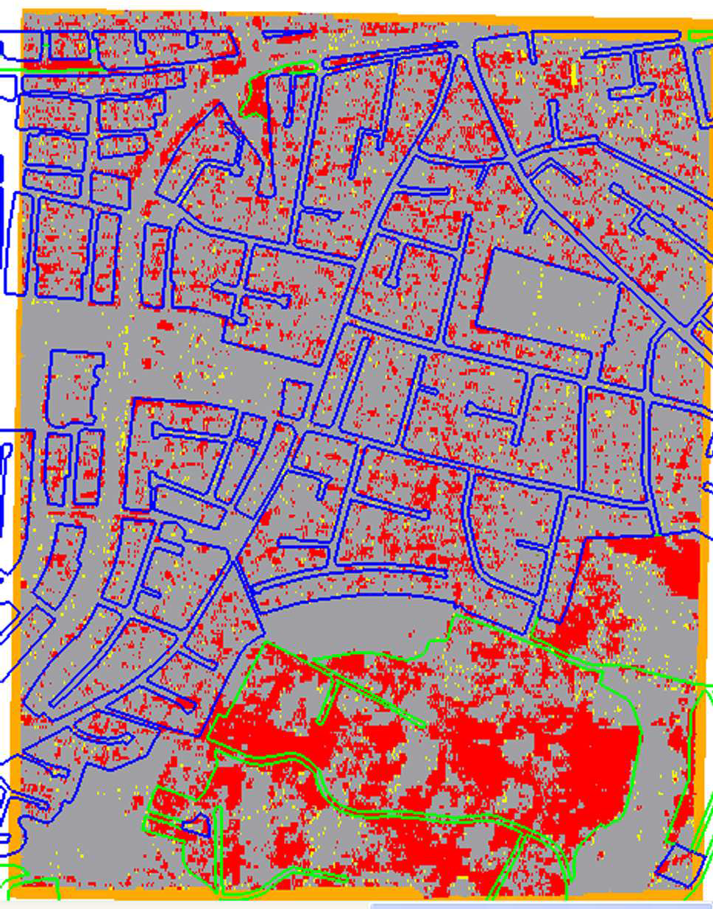
Figure 11. Classification of the grid elevations. The colours mean: Poor (internal) accuracy (red), low redundancy (yellow), and edge (dark yellow).

The editing of the derived grid data from the automatic DSM was done in two ways:
Edit1: Deleting all points with low redundancy and low accuracy as well as points at the border area (Match-T functions)
Edit 2: Filtering for blunders and reduction to the ground for built-up and forested areas (DTMaster functions).
Deleting of points will produce DTMs with gaps. These missing elevations can be found by interpolation using neighbouring elevations by means of the DTMaster function “Interpolate Gap”. DTMaster uses two types of interpolation when filling the gaps: linear prediction or

interpolation using reference points near the selected polygon. The first method results in high computation times. The program decides automatically which of the two methods will be applied. The obtained results without and with editing are summarized in Tables 9 and 10.

Terrain type | n | RMSE  [cm] | µ  [cm] | σ  [cm] | N | Q (0.683)  [cm] | Median  [cm] | NMAD  [cm]
Open | 136 | 326 | 55 | 323 | 2 | 27 | 17 | 20
Built-up | 146 | 52 | 27 | 44 | 4 | 34 | 15 | 32
Forested | 132 | 909 | 419 | 810 | 6 | 266 | 48 | 75

Table 9. Accuracy of the 3 m DSM determined by digital photogrammetry-Test C (without editing)

Terrain type | n | RMSE  [cm] | µ  [cm] | σ  [cm] | N | Q (0.683)  [cm] | Median  [cm] | NMAD  [cm]
Open | 130 | 22 | 15 | 16 | 0 | 26 | 17 | 20
Built-up | 107 | 40 | 18 | 36 | 3 | 26 | 8 | 25
Forested | 27 | 33 | 16 | 30 | 1 | 23 | 13 | 14

Table 10. Accuracy of the DSM determined by digital photogrammetry-Test C (with editing1)

Furthermore, an additional interpolation has to be applied in order to obtain a regular grid pattern (DTMaster tool “Interpolate”). The result for the forested area shows that the filling of the gaps failed. The built-up area could not be improved either. The editing functions cannot be carried out for the whole area in one run of processing. It has to be applied locally and separately for the terrain classes. This will be tried in the next experiment where post processing by means of DTMaster is used. Furthermore, the derived indicators for poor accuracy are only an ‘internal accuracy’. They do not necessarily correspond with the ‘external accuracy’ determined by accurate reference values (Wind 2008). The suppressing of the derived elevation according to the internal accuracy will therefore not be pursued further. Instead, it is better to check such areas

visually under stereo vision (see Test G). In a further test, a new editing (edit2) of the same DTM (∆=3m, undulating terrain, adaptive matching, use of morphological data) is tried. This editing of the DTM is carried out by means of

-change of the reference due to results with the control points and
-use of filters separately for the terrain types forest and built-up area.

The change of reference is easily carried out by the function “Move selection in Z”. For example, the average deviation of the ground control points from the DSM can be used for shifting the elevation of the complete area. The results with the 39 GCPs at the DSM of test C were µ=-4 cm (Median=+1cm) only. This is a very small bias and the correction is not carried out in this case. It should be mentioned that the systematic shift of the Z-reference will have big consequences in most of the applications, especially in construction work and estimating risks for flooding. This bias has to be determined accurately and should be as small as possible already in the generation of the DTM. Needless to say that the small systematic shift in this test is a result of an accurate orientation as well as of a good determination of the DEM at the places of the ground control points.

Various trials have been carried out in order to determine the used combination of filters in a project filter. The applied filtering of the DEM data was the following:

Filter strategy: Hoe 1
Gross error filter:
A positive and a negative threshold value are set to 1.5 m. Building filter:
In this filter the following parameters have been applied:
cell size: 6 m (=2 times point density) minimum area: (20 m)²
minimum slope: 0.6 (tanα=1.8m/3m)
According to the suggestion in the reference manual of “DTMaster”, two other building filters were used in addition in this strategy: 6.4, 20², 0.6 and 5.6, 20², 0.6.

The fourth filter applied uses the same parameters of the vegetation filter and detects buildings as well. In the strategy ‘hoe1’ the four parameters of this filter type were selected as follows:

Cell size 1: 12m (=2 x cell size) Cell size 2: 6m (=cell size)
Cell height 1: 1m (=0.33 x cell size) Cell height 2: 0.3m (=0.05 x cell size).

Vegetation filter
The following filters and parameters were used in the strategy.

Filter ‘dense wood’
Cell size 1: 8m (=1.33 x cell size) Cell size 2: 8m (=1.33 x cell size) Cell height 1: 3m (=0.5 x cell size) Cell height 2: 1m (=0.17 x cell size)

Filter ‘long range’
Cell size 1: 3m (=0.5 x cell size) Cell size 2: 3m (=0.5 x cell size) Cell height 1: -6m (=-cell size)
Cell height 2: -3m (=-0.5 x cell size)

The use of a vegetation filter for Match-T results is questioned by the producer of the program. Nevertheless trials have been carried out here.

The Figure 12 shows the result of the filtering in the orthogonal view. The classification in the four classes (built-up area in red, open area in blue, forested area in green and gross errors in violet) is not always correct. However, the goal is to have a DTM without outliers and gaps.

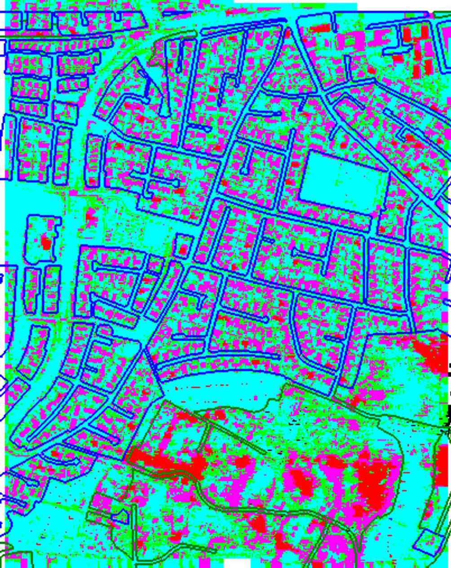

Figure 12 : Result of filtering of the photogrammetrically derived DSM using the strategy “hoe1”. The classes are buildings (red colour), forested area (green colour) and gross errors (violet colour). The non-classified areas are the “open areas” depicted in blue colour.

A closer look at a built-up area reveals that buildings are not clearly defined by a 3 m grid and the applied filter strategy (cf. Figure 13).
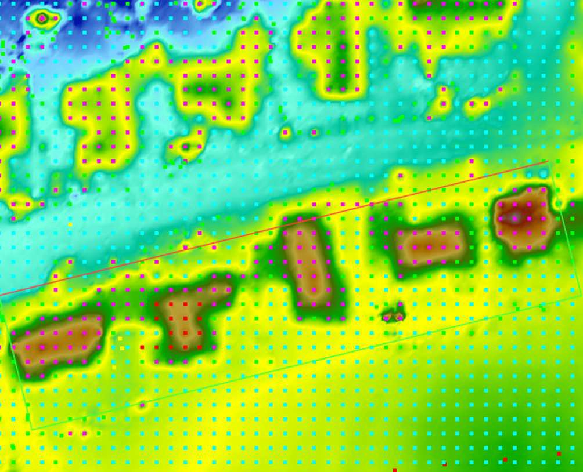

Figure 13. Effect of filtering along a road with houses at both sides of the road. The filtered classes are buildings (red colour), forested area (green colour), and gross errors (violet colour). The non-classified areas are the “open areas” depicted in blue colour. The checkpoints are depicted in yellow. The plotted rectangle is a selected profile (cf. Figure 14).

A profile of the same area reveals that the DTM and the checkpoints (in yellow colour) are in agreement (cf. Figure 14).

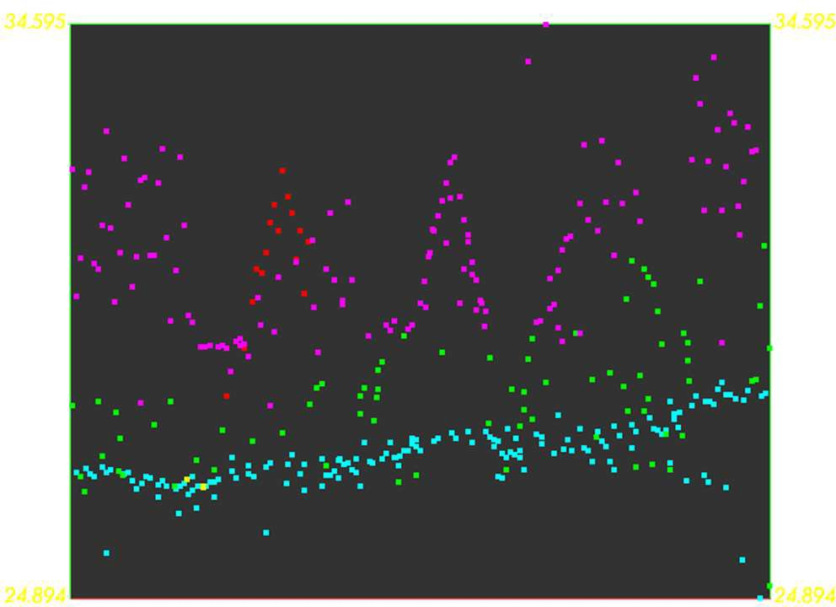

Figure 14. Profile of the derived DTM and checkpoints. The selected area is plotted by a rectangle in Figure 13. The classes are buildings (red colour), forested area (green colour), and gross errors (violet colour). The non-classified areas are the “open areas” depicted in blue colour. The checkpoints are depicted in yellow.

Vegetation, buildings and gross errors (in green, red and violet colour) have to be eliminated from the Match-T output in order to derive the DTM. The holes have to be filled by interpolation or other data, for example by manual measurements or older DTM data.

At this stage it is of interest whether the filtering of the DSM produced better results regarding the vertical accuracy. Table 11 gives an answer. Improvements could be achieved in the built-up and forested terrain by this filtering of the DSM. The results for ‘open terrain’ are about the same as before.

The accuracy measured by the NMAD value (corresponding to standard deviation at normal distribution) is now down to 21 cm (open terrain), 11 cm (built-up area) and 12 cm (forested area). The number of check points was relatively small (122, 56 and 27 respectively) due to the holes in the DTM.

Terrain type | n | RMSE  [cm] | µ  [cm] | σ  [cm] | N | Q (0.683)  [cm] | Median  [cm] | NMAD  [cm]
Open | 122 | 21 | 15 | 15 | 0 | 26 | 16 | 21
Built-up | 56 | 14 | -6 | 13 | 1 | 13 | -5 | 11
Forested | 27 | 24 | 10 | 23 | 0 | 22 | 13 | 12

Table 11. Accuracy of the 3 m DTM determined by digital photogrammetry-Test C (with editing hoe1)

These gaps have to be filled up. This process may introduce new errors. This interpolation needs elevation posts in the near neighbourhood, especially at hilly areas. The editing by means of filters (edit2) enables a more accurate DTM than the suppressing of data due to low redundancy and poor accuracy.

The completion of the DTM occurred with the tools of the program “ApplicationMaster” of Inpho GmbH. The functions of DTMaster, ‘Interpolate’ and ‘Merge/Convert’, were applied. A threshold for the distance between the position of the missing elevation and the next neighbour posts (‘gap distance’) can be selected. It was selected with 9 m (3 times grid spacing). A few gaps remained, especially in the DTM in the forested area. These gaps were filled by a second iteration using a longer gap distance (48 m). The completed DTM has 158144 posts and their elevations were checked with the checkpoints for the three classes of terrain. The results are presented in Table 12.

Terrain type | n | RMSE  [cm] | µ  [cm] | σ  [cm] | N | Q (0.683)  [cm] | Median  [cm] | NMAD  [cm]
Open | 136 | 22 | 14 | 15 | 1 | 25 | 15 | 21
Built-up | 146 | 17 | -7 | 16 | 3 | 14 | -4 | 12
Forested | 153 | 261 | 59 | 255 | 6 | 68 | 12 | 41

Table 12. Accuracy of the 3 m DTM determined by digital photogrammetry-Test C (with editing strategy ‘hoe1’ and completion of gaps by interpolation)

Using the robust measure ‘NMAD’ for evaluation, the DTMs derived by digital photogrammetry and automated editing have an accuracy of 21cm (open terrain), 12cm (built-up terrain), and 41cm (forested terrain). This accuracy has been derived from a relatively large number of checkpoints (136, 146, and 153 respectively) of superior accuracy. The absolute median value is also very small (≤15cm) in all types of terrain. The figure 15 displays all results of the edited and completed DTM graphically.
3
2
1
20

10

0

-10
Q(68.3%)
Median NMAD
80

70

60

50

40

30
-50
3
2
1
0
50
RMSE
Mean Std. dev.
150

100
200
250
300
Errors [cm]
Errors [cm]

Figure 15. Standard and robust accuracy measures of test C (Four images with GSD=10 cm, grid spacing: 3m) using editing with strategy ‘hoe1” and completion of gaps) separated for the three classes of terrain: Open (1), built-up (2) and forested (3). Note the differences in scale at the Error-axes.

When comparing all the results of test C (cf. Table 13), it can be concluded that

- editing is necessary
- the editing by filters (‘edit2’) give better results than the suppressing of poor results in matching (‘edit1’)
- the filling of the gaps has to be carried out in two steps, first using a small ‘gap distances’ then a longer one in a second step
- the robust values (Q(68.3%), median, NMAD) ) are not so much affected by outliers than the standard measures (RMSE, µ, σ) and should therefore be again applied as accuracy measures for DEMs.

This result with the four images with GSD=10cm is very promising with respect to that DTMs can be produced by digital photogrammetry and some automated post processing. The results are especially interesting for built-up areas where this type of imagery is applied.

no edit |  |  | with edit1 |  |  | with edit1, no gaps |  |  | with edit2 |  |  | with edit2, no gaps
Q | M | N | Q | M | N | Q | M | N | Q | M | N | Q | M | N
open terrain
27 | 17 | 20 | 26 | 17 | 20 | 28 | 16 | 21 | 26 | 16 | 21 | 25 | 15 | 21
built-up terrain
34 | 15 | 32 | 26 | 8 | 25 | 50 | 2 | 34 | 13 | -5 | 11 | 14 | -4 | 12
forested terrain
266 | 48 | 75 | 23 | 13 | 14 | 3642 | -2140 | 3140 | 22 | 13 | 12 | 68 | 12 | 41

Table 13. Results of test C (3m grid). The applied accuracy measures are the 68.3% quantile (Q), median (M), and NMAD (N). The values are in cm.

The open terrain and the forested area is imaged with GSD=20 cm for the FOT tasks. It remains the question why the blunders occurred and if they can be avoided or detected in a more efficient way.

Test D
The generation of the DEM from images with GSD=20 cm uses a similar processing as in the test C. The flying height of the DMC images was about 2000 m and, according to the results of the test C, the obtainable accuracy should be half, that is about 42 cm (=0.021% of the flying height) in the open terrain, 24 cm in the built-up areas, and 82 cm in forested areas.

In order to improve the accuracy some modifications in the processing have been applied. The generation type was set to DTM instead of DSM. Small houses and trees should then be filtered away due to the selected parallax bound. The spacing of the grid points should be 1.6 m only (like in the DTM 2007). The “void data” and the “extrapolated data” of the Match-T calculation are suppressed.

The orientation of the three images using 82 ground control points, which were well distributed over the whole image areas and also well defined (using manhole covers, drain gratings, and stones) revealed a high accuracy again. The residuals in the resection are between σ_{x’,y’}=2 and 6
µm (standard deviation) in the image.

The generation of the DEM used the following parameters:
Generation type: DTM Grid size: 1.6m
Terrain type: Undulating Smoothing: Medium Error detection: Standard

The derived DTM can be visualized using colour codes for the classes of accuracy (bad, OK, and low redundancy). It is obvious from Figure 16 that the accuracy classes ‘bad’ and ‘low redundancy’ are much less present in the test area compared with the tests using the 10 cm imagery (cf. Figure 11). Furthermore, there is only a small systematic shift present in the elevation reference (average error µ=8 cm and median=11 cm) when the elevations of the GCPs are compared with the interpolated DTM elevations. This shift in the reference can also be removed in the editing using the function “Move the selection in Z” in “DTMaster”.

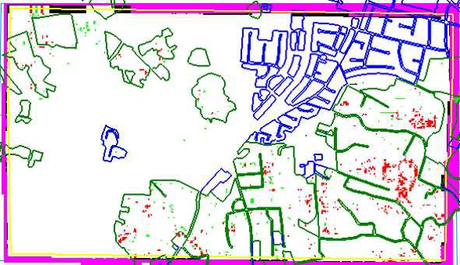

Figure 16. Classes of internal accuracy at processing of 20 cm imagery. The colours mean: Poor accuracy (red), low redundancy (green), and edge (violet).

The results of the DTM generation for the three classes (open area, built-up area and forested area) are summarized in Table 14. The obtained accuracy is 18 cm (open terrain), 43 cm (built- up terrain), and 33 cm (forested terrain) for the NMAD value. This DTM was not edited at all. When the results are compared with the ones derived from the DEM using 10 cm images (20cm, 32 cm, and 75 cm respectively) it is obvious that the results are of the same quality (cf. Table 9). This is surprising because the flying height was two times higher, but grid spacing less.

The editing of this DTM is done in two steps:
-remove of the systematic shift in the reference
-applying of filters.

These operations are carried out by the program “DTMaster”.

The used DTM has suppressed the void data and the extrapolated data. This is realised by the conversion from the hybrid SCOP format (extension .dtm) into an ascii format.
The shift of all DTM elevations by the correction, which has been derived from the GCPs, is carried out with the function “Move selection in Z” in DTMaster. (In this context it should be

mentioned that such reference points can be derived by aerotriangulation using GPS and IMU data as well. This so-called integrated sensor orientation connects images, the position- and attitude measuring sensors by means of automatically measured tiepoints. This gives the photogrammetric approach a great advantage for achieving high horizontal as well as vertical accuracy.)

The next step in the editing is the use of filters in order to remove blunders and reduce the elevation from the surface to the ground. The selection of the filter parameters has to cope with the new grid size (1.6 m). The following filters were selected in a new strategy:

Filter strategy: Hoe2 Building filters:
building filter #1:
cell size: 3.2 m minimum area: (20 m)² minimum slope: 0.56
building filter #2: 3.5m, (20 m)², 0.56
building filter #3: 2.9m, (20 m)², 0.56

Vegetation filters:
vegetation filter #1:
cell size 1: 6.4m cell size 2: 3.2m cell height 1: 1.1m cell height 2: 0.2m
vegetation filter #2 (dense wood): cell size 1: 4.3m
cell size 2: 4.3m cell height 1: 1.6m cell height 2: 0.5m

Gross error filter (Default smoother):
positive threshold: 2m , negative threshold: -2m

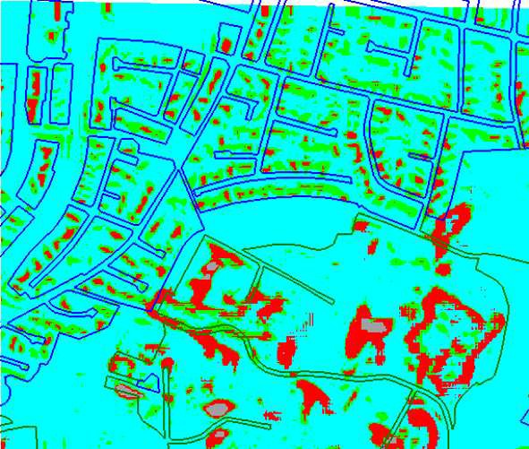
Vegetation filter #1 is useful for the detection of houses as well. All three filters extract elevations from the DSM and place them in a new file. The remaining DTM has then holes (cf. Figure 17). It is obvious that elevation values have been removed at the position of houses and at the forested area.
Figure 17. Result of filtering by strategy ‘hoe2’. The areas in green, red and gray colour are ‘filtered away’ from the DSM.

The applied filters do not completely remove all the elevations above ground. The individual houses can easily be recognized. They are detected mainly by the vegetation filter #1. The filtering is not usable for the classification of objects (houses or trees), but the task here is the generation of a DTM only. For this reason the three classes (buildings, vegetation, and gross errors) are merged to one class only. The selection of filters may require some test runs in order to achieve an optimal result for each area and imagery. It requires manual work and quite some experience. Some of it was gained from a recent student project at AAU (Overbye, 2008). The filtering of the whole block of images is then completely automatic. The filtering of the test area (about 1.4km²) took only a few seconds. The various results with the 20 cm imagery can be found in Tables 14-16.

Terrain type | n | RMSE  [cm] | µ  [cm] | σ  [cm] | N | Q (0.683)  [cm] | Median  [cm] | NMAD  [cm]
Open | 135 | 19 | 5 | 19 | 2 | 19 | 3 | 18
Built-up | 146 | 80 | 57 | 56 | 1 | 69 | 47 | 43
Forested | 122 | 290 | 101 | 273 | 4 | 45 | 17 | 33

Table 14. Accuracy of the 1.6 m DTM determined by digital photogrammetry-Test D (without editing) from 20cm images

Terrain type | n | RMSE  [cm] | µ  [cm] | σ  [cm] | N | Q (0.683)  [cm] | Median  [cm] | NMAD  [cm]
Open | 134 | 18 | -4 | 17 | 0 | 18 | -5 | 18
Built-up | 120 | 61 | 36 | 50 | 3 | 50 | 27 | 39
Forested | 98 | 108 | 28 | 105 | 2 | 27 | 6 | 21

Table 15. Accuracy of the 1.6 m DTM determined by digital photogrammetry-Test D from 20cm images (including automated editing)

Terrain type | n | RMSE  [cm] | µ  [cm] | σ  [cm] | N | Q (0.683)  [cm] | Median  [cm] | NMAD  [cm]
Open | 136 | 25 | -2 | 25 | 1 | 18 | -5 | 18
Built-up | 146 | 70 | 46 | 53 | 1 | 60 | 39 | 43
Forested | 124 | 230 | 77 | 218 | 4 | 38 | 9 | 30

Table 16. Accuracy of the 1.6 m DTM determined by digital photogrammetry-Test D from 20cm images (including automated editing and supplementing)

no edit |  |  | with edit |  |  | with edit, no gaps
Q | M | N | Q | M | N | Q | M | N
open terrain
19 | 3 | 18 | 18 | -5 | 18 | 18 | -5 | 18
built-up terain
69 | 47 | 43 | 50 | 27 | 39 | 60 | 39 | 43
forested terrain
45 | 17 | 33 | 27 | 6 | 21 | 38 | 9 | 30

Table 17. Results of test D (1.6m grid). The applied accuracy measures are the 68.3% quantile (Q), median (M), and NMAD (N). The values are in cm.

Table 17 summarizes the results using only the robust accuracy measures. The result for open terrain is NMAD=18 cm (σ=25 cm), which is derived from 136 checkpoints. This corresponds to 0.009% (0.0125%) of the flying height. Furthermore, the systematic shift was Median=-5 cm (µ=-2cm) only. Only one blunder was present. The result corresponds to the result with the 10cm imagery where wider grid spacing was used (cf. Table 13). It is a good result.

The editing does not improve the result in the open terrain. The editing at the other type of terrain (built-up and forested) was not very successful either. The filling of the holes due to editing seems to reduce the accuracy. More emphasis should be given to the completion of the edited DTMs by means of interpolation. The tolerable “gap distance” should not be too large. The figures 18 and 19 display the results of the edited and completed DTM graphically.

Figure 18. Standard accuracy measures of test D (GSD=20 cm images) separated for the three classes of terrain: Open terrain (1), Built-up (2) and Forested (3).
-50
3
2
1
0
50
100
150
200
250
RMSE
Mean Std. dev.
-10
3
2
1
10

0
20
30
50

40
60
70
Q(68.3%)
Median NMAD
Errors [cm]
Errors [cm]

Figure 19. Robust accuracy measures of test D (GSD=20 cm images) separated for the three classes of terrain: Open terrain (1), Built-up (2) and Forested (3). Note the differences in scale at the error axes.

Test E

The possibility to improve the accuracy of the matching by use of images with side lap of 60% and forward overlap of 80% could unfortunately not be realized. But the imagery at disposal has been taken from two flying heights and provided images of two different ground sampling distances (10cm and 20 cm). The results of the 20 cm imagery proved as good as from the 10 cm imagery. A combination of both imagery may give better results regarding accuracy, reliability and completeness.

The DTMs generated in test C and D will be merged and then tested by means of checkpoints. The grid size is selected to 2m. This grid size is some kind of a compromise between the selected grid size of test “C” (3m) and the one of test “D” (1.6m). A round grid size of 2m gives also advantages in the handling of the DEM data (for example at the selection of different origins when splitting the DEMs). The results of this idea are presented in Table 18.

Terrain type | n | RMSE  [cm] | µ  [cm] | σ  [cm] | N | Q (0.683)  [cm] | Median  [cm] | NMAD  [cm]
Open | 136 | 17 | 6 | 15 | 1 | 16 | 0 | 15
Built-up | 146 | 34 | 20 | 28 | 2 | 29 | 17 | 25
Forested | 156 | 277 | 109 | 255 | 7 | 66 | 15 | 41

Table 18. Accuracy of the merging of the 1.6 m DTM determined by digital photogrammetry using three 20cm images (including automated editing and supplementing) and the 3m DTM determined by digital photogrammetry using four images (including editing and supplementing)
- Test E

The accuracy derived from 136 checkpoints in the open terrain is only NMAD=15cm (σ=15cm). With Median=0cm (µ=6 cm) the systematic shift of the reference is also small. The achieved accuracy for the built-up terrain types has also improved to NMAD=25cm (σ=28cm). In the forested area the achieved accuracy with NMAD=41cm was not better than the result with the 20 cm imagery (NMAD=30 cm). The Figures 20 and 21 display the results graphically.

Errors [cm]

Figure 20. Result of Test E. The numbers mean classes of terrain: Open terrain (1), Built-up (2) and Forested (3).
3
2
1
0
50
100
150
200
250
300
RMSE
Mean Std. dev.
3
2
1
0
10
20
30
40
50
60
70
Q(68.3%)
Median NMAD
Errors [cm]

Figure 21. Result of Test E (robust accuracy measures). The numbers mean classes of terrain: Open terrain (1), Built-up (2) and Forested (3).

The merging of the two DTMs requires additional work but the accuracy could be improved by a factor of 0.83 (open terrain) and 0.58 (built-up terrain). Whether this additional work can be justified economically has to be decided.

Improvements are possible by a manual editing under stereo-vision. The outliers should be seen when the DTM points are superimposed on the stereo-model. Differences in elevation can be seen by the operator. The DTMaster software has then some functions which remove points or re-interpolate points.

The stereoscopic vision with a DTM of a small grid size (2m and less) has some problems because the neighbouring grid points can also be fused together. This effect occurs in the area of houses where the elevations are on the terrain. (In this context it should be considered by KMS to deliver the “DK-DEM/Terrain” with a wider grid size than 1.6m.)

Test F

The existing “DK-DEM/Terrain” has to be updated at areas of change, errors and lack of completeness. The surrounding areas of the DTM 2007 can possibly be used in the procedures for updating and may then contribute to the accuracy of a new generation of DTM. The following test uses the DTM derived by airborne laserscanning during the generation of a new DTM. The DTM 2007 data of the test area are used as morphological data (“Elevation points”) in the Match-T program. The results are shown in Tables 19-22.

Terrain type | n | RMSE  [cm] | µ  [cm] | σ  [cm] | N | Q (0.683)  [cm] | Median  [cm] | NMAD  [cm]
Open | 135 | 19 | 5 | 19 | 2 | 18 | 3 | 17
Built-up | 146 | 80 | 57 | 56 | 1 | 71 | 48 | 44
Forested | 122 | 286 | 99 | 269 | 4 | 44 | 17 | 33

Table 19. Accuracy of the 1.6 m DTM determined by digital photogrammetry using ALS data- Test F using 20cm images

Terrain type | n | RMSE  [cm] | µ  [cm] | σ  [cm] | N | Q (0.683)  [cm] | Median  [cm] | NMAD  [cm]
Open | 134 | 18 | -3 | 17 | 0 | 19 | -5 | 17
Built-up | 108 | 48 | 27 | 39 | 1 | 43 | 21 | 36
Forested | 92 | 45 | 15 | 42 | 2 | 26 | 7 | 21

Table 20. Accuracy of the 1.6 m DTM determined by digital photogrammetry using ALS data- Test F from 20cm images (including filtering and Z-shift)

Terrain type | n | RMSE  [cm] | µ  [cm] | σ  [cm] | N | Q (0.683)  [cm] | Median  [cm] | NMAD  [cm]
Open | 136 | 25 | -2 | 25 | 1 | 19 | -5 | 18
Built-up | 146 | 60 | 39 | 46 | 2 | 54 | 34 | 37
Forested | 124 | 86 | 17 | 84 | 3 | 38 | 7 | 33

Table 21. Accuracy of the 1.6 m DTM determined by digital photogrammetry using ALS data- Test F from 20cm images (including automated editing and completion)

no edit |  |  | with edit |  |  | with edit, no gaps
Q | M | N | Q | M | N | Q | M | N
open terrain
18 | 3 | 17 | 19 | -5 | 17 | 19 | -5 | 18
built-up terain
71 | 48 | 44 | 43 | 21 | 36 | 54 | 34 | 37
forested terrain
44 | 17 | 33 | 26 | 7 | 21 | 38 | 7 | 33

Table 22. Results of test F (1.6m grid, use of ALS data). The applied accuracy measures are the 68.3% quantile (Q), median (M), and NMAD (N). The values are in cm.

The results without editing for the robust quality measures are Q(0.683)=18 cm, Median=3 cm and NMAD=17cm at open terrain (cf. Table 19). When comparing the result with the results of test D (where no DTM 2007 data were used in the DTM generation), it can be seen (cf. Table 14)

that the results are about the same for this type of terrain and the used checkpoints (Q(0.683)=19 cm, Median=3 cm and NMAD=18cm). This is also true for the other two terrain types. The achieved results with filtering and completion (cf. Table 21) are NMAD=18 cm (open terrain), 37 cm (built-up terrain) and 33 cm (forested area).
The filters for removing the elevations from buildings were slightly modified.

Filter strategy: Hoe3
Building filters:
building filter #7:
cell size: 3.2 m minimum area: (16 m)² minimum slope: 0.3
building filter #8: 3.6m, (16 m)², 0.3
building filter #9: 2.8m, (16 m)², 0.3

Vegetation filters:
vegetation filter #1:
cell size 1: 6.4m cell size 2: 3.2m cell height 1: 1.1m cell height 2: 0.2m

Gross error filter:
GEF_2m:
positive threshold: 2m negative threshold: -2m

The result of the filtering is shown in Figure 22.

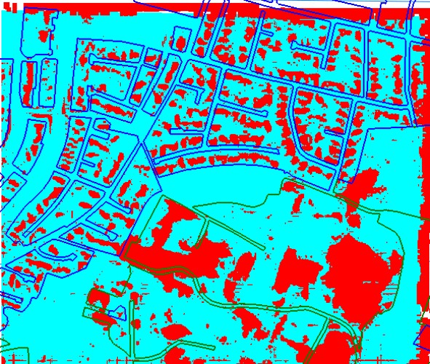

Figure 22. Result of filtering after applying the strategy ‘hoe3’

The red areas are the removed parts of the derived DTM and cover buildings, forested areas and posts with gross errors. The applied filters have removed the elevations from houses pretty well, the forested areas, however, are not very well detected. The used grid size of the generated DTM was 1.6 m. It could be further reduced to 5 x GSD = 5 x 0.2 m=1m in order to improve the detection of houses. Because the built-up area is photographed with a GSD=10cm the grid size can be selected with 0.5 m which will detect buildings much better. A small grid size in the photogrammetrically derived DSMs is one of the advantages of this DTM-acquisition method.
The investigations of the DSM is not part of this project.

The editing by automated filtration and completion of gaps did not produce much better results than the DTM generation without the “DK-DEM/Terrain” data (cf. Figures 23 & 24 with Figures 18&19). The use of “DK-DEM/Terrain” was therefore not very helpful in this test.

Errors [cm]

Figure 23. Standard accuracy measures of test F (GSD=20 cm images) and ALS data separated for the three classes of terrain: Open terrain (1), Built-up (2) and Forested (3).
3
2
1
100
90
80
70
60
50
40
30
20
10
0
-10
RMSE
Mean Std. dev.
-10
3
2
1
0
10
20
30
40
50
60
Q(68.3%)
Median NMAD
Errors [m]

Figure 24. Robust accuracy measures of test F (GSD=20 cm images and ALS data) separated for the three classes of terrain: Open terrain (1), Built-up (2) and Forested (3).

Test G

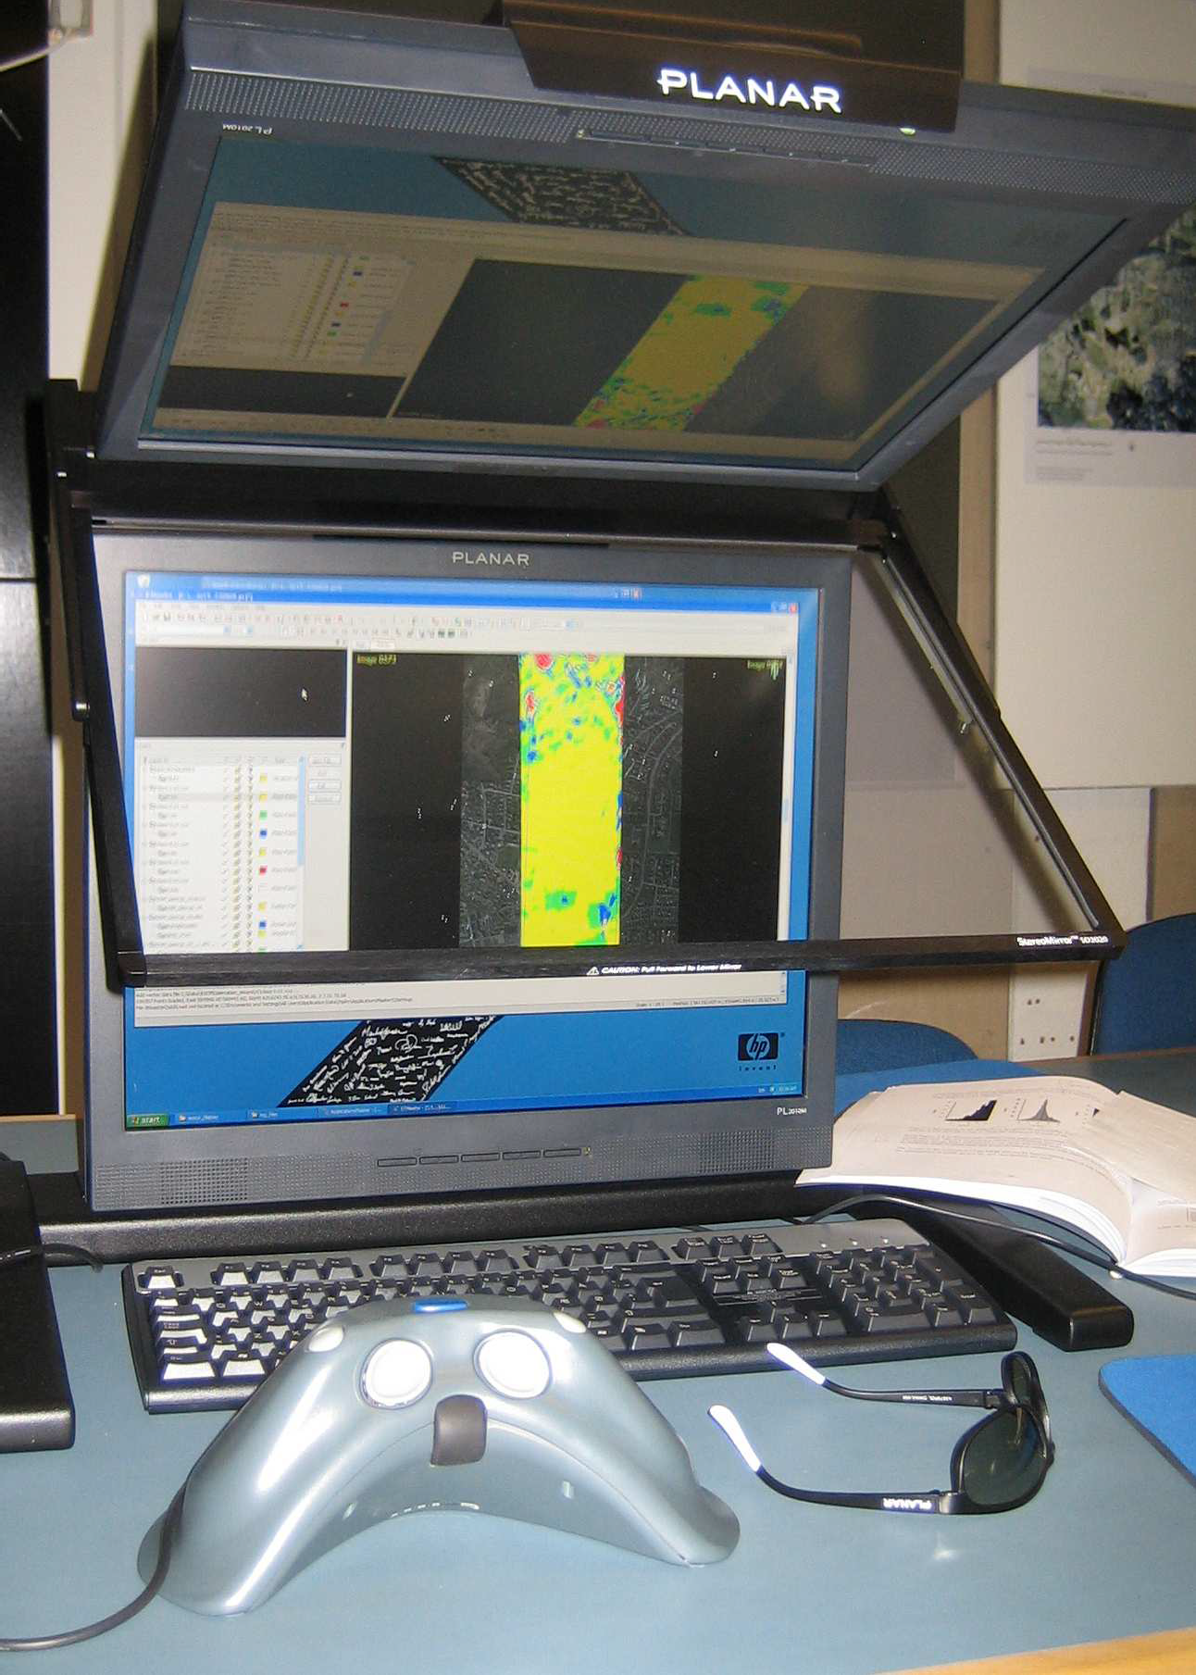
The automated editing by means of filtering and filling of the gaps may not have solved all problems. New errors may have been created in this process. A manual checking is therefore absolutely necessary. The best method for this process is the viewing in stereo on the stereo- model with superimposed DTM in form of ‘dots’ and/or contour lines (cf. Figure 25).

Figure 25.
Stereo Monitor enables comfortable viewing of colour-coded DTM points on top of the stereo model

Monoscopic (2D-) editing is also possible and because it can be realized by means of simpler hardware it may be chosen in addition to some editing functions.

The editing functions of DTMaster include among others:
-deletion of grid posts
-interpolate gap
-brush filter applied in a small squared or circular area
-re-interpolate of selected points (cf. Figure 6).
-move selection in Z
-measurement of single elevations
-setting of elevations.

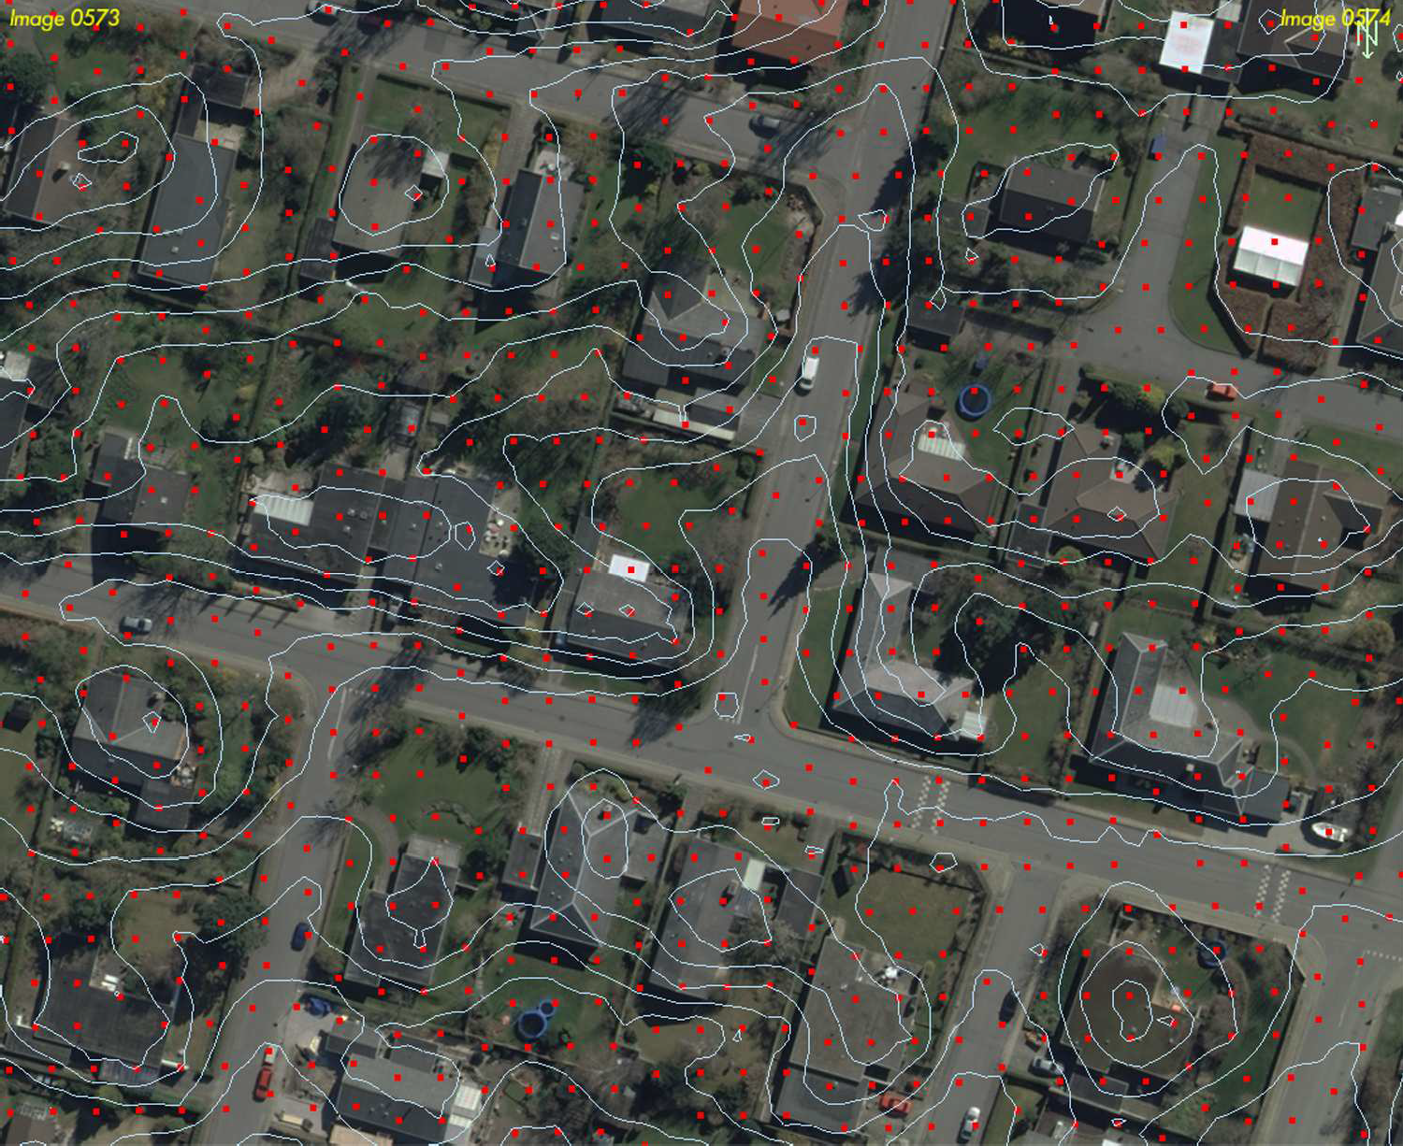
After applying such functions the contour lines will be derived ‘on the fly’ and the operator can judge whether the contours (and the dots) fit to the ground or not. The mentioned editing functions have been tried. The time required for this manual editing depends on the results from the previous steps. A systematic work can be supported by definition of working areas in a chess board like pattern. The result can be documented by displaying the contour lines on top of one image of the stereo-pair (cf. Figure 26) or an orthoimage. The DTM will have posts also at positions where houses and trees are, but all elevations will represent the terrain. Contour lines can then easily and quickly be derived. Viewing in selected profiles and perspectives may also be used in order to detect and remove errors.

Figure 26. Aerial image together with elevation dots and contour lines.
Monoscopic editing is usable for some of the editing functions only.

Economic considerations

The photogrammetric images are used for many purposes, for example in the orthoimage production, in stereo-compilation for updating the topographic databases, DEM quality control, etc. The use of the FOT imagery for the updating of the DEM products in the few areas of change would be already an economic factor. The Danish landscape consists mainly of open terrain. Forested areas cover only 10% of the territory. Built-up areas are important for the updating because it is there were most of the changes occur.

The times required for the steps in the updating of the DTM 2007 are about the following:

- Preparation (adaptation and checking of orientation data, generation of image pyramids, selection of checkpoints and of other reference data): 30 minutes per image.
- DTM generation (selection and input of DTM parameter and of morphological data, calculation, verification of results): 110 minutes per image
- Automated editing (selection and input of filter parameter, filtering, filling of gaps): 25 minutes per image.
- Manual editing (viewing of DTM-tiles with contour lines, in profiles, perspectives, and in stereo, removal of blunders, brush filtering, shifting of Z-reference, closing of gaps, conversion to an other format): 330 minutes per image or 4 hours per km² using 20cm imagery
- Assessment of accuracy (calculation of standard and robust accuracy measures, documentation of errors in metadata): approximate 10 minutes per image

A block of 12 images (three strips with four images each) with GSD= 20cm (covering about 16.3 km² at 60% forward overlap and 20% sidelap) could then be done in approximate 101 hours.
This performance of about 6.2 hours/ km² may be different for other software packages and its use under conditions of production when various persons are involved. The given times can be converted into costs when using salaries of the workforce, costs of acquiring instrumentation, and adding costs for amortization and overhead, etc. The manual editing (about 65% of the total time) may be reduced when the automatic editing performs more efficiently.

Summary and conclusions
The task of updating the DTM 2007 (DK-DEM/Terrain) in areas of change is investigated using standard photography of the FOT program. Every year colour images are taken in spring time for a third of Denmark in two ground resolutions (GSD=20 cm and GSD=10 cm). They are used for the generation of orthoimages and for the updating of the topographic data bases. New photogrammetric and editing tools were recently developed and made available for this investigation.
Checkpoints of superior accuracy were used in the assessment of DTM accuracy at three terrain classes. The images were geo-referenced by accurate and well defined ground control points.

Various DTMs were derived by automated procedures including the editing. The DTMs can be very dense (down to 0.5 m for 10cm images and 1.0 m for 20cm images) and complete. The results obtained at the 352 checkpoints were σ=17 cm for open terrain, the built-up areas and forested areas had higher errors (σ= 50cm and σ=105cm respectively) using the 20cm imagery and automated editing only. When applying the robust accuracy measures the detected blunders do not have an effect and the NMAD-values are then 18 cm (open terrain), 39 cm (built-up area) and 21 cm (forested area). The accuracies can further be improved when the results of two types of images (GSD=20cm and GSD=10cm) are used and when unchanged DTM 2007 data exist and used in the photogrammetric DTM generation. Manual editing will also improve but it takes a lot of time, about four hours per km². This editing by visual inspection is necessary in order to remove all errors and to fill gaps. Some of it can be done in 2D, but 3D editing by means of stereo-workstations is the most accurate and most efficient approach. A final assessment of the achieved accuracy has to be accomplished. Some errors may be outliers and the distribution of errors may be non-normal. This is the normal case in the automated photogrammetric approach (as well as in laser scanning). In the assessment of accuracy the robust measures median, 68.3% quantile and normalized median absolute deviation (NMAD) have therefore be used in addition to the standard measures (root mean square error, average error, standard deviation, number of outliers). The planimetric accuracy of the grid post elevations can be judged from the residuals of the orientation (σ_{max} =6 µm in the image or 5cm and 10 cm on the ground). It is very high.

This investigation was done in 2008 within a few months and limited resources. The delivery of the 20 cm images was delayed and the measurement of the ground control points and checkpoints suffered of it. The requested overlap (80% in the direction of flight and 60 % to the side) could unfortunately not be realized. According to literature better results can be achieved with such imagery. The interior orientation of the camera can further be improved by applying a calibration grid. The used programs in “MatLab” and “R” should be united, streamlined and prepared for a universal input, various types of interpolation and accuracy measures. The manual 3D editing would need more time to investigate all available functions and optimal procedures. The span of time between photography (spring 2008), field measurement of checkpoints (august 2008) and laser scanning (2007) may have some influence on the results due to changes in the vegetation. The investigation did not include the DEM products contour lines,

modelling of bridges and DSM. Other investigations may follow in order to test the photogrammetric approach for the other DEM products.

Recommendations
Based on the practical experiences from the tests the following recommendations can be made:
- The results in this investigation are encouraging to undertake the updating of the DK_DTM/Terrain in areas of change, errors and lack of data by means of photogrammetry using automated methods. A detailed specification of the work including the quality control should be written.
- The filtering of the photogrammetrically derived DTM should be improved by other approaches in order to reduce manual editing work.
- Tests deriving the Digital Surface Model (DSM) using new imagery with 80 % longitudinal and 60% lateral overlap should be started.
- The derivation of dense DSMs should include more advanced classification methods in order to detect and map objects like houses, bridges, hedges, etc. automatically.
- The use of robust accuracy measures (median, normalized median absolute deviation, 68.3% and 95% quantile) should be applied in all DEM accuracy assessments.
- The orientation parameters of the images will be delivered by the producer of the images and orthoimages. The accuracy of the parameters have to be ‘fit for purpose’ also regarding the DSM/DTM generation. This has to be ensured.
- It is suggested to supplement the DTM with metadata. Regarding the accuracy of the DTM the standard measures (RMSE, average error, standard deviation, number of blunders) as well as the robust accuracy measures (median, normalized median absolute deviation, 68.3% and 95% quantile) should be included in the metadata.

Acknowledgements
The author thanks stud.geom. Christian Øster Pedersen and Lars Østergaard Poulsen for field measurements and calculations of ground control points and checkpoints, ing. Marketa Potuckova, CU Prague, and cand. scient. Michael Höhle, LMU München, for programming work and discussions.

References used in this report
Gao, Y., 2008, Automatic DSM generation, M.Sc. thesis, University of Stuttgart
Höhle, J., 2007, Updating of the “DEM 2007” by means of photogrammetric methods, study for the Danish Survey and Cadastre”, phase 1, 27 pages
Höhle, J., Höhle, M., 2008, Quality assessment of Digital Elevation Models by means of robust statistical methods, manuscript, unpublished.
Inpho, 2008a, ApplicationsMaster 5.1, reference manual and tutorial Inpho, 2008b, DTMaster 5.1, reference manual and tutorial
Inpho, 2008c, Match-T 5.1, reference manual and tutorial
Inpho, 2008d, Exterior orientation, reference manual and tutorial Intergraph, 2008, Image Station Automatic Elevation (ISAE), users guide KMS, 2008, Proceedings of 2nd NKG workshop (preliminary version) KMS, 2007, betingelser for indkøb af digital højdemodel
Overbye, P., 2008, Ajourføring af Danmarks Digitale Højdemodel 2007- Kan fotogrammetrien anvendes?, Afgangsprojekt Landinspektørstudiet, Aalborg Universitet
Wind, M., Automatic generation of elevation data over Danish landscape, PhD thesis at Aalborg University, 2008.

References relevant for the topic
Aguilar, F., Agüera, F., and Aguilar, A., 2007a. A Theoretical Approach to Modeling the Accuracy Assessment of Digital Elevation Models, Photogrammetric Engineering & Remote Sensing, 73 (12), pp. 1367-1379
Aguilar, F., Aguilar, M., Agüera, F., 2007b. Accuracy assessment of digital elevation models using a non-parametric approach. International Journal of Geographical Information Science, 21(6), pp. 667-686
ASPRS Lidar Committee, 2004, ASPRS Guidelines Vertical Accuracy Reporting for Lidar Data, pp. 20. http://www.asprs.org/society/committees/lidar/Downloads/Vertical_Accuracy_Reporting_for_Li dar_Data.pdf (Accessed September 16, 2008)
Carlisle, B.H., 2005, Modelling the Spatial Distribution of DEM Error, Transactions in GIS, 9(4), pp. 521-540.

Daniel, C., Tennant, K., 2001, DEM Quality Assessment. In: Maune, D.F. (editor), Digital Elevation Model Technologies and Applications: The DEM User Manual, 1st. edition, ISBN-1- 57083-064-9, pp. 395-440.
Hoaglin, D.C., Mosteller F. and Tukey, J.W., 1983, Understanding Robust and Exploratory Data Analysis, John Wiley & Sons, Inc.
Höhle, J. and Potuckova, M., 2006, The EuroSDR Test “Checking and Improving of Digital Terrain Models, In: EuroSDR Official Publication no. 51, ISBN 9789051794915, pp. 10-55 Li, Z., Zhu, Q. and Gold, C., 2005, Digital Terrain Modeling – Principles and Methodology, CRC Press, ISBN 0-415-32462-9
Maune, D.F. (editor), 2007, Digital Elevation Model Technologies and Applications: The DEM User Manual, 2nd Edition, ISBN 1-57083-082-7
EuroSDR, 2008. Protocol of the discussion of the Science committee at the meeting in Cardiff, unpublished.

A. n.

A.

A. n.
- ' -
n.
A.
- I , n.
I , n.

132
n.
n.

n. A. A.
A. n.
n. 44

A. n.
n. A.
n.
A. n.
A.
n.
Karls

A. A. A.
A.
n. n.
A.
A.
A. 53
n.
A.
A. n.
A.
n.

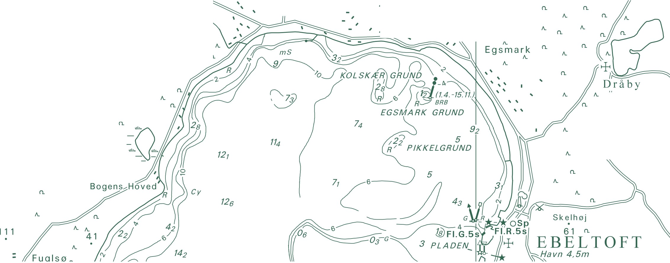A. Trehøje n.
(Dyrehøje) _{A.}
n.
127

National Survey and Cadastre Rentemestervej 8
2400 Copenhagen NV Denmark
http://www.kms.dk

