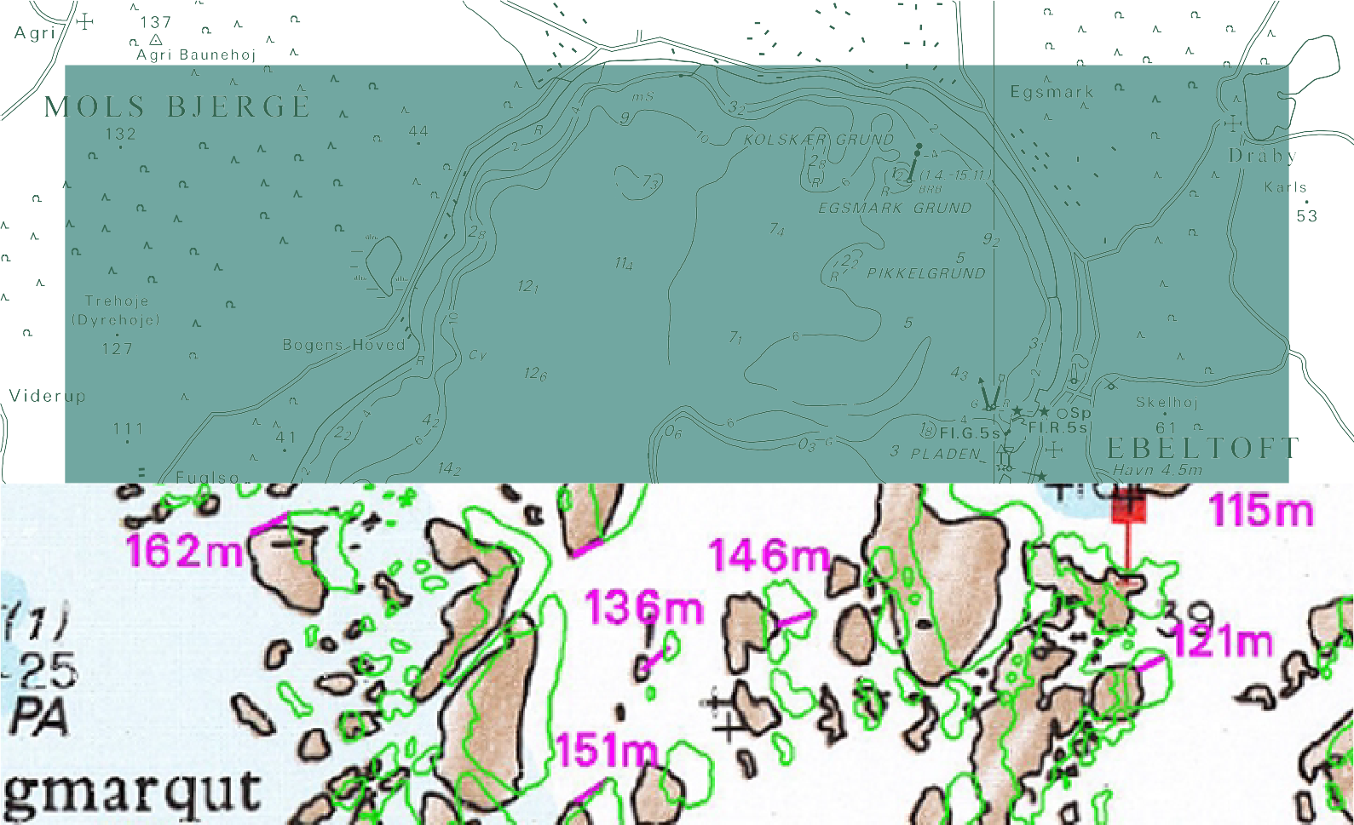

TECHNICAL REPORT NO. 02

Contributions from KMS to the 21st ISPRS Congress
Edited by Thomas Knudsen and Brian Pilemann Olsen

2

Contributions from KMS to the 21st ISPRS Congress

Edited by Thomas Knudsen and Brian Pilemann Olsen

National Survey and Cadastre – Denmark 8 Rentemestervej
DK-2400 Copenhagen NV Denmark

thokn@kms.dk bpo@kms.dk http://www.kms.dk

Edited by Thomas Knudsen and Brian Pilemann Olsen :
Contributions from KMS to the 21st ISPRS Congress

National Survey and Cadastre—Denmark, technical report series number 02 ISBN 87-92107-24-9
Technical Report Published 2009-02
This report is available from www.kms.dk

Prepared using pdfTeX and the LATEXtypesetting system. Parts of the main text typeset using Microsoft Word.

Contents

Geometrical Transformations for Nautical Charts of Greenland
Rune Carbuhn Andersen, Karsten Engsager, Tine Fallemann Jensen, and Thomas Knudsen 7
The Danish Way to a National Spatial Data Infrastructure
S.S. Dael, P. Frederiksen, and L. T. Joergensen 13
From Analog to Digital Aerial Imageproduction.
Experiences from NGA-Image-Production Based on EU-Tender
John Kamper 21

Foreword
This report is a collection of articles prepared and presented by the KMS (National Survey and Cadastre – Denmark) at the 21st ISPRS Congress, 3-11 July 2008 in Beijing, CHINA. Three articles are included in this report, and they were prepared by various departments in the KMS and in co-operation with other research centers, and thus gives an brief idea on which kind of research and development activities KMS is involved in.

The first paper Geometrical Transformations for Nautical Charts of Greenland was submitted to Commission 4, working group 4 Landscape Modelling and Visualisation.

The second paper The Danish Way to a National Spatial Data Infrastructure was also submitted to Commission 4, and presented at a special session: from National Mapping to an European Spatial Data Infrastructure.

The third and last paper From Analog to Digital Aerial Imageproduction. Experiences from NGA-Image-Production Based on EU-Tender was also submitted to Commission 4, working group 9 Mapping from High Resolution Data.

The articles has also been published in:

IAPRS Vol.XXXVII ISSN 1682-1750

GEOMETRICAL TRANSFORMATIONS FOR NAUTICAL CHARTS OF GREENLAND
Rune Carbuhn Andersen1 Karsten Engsager2 Tine Fallemann Jensen1 Thomas Knudsen1 1National Survey and Cadastre, 8 Rentemestervej, 2400 Copenhagen NV, Denmark, (rca tfj thokn@kms.dk)
| |
2Danish National Space Center, Juliane Maries Vej 30, 2100 Copenhagen Ø, Denmark (ke@space.dtu.dk)

KEY WORDS: Nautical Charts, Transformation, Kriging

ABSTRACT:

We present an algorithm for transformation and reconstruction of nautical charts, based on identification of common points in new orthophotos and old charts. The algorithm shows to be implementable and scalable, opening for its use in an operational setting.

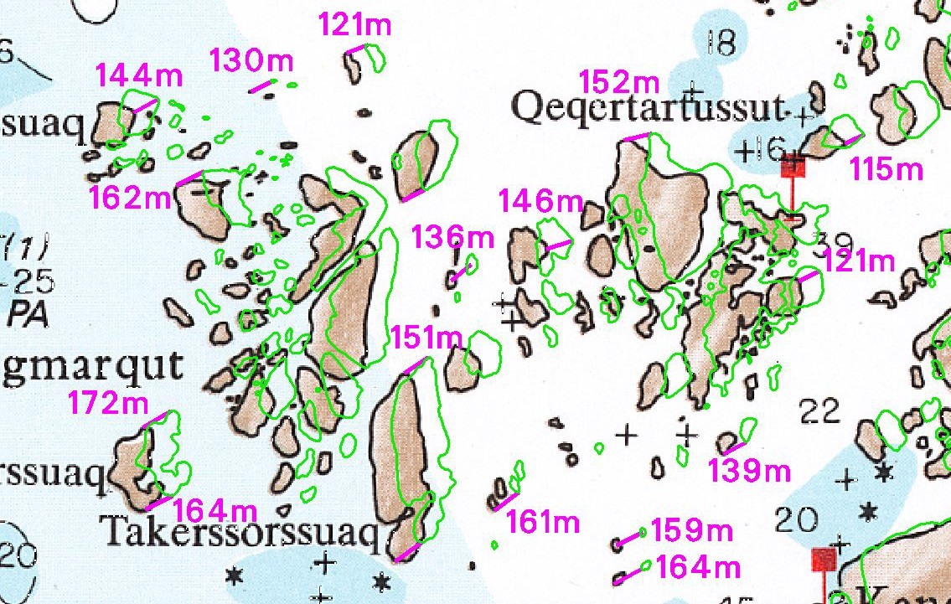
1 INTRODUCTION

The state of nautical charting for the waters around Greenland has historically reflected Greenland’s combination of huge size, small population, and (for large parts) inaccessibility due to harsh climate. The nautical charts in current use for the area are mainly based on surveys carried out in a long span of time from the 1930s to the 1980s. Most of the charts were produced in the 1960s due to a rising political awareness of the problem, after a dramatic 1959 event in the southern waters of Greenland, where the pas- senger ship “M/S Hans Hedtoft” was lost along with the lives of 95 passengers and crew members.

The current business development in Greenland includes a focus on petroleum and minerals prospection/exploration. This leads to increasing traffic through the archipelago as well as off-shore. Also the growing tourism industry has resulted in a steadily in- creasing number of large cruise ships in Greenlandic waters. In- shore, an increase of the number of small passenger ships is seen, due to a general change in the pattern of passenger transportation.

Hence, the need for more precise charts is growing significantly in these years, not only for the sake of the Greenlandic people but also for the sake of the vulnerable arctic environment. In this paper we summarize some recent work carried out in order to bringing the old charts up to date without having to do extensive and costly re-surveying.
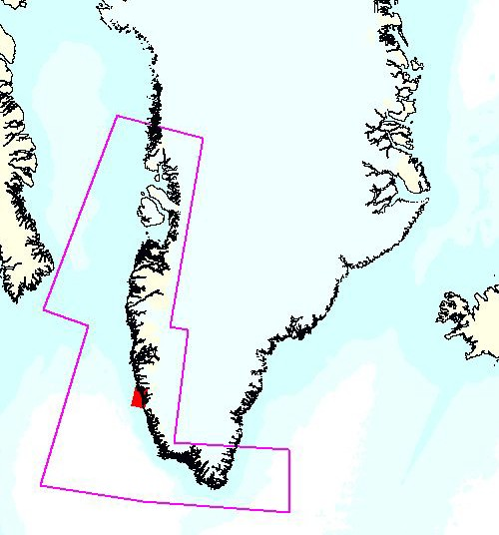
Figure 1: First part of the project involves updates for 65 charts inside the polygon outlined. The red spot indicates the coverage of chart no. 1212, which is our primary test site.

Figure 2: Major differences between the old chart no. 1212 Greenland and the new coastline.

The test site

Since Greenland is huge, it is important to select a good test site for initial development work. In our case, the initial part of the project involves enhancement of 65 charts covering the area indi- cated in figure 1. In the actual method development, we use chart no. 1212 (also sketched out in figure 1) for testing since the area covered by chart no. 1212 contains a fair amount of both new multibeam data and old soundings.

The problem

The reference frame used for the old nautical charts was based on astronomical observations and triangulations from the 1920s– 1950s (“Qornoq datum”). It was readjusted in the 1970s and 1980s after introduction of new absolute positioning from DOPP- LER and TRANSIT satellite observations, and a number of im-
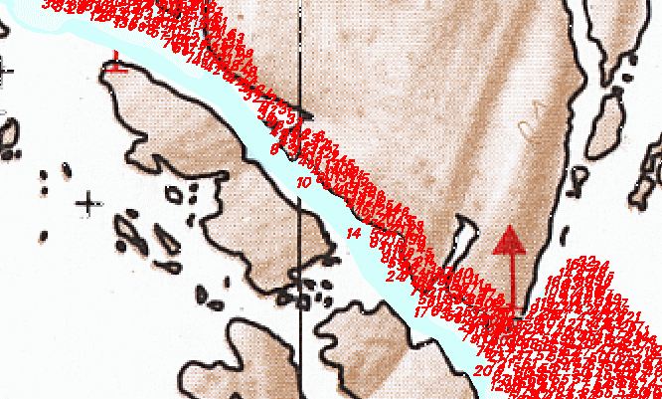
Figure 3: Differencies between the old chart no. 1212 and a set of newly measured multibeam data (shown in red). It is evident that the coastline registrations need adjustment.

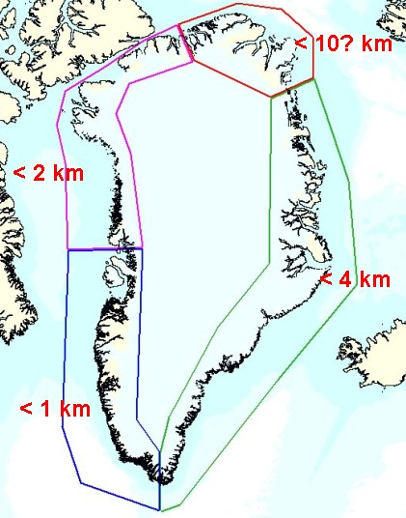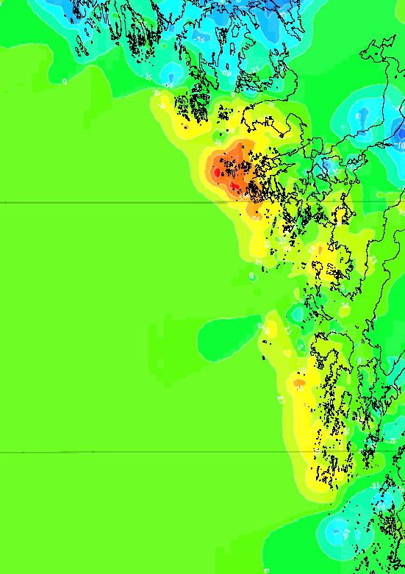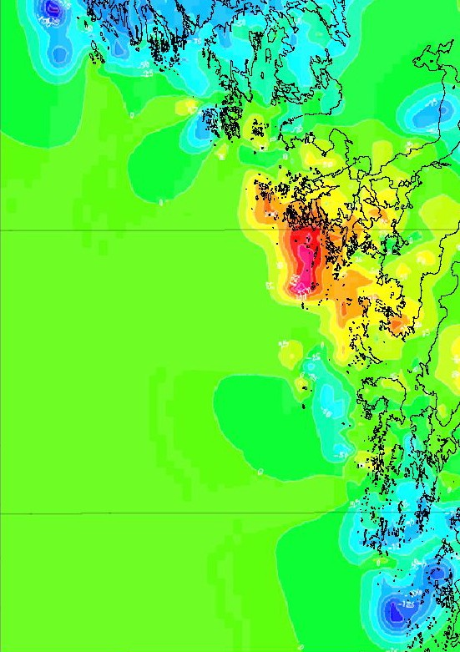

Figure 4: Area-wise maximum errors in the coastline position on the old charts. Mean errors are typically approximately an order of magnitude smaller.

proved station-to-station distances from a campaign based on elec- tronic distance measurement (EDM). The readjustment resulted in significant improvements, but in pre-GPS times, high accu- racy navigation in arctic regions was non-trivial, so despite an improved reference system, the surveys from the 1970s and 1980s were not necessarily of very high accuracy, although the relative positioning within a single survey (i.e. the precision) could be very high (Weber, 2007). Hence, it should come as no surprise that the introduction of GPS positioning and GPS based refer- ence frames, has revealed major errors in the old charts: while the overall geometrical accuracy varies from area to area, we do ac- tually find examples where the coastline appears to be misplaced by several nautical miles.

In most areas the errors are, however, less than 200 meters and most often better than 100 meters. In general the old charts have a good relative accuracy while their absolute accuracy is insuffi- cient for modern navigation. This is evident from figure 3, where a recent multi beam survey is overlaid on the old chart: the shape of the “ribbon” of multibeam reflections follows the shape of the narrow strait on the chart neatly. It is, however, somewhat dis- placed as seen from the fact that some of the multibeam reflec- tions actually come from areas which (according to the chart) are on land.

These inconsistencies result in major problems with the day-to- day maintenance of the charts: as new data become available they must to be fitted onto the old chart with reference to a coastline which is seriously misplaced. The fact that the old charts are still in raster format adds further to the complexity, making updates of the chart a time consuming and often impossible task.
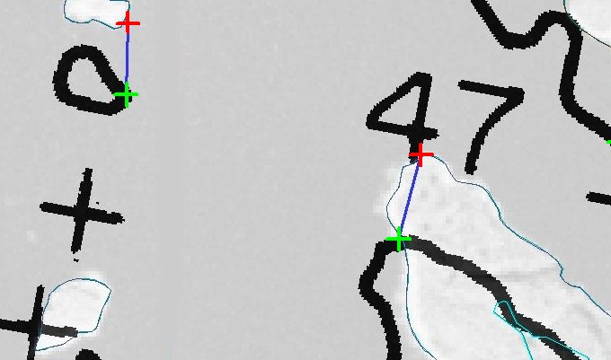
Figure 5: Digitizing homologous points: green points from old coastline and red points from new coastline.
Figure 6: Shift in northing (left) and easting (right) for chart no. 1212. In both directions, the shifts vary between between -200 m (blue) and +200 m (purple).

METHOD

The method developed in order to update the old nautical charts is based on an idea resembling the NADCON procedure (Mulcare, 2004) used for transforming from the NAD27 to the NAD83 da- tums in North America: our first aim is to derive individual grid shift models for easting and northing coordinates. This will al- low us to transform coordinates of points in the datum of the old charts to GR96, the most recent realisation of the Greenlandic ref- erence frame (a Greenlandic densification of the ITRF94 frame).

Each chart has it own maintenance history and has been adjusted in ways which are difficult (or impossible) to track. Much data used in the charts is of unknown origin making it impossible to handle the nautical information in groups according to its ori- gin: it is necessary to transform each chart as a whole. Hence, it was decided to base the transformation on deviations between the coastline on the chart and a new, photogrammetrically registered, high accuracy (and high precision) coastline.

In somewhat simplified form, the workflow of the method devel- oped is:
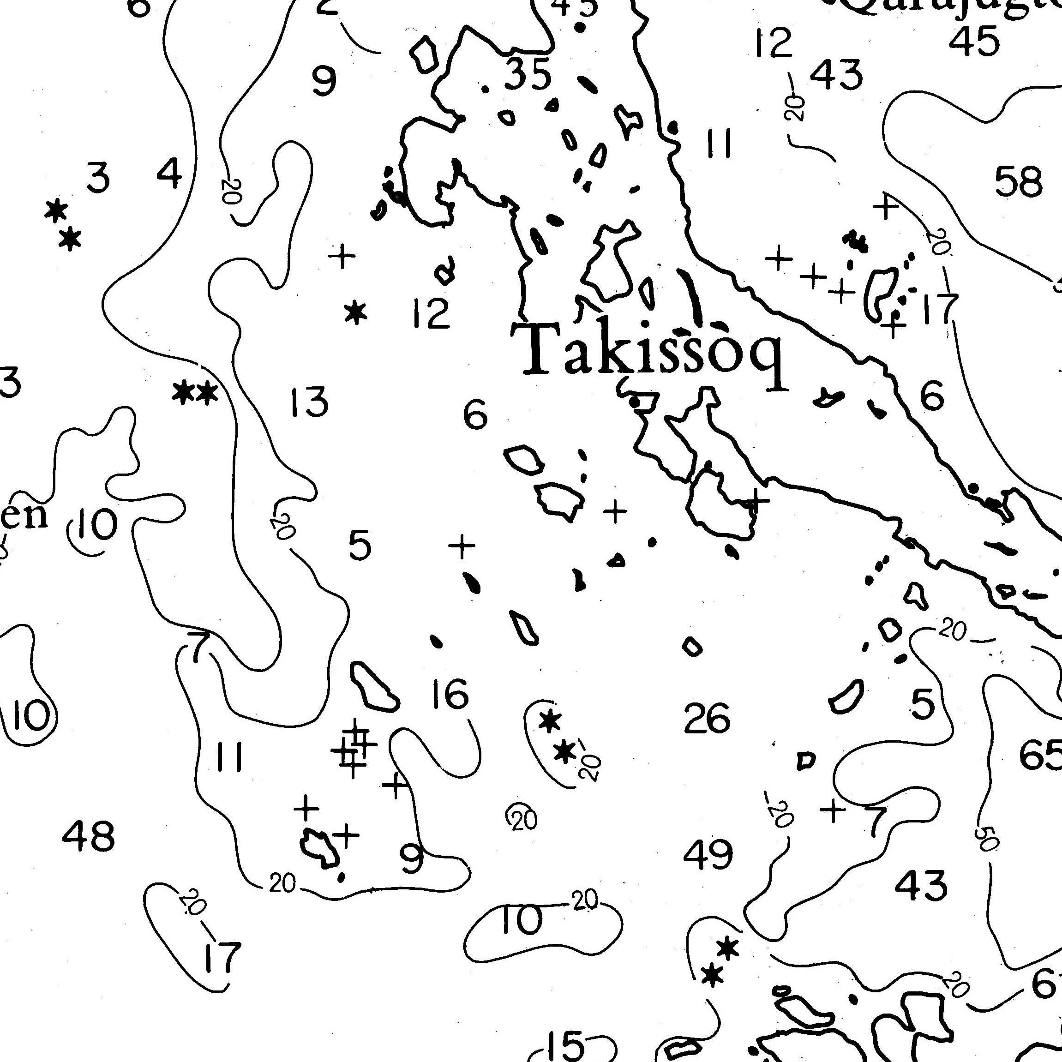
Figure 7: A small part of chart no. 1212, emphasizing the pri- mary object types being reconstructed in digital form: coastline, archipelago, rocks, depth soundings and depth contours.

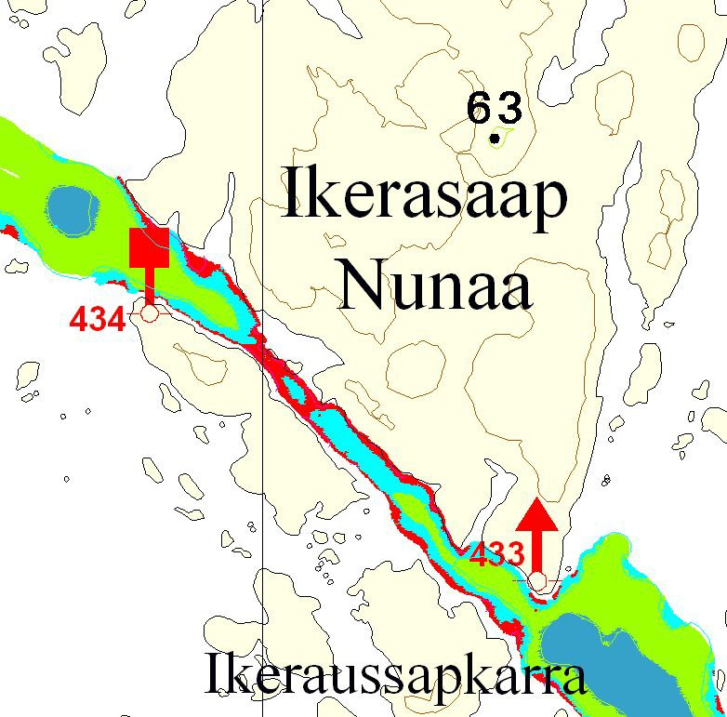
Figure 8: The new multibeam data fit perfectly with the trans- formed map.
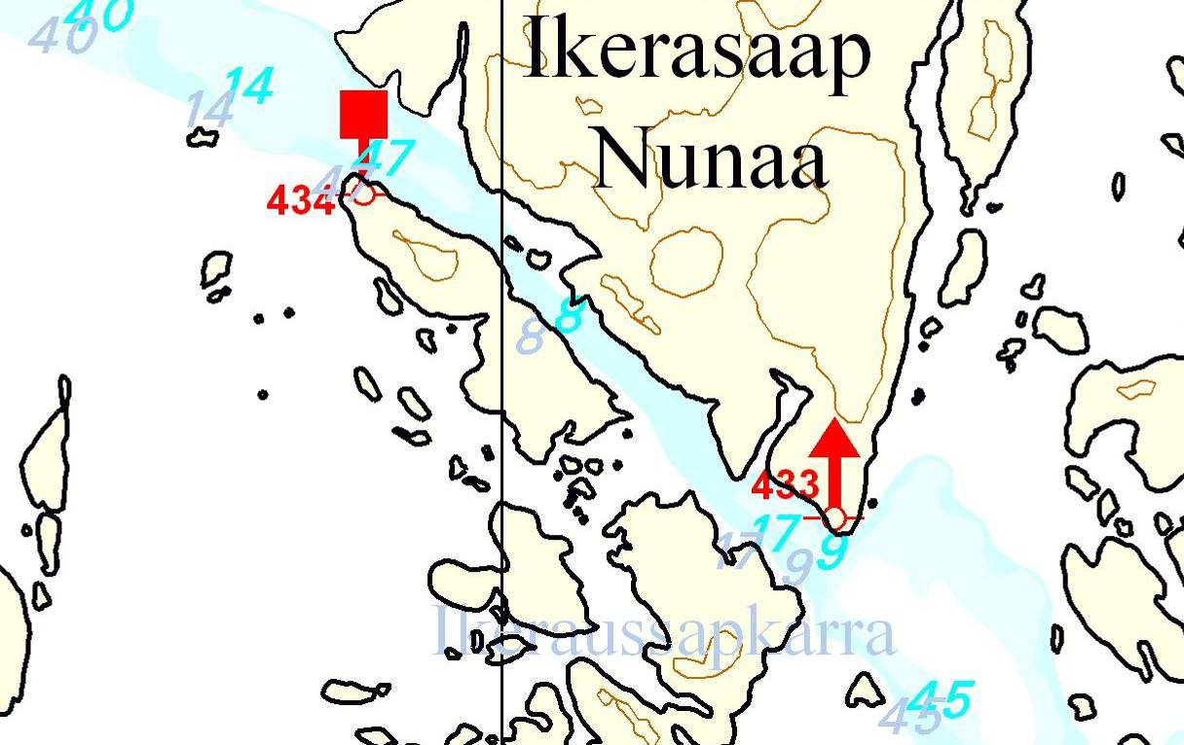
Figure 9: Effects of the transformation of existing soundings: old positions printed in grey, new in cyan.

    - Digitize homologous points on the new coastline and on the old coastline in the chart.
    - Estimate grid shift models for the shift in northing and east- ing by collocation/kriging.
    - Rectify the existing nautical information by interpolation in the grid shift models.
    - Combine the rectified old nautical information with newly measured nautical information (multibeam) and a new coast- line etc. into a new chart.

The local differences within the charts are distributed very irregu- larly and show significant variations over short distances, making the selection of a sufficient number of points non trivial.
The problem is, however, somewhat offset by the fact that we can put the focus on the the coastal areas (where the nautical informa- tion was traditionally geocoded using sightings to fiducial points on land). The information in the chart farther from shore is of less importance for the transformation: in the deeper waters the nautical information was traditionally geocoded using astronomic observations, so we should not expect superior results from coast- line based transformations in these areas.
In order to support the local variations in the transformation up to 1000 sets of homologous points are digitized manually for each
chart giving pairs of pixel coordinates and GR96 coordinates in UTM zone 24. The points must be very carefully selected fo- cusing on stable distinct features along the coastline. To improve the selection both the coastlines and a newly produced orthofoto were used - see figure 5.
These homologous points are the basis for the estimation of the grid shift models (cf. figure 6) in a kriging process (Cressie, 1993; Journel and Huijbregts, 1978).
The old charts are on raster format and are first being vector- ized before each objecttype individually are geometrically trans- formed from pixel coordinates to the proper GR96 datum by in- terpolation from the grid models.
When all the nautical information has been geometrically recti- fied all the different data sets can be gathered to a new improved chart. The data sets includes new coastlinie and topographic in- formation and newly measured mulitbeam data in selected areas. Also the geometrically rectified nautical information. The ratio- nale behind this collection of data is that we need a high degree of completeness and accuracy. When for example a rock is found in the old chart it is vital that it is also represented in the new chart. Only 100% completeness is satisfactory and this demands an ex- tended use of visual inspections with focus on especially small islands, rocks and soundings.

DATA
  - Photogrammetrically derived data
Between 1978 and 1986 a complete photogrammetric coverage of the ice-free parts of Greenland was obtained by KMS, using super wide angle cameras and high resolution B/W film. The flying altitude was around 14 km resulting in a scale of approxi- mately 1:150.000. In our project the relevant photos for the charts covering the southwestern part of Greenland was scanned with a resolution of 14µm.
A new aerotriangulation of the images was carried out using the improved datum of Greenland, GR96 (Engsager, 2007). Then a number of products were generated from the photogrammetry:

- Digital elevation models with 100 m grid cell size
- B/W orthophotos with 5 m pixel size
- Photogrammetrical registration of coastline, rivers, lakes, glaciers, fiducial points, and spot heights.

The coastlinie and the orthofoto are the basis for digitizing the nesseceary homologous points for the geometrical retification. The coastline is expected to have an accuracy of 10-15 meters.

Digitally reconstructed nautical information
The original nautical observations in the charts are not available in a suitable format. Therefore the old original printing material for the black layer of the charts was scanned at a resolution of 600 dpi, resulting in bitmap files without any geographical refer- ence. The object types of relevance were reconstructed in digi- tized form using commercially available semi-automatic services.
The primary object types reconstructed are depth soundings, bathy- metric contours, rocks, coastline (including all small islands in- side and outside of the archipelago),
Additionally, all geographical names were reconstructed in dig- ital form. These data were transformed into new Greenlandic spelling in collaboration with Oqaasileriffik, the Greenland Lan- guage Secretariat.

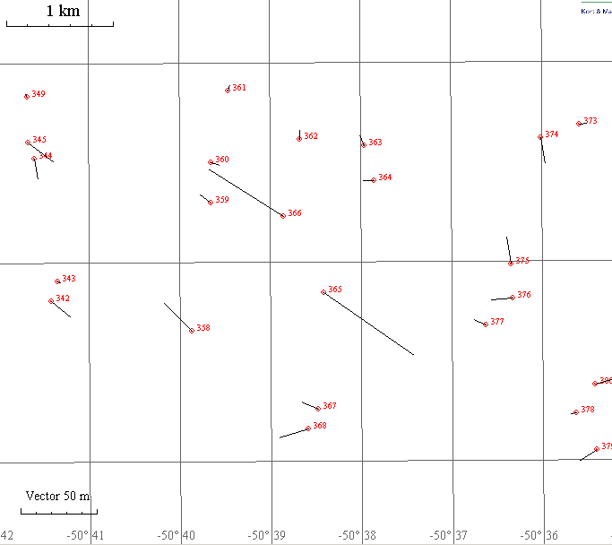
Figure 10: Local tension: while the transformation is overall suc- cesfull, we find here two points less than 1 km apart needing a residual movement of approximately 50 m in almost opposite directions. Such large discrepancies cannot be resolved by the method in any reasonable manner.

New bathymetric data
The Hydrographic Office of the Danish Maritime Safety Admin- istration is currently collecting large amounts of multibeam sonar data in the Greenlandic waters. With the update of the old data, these can (ideally) be merged seamlessly into the new generation charts.
Furthermore, experimental flights with red/green water penetrat- ing laser scanner systems have provided new sets of independent test data.

RESULTS AND EVALUATION

When evaluating the results, two issues are particularly relevant:

    - how well does the new coastline fit the new GPS-tagged multibeam data?
    - how accurate is the rectification.

The first issue is illustrated in figure 8, where it is seen that the new multibeam data are clearly placed correctly relative to the new coastline. The width of the channel in figure 8 is around 100 meters and all comparisons with reference data indicate an achieved accuracy of 10–15 m for the coastline.
The second issue is illustrated in figure 9, where we outline the difference between rectified and unrectified positions for recon- structed sounding depth information.
Both issues are evidently solved in a satisfactory manner, but to quantify the quality of the solutions a bit more: a back transfor- mation of the points used for the transformation reveals that out of 1050 points, 40 end up with a difference larger than 30 m. The mean absolute deviation is slightly better than 10 m for both northing and easting (for chart no. 1212).
Because of the unevenly distributed local variations due to the history of data, it is not always possible to ensure a perfect trans- formation. In figure 10, we show a pathological example: two

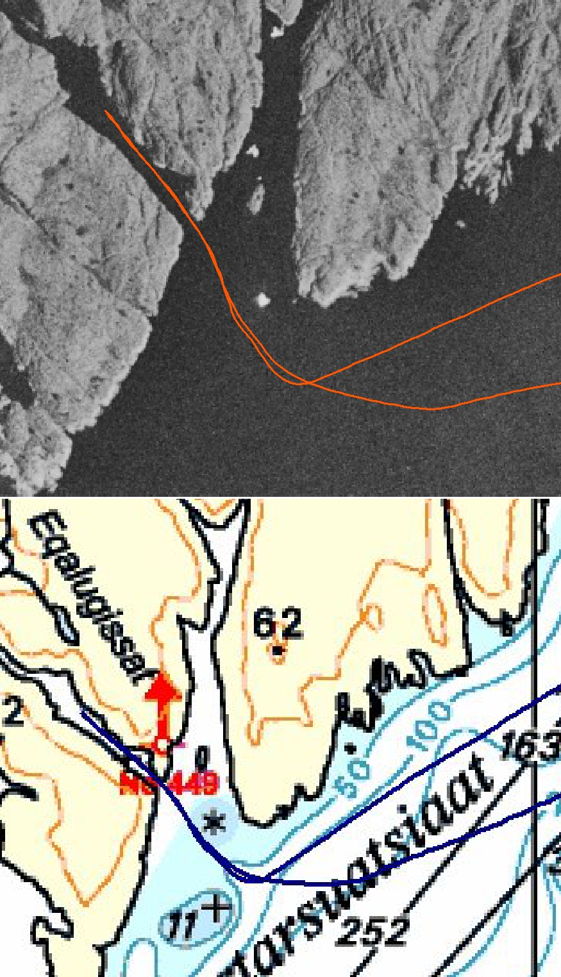

Figure 11: Test navigation exploring the accuracy of the updated version of chart no. 1212: entering and returning from a narrow fjord. At its narrowest points, the fjord is only 50 m from shore to shore. The GPS positions from the trip are plotted onto the updated chart and the orthophoto. It is seen that in this area, the new chart is certainly accurate enough for GPS based navigation.

points at a distance of less than 1 km need a residual movement of 50-60 m, in almost exactly opposite directions, while all the surrounding points have been transformed sufficiently. In order to handle such local phenomena, we need additional data.

Field test

The results of the pilot project are in general promising. But to ensure that the aerial triangulation and coastline production is correct several initiatives have been taken. One was a field trip inshore—with convincing results: The GPS track from (a part of) the trip is shown in figure 11 both on the electronic chart that was used direcly for navigation and onto the orthophoto. The channel is only 50 m wide at the narrowest cross section and as indicated from the GPS track, the vessel was placed firmly in the middle of the channel.

Lidar test

The least accurate areas in an aerotriangulation are normally the areas in the outskirts; in this case the outer islands. Therefore a

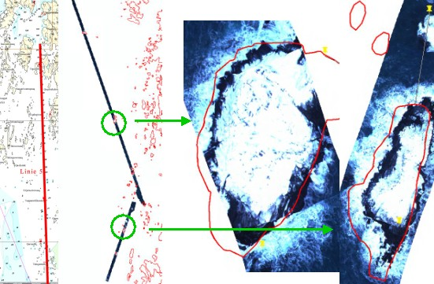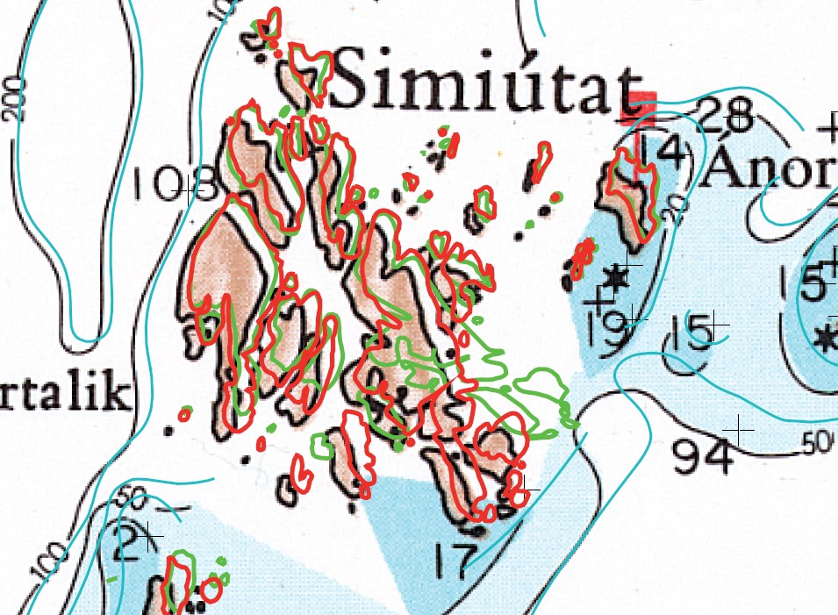

Figure 12: The new coastlinie compared to orthophoto from red- green lidar survey. The width of the lidar strips is approximately 100 m.
survey of red-green lidar scanning was conducted both for the in- terest in depth measurement from the lidar scanning itself and for positioning selected islands. As illustrated in figure 12 the islands detected using lidar fits with the coastlinie within a tolerance of 10–15 m.

Test of homologous points

It is crucial that the correction grids are as accurate as possible. A precondition is that the homologous points are error free. This is easily controlled by transforming the digizied coastline and comparing it to the new coast line. Figure 13 shows the result of misplacing a single point and thereby erroneously shifting the surrounding nautical objects.
The real challenge is the control of how the transformation in general has affected the nautical objects. It is important to em- phazise that the quality of specific rectification on the nautical object types cannot be controlled at all. All the data in the chart that need to be moved are in general of unknown origin. Hence, it may be spurious with respect to both planar position and to bathymetry. But under the given circumstances this method ap- pears to give reasonable results.

DISCUSSION AND CONCLUSION

We have presented a method for correction of existing nautical charts. The method has proven to be functional, scalable and operational. The first chart (no. 1212) has been published May 2008 and 5 more are planned for the rest of 2008. In the fol- lowing years, the remaining 59 charts from the block indicated in figure 1, representing the most busy waters around Greenland will be geometrically rectified and published. The charts will at a future date be integrated into a seamless database with nauti- cal information from all the charts, making future updates much simpler than when using the current procedure.
Figure 13: Erroneous placement of one homologous point. Colour code: old vectorized coastline (black), new coastline (red), transformed old coastlinie (green).

For the remaining 30 charts, covering the rest of the waters around Greenland we need a slightly modified procedure, since the amount of reference data is much smaller in the northern and eastern parts, than in the southwestern. A potential approach will be to integrate the use of recent and historical sattelite images as a sup- plement to the existing aerial photos.
Currently, less than 0.01 % of the waters around Greenland have been resurveyed recently with GPS reference. Most of the waters have only sporadic bathymetric soundings of unknown origin. So the biggest challenge for this project may actually be to avoid having the new charts signal an accuracy greater than reality, de- spite being much better than the existing chart series.

References
Cressie, N., 1993. Statistics for spatial data. Wiley, New York. Engsager, K. E., 2007. The Greenland reference frame 1996,
GR96. Copenhagen, Denmark, Danish National Space Center.
Journel, A. G. and Huijbregts, C. J., 1978. Mining Geostatistics. Academic Press, London.
Mulcare, D. M., 2004. NGS toolkit, part 8: The National Geode- tic Survey NADCON tool. Professional Surveyor Magazine.
Weber, M., 2007. Geodætiske referencenet og referencesystemer i Grønland. Copenhagen, Denmark, Kort & Matrikelstyrelsen.

THE DANTSH WAY TO A NATTONAL SPATTAL DATA TNFRASTRUCTURE
S.S.Dael, P. Frederiksen & L.T. Jørgensen

National Survey and Cadastre - Denmark, Rentemestervej 8, DK-2400 Copenhagen NV, Denmark (susla, pof, ltj)@kms.dk

Special Session 8 - EuroSDR

KEY WORDS: National Mapping, Infrastructure, eGovernment, Public Administration, Standardization

ABSTRACT:

In Denmark, location is a recognized gateway to eGovernment and public administration. The National Survey and Cadastre (KMS) participates in a range of public partnerships that work towards the generation of more effective public services. Recent developments in Denmark's public sector have placed new demands on KMS. The 2007 structural reform, in which Denmark's internal administrative boundaries were largely redrawn, has required the development of new cross-boundary solutions. This includes the sharing and merging of geographic information, which local and governmental authorities use in their administrative activities.

Geodata are generated and maintained based on standardized, coordinated and cost-effective procedures. This yields a unique spatial data infrastructure for eGovernment and public administration in general. KMS is responsible for establishing national standards for the generation, storage and sharing of geodata.

As Denmark's responsible authority for the implementation of the European directive INSPIRE, KMS has acquired new international obligations. This has required KMS to address the standardization of geodata as both a national and European activity.

KMS' activities include the establishment and maintenance of the following geodata types:

- National Geodetic Reference Systems and Networks
- Digital Terrain Models
- Place Names and Points of Interest
- The Digital Map Supply - web service
- Common/Shared Object Types - large and small scale map databases
- Cadastre
- Cadastral Archives
- Nautical Charts
- Administrative Boundaries

KMS is currently facing a transition from traditional mapping responsibilities to the development of a new infrastructure for sharing geodata in a wide range of contexts. This has required KMS to increasingly tailor its work to a rapidly changing national and international market.

  - TNTRODUCTTON

The National Survey and Cadastre (KMS) is an institution under the Danish Ministry of the Environment. KMS' vision is to provide Denmark's public sector, private companies and general public with accurate and updated geographic information about the territories and waters of Denmark, Greenland and the Faroe Islands. KMS is Denmark's public authority for maps and geodata, as well as the spatial infrastructure behind Denmark's growing eGovernment. The country is moving towards the implementation of a broad eGovernment strategy in which geodata will serve a central role in improving the efficiency of public administration. KMS ensures the development of the geodata required by civilian and military activities, but generates and produces very few paper maps or similar product. This production is tendered and outsourced to independent private contractors.
  - KMS' RESPONSTBTLTTTES AND TASKS
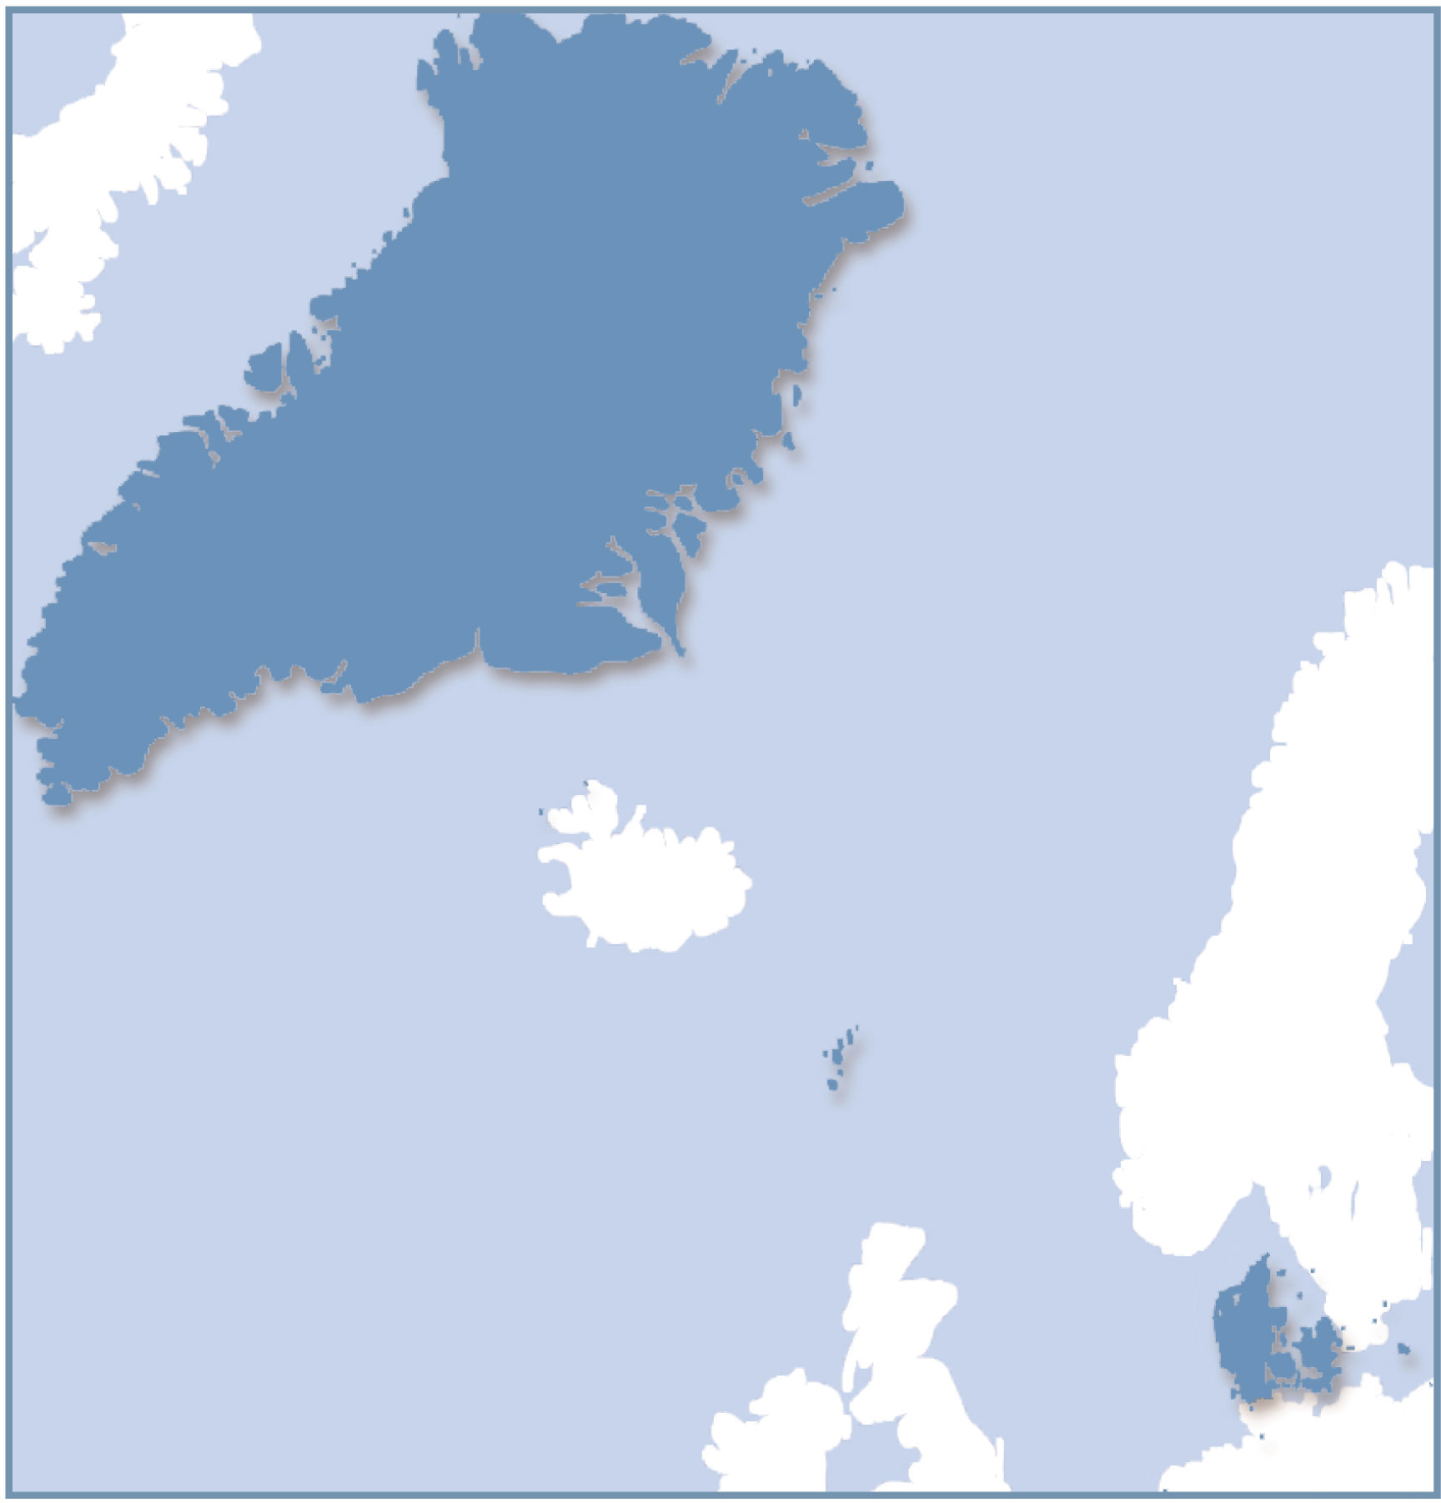

Figure 1. KMS' mapping responsibilities (Projection: LTP08)

    - eGovernment

Location is a gateway to eGovernment and public administration in Denmark. The national spatial data infrastructure is increasingly supporting the needs of digital society by meeting national standards and fulfilling international obligations. The Danish SDI model (figure 2) recognises the central role that geographical data can play when used as a common foundation. Responsibility for data is distributed among the users who actively use the data and are therefore willing to pay for their generation and maintenance.

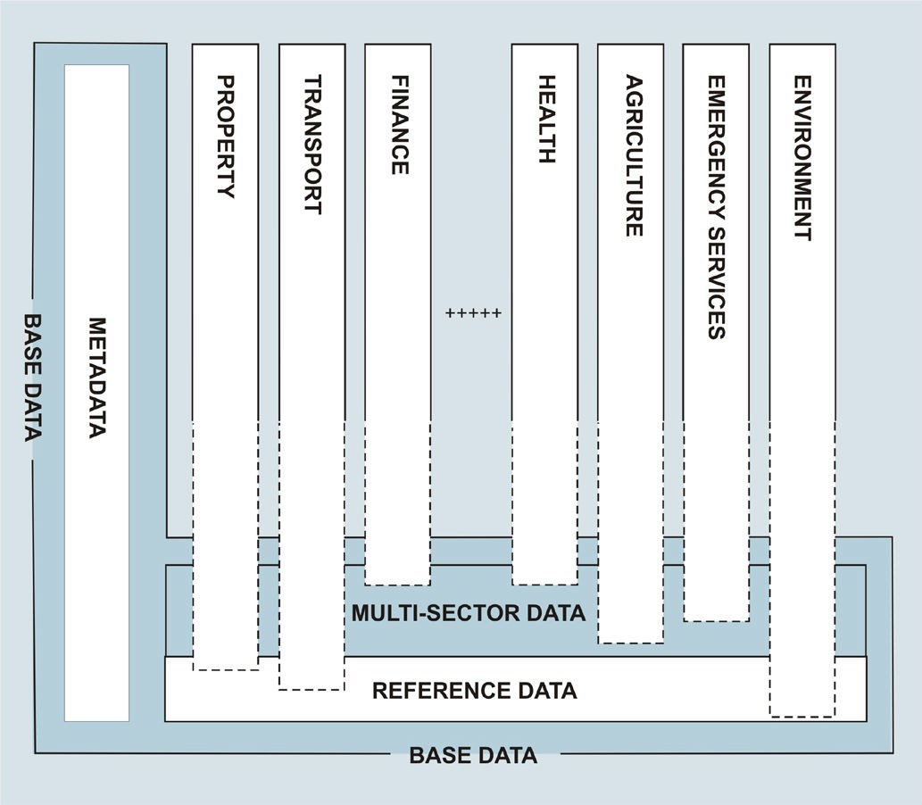

Figure 2. The Danish SDI model

In this model, KMS is responsible for the "base data" which consists of metadata, reference data and the multi-sector data that are shared and used in multiple sectors. Other public institutions maintain their own sector-specific data and provide for their compatibility with other institutions' data. KMS ensures that the acquisition and management of geodata is standardised, coordinated and cost-effective. This facilitates the use of maps and geodata as an administrative basis for Danish eGovernment.
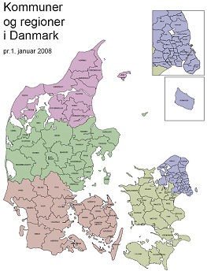

Figure 3. Administrative boundaries as of January 1, 2007:
5 Regions and 98 Municipalities
    - The 2007 Structural Reform

Recent developments in Denmark's public sector have placed new demands on KMS. The 2007 structural reform, in which 13 counties were merged into 5 regions and 270 municipalities were consolidated into 98 new, larger units, required the development of new cross-boundary solutions. The new authorities met an immediate need to share and merge their geographic information, in order to fulfil their administrative responsibilities. In the coming years, KMS will continue to develop a modern and robust national spatial data infrastructure to reinforce data sharing among the municipal, regional and national authorities.

    - Spatial Data Tnfrastructure and TNSPTRE

In many ways, the European INSPIRE Directive reflects Denmark's recent initiatives to develop standardised geodata that can be shared across boundaries and sectors and in broad administrative contexts. The implementation of INSPIRE places additional demands on the Danish spatial data infrastructure in a number of areas, including metadata, access and licensing. KMS participates in a range of public partnerships that work towards the generation of more effective public services. Standardisation is a precondition for efficiently using geodata across boundaries and sectors.

Both the INSPIRE Directive and national stakeholders, including the growing national eGovernment project, place demands on the standards that Danish geodata must meet. Therefore, the Spatial Data Service Community (SDSC) was established in 2002 to coordinate public collaboration of geodata resources. The Community members include KMS, Local Government Denmark, Danish Regions, The National Agency of Enterprise and Construction, the Directorate for Food, Fisheries and Agribusiness, the Road Administration and the Ministry of Science, Technology and Innovation. Together, their goal is to establish digital solutions that support effective eGovernment. KMS holds chairmanship and secretarial responsibilities for the SDSC.

  - GEODATA - THE BACKBONE OF EFFECTTVE eGOVERNMENT

KMS' activities include the establishment and maintenance of a wide range of geodata types. These include reference networks, a Digital Elevation Model (DEM), place name registers, topographic data, property registration records and archives, nautical charts and administrative boundary data.

  - National Geodetic Reference Systems and Networks

The development of GPS technology has revolutionized surveying methods in many ways, and has placed new requirements on KMS as Denmark's surveying authority. The national spatial data infrastructure requires an updated version of the national network of reference points, 3D network and an expansion of the national network of permanent GNSS stations. Furthermore, KMS has developed new technical coordinate systems and projections in connection with the implementation of ETRS84 (WGS84). KMS has also assisted local and government offices with the shift from the outdated systems to the new one.

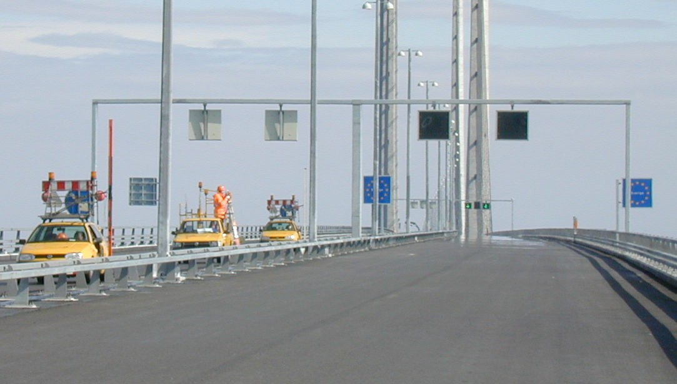

Figure 4. GPS measurements on the bridge that links Denmark and Sweden

The launch of the European satellite navigation system GALILEO will intensify the use of GNSS at all levels. Broader satellite availability will improve the prospects for a road pricing system. The registration of geographical data on a shared international basis and the uniform use of GPS throughout Denmark via national GPS services will be crucial.

  - Digital Elevation Model (DEM)

Digital elevation data is a necessary component of a spatial data infrastructure. Denmark's current digital elevation model is based on outdated terrain surveys and high altitude photogrammetry. There are growing demands for an accurate elevation model in applications such as climate change modelling, water management planning in accordance with the EU Water Framework Directive, shore protection, emergency management and defence. New techniques for gathering and processing precise elevation data have emerged in recent years.
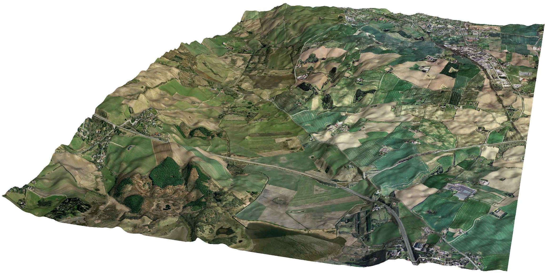

Figure 5. LIDAR-based terrain model

3.2.1 Technical Details of the DEM: KMS is currently supervising the development of a new national digital elevation model on behalf of the public sector. In addition to the economic benefits of the joint procurement, the model will also ensure a common data foundation among its users.

The new DEM is based on laser scanning (LIDAR) and comprises 3 components; a digital terrain model (DTM), a surface model (DSM) and contours. The model is produced by a consortium of two private companies - BlomInfo and Scankort - and the contract was signed in spring 2007. The first deliverables were made available during the summer of 2007 and a full first draft of the dataset was delivered by January 1, 2008. The data, covering the entirety of Denmark, were acquired in the period 2005 - 2007 and are stored in more than
700.000 files.
A comprehensive specification for the 3 models was given in the tender material. The grid size of DTM and DSM should be
1.6 meters (data acquisition density 0.45 point pr. square meter on average) and a vertical accuracy between 0.1 and 0.5 meters, depending on the material and characteristics of the surface.

KMS is responsible for quality control of the model. The control is carried out in co-operation with national and international experts. The procedures have been divided into a delivery check and a final quality control. The delivery check ensures completeness and identifies possible gross errors such as peaks, areas with no data and artificially generated data from data processing. This check was carried out during the first months of 2008 and was focused on the terrain model.

Early in the quality control process, it became evident that further developments were necessary in order to achieve a reliable surface model. Standard filtering for the entire country was not satisfactory and a differentiated procedure that took the various surface types into account was necessary.

The basic topographic vector database of Denmark (TOP10DK with 52 surface and object types and a specified accuracy of 1 meter) was chosen as the reference for separating and identifying surface and object types. A raster version of the vector data base was introduced and its object information used to create specific filter and interpolation methods based on surface type. The result of a close co-operation between the supplier consortium and KMS on this matter has yielded quite successful results.

The contours are calculated from the 1.6 meter raster DTM with a contour interval of 0.5 metres. Depending on the use and the scale of graphical presentation, the contours will be recalculated in order to match the degree of cartographic details. Both the smoothness and the contour interval will be adjusted. This includes contours on printed maps at various scales for armed forces use and a number of web applications.

  - Place Names and Points of Tnterest in Denmark and Greenland

There are approximately 25.000 authorised place names in Denmark. The standardisation of place names began in 1910, when the task was entrusted to the Place-Name Committee. The Committee is still the authority responsible for the orthography of Danish Place Names, and also distributes information about the official spelling of Danish place names.

KMS requires accurate information about place names in its data bases and on its digital maps. This includes spelling as well as correct positioning. KMS has developed a Place Name and Information Register that is linked to its topographic data bases.

More than 120.000 place names are included in the register -
25.000 of these are authorised - in addition to approximately
25.000 points of interest. These include camp grounds, museums, schools and the like.

As a result of the 2007 structural reform, many of the old place names related to the former 13 counties have been abolished. Naturally, some of the old names have been reused or modified in the new regional structure, but also many new names have been introduced.

As the Greenlandic nautical charts are currently being updated, there is a new need to translate a range of Greenland's place

names. The registration of the nautical charts' sea and land place names has contributed to the revision of the gazetteer of Greenlandic toponyms. The gazetteer will likely be published in a generally accessible web application, where it will be edited and updated on a running basis. This process is being carried out in collaboration with Oqaasileriffik - the Greenland Language Council.

  - Common/Shared Object Types (FOT)

Together with the Spatial Data Service Community and Local Government Denmark, KMS has launched FOTdanmark to establish a national base map for use at all administrative levels. For example, the 2007 structural reforms redistributed responsibility for environmental administration in the public sector. FOTdanmark will ensure that geodata can be shared across the new administrative boundaries.

A number of municipalities have already joined FOTdanmark. It is crucial that FOT geodata is established nationwide in the coming years to ensure that FOT becomes an integral part of the national spatial data infrastructure and, further, the e- Government.

The establishment and maintenance of FOTgeodata is based on aerial photographs. Updating will be incorporated into the existing routine administrative updating. Updates will reflect administrative changes as soon as they have been registered by the local authority, and there will be integration between the shared geodata resources and the administrative realities.
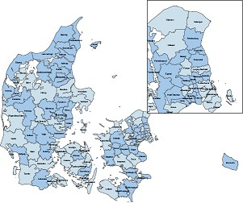

Figure 6. Members of FOTdanmark are shaded in darker blue

3.4.1 The FOT Collaboration: The FOT concept is based on a combination of the information from existing maps, including the nationwide topographical TOP10DK database, which has a specified accuracy of 1 meter in all three dimensions, and large scale "technical" maps with an accuracy requirement of 10-20 cm used by local government administrations.

The FOT object list comprises more than 60 object types; most of these are mandatory.

Three classes of photogrammetric registration (mapping) are defined for rural areas, built-up areas and city areas. The areas and the corresponding object types and registration rules are named OP1, OP2 and OP3 respectively.
Data is acquired stereoscopically from digital aerial photos. Although the FOT specification identifies 3 image scales for the 3 different mapping classes, practise has shown that 2 ground sample distances in the photos are sufficient, i.e. 10 cm and 20 cm pixel size.

Seamless orthophoto maps have become an extremely popular product and several municipalities have decided that their respective administrative areas should be registered with 10 cm pixels, replacing a complete registration with 20 cm pixels and
10 cm registration of city areas. Utilizing modern photogrammetric software, digital orthophoto production is fast and cheap.

Orthophotos are an integral part of the FOT concept and the same digital photos are used for both stereo digitising and orthophoto production. In this way, complete consistency is achieved for vector data and orthophoto maps. In addition, the orthophotos are used in the quality assurance process for geometric completeness.

The production of FOT vector data is carried out through tendering by external contractors, in accordance with the FOT specification. The tendering is managed by the FOT networks, typically consisting of 6-8 municipalities and the national government, represented by KMS. The final check to ensure the data is harmonic countrywide and properly stored is a KMS responsibility.

So far it has been difficult for the contractors to meet the specification requirements and create a production line that can deliver data acceptable for the FOT networks. FOT is built on the idea that all the best of existing data should be reused and supplemented with the new registrations, in order to create an updated and complete geodatabase. However, the merging of existing data that is registered according to outdated specifications and data from new aerial photos is a very difficult task. Consequently, a more pragmatic solution has been agreed in some of the FOT networks. Most of the geometry is photogrammetrically registered from new aerial photos, while a significant percentage of attributes are reused from existing registers and databases.

  - Topographic data

Currently, the topographical databases and the various small scale map series are all based on the TOP10DK databases. Data for the various products are derived from the basic database by a complex set up of generalisation routines and links to place names and points of interest. Some of the map series can now be derived more or less automatically.

As FOT is implemented, the new FOT data will replace the existing TOP10DK data in the topographical databases. It will take a few years before all TOP10DK data is replaced, and in the meantime, a hybrid database is being used. Some areas are covered by TOP10DK data and some registered as more detailed FOT data. However, all topographic map series and data for KMS' web applications are derived from this basic database.

Figure 7 shows data from the hybrid database. The lower left part is detailed FOT data, while the upper right part represents TOP10DK data.

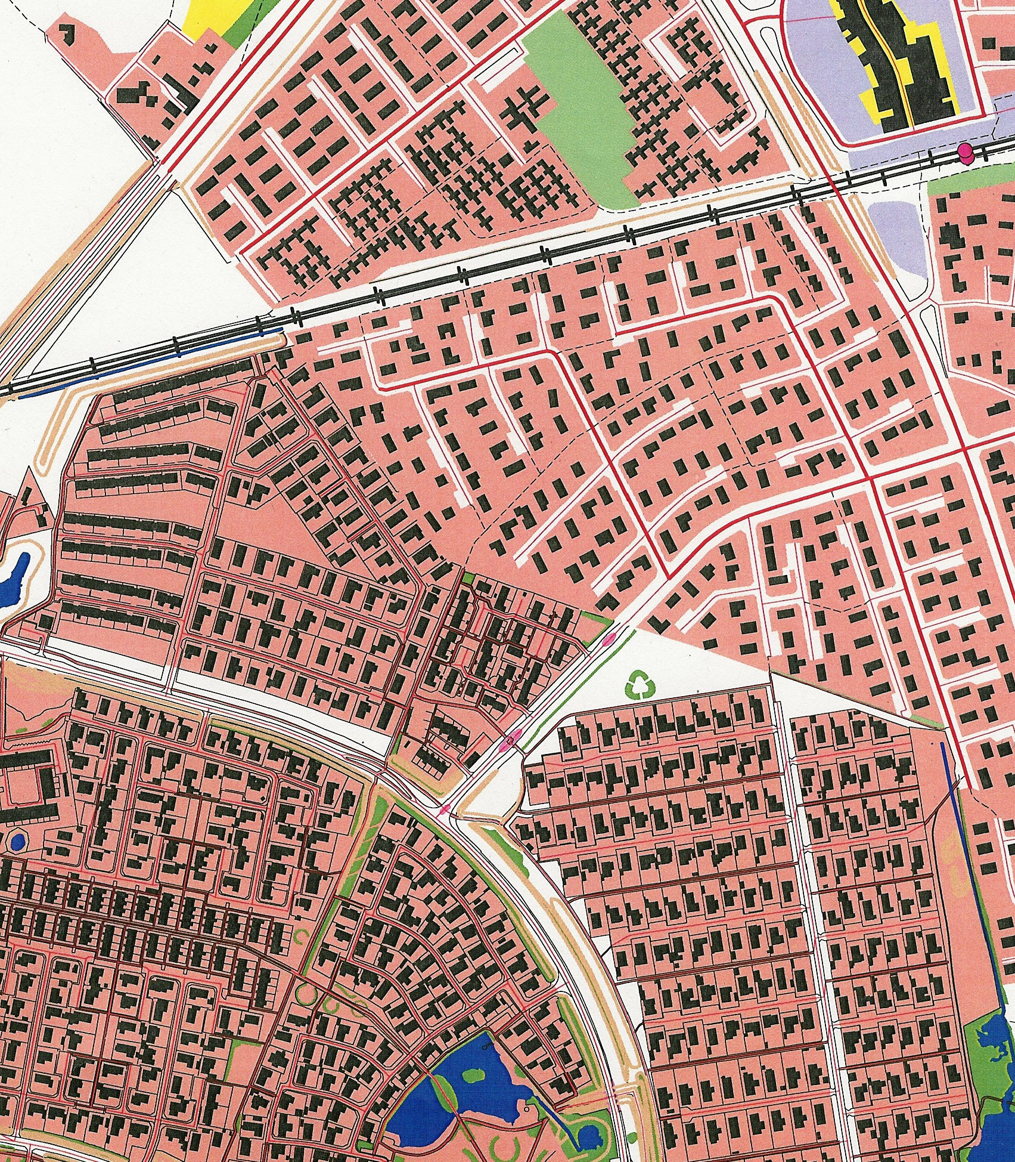
Figure 7. Merged FOT and TOP10DK data

  - Cadastre and Property management

A comprehensive property register is an important precondition for efficient economic development. The cadastre is the basis for property registration in Denmark.

An ambitious restructuring of the cadastral systems and procedures is underway, in order to improve the efficiency and quality of land administration and to support the land registration reforms.

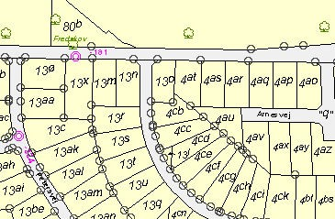

Figure 8. Part of Danish cadastral map

Once these reforms are complete, the cadastre and cadastral map will be a fully integrated component of the national spatial data infrastructure. It will also meet the criteria of a multi- functional cadastre. KMS takes responsibility for establishing models of cooperation for implementing this activity.

KMS continues to maintain the national cadastre at high standards, while simultaneously moving towards a paperless interface between chartered surveyors in private companies and KMS. This is being carried out in conjunction with the Danish Association of Licensed Surveyors. In the future, both parties will contribute to establishing paperless processes in further areas of property administration.
Further development of the cadastre includes techniques for registering new types of property, including properties and infrastructure at elevation and depth. KMS will ensure that these needs are met.

  - Cadastral Archives

KMS has initiated a comprehensive digitisation of the Danish cadastral archives. The oldest records in the archive date back to 1844. The new digital records will be integrated into the national spatial data infrastructure, where they will complement e-Government services.
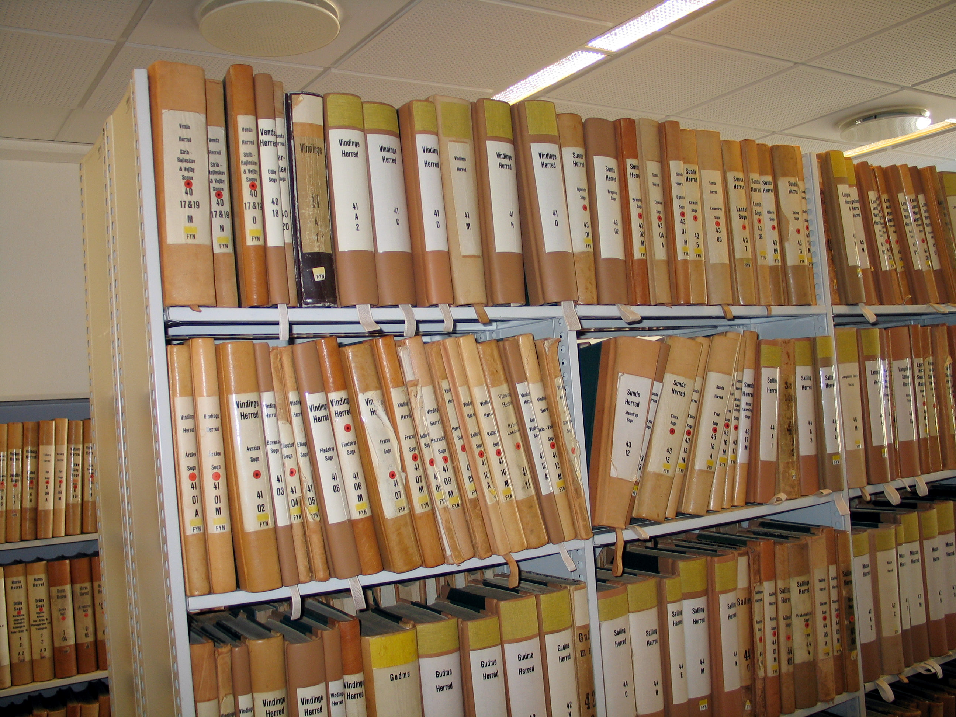
Figure 9. Old analogue cadastral archives

This digitisation project contributes to securing the objectives of the national eGovernment strategy, entitled Towards Better Digital Service, lncreased EJJiciency and Stronger Collaboration 2007-2010. The project also increases access to KMS' records for citizens, enterprises, researchers and others.

Digitisation of all cadastral archives constitutes a long-term process that is balanced against KMS' other strategic objectives. The most frequently used survey data and historical cadastral maps will be prioritised highest and digitised first.

  - Nautical Charts

KMS is responsible for nautical mapping of the Danish, Greenlandic and Faeroese waters, as well as for the quality assurance of the marine geodata of these regions.

A seamless interface between hydrographic and topographic geodata can be valuable, if not critical. This is the case in Armed Forces preparedness as well as emergency management and environmental administration. In the next few years, the need for greater integration between hydro- and topographic data is expected to grow.

3.8.1 Revised Charts in Greenland: Changes in navigation patterns, improvements in ships' navigation equipment and intensification of mineral resources prospecting around Greenland have created demands for higher quality nautical charts than those currently available. The geometrical accuracy varies, and calculations have shown the coastline to be several nautical miles displaced in some areas. KMS is working with Greenland's authorities to improve and reissue a substantial number of the Greenlandic charts over the next four years.

Nautical charts in Greenland are mainly based on surveys from 1930-1988. Based on the need for nautical charts at a reasonable accuracy in a GPS-based datum, transformation of the existing data from the old chart to a new one based on datum WGS84, was investigated. WGS84 is realized as GR96 - the Greenland 1996 datum.

GR96 was developed on ITF94 observations in a few stations distributed across Greenland. The result of some older GPS, Transit and Doppler observations were datum shifted to GR96. The entire triangulation network with fairly few distance observations was adjusted.

From 1978 to 1986, KMS initiated a complete coverage of the ice-free parts of Greenland with super wide angle photogrammetric images. The scale is approximately 1:150.000. The black and white photos that cover the relevant charts were scanned and a new improved aerotriangulation was established based on the improved GR96 datum. A new coastline was registered photogrammetrically, a terrain model calculated by correlation and finally an orthophoto produced.

Since the original observations for the old charts were not available, the adjustment was based on a scanning and a subsequent vectorization. The photogrammetrically plotted coastline was used as the coastline in the new chart. Corresponding points, which were easy to recognize in both the old and in the new charts were chosen giving pairs of pixel in UTM zone 24 GR96 coordinates.

The differences between the charts were irregularly distributed, showing major differences over short distances. The most important data to be transformed were close to the coast, i.e. highest weight in the transformation. The farther away from the coast the information is, the more general the transformation should be. A collocation interpolation has such behaviour.

By the combination of geodetic observations, photogrammetic procedures and scanning/vector techniques, a cheap and efficient method has been developed to transform an old paper chart with substantial errors to a relatively geometrically correct GPS-based chart. Further, the charts are now in digital (vector) form, and can easily be updated when new information becomes available.
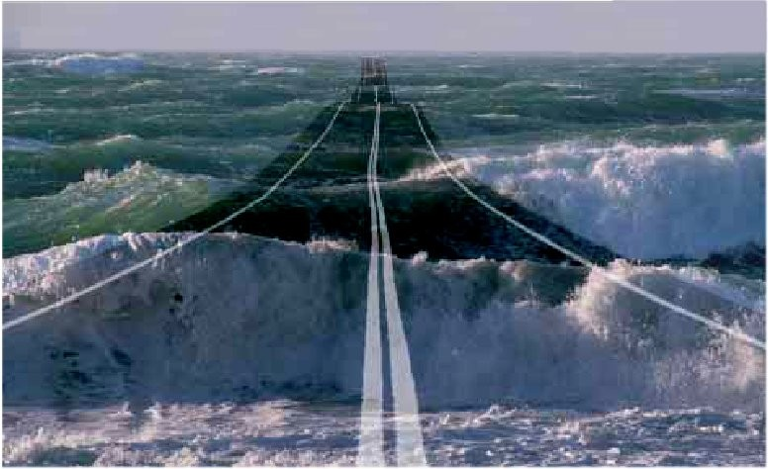

Figure 10. Securing the Maritime Highway
3.9 Administrative Boundaries

The 2007 structural reform affected municipal areas, jurisdictional districts, police districts and constituencies, and resulted in new administrative boundaries. This required the generation of a new official representation of Denmark's administrative units for statistical, planning and administrative purposes.

The INSPIRE Directive presents additional requirements for geodata on administrative boundaries. Together with Denmark's national authorities, KMS will ensure the establishment of a new independent dataset named Administrative Boundaries oJ Denmark. Once established, this dataset will be integrated into the national spatial data infrastructure.

  - APPLTCATTONS

  - The Digital Map Supply

KMS' services are digital. Via the Digital Map Supply, the Internet has become the institution's most important channel for the distribution of geodata. The Digital Map Supply is thus an integral part of the national spatial data infrastructure and meets the INSPIRE requirements for geodata distribution services. The Digital Map Supply distributes geodata and spatial functionality based on a service-oriented architecture (SOA).
It is not an end-user service, but feeds data into independent providers' own solutions. KMS' geodata is hereby simultaneously integrated into emergency services, environmental administration and other unique applications.

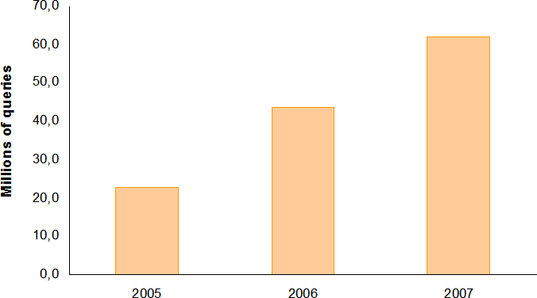

Figure 11. Queries to the Digital Map Supply

In the maritime sector, the distribution of electronic nautical charts is managed by Primar in Norway. The possibilities for parallel distribution through the Digital Map Supply are being examined.

  - Emergency data

In emergency situations, critical demands are placed on the ability to rapidly access and utilize geographical information.

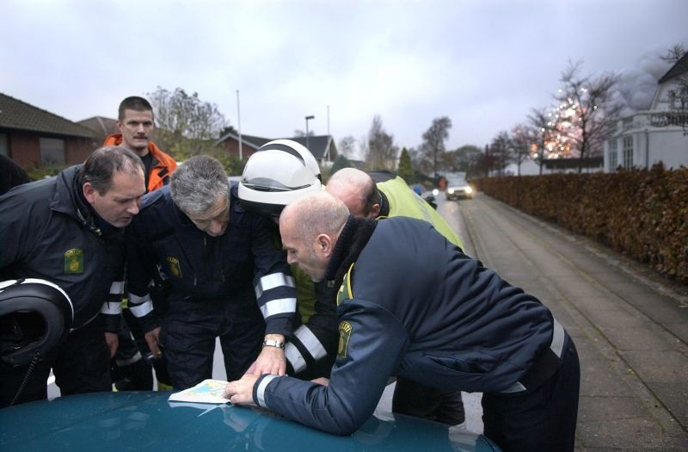

Figure 12. An Emergency situation - with analogue map
Foto: Uffe Kongsted, copyright (Politiken www.pol.dk)

The growing threats of terror attacks, natural disasters, environmental pollution, epidemics, outbreaks of veterinary diseases, etc. demand emergency preparedness among national authorities.

Spatial data infrastructure can be a valuable element in the successful management and mitigation of emergency situations. KMS ensures that geodata is immediately accessible in emergency situations to provide a common operational picture for emergency management authorities.

KMS' activities in the emergency preparedness area will also reinforce the European initiative GMES, which fosters the development of environmental and safety information services linked to spatial data infrastructure.

  - Armed Forces

KMS signed a new contract with the Danish Armed Forces at the end of 2006. The contract identified KMS as a consultant to the Armed Forces and as their centre of geodata expertise. KMS prioritizes the continued development of its cooperation with its military partners and will continue to respect their unique situations and responsibilities. The Danish Armed Forces have a strong focus on the development of their future spatial data resources. Their international engagements are also critical.
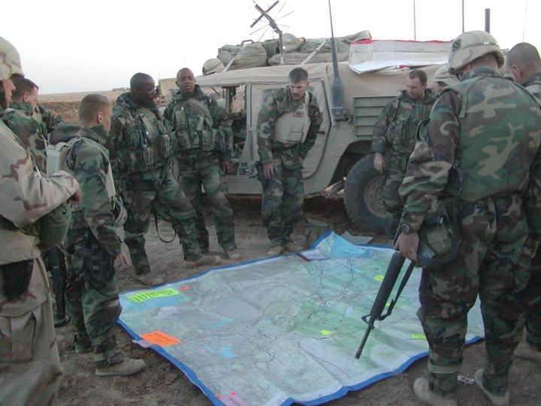

Figure 13. Military planning using analogue maps

A synergy between military and civil needs for spatial data infrastructure has become increasingly apparent. While implementing its contract with the Armed Forces, KMS will ensure that its efforts in the military sector are coordinated with
its work for the civil sector. This will ensure a more efficient and effective resource deployment in both sectors.

  - CHALLENGES AND PERSPECTTVES

Topicality in all KMS databases is a demand for today, as is immediate accessibility. Up-to-date data including comprehensive metadata is critical for almost any activity in modern society, and in many cases, it can be more important than geometrical accuracy.

The Digital Map Supply is a cornerstone in the distribution of data to partners in the public and private sectors. KMS focuses on well-tuned IT systems that support automatic and semi- automatic data quality assurance procedures, effective databases and rapid information dissemination.

KMS is currently facing a transition from its traditional responsibility of generating maps to fulfilling new demands for geographical data that can be shared and applied in a wide range of contexts. This has required KMS to increasingly tailor its work to a rapidly changing national and international market.

  - REFERENCES

Andersen, R.C. et al. 2008. Geometrical Transformation of Nautical Charts in Greenland. ISPRS, Beijing, P.R.China

Danish Government, Local Government Denmark and Danish Regions, 2007. Towards Better Digital Service, Increased Efficiency and Stronger Collaboration. The Danish e- Government Strategy 2007-2010.

Holmberg, B. and J. Jensen, 2007. Report of Denmark. Ninth United Conference on the Standardization of Geographical Names, New York, USA

KMS, 2008. Location - a gateway to e-Government. Strategic objectives 2007 - 2010.

KMS, 2008. Review 2007 of the spatial data infrastructure.

Larsen, B.C., 2006. Geodata - The Backbone of Effective eGovernment. The Digital Taskforce.

Website of National Survey and Cadastre: www.kms.dk

FROM ANALOG TO DIGITAL AERIAL IMAGEPRODUCTION.

EXPERIENCES FROM NMA-IMAGE-PRODUCTIONS BASED ON EU-TENDER.
John kamper

National Survey and Cadastre – Denmark, Rentemestervej 8, DK-2400 Copenhagen NV, Denmark jk@kms.dk

KEY WORDS: Digital Cameras, Photogrammetry, Remote sensing, Production, Mapping, Work flow

ABSTRACT:

This paper presents considerations and solutions, done by the National Survey and Cadastre (KMS), to overcome challenges in the transition from analogue to pure digital aerial image collection. Considerations and solutions are generalized - but are actually linked to the case, when production is executed through partnerships established by a EU-tender.

1. INTRODUCTION

In Denmark, aerial images are collected in March and April every year, before leafing, through a photo-campaign planned and organized by the National Survey and Cadastre (KMS). The purpose of the images are to revise the national topographic map database FOT (earlier TOP10DK), which is maintained in collaboration between KMS and the local municipalities in Denmark (FOT-Danmark, 2008 and Kort & Matrikelstyrelsen, 2001).
Images are collected through KMS, by one of a number of contractors found each year in an EU-tender-process.
Each image collection campaign, are planned and organized by the chosen contractor, according to a set of detailed specifications defined by KMS in each years tender. Before the contractor is allowed to initiate the data-capture, the production-solutions must be approved by KMS.
During the data capture and the following data processing done by the contractor, KMS are continuously involved in predefined quality assurance procedures and to secure the overall quality of the process and the final data material.

2 EVOLUTION OF TECHNOLOGY

Today the campaigns are fully digital.
The transition from analogue to digital data capturing, has been prepared and implemented through a period of 4-6 years. This chapter presents an overview of the evolution of the data capturing techniques used for establishing and updating the national topographic map database (FOT / TOP10DK), and how these changes in techniques were adapted into the planning and production workflow.
From the mid 90’s, when production of the Danish Topographic Map-database TOP10DK was first started, aerial images of one fifth of Denmark were produced every year, in scale 1:25.000 using black/white film. After a period of about 5 years, when the databases were to be
revised, the image media was changed from B/W to colour film.
The analogue images were digitalized using photogrammetric scanners, and after that processed on digital photogrammetric workstations for further collection of 3D map objects.
Around 2004 companies started to invest in digital aerial cameras. At that time there was great expectations but little knowledge, on how a transition from analogue to digital image data collection would influence the data workflow on specifications, data handling etc.
KMS did at this time investigations concerning the digital technique and how it was adaptable into a traditional photogrammetric map update workflow (Brian Pilemann Olsen et al., 2005 and 2006).
On this background, in 2005, KMS first extended its tender- material to allow contractors to offer the production done with digital cameras. For a start, digital production was an option not a demand.
Through the image campaigns in both 2006, 2007 and 2008, parts of the productions have been done with digital captured images in GSD 10cm and 20cm. The image-scale was changed due to a shift in map-database-specification (FOT). After each production-year gained experiences have resulted in further revision of the tender material.

EVALUATION OF TENDER

This chapter gives an overview of the elements that KMS has changed in the tender-material around 2005, to do a first important step towards digital aerial image data collection. Elements are presented and discussed for their importance.
As a consequence of investigations done in by KMS on the digital camera techniques, it was decided for a start, only to allow digital image production with digital cameras build on frame-technology. It is expected though that from 2009 the tender could be opened up for production with digital line scanners as well.

Image extend

A basic-point to define a traditional analogue photo campaign, is the camera frame or the image-extend, meaning the resulting area on the ground that is covered through one image by the analogue camera.
All “full size” analogue aerial cameras use the same frame size, defined by the film size of 23cm by 23cm, and by that also represent the same image-extend on the ground - given a specific camera lens system (focal length) and a specific flying height.
This is not the case for the digital cameras, where CCD’s has substituted the traditional film-media. There are big differences on how the cameras CCD’s are combined and arranged into the final image-frame. And by this, also different resulting image-extends.
Because there is no exact conversion from one single analogue image-extend to the various digital CCD frame image-extends. The term image-extend is no longer used in the specification for a KMS digital photo campaign.

Image-scale / Flying height

For an analogue photo-campaign, it is also necessary to define the two interacting parameters image-scale and flying-height. Image-scale is the most commonly used and exact term, which through a predefined camera-lens-system (and image-extend), also specifies the exact flying height.
For a digital image campaign, image-scale and flying-height are also interconnected and by so it is only needed to specify one of them.
The image-scale specification for digital cameras, are the definition of “ground sampling distance” (GSD). The GSD defines what size on the ground that has to be represented in one pixel. Normally the GSD are specified as “X centimetres” meaning that one image pixel (must) represent “X centimetres by X centimetres” on the ground (flat ground).
Specification of GSD is sufficient and preferable to substitute the traditionally definition of both image-scale and flying-height. Using the GSD, the specification is neutral to which digital camera could be used. Different cameras with different camera-lens parameters will adapt the requested GSD, by doing the data-collection from different flying heights.

Coverage / Flight lines

By the fact that the different digital cameras consist of different image extents, the cameras do also cover various areas on the ground, given a specific GSD. This is also the case when compared to an analogue camera.
A transition from analogue to digital image campaigns, or “year by year” transitions between digital camera types, will therefore cause ongoing fluctuations in “ground coverage” on images and by that also fluctuations in “number of images and number of flight-lines” needed to cover a specified image-campaign.
When the production, as for KMS, is highly repetitive and based on tenders with possible changing contractors, the image footprint and number of images for each campaign are very seldom constant over years.

Summary

At KMS, the first revision of the tender material to adapt a digital production, resulted in exclusion of all references of image extends, camera lens system, flying height and image scale. Instead the GSD “ground sampling distance” was introduced and substituted to describe matters where the excluded specifications were used.

These matters do in some ways simplify the tender, by focussing on only GSD as the primary specification of a photo campaign. But other parts, as missing continuity in technology, image positioning and image extend (by different camera-types) could cause a more complicated tender evaluation and production QA.
In table 1 is shown an overview of these discussed elements.

Subject | Analogue | Digital
Image extent | Same for all camera-types | Differs for each camera-type
Flying height | Exact for each image scale | Differs for each camera-type
Image scale  / GSD | Image scale… exact | GSD….  exact
Coverage | Exact for each image scale | Differs for each camera-type
Table 1: aspects on analoug/digital camera-types

EVALUATION OF WORKFLOW AND END-PRODUCTS

In the production workflow, the different phases of planning, tender, data collection, logistics, data processing, documentation etc. have all shown elements, where the use of the digital camera technology causes serious considerations and serious need for changes.

These different workflow-phases of the digital image data collection will be discussed. Critical points and recommended practical solutions will be presented and argued.

Planning

The initial revision of the KMS photo campaign tender- material, was focused on the referred matters presented in section 3. To allow data capturing with digital cameras, all references of image-extend, camera-objective, flying-height and image-scale had to be removed from the tender material

and substituted with the term “ground sampling distance” (GSD).
To consider, is also the effective “ground coverage” of each image, which, in case of digital production, is depending on the camera type used by the chosen contractor. Therefore a pre-flight planning of image positions and image frames, should no longer to be part of the tender material.
The pre-planning was earlier produced and estimated by KMS. Results was given as information to the tenders, as input for there calculations and price-estimations.
Planning now has to wait until the contractor and thereby the camera type has been defined. This means that each tender now have to do his own pre-planning, to estimate the necessary workload and a price.
Because the flight planning has now been fully removed to be a part of the bidder’s job and subsequently a job for the chosen contractor, KMS instead maintain and deliver a detailed specification on how planning and project- definitions must be done.
Before the contractor is allowed to initiate the data-capture, the production-solutions must be approved by KMS.

Tender evaluation

The KMS photo campaign tender, is an EU-tender assigned to certain specific rules regarding publication, evaluation and so forth. These rules are the same though, for both analogue and digital image production.
One topic that has shown to have big influence on the process of tender-evaluation, is the number of bets that is received on a tender. The number of bets received on a digital photo campaign is, among other topics, also a question on how many companies that actually do offer a digital solution. Especially in the first years this was evident.
If a tender is open for digital production only, it will probably mean that prices will be high, reflecting that there is only little competition. On the other hand, if a tender is open to both analogue and digital production, then one has to seriously consider the different weights on the evaluation criteria, on both economy and on quality.
If the economy is weighted to high, it is certain that the analogue bidder’s are favoured, by not having new investments to pay, and one might be “stocked” on old technology. But if quality is weighted to high, it is likely that the price-jump from an earlier analogue production will be high, even though there might be analogue and cheaper bets in the tender as well.
By tuning the evaluation criteria’s in the tender, year by year, one might keep influence on operating the photo campaign, in a world of changing accessibility to old and new technical production systems.
Another topic is that the evaluation of the tender has shown to be more complicated to handle than before. This is basically because a digital solution differs more compared to both analogue and also to other digital solutions, than it did before. When comparing each solution on technology, methodology and logistics and quality assessments.

Data capture

The digital data capture, as for the analogue, is produced by the contractor, including only informative communication to the customer on quality and progress.
The digital data capture is facilitated by a possibility to do “on the fly” verification of what is logged on the camera- computer. Normally this is done solely by the contractor.
Because of the digital camera-technique and optics, it has shown that even images captured in less good conditions as “high cloud cover” or “low sun angle”, can actually be used for mapping, orthoimages etc. with good results. This is also because image quality can be optimized in the image processing.
This means that data capturing time can be extended to include both some “cloudy days” and also by more production hours on both ends of a photo day. On the other hand, because image extend, in the digital cameras are smaller than in the analogue cameras, a higher number of flight lines are needed to cover the same area.
Camera-failures are more “unexpected” and “uncertain” in the new digital cameras, when it comes to technique and architecture, as they are still not yet as fully proven and understood. KMS has not yet conclusions on how often and how much this affect the data capture campaign.

Data logistics

Data logistic is in both analogue and digital data collection in responsibility of the contractor, with only informative communication with the customer on quality and progress.
The time delay from “when images are taken” until the customer has a “read-out image for QA”, is shortened dramatically. This means that the customer now “has a chance to be”, more involved in the early process of QA- dialog with the contractor. This might request more work and also some new capabilities by the costumer. But it is also a tool for optimizing the data and the forthcoming use of the data.
A matter to be aware of on logistics, is the maximum possible data amount to be captured in one day. As for the analogue production one might run out of film, in the digital production one must be aware of how much disc space are available for both capturing images for a whole day, and also how much disc space and time (speed) are available for emptying the camera-data to a transport media. It is important that this does not delay the photo campaign. Especially if data has to be captured within a limited time- period.

Data processing

Data processing is essential on merging the digital cameras different single CCD’s into one geometrically correct image. Software to do this is developed by the camera- producer and is derived to handle one specific camera type.
While processing the merged image from the different CCDs, the contractor also set up the radiometric presentation of the image. This can include direct processing, pan sharpening and also 12 bit to 8 bit image

conversion. The different camera-types uses different techniques and different user interfaces for these processes. And therefore reflect an “camera-specific methodology”. Actually one has to rely completely on the producers skills and experiences with the software.
Many important aspect of the image presentation are included in the image-processing. And the processing is often managed or presented, as a “black box”. Therefore the conclusion in KMS is, that this is a very important topic, which KMS will focus on in the future.
Until now experiences are that, in general it is not very easy to interact with the producers, during this process.

Data volume

By analogue aerial image campaigns, the images were traditionally exposed on either colour or black/white film. For digital use the film were afterwards scanned in a resolution that were reasonable for their intended use. The chosen scan resolution directly reflecting the data volume.
Now using digital captured data, the scanning is no longer a parameter, meaning that data are always saved in the best possible resolution.
It is often the case, that data are captured not only in the panchromatic band but also in red, green and blue bands, and sometimes also in the near infrared band. Because the CIR images can be produced partly parallel to the RGB images CIR-data are often offered as part of other production.
Through the image-processing, data is then merged into pan sharpened RGB images or pan sharpened CIR images.
It is most likely that the use of digital captured data, will keep on expanding the need of disk space dramatically. One thing to do, is to precisely consider what data are actually relevant to keep.
At KMS data are normally delivered in tif-format. For daily use data are also compressed into ecw-format, but this is not an important parameter for estimating the overall disk space because the compression is very hard. Post-processed data as orthofotos is not considered in this estimate.
In KMS productions, it has until now not been adequate, to save the image-data in 4-channel images (R,G,B,NIR). Instead we have been attach to the fact that software in general is not ready to handle 4-channel images. KMS keep two 3-channel images (one RGB and one CIR). Using a 4- channel image solution would clearly solve some lack of disc-space. But to take this step, it is needed that most photogrammetric software and image processing software are able to access 4-channel data. So they can be processed afterwards.

Metadata

Because a data label on the images is no longer present, there is a risk that metadata for the image will loose its connection to the image.
One way to solve this is by defining the Image ID in an systematic way – so that sufficient information is available
within its ID. One example is to name the images as shown figure 1.
The Image ID’s shown in figure 1 is created from “year and project identification”. Followed by a “flight-line-exposure- number”. Next included is the identification of image-type as “RGB”, “PAN” or “CIR”. Finally followed by the “image enter, Easting- and Northing-UTM-positions” calculated by IMU, GPS and AT.
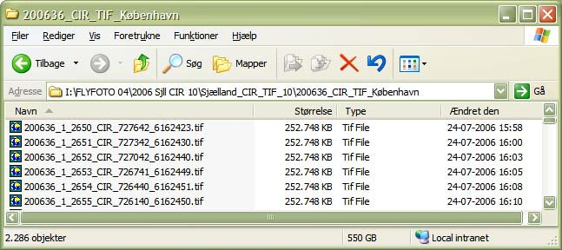
Figure 1: Filenames representing project- flightline- and image-ID’s, image type (CIR) and UTM-coordinates (E+N in Z32N).
Another way to secure metadata, is to specify that metadata must be incorporated in the image files. KMS uses image files in two formats, tiff and ecw. In both cases it is possible to incorporate metadata in the file-header.
But our experiences has shown that metadata in the image files are not easily read and we have also found that data in the header is often with errors. As a consequence, KMS has been working on automatic software procedures, to check the validity of metadata in image files.
Results are that many errors are found in the QA- procedures, already when data are receive, and by this is corrected immediately.

End-products

Even though KMS has experienced, that digital captured aerial images, in general represents images with a higher image-quality than analogue images. There are still some general errors found in the images, which is often not revealed until somebody by accident look into it.
Errors are apparently not found and corrected during image- processing in an automatic way. Some examples are shown and commented in figure 3, 4 and 5.
Images captured for KMS are being used in two different production workflows. One derived production is to use images and image orientations in photogrammetric workstations for mapping purpose. And another derived production is to use images and image-orientations, together with a DTM to produce orthoimages for administrative purposes.
Both analogue and digital captured images has been used in these two KMS productive workflows. The conclusion is for both derived products, that we do not observe any differences in neither productivity nor quality, which can be by related to the use of analogue or digital derived images.

Summary

The planning process for the digital image campaign has become more simple as the only technical specification that has to be decided, is a relevant ground sampling distance. This together with the fact that KMS now is having the tender-companies to do their flight plan for the image campaign area specified.
On the other hand, the tender-evaluation process has been complicated, because incoming tenders are found often to be more different in character.
In general, KMS do not see any trends in having a faster or slower data capturing process for the digital image capturing. KMS experience that the weather is still the major-factor for having data captured before leafing.
On the other hand data processing gives relatively fast results, so that processed data can be part of the map- production and ortophoto production, already in June. Data logistics and data processing is kind of a “black box” which is controlled solely by the contracting company. It is planned that KMS will focus on image radiometry and image processing in the future, because we see this as a procure of high importance on the final image results.
The data volume has been seen to explode, when going into digital image collection. This will to some extend be solved when software in time are ready to handle 4-channel images. But even with 4-channel images, it must be evident that working with aerial images, data volumes are and will still be huge.
Regarding image metadata, this is a topic that has been focused on by KMS in resent years. This was caused by a potential risk, to end op having an image-bank containing images with no metadata (time, location etc.). We experienced that it was not an easy job to secure that metadata are available an in sufficient quality, as some companies don’t focus enough on this topic
Images and end-products as orthophotoes and derived maps derived from digital cameras data, are found to be of generally high quality. Even though, images still end up showing some unexpected errors.

REFERENCES

Brian Pilemann Olsen, Thomas Knudsen, Morten Nielsen, Kristian Keller, LarsTyge Jørgensen, Poul Frederiksen. Evaluation of digital photogrammetry in an operational mapping environment, In International Archives of Photogrammetry, Remote Sensing and Spatial Information Sciences, vol. XXXVI, part 1, 2005
Brian Pilemann Olsen, Thomas Knudsen, Kristian Keller, Morten Nielsen, Rune Carbuhn Andersen, John Kamper, Lars Tyge Jørgensen og Poul Frederiksen. Digital high resolution images and their application in operational mapping Environments. In Proceedings of 7th Geomatic week, Barcelona, Spain, 2006
FOT-Danmark. FOT specifikationen. http://www.fotdanmark.dk/, May 2008. Last visit 2008-05.
Kort & Matrikelstyrelsen. TOP10DK. Geometrisk registrering. Technical report, National Survey and
Cadastre—Denmark, Rentemestervej 8, 2400 København NV, Denmark, maj 2001.

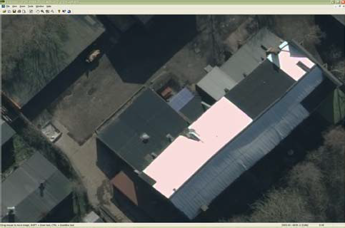
Figur 2: Image found to be oversaturated in parts.

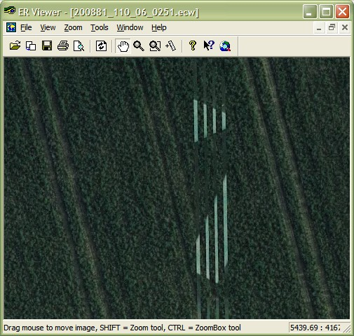
Figur 3: Image found to include pixel-errors.

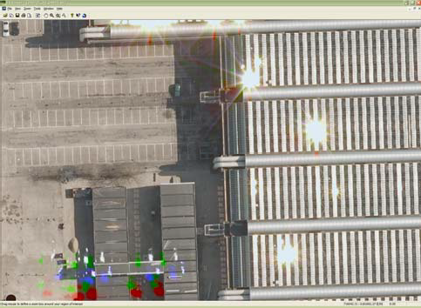
Figure 4: Image found to include both sun-spots and lense-flares.

A. n.

A.

A. n.
- ' -
n.
A.
- I , n.
I , n.

132
n.
n.

n. A. A.
A. n.
n. 44

A. n.
n. A.
n.
A. n.
A.
n.
Karls

A. A. A.
A.
n. n.
A.
A.
A. 53
n.
A.
A. n.
A.
n.

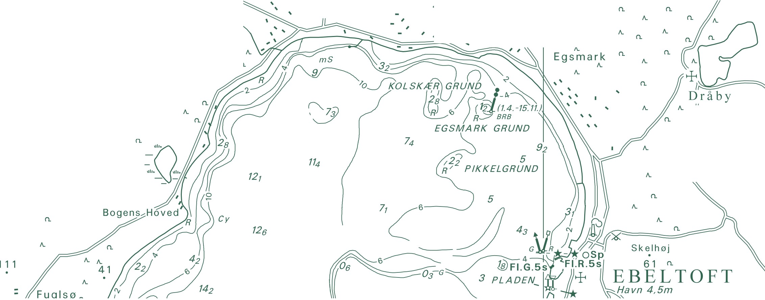A. Trehøje n.
(Dyrehøje) _{A.}
n.
127

National Survey and Cadastre Rentemestervej 8
2400 Copenhagen NV Denmark
http://www.kms.dk

