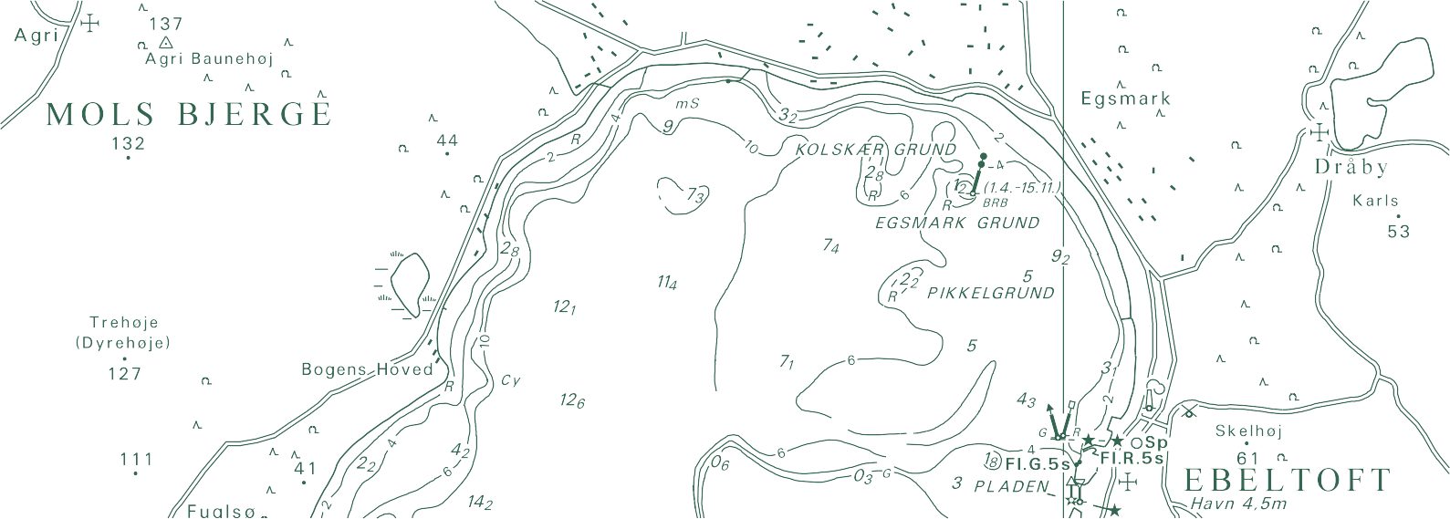

TECHNICAL REPORT NO. 14

Data Assimilation for Updates of Digital Terrain Models
Thomas Knudsen

Thomas Knudsen
Data Assimilation for Updates of Digital Terrain Models

National Survey and Cadastre—Denmark, technical report series number 14 ISBN 978-78-92107-40-4
Technical Report Published 2011-12-18
This report is available from http://www.kms.dk

Due to the use of material distributed under Creative Commons Attribution-Share Alike 3.0 Un- ported license (see Acknowledgements), this report in its entirety is distributed under the Creative Commons Attribution-Share Alike 3.0 Unported license, as well.

Contents

- Introduction 4
  - DK-DEM 4
  - Scope and aim 4
  - Data assimilation 5
- Prerequisites 6
  - Introductory remarks 6
  - Spatial autocovariance 7
  - A DEM filtering scheme 8
  - Spatial interpolation 8
  - Delaunay triangulation 10
- Test site and test data 11
  - Test site location and topography 11
  - A DTM with synthetic changes: The new ground truth 11
  - Synthetic LiDAR observations 11
- Experiments 16
  - Experiment 1: Geostatistical characterization 16
  - Experiment 2: Updating with simple kriging 18
  - Experiment 3: Handling observational noise 21
  - Experiment 4: Eliminating drift by draping 22
- Outroduction 24
  - Future work 24
  - Conclusion 24
Acknowledgements 24
Notes 25
Bibliography 25
APPENDIX 27
- Code 27
  - Bimorphologically constrained filtering 27
  - A noise reduction experiment 29
  - A draping experiment 30

Chapter 1 Introduction

DK-DEM
DK-DEM, the national Danish digital elevation model, consists of three primary products (Dalå et al., 2009):
    - A gridded digital terrain model (DTM)
    - A gridded digital surface model (DSM)
    - A set of terrain contour curves
Supplementary products include a digital terrain model with bridges included (for orthophoto pro- duction), but specifically not the raw data (i.e. the point cloud) used for computing the grids.
The gridded models (DSM and DTM) have a grid ground sample distance (GSD) of 1.6 m (i.e.
0.4 point/m2) and were based on airborne Li-
≈
DAR observations with a similar mean density.
The LiDAR data sets used were collected by the companies BlomInfo and Scankort in the time frame 2005–2007. So while DK-DEM was a big improvement compared to what was avail- able prior to its introduction in 2009, it was al- ready at that time slightly dated.
For many purposes, DK-DEM is still perfectly adequate, but for other purposes (most obviously the ones exceeding the original scope of DK- DEM) it has shown necessary to collect new data. These data, typically collected by public institutions with special tasks in limited areas, could be put to good use in the process of updat- ing DK-DEM. The aim of this report is to take some steps towards a practical realization of just that.

Scope and aim
Since the original point cloud data sets behind the DK-DEM grids are not available, all updates
must be carried out by combining the existing grids with new data, which may be either grids or point cloud data.
A few years ago, Joachim Höhle (Höhle, 2009) presented a very systematic approach to DK-DEM updates, suggesting the use of pho- togrammetric methods, systematically utilizing aerial photos already collected for mapping, to generate new height grids with an accuracy ap- proaching that of LiDAR. These height grids will then fully replace the existing LiDAR based grids.
In a sense, this report takes the opposite ap- proach to Höhle: rather than generating height data from sytematically collected data of oppor- tunity, we are aiming for utilizing existing height data, collected (in potentially non-coordinated or even non-systematical, ways), for opportunistic updating of the existing height model.
Combining the two approaches, we may be able to put all available data into optimum use and, not the least, gain improved insight and con- fidence in the precision and accuracy of the up- dated model.
It is not just in its approach, but also in its scope and aim, the work presented here differs from that of Höhle (2009): Höhle presents and evaluates a practical study based primarily on the use of commercial implementations of al- gorithms and methods that have been developed through more than a decade of research by Höhle and his colleagues in international surveying and photogrammetry laboratories.
This report, on the other hand, presents work based on methods for gravity data analysis, orig- inally developed and used since the 1960s by the physical geodesy community. The application of these methods to elevation data is unconven- tional, so in order to further develop the methods

and ideas within a controlled framework, all the work presented here is based on simulated data (albeit data derived from a real DTM covering a 1 km 1 km test site).
×
Since the results are encouraging and the im- plementation straightforward, I hope, in future work, to be able to follow Höhle’s example of evaluating full scale experiments based on real world data (cf. section 5.1).

Data assimilation
Data assimilation is a term primarily used in nu- merical weather prediction, where it covers the process of combining newly arrived atmospheric observations with the current model forecast, in preparation for the next forecast cycle. Appar- ently this has nothing to do with height models, so how did data assimilation make it into the title of this report? For two reaons, really:
First, data assimilation in the form of op- timum interpolation is an idea for which the time was ripe in the 1960s: Largely similar ap- proaches: optimum interpolation in dynamic me- teorology, kriging in mining engineering, and least squares collocation in geodesy1, were pub- lished within a few years time. So the term data assimilation hints at all these ways of integrating spatial and/or spatio-temporal observations in a way that optimizes the recovery of the physical
signal (modelled as a stochastic process) behind the data.
Second, data assimilation, ethymologically speaking, hints at a process of “making sim- ilar” (to assimilate). And making data simi- lar is exactly what we need when taking the opportunistic-synergistic approach of making as much use as possible of whatever data that hap- pens to come our way.
Getting better data for one area does not in any way make it possible for us to say much new about a neighbouring area. Hence, we must make existing and new data fit together – make them similar.
Sometimes we may even find that the long wavelength accuracy of the existing model may be much better than the new data, while the new data still have much higher accuracy at short
wavelengths. 2 This is especially the case for corridor mapping data sets, where long, essen- tially one dimensional, areas around elongated
features (power lines, railroads, highways) are mapped using just one flight line.
Hence the term data assimilation – to hint at a two way process that in one direction aims at updating an existing model by incorporating new data (as in a human cognitive process), and in the other direction makes the new data more similar to the existing, by propagating a splash of preju- dice/prior knowledge/existing state, to the obser- vations before incorporation.

Chapter 2 Prerequisites

Introductory remarks
This chapter presents some of the more impor- tant mathematical and geophysical prerequisites for the experiments presented in chapter 4. The presentation is neither extensive nor complete, it is simply a brief reminder that may be safely skippped by readers well informed in these mat- ters.
But before skipping on to the experiments, the reader is encouraged to consider a few points about updating of height models which may put the experiments in a different perspective:
    - If we have new and “perfect” data for an area that reveals a bias in the heights of the old model, what should we do at the border between old and new data?
Introduce the new data directly in the model, and live with the step in- evitably introduced on the border be- tween the biased and the unbiased data?
•
Arbitrarily modify the old data near the border to get a smooth transition?
•
Gradually introduce the bias of the old data into the new data, as we get closer to the border?
•
    - The difference between updating and bring- ing up to date: what should be done in ar- eas where we have new data, but also know that these data are already outdated by even newer developments?
    - New observations having error bars falling entirely within the error bars of the old model may actually not bring any new in- formation to the table. Do we update the
models anyway (e.g. to get a local reduc- tion of the error bars)?
    - What should we do if we get new, but tech- nically inferior data (e.g. more noisy and/or lower resolution than the existing model) for an area where we know that changes have happened.
Any competent practitioner will have good an- swers or opinions about these questions.
But when updating a national height model we are changing an essential piece of the geospatial infrastructure. A piece that may be in use in un- known and unexpected ways in various institu- tions. Hence, updating/changing the model may break existing applications in interesting, but ex- pensive and disrupting, ways.
This means that a large number of relevant stakeholders may have differing opinions on the subject. Opinions that may even be mutually ex- clusive.
A technically simple way to deal with this could be to operate with a conservative model that is only updated at predictable and agreed intervals, and a progressive model semi- automatically incorporating all available new data, including their potential errors—Bleeding Edge, Blunders Included!.
But even in the case of stakeholder consen- sus on a purely conservative model, one should not underestimate the value of a process of con- tinuously integrating new data, even though the improved model will not be distributed: in the case of continuous integration, one gets a much better feeling of the actual quality of the exist- ing model, which in turn may lead to improved metadata.

Spatial autocovariance
Spatial autocovariance (or simply spatial covari- ance) is a concept describing how well a physical observable is represented by a nearby measure- ment. To define the autocovariance we start from the variance of a set of n spatial observations z_{i}:
z 2 n
C₀ = ∑ i . (2.1)
Readers expecting a different expression are re- ferred to the note on means versus models below. We now define the lag, d as the distance be- tween two observations. For any given d, we
compute the variance-like expression
∑

A note on means versus models
In geodesy it is common practice to work on anomalies, rather than raw physical values. Anomalies (or more generically speaking: resid- uals) are computed with respect to a model, es- sentially separating the deterministic part of the signal from the stochastic. This enables us to use the right tool for each job: Physical reasoning for the deterministic part, and geostatistical methods for the stochastic part.
When not working on anomalies, it is common practice to model the deterministic part of a sig- nal as the mean of the observations. Hence the well known expression

C_{d} =
z_{i}z _{j} n_{d}

(2.2)
σ 2 = ∑
(z_{i} − m)² (2.4)
n − 1

where the sum is understood to run over all n_{d} pairs z_{i}, z _{j} having a mutual distance of d (or, in most practical cases, a mutual distance of ap- proximately d).
{ }
Computing C_{d} for a range of different lags re- sults in a discrete set of numbers known as the empirical covariance. To be able to estimate the covariance for any d, we fit a continuous model to the discrete set.

The Hirvonen covariance model
One of the simplest and most useful covariance models was published by Hirvonen (1962). Hir- vonen’s model is isotropic, i.e. assuming that the covariance is a function of distance only (which we also did implicitly in the description above). The Hirvonen model is defined as:
for the variance of a set of n observations z_{i} with mean value m.
When subtracting an independently derived deterministic model from the observations, we really subtract something that is potentially more meaningful than the mean (i.e. a local model value, rather than a global mean).
In computations involving anomalies, the last step is to add back the value of the appropriate deterministic model, all in all a scheme known as the remove-restore principle, cf. e.g. Hofmann- Wellenhof and Moritz (2006, pp. 379–381).
Hence, the implied use of the remove-restore principle in equations 2.1–2.2, plays the same role as the removal of the mean, m, in equa- tion 2.4 3.
It is, however, not uncommon to further fit and subtract a low order spatial polynomial from

C (d) = C0

(2.3)
the anomalies. Essentially this amounts to mod-

H 1 d 2
+ L
d

where C₀ is the variance of the data set (equa- tion 2.1), and L_{d} is the lag for which the covari- ance C_{d} (equation 2.2) has dropped to C₀/2.
C₀ and L_{d} can both be read directly from a plot of the discrete empirical covariance values. But be aware that C₀ and L_{d} are not just properties of the data set. They are properties of the physical field investigated.
Hence, one should be very sceptical if a new data set exhibit covariance values that differ much from the existing. In other words, estima- tion of a covariance model is a natural early step in the acceptance check of any new data set. 7
elling (as a low order trend surface) effects un- resolved by the deterministic reference model. Evidently, when selecting a polynomial of order zero, this is equivalent to removing the residual mean, as in equation 2.4.
The use of n in the denominator of equa- tions 2.1–2.2, rather than the n 1 used in equa- tion 2.4, comes from the fact that n 1 signifies the loss of one degree of freedom by the compu- tation of the mean from the same sample used to estimate the variance. When obtaining the “mean equivalent” from an independent model, this loss does not occur.
−
−

A DEM filtering scheme
When applying to heights methods that were de- veloped for use with gravity data, we must cut some corners and cannot expect to gain the same level of conceptual rigor as in the original field.
In the present work, this is most evident in the case of splitting the deterministic part of the sig- nal from the stochastic. The deterministic part is constructed from the original DTM in a mean- ingful, but openly heuristic, method dubbed Bi- morphologically Constrained Filtering (BCF).
The method is documented by a code snippet in appendix A.1, but in brief it is based on it- erative application of still wider gaussian filters then, for each grid point, selecting the maximum degree of filtering still keeping the change below a predefined threshold.
This threshold is then relaxed for singular out- liers, which we do not want to consider part of the deterministic signal. The relaxation is based on operators from the field of mathemat-

Global mean interpolation
In global mean interpolation, all N observations are assigned the weight w = 1/N. This also means that all POIs will get the same value.

Local mean interpolation
In local mean interpolation, all n observations within a given search radius r of the POI, are as- signed the weight 1/n. For large values of r local mean interpolation tends toward global mean in- terpolation.

Inverse distance weighting
In inverse distance weighting, the weights are constructed such that observations close to the POI gets higher weights. Let d_{i} denote the dis- tance from the POI to observation number i. Then weights are assigned as:
w 1/d_{i}
∑

ical morphology (Haralick et al., 1987). In other
words, the filter is constrained by both the land-
i = N j=0
1/d_{j}

scape morphology and by mathematical mor- phology. Hence, the Bimorphologically Con- strained. . . moniker.
An example of BCF in action is shown in sec-
Which is trivially generalized to weights based on powers of the inverse distance:
1/d^{p}

tion 4.1.
w_{i} = N i p
(2.5)

Spatial interpolation
In the experiments (chapter 4), we will need to carry out spatial interpolation in various ways. For information, we quote below (without derivations, but with some comments), some of the main results derived in the admirably clear, compact, and highly recommended lecture note by Nielsen (2009). For a very different (but equally clear) approach, see Bourke (1999)
In general, interpolation is carried out by com- puting a weighted mean of observations in the vicinity of a point of interest (POI). Essentially interpolation schemes differ only in how they de- fine vicinity, and how they assign weights.

Nearest neighbour interpolation
In nearest neighbour interpolation, the observa- tion nearest to the POI is assigned the weight
w = 1. All other observations are assigned the
weight w = 0. 8
∑ _{j=0} 1/d_{j}
Often p = 2 is used (inverse square distance weighting). Presumably inspired by the inverse square nature of gravitational and electomag-
netic force fields. There is, however, nothing magical about p = 2, so if using inverse distance weighting, the p factor should be selected in a way commensurable with the autocovariance of the phenomenon at hand.
For p = 0, d^{p} = 1 for all i, turning inverse dis- tance weighting into global mean interpolation
i
(or local mean if the sum is restricted to points within a certain distance from the POI).
For p ∞, the weight function drops off more and more sharply, so in this case inverse distance weighting tends toward nearest neighbour inter- polation. For most practical purposes, p = 10 is sufficiently close to infinity to make this happen.
→
This feature arguably makes 10 one of the small- est infinities in common use!

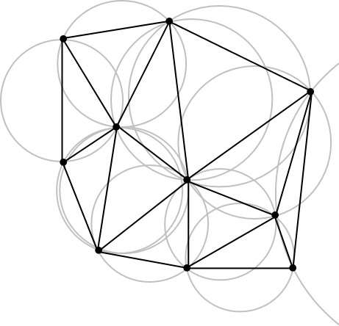

Figure 2.1: The Delaunay triangulation for a set of points: no point of the set is inside the circumcircle of any triangle. Delaunay triangulations tend to avoid long skinny triangles since they maximize the minimum angle of all the angles in the triangulation.

Kriging
In kriging (named after the South African mining engineer Danie Krige), the prediction weights are designed to result in a central estimator with minimum estimation variance. This is a cryptic way to say two things.
First that since we do not know the actual
timate a good covariance model for the physical field we are studying. Having obtained a vari- ance model, we must compute variance values C_{P} _{j} for the distances between the POI and the ob- servations, and C_{i} _{j} for the distances between the individual observations. The weights can then be found by solving the set of linear equations:

value at the POI, we cannot know the size of the
.
.
 C₁₁ · · · C_{1N}
.
.
 w1 
 CP1 

prediction error (i.e. the difference between the
actual value and the predicted). But by designing
the estimator appropriately, we can make sure
 . . . .
.   .
 =  .
 (2.6)

that the statistical expectation value of the pre- diction error is zero, i.e. that the mean error of a
w_{N}
CPN

The prediction is then given by:
C_{N1} · · · C_{NN}

large number of predictions is zero. This is what
central estimator means.
Second that once we have designed the esti- mator to result in zero mean prediction errors,

Z₀ =
w₁ · · · w_{N}
 Z1

.
Z_{N}



 (2.7)

we also want to have optimum confidence that
any individual prediction error is as small as pos-
The prediction variance is, in turn, given by

sible (we do not want to achieve a zero mean by delicately balancing huge errors with alternating signs). Assuming that errors are approximately normally distributed, the chance of running into



σ 2 = C₀ −
0

w₁ · · · w_{N}

CP1
.
.
CPN
 (2.8)

a large error grows with the variance of the dis- tribution. Hence, by designing the weights to re- sult in minimum error variance, we maximize the chance that the error of any individual prediction really is very close to zero.
To make this happen in real life, we need to es-
To compute the set of N weights, we need to solve a set of N linear equations. But the pro- cessing power needed to do this is proportional to N3, which quickly makes it prohibitively ex- pensive in computer time to solve for more than just a few weights.

As a simple example consider the ratio be- tween 53 = 125 and 33 = 27, indicating that it takes almost 5 times as long to solve for 5 weights than for 3 weights.
This means that even for moderately large computations, we need an efficient way to select a small, relevant subset of observations for any POI at hand.
To this end, the Delaunay triangulation comes to the rescue.

Delaunay triangulation
The Delaunay triangulation was introduced by the Russian mathematician Boris Delaunay (De- launay, 1934). Any given set of points can be organized as a area partitioning set of triangles (see figure 2.1). The Delaunay triangulation is defined as the (unambiguous) partitioning that globally maximizes the minimum angle of the entire triangulation.
For any triangle in a Delaunay triangulation, no other points than its three corner points will
be situated inside the circumcircle of those three points. Hence, elongated triangles are essen- tially avoided, since they correspond to exces- sively large circumcircles.
Due to its many practical uses, much effort has been put into the derivation and development of very fast algorithms for constructing the Delau- nay triangulation. In this work, the QHULL al- gorithm (Barber et al., 1996) is used. QHULL is widely used in closed- as well as open source software. The Triangle algorithm by Jonathan Shewchuk (Shewchuk, 1996) is another excel- lent implementation, but Triangle is less used than QHULL, arguably due to a more restrictive licencing policy.
Once the Delaunay triangulation is con- structed for a given set of points, it is easy to find the triangle surrounding any given POI, and hence obtain a small set of 3 observations that may not necessarily be the nearest neighbours of the POI, but which are close to the POI and spatially distributed in a way making them good candidates for a robust estimation of the value needed at the POI.

Chapter 3
Test site and test data

Test site location and to- pography
The 1 km 1 km test site used for the exper- iments in chapter 4, is situated just northwest of the village of Vejby in Helsinge Municipality, North-Zealand (figure 3.1). The landscape of the Vejby area is glacially shaped and gently undu- lating. Due to its beauty, the area was the subject of a large number of paintings from the 1840s by the National Romantic painters J.Th.Lundbye (cf. figure 3.2) and P. C. Skovgaard (Jørgensen, 1995).
×
The test site is characterized by relatively large and sometimes steep, height variations. The land use/land cover (LULC) includes hedgerows, paths, dirt roads, farms, wetlands, lakes, a small forest, farmland, a closed down and only par- tially refilled, clay pit, and (in the northern end) a cottage area from around 1960. All in all a land- scape that is not only beautiful, but also challeng- ing and hence highly interesting from a height modelling point of view.
To establish a well controlled framework for our DTM updating experiments, we introduce synthetic changes in the existing DTM (sec- tion 3.2), and use the modified model as the new ground truth.
This ground truth is in turn used as target for a synthetic LiDAR flight (section 3.3), generating new synthetic observations of the changed ter- rain.
Finally, in chapter 4, we combine the origi- nal (unchanged) DTM with the new synthetic Li- DAR observations, attempting to reproduce the synthetic ground truth.

A DTM with synthetic changes: The new ground truth
The 1 km 1 km test area is represented by a 626 626 grid stored in an ESRI ascii format file (figure 3.1). We introduce change in the form of a synthetic road spanning the grid rows num- bered 523–527 (marked in white on figure 3.1).
×
×
The “road” is constructed as follows: First we remove any across track slope by computing the columnwise mean of the set of 5 rows.
Then we carry out an along track gaussian fil- tering of the mean row, i.e. easing the road for the cyclists by cutting hilltops and filling val- leys (figure 3.3). Finally the filtered mean row is copied back into the original five rows 523–527. The resulting grid (figure 3.4) is now consid- ered the new ground truth for the experimental
work.

Synthetic LiDAR observa- tions
The synthetic LiDAR observations are intended to simulate the result of a single flight strip in a corridor mapping effort, mapping a strip cen- tered on the new road. The observations are gen- erated by this little snippet of Octave code, which notably does not take any roll/pitch/yaw irregu- larities into account:
% rand: uniform, randn: gaussian randomness 1
N = 2*100*1000; 2
north = 6218000 + 160 + 100*(rand (N, 1) - 0.5) 3
east = 694000 + 500 + 1000*(rand (N, 1) - 0.5) 4
z = interp2 (h.x, h.y, g, east, north); 5
% add gaussian noise with a variance of 5 cm 6
noise = sqrt (0.05) * randn (N, 1); 7
z += noise; 8

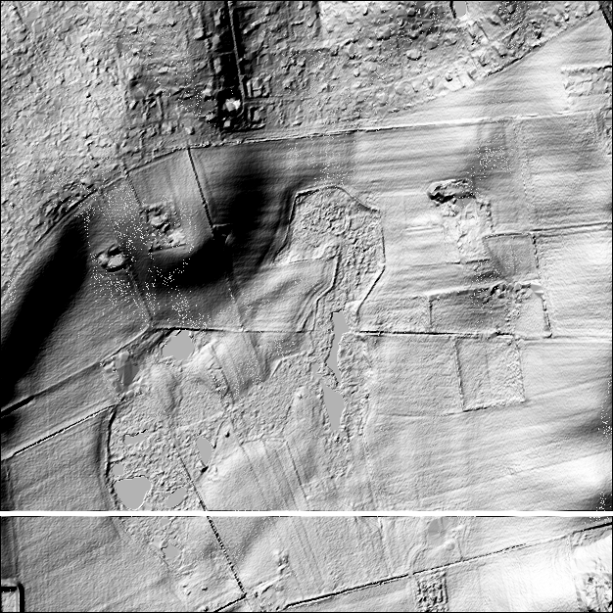

Figure 3.1: The test site covers a range of 6218000 m–6219000 m northing and 694000 m–695000 m easting in UTM zone 32/ETRS89 coordinates. Heights are in the range of 10.4 m–35.3 m (referred to the Danish vertical datum DVR90) with a mean value of 18.3 m and a median of 15.6 m. The white strip in the lower part of the figure indicates the position of the synthetic road introduced for the DTM update experiments (cf. section 3.2).

Figure 3.2: Johan Thomas Lundbye: Landskab fra Vejby (Landscape from Vejby), 1843.

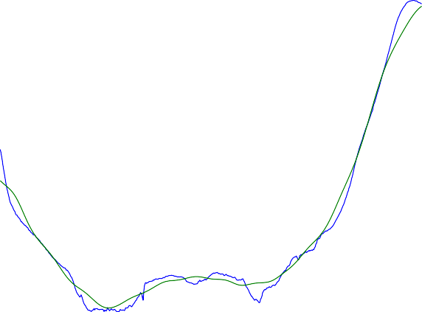24 0.1

22
0.08

20

0.06
18

16
0.04

14

0.02
12

10
694000 694200 694400 694600 694800 695000
0
0 10 20 30 40 50 60 70 80

Figure 3.3: Left: The raw road profile (blue), and the final along track filtered road profile (black).
Right: The 50 point gaussian filter used to even out the bumps in the synthetic road.

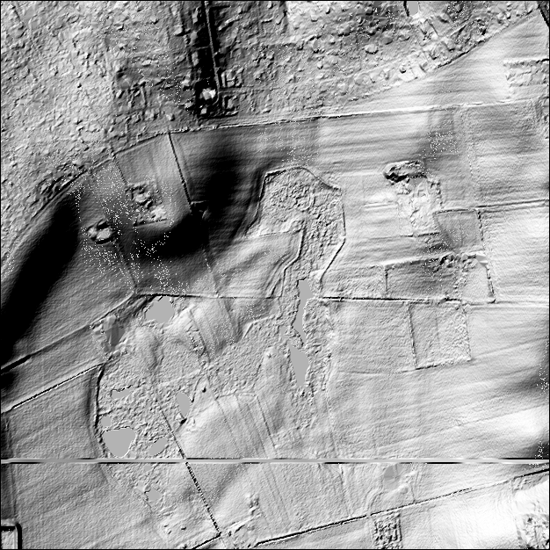

Figure 3.4: The final synthetic road introduced into the original grid.

The call to interp2 interpolates new height values from the ground truth grid g.
The constants of the code snippet are to be in- terpreted as follows:
(6218000, 694000) Northing/easting of the lower left corner of the test site.
(160, 500) The center of the LiDAR cov- ered area is situated 160 m north and 500
m east of the loweer left corner.
(100, 1000) The flight strip is 100 m wide (north/south) and 1000 m long (east/west).
N=2*100*1000 We need 2 observations/m2 for each of the 100 m 1000 m covered,
×
i.e. a total of 200 000 observations.

Chapter 4 Experiments

Experiment 1: Geostatis- tical characterization
The first thing to do with a newly acquired geodetic data set is to get a general feeling of its characteristics. For data which can be plot- ted in meaningful and straightforward ways (e.g. imagery, simple time series), plotting is the ob- vious first action. But in our case of irregularly sampled observations, a geostatistical character- ization is the obvious first action.
Actually the first step of the geostatistical characterization is not geostatistical at all, but strictly statistical (sans geo-). The first step is to plot the histogram of the data, to get an idea of what kind of distribution is behind the data.
The upper left panel of figure 4.1 shows the histogram for the heights of the DTM of the test area (figure 3.1). It is not evident what kind of distribution might fit this histogram, but it certainly isn’t a normal (Gaussian-) distribu- tion. This is even more clear from the QQ-plot in the upper right panel of figure 4.1, where the quantiles of the distribution (i.e. the lower quar- tile, median, upper quartile, and their unnamed brothers and sisters for other values than 25%, 50%, and 75% of the distribution mass) is plot- ted against the corresponding quantiles of the
standard-normal distribution (i.e. the normal dis- tribution with parameters (µ, σ 2) = (0, 1)). In a QQ plot, normal distributions will be depicted as a straight line, with the slope determined by the σ 2 parameter, and the offset determined by the µ parameter of the actual distribution. It is evident
from the QQ-plot that the distribution of the raw heights is not normal at all.
Suspecting that the non-normality is due to autocorrelation effects induced by causal (deter- ministic, non-stochastic, etc.) processes, we go
on to construct a “deterministic height surface”, as described in section 2.3, using the code pre- sented in appendix A.1. The resulting smooth surface, and its corresponding anomalistic sur- face are shown in figure 4.2.
The histogram for the anomalies are shown in the upper left panel of figure 4.3. Despite a marked “knee” around δh = 1m and a minor wart
−
around δh = 1m, the histogram looks much
more normal than the corresponding histogram
for the raw heights. The normality is confirmed by the QQ-plot in the upper right panel.

Covariances
The covariances of the raw terrain model and the anomalies, along with the corresponding Hirvo- nen covariance models, are shown in the lower right panels of figures 4.1 and 4.3, respectively.
The first thing to note is that removing the “de- terministic height model”, really reduces both variance and correlation length: Where the raw DTM (with mean height removed, since it is not an anomaly, as per the discussion in section 2.2)
corresponds to a Hirvonen model with parame- ters (C₀, L_{d}) = (85 m2, 182 m), the correspond- ing parameters for the anomalies are (C₀, L_{d}) = (0.57 m2, 44.8 m). In other words: by removing the “deterministic model”, the covariance scale
is reduced by a factor of almost 150, and the cor- rellation length is reduced by a factor of more than 4.
It is also striking how well the Hirvonen model fits the actual data – especially in the interval
[0 . . . L_{d}], which is really the interval we usually would need4.
One should, however, bear in mind that the empirical covariances in these cases are based on very simplified computations based directly on

6 40

5 35

4 30
empirical quantile, raw

3 25
percentage, raw

2 20

1 15

0
10 15 20 25 30 35 40
height

10
-6 -4 -2 0 2 4 6
N(0,1) quantile

1

0.8

0.6
mean autocorrelation, raw

0.4

0.2

0

-0.2

100

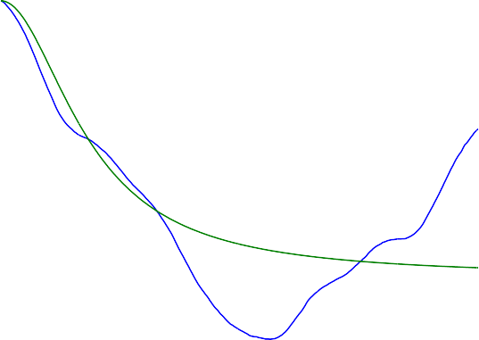
80
Empirical covariance Hirvonen model (85,182)

60
mean autocovariance, raw

40

20

0

-0.4

0 200 400 600 800 1000
lag [m]
-20

0 200 400 600 800 1000
lag [m]

Figure 4.1: Raw DTM geostatistics. Upper left: Histogram. Upper right: Quantile plot of data quantiles vs. quantiles from a standard normal distribution. Lower left: Empirical autocorrelation. Lower right: Empirical autocovariance. Note that the autocorrelation only changes very slowly from
    - In other words, far away points are as important as very nearby points in predicting the height at any given point.

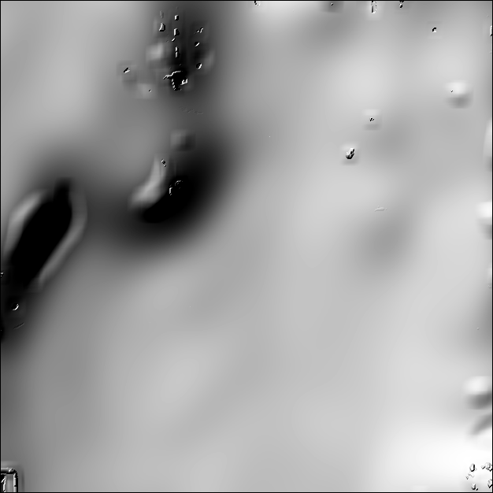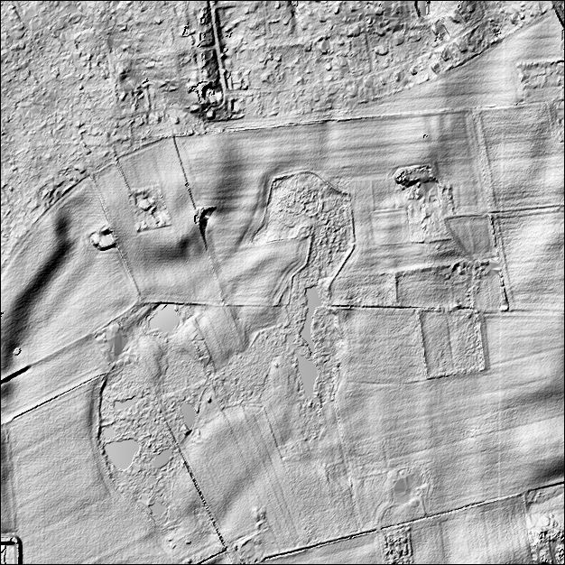

Figure 4.2: Left: filtered “deterministic” terrain model. Right: corresponding anomalistic (residual) terrain model.

the gridded structure of the data: covariances are computed for two directions only (the directions of the northing and easting axes), and using the boundary values of the grid as starting points.
Hence these data are based on 1252 sets of em- pirical covariance values for each of the two di- rections, each set consisting of 626 values cover- ing the lags d [0 m . . . 1000 m] at steps exactly corresponding to the grid GSD of 1.6 m.
∈
While being a simple and totally sensible app- proach, one should expect more smooth covari- ance values than what would be the case for the the more complex algorithm necessary for arbi- trarily distributed data.
The more complex algorithm has been used for preparation of figure 4.4: Here, we work on a dataset consisting of 63 grid lines centered on the center line of the artificially introduced road (cf. section 3.2), i.e. grid line number 525. In other
words, we work on a set of 63 626 = 39438 grid points which we in this case treat as a non-
×
structured point cloud. Obviously, we might have used the synthetic LiDAR data set cover- ing the same region (cf. section 3.3), but to keep in line with the data used above, we stay with the orginal grid values.
Now, we randomly select 5 million point pair combinations and sum up their products accord- ing to equation 2.2. The sums are computed in bins of width 1.6 m, centered on the set
[1.6, 3.2, 4.8,..., 1000] (see Nielsen (2009) for
details of the construction). In other words,
rather than the almost isotropic data used above, each bin now gets contributions from point pairs at different bearings and different distances (ex- cept for the very first few bins, where only a few combinations of distance and bearing are possi- ble)
Not unexpected, the data in figure 4.4 look rather more noisy than the previous plots. Also note that the restriction to a smaller area has reduced both the variance and the correlation length of the raw values as well as the anomalies. This is also as expected, as we now compare a more uniform data set (especially with respect to the raw heights, where we now avoid the effects of the large north–south height undulation).

Experiment 2: Updating with simple kriging
Figure 4.5 shows the original grid (figure 3.1), improved with data predicted using the simple kriging method described in section 2.4, and the synthetic LiDAR data presented in section 3.3.
There really is not much to say about the re- sults: in comparison with the artificial ground truth (figure 4.5), the most striking differences are the (expected) effects of the noise added in

4 3

3.5
2
3

2.5 1
percentage, anomaly
empirical quantile, anomaly

2

0
1.5

1
-1

0.5

0
-2 -1 0 1 2 3
height
-2
-6 -4 -2 0 2 4 6
N(0,1) quantile

1

0.8

0.6
mean autocorrelation, anomaly

0.4

0.2

0

-0.2

0.8

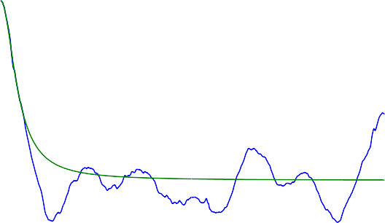
0.6
mean autocovariance, anomaly
Empirical covariance Hirvonen model (0.57,44.8)

0.4

0.2

0

-0.4

0 200 400 600 800 1000
lag [m]
-0.2

0 200 400 600 800 1000
lag [m]

Figure 4.3: Anomaly DTM geostatistics. Upper left: Histogram. Upper right: Quantile plot of data quantiles vs. quantiles from a standard normal distribution. Lower left: Empirical autocorrelation. Lower right: Empirical autocovariance. Note that the autocorrelation falls rapidly from 1. In other words, far away points are not as important as very nearby points in predicting the height at any given point.

14
Empirical covariance
Hirvonen model (13,109)
0.2
Empirical covariance
Hirvonen model (0.15,32)

12

0.15
point data covariance, gridded-elevation
point data covariance, gridded-anomaly
10

8 0.1

6

0.05

4

2
0 20 40 60 80 100 120 140 160
lag [m]

0
0 20 40 60 80 100 120 140 160
lag [m]

Figure 4.4: Covariances for the narrow region around the new road. Note that the lag-axis only covers the first 160 m. Left: Full elevations. Right: Anomalies

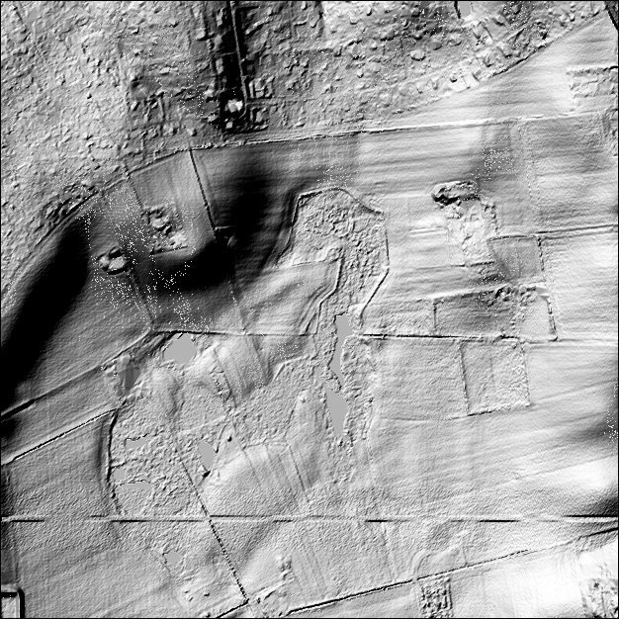

Figure 4.5: The test site modified with updated values (computed by simple kriging) in the area around the artificially introduced road. The effect of the deliberately introduced noise is clearly seen.

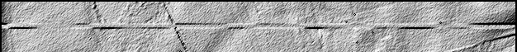

Figure 4.6: Upper panel: The updated values computed by simple kriging in the area around the artificially introduced road. Centre panel: The artificial ground truth (cf. section 3.2). Lower panel: The updated values computed by simple kriging with noise reduction applied (cf. section 4.3).

the production of the synthetic LiDAR data.
In the next section we will show how this noise can be reduced. Not by filtering the gridded data, but directly as a part of the prediction process for the updated grid values.
Now consider that the observation at point A was influenced by a noise characterized by σ 2 = 0.1m2. If we add that noise term to the diago-
nal element for A, and solve once again for the weights, we get

Experiment 3: Handling observational noise

w_{a} =
0.23022
0.30178
 
0.53773

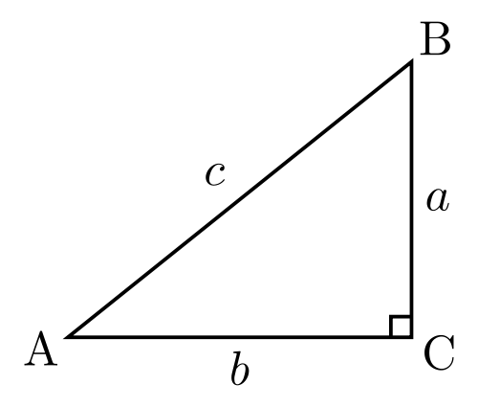
Consider a height field described by a Hirvonen covariance model with the parameters (C₀, L_{d}) = (0.5 m2, 5 m), and consider the configuration shown in this sketch,
i.e. the weight for the noisy observation is re-
duced (and so is the total sum of weights).
But what if all 3 observations were equally in- fluenced by noise? Let us add the same noise term to the other diagonal elements, and solve once again for the weights:
 0.29204 
wabc =
0.29875
0.41855

with 3 observations made at the 3 corners A, B,C of a right triangle with side lengths a = 3, b = 4, and c = 5. Furthermore, let us place the origin of our system at A, and the POI, P at the barycen-
ter of the triangle (i.e. at the intersection of its medians). In this case, the code in appendix A.2, solving the simple kriging system, equation 2.6, results in the weight vector
 
0.30420
w₀ = 0.29346
0.49874
Now, the two weights originally largest are re- duced, while the smallest weight is slightly en- larged. All in all moving the estimator more in the direction of equal weights, which would im- prove the suppression af random noise.
In figure 4.6, we show the result of adding the artificially generated noise source (section 3.3) to the diagonal elements of equation 2.6 for an entire grid prediction experiment.
The result is quite convincing, although one should consider that only part of the noise reduc- tion is due to the blurring: another part is due to the relative downweighting of the anomaly com- pared to the deterministic part.

One may see this as an advantage or a disad- vantage. In either case, the downweighting with respect to the deterministic part would not hap- pen if using Ordinary Kriging (OK), rather than Simple Kriging (SK) as used here: in OK, the sum of the weights is forced to unity, and no prior assumptions are made with respect to the mean value of the signal, which is implicitly reesti- mated for every prediction, hence, perhaps elim- inating the need for computing the “determinis- tic” surface.
The use of individual noise estimates for each observation will probably become possible as access to full waveform reflection data become more common. When that happens, including the noise term in the prediction process will make even more sense.

Experiment 4: Eliminat- ing drift by draping
Airborne LiDAR observations depend heavily on a well functioning inertial navigation system (INS) providing the pointing of the platform: The combination of position information from the GPS, and pointing from the INS is essentially what makes it possible to convert LiDAR reflec- tion timings to ground elevations.
But INS tend to drift – a feature that can often be corrected for by cross over adjustments with
neighbouring flight strips. But in the case of cor- ridor mapping, few or no neighbouring strips are recorded. In such cases the technique of draping (cf. e.g. Strykowski and Forsberg (1998)) comes handy. Draping builds on the assumption that if two datasets that are supposed to have identi- cal long wavelength parts tend to drift from each other anyway, then we must construct a correc- tion surface.
We may think of the two datasets as an old, stable but noisy model, and a newer drifting, but less noisy one.
We construct the correction surface by low- pass filtering both signals and subtracting them. The draping operation is then carried out simply by applying the correction surface to the newer dataset.
The new dataset is then said to have been draped over the old, inheriting the old dataset’s long wavelength accuracy, while keeping its own
higher short wavelength accuracy.
Figure 4.7 shows a somewhat exaggerated ex- ample based on simulated data: An old terrain model of moderate quality (σ 2 = 0.5m) is to be updated by new data of much higher quality (σ 2 = 0.05m). Unfortunately, the new data suf-
fers from a huge drift of almost 8 m along the
100 km track. The draping process (see code in appendix A.3) improves the RMS between the “true” landscape and the new data from a ghastly
4.45 m, to the more acceptable 0.24 m

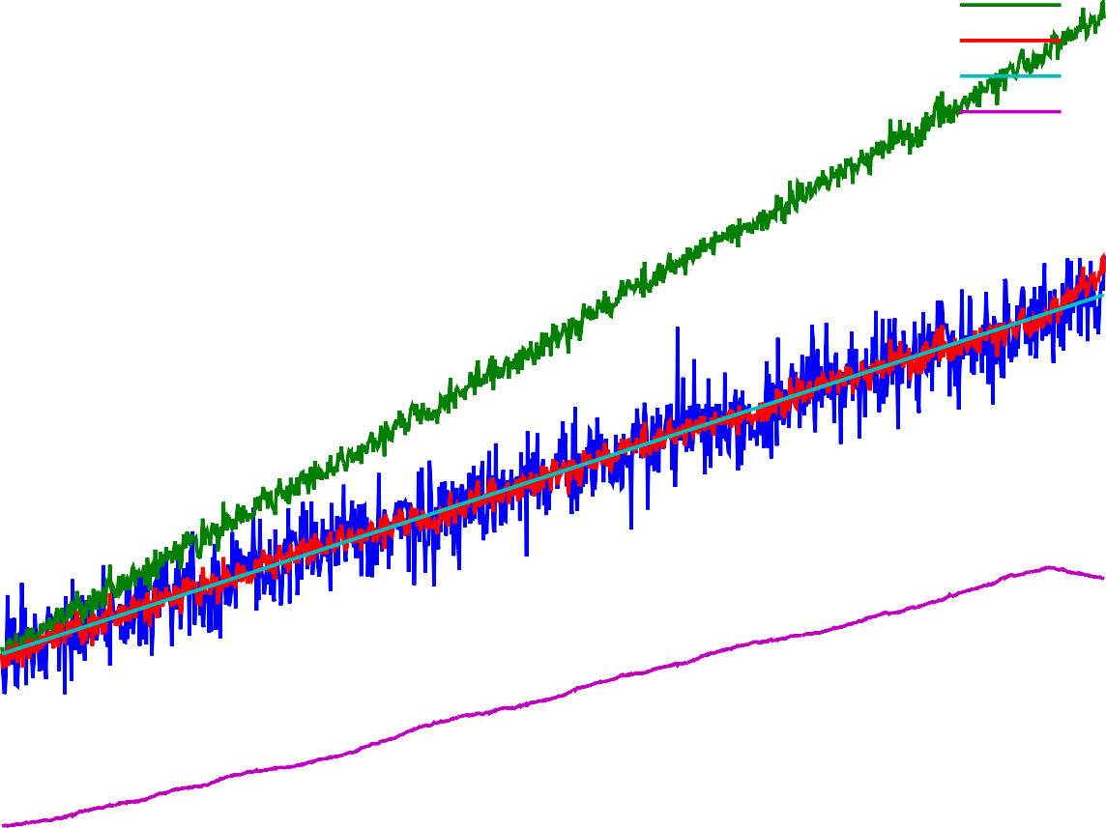30
Ldtm
Nobs Ndtm Ltrue Corr+5

25

20
height [m]

15

10

5
0 20 40 60 80 100
distance [km]

Figure 4.7: Removing drift by draping (cf. section 4.4. Except for the last 5 km, where some boundary effects become visible, the draping process is very succesful in removing the drift. Cyan: The true landscape. Blue: The old, noisy terrain model. Green: The new, less noisy but drifting observations. Purple: The correction surface (biased by 5 m to make it fit onto the plot). Red: The new terrain model, consisting of the new observations (green) corrected by the correction surface (purple) / draped onto the old model (blue).

Chapter 5 Outroduction

Future work
The fields of geostatistics and geodesy can pro- vide plenty of useful methods and techniques for updates of height models.
The next obvious step in the work will be to use some of the methods presented here with new real data, rather than the simulated data used in this report.
Other interesting work will be the (fairly sim- ple and ordinary) switch from Simple Kriging to Ordinary Kriging, with its implicit reestima- tion of the mean value for each prediction. This may also eliminate the need for the deterministic surface in the predictions (while it may still be of use for visualisation and contour line genera- tion).
Also the case of non-isotropic covariance models, which has been left out of the scope for this report, needs to be handled. A particularly simple (conceptually, not implementation-wise!) example of this is the handling of breaklines by modifying covariances for vectors crossing the breakline.
Another interesting way of handling break- lines is through the direct inclusion of the break- line into the Delaunay triangulation (i.e. a so called constrained Delaunay triangulation).
Finally, there is the problem of surface mod- els. In the case of surface models, we do not have a geostatistically uniform area to model. This is a significant complication, which will probably lead on to new and interesting problems!
There’s plenty of work to take up!

Conclusion
For fear of sounding too optimistic, speaking on the basis of purely synthetic data, I have re-
frained from quoting numerical results in this re- port. But the examples presented have shown to be quite convincing.
Hence, taking the geostatistical/geodetic route seems to be a viable option, with plenty of new opportunities that should be further explored.

Acknowledgements
Figure 2.1 was produced by Wikipedia user Nü es. The original version is available from http://commons.wikimedia.org/wiki/File: Delaunay_circumcircles.png, and is distributed under the Creative Commons Attribution-Share Alike 3.0 Unported license.
Figure 3.2 Johan Thomas Lundbye: Landskab fra Vejby (1843) was pro- vided by Wikimedia Commons (http:
//commons.wikimedia.org/wiki/File:Johan_ Thomas_Lundbye_-_Landskab_fra_Vejby.jpg), where it was uploaded by user Rlbberlin and marked as being “in the public domain in the United States, and those countries with a copy- right term of life of the author plus 100 years or fewer”. A somewhat better reproduction, but with less clear reproduction right statements can be found at the web site of the National Gallery of Denmark (Statens Museum for Kunst), http:
//soeg.smk.dk/VarkBillede.asp?objectid=10236.
The right triangle illustration in section 4.3 was produced by Wikipedia user Gustavb (http://en.wikipedia.org/wiki/User:Gustavb).
The original version is available from http://en.wikipedia.org/wiki/File:Rtriangle.svg, and is distributed under the Creative Commons Attribution-Share Alike 3.0 Unported license.
Allan Aasbjerg Nielsen, Andrew Flatman,

Gitte Rosenkranz, Kai Sattler, Lars Stenseng, Niels Broge, Nynne Sole Dalå and Simon Lyngby Kokkendorff read and commented on the manuscript (it goes without saying that the author assumes full responsibility for any remaining errors).
My wife and kids suffered much through my many prolonged working days during the execu- tion of this project. I am deeply grateful for their love, care and support.

Notes
1 Least Squares Collocation is a considerably more general framework than the other geostatistical approaches mentioned. Cf. e.g. Krarup (1969) or Hofmann-Wellenhof and Moritz (2006), chapter 10
2Although one should rather talk about precision than accuracy in such cases
3One should, however, never understimate the potential for holy wars over this issue. In this author’s totally subjec- tive, and potentially uninformed, opinion, this is probably due to the empirical roots of statistics, making it a fruit- ful field of study and application alike—hence haunted by domain specific practitioners, as well as more mathemat- ically inclined theorists. In discussions of (geo)statistics, these groups will often find themselves “divided by a com- mon language”.
4For exactly this reason, the parameter C₀ is computed directly as the variance of the data, and L_{d} is found through interpolation around the first lag corresponding to a vari- ance of less than C₀/2. If doing an actual least squares fit, one would run a serious risk of putting way too much weight on fitting the fluctuations for large lags.

References
C. Bradford Barber, David P. Dobkin, and Hannu Huhdanpaa. The quickhull algorithm for con- vex hulls. ACM Trans. Math. Softw., 22:469– 483, December 1996. ISSN 0098-3500. doi: http://doi.acm.org/10.1145/235815.235821. URL http://citeseerx.ist.psu.edu/viewdoc/ summary?doi=10.1.1.117.405. 2.5
Paul Bourke. Interpolation methods, 1999. URL http://paulbourke.net/miscellaneous/ interpolation/. 2.4
Nynne Sole Dalå, Rune Carbuhn Ander- sen, Thomas Knudsen, Simon Lyngby Kokkendorff, Brian Pilemann Olsen, Gitte Rosenkranz, and Marianne Wind. DK-DEM:
one name—four products. In Thomas Knudsen and Brian Pilemann Olsen, editors, Proceedings of the 2nd NKG workshop on national DEMs, Copenhagen, November, 11–13 2008, number 4 in Technical Report Series, page 4. National Survey and Cadas- tre (KMS), Copenhagen, Denmark, 2009. URL ftp://ftp.kms.dk/download/Technical_ Reports/KMS_Technical_Report_4.pdf. 1.1
B. Delaunay. Sur la sphère vide. Izvestia Akademii Nauk SSSR, Otdelenie Matematich- eskikh i Estestvennykh Nauk, 7:793–800, 1934. Here quoted from the WikiPedia article “Delaunay Triangulation”, http://en. wikipedia.org/wiki/Delaunay_triangulation. 2.5
R. M. Haralick, S. R. Sternberg, and X. Zhuang. Image analysis using mathematical morphol- ogy. IEEE transactions on Pattern Analy- sis and Machine Intelligence, 9(4):532–550, 1987. 2.3
R. A. Hirvonen. On the statistical analysis of gravity anomalies, volume 37 of Publications of the Isostatic Institute of the International Association of Geodesy. The Isostatic Institute of the International Association of Geodesy, Helsinki, Finland, 1962. 2.2
Bernhard Hofmann-Wellenhof and Helmut Moritz. Physical Geodesy. Springer, Wien/New York, Second corrected edition, 2006. 2.2, 1
Joachim Höhle. Updating of the Danish Ele- vation Model by means of photogrammetric methods. Technical Report 3, National Sur- vey and Cadastre (KMS), Copenhagen, Den- mark, 2009. URL ftp://ftp.kms.dk/download/ Technical_Reports/kmsrep_3.pdf. 1.2
Jens Anker Jørgensen. Vejby i vore hjerter. In Vejby-Tibirke årbog, page 5. Vejby-Tibirke Selskabet, 1995. URL http://www.vejby-tibirke-selskabet.dk/ aarbog/aarbog.asp?page=33. 3.1
Torben Krarup. A contribution to the mathemati- cal foundation of physical geodesy, volume 44 of Geodætisk Institut Meddelelser. Geodætisk Institut, Copenhagen, Denmark, 1969. 1

A. A. Nielsen. Geostatistics and analysis of spa- tial data, oct 2009. URL http://www2.imm. dtu.dk/pubdb/p.php?5177. 2.4, 4.1
Jonathan Richard Shewchuk. Triangle: Engi- neering a 2D Quality Mesh Generator and Delaunay Triangulator. In Ming C. Lin and Dinesh Manocha, editors, Applied Computa- tional Geometry: Towards Geometric Engi- neering, volume 1148 of Lecture Notes in Computer Science, pages 203–222. Springer- Verlag, May 1996. URL http://www.cs.cmu.
edu/~quake/triangle.research.html. From the First ACM Workshop on Applied Computa- tional Geometry. 2.5
Gabriel Strykowski and René Forsberg. Opera- tional merging of satellite, airborne and sur- face gravity data by draping techniques. In René Forsberg, Martine Feissel, and Rein- hard Dietrich, editors, Geodesy on the Move; Gravity, Geoid, Geodynamics and Antarctica, pages 243–248. Springer Verlag, 1998. 4.4

Appendix A Code

Bimorphologically constrained filtering
NOTE: this code is taken directly from the Octave input file. Some lengthy input/output operations have been edited out, and all subroutines called have been left out from the listing, as the code is provided for illustration only – mostly as pseudocode.
function ret = filtering (base, cmax, padsize) 1
[h g] = (read header and grid data here) 2
3
kernelsizes = [3 5 7 9 11 21 41 77] 4
kernelvariances = [.1 .1 .1 .09 .07 .07 .04 .04] 5
iter = prod(size(kernelsizes)) 6
f = zeros([size(g) iter]); 7
8
f(:,:,1) = g; 9
10
% filter 11
12
13
for i = 2:iter, 14
iteration = i 15
kernel = gaussian(kernelsizes(i), kernelvariances(i)); 16
kernel = kernel*kernel’; 17
kernel /= sum(kernel(:)); 18
f(:,:,i) = filter2 (kernel, f(:,:,i-1)); 19
end 20
21
% compute corrections going from filtered to plain signal 22
d = zeros([size(g) iter]); 23
for i = 2:iter, 24
d(:,:,i) = f(:,:,i) - g; 25
end 26
27
maxd = max(d(:,:,iter)(:)) 28
mind = min(d(:,:,iter)(:)) 29
30
% for each grid node select the filter giving maximum smoothness without excessive adjustment 31
% avoid some noise by morphological transformations 32
n = iter * ones (size (g)); 33
c = d(:,:,iter); 34
for i = iter-1:-1:1, 35
mask = logical((c > cmax) | (c < -cmax)); 36
mask = bwmorph(mask, ’clean’); 37
mask = bwmorph(mask, ’open’); 38
39
c(mask) = d(:,:,i)(mask); 40
n(mask) = i; 41
end 42
43
final = g+c; 44
45
46
47
kernel = gaussian(19, 0.1); 48
kernel = kernel*kernel’; 49

kernel /= sum(kernel(:)); 50
f = filter2 (kernel, final); 51
52
c = f - g; 53
mask = logical((c > cmax) | (c < -cmax)); 54
absolutely_final = f; 55
absolutely_final(mask) = final(mask); 56
57
(write reults here) 58
59
endfunction 60

A noise reduction experiment
This is the code referred to in section 4.3
1
% coordinates of observations 2
A = [0 0]; 3
B = [4 3]; 4
C = [4 0]; 5
6
% coordinate of the POI 7
P = (A+B+C)/3; 8
9
Dp = [ sqrt(sum((P-A).^2)) % distance from P to A 10
sqrt(sum((P-B).^2)) % distance from P to B 11
sqrt(sum((P-C).^2)) ]; % distance from P to C 12
13
14
15
Dn = [ 0 5 4 % distances from A to A, B, C 16
5 0 3 % distances from B to A, B, C 17
4 3 0 ]; % distances from C to A, B, C 18
19
% Hirvonen parameters 20
C0 = 0.5 21
Ld = 5 22
23
% Covariances between the observations 24
Cn = C0 ./ (1 + (Dn./Ld).^2) 25
26
% Covariances between the POI and the observations 27
Cp = C0 ./ (1 + (Dp./Ld).^2) 28
29
% Compute weights 30
w0 = Cn\Cp 31
32
33
% Assume observation at A is noisy 34
Cn(1,1) += 0.1; 35
36
% Compute new weights 37
wa = Cn\Cp 38
39
% Assume all observations are equally noisy 40
Cn(2,2) += 0.1; 41
Cn(3,3) += 0.1; 42
43
% Compute new weights 44
wabc = Cn\Cp 45

A draping experiment
This is the code referred to in section 4.4.
% true landscape 10 observations/km for 0..100 km: 1
X = [0:0.1:100]; 2
3
Ltrue = 10 + 0.1 * X; 4
5
% existing DTM: noisy 6
Ldtm = Ltrue + sqrt(0.5)*randn(size(Ltrue)); 7
8
% the inertial navigation system drifts slowly. 9
Inoise = sqrt(0.0001)*randn(size(Ltrue)); 10
Idrift = cumsum(abs(Inoise)); 11
max(Idrift) 12
13
% new observations: less noisy, but drift from the INS 14
Nobs = Ltrue + sqrt(0.05)*randn(size(Ltrue)) + Idrift; 15
16
17
% box filter kernel 18
B = ones(1,50)/50; 19
20
% Filter the DTM 21
w = Ldtm; 22
% pad with boundary values to reduce boundary effects of the filtering 23
u = [repmat(w(1), size(w)) w repmat(w(end),size(w))]; 24
% do a symmetric filtering to avoid pushing the signal rightwards 25
f1 = filter(B, 1, u)(prod(size(w))+1:2*prod(size(w))); 26
u = u(end:-1:1); % reverse raw signal 27
f2 = filter(B, 1, u)(prod(size(w))+1:2*prod(size(w))); 28
f2 = f2(end:-1:1); % reverse result 29
Fdtm = (f1+f2)/2; 30
31
% Then filter the new observations using the same code 32
w = Nobs; 33
u = [repmat(w(1), size(w)) w repmat(w(end),size(w))]; 34
f1 = filter(B, 1, u)(prod(size(w))+1:2*prod(size(w))); 35
u = u(end:-1:1); 36
f2 = filter(B, 1, u)(prod(size(w))+1:2*prod(size(w))); 37
f2 = f2(end:-1:1); 38
Fobs = (f1+f2)/2; 39
40
% the correction factor is the long wavelength difference 41
Corr = Fobs - Fdtm; 42
43
% remove INS drift from New OBServations, creating the New DTM 44
Ndtm = Nobs - Corr; 45
46
plot (X’, [Ldtm; Nobs; Ndtm; Ltrue; Corr+5]’); 47
grid on; 48
xlabel (’distance [km]’); 49
ylabel (’height [m]’); 50
legend(’Ldtm’, ’Nobs’, ’Ndtm’, ’Ltrue’, ’Corr+5’); 51

:æ
n. n.
A. n.

A.
A. n.
- I,

I ,
n.
n. n.

132
n.
n.

n. A. A.
A. n.
n. 44

Dråby

A. n. n.
n. A.
Karls

n. n.
53
A.
A.
A. n.
A.
A.
- n. n.
  - A.
A. n.
A. Trehøje n.
(Dyrehøje) _{A.}
n.
127

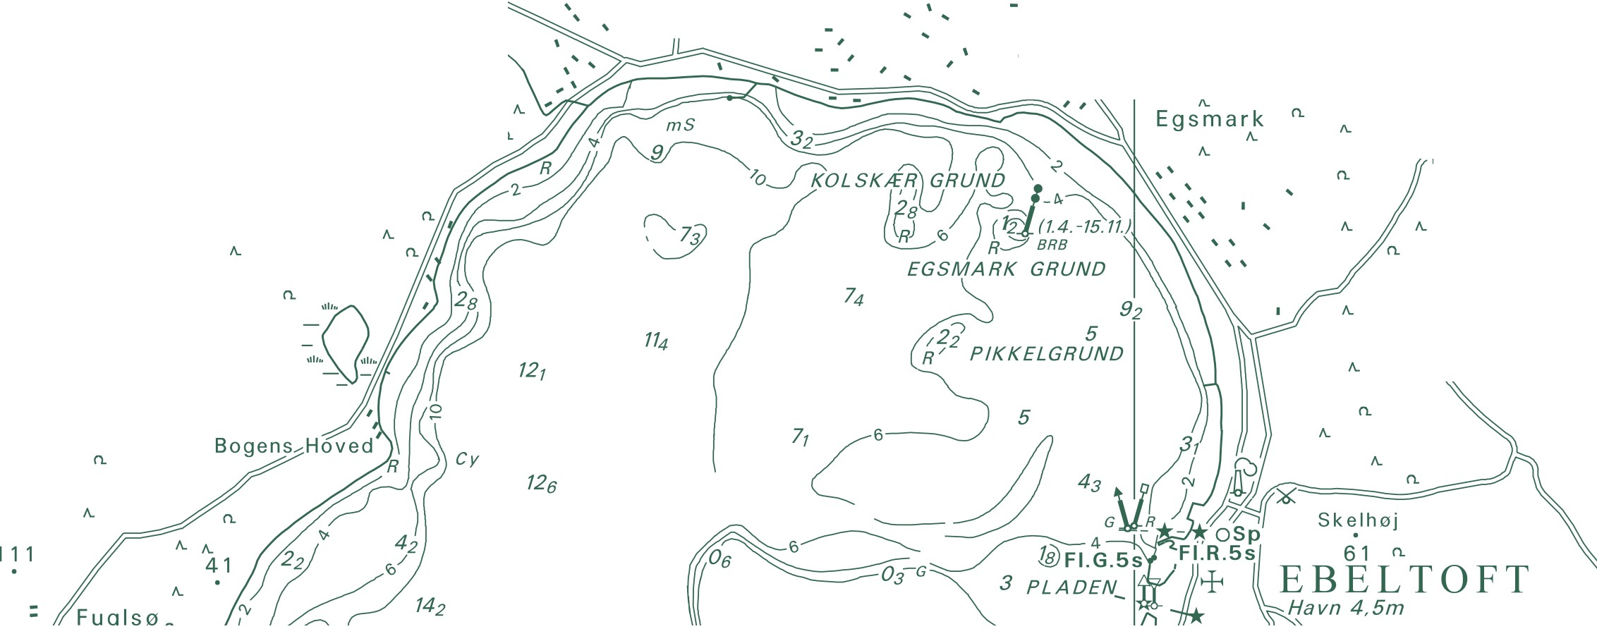National Survey and Cadastre Rentemestervej 8
2400 Copenhagen NV, Denmark http://www.kms.dk

