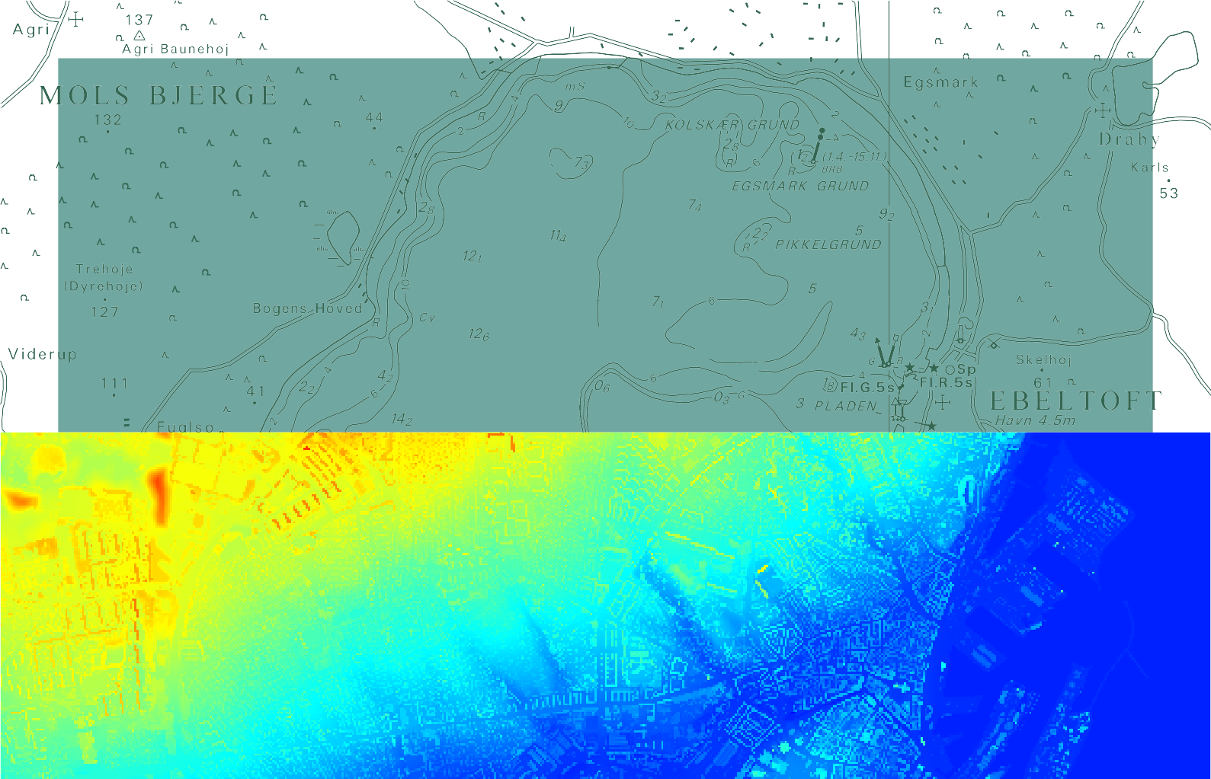

TECHNICAL REPORT NO. 10

Horizontal Accuracy of Digital Elevation Models
M. Nour Hawa Thomas Knudsen Simon L. Kokkendorff Brian P. Olsen Brigitte C. Rosenkranz

Contents
Preface
Lolita Bahl 3
Horizontal Accuracy of DK-DEM: Summary of results
M. Nour Hawa and Thomas Knudsen 4
On the Horizontal Accuracy of Digital Elevation Models
Thomas Knudsen, Simon L. Kokkendorff, Brigitte C. Rosenkranz, Brian P. Olsen 6
A Method For Determination of Horizontal Accuracy of a Digital Elevation Model
M. Nour Hawa 10
Test site reports 15
Test Site Aalborg
M. Nour Hawa 16
Test Site Esbjerg
M. Nour Hawa 17
Test Site Århus
M. Nour Hawa 18
Test Site Nordsjælland
M. Nour Hawa 19

M. Nour Hawa Thomas Knudsen Simon L. Kokkendorff Brian P. Olsen Brigitte C. Rosenkranz: Horizontal Accuracy of Digital Elevation Models
National Survey and Cadastre—Denmark Technical Report, number 10

Series editors: Brian Pilemann Olsen and Thomas Knudsen ISBN 978-78-92107-36-7
Published 2011-01-05
This report is available from http://www.kms.dk

Preface
Lolita Bahl

Quality control procedures for digital elevation models are often focused on checking the validity of the raw measure- ments behind the final gridded model. And rightfully so since, as the adage goes, “garbage in, garbage out”: without good measurements it is impossible to obtain a good final model.
But for the end user of the gridded model, the validity and accuracy of the model per se is much more interesting. And while the vertical accuracy of the final model can be checked in a fairly straightforward manner (by comparing indepen- dently surveyed point heights with height values obtained by interpolation in the grid), the same is not true with respect to the horizontal accuracy: The horizontal accuracy relates to the true position of objects in the landscape – objects which may even be hard to resolve due to the limited grid cell size.
For DK-DEM, the new Danish national elevation model, we have a stated goal of a horizontal accuracy on the order of 1 m – but a grid cell size of 1.6 m. It should be evident that while we have all reasons to believe that the desired accuracy has been reached for the LiDAR point cloud behind DK-DEM, it is an entirely different and much more complex, story to ensure that the accuracy has been carried all the way through to the grid.
The following papers tell that “much more complex story”: First an executive summary, confirming that the accuracy goal has been reached. The summary is followed by a paper describing in which sense we define horizontal accuracy. The third paper describes how the actual tests were carried out, and is followed by 4 lab reports describing the results from each of 4 test sites.
DK-DEM is a large and complex dataset, so by its very nature it will have occasional errors. The present report does, however, support the assertion that the overall quality of DK-DEM is very high.
I would like to thank all the authors for their efforts in documenting this. Special thanks go to M. Nour Hawa for his excellent work, carried out during an internship with KMS as part of his MSc (surveying) studies.

Copenhagen, December 2010 Lolita Bahl
Head of Reference Networks Division National Survey and Cadastre – Denmark (KMS)

Horizontal Accuracy of DK-DEM: Summary of results.
M. Nour Hawa (Aalborg University) and Thomas Knudsen (Kort & Matrikelstyrelsen).

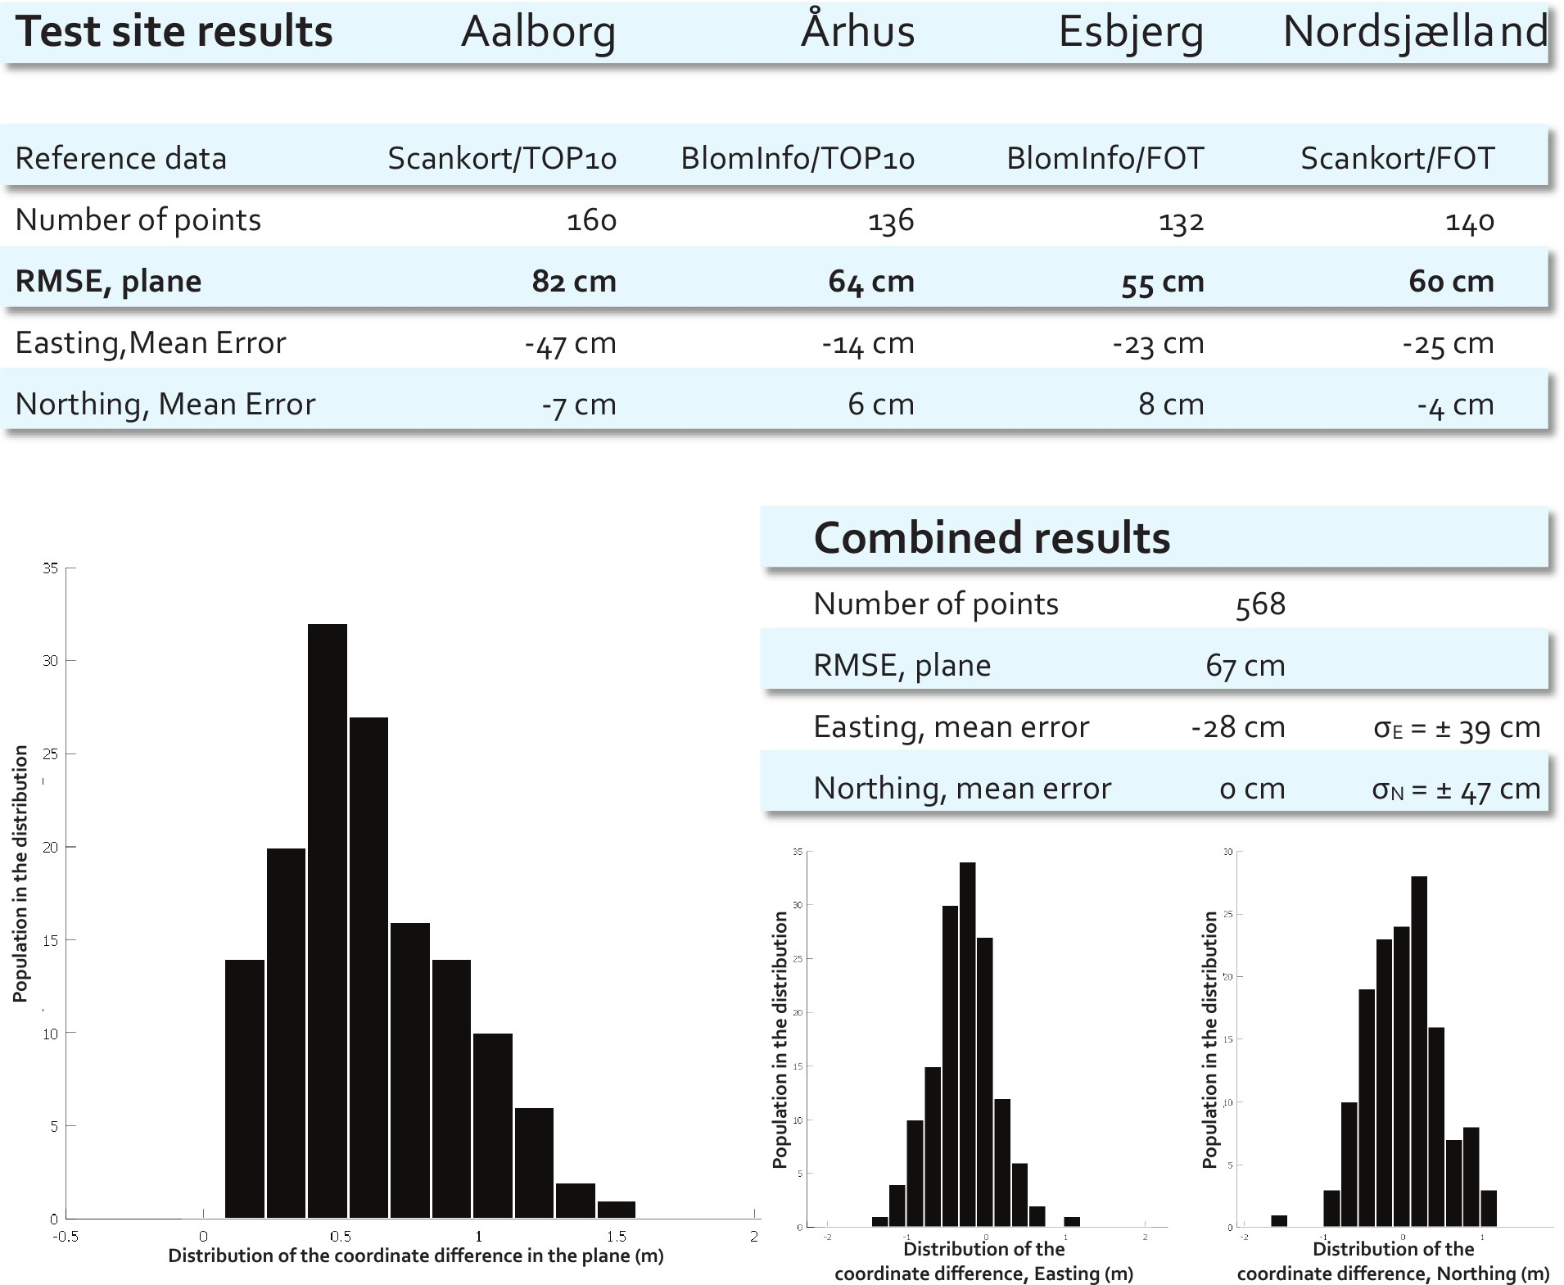

The figure above summarizes the results from a series of estimates of the horizontal accuracy of DK-DEM, the national coverage Danish elevation model. The accuracy was estimated at four representative test sites (Aalborg, Århus, Esbjerg, and Nordsjælland), through comparison of building corners as measured in the elevation model, with corresponding coordinates as registered in two topographic databases (FOT and TOP10DK).
The results indicate that the grid production work flows introduce small biases in the easting accuracy, and somewhat smaller biases in the northing accuracy. But evidently from the RMSE values, the biases do not influence the accuracy in any intolerable way: The horizontal RMSE ranges from 0.55 m to 0.82 m, for an overall RMSE of 0.67 m. This is well below the original requirement of 1.0 m.

Note however, that the question of the horizontal accuracy of a grid, is somewhat ill-posed. So before attempting to interpret these figures in any extensive way, please consult the papers accompanying this summary, where we present the details of the estimation method, and give the rationale for its use.

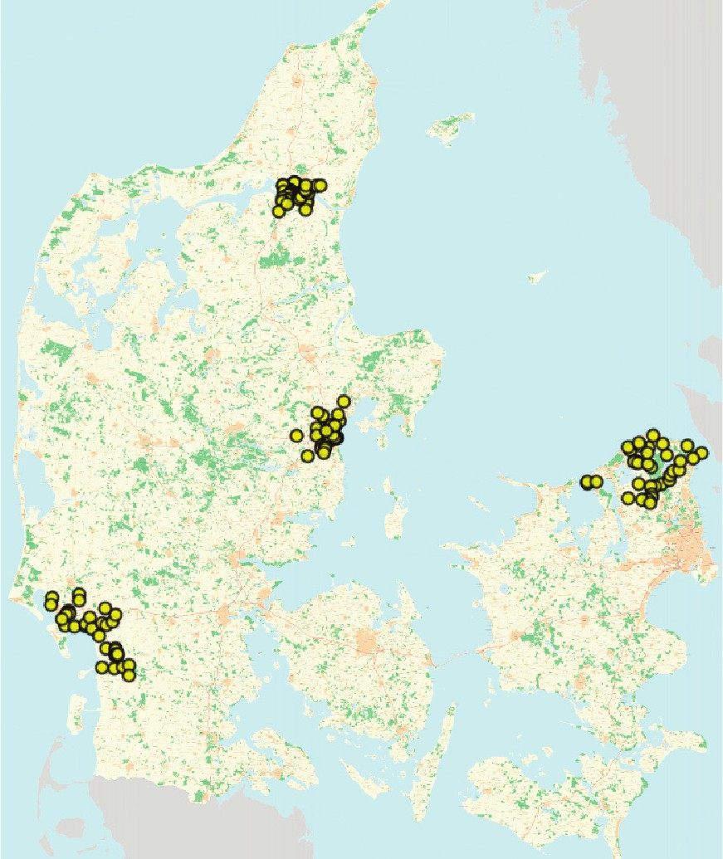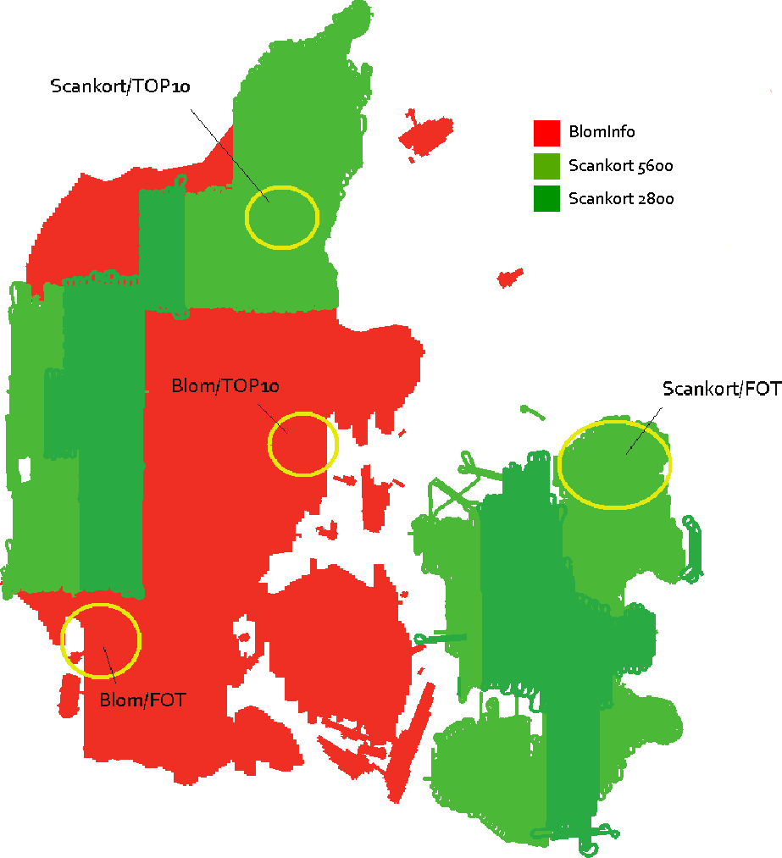

The left panel of the figure above shows the actual positions of the buildings measured. The right panel shows the approximate positions of the test sites, and the combinations of data providers (BlomInfo, Scankort), laser scanners (Riegl Litemapper 2800, Riegl Litemapper 5600, Optech ALTM3100), and topo- graphic databases (FOT, TOP10DK).
The emphasis has been on testing each possible combination of data provider and topographic database. This should reveal any effects from the differing work flows of the providers, while also testing the estima- tion method by comparing results based on the older TOP10DK data with results based on the newer and presumably more accurate FOT data. As expected, TOP10DK data agrees very well with DK-DEM, while FOT data tends to agree even better.
Points worth noting:
- The results from the Aalborg test site are well within the limits set by the original specification, but notably worse than results from the three other test sites. Further investigation has indicated that this is due to a site specific variation in the kind of ground control points available as reference material for the original adjustment of the laser point cloud.
- Sites measured with the Riegl 2800 scanner have not been tested independently. The 2800 and 5600 data were, however, processed through the same work flow (by Scankort) and integrate seam- lessly at the boundaries.
- Bornholm is not represented in the test. But Bornholm was measured and processed by BlomInfo using the same Optech ALTM3100 setup as in the two existing BlomInfo test cases.
All in all, the test results give us good reasons to believe that the overall horizontal accuracy of DK-DEM is well within the stated requirement of 1 m.

On the Horizontal Accuracy of Digital Elevation Models
Thomas Knudsen, Simon L. Kokkendorff, Brian P. Olsen, Brigitte C. Rosenkranz

Abstract
We give the rationale behind a simple method for determi- nation of the horizontal accuracy of a raster elevation model, and present a brief and informal analysis of why this metric is ill-posed unless further constraints and definitions are introduced.

Keywords: Digital surface model, digital elevation model, raster, compressive sampling, horizontal accuracy, quality con- trol, LiDAR

Introduction
In the early spring of 2010 we were asked to derive a mea- sure for the horizontal accuracy of DK-DEM, the new national coverage Danish elevation model.
DK-DEM consists of gridded data with a node length of 1.6
- Colloquially this is often referred to as the resolution al- though in classical terms, the resolution really is twice that number. To avoid any confusion we will use the remote sens- ing term GSD, Ground Sample Distance below.
The specification behind the original tender for DK-DEM required a horizontal accuracy of 1 m. While this kind of re- quirement is well defined and makes good sense for the LiDAR point cloud behind the gridded model, it is an entirely different thing for the gridded model itself. We will give an informal analysis of this in section 2 below, but assume that the reader will readily accept that the concept of a 1 m accuracy for a grid with a GSD of 1.6 m is non-trivial to define rigorously.

- Why is the horizontal accuracy of a gridded data set an ill-posed question?
In order to answer the question of why the accuracy of a grid-

Figure 1: Five cycles of a square wave. In the following figures, we zoom in on one of these cycles for a very simplified building model.

a given grid node! To evaluate the horizontal accuracy, we must look at large, well defined structures in the landscape (rather than well defined points as specified in accuracy stan- dards such as ASPRS (2005); FGDC (1998)). In the urban landscape, such structures are ample since block shaped build- ings are littered literally at every street corner. So in order to gain some insight in the problem, we take a brief look at a very simple building model.

2.1 Representing a block shaped feature in an elevation model
To understand the characteristics of a block shaped feature, we initially model the feature as one full cycle of a square wave (cf. figure 1).
Following the (time domain) notation of Smith (1997), we then write up the Fourier synthesis of the wave as

ded data set is an ill-posed question, we will first frame it by x ∞ ∞

describing why the complementary question of the horizon-
(t) = a₀ + ∑ a_{n} cos(2π f tn) − ∑ b_{n} sin(2π f tn) (1)

tal accuracy of a corresponding LiDAR point cloud, is a well posed question.
This question is well posed because for every LiDAR reflec- tion in the point cloud, there has been a corresponding reflector on the ground. Hence, we may in a meaningful way compare the measured northing, easting, height (NEh) triplet, with the
n=1

a = 1
0
T

T/2

T/2

−T/2
/
n=1

x(t) d t (2)

surveyed position of an actual physical object on the ground.
a 2 /
x t cos 2πtn 1 d t (3)

If not always in practice, then at least ideally speaking.
This should also give the first hint at why the original ques- tion is ill-posed: for a gridded data set there is not necessarily
any real world object corresponding to the height registered in
n = T
( ) T
−T/2
T/2
T

{thokn|bpo|simlk|bicro}@kms.dk, Kort & Matrikelstyrelsen, Rentemestervej 8, 2400 Copenhagen NV, Denmark
b_{n} = − 2 /
−T/2
T
x(t) sin 2πtn 1 d t (4)

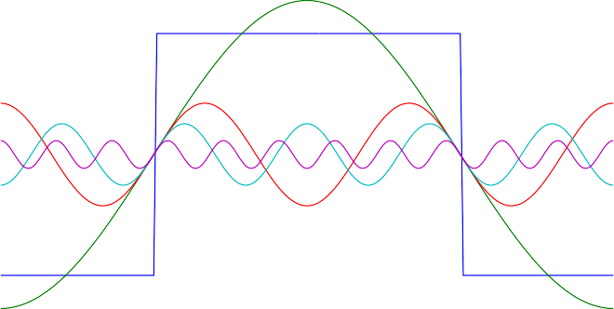
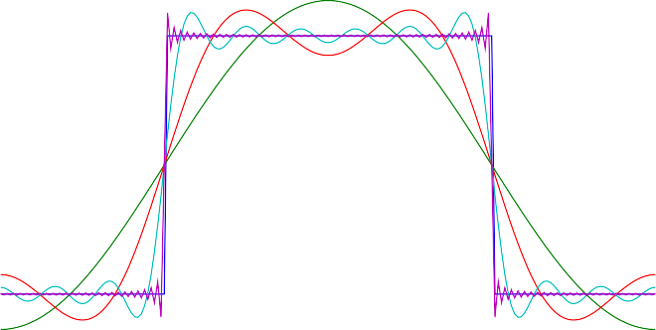
Figure 2: A building model created by zooming in on one cycle of the square wave from figure 1 above. The left panel shows the square wave and its Fourier cosine components number 1, 3, 5, and 11. While the amplitude of the components diminish as the frequency rises, the components still contribute significantly to the series through the cumulative effect. This is evident from the plot in the right panel where we show the same square wave, now accompanied by its Fourier cosine series, truncated after component number 1, 3, 11, and 99, respectively. In order to represent the flat top of the wave (i.e. the wall/roof transition of a building) realistically, we need to sum the series up to a rather high frequency.

Where T is the period of the square wave (corresponding to its wavelength in spatial terms). In our case of a square wave with a pulse height (A) of unity, this simplifies to
a₀ = 0 (5)
since the square function is symmetric and hence vanishes when integrated over a full period; additionally
b₀ = 0 (6)
since the square function is symmetric wrt. t = 0, whereas the sine components are antisymmetric, and finally
GSD of the grid. But according to the Nyquist/Shannon sam- pling theorem (Koopmans, 1974; Shannon, 1948, 1949; Smith, 1997) a sampling with a given GSD will only resolve signals with wavelengths longer than twice that GSD. So in our case of a 1.6 m GSD, we cannot resolve wavelengths shorter than
3.2 m, which is significantly longer than the 1.8 m required to represent an even moderately sharp edge.

2.3 But. . .
Nevertheless, it is well known from photogrammetry that dur- ing the orthorectification of aerial photos, even a non-skilled stereo analyst is able to pinpoint the location of well defined

a_{n} = 2 sin nπ
(7)
points (e.g. road crossings, building corners, etc.) with an ac-

nπ 2
which vanishes for even n, so we are left with a series consist- ing of odd-numbered cosine components reducing equation 1 to the much simpler
curacy that is 3–5 times better than the GSD of the photos (Ge- oforum Danmark, 2005).
In the light of the analysis above, this is quite counterintu- itive. But from everyday experience it is not at all surprising, since the stereo analyst is able to incorporate a large amount of

x(t) =
∞
∑
n=1,3,...
2 sin
nπ

nπ cos(2π f tn). (8) 2
a priori knowledge and experience in the interpretation. Espe- cially it is not surprising that the corner of a building (defined as the intersection between lines secant to two perpendicular
walls) is much better defined than any individual point on the

In figure 2 we demonstrate that a number of high frequency components is needed in order to represent a wall/roof transi- tion in any realistic way. From the figure, it is evident that we need at least all components up to 11 in order to have a reason- able (but still blurry) representation of the building. What does that mean for our ability to locate buildings in the elevation model data?

2.2 So what?
First and foremost let us quantify a bit: Assume that a typical building has a cross section of 10 m. In that case, the funda- mental wavelength of our Fourier synthesis will be twice that,
i.e. 20 m. The eleventh cosine component will have a wave- length of 20 m / 11 ≈ 1.8 m. This is very close to the 1.6 m
walls.
In recent years, the theoretical basis for such phenomena has been enhanced through the research field of compressed sampling (Candès, 2006; Candès and Wakin, 2008).

Method
Utilizing these analyses, we proposed to evaluate the accuracy of the gridded data by following these steps:
Compute nDSM. The normalized digital surface model (nDSM) is defined as the difference between the surface model (DSM) and the terrain model (DTM), i.e. nDSM = DSM - DTM. The nDSM highlights blob shaped objects

in the landscape (buildings, trees), simplifying the next steps.
Threshold nDSM. Threshold the nDSM at the 2 m level.
≈
This should highlight buildings even more.
Digitize building corners. Display the nDSM in a GIS, and digitize the corners of a number of buildings.
Compare with known data Compute the accuracy as the (RMS sense) difference between the digitized corners and the existing registrations from e.g. map databases.
As outlined above, the algorithm seems deceptively simple. But as in all cases of real world data investigation, a large num- ber of devils lurk in the details. These devils were chased, captured and crunched by M. Nour Hawa, who did the ac- tual implementation of the algorithm, and subsequently, car- ried out the investigation of the accuracy of DK-DEM, as re- ported in Hawa (2010a,b,c,d,e); Hawa and Knudsen (2010).

3.1 But does this really measure the accuracy?
How can we be sure that the measure arrived at actually tells something meaningful about the accuracy of the elevation model? After all, the registration variance of a typical map database is on the same order of magnitude as the accuracy we want to determine. We argue that the measure is meaningful through the statistical fact that (under appropriate assumptions) the variance of the difference between two elements is greater than the particular variances of the elements
To see this, we first assume that the absolute error of point coordinates in a collection of geodata (i.e. the difference be- tween the point coordinates and the coordinates of the corre- sponding “true physical” points) are samples of a random dis- tribution with some standard deviation, which reflects the qual- ity of the dataset.
Under this assumption the relative error between two differ- ent, uncorrelated datasets, which describe the same physical points, will be randomly distributed with a standard deviation which is greater than the individual standard deviations. This follows from the basic addition formula for variances:
We let A and B denote the two measured datasets, and let C_{A} and C_{B} denote the point coordinates (say, the easting coordi- nates). Then the absolute errors of these coordinates are given as EA = CA Ctruth and EB = CB Ctruth.
− −
From this we may compute the relative error between the coordinates in the two datasets as:
Var(C_{A} − C_{B}) = Var(C_{A} − C − C_{B} +C ) =
obtained from map data and coordinates obtained from DK- DEM.
Essentially, the map data are derived from photogrammet- ric stereo measurements. Most often, this is done using frame data with direct georeference from GPS/INS, further refined using block adjustment based on a large number of well de- fined points measured in the photos.
The DEM data on the other hand, is derived from a LiDAR point cloud. While still using the GPS/INS combination for georeference, the scanning geometry of the LiDAR data ac- quisition system is very different from the frame geometry of the photogrammetric camera.
Hence, the production workflows between the map data and the DEM are very different, justifying the assumption that the same is true with respect to the primary error sources for the two data sets. This is also almost certainly sure in the case of the DK-DEM terrain model. The DK-DEM surface model was, however, improved by applying three different rules de- rived from existing building registrations (Flatman, 2010):
  - The DSM interpolation routine was set to allow sharp steps in height within a buffer zone derived from exist- ing registrations.
  - The DSM data rejection criterium was relaxed within the polygons of the existing building registrations.
  - The DSM interpolation routine was allowed to do long baseline interpolation (and extrapolation) within the do- main defined by a building registration.
Item 1 above allows the interpolation routine to actually pro- duce the sharp steps in height that are essential in order to rep- resent a building in the DSM (in a DTM, sharp steps are usually indications of inadequate removal of above-terrain points in the point cloud). But the interpolation routine will only produce the steps if point data actually support that they are present.
Item 2 above was introduced in order to be able to repre- sent buildings with very dark roofs (primarily roofing felt): in such cases it is commonly seen that only a few points are ac- tually reflecting light back to the LiDAR instrument. Under normal statistical assumptions, such observations will be dis- carded as outliers. Using the item 2 criterion, it was possible to arrive at a much more accurate model by keeping these data, and applying the item 3 criterion to the local interpolation (es- sentially equivalent to filling in with a mean observed height inside sparsely measured building outlines).
Hence in order for the horizontal accuracy algorithm to

Var
truth
truth
work properly, it is essential that it is used on datasets based

(E_{A} − E_{B}) = Var(E_{A}) + Var(E_{B}) − 2Cov(E_{A}, E_{B}) ⇒
Var(E_{A} − E_{B}) ≈ Var(E_{A}) + Var(E_{B})
Or in other words: under the assumption of no correlation be- tween the two elements, the variance of the difference is larger than the largest variance of the individual elements.

Caveats
There are however a few caveats with respect to the algorithm. First and foremost we need buildings (or other large scale rect- angular features). Hence, this kind of accuracy estimation can only be carried out in relatively densely populated areas (i.e. cities and suburbs). Second, we need to substantiate our as- sumption of no correlation between the errors in coordinates
on measurements from well reflecting roofing material only. In practice, this means that the interpretation must be supported by a colour orthophoto for the selection of light, well reflecting roofs.

Conclusion
In section 1 above, we assumed the reader would readily accept that the concept of a 1 m accuracy for a grid with a GSD of 1.6 m was non-trivial to define rigorously.
In conclusion we would like to stress that we have certainly not given a rigorous definition of this ill posed question. We have however, given a number of good reasons for the plausi- bility of the algorithm proposed.

The practical implementation and test by Hawa (2010a,b,c,d,e), supplements the plausibility by indicat- ing the practical usefulness of the algorithm.
But further analysis and scrutiny of the subject would cer- tainly be a matter of more than (just) academic interest.

References
ASPRS. ASPRS LiDAR Guidelines: Horizontal Accuracy Reporting. 2005. URL http://www.asprs.org/society/ committees/standards/Horizontal_Accuracy_Reporting_ for_Lidar_Data.pdf.
Emmanuel J. Candès. Compressive sampling. In Proceedings of the International Congress of Math- ematicians, Madrid, Spain, volume 3, pages 1433– 1452, 2006. URL http://www.acm.caltech.edu/~emmanuel/ papers/CompressiveSampling.pdf.
Emmanuel J. Candès and Michael Wakin. An introduction to compressive sampling. IEEE Signal Processing Magazine, 25(2):21–30, March 2008. URL http://dsp.rice.edu/files/cs/ CSintro.pdf.
FGDC. Geospatial Positioning Accuracy Standards, FGDC- STD-007. 1998. URL http://www.fgdc.gov/standards/ projects/FGDC-standards-projects/accuracy/part1/index_ html.
Andrew Flatman. Pers. comm., March 2010.
Geoforum Danmark, 2005. Specifikation for Ortofotos. Copenhagen, Denmark, 2. edition, November 2005.
M. Nour Hawa. Test site Aalborg. In this volume, page 16, 2010a.
M. Nour Hawa. Test site Århus. In this volume, page 18, 2010b.
M. Nour Hawa. Test site Esbjerg. In this volume, page 17, 2010c.
M. Nour Hawa. A method for assessment of the horizontal accuracy of a digital elevation model. In this volume, pages 10–14, 2010d.
M. Nour Hawa. Test site Nordsjælland. In this volume, page 19, 2010e.
M. Nour Hawa and Thomas Knudsen. Executive summary. In
this volume, pages 4–5, 2010.
Lambert Herman Koopmans. The spectral analysis of time se- ries. Academic Press, London, 1974.
Claude E. Shannon. A mathematical theory of communication.
Bell System Technical Journal, 27:379–423, 623–656, 1948.
Claude E. Shannon. Communication in the presence of noise. Proc. Institute of Radio Engineers, 37(1):10–21, January 1949.
Steven W. Smith. The Scientist and Engineer’s Guide to Dig- ital Signal Processing. California Technical Publishing, 1997. URL http://www.dspguide.com.

A Method for Assessment of the Horizontal Accuracy of a Digital Elevation Model
M. Nour Hawa

Abstract
This article introduces a simple method for determination of the horizontal accuracy of a raster digital surface model (DSM) and corresponding digital terrain model (DTM). The method (which is implemented using readily available software) is based on determination of coordinate differences between ref- erence data and measured objects in the DSM. Measuring ob- jects in the raster model is the challenge. The method is pre- sented in general terms, and applied in a case study of the offi- cial Danish height model, DK-DEM.
Keywords: Digital surface model, digital elevation model, raster, compressive sampling, horizontal accuracy, LiDAR

Introduction
Often, when validating and verifying digital elevation models (DEMs), only the vertical accuracy is considered—probably because the DEM is typically created from aero-triangulated LiDAR data, that have already been evaluated for horizontal accuracy.
But even in the case of perfect horizontal matching, the DEM may still suffer from errors introduced during interpo- lation and rasterization of the point cloud. Verification by ver- tical accuracy only, yields results which are only strictly valid on level terrain. Due to the unknown horizontal accuracy, it is impossible to gain any significant insight into the vertical accuracy of the model in sloping areas.
Unlike an orthophoto, object features other than height can- not be seen directly in a DEM. Hence, in the case of DEMs we cannot use the well established methods for assessment of hor- izontal accuracy of orthophotos (cf. e.g. Geoforum Danmark, 2005). Generally a DEM is also of coarser resolution than an orthophoto. This makes it troublesome to determine where the reference objects/ground control points are to be measured.
In section 2 below, we present a simple method for valida- tion and verification of the horizontal accuracy on a DEM (or in more specific terms: a digital terrain model, DTM, respec- tively a digital surface model, DSM). In section 3, a case study will be shown using this method to assess the accuracy of the official Danish height model, DK-DEM.

Method
In broad terms, the method described below, is based on man- ual measurement of reference object coordinates in the DEM and comparison with suitable reference data.
Due to the typical resolution of DEMs, buildings are the only geometrically well defined objects that can be large
M. Nour Hawa mnha06@land.aau.dk, Aalborg University, Fibigerstræde 11, 9220 Aalborg, Denmark
enough to be clearly visible in the DEM. Hence, we choose buildings as our target objects.
The method is presented in diagrammatic form in ap- pendix B below. The description here is mostly comments elaborating somewhat on the diagram.
The main steps of the algorithm are:

- Prepare the DEM data

- Find and measure the objects

- Compare with reference data to obtain the results

The reference data consists of coordinates of the building cor- ners. These can be obtained from field surveys, or from a suit- able map product. The accuracy of the reference data should be taken into account.
To optimize the measurement conditions, a normalised DSM (nDSM) is created, by subtracting the DTM from the DSM. Then a vertical threshold is selected, so only objects higher than the threshold value is visible (see figure 1).
The next step is to find suitable buildings and measure them. With the nDSM it is possible (even easy) to identify buildings. The measurement is carried out by visual estimation: it is well known from photogrammetry, that even an unskilled stereo op- erator is able to estimate the position of rectangular crossing lines with an accuracy that is 3–5 times better than the resolu- tion of the imagery (e.g. the réseau marks of traditional metric cameras utilize this by design).
The mismatch of each corner of a building is combined into one value, representing the displacement for each build- ing measured. The overall characteristics for each test site is obtained as the primary statistical descriptors (mean, variance, etc.) for a number of buildings.

  - Interpretation and measurement
The main problem of the method is to determine how to mea- sure with sufficient accuracy. The resolution/grid size plays a significant role in this aspect, affecting both the measuring ac- curacy, and the horizontal representation of the buildings (the latter affects both the scaling and the apparent positioning, cf. figure 3).
To minimize the scaling errors related to the grid resolution, each corner of the building (typically four) must be measured for mismatch. The mismatch of the building is represented as the mean mismatch of its corners. In order to simplify the data processing, the same number of corners are measured for all buildings.
Combining the results from individual corners does not equalize the positional error due to grid aliasing (see figure 3: these kinds of errors are actually part of what we try to describe (i.e. an accuracy measure that relates to the end product, with all its physical and stochastic imperfections).

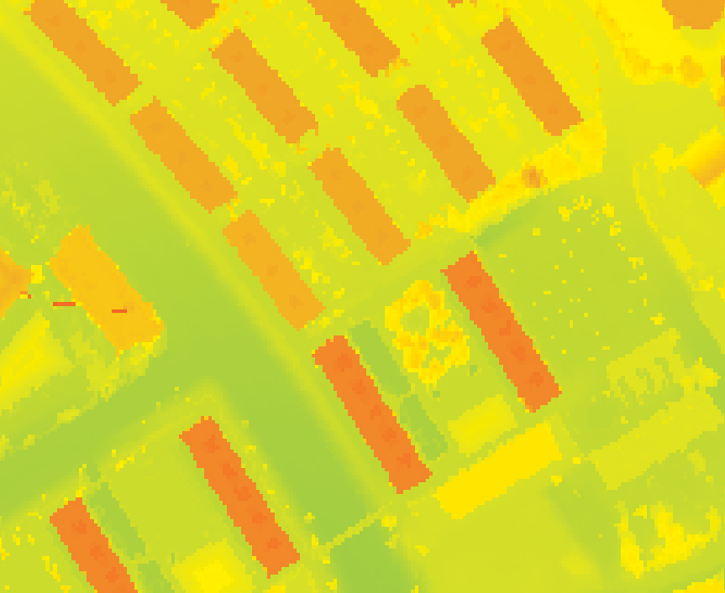
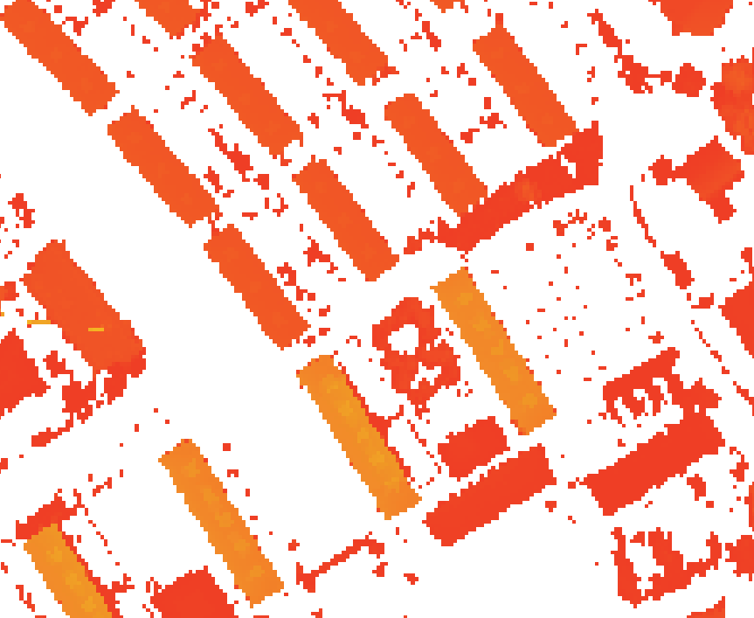

Figure 1: Top: DTM, center: DSM, bottom: normalized DSM (i.e. DSM-DTM), after threshold of 1.5 m has been applied

  - Visual estimation
A human doing a visual interpretation of an image is able to estimate the intersection of two well-defined lines, with an ac- curacy that is way better than one would expect from the reso-

Figure 2: Lines representing the visual estimation of the sides to de- fine the corners. A simple set square physically moved around on the screen is a useful guideline for the estimation. The points show where to measure the coordinates in the nDSM

Positioning and scaling issues due to the grid

Figure 3: Leftmost two panels: The black boxes represent two build- ings with same size, but positioned differently (and hence being regis- tered with differing horizontal accuracy). Rightmost two panels: the black boxes represent two different buildings, each having the same size in the grid

Suitable building Invisible building feature

Offset cuts of the building Time difference of aquisition

Figure 4: Four examples on situations where interpretation is needed. Imagine the pixels shown are in a 2 meter grid and represent buildings.
The black lines represent the building in the reference data

lution and signal-to-noise ratio of the image.
This phenomenon has been utilized for many years in op- erational photogrammetry, where the rule of thumb says that an experienced stereo operator can determine the position of a well-defined point with a precision that is 3–5 times better than the image resolution (cf. e.g. Geoforum Danmark, 2005). In recent years, the phenomenon has been put on more firm

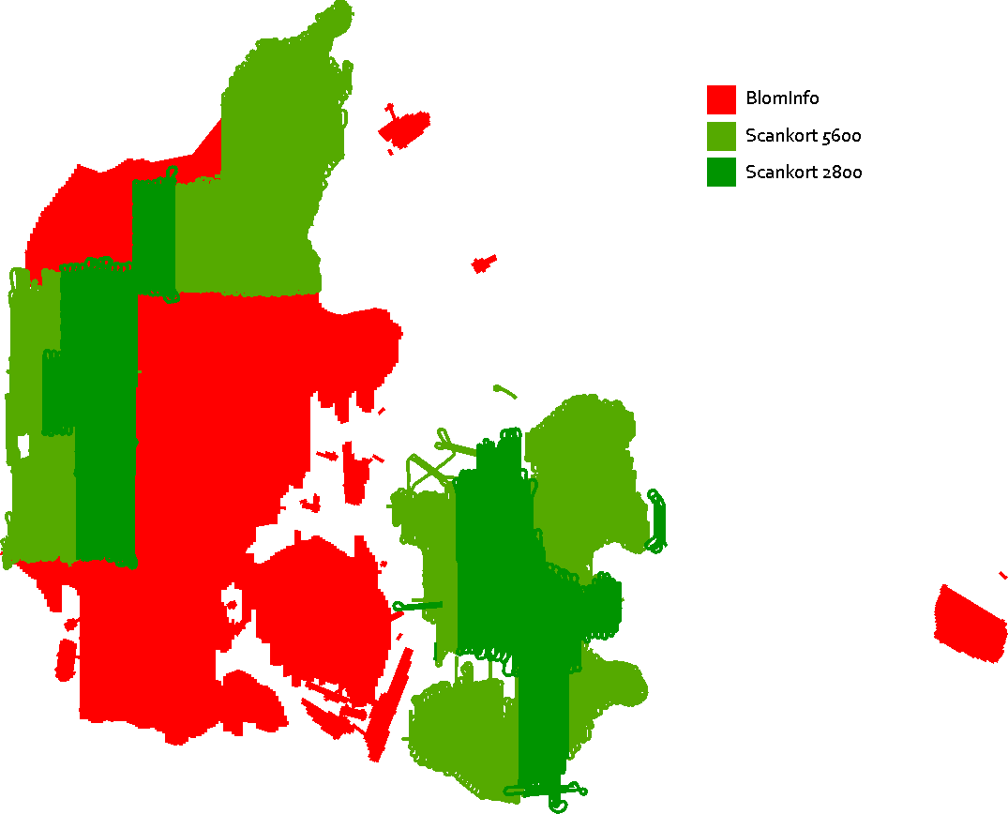

Figure 6: The coverage of the two companies, providing the LiDAR data

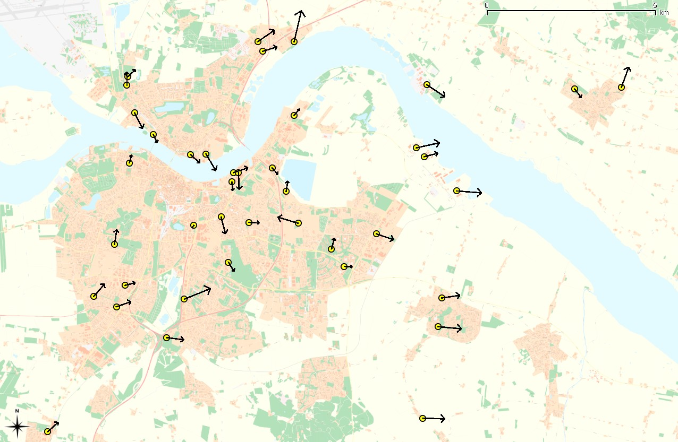
Figure 7: The testsite of the city Aalborg, with the resulting errors shown as arrows with direction and error size

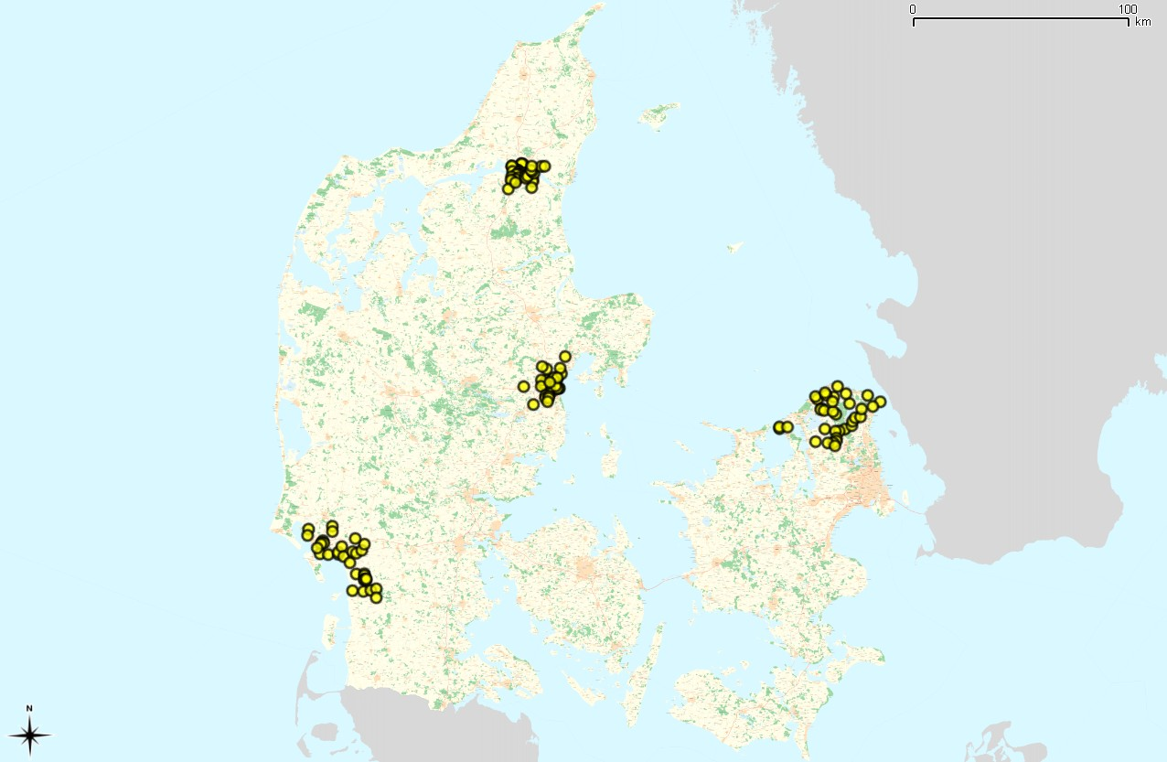
Figure 5: The four representative areas the analysis is based on

ground through the theory of compressive sampling (Candès, 2006; Candès and Wakin, 2008).
Here, we will not investigate the theoretical or practical background of the visual estimation problem any further. But in figures 1–2 illustrates the plausibility of high precision vi- sual intersection estimation.
  - Implementation
A script using Python and GDAL (Warmerdam, 2010) was written to output the nDSM and converting it from ESRI ascii to GeoTIFF format.
For the measurements, QuantumGIS (QGIS , 2010) with the GeoReferencer plugin was used. The visual estimation was guided using a set square (or drafting triangle) slided directly on the LCD panel to align optimally along the building sides. This software is highly recommeded, as it gives a simple and efficient workflow.
For the statistics and other output files, an Octave script was written.

Case study, DK-DEM
The Danish national DEM (DK-DEM) is the study object, and prime inspiration, for this work. The DK-DEM consists of a DSM and a DTM, both in the form of raster grids with a node distance of 1.6 m.
In the tender for the DEM, the specification for horizon- tal accuracy was set to 1 m. While this accuracy was most probably reached for the underlying point cloud, it was never checked whether further inaccuracies had crept in during the post processing, gridding, georeferencing, etc. phases.
In order to check for these kinds of mistakes, the algorithm described above, was put to use in the case of DK-DEM
To keep the scale of the analysis small, it was decided to use national topographic maps as reference data, and to limit the measurements to four representative areas (see figure 5).
DK-DEM is based on LiDAR data provided by two differ- ent companies, using three different scanners. This has been taken into account when selecting test sites (compare figures 5 and 6).
After initial implementation and testing of the method, the work on the DK-DEM took approximately 40 hours, including nDSM creation and load times. The biggest challenge (and
most time consuming part of the process) was to identify a sufficient number of suitable buildings. The actual registration and data processing went quite fast.

  - Results
All in all, 568 building corners were measured for 142 build- ings
For each test site an output file is generated, containing di- rection and size of the deviations for each building, see figure 7 for an example.
The results do not take into account the accuracy of the to- pographic maps and of the the visual estimation. So one could argue that this makes the result relative. But since the produc- tion of DK-DEM and the topographic maps are largely inde- pendent, when one arrives at largely identical results, we can apply a rule of thumb that the absolute error is no larger the relative deviation. A more formal argumentation (which will bring us to the same conclusion) is outlined in appendix A, below.
The details of the accuracy analysis are described in Hawa (2010a,b,c,d).
The calculated RMS for the horizontal error for the four test sites, spans from 55 cm to 82 cm.
•

The overall coordinate difference in the northing direction is close to 0: by far the largest part of the difference is in the easting direction.
•
No systematic differences appear to exist between results based on data from the two different providers.
•
No systematic differences appear to exist between results based on data from the two different reference data sets.
•
It is notable that the model appears to be shifted mostly to- wards the east (compared to the reference data). The reason for this is unknown – and as we work at small scales compared to the grid node length, a deeper understanding will require a very thorough analysis (which is way outside the scope of this work).

Conclusion
The method described can be used to determine the horizon- tal accuracy of a raster DSM and corresponding DTM. It is a simple method where no advanced software is needed.
The procedure can be executed quickly, and hence offers an excellent price/performance ratio.
The method is mainly a manual process, where coordi- nate differences are measured between reference objects in the DEM and suitable reference data. In the case study, two differ- ent topographic map data sets were used.
For the case-study of DK-DEM an overall horizontal accu- racy on the order of 1 m was expected and observed.

Acknowledgements: This work was carried out during an internship at the National Survey and Cadastre (KMS), as part of the author’s studies for the degree of cand. geom. (surveying) at Aalborg Univer- sity.
My colleagues at the KMS have influenced the work significantly: the algorithm described was originally proposed by Simon Lyngby Kokkendorff, Thomas Knudsen, Brian Pilemann Olsen, and Brigitte Christine Rosenkranz.
Brian Pilemann Olsen and Brigitte Christine Rosenkranz were instru- mental in gathering the data needed.
Simon Lyngby Kokkendorff wrote the Python script used.
Thomas Knudsen guided in the use of QGIS plugins and in the se- lection of background literature. He also read and commented on numerous versions of this paper.
Lolita Bahl, manager of the Reference Networks Division at KMS, gave me the opportunity to work on this interesting subject.

References
Emmanuel J. Candès. Compressive sampling. In Proceedings of the International Congress of Math- ematicians, Madrid, Spain, volume 3, pages 1433– 1452, 2006. URL http://www.acm.caltech.edu/~emmanuel/ papers/CompressiveSampling.pdf.
Emmanuel J. Candès and Michael Wakin. An introduction to compressive sampling. IEEE Signal Processing Magazine, 25(2):21–30, March 2008. URL http://dsp.rice.edu/files/cs/ CSintro.pdf.
Geoforum Danmark, 2005. Specifikation for Ortofotos. Copenhagen, Denmark, 2. edition, November 2005.
M. Nour Hawa. Test site Aalborg. In this volume, page 16, 2010a.
M. Nour Hawa. Test site Århus. In this volume, page 18, 2010b.
M. Nour Hawa. Test site Esbjerg. In this volume, page 17, 2010c.
M. Nour Hawa. Test site Nordsjælland. In this volume, page 19, 2010d.
QGIS (2010). Quantum GIS User Guide, version 1.4.0 “Ence- ladus”, 2010.
Frank Warmerdam. GDAL—geospatial data abstraction li- brary, 2010. URL http://gdal.org/.

A The variance of the difference between two elements is greater than the variance of the elements (proof)
We take as our starting point the often used assumption that the absolute error of point coordinates in a collection of geo- data (e.g. the difference between the point coordinates and the coordinates of the corresponding “true physical” points) are samples of a random distribution with some standard devia- tion, which reflects the quality of the dataset.
Under this assumption the relative error between two differ- ent, uncorrelated datasets, which describe the same physical points, will be randomly distributed with a standard deviation which is greater than the individual standard deviations – sim- ply by the basic addition formula for variances:
Given two datasets A and B, let C_{A} and C_{B} denote the point coordinates (say, the easting coordinates) and E_{A} and E_{B} denote the absolute errors of these coordinates: e.g. E_{A} = CA Ctruth.
−
Then we have for the relative error between the coordinates
in the two datasets:
Var(C_{A} − C_{B}) = Var(C_{A} − C_{truth} − C_{B} +C_{truth}) = Var(E_{A} − E_{B}) = Var(E_{A}) + Var(E_{B}) − 2Cov(E_{A}, E_{B}) ⇒ Var(E_{A} − E_{B}) ≈ Var(E_{A}) + Var(E_{B})
Hence, the variance of the difference is larger than the largest variance of the individual elements.
If the individual absolute errors are normally distributed and the errors are independent (as assumed), then the relative er- ror between the two datasets will also be normally distributed, (cf. e.g. http://en.wikipedia.org/wiki/Normal_distribution for a brief outline).

B Diagrammatic outline of the procedure

Main process

Methods and choises
Requisite

Depending on the scale of the analysis and diﬀerences in your data, decide where, how much and how many areas you wish to cover
Prepare data
DTM, DSM and oﬀset va- lues to create a normali- sed DSM that only shows objects above terrain
Data for measurement
DEM and reference data

Use visual estimation for
measureing the building- corners in the nDSM. Mea- sure all four corners on suitable buildings and create a mean error diﬀe- rence for each building
Decide which statistical va- lues to compute to des- cribe, validate and conclude the horizontal accuracy
Statistics
Simple software to read and analyse the coordi- nate diﬀerences
Result
Coordinate ﬁles

Measurements

Standard mapping soft- ware (CAD/GIS) to extract and measure coordinates in the two data sets

Diagram Legend
Process
Input/output

Test site reports

In the following four pages, we reprint the test site reports for each of the four test sites in the DK-DEM horizontal accuracy project.

Test site - Aalborg

Number of measured reference points 160
Reference data TOP10DK (Danish topographic map)
parallel with the the north/south or east/west axis
Object type Well-defined building corners on large buildings, non-
Scanner and operator Riegl Litemapper 5600 / Scankort
Algorithm 4 measurements per building, combined into one value

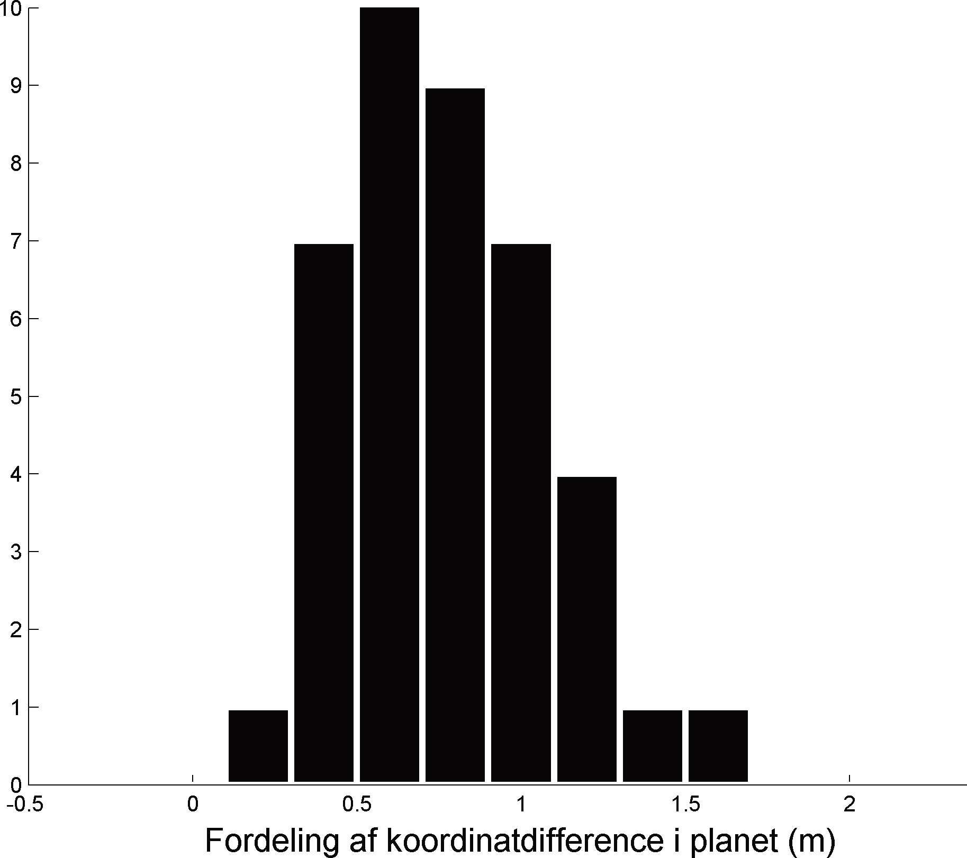RMSE, plane 82 cm
Results
Mean, plane 76 cm
Distribution of the coordinate difference in the plane (m)
Population in the distribution

Maximum deviation 156 cm

Easting, mean error -47 cm

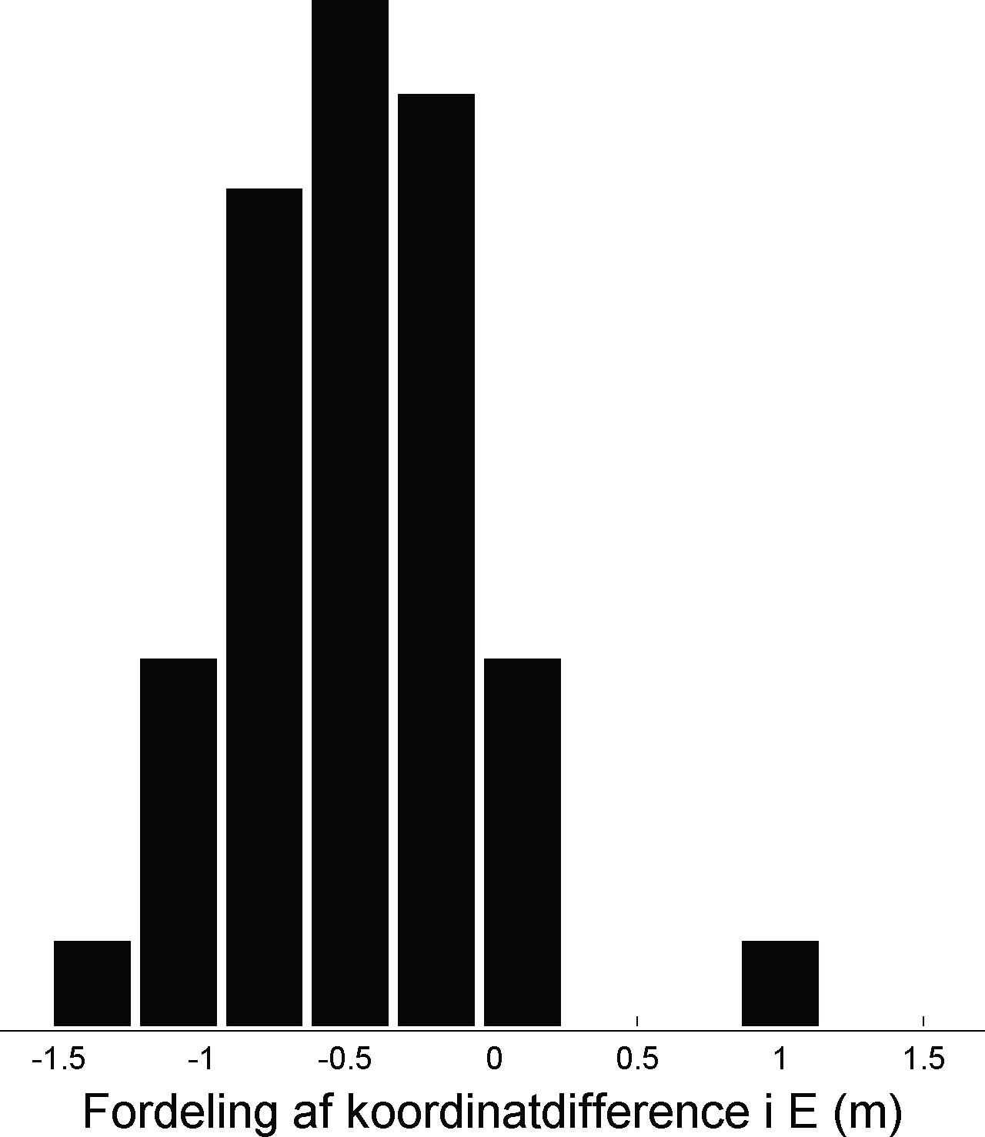Northing, mean error -7 cm
Easting, standard deviation 44 cm

Distribution of the coordinate difference, Easting (m)
Population in the distribution
Northing, standard deviation 52 cm
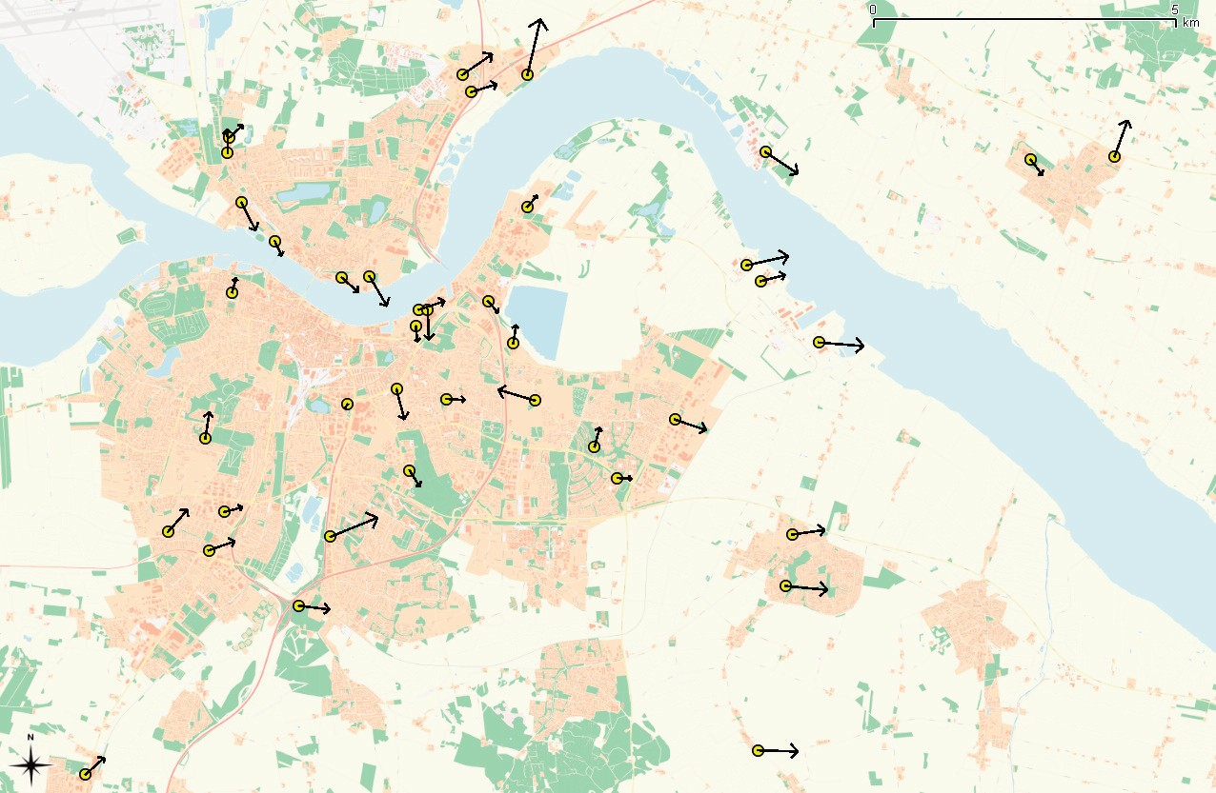
The yellow points represent the measured buildings around the Århus area.

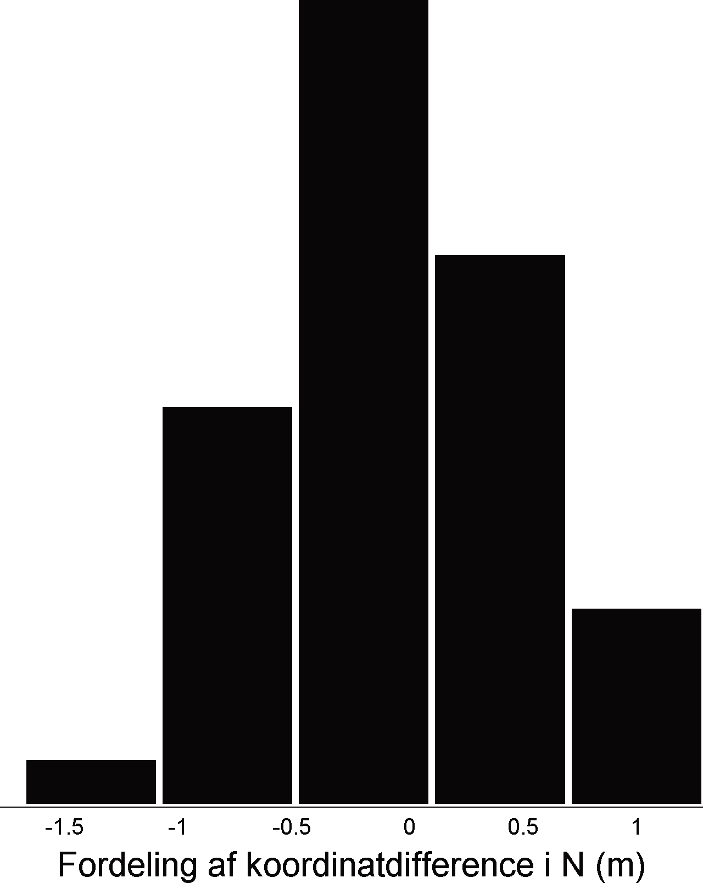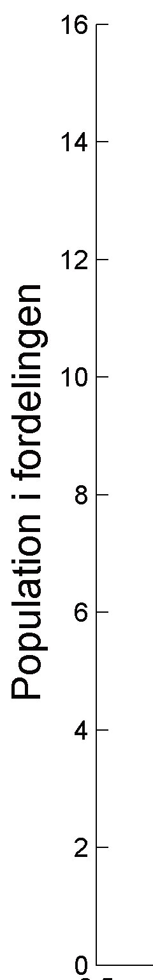The arrows show the directions and RMSE value, of the coordinate diﬀerences. Ar- rows are exaggerated by a factor 500.

Distribution of the coordinate difference, Northing (m)
Population in the distribution

As also reﬂected by the result table, the DEM aprears to be shifted aprroximately 50 cm eastwards.

Test site - Esbjerg

Number of measured reference points 132
Reference data FOT (Danish topographic map)
parallel with the the north/south or east/west axis
Object type Well-defined building corners on large buildings, non-
Scanner and operator Optech / BlomInfo
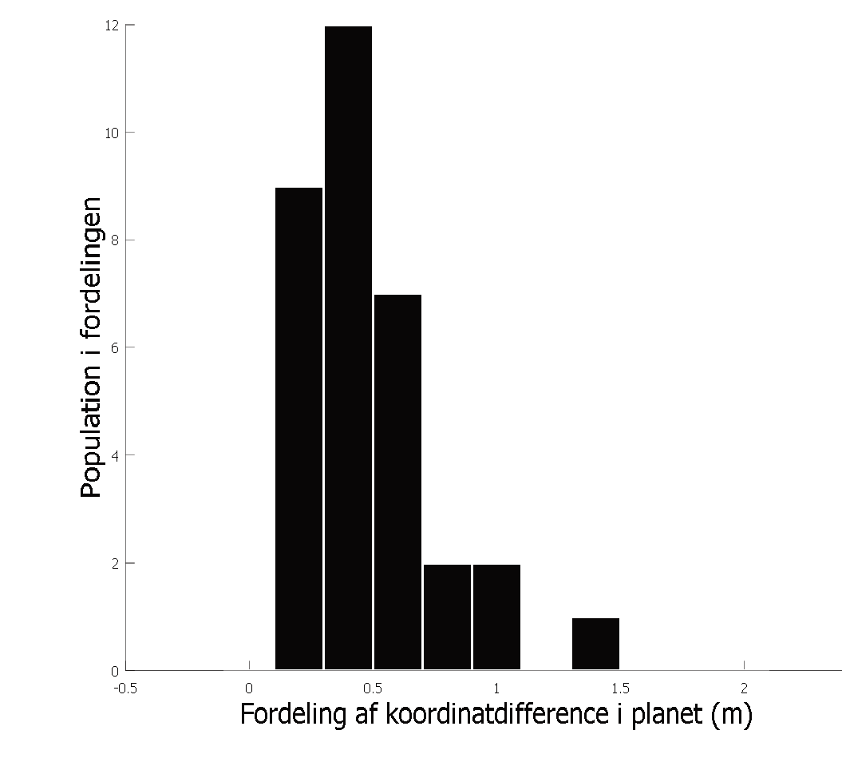Algorithm 4 measurements per building, combined into one value
RMSE, plane
55 cm
Maximum deviation
134 cm
Easting, mean error
-23 cm
Northing, mean error
8 cm
Distribution of the coordinate difference in the plane (m)
Mean, plane 48 cm
Population in the distribution

Results

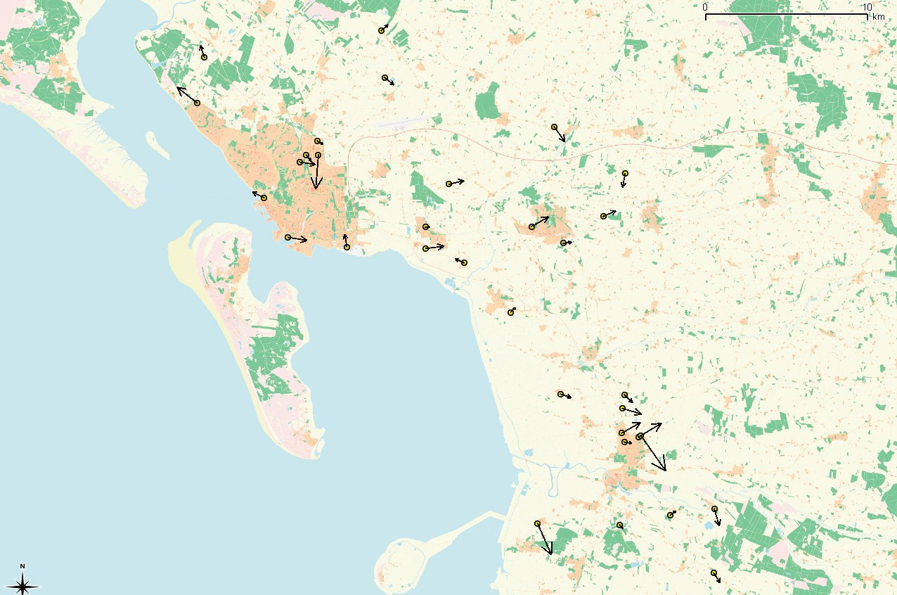
Northing, standard deviation 40 cm

The yellow points represent the measured buildings around the Esbjerg area.

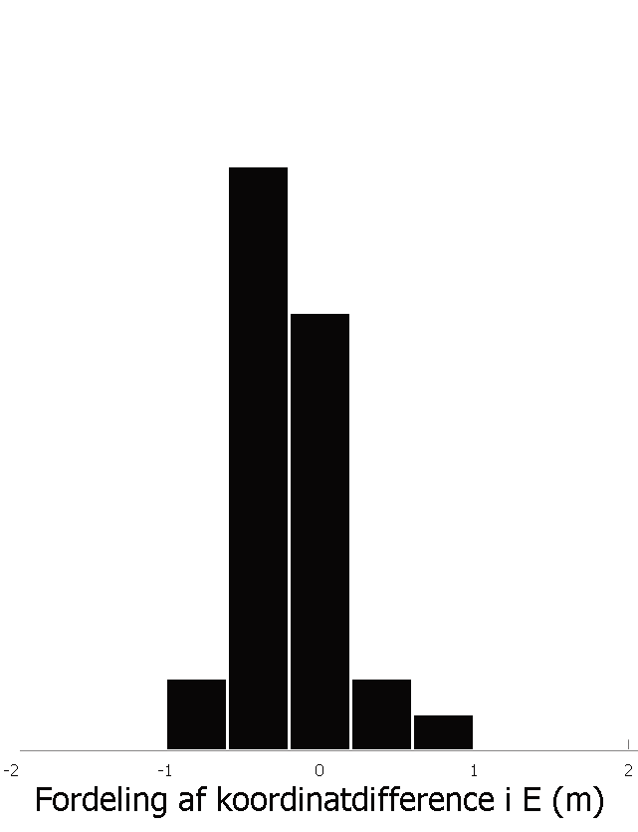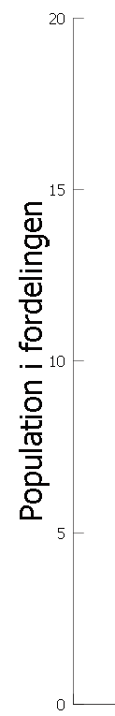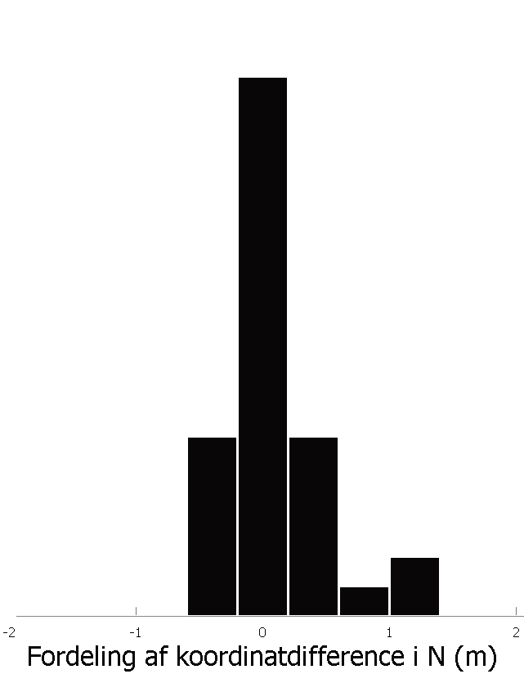The arrows show the directions and RMSE value, of the coordinate diﬀerences. Ar- rows are exaggerated by a factor 2000.
Easting, standard deviation 31 cm

Distribution of the coordinate difference, Easting (m)
Population in the distribution
Population in the distribution

Distribution of the coordinate difference, Northing (m)

Test site - Århus

Number of measured reference points 136
Reference data TOP10DK (Danish topographic map)
parallel with the the north/south or east/west axis
Object type Well-defined building corners on large buildings, non-
Scanner and operator Optech / BlomInfo
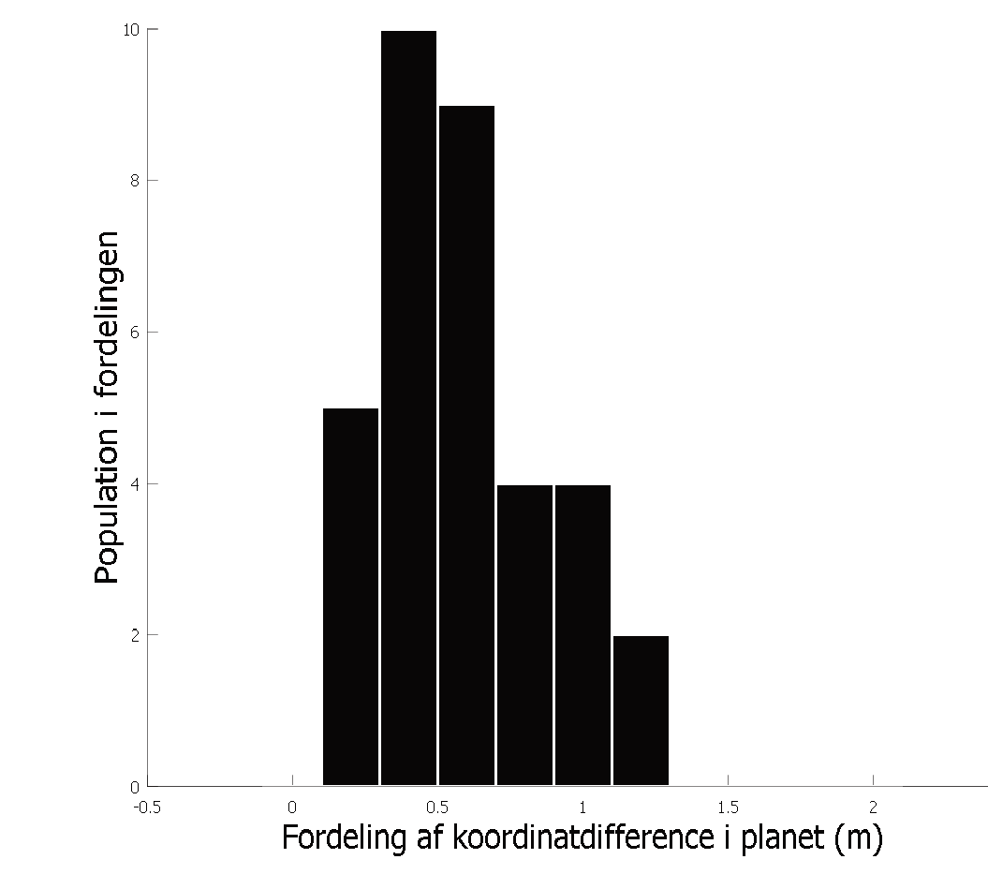Algorithm 4 measurements per building, combined into one value
RMSE, plane
64 cm
Maximum deviation
122 cm
Easting, mean error
-14 cm
Northing, mean error
6 cm
Distribution of the coordinate difference in the plane (m)
Mean, plane 58 cm
Population in the distribution

Results

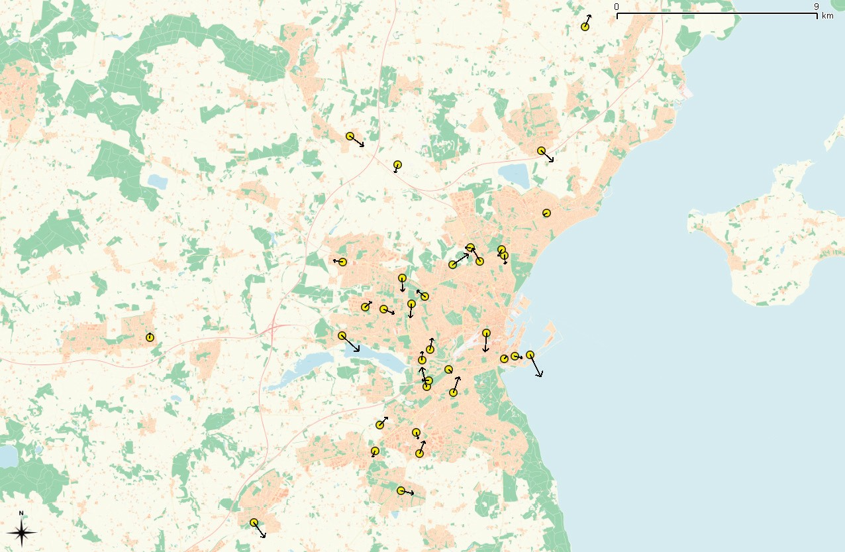
Northing, standard deviation 53 cm

The yellow points represent the measured buildings around the Århus area.

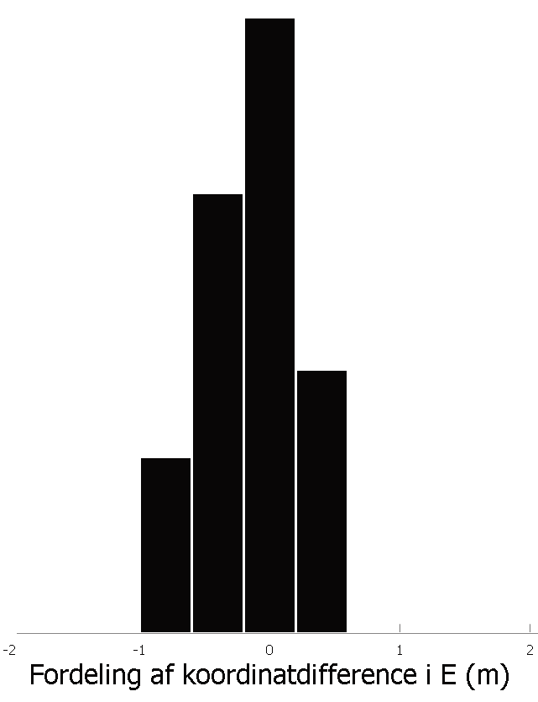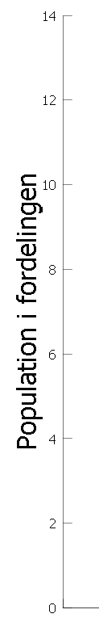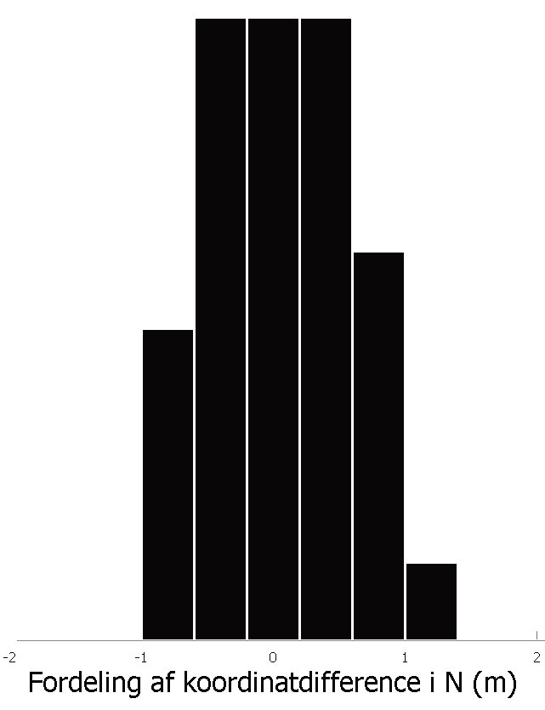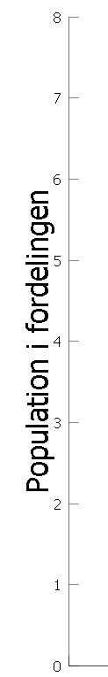The arrows show the directions and RMSE value, of the coordinate diﬀerences. Ar- rows are exaggerated by a factor 900.
Easting, standard deviation 38 cm

Distribution of the coordinate difference, Easting (m)
Population in the distribution
Population in the distribution

Distribution of the coordinate difference, Northing (m)

Test site - Nordsjælland

Number of measured reference points 140
Reference data FOT (Danish topographic map)
parallel with the the north/south or east/west axis
Object type Well-defined building corners on large buildings,non-
Scanner and operator Riegl Litemapper 5600 / Scankort
Algorithm 4 measurements per building, combined into one value

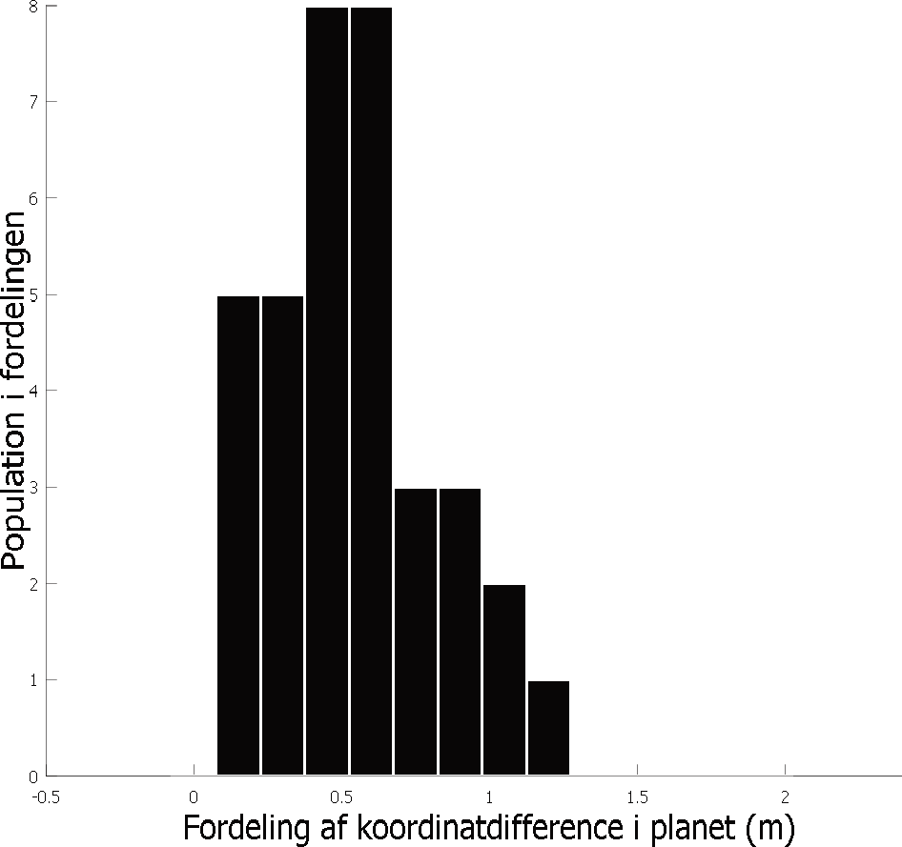RMSE, plane 60 cm
Results
Mean, plane 53 cm
Distribution of the coordinate difference in the plane (m)
Population in the distribution

Maximum deviation 123 cm

Easting, mean error -25 cm

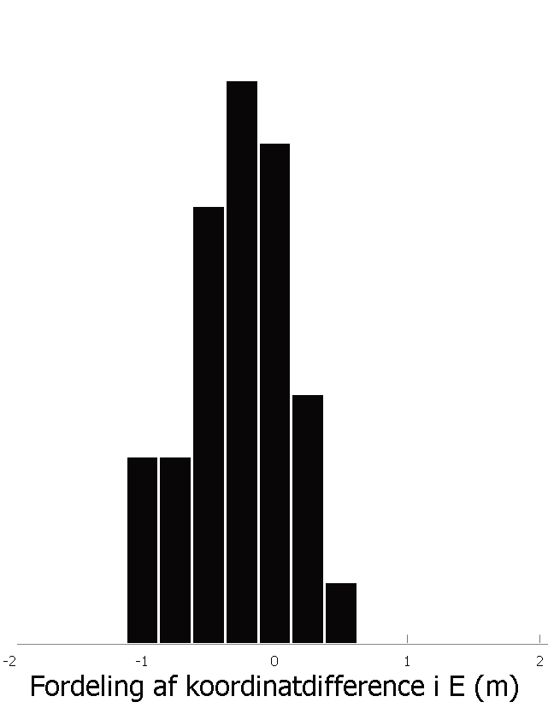Northing, mean error -4 cm
Easting, standard deviation 38 cm

Distribution of the coordinate difference, Easting (m)
Population in the distribution
Northing, standard deviation 40 cm
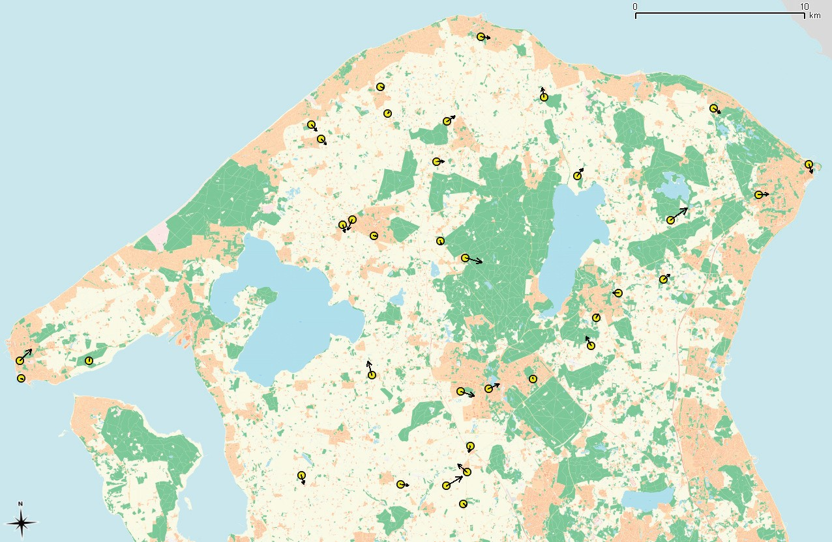
The yellow points represent the measured buildings around the Nordsjælland area.

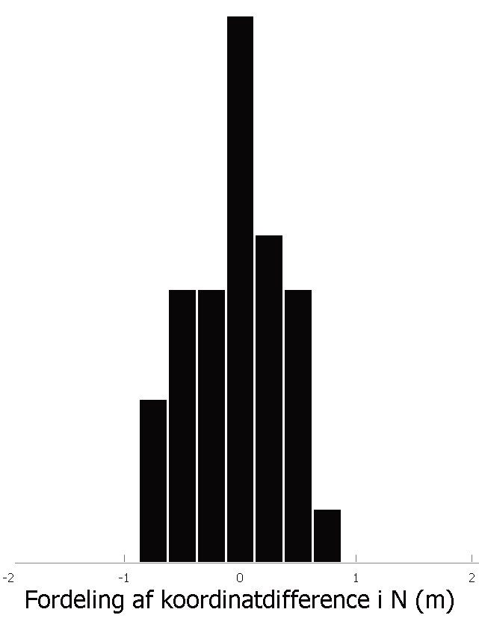The arrows show the directions and RMSE value, of the coordinate diﬀerences. Ar- rows are exaggerated by a factor 500.
Population in the distribution

Distribution of the coordinate difference, Northing (m)

A. n.

A.

A. n.
- ' -
n.
A.
- I , n.
I , n.

132
n.
n.

- A. A.
A. n.
n. 44

A. n.
n. A.
n.
A. n.
A.
n.
Karls

A. A. A.
A.
n. n.
A.
A.
A. 53
n.
A.
A. n.
A.
n.

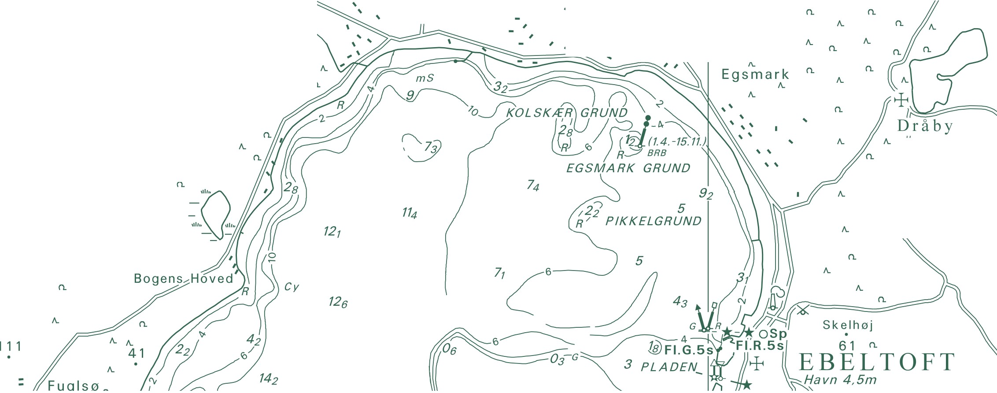A. Trehøje n.
National Survey and Cadastre Rentemestervej 8
2400 Copenhagen NV Denmark
http://www.kms.dk
(Dyrehøje) _{A.}
n.
127

