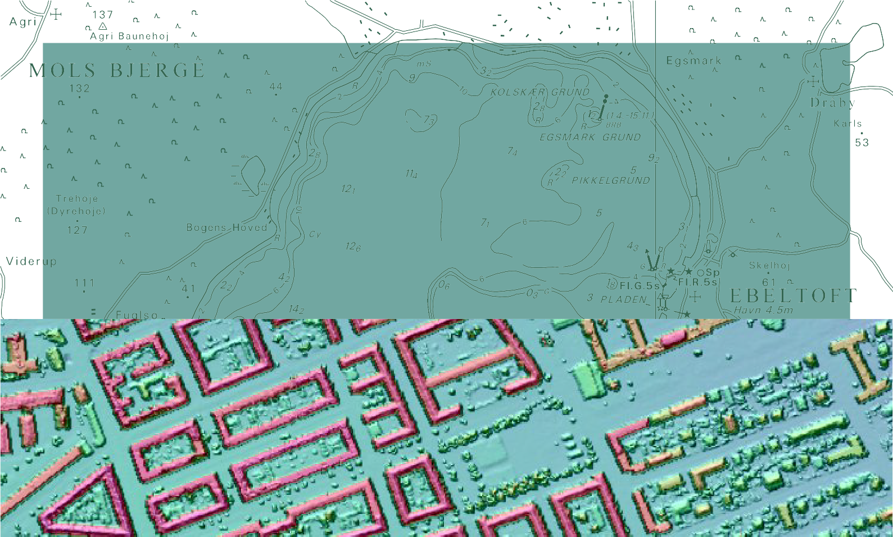

TECHNICAL REPORT NO. 04

Proceedings of the 2nd NKG workshop on national DEMs, Copenhagen, November, 11–13 2008
Edited by Thomas Knudsen and Brian Pilemann Olsen

Contents
Welcome address
Nikolaj Veje 3
DK-DEM: one name—four products
Nynne Sole Dalå, Rune Carbuhn Andersen, Thomas Knudsen, Simon Lyngby Kokkendorff, Brian Pilemann Olsen, Gitte Rosenkranz, Marianne Wind 4
Outreach: exploring the full potential of national DHMs
Nynne Sole Dalå, Thomas Knudsen 5
Dialog with interested parties
Gunnar Lysell 8
Flood Mapping of the Tornio River—Part One
Heli Laaksonen, Thomas Lithén, Clas-Göran Persson 9
Danish National Digital Elevation Model (DK-DEM)—User’s experience
Niels Broge, Klaus Vestergaard 11
A priori land use information for improvement of digital surface models through fine grained selection of surface model gridding parameters.
Thomas Knudsen, Andrew Flatman, Brian Pilemann Olsen, Rune Carbuhn Andersen 16
Quality control in NLS of Finland
Juha Kareinen 18
The KMS DHM Quality Control procedure: a project management perspective
Marianne Wind 20
Digital height models of ice in the Arctic
Lars Stenseng 21
A procedure for detection of horizontal offsets in point cloud laser data
Simon Lyngby Kokkendorff 22
Factors affecting precision and accuracy of airborne laser scanning
Milan Horemuz 24
Checking strip adjustment without access to navigation records
Brigitte Christine Rosenkranz, Thomas Knudsen 25
First results from an integrated test of multi beam sonar and red/green laser for nautical surveys in Green- land.
Rune Carbuhn Andersen, Thomas Knudsen, Tine Fallemann Jensen 27
PINGPONG: a program for height model gridding and quality control
Thomas Knudsen 29
COWI’s lidar and DEM activities today and tomorrow
Kristian Keller, COWI, krke@cowi.com 32
Digital Elevation Model of Iceland
Jóhann Helgason 33

KMS Technical report number 04:
Proceedings of the 2nd NKG workshop on national DEMs, Copenhagen, November, 11–13 2008. Editors: Thomas Knudsen and Brian Pilemann Olsen
Copenhagen, Denmark, December 2008 (draft) / October 2009 (final). ISBN: 978-87-92107-26-8.

Welcome address
Nikolaj Veje, Deputy Director General, KMS

Welcome
Dear Nordic friends and colleagues,
In March this year, Lantmäteriet invited Nordic colleagues to the first NKG workshop on national DEMs—a workshop aiming at sharing information about the state of the art wrt. DEMs in the Nordic countries, and gauging whether there was interest in collaborating on the subject under the auspicies of NKG.
There certainly was: already one month later, the NKG DEM task force was recognized by the NKG presidium. So during a spring and summer busy with data collection, model production, etc., we have been looking forward to host this meeting in Copenhagen, where the task force will formally es- tablish itself and lay out the plans and guidelines for the next few years of work.
It was also with great excitement we concluded that it would be possible to fill an entire 9 hour conference day with talks about ongoing and prospective work in the field of Digital El- evation Models: such stuff is not just useful for mutual ex- change of information, but also for mutual induction of inspi- ration.
ground papers, via application demonstrations to project man- agement considerations. To me this emphasizes that DEM is a multidisciplinary subject calling for collaboration across pro- fessional, as well as national borders.
One interesting example of the latter is represented by the paper presenting the Finnish/Swedish collaboration on a cross- border DEM for the Tornio river. Here, more than 25 years of NKG work on unification of fennoscandian reference net- works, is leveraged to make it possible to create a cross-border DEM.
This also stresses that work on DEM is a natural evolu- tion from the traditional gravimetric roots of NKG—you are carrying along a historic tradition of Nordic collaboration in geodesy, extends it in ways that can potentially improve the general public’s understanding of geodesy: of the three geode- tic reference surfaces (ellipsoid, geoid, and terrain) only the latter is visible and recognizable to the layman. But once we have an adequate geoid model, a high precision terrain model gives us the means to provide the layman with an idea of the geoid height and the meaning of the geoid. So for geodesy at large, DEMs are important for their own utility, as well as by being a means for providing an increased geodetic awareness. With this, I will say: welcome to Copenhagen, welcome to
KMS, and I wish you a fruitful workshop!

I have had the pleasure of taking a sneak peek in the pro-

ceedings of the meeting, and it is striking to see the wide rang- ing aspects of the papers to be presented: from technical back-
Nikolaj Veje, Kort & Matrikelstyrelsen, Rentemestervej 8, 2400 Copenhagen NV, Denmark

DK-DEM: one name—four products
Thomas Knudsen, Rune Carbuhn Andersen, Nynne Sole Dalå, Simon Lyngby Kokkendorff, Brian Pilemann Olsen, Brigitte Christine Rosenkranz, Marianne Wind

Introduction
DK-DEM is the official English language name of the latest national coverage height model for Denmark. The name DK- DEM is, however, slightly ambiguous: we really have a group of four different products under the DK-DEM umbrella. In or- der to clarify the concepts, we give a brief overview of these products (DTM, DTM with bridges, DSM, Contour curves). The intention with this paper is primarily to set the terms straight such that other papers may use the name DK-DEM in its generic, as well as its specific meanings, without having to explain these peculiarities in each case.

Danish and English names

For completeness, we also offer the factoid that the Danish name of the height model set is DHM, meaning Danmarks Højdemodel i.e. “Denmark’s Height Model”. Since the ab- breviation DHM is very likely to be taken for Digital Height Model, DK-DEM, rather than DHM should be used in non- Danish contexts.

Background
The DK-DEM project was initiated with a public tender in the spring of 2007. The tender was won by a consortium consisting of the two companies Scankort and BlomInfo.
DK-DEM is acquired by Kort & Matrikelstyrelsen (KMS/National Survey and Cadastre) on behalf of Danish State institutions. The Scankort/BlomInfo consortium handles production, quality control, and delivery, while quality assur- ance (i.e. checking that the quality control procedures are suf- ficient) is carried out by KMS (Wind, 2008). Certain devel- opment tasks are undertaken in collaboration (Knudsen et al., 2008). The final quality assured model is sold and distributed to private and public (non-state) customers by the consortium.

Terrain model (DTM)

The terrain model, DHM/Terræn or DK-DEM/Terrain, is an ordinary grid model covering the entire Danish land territory with a grid node size of 1.6 m.

Terrain model contours (DTM)
The terrain model contours are based on DK-DEM/Terrain. The contours are computed with an equidistance of 0.5 m

Terrain model without bridges (DTM)
The terrain model without bridges, DHM/Broer or DK- DEM/Bridges, is a first step towards a hydrologically more useful model. It is a special version of DK-DEM/Terrain, where a priori knowledge have been used to filter away bridges, which would otherwise look like dams to a hydrological model.

Surface model (DSM)
The surface model, DHM/Overflade or DK-DEM/Surface, takes the inclusion of a priori data used in DK-DEM/Bridges, to new heights. DK-DEM/Surface includes a priori informa- tion from topographic maps to specially tune the interpolation routines for each relevant surface type. The coverage and grid node distance is identical to the terrain model (Knudsen et al., 2008).

References
Thomas Knudsen and Brian Pilemann Olsen, editors. Proceed- ings of the 2nd NKG workshop on national DEMs, Copen- hagen, Denmark, 2008. National Survey and Cadastre.
Thomas Knudsen, Brian Pilemann Olsen, and Rune Carbuhn Andersen. A priori land use information for fine grained se- lection of surface model gridding parameters: definition and implementation of the FLATMAN procedure. In Knudsen and Olsen (2008).
Marianne Wind. The KMS DHM quality assurance procedure: a project management perspective. In Knudsen and Olsen (2008).

Thomas Knudsen thokn@kms.dk, Nynne Sole Dalå nsd@kms.dk, Rune Car- buhn Andersen rca@kms.dk, Simon Lyngby Kokkendorff simlk@kms.dk, Brian Pilemann Olsen bpo@kms.dk, Brigitte Christine (Gitte) Rosenkranz bicro@kms.dk, Marianne Wind maw@kms.dk. Kort & Matrikelstyrelsen, Rentemestervej 8, 2400 Copenhagen NV, Denmark

Outreach: exploring the full potential of national digital height models
Nynne Sole Dalå, Thomas Knudsen, KMS

Introduction

In the procedure leading to DK-DEM (Dalå et al., 2008), one goal was to push for the emergence of a common view of “what is a DEM, and what can it be used for” across all levels and sectors of the Danish public admin- istration.
A number of activities have been carried out to take us toward this goal. One of the most recent was a full day seminar with 12 presentations from public sector profes- sionals treating the “what is it” and/or “what’s its use” questions from their individual professional field, but in the common context of environment and climate effects management/protection.
In this extended abstract, we will first give a brief sem- inar report, then offer a few thoughts on why such a sem- inar is a good idea, and what can be done to follow up in order to ensure maximum benefit.

  - Seminar report
On Thursday, 2008-10-02, approximately 160 partici- pants gathered at Copenhagen University College of En- gineering in Ballerup, near Copenhagen for a day of networking, information sharing, listening, and learning. Twelve speakers from almost as many fields, had agreed to share their experience and views of the use and use- fulness of digital height models, especially in relation to climate effect response and preparation.

    - Keynote
After a brief welcome address from Nikolaj Veje, KMS, the keynote speech was given Ole Gregor (Gregor, 2008) of the regional environmental protection center in Aarhus. Ole Gregor has more than 15 years of experience in management of environmental effects and coupling be- tween rivers and agriculture in flooding prone areas. He has been an outspoken and passionate critic of the former state of the art in Danish elevation data, and was evidently delighted in telling how much better things have become due to the new height model.

Nynne Sole Dalå nsd@kms.dk, Thomas Knudsen thokn@kms.dk, Kort & Matrikelstyrelsen, Rentemestervej 8, 2400 Copenhagen NV, Denmark

The improvements do, however, not come for free, he noted: the much higher resolution of the new model is tough to handle for most desktop GIS systems used in lo- cal planning and administration offices. Hence, Gregor stressed the need for derived statistical products, and re- duced resolution versions of the height model products.

    - Quality control, and ancillary models
After the keynote, two presentations from KMS (Ander- sen, 2008; Wind, 2008b) outlined the KMS DHM quality control procedures, and the work being done in order to improve the digital surface model (DSM). In this volume, these matters are further described in the papers by Wind (2008a) and by Knudsen et al. (2008), respectively.

    - Flooding risks and consequences
Flooding risks and their consequences, were treated in two presentations.
Birgit Paludan, Greve Municipality (Paludan, 2008) focused on the integrated effects of sea level rise and increased precipitation. She showed how the DK- DEM/terrain could aid in drainage/sewer capacity plan- ning, and (in cases of flooding) in civil protection by detecting local terrain minima, and designating some of those as sewer reservoir basins.
Niels Rauff, Hedensted Municipality (Rauff, 2008) fo- cused on sea level rise, its direct flooding consequences, and how to communicate this to political decision mak- ers. Using a simple flooding model based on DK- DEM/terrain, Rauff had shown decision makers where flooding could be expected during the next 50-100 years, if no action was taken. After this map style presenta- tion, the same people were taken on a bus trip through the landscape, and the potentially flooded zones were pointed out directly on location. This had been an important eye- opener for the decision makers, Rauff noted.

    - Modelling and planning
Modelling and planning was covered by 4 presentations. Mogens Lindhardsen (Lindhardtsen, 2008) was con- cerned with restoration of marginal agricultural areas to their original natural shape. He used DK-DEM/terrain to evaluate the effects of reduced drainage for summer and
winter conditions under different scenarios.

Marie Louise Mikkelsen (Mikkelsen, 2008) presented an integrated modelling study of stream an ground wa- ter. In particular, she stressed the need for not just a sur- face height model, but also a bottom height model, i.e. a model including the bottom profile of streams and lakes. This will be a challenging new task calling for the in- troduction of new generations of water penetrating green and multicolour laser systems.
Johan Lassen (Lassen, 2008) presented a large study of transports of water and nitrogen in partially flat terrain, where small surface variations may lead to dramatically different modelling results.
Finally, Peder Klith Bøcher (Bøcher, 2008) described how new, highly I/O-efficient model algorithms had dra- matically improved the speed with which he could model and compute hydrological parameters from a terrain model. This was especially interesting in relation to Ole Gregor’s (Gregor, 2008) remarks about the problems aris- ing from handling the sheer amount of data in a high res- olution height model.

    - Legal and administrative aspects
Legal and administrative aspects were handled in two presentations.
Kirsten Flemming Hansen (Hansen, 2008) presented governmental plans and status regarding the implementa- tion of the EU floods directive. It is evident that a high accuracy height model is of great importance to that end. Steffen Svinth (Svinth, 2008) presented the status and plans for a new governmental web portal aiming to be the knowledge base for national climate accomodation plans.

    - Poster session
In the program for the seminar, we had invited any partic- ipant interested to bring poster presentations of their per- sonal (or departmental) work. This was done by approx- imately 20 participants. Their posters were handed in to the arrangement staff during registration, and were posted in the lunch/coffee break area throughout the day. Since lunch and coffee breaks were taken “in upright position” (i.e. no tables or chairs), interaction was unhindered: par- ticipants could study posters, discuss with each other and with the poster presenters in a very informal, and very productive way. For this to work, it is important that the lunch break is not too short. The 1 hour break we had planned was probably close to optimum, although dis- cussions were still very much going on when the seminar was reconvening after lunch.

  - Discussion, conclusion, and outlook
Most actual and potential height model users are working in small teams without any tradition or means for using
or exploring potential benefits of new data and tools.
On the other hand, given enough teams, enough time, and a reasonable amount of sheer luck, the right prob- lem will meet the right team, with the right set of ideas, skills, curiousity, and courage, to come up with great and innovative solutions. In such cases, we have a landmark project which can serve as inspiration for other teams.
In order to let this materialize, we need to give other- wise isolated teams a chance to meet each other for dis- cussions and demonstrations.
Hence, for an agency trying to promote the use of dig- ital height data (or any other new method or technology for that matter), we see three points as especially impor- tant:
- Know your users.
- Spot the landmark projects.
- Bring your users together for inspiration and infor- mation.
Once this has been done, medium term effects can be sup- ported in a very simple way by providing on line access to the seminar presentations: in this way, participants have an easy way to support their selling points in discussions with local colleagues who didn’t attend the seminar.
For the long term effects, we envision that it will be a very good idea to further enhance the documentation of some of the most prominent landmark projects, by pub- lishing a Fact Sheet series.
Fact sheets would be brief (4–8 page) folders with semi-journalistic descriptions of the problems at hand, combined with cookbook style descriptions of solutions at a sufficiently high technical level to be immediately applicable for any skilled professional.
Fact sheets will, however, not replace seminars: spot- ting landmark projects, and bringing users together for inspiration, is an ongoing process, that should be iterated in regular intervals (e.g. annually), as skills, ideas, and solutions evolve.

References
Rune Carbuhn Andersen. Udvikling af metoder til etablering af en landsdækkende digital over- flademodel (DHM/overflade). http://www.kms.dk/ Referencenetogopmaaling/dhm/seminar.htm, 2008.
Peder Klith Bøcher. Intelligent beregning af hydrologiske parametre afledt af en terrænmodel. http://www.kms. dk/Referencenetogopmaaling/dhm/seminar.htm, 2008.
Nynne Sole Dalå, Thomas Knudsen, Rune Carbuhn An- dersen, Simon Lyngby Kokkendorff, Brian Pilemann Olsen, Brigitte Christine Rosenkranz, and Marianne Wind. DK-DEM: one name—four products. In Knud- sen and Olsen (2008).

Ole Gregor. Opgaver og faglige udfordringer, hvor den nye generation af højdemodeller kan bidrage til en bedre opgaveløsning i miljø- og klimasek- toren. http://www.kms.dk/Referencenetogopmaaling/ dhm/seminar.htm, 2008.
Kirsten Flemming Hansen. Oversvømmelsesdirektivet— status og planer vedr. implementering. http://www. kms.dk/Referencenetogopmaaling/dhm/seminar.htm, 2008.
Thomas Knudsen and Brian Pilemann Olsen, editors. Proceedings of the 2nd NKG workshop on national DEMs, Copenhagen, Denmark, 2008. National Survey and Cadastre.

Thomas Knudsen, Andrew Flatman, Brian Pilemann Olsen, and Rune Carbuhn Andersen. A priori land use information for improvement of digital surface models through fine grained selection of surface model grid- ding parameters. In Knudsen and Olsen (2008).
Johan Lassen. Anvendelse af dhm/terræn til beskriv- else af vand- og kvælstoftransport. http://www.kms. dk/Referencenetogopmaaling/dhm/seminar.htm, 2008.
Mogens Lindhardtsen. Anvendelse af DHM/Terræn til konsekvensberegning af vandstandshævning.
http://www.kms.dk/Referencenetogopmaaling/dhm/ seminar.htm, 2008.
Marie Louise Mikkelsen. Anvendelse af dhm/terræn til simulering af oversvømmelsessituationer. http://www. kms.dk/Referencenetogopmaaling/dhm/seminar.htm, 2008.
Birgit Krogh Paludan. Anvendelse af DHM/Terræn i greve kommunes strategi imod oversvømmelser. http://www.kms.dk/Referencenetogopmaaling/dhm/ seminar.htm, 2008.
Niels Rauff. Visualisering af konsekvenser af kli- maforandringer og betydningen for den politiske pro- cess. http://www.kms.dk/Referencenetogopmaaling/ dhm/seminar.htm, 2008.
Steffen Svinth. Den nationale klimatilpasningsstrategi og klimatilpasningsportalen. http://www.kms.dk/ Referencenetogopmaaling/dhm/seminar.htm, 2008.
Marianne Wind. The KMS DHM quality assurance pro- cedure: a project management perspective. In Knudsen and Olsen (2008).
Marianne Wind. DHM kvalitetskontrol—status og videre forløb. http://www.kms.dk/Referencenetogopmaaling/ dhm/seminar.htm, 2008b.

Dialog with interested parties
Gunnar Lysell

Abstract
During the planning process for the project New national DEM for Sweden we have found it important to initiate a dialog with “interested parties”, i.e. potential users, responsible authorities and others.
The dialog focuses on three crucial issues. The first issue is to discuss the production priorities and quality requirements on the DEM, including requirements on updating, from a user perspective.
The second is to agree on what end products should be pro- vided by Lantmäteriet and what can be left to the commercial market to provide.
Finally, we also address the marketing conditions for ele- vation data regarding such issues as business model, prices, copyright etc. These questions are discussed in an INSPIRE perspective saying that “Each Member State shall adopt mea- sures for the sharing of spatial data sets and services between its public authorities”.
All of the above is important in order to fulfill the aim of our owner, which is that everything we do with tax payer’s money shall be of “Greatest possible benefit for the entire society”.

Gunnar Lysell, horemuz@kth.se Lantmäteriet, 801 82 Gävle, Sweden

Flood Mapping of the Tornio River – Part One

Heli Laaksonen (FIN) & Thomas Lithén, Clas-Göran Persson (SWE)

Presented at “The 2nd Workshop of the NKG DEM Task Force” Copenhagen, Denmark, November 11-13, 2008

  - The project

In accordance with the Flood Directive, a common EU project has been established between Sweden and Finland, to carry out flood mapping of the Tornio River.

Participants:
    - Lapland Regional Environmental Centre, Finland (lead partner)
    - Swedish Rescue Services Agency
    - Swedish Mapping, Cadastre and Land Registration Authority (Lantmäteriet)
    - National Land Survey of Finland
    - Swedish Meteorological and Hydro- logical Institute
    - SYKE, Finland
    - County Administrative Board in North Botnia, Sweden
    - Regional Authorities in Finland
Project goals:
    - Flood mapping in co-operation
    - Local and regional anchorage
    - Increased knowledge and skills regarding flood forecasts
Work Packages:
    - Digital Elevation Model
    - Flood Hazard Maps
    - Improvement of hydrological prognosis and ice-jam prognosis
    - Education
    - Dissemination of information

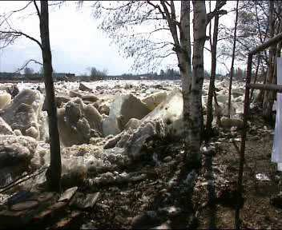
Figure 1: Ice-jam, one reason for flood mapping.

An application was entered on September 30, 2008. Nothing has been decided so far. If accepted, the project will run during the period 2009-2012. The total turn over is around 1 M€.

  - Production of the DEM
The basic part of the project is to produce the Digital Elevation Model (DEM), to be used in different hydrological analyses. The national land surveys of the two countries will co- operate in this work.
Today, Finland is far more operational than Sweden concerning work processes for DEM production. Therefore it was decided to use the Finnish approach throughout and to appoint the Finnish National Land Survey as leader of this work package.
The DEM will be produced with the use of laser scanning and presented in a 2*2 meter grid with a vertical standard error of around 3 dm. An external producer will be purchased for the data capture.
In addition, cross-sections showing the bottom topography will be determined along the river.

  - Issues to consider
There are some special issues to take into consideration when working on the border between two countries (reference systems, map projections, rights, rules etc.).
The geodetic aspects are quite easy to handle. The work within NKG (the Nordic Geodetic Commission) has resulted in a good agreement between the reference systems of the Nordic countries – and in case there are differences, these are accurately estimated.
The differences – in the project area – are:
    - 3-D Reference Systems (SWEREF 99 vs. EUREF-FIN); 8 mm North, 2 mm East and 16 mm Up
    - Height Systems (RH 2000 vs. N2000); less than 2 mm
    - Geoid Models (SWEN08_RH2000 vs. FIN2005N00); less than 10-20 mm
However, the geodetic expertise in the two countries should be consulted, in order to secure an optimal use of GPS in this cross- border area.
Within the project, for consistency purposes, the DTM will be presented in the Finnish reference systems, the Finnish map projection and the Finnish map sheet division, see Fig. 2.
Later on, Sweden will transform the Swedish part of the DTM into the Swedish geodetic datum and include it in the new national DEM.
The following is a check-list of the “non- geodetic” aspects – other things that have to be considered and solved prior to project start.
Are there any differences between the two countries when it comes to:
    - Rules for public procurements
    - Agreements with the producers
    - Secrecy
    - Property rights
    - Business models
    - Conditions for use

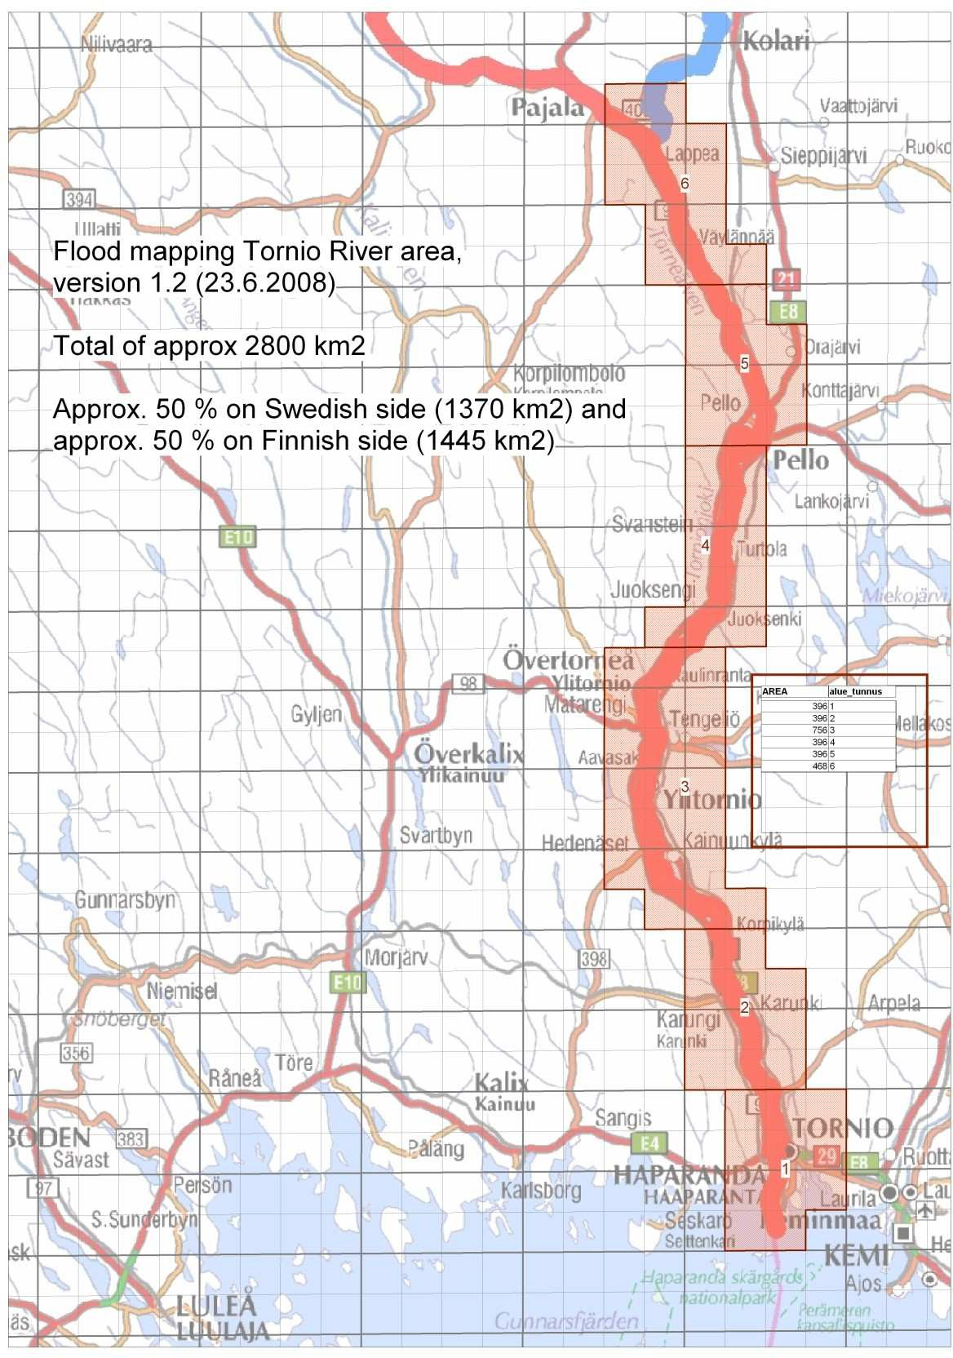
Figure 2: Project area.

Task Force Aspects

This is a good example of Nordic co-operation
– in “the spirit” of NKG. We can learn from each other and together we can simplify the solution of cross-border problems. And thanks to NKG for having established the necessary geodetic frame-work!

  - Final words
This time we have perhaps more questions than answers, so we think it would be nice to come back at the next work shop to deliver the remaining answers in a Part Two of this paper.

  - References
Lysell G (2008): Dialog with Interested Parties. The 2nd Workshop of the NKG DEM Task Force, Copenhagen, DK, November 11-13, 2008.
Korkeusmallin välinekehitysprojektin (KOVA) loppuraportti (2008). Project Archive of the National Land Survey of Finland.

Danish National Digital Elevation Model (DK-DEM) – Users experience

Niels Broge & Klaus Vestergaard Informi GIS A/S

Informi GIS A/S is a software developer and distributor of GIS products that enables Danish professionals access, analyze, and share all types of geodata and imagery. Informi GIS A/S is the Danish distributor of GIS and remote sensing software products from the market leading companies such as ESRI and ITT Visual Information Solutions.
Roughly 40% of the Danish municipalities are using products from ESRI’s ArcGIS suite. Informi GIS A/S has collaborated with some of these municipalities, in particular the municipality of Kolding, in utilizing the new detailed DK-DEM, some of which have led to successful implementation of solutions based on the results of the GIS analyses.
Four case studies will be presented. The case studies include a flood prevention project, an urban planning project and a surface run-off project. The case studies involve both the terrain model and the surface model included in DK-DEM as well as the classified laser point cloud. All elevation data were provided by BlomInfo A/S and Scankort a/s. Note that these data are from an early version of DK-DEM, which has not been subjected to a thorough quality control procedure. Vector data were provided by Municipality of Kolding.

Case study 1 – Flood prevention
Flood situations may all be characterized by of temporary drainage problems causing large water masses to flood areas that are normally dry. However, the causes of temporary drainage problems may be many. The most common cause of flooding in Denmark is probably high water levels in the sea caused by a combination of high tides and storms. Although dikes may prevent the seawater from flooding areas of low elevation in the coastal zone, these areas may be flooded by freshwater, which is captured behind the dikes and lock gates. Extreme irrigation events may also cause flooding, because discharge exceeds the capacity of natural waterways and drainpipe systems. Finally, groundwater tables are expected to rise as a direct result of the expected climate changes, especially in areas characterized by sandy soils such as the western part of Jutland (Olesen, 2008). This will contribute to the risk of flooding in areas dominated by high ground water tables.
The case study describes a flood situation in Christiansfeld, where a new recently opened nursing home for elder citizens was flooded as a result of an extreme cloudburst causing the stream, Taps Å, to overflow. The subsequent restoration of the buildings and the rehousing of the senior citizens became an expensive affair for the municipality. As a result of this, the town council requested an investigation to identify other areas in the municipality which are at risk of being flooded if the water table of Tabs Å increases dramatically in the future. Using the DK-DEM terrain model or a digital terrain model with similar characteristics, the risk areas may be mapped. Additionally GIS analyses made on the basis of such a terrain model can be used to suggest where new dikes should be constructed to avoid future flooding.

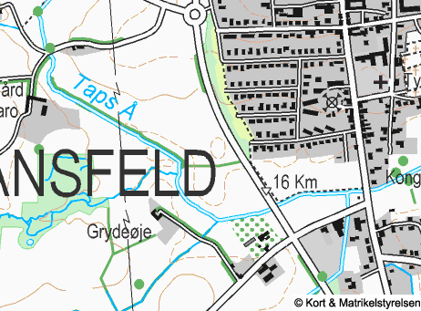 | 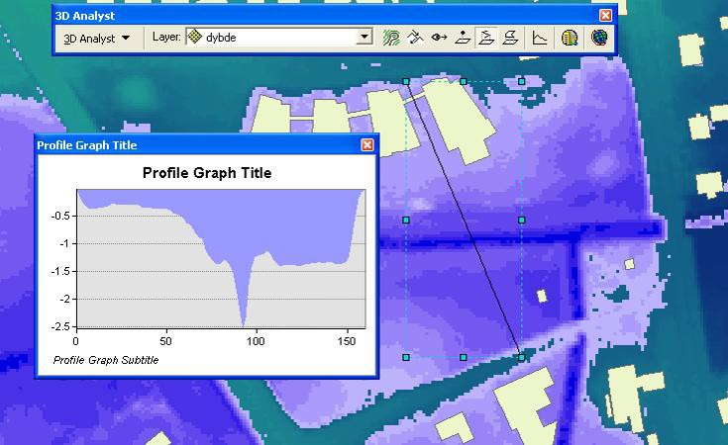
<Figure 1a> Topographic map showing the area upstream from the aqueduct under the bridge (Kongebroen). | <Figure 1b> Maximum flood area and equivalent water depths calculated for a blockage of Kongebroen in Christiansfeld. The image is calculated from the terrain model using the ‘fill’ routine to calculate the basin plane followed by the ‘cut/fill’ routine to calculate the volume and area of the flood. The difference between the digital terrain model (DTM) and the “filled” DTM correspond to the water depth.

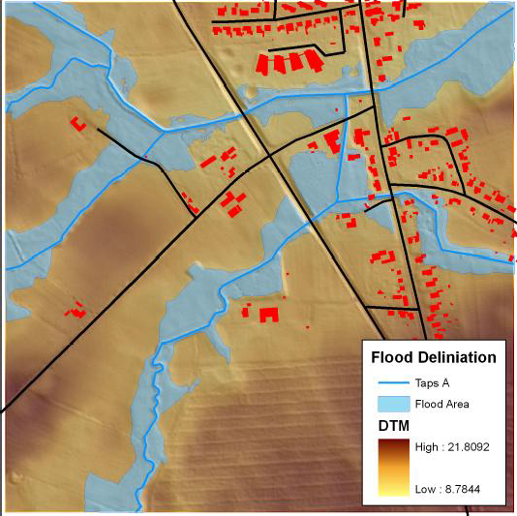
<Figure 2> Flood delineation for a 1m increase of the water level along the Taps Å system of streams. The map is calculated assigning z-values from the DTM to a 2D river theme provided by the municipality.
One meter is added to the z-value of each vertex in the resulting 3D river theme. A new plane is then calculated by circular extrapolation and averaging from each river vertex point using a radius of 30 cells. The radius should be large enough to ensure that all flooded areas of the river bed are included. Finally the calculated surface is superimposed onto the DTM, representing flooded areas of the river bed for a water level increase of 1m.

Case study 2 – Urban planning
GIS tools provide very powerful tools to model and visualize the landscape as well as the urban environment in 3D. These models provide an important input for fast visualization and evaluation of the effects of forthcoming construction projects. This case describes how the municipality of Kolding in collaboration with Informi GIS has used DK-DEM including both the DTM and the digital surface model (DSM) to visualize how

the reconstruction of a former commercial laundry enterprise to form a modern apartment complex with four buildings, each 5 stories (20 meters) high, will affect the local urban environment.
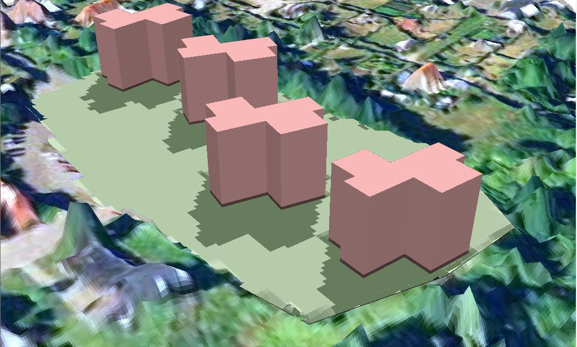
<Figure 3> The DSM with ortophoto draped on top and modified to represent the ground level of the proposed construction site in Kolding. Superimposed is the prospect of the new apartment buildings, with calculated shade patterns at 3 pm, vernal equinox (21 March). The model is a true 3D model, which allows for visualization from all directions and angles, or generation of fly-through movies.

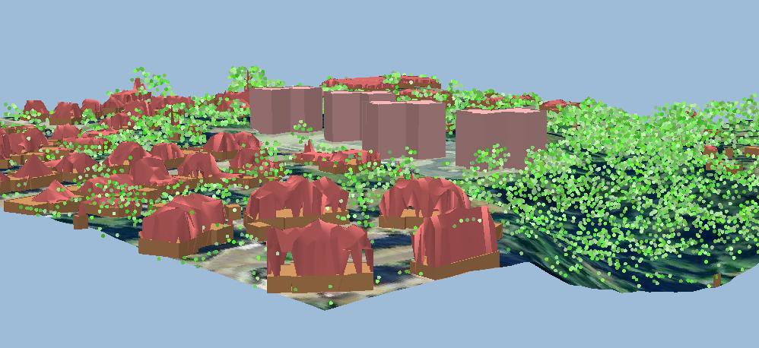
<Figure 4> Example showing a simple 3D city model of the proposed construction site in Kolding including the immediate surroundings. The 3D model is based on three data sources that are available to most Danish municipalities. The three data sources are (1) Laser data (DTM, DSM, filtered point cloud),
(2) Ortophoto and (3) The buildings and homes register (BBR).

Case study 3 – Surface run-off
Before the onset of new construction works in Denmark the impact of the proposed construction on the environment must be assessed according to Danish legislation. This procedure is known as VVM-evaluation. This case presents an example of how the DTM may be used to calculate topographic watersheds and flow pattern of a toxic spill. In this hypothetical example a farmer has filed an application regarding the construction of a new container for animal slurry. As part of the VVM assessment procedure the flow line from the location of the proposed slurry container may be calculated. The impact on the local environment of a potential spill from the slurry container on its way to the nearby stream as well as its dilution in the water body downstream from the stream assess point of the spillage flow path, may then be evaluated by combining the spillage flow line with the geographical extent of f.ex. rare plant species.

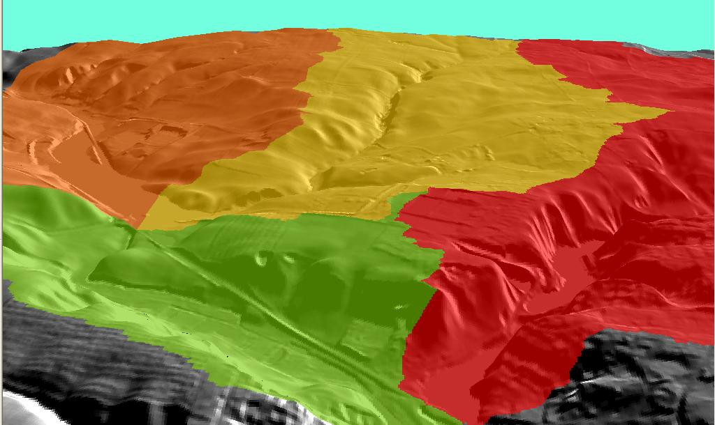 | <Figure 5> Calculation of topographic watersheds (min. threshold = 1 km²), shown in 3D.
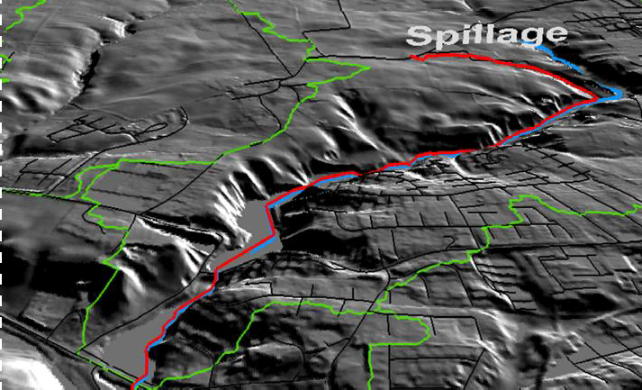 | <Figure 6> Calculation of approximate stream location (blue line) and delineation of the toxic flow pattern caused by a spillage incident (red line). Topographic watershed boundaries are shown in green, and paved roads are shown in black.

Case 4 – Terrain levelling

The municipality of Ringkøbing-Skjern has carried out precision xyz field measurements using DGPS in planning the construction of a soccer field. Their findings show that DK-DEM is modeling the absolute height of the field with mean accuracy better than 5 cm. This comparative study has provided great confidence in DK-DEM in the municipality, and has led to serious considerations on how to replace resource intensive field

measurements with DK-DEM data in future construction planning projects. On the basis of the DTM the municipality was able to determine the most cost effective elevation level of the soccer field, calculated to be
28.44 m DVR, i.e. the level at which the least amount of soil needs to be moved. Further, this approach enables the municipality to calculate the exact volume of soil that needs to moved and provide the contractors with maps showing the exact delineation of the 28.44 contour line.
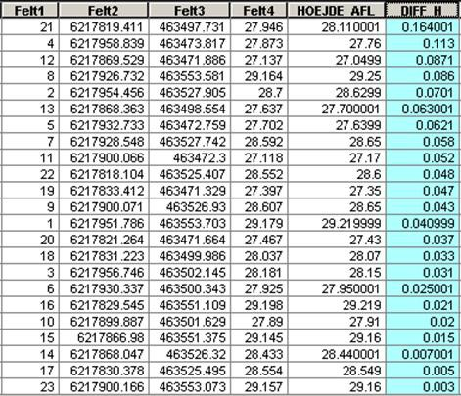
<Figure 7> Table showing point measurements derived by GPS compared to the elevation values of the corresponding pixel in the DTM. The area represents an agricultural field under cultivation. The column highlighted in magenta shows the absolute difference between the elevation measurements derived by GPS and the DTM at 23 locations evenly distributed across the site.
Mean difference: ~5cm Maximum difference: 16.4 cm

In conclusion, our preliminary experience with DK-DEM indicate, that DK-DEM or similar datasets hold great potential for the municipalities of Denmark. Thus, we believe that this new generation of terrain models will allow the wide community of professionals in city planning and landscape modeling to address such issues in a new and more comprehensive fashion.

References:

Olesen, J. (2008), ”Hvordan vil klima ændringerne påvirke Danmark?”, In: ”Klimaændringerne – Menneskehedens hidtil største udfordring”, Report from National Environmental Research Institute, 2008 (Red. Hans Meltofte), ISBN: 978-87-7070-125-9, http://www2.dmu.dk/pub/mb13.pdf.

A priori land use information for improvement of digital surface models through fine grained selection of surface model gridding parameters.
Thomas Knudsen, Andrew Flatmann, Brian Pilemann Olsen, Rune Carbuhn Andersen

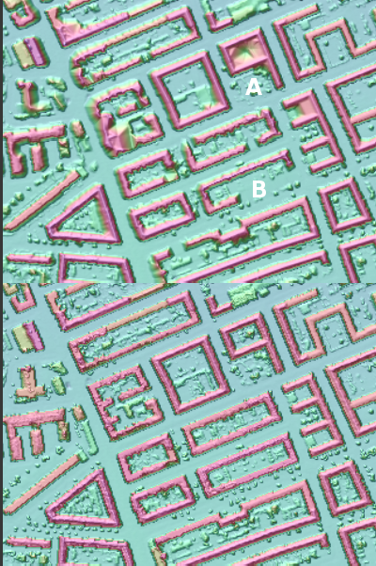
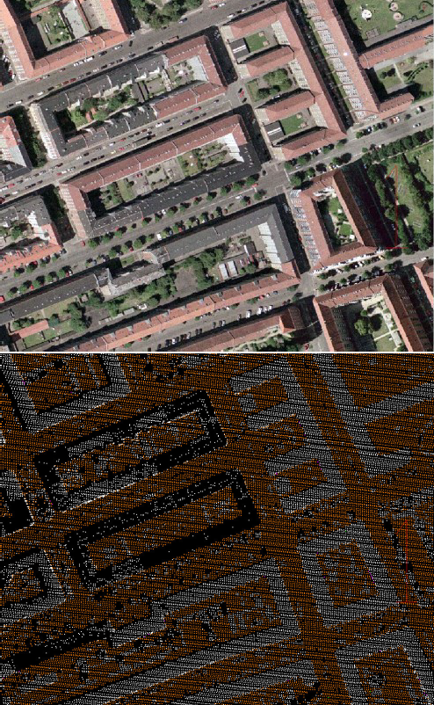

Figure 1: City DSM before (upper panel) and after (lower panel) in- corporation of a priori data from a land use/land cover (LULC) model. Note how the backyard vegetation giving problems (near A) are fully resolved after incorporation of LULC. Also, the missing building (near B) is reconstructed by validating the few reflections actually available against LULC information that a building really is expected here.

ABSTRACT: In figure 1, we demonstrate how utilizing a pri- ori knowledge of land use is a valuable aid when selecting the most sensible local gridding parameters for digital surface models (DSMs).
Sparse reflections from dark roofed buildings, forest like vegetation, solitary trees and bushes (cf. figure 2), are often discarded entirely from a laser scanned data set, if using stan- dard blunder detection schemes. For digital terrain models it

Thomas Knudsen thokn@kms.dk, Brian Pilemann Olsen bpo@kms.dk, Rune Carbuhn Andersen rca@kms.dk, Kort & Matrikelstyrelsen, Rentemester- vej 8, 2400 Copenhagen NV, Denmark; Andrew Flatman, acf@scankort.dk Scankort, Selsmosevej 2, 2630 Taastup, Denmark

Figure 2: Orthophoto and corresponding laser point densities, show- ing how building B in figure 1 yields a very low number of reflections due to its black roof.

is really not a problem, to lose such “above terrain features” from the input data set. For DSMs, on the other hand, it is ac- tually a severe problem. Adding a priori knowledge to adjust the editing and gridding parameters is evidently necessary.
In figure 3, we present results from a simple decision-tree based algorithm combining layers of existing topographical data into a high resolution land use/land coverage (LULC) grid which can be fed into the DSM gridding parameter selection procedure.
Once an initial rasterization of the topographical data has been carried out, the LULC algorithm runs in constant (almost zero) memory, and in linear time wrt. number of grid cells, making it feasible for large/national scale operations.

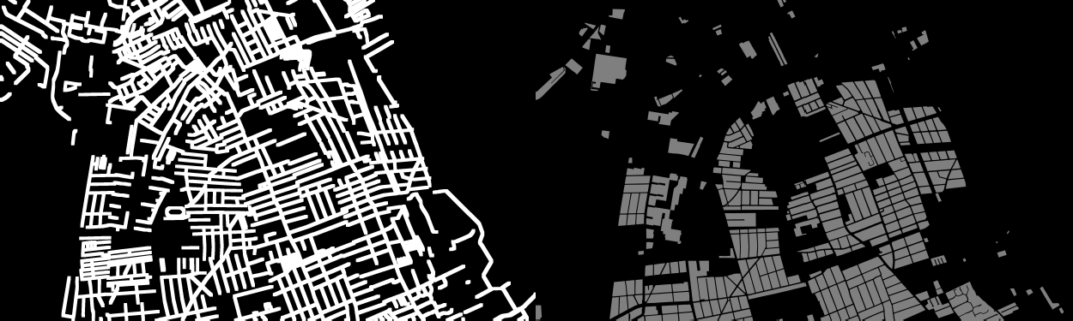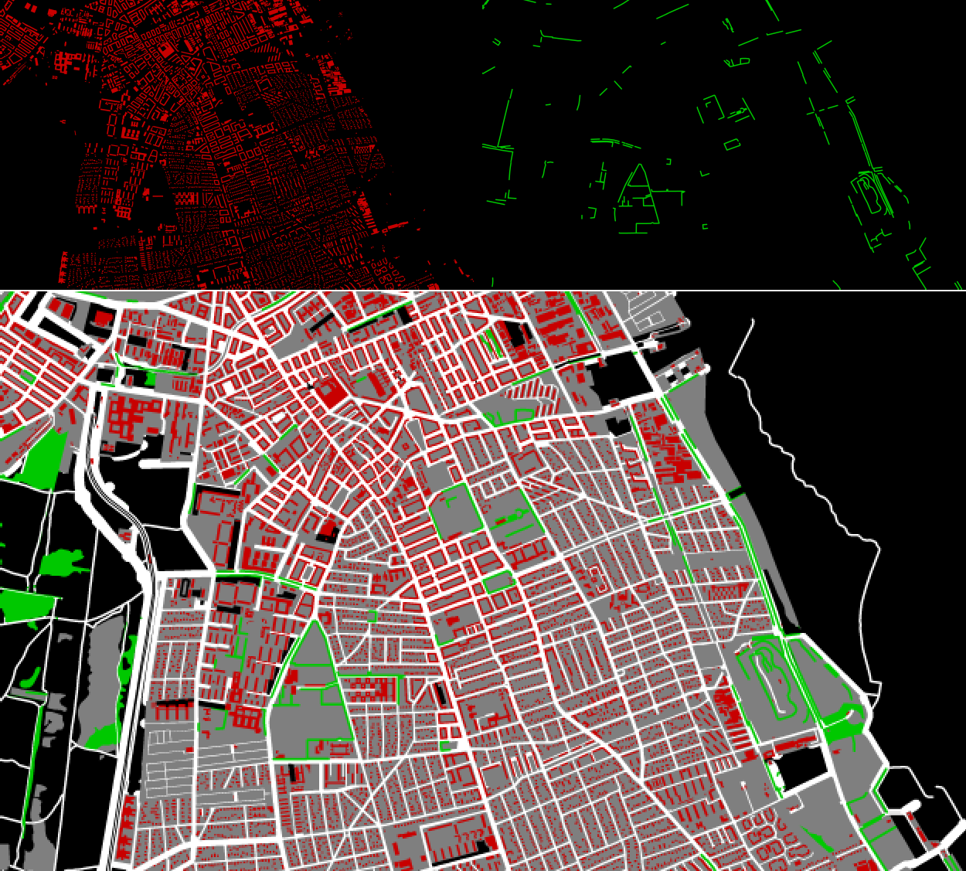

Figure 3: Top: 4 steps toward the LULC model. Bottom: The LULC model. White: road, green: vegetation, grey: built up areas, red: buildings, black: unknown/irrelevant

Quality control in NLS of Finland

Juha Kareinen
National Land Survey of Finland, Helsinki, Finland. juha.kareinen@nls.fi

Abstract
DEM-production has started in the spring 2008 in NLS of Finland. There have been given specific definitions for the quality of the laserdata to be used in the DEM-production. NLS of Finland buys laserdata from consultants. So NLS of Finland must do quality control to laserdata to be sure that the data will fill up the specific definitions. The following two figures sum up some practical experiences and outlines What and How the quality control is carried out.

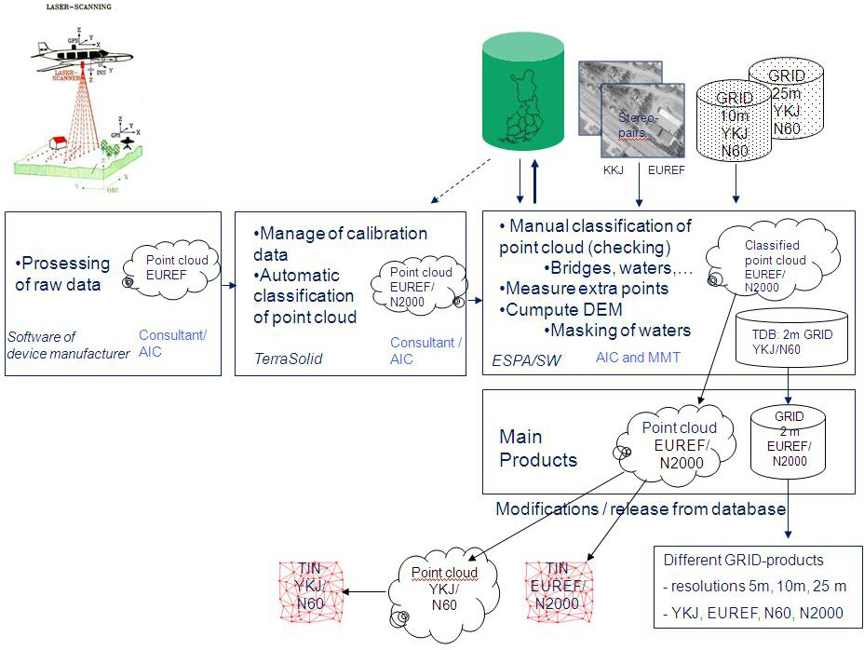

Figure 1: Laser production process in NLS of Finland from raw data to final products.

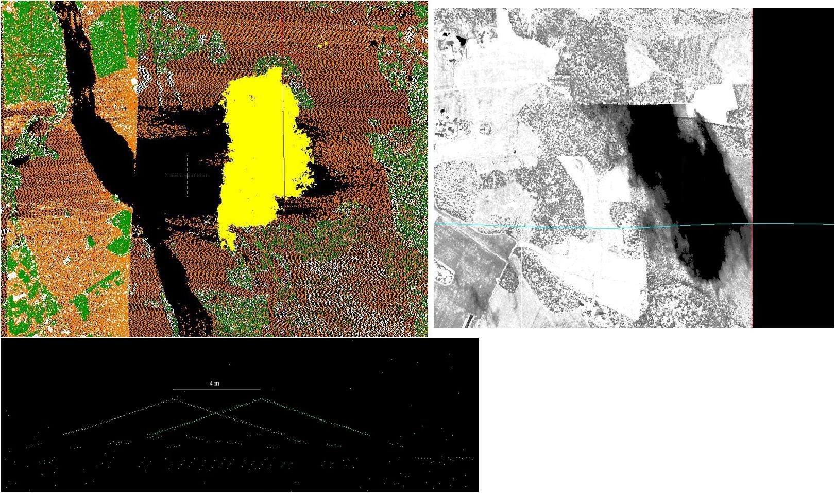

Figure 2: Problems in this year (2008) production. In upper pictures clouds which make holes in ground. Lower picture there is geometric problems. Flight line adjustment hasn’t been successful.

The KMS DHM Quality Control procedure: a project management perspective
Marianne Wind, KMS

Abstract
The Quality control procedures leading towards final accep- tance of DK-DEM, the new Danish National Height Model, have been quite extensive. They were organized in a dual struc- ture: a gate keeper function, and a quantitative control.
At each batch delivery, a visual check was carried out by highly experienced cartographers. This gate-keeper procedure was designed to persist, potentially through numerous rounds of batch rejections and re-deliveries, until something "looking like a DEM" was accepted into the quantitative quality control procedure.
In the quantitative part, a team of cartographers, engineers, geophysicists, surveyors, and mathematicians, were hammer- ing on the DK-DEM, each using their tool (of which much will be described in other presentations).
Evidently, project management in such a diverse setting is not a trivial task: it includes ensuring proper communication between line management, two levels of quality control pro- fessionals, and a consortium of two companies doing the actual delivery work - while still also making room for improvements, because we learn along the way.

Marianne Wind maw@kms.dk, Kort & Matrikelstyrelsen, Rentemestervej 8, 2400 Copenhagen NV, Denmark

Digital height models of ice in the Arctic
Lars Stenseng

Abstract
Digital height models over land and sea ice in the Arctic area have, until now, mainly been based on observations from satel- lites. These observations are generally erroneous, as most satellite altimeter instruments are designed to observe the ocean.
The SIRAL-2 instrument on CryoSat-2 (scheduled launch summer/autumn 2009) is a new generation of radar-altimeters specifically designed for land and sea ice. DTU Space has since 2004 participated in the collection of radar and laser data for the calibration and validation of SIRAL-2 type radars.
Examples of the work with collecting and interpretation of the datasets and the challenges that the Arctic offers will be presented. Finally the PROMICE project will be presented. PROMICE has focus on the observation of the margin zone of the Greenlandic inland ice, an area where SIRAL-2 is expected to be erroneous.

Lars Stenseng, stenseng@space.dtu.dk DTU Space, Juliane Maries Vej 30, 2100 Copenhagen Ø, Denmark

A procedure for detection of horizontal offsets in point cloud laser data.
Simon Lyngby Kokkendorff

Introduction
Here we will discuss a procedure for determining georeferenc- ing errors in point cloud laser data, and a simple software pack- age designed to perform this task.
We will denote our point cloud data by P, which is then
a set of 3-d points (x, y, z). To be more explicit, we think of
mation φ . We can:
- Find φ such that the (e.g. RMS) distance of φ (R) to a subset of P is minimal.
- Choose an interpolation scheme in between points of P, such that z(x, y) gets defined in a region containing P, and find φ such that the error in z-values is minimal. I.e. we minimize:
1

a point p = (x, y, z) P as consisting of a two-dimensional coordinate (x, y) in a coordinate system covering the area in question as well as a height z = z(x, y) in an associated height
∈
E_{α} (φ ) =
∑
p∈R
(
N |z(φ (p)_{xy}
1
) − φ (p)_{z})|α
)
α

system. We then hope that P represents a good discretization of the physical terrain, whose continuous geometry can then be approximated by interpolating in between points in P. This is, of course, most problematic in areas where the point density is low. In these areas we also have the largest ambiguity due to different choices of interpolation method.
Here N denotes the number of reference points and for φ (p) = (x, y, z) we put φ (p)_{xy} := (x, y) and φ (p)_{z} := z. α > 0 is a fixed number, and E_{α} is called the α-power mean error. Typically one would work with α = 1, i.e. mean absolute error, or α = 2, RMS-error.

Georeferencing
Our problem is to determine if there is a ’rigid motion’ φ , such that φ (P) = φ (p) p P matches the ’real’ physical ter- rain better. Here we mean by a rigid motion a transforma- tion/mapping which preserves distances, i.e. an isometry. We can also enlarge our category slightly and consider Helmert transformations, which include also a scaling factor. It is of course possible that scaling errors could be present in point cloud data, even though one would expect them to be negli- gible. We assume that we have a good coordinate system and consider a sufficiently small region, so that our transformations have the usual coordinate representations as affine mappings.
{ | ∈ }
E.g. for a Helmert transformation:
φ (p) = v + αR(p),
where v R3 represents a translation, α > 0 represents the scaling and R SO(3) is a rotation matrix.
∈
∈
To perform this task we need a set of trustworthy reference points measured with some well known technique, where we have a good estimate for the accuracy. Let us denote our set of reference points by R, which has the same format as P, but typically contains a lot fewer points and has a much lower point density. Instead of transforming P we have, for imple- mentation reasons, chosen to move R around. This amounts to the same same however: transforming R by φ corresponds to transforming P by the inverse transformation.

Determining an optimal offset
We need to define a criterion of ’optimality’ to set up a min-

90

80

70

60

50

40

30

20

10

0

100

80

60

40

20

0

Histogram of errors against point cloud Kbh2.ref

-0.8 -0.6 -0.4 -0.2 0 0.2 0.4 0.6 0.8
E1: 0.219

Point cloud errors after optimization Helmert optimization: Yes Opp: 3
E1: 0.156
-0.5 0 0.5 1

imization problem, which we can then solve for our transfor-
Simon Lyngby Kokkendorff, simlk@kms.dk, Kort & Matrikelstyrelsen, Rentemestervej 8, 2400 Copenhagen NV, Denmark
Figure 1: Program output: example of a histogram of errors against the point cloud. Optimization improves the mean absolute error by approximately 5 cm. This is not the reference data from figure 2.

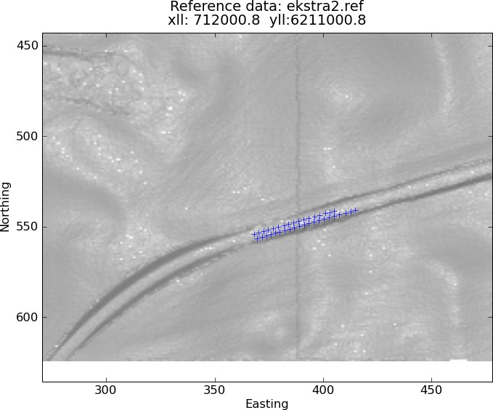

Figure 2: Program output: reference data plotted against the DTM grid.

In the ideal situation, where the point density of P is uni- formly (very) high, method 1 and 2 above should amount to the same. Also the choice of interpolation in 2 becomes irrele- vant.
In the before mentioned software we have chosen to work with a very primitive interpolation scheme: given (x, y) simply chose z from the nearest point in P. This is a setup which can easily be altered; this should definitely be done if we work with point clouds with ’low’ density.

The software and output
The software performing the task of finding the (near) optimal transformation φ is written partly in the MatLab compatible (but free and open source) program GNU Octave and partly in Python. However, using the pythonic numerical mathematics package NumPy everything could easily be migrated to pure Python.
The essential optimization is a simple procedure based on the steepest descent method but also applying features inspired by simulated annealing, which should make it less likely to get stuck at local minima. This is an important issue, since it is easy to set up situations, where there will be ’energy barriers’ on the way to a global optimum. This is of course mainly a problem if the optimum is located ’far’ from the ini- tial guess, i.e. we have large errors in georeferencing. Also it is important to tune the weighting of step sizes in the planar, vertical and tilt/scale directions to the situation at hand (if we know what to expect, otherwise experimentation with different choices might be appropriate).
The program can run directly on point cloud data or on grid-
ded data (which is much faster) and can work with optimiza- tions using just a 3-d translation, a translation and a rotation or a full Helmert transformation. In the case of Helmert transfor- mations, which includes scaling, one can get unrealistic ’opti- mal’ transformations if the reference data is located in a very flat/featureless region. In every case the output should be in- spected for realism and significance:
Do we get a significant improvement of errors due to the new georeferencing?
•
What is the difference between including rotations and not?
•
Do we have enough reference points to ensure that the improvement is not just a ’lucky punch’?
•
Linked to the previous point: Does the reference data have enough features to really distinguish the area from the sur- rounding terrain? Here features could be something like edges, ridges, pointy hills...
•
In most cases a visual inspection is useful. For this reason the program also produces a (primitive) visual output.
The program also applies an error pass filter, whose toler- ance is set by the user, to eliminate gross errors which should not be included in the optimization procedure. Such errors should of course not be present if the reference data (and the point cloud) is of good quality. However it can be of interest to include large amounts of reference data of a minor quality, e.g. from technical measurements of roads, in the quality control to get a solid statistical test of the DEM. Here such a filter is useful.

Factors affecting precision and accuracy of airborne laser scanning
Milan Horemuz

Abstract
Georeferencing of airborne laser scanning measurements is a complex procedure involving combination of observables from at least three sensors: GPS receiver, Inertial navigation unit and laser scanner.
It is obvious that the quality of the georeferenced point cloud depends on the quality of each sensor. But there are also other factors affecting the precision and accuracy of the computed coordinates, such as:
determination of relative position and orientation of sen- sors
•
- synchronisation of sensors
- mounting stability of sensors
calibration of individual sensors and the stability of cali- bration parameters
•
flight parameters: speed, height and attitude of helicopter or airplane
•
- atmospheric condition
In this article we give a short of description of these factors and their effect on the final coordinates. We will also derive the combined effect of all error sources, i.e. the expected precision of the coordinates. This analysis can be a base for setting the tolerance values used for the quality control of airborne laser scanning projects.

Milan Horemuz, horemuz@kth.se Kungliga Tekniska högskolan, Stockholm, Sweden

Checking strip adjustment without access to navigation records
Brigitte Christine Rosenkranz, Thomas Knudsen

Introduction
During the delivery and quality control phase for DK-DEM, we have access to the entire point cloud behind for quality con- trol purposes (Dalå et al., 2008; Wind, 2008a).
We do, however, not have any access to position and atti- tude (i.e. GPS and INS) data. Lacking both this and block adjustment experience, the outlook was somewhat bleak, for our initial ambitions towards checking the strip adjustment of the flight lines.

Strip adjustment
Strip adjustment is basically the procedure of making overlap- ping flight lines result in identical height observations inside the overlap zone. For small areas, this may be as simple as estimating an additive constant for each flight line. But for a national scale DEM, we suspected that the adjustment might lead to oscillatory behaviour, where height drift across track is reduced by alternating over- and under correction in neigh- bouring flight lines.

Mechanism
If present, this behaviour will be revealed in open land, by computing a normalized DSM (i.e. the difference between a DSM and a DTM). The reason for this is outlined in figures 1– 3:

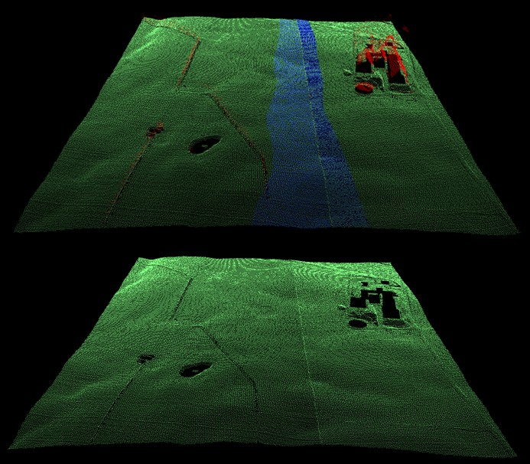

Figure 1: Classified point clouds for a digital surface model (up- per panel) and the corresponding digital terrain model (lower panel). Points in the overlap zone are shown in blue; points classified as ter- rain are shown in green; points classified as above terrain are shown in red.

The DTM is generated from points classified as terrain (i.e. local minimum values).
±
In cases where (due to adjustment imperfections) one strip is systematically lower than the other, the terrain model which is interpolated from trerrain classified points of one strip only will result in a step at the breaking line.
In the cross over regime, a surface model (which is based on interpolation including all points) will differ from the ter- rain model by an amount of approximately half the adjustment residual, since approximately half of the points used will come from either strip.
This is evidently a somewhat extravagant procedure, requir- ing the computation of two new height models (a DSM and a DTM) in order to check one existing model. We did, however, do this for extensive areas using pingpong, a gridding program which is fast enough to make the procedure computationally feasible (Knudsen, 2008). In our current setup, the network bandwidth is the limiting factor for the gridding procedure, so currently we do not need anything faster than pingpong.

Brigitte Christine (Gitte) Rosenkranz bicro@kms.dk, Thomas Knudsen thokn@kms.dk, Kort & Matrikelstyrelsen, Rentemestervej 8, 2400 Copen- hagen NV, Denmark

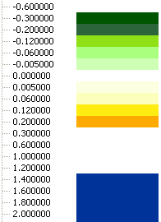Figure 2: Normalized surface model (nDSM) for an area with remain- ing strip adjustment errors. Caption unit is m. The dual range ( 0.6 m and above 1.5 m ensures that building outlines are included as blue patterns in the image as a visual guidance for the human interpreter.

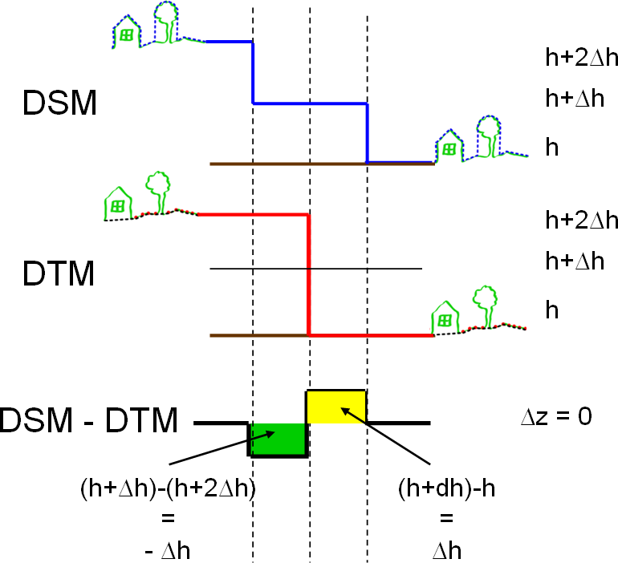

Figure 3: The mechanism for detecting strip adjustment residuals.
The DTM is generated from points classified as terrain (i.e. local minimum values). The points classified as terrain will be the lowest points of each strip until the border line. At the border line the lowest points of the next strip will be classified as terrain.
In cases where one strip is systematically lower than the other (due to adjustment imperfections) the terrain model will have a step at the border.
In the cross over regime, a surface model (which is based on interpolation including all points) will differ from the terrain model by an amount of approximately half the adjustment residual, since approximately half of the points used will come from either strip. The result will be the mean value of both strips.
Subtracting the DTM (half of the terrain points) from the DSM (all points) will result in zero where they are equal and plus or minus ∆h where they differ.

Results

As expected, an oscillatory pattern pinpoints areas where the strip adjustment has (to some extent) failed (cf. figure 1).
The oscillatory behaviour can be reduced by setting less strict parameters during the strip block adjustment (i.e. esti- mating a larger number of parameters). But evidently the ven- dor is reluctant to do this in the general case, because less tight control parameters may lead to entirely wrong, but pointwise correct, flight line parameters (i.e. overfitting), meaning that most of the time there are perfectly meaningful reasons to go for the strict control.
We do, however, believe that the normalized DSM is a good diagnostic tool pinpointing areas where it makes sense to allow a little more slack in the strip adjustment (i.e. where the actual flight pattern has been deviating in a more complex way from what was registered by the GPS/INS systems). Initial results (not shown here) from a readjustment experiment appear to confirm this belief.

References
Nynne Sole Dalå, Thomas Knudsen, Rune Carbuhn Ander- sen, Simon Lyngby Kokkendorff, Brian Pilemann Olsen, Brigitte Christine Rosenkranz, and Marianne Wind. DK- DEM: one name—four products. In Knudsen and Olsen (2008).
Thomas Knudsen. PINGPONG: a program for height model gridding and quality control. In Knudsen and Olsen (2008).
Thomas Knudsen and Brian Pilemann Olsen, editors. Pro- ceedings of the 2nd workshop of the NKG height model task force, Copenhagen, Denmark, 2008. National Survey and Cadastre.
Marianne Wind. The KMS DHM quality control procedure: a project management perspective. In Knudsen and Olsen (2008).
Marianne Wind. DHM kvalitetskontrol—status og videre forløb. http://www.kms.dk/Referencenetogopmaaling/dhm/ seminar.htm, 2008b.

First results from an integrated test of multi beam sonar and red/green laser for nautical surveys in Greenland.
Rune Carbuhn Andersen, Thomas Knudsen, Tine Fallemann Jensen, KMS

Abstract

Sonar surveying of arctic inshore waters is a dangerous, slow, and hence, costly, procedure. To speed up the surveys of the Greenlandic west coast, KMS and the Danish Maritime Safety Administration, have carried out an initial experiment of near- synchronous test surveys using multi beam sonar and red/green airborne laser instruments.
In general, the difference between the surface reflected red laser point and the water column penetrating green laser point agrees well with the results from the sonar surveys. Arctic sur- veying IS however, non-trivial, and much care must be taken in the analysis of this kind of data.
In the presentation, we will outline the processing algo- rithms in block diagram form, and show in more detail how our existing control procedures for land based laser data is modi- fied to fit with the multi beam and red/green laser data sets.

1 Introduction

The state of nautical charting for the waters around Greenland has historically reflected Greenland’s combination of huge size, small population, and (for large parts) inaccessibility due to harsh climate. The nautical charts in current use for the area are mainly based on surveys carried out in a long span of time from the 1930s to the 1980s. Most of the charts were produced in the 1960s due to a rising political awareness of the problem, after a dramatic 1959 event in the southern waters of Green- land, where the passenger ship “M/S Hans Hedtoft” was lost along with the lives of 95 passengers and crew members.
The current business development in Greenland includes a focus on petroleum and minerals prospection/exploration. This leads to increasing traffic through the archipelago as well as off-shore. Also the growing tourism industry has resulted in a steadily increasing number of large cruise ships in Greenlandic waters. Inshore, an increase of the number of small passenger ships is seen, due to a general change in the pattern of passen- ger transportation.
Hence, the need for more precise charts is growing signifi- cantly in these years, not only for the sake of the Greenlandic people but also for the sake of the vulnerable arctic environ- ment. In this paper we summarize some recent work carried out in order to bringing the old charts up to date without hav- ing to do extensive and costly re-surveying.

Rune Carbuhn Andersen rca@kms.dk, Thomas Knudsen thokn@kms.dk, Tine Fallemann Jensen tfj@kms.dk, Kort & Matrikelstyrelsen, Rentemestervej 8, 2400 Copenhagen NV, Denmark
  - The problem
The reference frame used for the old nautical charts was based on astronomical observations and triangulations from the 1920s–1950s (“Qornoq datum”). It was readjusted in the 1970s and 1980s after introduction of new absolute position- ing from DOPPLER and TRANSIT satellite observations, and a number of improved station-to-station distances from a cam- paign based on electronic distance measurement (EDM). The readjustment resulted in significant improvements, but in pre- GPS times, high accuracy navigation in arctic regions was non- trivial, so despite an improved reference system, the surveys from the 1970s and 1980s were not necessarily of very high ac- curacy, although the relative positioning within a single survey
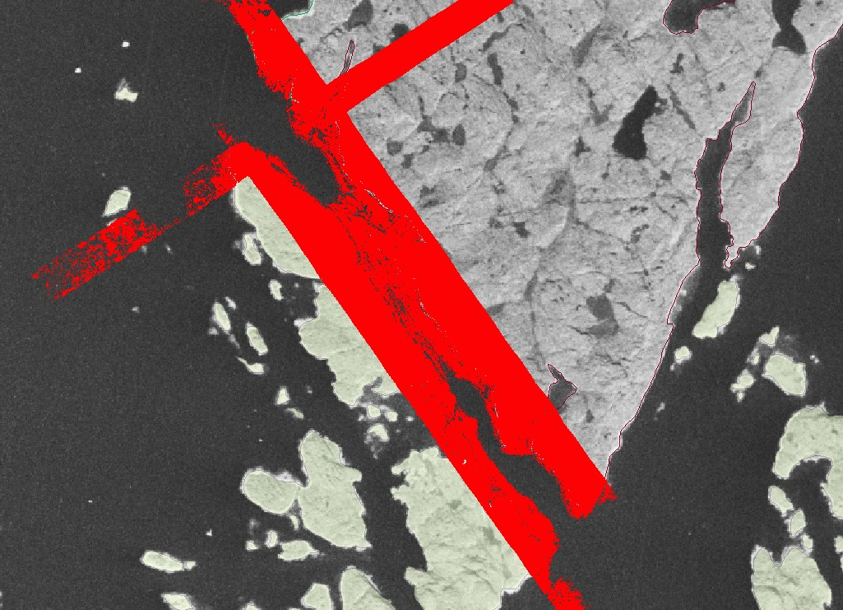

Figure 1: BW 1980s orthophoto with red/green laser points overlaid in red after transformation to datum Gr96/UTM zone 24.
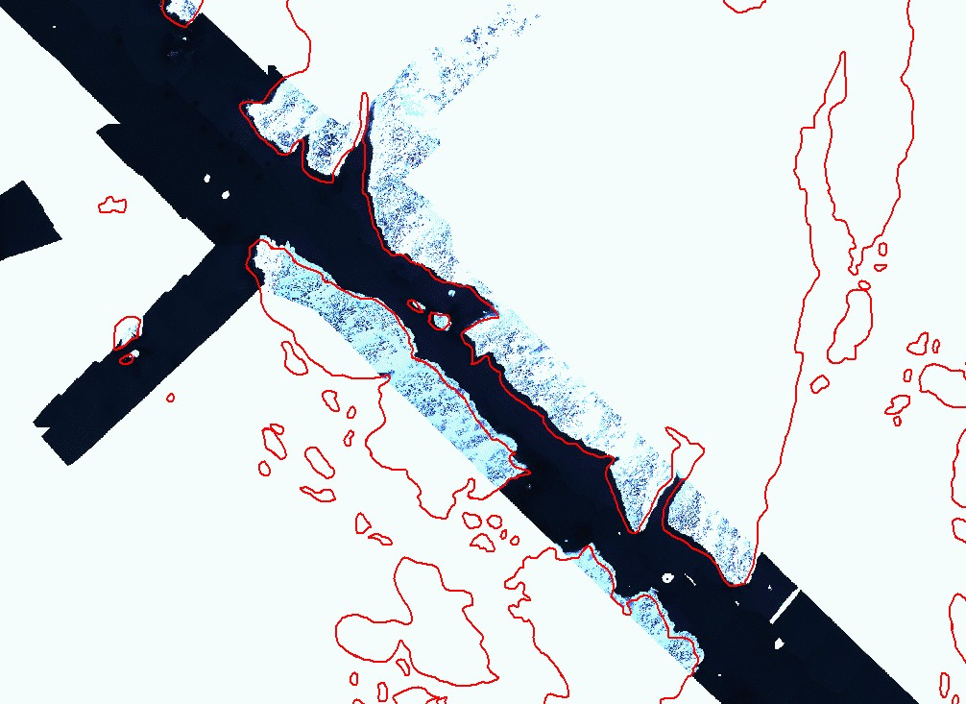

Figure 2: New shoreline draped onto new orthophoto (WGS84/UTM22).

(i.e. the precision) could be very high (Weber, 2007). Hence, it should come as no surprise that the introduction of GPS po- sitioning and GPS based reference frames, has revealed major errors in the old charts: while the overall geometrical accuracy varies from area to area, we do actually find examples where the coastline appears to be misplaced by several nautical miles. In most areas the errors are, however, less than 200 meters and most often better than 100 meters. In general the old charts have a good relative accuracy while their absolute accuracy is insufficient for modern navigation. This is evident from fig- ure 3, where a recent multi beam survey is overlaid on the old chart: the shape of the “ribbon” of multibeam reflections fol- lows the shape of the narrow strait on the chart neatly. It is, however, somewhat displaced as seen from the fact that some of the multibeam reflections actually come from areas which
(according to the chart) are on land.
These inconsistencies result in major problems with the day- to-day maintenance of the charts: as new data become avail- able they must to be fitted onto the old chart with reference to a coastline which is seriously misplaced. The fact that the old charts are still in raster format adds further to the complex- ity, making updates of the chart a time consuming and often impossible task.

  - Photogrammetrically derived data
Between 1978 and 1986 a complete photogrammetric cover- age of the ice-free parts of Greenland was obtained by KMS, using super wide angle cameras and high resolution B/W film. The flying altitude was around 14 km resulting in a scale of approximately 1:150.000. In our project the relevant photos for the charts covering the southwestern part of Greenland was scanned with a resolution of 14µm.
A new aerotriangulation of the images was carried out using the improved datum of Greenland, GR96 (Engsager, 2007). Then a number of products were generated from the pho- togrammetry:
- Digital elevation models with 100 m grid cell size

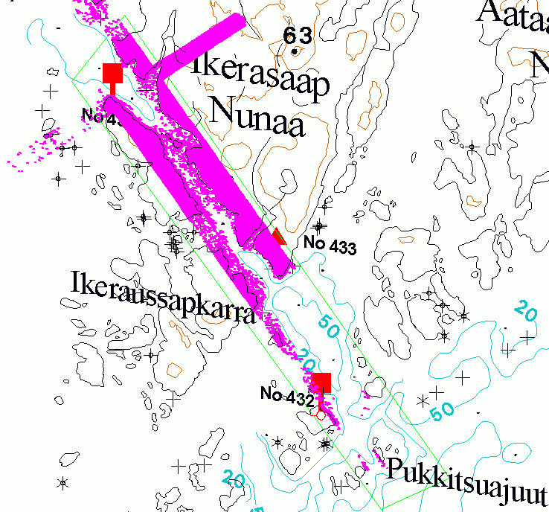

Figure 3: Revised nautical chart with multibeam observations from the Danish Maritime Safety Administration (Gr96/UTM24).
- B/W orthophotos with 5 m pixel size
- Photogrammetrical registration of coastline, rivers, lakes, glaciers, fiducial points, and spot heights.
The coastlinie and the orthofoto are the basis for digitizing the nesseceary homologous points for the geometrical retification. The coastline is expected to have an accuracy of 10-15 meters.

  - Digitally reconstructed nautical information
The original nautical observations in the charts are not avail- able in a suitable format. Therefore the old original printing material for the black layer of the charts was scanned at a res- olution of 600 dpi, resulting in bitmap files without any geo- graphical reference. The object types of relevance were recon- structed in digitized form using commercially available semi- automatic services.
The primary object types reconstructed are depth soundings, bathymetric contours, rocks, coastline (including all small is- lands inside and outside of the archipelago),
Additionally, all geographical names were reconstructed in digital form. These data were transformed into new Green- landic spelling in collaboration with Oqaasileriffik, the Green- land Language Secretariat.

  - New bathymetric data
The Hydrographic Office of the Danish Maritime Safety Ad- ministration is currently collecting large amounts of multibeam sonar data in the Greenlandic waters. With the update of the old data, these can (ideally) be merged seamlessly into the new generation charts.
Furthermore, experimental flights with red/green water pen- etrating laser scanner systems have provided new sets of inde- pendent test data.

References
Karsten E. Engsager. The Greenland reference frame 1996, GR96, 2007. Copenhagen, Denmark, Danish National Space Center.
Mette Weber. Geodætiske referencenet og referencesystemer i Grønland, April 2007. Copenhagen, Denmark, Kort & Ma- trikelstyrelsen.

PINGPONG: a program for height model gridding and quality control
Thomas Knudsen

Abstract
Pingpong is a simple inverse distance weighting (i.e. low pass filter) gridding program. It does, however, implement a highly efficient, data organization and data selection scheme, running in O(n log n) time (where n denotes the number of raw point observations).
This makes PINGPONG very efficient for initial explorative gridding of laser scanner data. Providing actual operational height models is, however, explicitly not the intention with PINGPONG.
In this paper, the basics of the program is outlined, and demonstrated by a sample run, providing a digital surface model (DSM), a grid of variance estimates for the DSM, and a corresponding grid of the local point density.
In a companion paper (Rosenkranz and Knudsen, 2008), we show how the efficient explorative gridding allows us to check the quality of laser scanning strip adjustment procedures, with- out any access to GPS or INS data.

PINGPONG—the name and the aim.
PINGPONG is a self-referring, recursive acronym meaning PINGPONG Is Not Geogrid, PINGPONG’s an Ordinary New Gridding program (where the geogrid referred to is the name of a classical gridding program, widely used by geodesists).
The primary aim of PINGPONG is to aid in the initial ex- ploration of a laser scanned point cloud, by providing rough gridded estimates of
  - elevation,
  - elevation estimation variance and
  - local point observation density.
The distance from each grid node to the nearest observed point is used as a proxy for the estimation variance. This definitely is a coarse approximation, but for a dense data set (as is typical for laser scanning) this proxy gives a good insight of how the scanning geometry interacts with the grid geometry, and hence helps diagnose potentially intricate aliasing effects.

Example
Figures 1–2 show output from a test session with PINGPONG. The test was run on a fairly modest portable PC: 1.6 GHz Intel Centrino with 1GB RAM, running Ubuntu 8.04, Linux kernel
2.6.24. The input data set consisted of approximately 500 000 data points. The output grid dimensions were 1000 × 1000
Thomas Knudsen thokn@kms.dk, Kort & Matrikelstyrelsen, Rentemestervej 8, 2400 Copenhagen NV, Denmark
nodes (i.e. 1 000 000 height, variance, and density estimates). It ran in slightly less than 10 seconds, which in our case is ap- proximately as fast as we can push the output back onto the backing storage. Hence, motivation for additional speed opti- mization is minor.

Method
For nation wide height models, we will have to handle a very large amount of data. So even though it is common practice to operate within smaller rectangular zones (as the 1 km by 1 km grid example above), we do need a fairly efficient data organization structure in order to complete the gridding task in a reasonable amount of time: searching through all 500 000 input data items for each of the 1 000 000 grid points in the example, is simply not feasible.
The data organization structure used is outlined in figure 3. The primary design consideration is that for any grid node, we need only consider point observations that are within a certain search radius, R₀, ideally determined in terms of the autocor- rellation of the physical phenomenon observed.
As a first step in utilizing this (before doing any gridding at all), we sort all point data according to their northing coordi- nate, in north south collating order.
→
Now, since we do the gridding row-wise, we may utilize the fact that each node in row number i has the same northing co- ordinate N_{i}. Hence, at the start of the row, we may bracket the
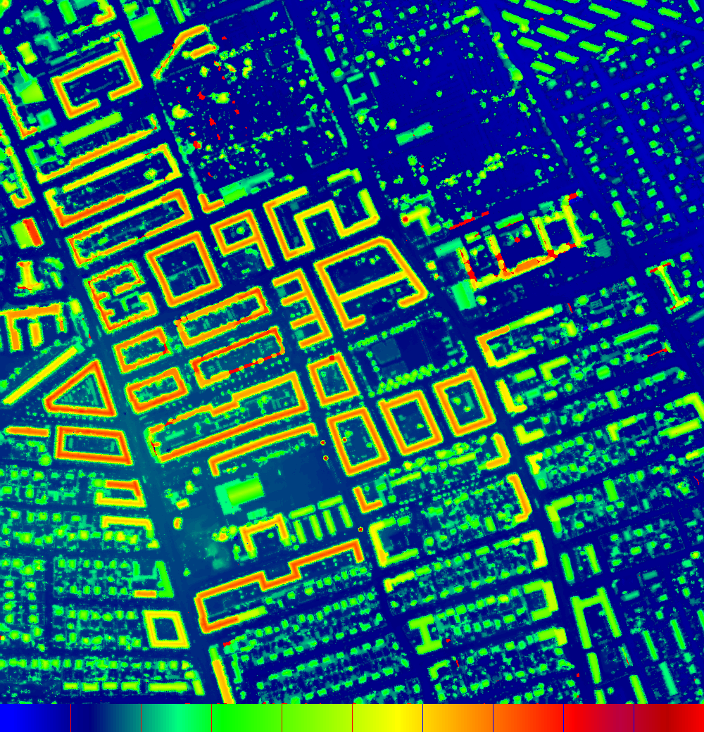

Figure 1: Digital Surface Model (DSM), from a sample run of PING- PONG(range 0 m–35 m).

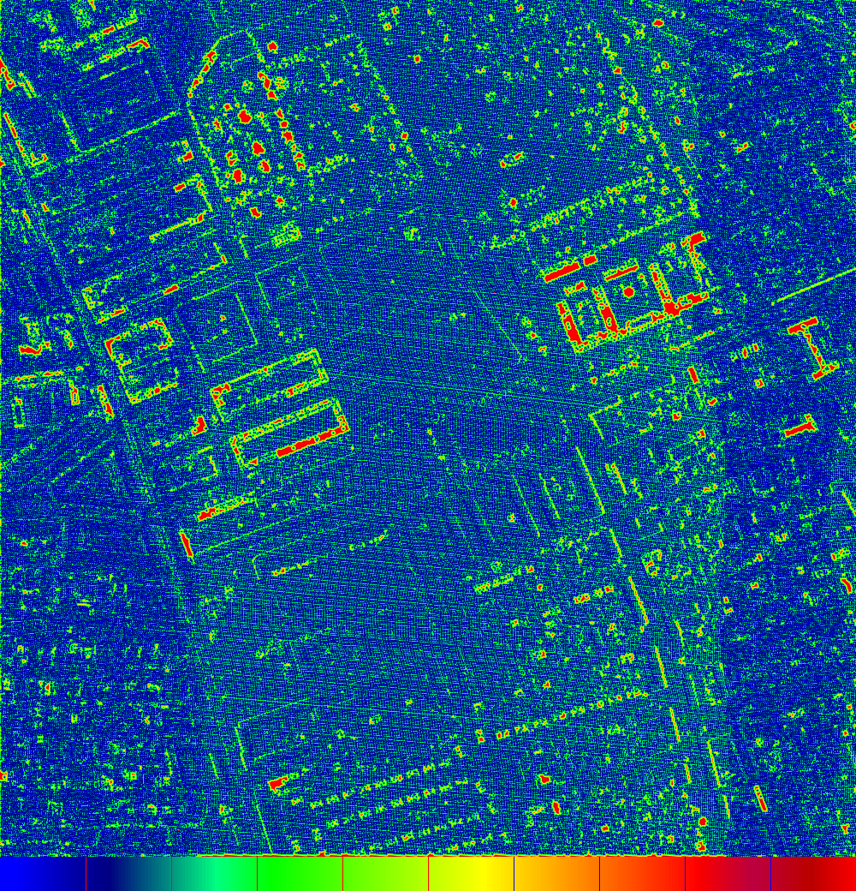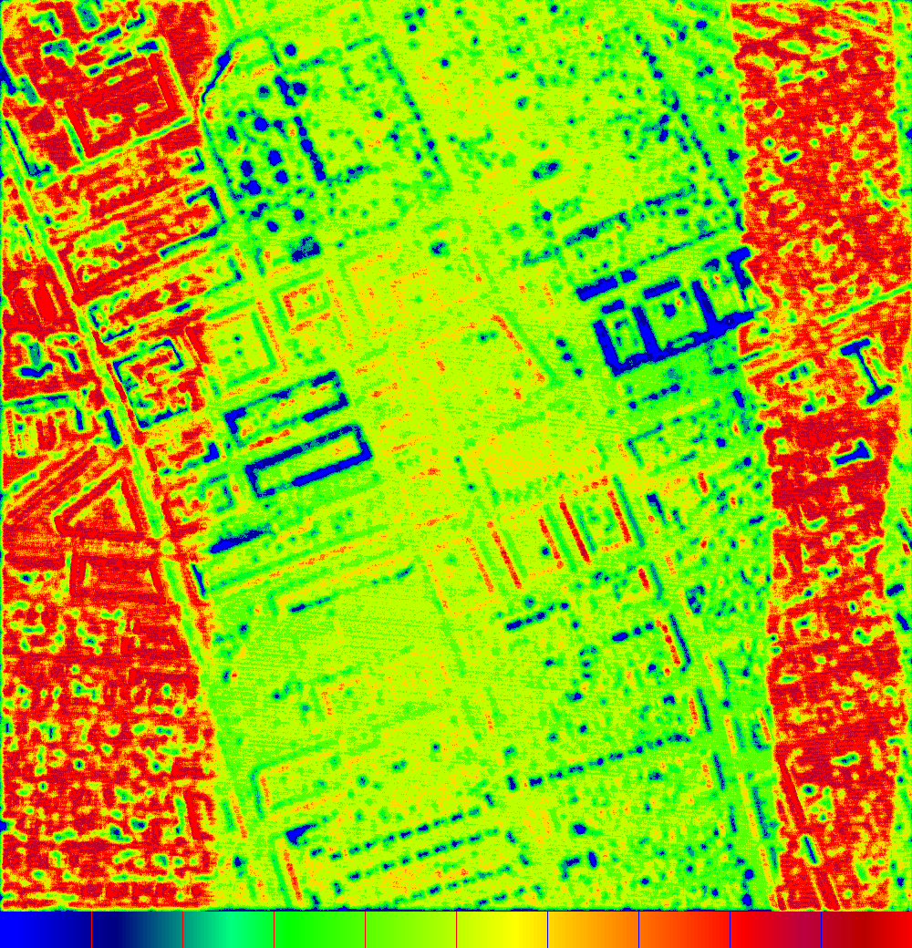

Figure 2: The quality parameters computed by PINGPONG (same sample run as in figure 1). Left: Variance estimate proxy (range 0 m–4 m), computed as the distance from the grid node to its nearest point observation. For uniform input data sets, this gives a fairly good estimate of the relative quality of the grid node height estimates. It also gives a warning of potential aliasing effects, through the intensity of the moire pattern between the laser scanner swath and the grid lines. Right: Point density (range 0/m2–1/m2), estimated as D = n/πR02, where n is the number of points falling within a search radius of R0 from the grid node. Note the clear delineation of the overlap zones between the flight strips, where the data density is very high. Also note the cases of very low data density typical of very dark roofs. This problem is described in more detail in Knudsen et al. (2008).

input data, leaving only the data points falling within a narrow zone N [N_{i} + R₀ . . . N_{i} R₀].
∈ −
After this bracketing, we have a small data set which is much faster to run a search through. But knowing that we do the grid- ding systematically from west to east, we speed up the process even more by sorting the bracketed data according to their east- ing coordinate, in west east collating order. Now, we have a small, and very well organized set of data, and can do the com- bined gridding, variance estimation, and density determination with minimal search effort.
→
To reiterate, the overall idea of the algorithm is to gain effi- ciency by avoiding repeated work: The entire data set is only sorted once, at the start of the process. Then smaller subsets are sorted once at the start of each grid row. Only linear search and no sorting, is carried out during the actual estimation of grid node values. Here the only computation not directly used in the estimation process is related to the rejection of points being outside of the search radius, R₀, but within the box de- fined by the coordinate ranges N [N_{i} + R₀ . . . N_{i} R₀] E [E_{j} + R₀ . . . E_{j} R₀], where (N_{i}, E_{j}) represent the northing and easting coordinate of the current grid node, respectively.
−
∈ − ∧ ∈

Discussion and future work
Currently, PINGPONG runs sufficiently fast, and handles suf- ficiently large data sets for our needs. Algorithms for faster handling of larger datasets exist (it is, for example one of the core research areas of the Massive Data Algorithmics center at Aarhus University—http://www.madalgo.au.dk/).
Hence, speeding up operations is not a priority in future work with PINGPONG. However, the algorithm for checking
of strip adjustment, presented in (Rosenkranz and Knudsen, 2008), will gain a significant speed up and a much simplified operation if implemented directly in PINGPONG. This, as well as an extended amount of documentation are priority items for the future work on PINGPONG. It should be noted, however, that PINGPONG is distributed under the terms of the GNU gen- eral public license, which ensures that any user has full rights to modify and improve the software as she sees fit.

References
Thomas Knudsen and Brian Pilemann Olsen, editors. Proceed- ings of the 2nd NKG workshop on national DEMs, Copen- hagen, Denmark, 2008. National Survey and Cadastre.

Thomas Knudsen, Andrew Flatman, Brian Pilemann Olsen, and Rune Carbuhn Andersen. A priori land use informa- tion for improvement of digital surface models through fine grained selection of surface model gridding parameters. In Knudsen and Olsen (2008).

Stephen Lacey and Richard Box. A fast, easy sort. BYTE, 16 (4):315ff, April 1991.

Brigitte Christine Rosenkranz and Thomas Knudsen. Check- ing strip adjustment without access to navigation records. In Knudsen and Olsen (2008).
Acknowledgement: Scankort A/S (through inimitable laser scanner magician par excellence, Andrew C. Flatman), pro- vided the laser point cloud used in the example.

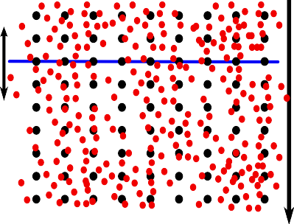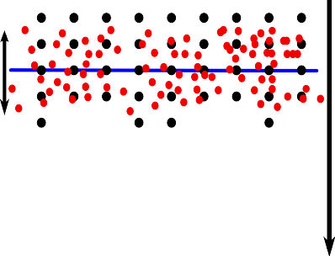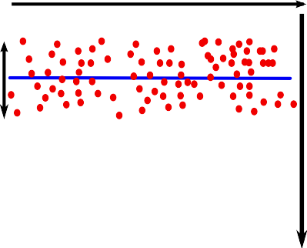Figure 3: The data sorting algorithm: point data are shown as red dots, grid nodes as black dots, and the grid row currently worked at as a blue line. Left: Prior to any gridding, the full data set is sorted from north to south. Center: We bracket the data relevant for the current grid row, by ignoring point data too far north or south of the current grid row to make a difference (in a statistical sense). Left: Before starting the gridding, we sort the bracketed data from west to east, then do the gridding in the same direction.
SORT SELECTION LONGITUDINALLY
SORT POINTS LATITUDINALLY
SELECT
SORT POINTS LATITUDINALLY
SELECT
SORT POINTS LATITUDINALLY
SELECT

Appendix
- Sort algorithm
PINGPONG uses the combsort algorithm for sorting observa- tions into a fast access order. Combsort (Lacey and Box, 1991) is a modification of the classical, simplistic bubble sort—but where bubble sort works in time proportional to the square of the number of elements to be sorted, i.e. O(n2), combsort re- duces this to O(n log n).
O(n log n) is comparable to the average quicksort time—but while quicksort may work very slowly in pathological cases (most notably when applied to an already sorted array), comb- sort does not appear to suffer from such maladities.

  - Bubble sort
Bubble sort operates by striding through the input array, com- paring neighbouring points, and swapping them if out of se- quence. When reaching the end, the process is repeated from the beginning until all elements have been bubbled into place. This means that large elements near the beginning of the input array are bubbled all the way to the end during just one pass (although with O(n) comparisons under way). By allegorical analogy, these elements are called rabbits. Small values near the end of the array are, however, more problematic, since they bubble only one position backwards for every pass through the array, i.e. they reach their final position only after O(n) passes. By a related analogy, such elements are known as turtles.

  - Combsort
Combsort repairs this problem by varying a gap parame- ter from an initial value of approximately gap = 0.77 array length down to 1, by setting gap = 0.77 gap at the be- ginning of each pass through the input array.
×
×
The gap parameter specifies the gap between the two array elements being compared in the sorting process. So initially, we have a very large gap—which means that turtles are quickly eliminated.
Eventually, the gap will reach the fixed value 1, where the algorithm will degenerate to bubble sort. But at this stage, the array will typically be “almost sorted” meaning that only a few
bubble steps will be needed to get the final elements into order. Evidently combsort is highly related to bubble sort, and may share its conceptual clarity and coding economy (as can be
seen from the “bare basics” implementation in appendix B). It is less evident that the speed of combsort rivals that of quick- sort - this is however an empirical fact, and the reason it has been selected as "the work horse" here.

  - Implementation details
The original analysis by Lacey and Box revealed that should the gap parameter at any time reach 10 or 9, a more optimum last steps route will be obtained by forcing gap to 11 and pro- ceeding from there. This variant of the combsort algorithm is widely referred to as “combsort11”.
PINGPONG needs to sort the array of observations according to two different criteria: first a descending (i.e. smallest values last) sort along the northing parameter, then an ascending sort along the easting parameter.
Implementing both kinds of sorting in a shared function would imply a time penalty through the need for an extra com- parison during each pass through the central loop. To avoid this, the two different sort strategies (using the same algorithm) are implemented as two different functions.

Combsort sample implementation
A simplified implementation of combsort11: sort n integers stored in T

void combsort11(int *T, int n) { int i, f, gap=n;
do {
gap = (gap*10)/13; if (gap==0) gap=1;
if ((gap==9) || (gap==10)) gap = 11;
for (i=0, f=0; i < n-gap; i++) { if (T[i] > T[i+gap]) {
int temp = T[i]; T[i] = T[i+gap]; T[i+gap] = temp; f = 1;
}
}
} while(f || (gap>1));
}

COWI’s lidar and DEM activities today and tomorrow
Kristian Keller, COWI, krke@cowi.com

Abstract
The keyword is flexibility for future lidar mapping!
At COWI we have been working with lidar for more than 10 years and for many various purposes: From rough 1m scale DEMs for large scale ortho photo production to high precision height data at the cm level for corridor mapping. Furthermore COWI has through the years experienced a larger demand for high density DEM as well as a higher accuracy for city map- ping. This will most likely continue, however we also need to be able to handle these data...
Working with lidar data does also give a lot af challanges in terms of software limitations and other ’interesting’ incidents: One man’s noise is another man’s signal. This fact will force us to treat data very carefully and maybe very differently form case to case. But as long as you can document your ’where- abouts’ you are on the safe side. In the talk some examples will be given on COWIs experiences in the world of lidar data.

Kristian Keller krke@cowi.dk, COWI, Parallelvej 2, 2800 Kongens Lyngby, Denmark

Digital elevation model of Iceland

Status report, November 2008

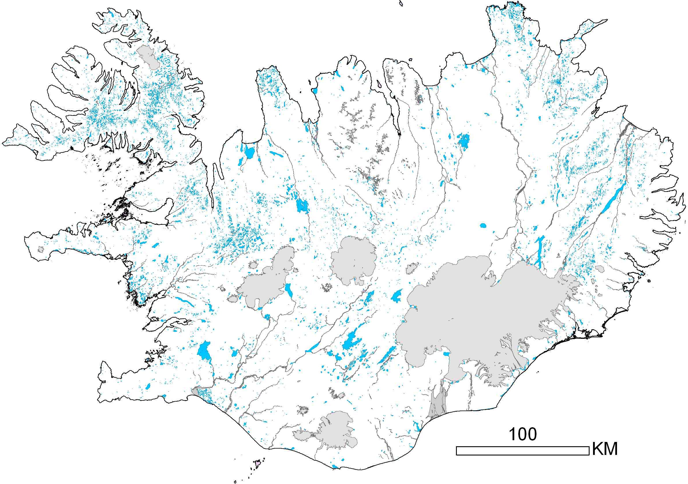

The landscape of Iceland (103.000 km2) is mountaneous with some 40% of the country above 600 m. Thus good elevation data is crucial for describing the landscape but the present DEM of Iceland is, however, in great need of revision. This is foremost due to two reasons, first the available model for the whole country is based on up to 50 year old data that was obtained through scanning and vectorization of 1:50.000 scale map sheets. Secondly, the land surface in Iceland has changed drastically in the last few decades, in particular the glaciers that make up 11% of the land area. The elevation accuracy needed is variable but generally greatest in urban areas as well as remote areas where hydroelectric power stations are being considered.
The National Land Survey of Iceland (Landmælingar Íslands) has produced a countrywide DEM layer for Iceland from our 1:50.000 data base. Recently, our approach and methodology toward this task has been evaluated but is, however, still partly under revision.

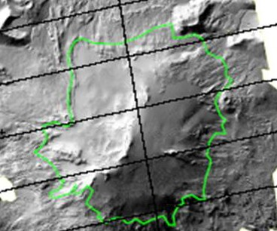
Airborne IPY-Lidar project 2008 (TopScan): Snæfellsjökull.

As part of quality control of elevation data a field effort was conducted in the summer of 2008. Thus vehicles were used to collect elelvation data as part of gps road measurements. This provided data with vertical accuracy < 0.5 m. The elevation data set so collected was then used for comparison with elelvation data in our IS50V-DEM raster layer (with 20x20 m pixels). Work in progress has shown areas of weakness and helped us focus on where the need is greatest for upgrading the national DEM layer. We also used the collected road data for comparing several other elevation data sets with different level of accuracy and methodology. As a framework for the upgrading work we now use a seamless network with network size 1-10 km rather than focusing, as we have in the past, on map sheet boundaries in scales of 1:50.000. Definition of acceptable vertical accuracy for an upgraded DEM layer is still under discussion. A short term goal for vertical accuracy will probably be about 10 m with a long term goal of better than 5 m. Clearly, however, this will differ widely for areas based on need and availability of data. Origin of data will both be from governmental sources as well as the private sector. Data quality control will play an important role in the assessement of acceptable elevation data and its pricing.
The National Land Survey of Iceland cooperates with universities and governmental research institutions in Iceland. Through this cooperation, as an example, a three year project, in connection to the International Polar Year, is in progress where the glaciers of Iceland are being scanned using airborne Lidar equipment. This Lidar data set will be used in the upgrading work of our DEM layer. Enclosed photo of Snæfellsjökull glacier gives an example of this year´s results.

A. n.

A.

A. n.
- ' -
n.
A.
- I , n.
I , n.

132
n.
n.

n. A. A.
A. n.
n. 44

A. n.
n. A.
n.
A. n.
A.
n.
Karls

A. A. A.
A.
n. n.
A.
A.
A. 53
n.
A.
A. n.
A.
n.

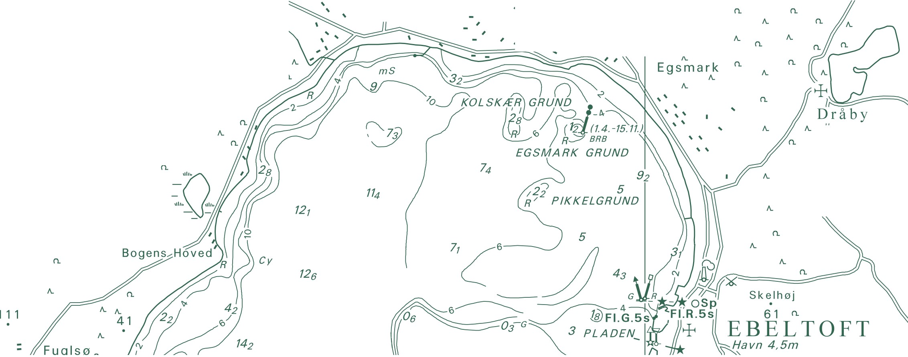A. Trehøje n.
(Dyrehøje) _{A.}
n.
127

National Survey and Cadastre Rentemestervej 8
2400 Copenhagen NV Denmark
http://www.kms.dk

