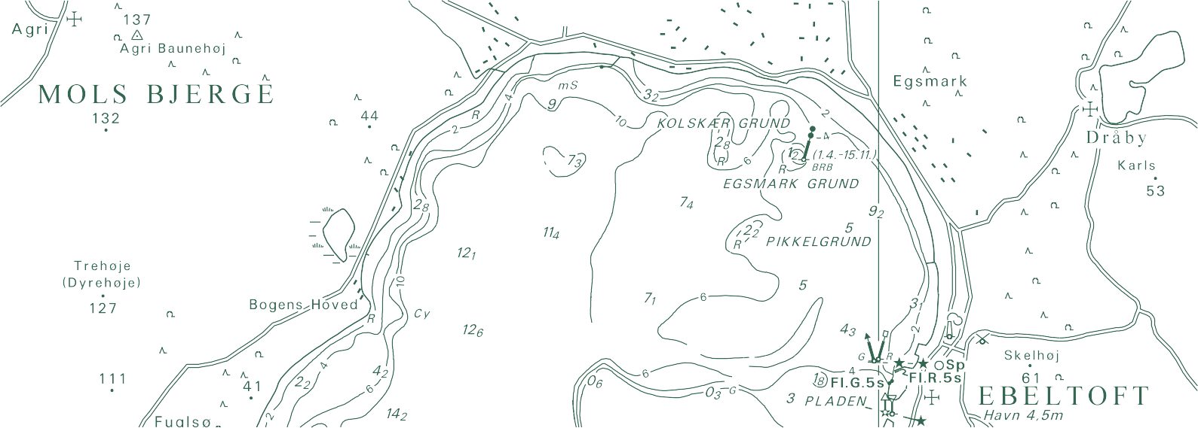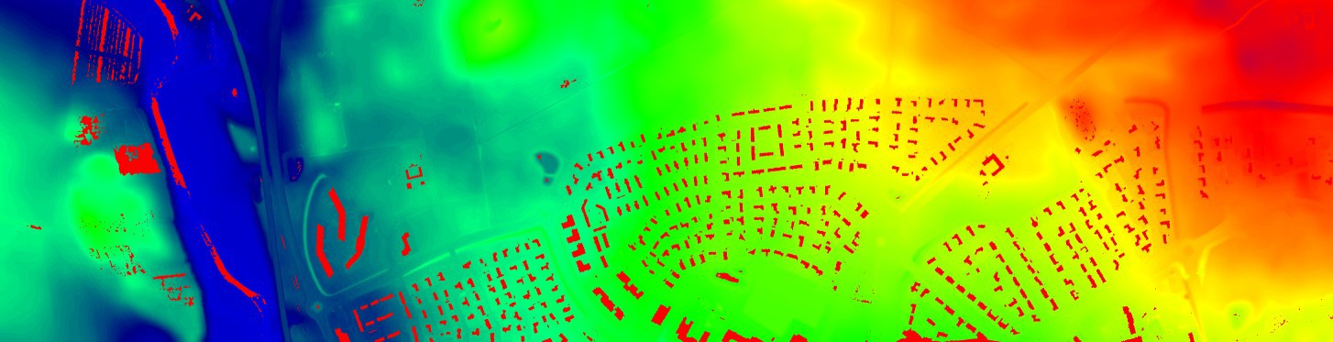

TECHNICAL REPORT NO. 18

Change Detection in Digital Terrain Models: A Tentative Experiment
Thomas Knudsen

Thomas Knudsen
Change Detection in Digital Terrain Models: A Tentative Experiment

Danish Geodata Agency, Technical Report Series Volume 18 ISBN 978-87-92107-64-0
Technical Report Published December 2013
This report is available from http://www.gst.dk

Contents

Introduction 4
The Næstved test case 5
Geographical location of the test site 5
Point Density and Coverage 6
Elevation model 7
The anomalistic terrain model, and its significant component 8
Two sites of heavy change 9
Soccer as a change agent 10
A convoluted case of tunnels and bridges 11
Conclusion 12
Final Remarks 12
Acknowledgements 12
Bibliography 13

Introduction

In a recent report, Data Assimilation for Updates af Digital Terrain Models (Knudsen, 2012), a num- ber of methods for updates of DTMs were presented, from a (mostly) theoretical point of view.
The present report is more practically oriented, presenting an example of change detection between old and new data.
Change detection is the first step in the update process and hence a very important subject, especially in cases where human intervention in parts of the update procedures is anticipated: A human operator has a much easier task ahead if at least (s)he knows where to concentrate the effort..
As in Knudsen (2012), the work is set in the context of the national Danish height model, DK-DEM. DK-DEM consists of three primary products (Dalå et al., 2009):

- A gridded digital terrain model (DTM)
- A gridded digital surface model (DSM)
- A set of terrain contour curves

The gridded models (DSM and DTM) have a grid ground sample distance (GSD) of 1.6 m (i.e. 0.4 point/m2) and were based on airborne LiDAR observations with a similar mean density.
≈
The LiDAR data sets used were collected by the companies BlomInfo and Scankort in the time frame 2005–2007. So while DK-DEM was a big improvement compared to what was available prior to its introduction in 2009, it was already at that time slightly dated.
For many purposes, DK-DEM is still perfectly adequate, but for other purposes (most obviously the ones exceeding the original scope of DK-DEM) it has shown necessary to collect new data. These data, typically collected by public institutions with special tasks in limited areas, could be put to good use in the process of updating DK-DEM.
With this report we take a few small steps towards this use, by showing how a new, very high resolu- tion data set originally collected for the Danish Road Directorate, can be used for change detection for updates of the existing terrain model.

The Næstved test case

Geographical location of the test site

This study is based on LiDAR data obtained by the Danish Road Directorate (Vejdirektoratet, VD), for construction planning purposes.
The planning site is situated north of Næstved in the southern part of Sjælland (Zealand), Den- mark. The map below gives the general location of the site. Its approximate center coordinates (UTM32/ETRS89) are 6 136 000 m (northing), 675 000 m (easting).
More detailed descriptions on the following pages.

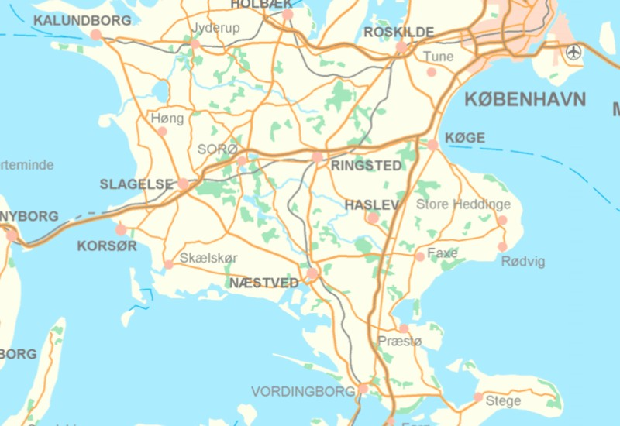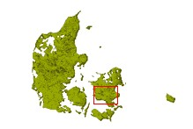

Point Density and Coverage

The plot below is centered on UTM32/ETRS89 675 000 E 6 136 000 N. It covers an area of 9000 m northing by 10500 m easting.
The bright colour pattern shows the ground sample density of the VD LiDAR data using a colour scale going from 10 points/m2 (blue) to 50 points/m2 (red), i.e. a very high resolution data set, compared to the original DK-DEM mean sample density of approximately 1/2 point/m2.
The rectangular bounding box for the full survey is 3500 m northing by 7880 m easting, i.e. a total of 27,6 km2. But since the coverage is corridor-like, and curved with respect to the northing and easting axes, the area actually covered by the LiDAR is only 12.2 km2.
In total almost 206 millions of LiDAR heights were recorded, for a mean point density of almost 17 height measurements / m2.

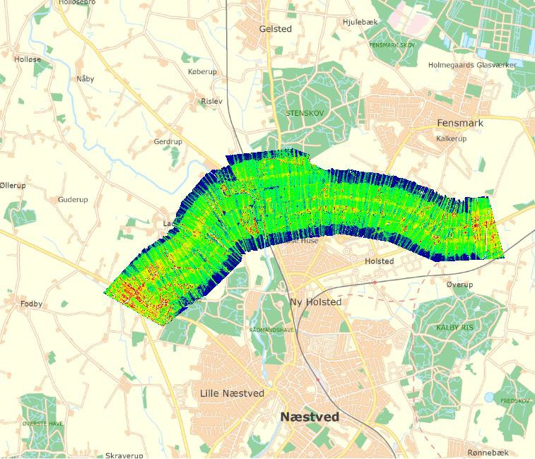

Elevation model

For quick-and-dirty assessment of the point cloud, this simplistic digital terrain model was computed using inverse distance weighting, as implemented in the PINGPONG gridding program (Knudsen, 2009).
Prior to gridding, all points not classified as ground, i.e. LAS format category 2 (ASPRS), were removed from the VD LiDAR data set.
The resulting height range (vertical datum DVR90) is [3 m. . . 70 m].

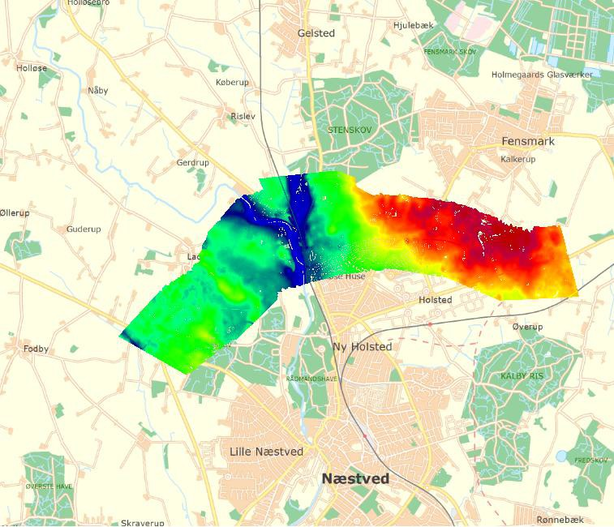

The anomalistic terrain model, and its significant component
For the actual change detection, we treat the DK-DEM as a known (or deterministic) signal (Knudsen, 2012).
If we remove the deterministic signal from the new dataset, we obtain the anomalistic signal. Typ- ically, the anomalistic signal has a much smaller amplitude than the full signal from the raw data: Modulo noise and systematic effects (e.g. point misclassifications), it only deviates from the existing model in areas where real change has taken place since the original data survey.
Hence, we need only consider areas where the absolute difference between the old and the new data is above the noise level, as outlined in the panels below.
Upper panel: Anomalistic terrain model. Prior to gridding, all terrain points are normalized with respect to the current terrain model, DK-DEM/Terrain. This is done by subtracting interpolated grid values from the new point cloud. As seen from the almost uniform colour, the amplitude of the anomalistic signal is small (range [-6.0 m. 7.5 m]) compared with the full signal on the previous
page.
Lower panel: The significant part of the anomalistic terrain model. Here defined as the points that deviate by more than 20 cm from the current model.
The red rectangle indicates an area with large changes, which we will look at in greater detail in the following pages.
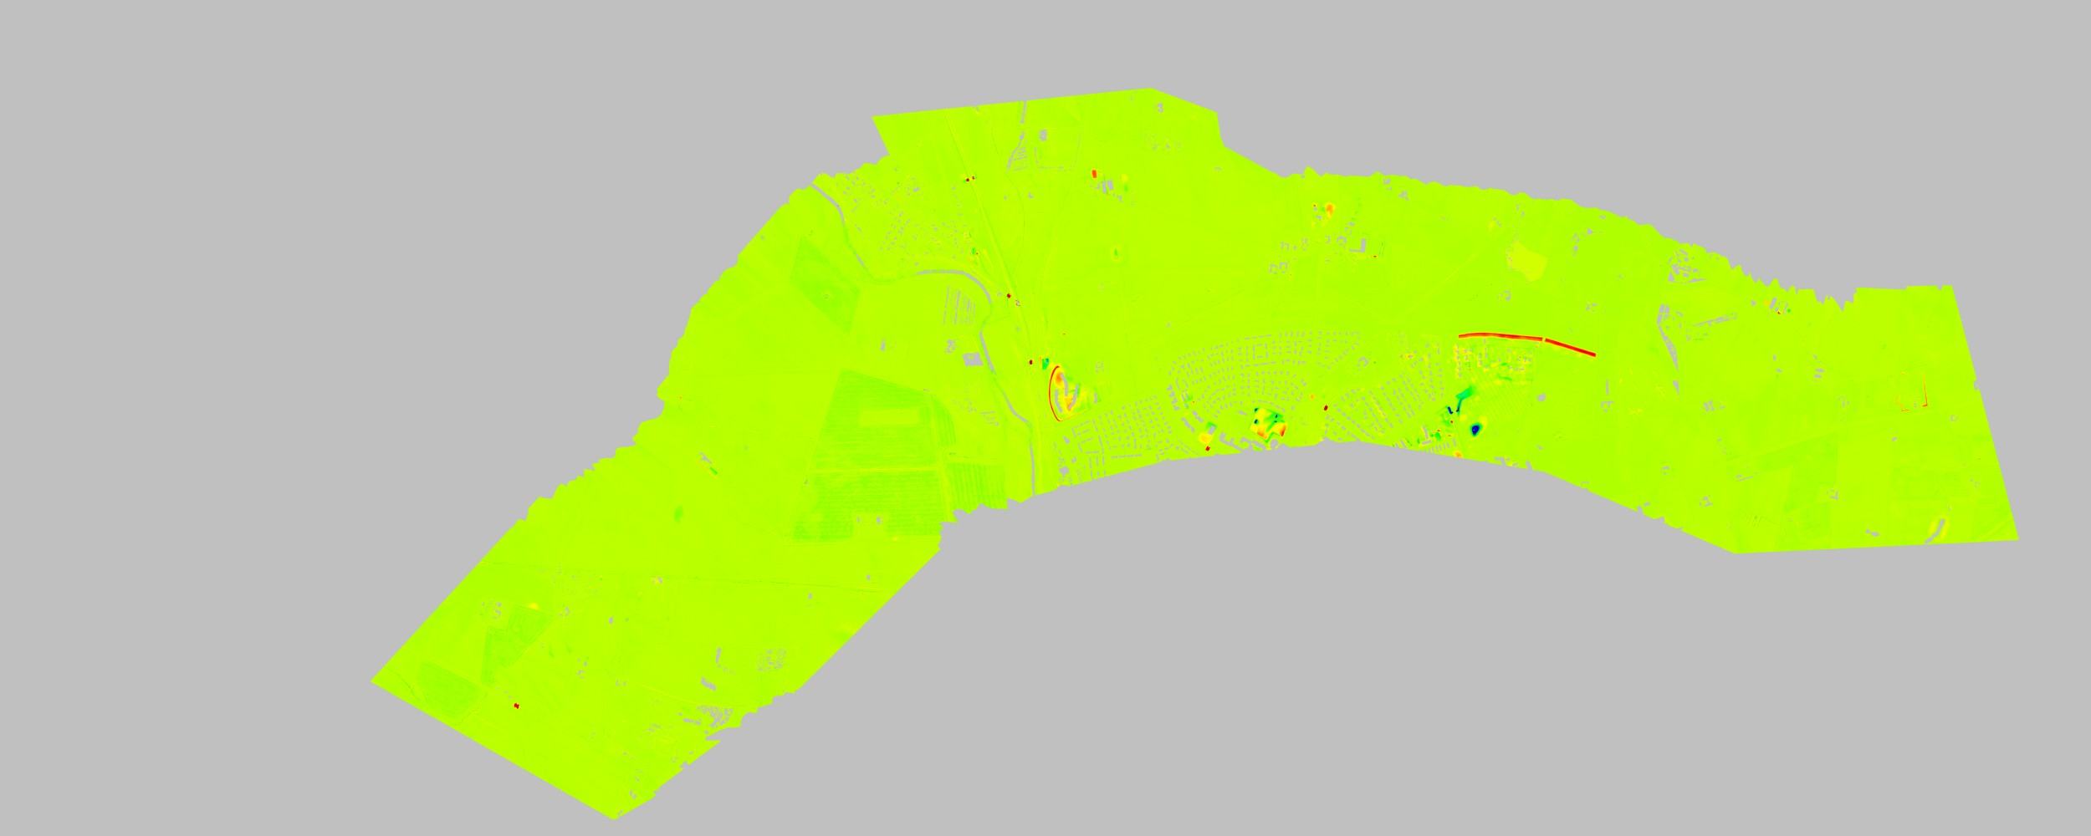

Two sites of heavy change

The orthophoto shown below covers an area of 530 m (easting) by 450 m (northing).
The most striking feature of the anomalistic overlay on top of the orthophoto, is the large number of point features, often conglomerated into long linear features.
Most of these features, however, appear to be the result of a comparatively small number of low vegetation reflections, misclassified as ground: The large point search radius used for the gridding, makes even a single data point stand out as a large cicular disk.
The two areas highlighted using a blue and a white box, on the other hand, represent real change.
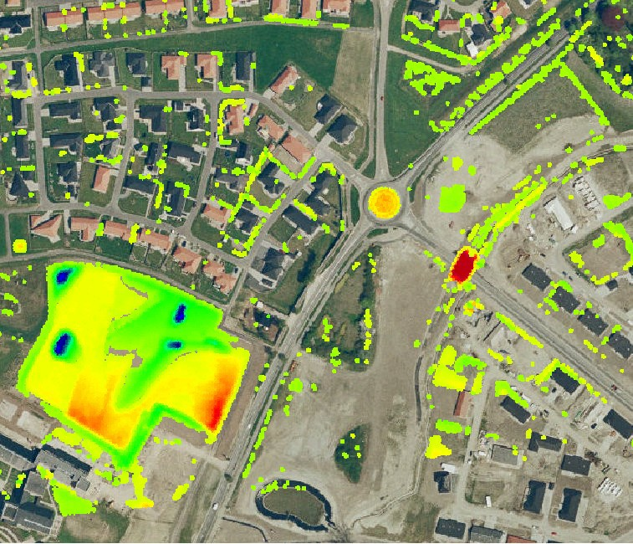

They are also easy to accept as real for an operator acting as part of a “human in the loop” algorithm for LAS processing, leaving the remaining noise for removal by automated processes.
We take a closer look at the two very different examples of change on the following pages.

Soccer as a change agent

If we take a look at the orthophoto from the previous page, but remove the anomalistic height overlay (left panel below), it is evident that the change has taken place somewhere that looks like a field.
The orthophoto in the left panel is from 2006, i.e. during the time the material for DK-DEM was shot. The orthophoto in the right panel is from 2010, i.e. just before the material for the VD LiDAR data set was shot.
It is quite evident, that in the time frame 2006–2010, the field has been transformed into a soccer ground (cf. the goals in the enlarged section). And since regular footballers are significantly more demanding than regular agricultural crops, a significant amount of soil had to be shifted around, for the footballers to thrive in this habitat.
Hence, in this case, the change detected really is due to change. The next case is way more convo- luted. . .

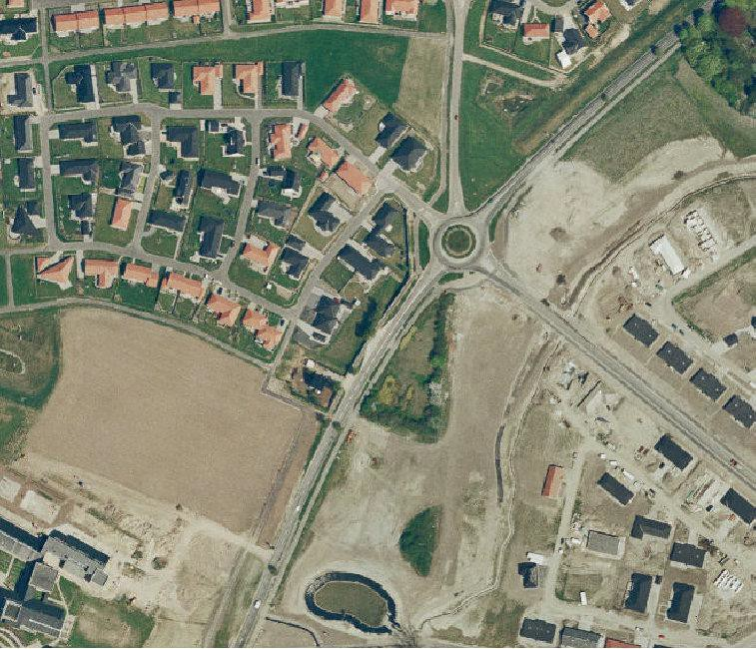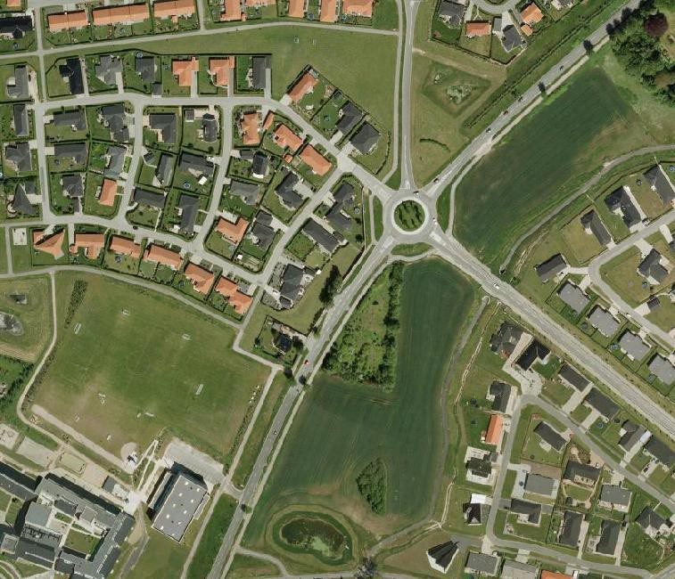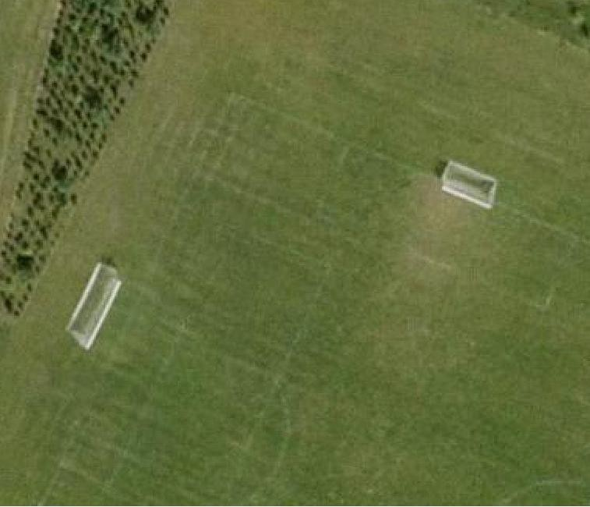
2006
2010

A convoluted case of tunnels and bridges
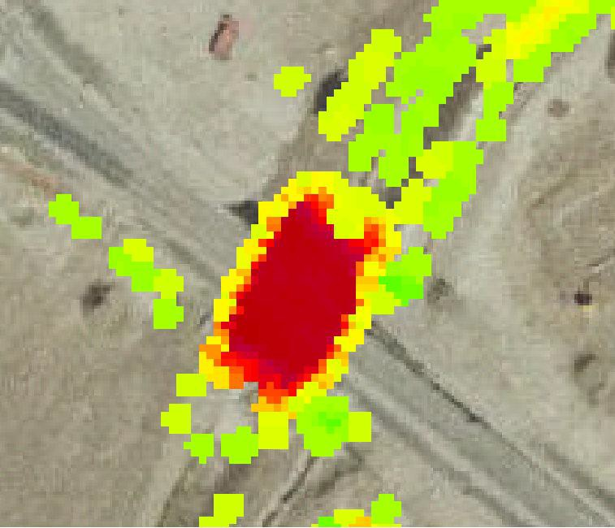According to the anomalistic terrain model (upper panel), we see here a vertically large, but horizon- tally limited change event.
2006
Removing the overlay, and looking directly at the 2006 orthophoto (center panel), it is quite evident that the change has happened directly on a road bridge.
Comparing that with the 2010 orthophoto (lower panel), it is equally evident that something really has happened.
It is, on the other hand, also evident that what the 2010 orthophoto shows cannot be true, but must be due to some error in the terrain model used in the orthoprocessing.
What has happened?
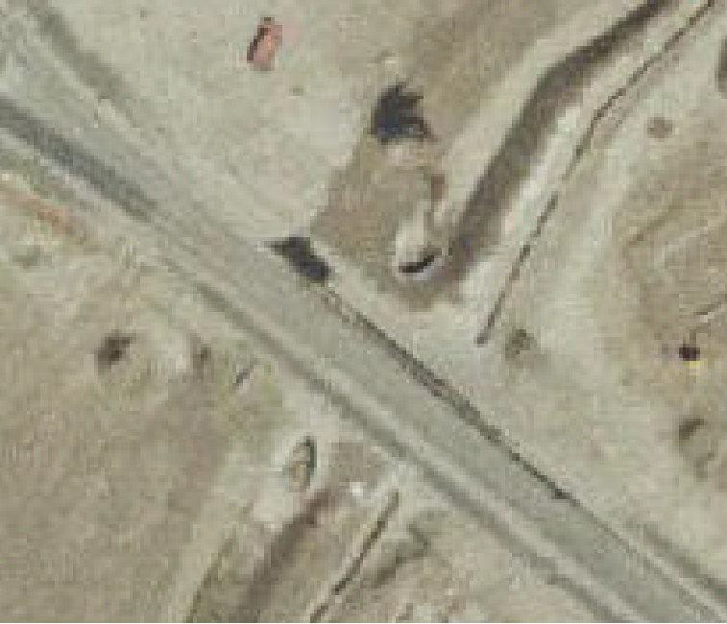Well, the 2006 orthophoto was based on an older terrain model, which appears to represent the road surface well.
2006
The 2010 orthophoto, on the other hand, was based on DK-DEM, which in 2010 was brand new, and well checked—so why this obvious er- ror?
The reason is that the original specification for DK-DEM said that bridges had to be cut out from the terrain model.
Otherwise (due to the 2.5D nature of a grid- ded DEM), the bridges would look like dams, and make DK-DEM less suitable for hydrologi- cal modelling.
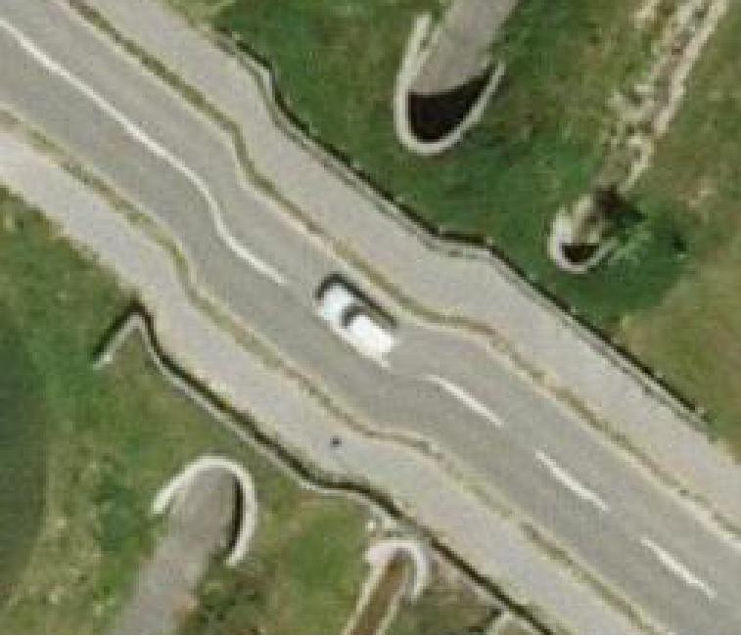Without bridges, however, the model was less suitable for production of orthophotos. So a spe- cial version, with bridges reinserted, was created by the same companies producing the original model.
2010
Apparently, the bridge reinsertion process is not in all cases equally succesful (which is probably not surprising, since it is a somewhat backward way of doing things).
Hence, we have here a case where a new data set is probably a better representation of the real world, than the original DK-DEM and its bridges- reinserted counterpart.
Nevertheless, the new data set does not comply with the specification for DK-DEM, and (unless the specification is changed) the model should not be changed here.

Conclusion

Final Remarks

The primary aim of this report was to present some simple examples introducing how change detection and anomalistic terrain models could play a role as tools for DTM updates as very high resolution LiDAR data sets become available.

The main hypothesis was that since human in the loop processing will probably make sense for many years to come, we might as well make it as pleasant and productive as possible to be the human in the loop.

The indication that the anomalistic model could also be used for automated improvement of ground reflection misclassifications (page 9), was unexpected and, hence, an additional encouragement to- wards continuing and expanding this tentative work.

Acknowledgements

I would like to thank a number of people for their role in making this work possible.

First and foremost thanks go to Svend Elgaard of the Danish Road Directorate. Svend provided the high density point cloud used, and has for many years been pushing for improvement of height data, height measurement technology, and height models.

Additional thanks go to my colleagues at the National Geodata Agency (GST). For being ready to discuss and collaborate on the subject almost any time, and for creating such a nice work environment.

Finally, a bunch of thank-yous to Allan Aasbjerg Nielsen, National Space Institute of the Technical University of Denmark, who continues this study with way more geostatistical insight (and outlook) than anyone else I know.

Bibliography
ASPRS. LAS specification, version 1.2, 2008. URL http://www.asprs.org/a/society/committees/ standards/asprs_las_format_v12.pdf. (document)
Nynne Sole Dalå, Rune Carbuhn Andersen, Thomas Knudsen, Simon Lyngby Kokkendorff, Brian Pilemann Olsen, Gitte Rosenkranz, and Marianne Wind. DK-DEM: one name—four prod- ucts. In Knudsen and Olsen (2009), page 4. URL ftp://ftp.kms.dk/download/Technical_Reports/ KMS_Technical_Report_4.pdf. (document)
Thomas Knudsen. PINGPONG: a program for height model gridding and quality control. In Knud- sen and Olsen (2009), pages 29–31. URL ftp://ftp.kms.dk/download/Technical_Reports/KMS_ Technical_Report_4.pdf. (document)
Thomas Knudsen. Data assimilation for updates af digital terrain models. Technical Report 14, Na- tional Survey and Cadastre (KMS), Copenhagen, Denmark, 2012. URL ftp://ftp.kms.dk/download/ Technical_Reports/KMS_Technical_Report_14.pdf. (document)
Thomas Knudsen and Brian Pilemann Olsen. Proceedings of the 2nd NKG workshop on national DEMs, Copenhagen, November, 11–13 2008. Technical Report 4, National Survey and Cadastre (KMS), Copenhagen, Denmark, 2009. URL ftp://ftp.kms.dk/download/Technical_Reports/KMS_ Technical_Report_4.pdf. (document)

:æ
n. n.
A. n.

A.
A. n.
- I ,

I ,
n.
n. n.

132
n.
n.

n. A. A.
A. n.
n. 44

Dråby

A. n. n.
n. A.
Karls

n. n.
53
A.
A.
A. n.
A.
A.
- n. n.
  - A.
A. n.
A. Trehøje n.
(Dyrehøje) _{A.}
n.
127

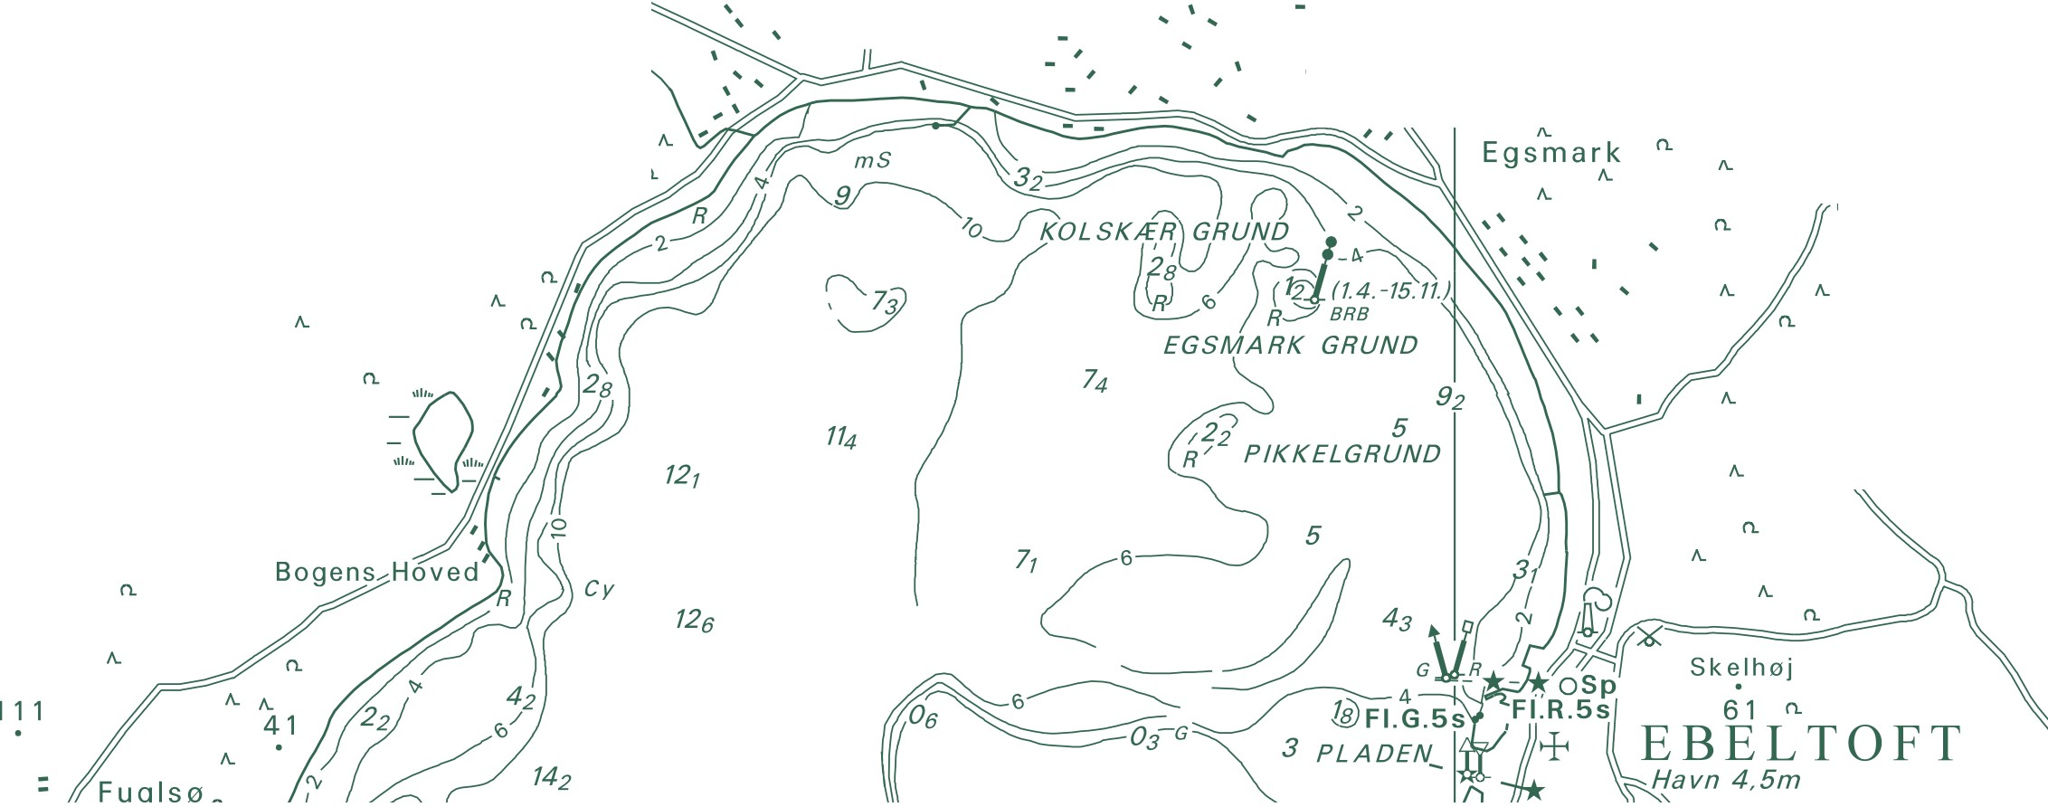Danish Geodata Agency Rentemestervej 8
2400 Copenhagen NV, Denmark http://www.gst.dk

