Analysis of geospatial data requirement to support the operation of autonomous cars

Project Report
SDFE - Danish Ministry of Energy, Utilities and Climate

December 2017

.

Notice
This document and its contents have been prepared and are intended solely for the SDFE - Danish Ministry of Energy, Utilities and Climate’s information and use in relation to the task Analysis of Geospatial data requirements to support the operation of autonomous cars.

Atkins Denmark assumes no responsibility to any other party in respect of or arising out of or in connection with this document and/or its contents.

This document has 83 pages including the cover.

Document history
Job number: 1012747-1
Revision | Purpose description | Originated | Checked | Reviewed | Authorised | Date
Rev 1.0 | Draft issued for comment | MC/IL/JBO |  |  |  | 11/12/17
Rev 2.0 | Final report revised | JBO |  | DW | JBO | 20/12/2017
Rev 2.1 | Final report | JBO |  | DW | JBO | 9/1/2018

Table of contents

- Introduction 5
Summary 6
Activity 1: International Evidence 7
- CAV terminology 8
  - Connected and autonomous vehicles (CAVs) 8
    - Terminology 8
    - Evolution and challenges 9
  - Geospatial data 11
- CAV functionality 13
  - Overview 13
  - Scanning and monitoring the environment 13
  - Connectivity 15
    - GNSS based connectivity 15
    - V2X based connectivity 15
  - Mapping and geospatial data 16
  - Decision making 18
- CAV projects review 20
  - Overview 20
  - Geospatial data as a tool 21
  - Geospatial data as the objective 23
  - Activities of mapping companies 27
- Activity 1 lessons learnt 29
Activity 2: Gap analysis 30
- Background to Activity 2 31
  - Geospatial Data 31
- Comparing data and use 36
  - Data for strategic path planning 36
  - Data for tactical path planning 39
  - Data for reactive path planning 42
  - Gaps and challenges 42
- Activity 2 lessons learnt 44
Activity 3: Perspectives 45
- Trends influencing the development of CAVs 46
  - Overview 46
  - Technological trends 47
    - Connectivity technologies 47
    - Automation technologies 48
    - Other technologies 51
  - Social trends 51
    - Decrease in car ownership 51
    - Public acceptance 52
    - Attitudes towards data privacy and sharing 52
    - Tendency to share journeys and vehicles 53
    - Ageing population 53
    - Urbanisation 53
    - Working practices 53
    - Shift towards clean transport modes 54
  - Economic trends 54
    - High technology cost 54
    - Business models 54
  - Political trends 55
    - Investment and funding availability 55
    - Standardisation 55
    - Regulation 55
- Opportunities for SDFE in the emerging value chain 57
  - Potential roles – in long term perspective 57
  - SDFE’s role in the emerging CAV ecosystem (short and mid-term) 59
    - High Quality road topology and topography 60
    - Dynamic traffic data and messaging service 60
    - High Quality positioning service 61
    - Repository for CAV data 61
  - Benefits of the geospatial infrastructure 61

Appendices
Appendix A. | Example C-ITS applications | 65
Appendix B. | Investment stakeholders | 67
Appendix C. | Geospatial data as a tool | 69
Appendix D. | Activities of mapping companies | 79
Appendix E. | Trends analysis | 81

Introduction
Atkins Denmark has been commissioned by SDFE, an Agency under the Danish Ministry of Energy, Utilities and Climate, to support its understanding of the use of geospatial data for the operation of autonomous cars and discuss its potential role in the industry.

This analysis is based on three activities:

- Activity 1: An overview of the use of geospatial data for the operation of autonomous cars, based on domain knowledge and a review of international case studies;

- Activity 2: Identification of SDFE datasets which could be potentially used for the operation of autonomous cars, based on insights from Activity 1; and,

- Activity 3: A review of the associated trends for technology and society and identification of the potential role for SDFE in the emerging CAV ecosystem.

The capability of autonomous vehicles has been progressing at a great rate and is expected to continue to do so. Trials and research to date has focused on technological performance and operations, with further work around safety, regulation and the human-machine interface.

The rapid development of automotive technologies has been accompanied by a change in the structure of the market and of traditional service providers. In particular, it is increasingly clear that the provision of data to autonomous vehicles will be key, including geospatial data.

As a government body, the Agency for Data Supply and Efficiency (SDFE) supplies the public sector, the public and business with data. It is therefore of interest to understand the potential future role of SDFE in the operation of autonomous vehicles. This study is concerned with the immediate future for CAVs, considering primarily the period to 2025.

This report is split into three sections, detailing the outputs from each Activity.

Summary
The capability of self-driving cars has increased substantially in recent years, and are expected to be an important part of the fleet within the next decade. These vehicles can be thought of in two different ways – connected vehicles and autonomous vehicles. Connected vehicles (CV) allow vehicles to communicate with each other and the world around them. This concept is often about supplying useful information that can inform decision making – it does not necessarily imply that the vehicle is “making” choices for the driver. These sorts of technology are already well embedded in the vehicle fleet, for example with GNSS-based navigation systems often including dynamic route guidance. Autonomous vehicles (AV) remove some or all tasks from human control. The level of automation in a vehicle may vary, ranging from minor “assistance” to the driver, to a fully automated vehicle that does not require a driver to function. Some of these technologies are market- ready and available to users, including self-parking, lane-keep assist, and emergency braking systems. These technologies are often described using the SAE International Standard, describing vehicles from Level 0 (No automation) to Level 5 (Full automation).

The Danish Geospatial Agency (SDFE) supplies citizens and business with reliable data, giving information about infrastructure and society. An important part of the role of SDFE is understanding the requirements placed on its data, and undertaking a programme of continuous improvement to ensure benefits from data provision are maximised. It is therefore essential for SDFE to understand the potential requirements for geospatial data to support the operation of autonomous vehicles.

Atkins have been commissioned to evaluate these requirements, and to understand the role of SDFE in the emerging CAV ecosystem. This report details the work undertaken by Atkins on behalf of SDFE.

The key conclusions of this study are:

- Geospatial data is important – CAVs will need to have an understanding of the environment around them. Whilst an element of this will be achieved through on-board sensors, geospatial data and base mapping will likely be essential. Geospatial data is already a crucial enabler for a variety of CAV trials, and this is likely to continue.

- The quality of geospatial data will impact the efficiency, effectiveness and benefits of CAVs – benefits to consumers, network operators and infrastructure providers will be enhanced through accurate, reliable and comprehensive geospatial and mapping data. This is a potentially important role for public sector organisations such as SDFE – ensuring the right data is available to maximise societal benefits, and implementing standards to ensure a minimum level of service.

- Private geospatial data companies are active – the market is reacting to the need for this data, ensuring the requirements for CAV operation are available. The automotive industry is committed to the introduction of autonomous vehicles. Where geospatial data is a key requirement of CAV operations, the private sector has also demonstrated a willingness to provide these data. This is best illustrated by the acquisition of mapping company HERE by a consortium of German car makers.

- Data held by SDFE and other agencies potentially has great value – but there are recognised issues with precision, coverage, access and conformity that may limit application. It is also recognised that there is no single repository for geospatial data for roads in Denmark, and no clear owner of standards and regulation.

- There is an important gap in the emerging CAV ecosystem – in order to facilitate the operation of connected and maximise the benefits for society. SDFE are well-placed to enable and establish a scalable and flexible geospatial data platform, capable of ingesting, aggregating and distributing data both from and for autonomous vehicles. SDFE are also ideally placed to drive development of standards and data and reference models that will be required to ensure consistency in data, again ensuring that the societal benefits of CAVs – for congestion, environment and safety – can be realised.

Activity 1: International Evidence
This activity (Activity 1) seeks to understand current and proposes uses of geospatial data in autonomous cars. This is split into the following sections:

- A clear summery of the terminology and definitions around autonomous vehicles (Section 2);

- An overview of the functional modules of autonomous vehicles, outlining the associated technologies and services (Section 3);

- A review of international case studies, including public and privately funding research projects into driverless vehicles, and the activities of mapping companies (Section 4);

- Lessons learnt from this study (Section 5).

CAV terminology
This section will discuss the definitions and terminology associated with autonomous vehicles and their relation to the wider ecosystem.

Connected and autonomous vehicles (CAVs)

Terminology
Autonomous vehicles (also known as autonomous cars and self-driving cars) is an umbrella term used to refer to a wide range of emerging technologies. These can broadly be divided into two categories – connected vehicles and autonomous vehicles.

This categorisation is based on two set of technologies which are not necessarily reliant, but are generally accepted to work in tandem, combining to allow for safer, quicker and more efficient movement. This is further explained below.

- Connected vehicle (CV) technologies allow vehicles to communicate with each other and the world around them. The connected vehicle concept is about supplying useful information to a driver or a vehicle to help the driver (or vehicle) to make safer or more informed decisions. Use of a “connected vehicle” doesn’t necessarily imply that the vehicle is making any choices for the driver; rather, it supplies information to the driver, including potentially dangerous situations to avoid. Vehicles today are already more connected than many realise, with navigation systems often including connected vehicle functionality, such as dynamic route guidance. For example, GPS-based route guidance systems may receive information on congestion in the road ahead through cellular signals (4G LTE or 3G) and suggest an alternative route.

- Autonomous vehicle (AV) technologies remove some or all tasks from human control. The level of automation of a vehicle may vary, ranging from minor “assistance” to the driver, to a fully automated vehicle that does not require a driver to function. Some of these technologies are becoming available to consumers, including self-parking, driver assistance, lane control and emergency braking systems.

With various levels of autonomous vehicle technology – from driver assist through to fully automated driverless vehicles – it is important to be clear about the terminology used. The SAE International Standard J3016 sets out the taxonomy used when discussing the levels of autonomy based on the respective roles of the driver and system as outlined in Figure 1. SAE’s levels of driving automation are descriptive and informative, rather than normative, and technical rather than legal1.

Figure 1: Levels of automation
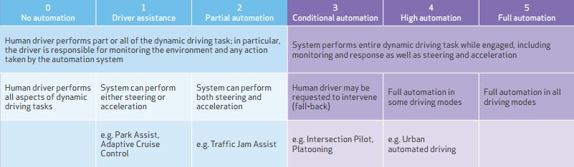

Source: Market forecast for connected and autonomous vehicles, Transport Systems Catapult (2017)

1 Surface Vehicle Recommended Practice, SAE, September 2016

Each level of automation is associated with a number use cases, with some examples detailed below2:

- Level 1 – use case: Park Assist. The system assists the driver by automatically carrying out the optimum steering movements in order to reverse-park on the ideal line. The measurement of the parking space, the allocation of the starting position and the steering movements are automatically undertaken by the Park Assist: all the driver has to do is to operate the accelerator and the brake. This means that the driver retains control of the car at all times.

- Level 2 – use case: Traffic Jam Assist. The function controls the vehicle longitudinal and lateral to follow the traffic flow in low speeds (<30km/h). The system can be seen as an extension of the Adaptive Cruise Control with Stop&Go functionality (i.e. no lane change support). It detects a preceding vehicle, maintains a safe distance by automatically applying the brakes and accelerating.

- Level 3 – use case: Platooning. Distance between two vehicles is automatically adjusted to ensure safety and efficiency. The driver deliberately activates the system, but does not have to monitor the system constantly. The driver can override or switch off the system. The system can request the driver to take over within a specific time if automation gets to its system limits.

- Level 4 – use cases based on full automation in some driving modes, such as Urban Automated Driving, Rural Automated Driving, or Highway Automated Driving.

- Level 5 – no driver is required at this level. It is full automation for the full end-to-end journey, such as an automated taxi.

Autonomous vehicles do not necessarily need connected vehicle technologies to function since they must be able to independently navigate the road network. However, CV technologies provide valuable information about the road ahead—allowing rerouting based on new information such as a lane closures or obstacles on the road. By incorporating CV technology, AVs have the opportunity to be safer and more efficient.

Furthermore, virtually all autonomous vehicles will require some form of connectivity to ensure software and data sets are current. As autonomous vehicles rely on knowing the roadway they are traveling on, changes to the roadside such as new developments or construction will require the type of frequent update of information that CV technology provides.

For the purposes of this study, the term CAV – connected and autonomous vehicle – will be used when referring to this evolving technology.

Evolution and challenges
Forecasting technological change is a difficult undertaking. Several studies have sought to do this for CAVs, both in terms of sales and proportion of the vehicle fleet. This requires a series of assumptions, including cost, technological availability, public acceptance, and the necessary regulations.

The study from Transport Systems Catapult considers three main scenarios for the global uptake of CAVs, which are summarised in Figure 2.These scenarios are based on projections made by previous studies, and are intended to represent the boundaries of reasonable probability for global CAV adoption.

2 http://www.ertrac.org/uploads/documentsearch/id38/ERTRAC_Automated-Driving-2015.pdf

Figure 2: Scenarios for the uptake of CAVs in the LDV and HDV vehicle market
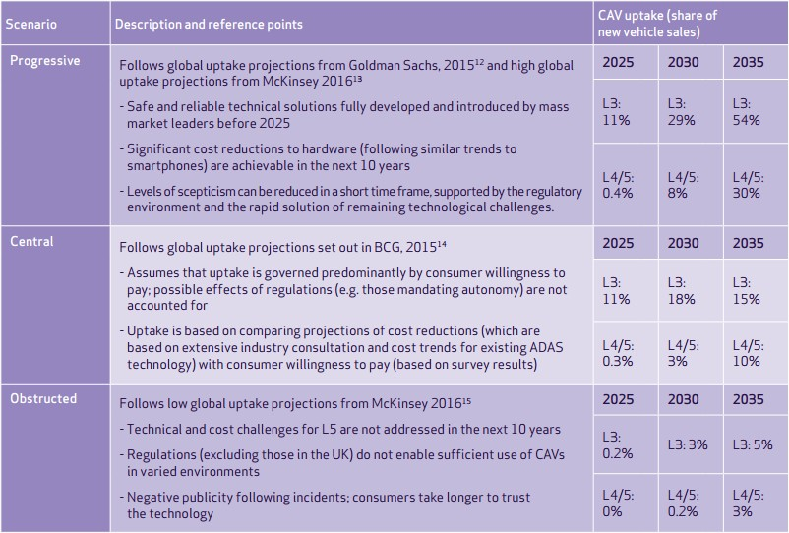

Source: Market forecast for Connected and Autonomous vehicles (Transport Systems Catapult, 2017)

There are clear and expected trends around the adoption of low level automation technologies (L2, L3), with a growing share of the new vehicle fleet. Significant uncertainties remain on the evolution of the CAV penetration. Those uncertainties can be explained by the following impacting factors3:

- Regulation – the pace of change is slower than technological advancement, potentially slowing down the introduction to market. Regulatory bodies may also impose restrictions on CAVs (such as mandating segregated corridors) and therefore impact the ‘supply’ of CAVs;

- Liability – there is currently no agreement on responsibility in case of incidents;

- High cost – as an emerging technology, CAVs may be prohibitively expensive in the short term, limiting uptake on a large scale;

- Consumer acceptance – there is a potential lack of trust from consumers, and an underlying “desire to drive” that may prevail;

- Security – with potential concerns that security systems are not sufficient to permit higher level functionality;

- Human machine interaction (HMI) – a specific concern around partially automated vehicles (L3), which may not enter the market due to the risk of drivers not monitoring the road, but expected to resume control at any time; and,

- Political and social factors – with concerns over job protection and labour risks due to automation.

3 http://library.rpa.org/pdf/RPA-New-Mobility-Autonomous-Vehicles-and-the-Region.pdf

A clear challenge here is the sheet number of actors involved. Whilst CAVs are first associated with vehicle manufacturers and OEMs, they are of course part of a wider ecosystem. This will impact their evolution, both in terms of technology and their deployment on the road. This can be mapped as a “CAV ecosystem” – an example of which is illustrated in Figure 3. These stakeholders will all play an important role.

Figure 3: The evolving CAV ecosystem
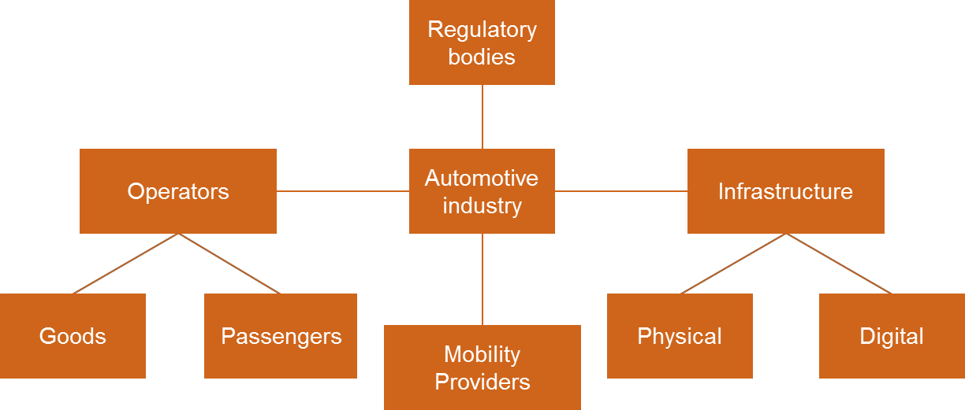

The figure illustrates relations between the stakeholders:

  - Automotive industry, providing the transportation units – CAV’s
  - Regulatory bodies (Public authorities) providing legal, safety and regulatory framework for use of CAV’s
  - Operators as citizens, transportation industry etc.
  - Infrastructure providers necessary for operating the CAV’s both in terms of roads, digital maps and positioning systems
  - Mobility Providers a new upcoming service business and industry for provision of transport

The CAV industry is a sector which is still evolving rapidly, with new companies entering the market through investment, acquisition, or partnership. It is not possible to definitively state the structure or content of this ecosystem – but it is recognised that it is a departure from the traditional automotive sector. Alongside the uptake of low-level automation technologies, the years to 2025 are likely to see an acceleration in the deployment, trial and testing of high-level automation technologies. This study is therefore concerned with all classifications of CAV, and all elements of this ecosystem.

Geospatial data
For completeness, clarification of the definition of geospatial data is required. This includes all data with a geographic component to it. This means that the records in a dataset have locational information tied to them such coordinates, address, city, or postal area code. Four location types can be distinguished4:

- Point location (e.g. the position of roadside infrastructure);
- Segment location (e.g. the position and extent of a traffic jam);
- Area location (e.g. a weather situation); and,
- Volume (e.g. position and shape of an obstacle).
Location is an important aspect of autonomous vehicle technology. The role of geo-data and the need for geo- data infrastructure is crucial to the functioning of an autonomous vehicle, with potential sources including5:

- In-car sensor data;

4 ETSI TR 102 863 – Intelligent Transport Systems (ITS); Vehicular communications; Basic set of applications, Local Dynamic Map (LDM); Rational for and guidance on standardization
5 “Geospatial Infrastructure and Standards for Autonomous Vehicles”, Geonovum, 2016

- Base map data for navigation (also referred as static mapping);
- Additional map data with traffic signs, works or other layers;
- Connected vehicle-to-vehicle or vehicle-to-infrastructure data;
- Social network (e.g. Twitter) or commercial traffic data (e.g. INRIX); and,
- Open source data (e.g. Waze).

The following sections will discuss the role of geospatial data for CAV operations, followed by a series of case studies of practical uses.

CAV functionality
This section discusses the functional components of connected and autonomous vehicles. As with general terminology, definitions and standards, these are evolving and are therefore not definitive. However, this is useful for conceptualising connected and autonomous vehicle systems.

Overview
Functionalities of CAVs can be conceptualised with four modules, illustrated in Figure 4:

- Monitoring and scanning the environment;
- Mapping and geospatial data;
- Decision making; and,
- Connectivity module.

The first three modules are associated with the autonomous aspect of CAVs. The following sections detail the function of each module and the associated technologies and applications.

Figure 4: CAV functional modules
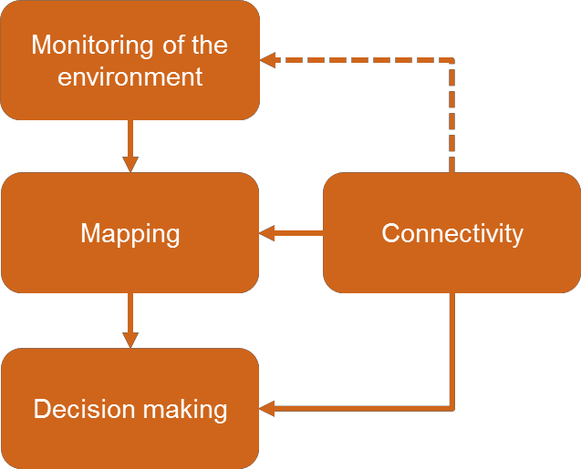

  - Scanning and monitoring the environment
The environmental scanning module of CAVs represents their ability to obtain a detailed view of its surroundings, including static objects (e.g. road layout) and dynamic objects (e.g. vehicles, pedestrians etc.). Information gathered includes position, behaviour and nature of those objects. This information is obtained from a range of technologies, listed below (non-exhaustive list)6:

- Radar sensors to monitor the position of vehicles nearby;

- Cameras (videos/optical) to detect traffic lights, read road signs and track other vehicles, pedestrians and obstacles;

6 There are a range of sources for AV technologies, including http://www.telegraph.co.uk/cars/features/how- do-driverless-cars-work/

- Lidar sensors to detect the edges of roads and identify lane markings; and,

- Ultrasonic sensors in the wheels to detect the position of curbs and other vehicles when parking.

Each technology has different strengths and weaknesses and may be evaluated based on cost, size, range, resolution, proximity detection, the ability to detect speed, the ability to provide colour/contrast, and the ability to work under different conditions (dark/bright/snow/fog/rain). To increase efficacy, quality, reliability and resilience, autonomous vehicles are expected to use multiple sensing technologies.

Applications and services for each technology are presented in Figure 5:

Figure 5: Example technologies for environmental monitoring and scanning

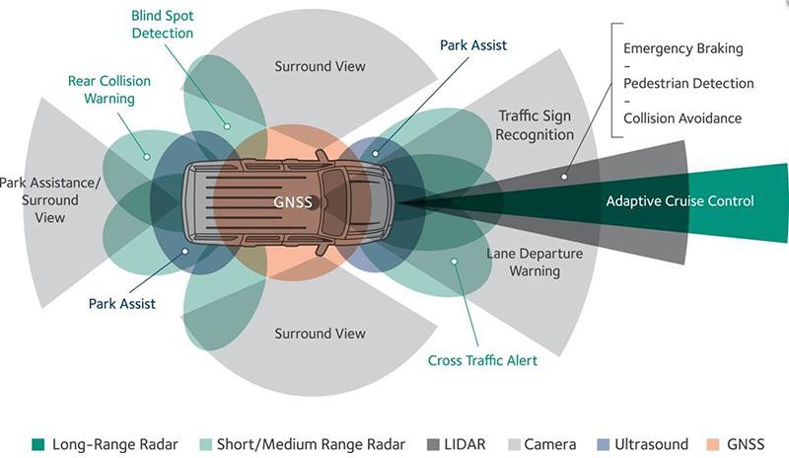

Source: https://www.novatel.com/industries/autonomous-vehicles/technology/

Information about the surrounding of the vehicle is then fed into the mapping module, explained in the following section. A key element between the environment scanning module and the mapping module is the geospatial position of the vehicle, acquired by7:

- Various on-board sensors (i.e. as discussed earlier in this section) – if the exact location of the surrounding objects is known, those technologies can potentially provide the absolute vehicle location based on the relative position of the vehicle to those objects. When the exact location of the surrounding is not known, sensors information can be used to augment GNSS; and,

- GNSS positioning systems, providing the absolute location of the vehicle. This is further detailed in Section
  - These technologies are potentially augmented by a variety of techniques, such as dead reckoning (DR) or differential positions.

Highly automated technologies (L3, L4, L5) are likely to require highly accurate positioning (at decimetre level or less), available at all times, in all locations, and under any condition. Although a distinction may be made between sensor-based and connection-based solutions for a variety of vehicle services, a ‘converged solution’ is likely to be utilised, combining the best of both approaches8. This is expected to be achieved by using sensor

7 https://www.novatel.com/industries/autonomous-vehicles/technology/
8 https://www.gsa.europa.eu/newsroom/news/satellite-navigation-core-future-connected-car-systems

fusion of individual positioning technologies mentioned above. This will improve reliability of the system, reduce the need for most expensive sensors, and save money on infrastructure.

Connectivity

GNSS based connectivity
Typical GNSS systems are only capable of positioning to the road level with 2 – 5 metre accuracy9. Enabling the next levels of autonomy (L3, L4, L5) requires lane-level positioning, which in turn requires a GNSS system with centimetre-level accuracy (~10 cm). To provide this increased level of performance, it is necessary to correct for several sources of error that typically limit the accuracy achievable with GNSS. Correction methods use a dense network dense network of reference stations (Differential GNSS, Real Time Kinematics (RTK), or Wide Area RTK (WARTK)) or just a few stations (Precise Point Positioning - PPP)10.

Two correction methods, RTK and PPP, offer cm-accurate positioning suitable for CAVs but some other limitations need to be addressed, including cost11 and reliance on infrastructure12 for RTK, and high convergence times for PPP (i.e. the time taken to converge to a corrected solution13). GNSS has also its own inherent intermittency problems, such as signal blockages and multipath interference, as well as standard equipment failure models.

GNSS requirements vary with the type of applications, as explained in Figure 6.

Figure 6: Key GNSS requirements
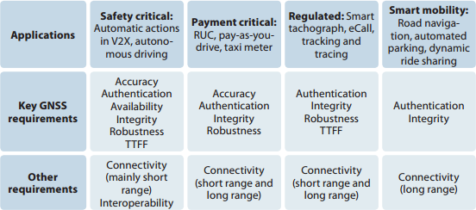

Source: https://www.gsa.europa.eu/2017-gnss-market-report

Competition in the location technologies segment ranges from crowd-funded start-ups to technology giants Google and Alibaba14.

V2X based connectivity
As explained in Section 2.1, connectivity allows vehicles to communicate with each other and the world around them. This is based on three broad categories of technology:

9 https://www.gsa.europa.eu/2017-gnss-market-report
10 http://navipedia.net/index.php/GNSS_Augmentation
11 http://articles.sae.org/15067/
12 https://www.trimble.com/positioning-services/pdf/WhitePaper_RTX.pdf
13 http://articles.sae.org/15067/
14 http://articles.sae.org/15067/

- Vehicle to vehicle (V2V) technology – allowing vehicles to communicate with one another (for example, about traffic conditions);

- Vehicle to infrastructure (V2I) technology – allowing vehicles to communicate with the highway infrastructure, (for example, vehicle to traffic signal communications to provide guidance on signal phasing); and,

- Vehicle to everything (V2X) technology, including V2V and V2I but also communication with all appropriate technologies, including the cloud or connected devices hold on pedestrians/cyclists.

Examples of applications are presented in Appendix A, categorised according to the end-objective, whether connectivity based safety, traffic efficiency, environment, comfort, maintenance or planning.

Mapping and geospatial data
In order to make safe driving decisions, autonomous vehicles need reliable geospatial information to assist them in any situation, such as knowing road layouts, what obstructions may lie ahead, and updates about local traffic laws15. The function of the mapping module is to provide a geospatial data to support autonomous driving by storing information on the environment, allowing vehicles to understand the world that surrounds them. There are two key requirements for the map – to be precise, and to be up-to-date. Modern maps generally refer to a three-dimensional model of space, with high precision, and an additional requirement to be ‘live’, updating itself at high frequency (even at the 1Hz level)16.

Maps can be stored locally (on the vehicle), be cloud-based, or generated from external data (such as other vehicles). The data may be considered to be static or dynamic.

Static maps are generally stored locally, with non-frequent updates (e.g. quarterly), and providing information about objects that are themselves largely “static”. This includes road topography, road attributes (such as speed limits and functional road class) and points of interests. The information is high level rather than ‘local’ information, (such as exact lane geometry) and are often provided by a dedicated supplier such as TomTom. This static map is ‘updated’ with live information from the ‘dynamic map’. including information on dynamic features such as:

- Objects in close vicinity of the vehicle;

- Objects with dynamic behaviour over time or space (such as roadworks or an incident); and,

- Absolute and relative position of the vehicle itself.

These two elements are usually presented combined and through layers. Figure 7 illustrates an example of map representation. The first two bottom layers, ‘map from provider’ and ‘landmark for referencing’, are components of the static map whilst the first top layers, ‘temporary regional information’ and ‘communication nodes, fusion results’ are components of the dynamic map.

15 HERE Technologies Self-Healing Map Tech Brief, available for downloaded here
16 http://www.audi.com/en/innovation/piloteddriving/Audi_piloted_driving.html

Figure 7: Example of map representation

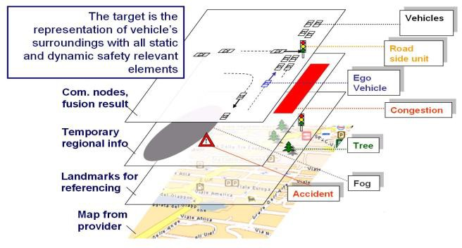

Source: http://inlane.eu/wp-content/uploads/sites/6/2017/10/2-J.-Ibanez-Guzman-Localisation-Systems-for-Autonomous- Vehicles.pdf

Data sources for each type of maps are illustrated in Table 1.

Table 1: Potential sources of map data

Static Map | Dynamic Map
- Satellite imagery  - Aerial imagery from drones/planes (camera based)  - Aerial LiDAR data  - Mobile (driven) LiDAR data  - Field survey | - Vehicle on board-sensors including RADAR, LIDAR, ultra-sonic  - V2X messages based on DSRC/ITS-G517 transmitter  - Over-the-air updates via the internet  - GNSS  - Internal measurement units (accelerometers/gyroscopes/magnetometers)

Quickly and efficiently generating robust geospatial information is technically challenging. There is an increasing need for precision data (centimetre level precision), and hence map products are often called high definition (HD) maps for this reason18. The mapping company HERE refers to a level of accuracy of 10 to 20cm for their products and the company Sanborn accuracy in the 7-10cm. Moreover, localisation, which is the process of using a map to pinpoint the position of a car in 3D space, needs to be accurate, fast and robust.

Maps also need to reflect changes on the roads. This raises a significant requirement for the software infrastructure that should not only handle massive amount of HD map data, but also be efficient in handling

17 DSRC stands for dedicated short-range communications which are one-way or two-way short-range to medium-range wireless communication channels specifically designed for automotive use. ITS-G5 is a corresponding European standard introduced by ETSI
18 https://medium.com/deepmap-blog/your-data-your-map-1f0280eda0c3

the communications between cars and the cloud while maintaining a low cost. Finally, maps need to work seamlessly with the rest of self-driving system.

Given these requirements, it is highly unlikely that an autonomous vehicle would require solely on static or dynamic maps. Instead, a converged solution is expected, with high-definition map data augmented by monitoring and scanning the environment. This is an established solution, with augmented GNSS and map- matching algorithms well used in the current vehicle fleet.

Decision making
Autonomous vehicles must be able to understand the world that surrounds them, and this environmental context can be provided in the form of a machine-readable high-definition (HD) map19. This is based on the environmental scanning module and mapping module (see section 3.2 and 3.4). Vehicles also need precise localisation to accurately position themselves within the reference map, combining the functionality of connectivity, environmental monitoring and scanning, and geospatial data.

Then, the vehicle needs to process this information and coordinate the mechanical functions of the car. To drive autonomously, vehicles need software which emulates the routines of natural human cognition (processes used to judge, plan, acquire knowledge, or otherwise — “think”)20. This can be summarised as the decision-making module, which considers information available to make decisions on the path vehicles need to follow. Type of decisions vary with their geospatial fingerprint, and the speed with which they need to be taken. Path planning can be categorised into three decision levels21 (figure 8):

- Strategic path planning, focusing on the link level and timing of more than 60s e.g. route planning to arrive at destination;

- Tactical path planning, focusing on the lane level with and timing of between 3-60s. e.g. lane positioning along that route; and,

- Reactive path planning, focusing on the lane/geometry level and timing of less than 3s. e.g. braking to avoid hitting an obstacle.

Figure 8: Decision making level
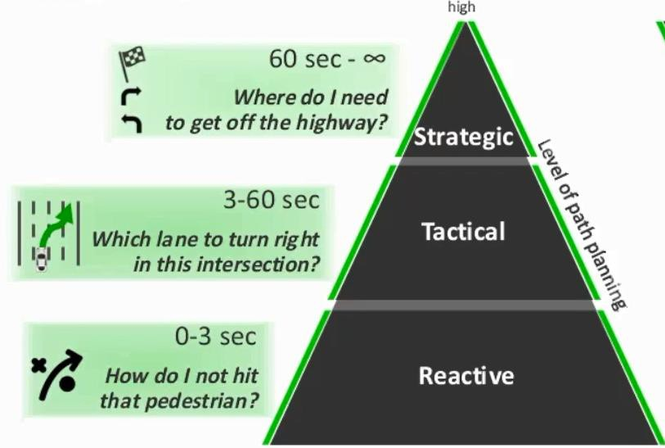

Source: https://automotivemegatrends.com/highly-accurate-navigation-in-the-age-of-automated-driving/

19 https://civilmaps.com/cognition-for-autonomous-cars-using-6d-localization/
20 https://medium.com/@CivilMaps/cognition-for-cars-using-6d-localization-b4a76527a110
21 https://automotivemegatrends.com/highly-accurate-navigation-in-the-age-of-automated-driving/

Examples of geospatial data required at each step of path planning are given in Table 2.

Table 2: Geospatial data required for path planning

Strategic path planning | Tactical path planning | Reactive path planning
Road class  Traffic flow & congestion Traffic restrictions Weather, e.g. fog Incident  Other hazard warning Road construction data EV services  Parking  Point of interest | Road lanes Traffic signals Signage  Paint markings Curvature Slopes  Speed limits Intersection Road edges Road shoulders Road dividers | Obstacles in close vicinity, including pedestrian, objects on the road etc.

Based on an initial review of available public datasets, available datasets fall both into the category - strategic path planning, with the following datasets being relevant22 - address point data, address, roadworks, carpool points, bridge and tunnel access, traffic status, road geometry, rest areas, height restrictions on bridges, and into the category for tactical planning purposes (where datasets are available from both central and local authorities based on the administrative structure) Both is discussed further in Activity 2.

22 Datasets as provided to Atkins in October 2017 for the purposes of this project

CAV projects review

Overview
This section provides a series of case studies to outline how geospatial data is being used for CAV operations. Main players investing in the CAV ecosystem were first identified and associated projects were then selected according to their relevance to geospatial data. Key stakeholders investing in CAVs are governmental bodies, OEMs, and other technology companies such as Google. More information is provided in Appendix B of this report.

In total, 103 projects were reviewed, including 66 European projects, 11 Asia-Pacific, 20 US and 6 OEM based projects. Case studies were then selected and are detailed in this section to show the variety of services geospatial data are used for, as well as the variety of stakeholders involved (location, type of companies etc.). The case studies are categorised according to the increasing use of geospatial data, as follows:

- Geospatial data as a tool - geospatial data are used as an underlying tool required for meeting the objectives of the projects (58 case studies); and,

- Geospatial data as the objective - developing mapping capabilities based on geospatial data for CAVs is the objective or part of the objectives of the case studies (seven case studies).

A further 17 projects have only very high-level information being available, and therefore were not classified. Due to limited scope, a number of project (21) do not feature geospatial data. These projects focus only on one or few elements of CAVs, such as hardware, algorithms for artificial intelligence or predictive maintenance of tyres. Ultimately, these elements would be integrated with all the other necessary elements of CAVs, including geospatial data.

Particular attention was given to the objectives of the projects as it highlights where the market main appetite lies. As an example, Table 3 summarises the objectives of projects in the UK. As strategic objectives are similar across geographical areas, it is believed this study provides a relatively representative picture. Connectivity aspects were considered 57% of the time, whilst autonomy aspects were considered 29% of the time. Other topics such as human factors or cyber security were categorised as ‘Other’, accounting for 14% of the projects.

Table 3: Objectives of reviewed CAV UK projects (50 projects)

Connectivity related (57%) | Autonomy related (29%) | Other (14%)
Efficiency (28*)  Connectivity based safety (21) Environment (16)  Transport planning (12)  Comfort (10)  Maintenance (6) | Autonomy based safety (15) Lane assistance (14)  Traffic jam assistance (13) Parking assistance (12) | Human factors (5)  Social acceptance (5)  Cyber security (5)  Simulation (4)  Insurance (2)
* Number of cases where the objective/topic is mentioned (one project can deal with more than one topic).

The greatest focus is on connectivity. There are a number of potential reasons for this focus, such as suggested by the US Intelligence Transportation Systems Joint Programme Office23.

- Compared to other alternatives, such as radar, cameras, and other sensors, connected vehicle technology is less expensive. $341 to $350 is about how much connected vehicle technology will add to the cost of a

23 https://www.its.dot.gov/cv_basics/cv_basics_facts.htm#fact4a

new car in 202024. That cost is projected to fall to $209 to $235 by 2058, as mass production of vehicles with connected vehicle technology increases.

- It also has significant advantages over the other in-vehicle technologies. Connected vehicle technology has a greater range, allowing vehicle to receive an alert about a dangerous situation much sooner, giving you more time to react and prevent an accident. It also can "see" around corners and "through" objects, alerting vehicles to potentially hazardous situations out of their view that they aren't aware of.

- Connected technologies are expected to bring significant benefits, in terms of traffic efficiency and safety, and environmental, without changing the fundamental driving experience.

Geospatial data as a tool
Most of the case studies in the literature review fit into this category as outlined in the overview. Geospatial data are used as an underlying tool required for meeting the objectives of the projects. Geospatial data from multi sources are stored on the map as described in Section 3.1 and are used for the decision-making process.

Two CAV projects with various objectives are presented in this section to show the broad landscape of the CAV industry. A further ten are presented in Appendix C. The majority of case studies are delivered by a consortium of different companies and public sector organisations, demonstrating the breadth of technologies and disciplines involved.

Table 4: Geospatial data as a tool (Case Study 1)

Title/Country |  | Europe
Objectives | Trial of CV technologies in passenger cars (Ford, Jaguar Land Rover and Tata Motors European Technical Centre), both on track and on roads in Coventry and Milton Keynes  Trial of an on demand, point-to-point public transport system of 40 driverless pods in Milton Keynes.  Topics investigated: interoperability/scalability of different approaches and technologies, public attitudes, commercial viability, environmental benefits
Stakeholder | Consultancy, Local authority, OEMs, University and research organisation, Insurance, automotive engineering  ARUP, Milton Keynes Council, Coventry City Council, Jaguar Land Rover, Tata, RDM, Ford Motor Company, MIRA Thales, Transport Systems Catapult, Oxbotica, AXA Insurance Limited, Wragge- Lawrence-Graham, University of Oxford, University of Cambridge, Open University
Timeframe | 2016-2018

24 https://www.its.dot.gov/cv_basics/cv_basics_facts.htm#fact4a

Title/Country |  | Europe
Services | Connectivity services being investigated:  Emergency Vehicle Warning (EVW) – Sends a signal directly from the emergency vehicle (e.g. ambulance, fire engine, police vehicle) to nearby connected cars. Driver is informed that the emergency vehicle is approaching and advised to make way for it.  Intersection Collision Warning (ICW) – Warns the driver when it is unsafe to enter an intersection, due to a high probability of collision with other vehicles.  In-Vehicle Signage (IVS) – Sends information about road conditions, congestion or other incidents directly to the in-car display, rather than having to rely on expensive gantry systems.  Electronic Emergency Brake Light (EEBL) – Alerts the driver when a vehicle in front suddenly brakes, providing advanced warning, especially when the driver is unable to see the lights of the braking vehicle due to weather conditions, road layout or other vehicles in between.  Green Light Optimal Speed Advisory (GLOSA) – Sends traffic light information to the connected car which is able to calculate the optimal speed for approaching the lights, potentially minimising the number of red light stops, improving traffic flow and reducing emission levels from idling vehicles.  Intersection Priority Management (IPM) – Assigns priority when two or more connected vehicles come to an intersection without priority signs or traffic lights. Collaborative Parking – Provides real-time information about free parking spaces either in the vicinity or close to the driver’s final destination
Technologies | Stereo cameras, LiDAR and radar-based obstacle detectors, computers required for steering + GPS
Autonomy level | N/A - Connectivity services
End user | Driver, Emergency services, Traffic operators
Geospatial data use | Underpinning all mentioned services, e.g. information about location of intersections, road conditions, and available parking space.
Reference | http://www.ukautodrive.com/

Table 5: Geospatial data as a tool (Case Study 2)

Title/Country |  | Europe
Objectives | Identification of means of applying the platooning concept in practice in daily transport operations.
Stakeholder | OEM, Universities, Research institutes, Haulage company  Scania, Volkswagen Group Research, Stockholm’s Royal Institute of Technology KTH, Oldenburger Institut für Informatik (OFFIS) in Germany, IDIADA Automotive Technology in Spain, Science & Technology in the Netherlands and the Spanish haulage company Transportes Cerezuela
Timeframe | 2013 – 2016
Services | Development of a coordination system to create platoons, taking into account information about the state of the infrastructure (traffic, weather, etc.)  Data proposal for V2V communications: e.g. Vehicle ID of the current vehicle, Platoon ID of the current vehicle, Vehicle position in platoon according to assignment plan, distance to vehicle ahead, speed of vehicle ahead, speed of the current vehicle
Autonomy level | Level 4
End user | Fleet operators, transport operators, automotive companies
Geospatial data use | Underpinning platooning services, e.g. information about location of incoming truck, all trucks currently in the platooning and also the location of intersections and road conditions.
Reference | http://www.companion-project.eu/

  - Geospatial data as the objective
In a smaller number of cases, generate geospatial data for CAVs is the objective or part of the objectives of the case studies.

Five case studies are presented here, all of which are primarily concerned with geospatial data, mapping or positioning technologies.

Table 6: Geospatial data as an objective (Case Study 1)

Title/Country | Low Cost GNSS and Computer Vision Fusion for Accurate Lane Level Navigation and Enhanced Automatic Map Generation | Europe
Objectives | Development of a low-cost EGNOS/EDAS + GNSS + IMU + Computer Vision based positioning module prototype for fast HW/SW in-the-loop development, which will enable enhanced positioning capabilities  Development of new, computer vision based, road modelling (lane modelling), traffic signal identification and road/traffic element tracking and identification.  Creation of a new generation of enhanced maps that will update continuously thanks to crowdsourcing (information provided by all the inLane navigation users)  Definition and development of complex fusion and hybridisation algorithms for GNSS, IMU, Map and Computer Vision technologies for reaching sub-metre accuracy (precise in- lane position), Target performance: 5 cm accuracy related to absolute location  Validation of the positioning performance improvement that can be expected from Galileo and/or EGNSS + IMU + Computer Vision for cartography generation applications
Stakeholder | Research Institutions (x3), Consumer Services, Local authority, Navigation Systems (x2), University, Intelligent Transport Systems, IT  Vicomtech, Racc, Ajuntament de Barcelona, IFSTTAR, TomTom, Eindhoven University of Technology, Ertico, TeleConsult Austria, Intel, Honda Research Institute
Timeframe | 2016 – 2018
Services | Low-cost, lane-level, precise turn-by-turn navigation application through the fusion of EGNSS and Computer Vision technology.
Technologies | 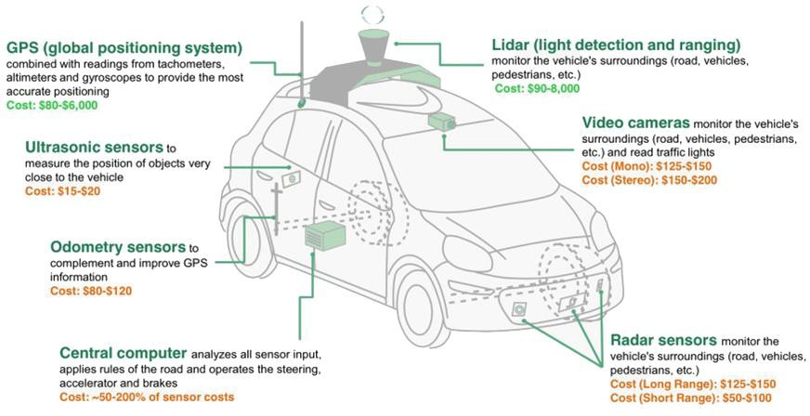
End user | Map makers, OEMs
Geospatial data use | Detailed location of vehicles
Reference | http://inlane.eu/consortium/

Table 7: Geospatial data as an objective (Case Study 2)

Title/Country |  | Europe
Objectives | Research and develop data, communications, navigation and processing requirements that will underpin successful deployment of CAVs.
Stakeholder | Mapping company, Local authority, University and research organisation  Ordnance Survey, Satellite Applications Catapult, GOBOTiX Ltd, Oxford Technical Solutions Ltd, Transport Research Laboratory, Royal Borough of Greenwich, Sony Europe
Timeframe | 2016 – 2017
Services | Mapping services, including position, sensor augmentation and V2X connectivity
Technologies | Radar technology
End user | Knowledge sharing and thought leadership with industry partners
Geospatial data use | Integration of static data to sensor input for decision making purposes
References | https://www.ordnancesurvey.co.uk/about/news/2016/uk-given-green-light-driverless- cars.html

Table 8: Geospatial data as an objective (Case Study 3)

Title/Country |  | Europe
Objectives | Measurement of the 3D geometry of a small patch of road surface below the vehicle to use this as a 'fingerprint' to uniquely determine the vehicle's location.
Stakeholder | Research company, University  Machine with Visions, Durham University
Timeframe | 2016 - ongoing
Services | High precision in Determining vehicle’s location
Technologies | Map and location software, sensor hardware
End user | Driver, OEMs
Geospatial data use | Detailed location of vehicles
Reference | https://www.machineswithvision.com/

Table 9: Geospatial data as an objective (Case Study 4)

Title/Country | HIGHTS | Europe
Objectives | Achievement of high precision positioning system with the accuracy of 25cm.
Stakeholder | Academic institutions (x5), Universities, Research Institutes, Large Companies, High- Tech venture companies and Legal and Consulting companies  Jacobs University Bremen Ggmbh, Eurecom, Deutsches Zentrum Fuer Luft - Und Raumfahrt Ev, Commissariat A L Energie Atomique Et Aux Energies Alternatives, Chalmers Tekniska Hoegskola Ab, Fb Consulting S.A.R.L., Robert Bosch Gmbh, Tass International Mobility Center Bv, Be Spoon Sas, Zigpos Gmbh, Spaanderman Paulus Teun, Objective Software Gmbh, Ibeo Automotive Systems Gmbh, Innotec21 Gmbh
Timeframe | 2015 - 2018
Services | Development of:  - A protocol and network support for data exchange between vehicles, infrastructure and any Internet-of-Things (IoT) devices available, which stand for the technical backbone of cooperative strategies required to reach a sub-meter (less than 25 cm) localization precision  - A system to allow vehicles (V), infrastructure (I) and surrounding objects / things (T) to exchange any type of data (ranging, GPS position, maps, caching, contexts) of various quality that can be used by HIGHTS cooperative fusioning algorithms for increased positioning accuracy  - A system of semantic annotation for the data to guarantee mutual understanding of nodes of interest  - Decision/estimation building blocks and networking functionalities contributing to the definition of the European-wide positioning service platform based on enhanced Local Dynamic Maps;  - A European-wide proposition for a positioning service platform based on the interaction of various on-board sensors, cooperative data streams, fusion algorithms and enhanced LDMs.
Technologies | Satellite systems, on-board sensing, infrastructure-based wireless communication technologies
End user | Map makers, OEMs
Geospatial data use | Detailed localization of vehicles
Reference | http://hights.eu/about/

Table 10: Geospatial data as an objective (Case Study 5)

Title/Country | A new era of GPS-independent route tracking | Europe
Objectives | On- and off-road positioning for any vehicle to complement existing and upcoming technologies for map-independent 3D route reconstruction in real time.  Development of solution for the inability of GPS to operate in buildings, tunnels and under tree canopies
Stakeholder | Research, development and consultancy in electronic engineering  Roke Ltd
Timeframe | 2015 – 2018
Services | Overcoming the inability of GPS to operate in buildings, tunnels and under tree canopies
Technologies | Inertial sensors determine velocity and orientation from motion Inertial drift controlled with visual information from monocular camera  Integrated solution outperforms positioning performance of either in isolation
End user | Driver
Geospatial data use | Detailed location of vehicles
Reference | https://www.roke.co.uk/

It is evident that the objectives of these projects is to satisfy the requirements of CAVs (i.e. as set out in Section 3 of this report). This demonstrates the ability of the broad ecosystem to react to the changing needs of connected and automotive vehicles.

Activities of mapping companies
The review of international case studies documented earlier translates the ‘big picture’ of the CAV ecosystem to the specifics of geospatial data. Alongside these high-profile projects involving a wide range of stakeholders, CAV-related activities are also undertaken by geospatial data and mapping companies. These companies are also direct providers to the automotive industry, and are therefore an important component of the ecosystem. This section provides further information on the activities on CAVs of map making-related companies. In total, 16 companies were identified to be involved in the CAV industry and their involvement is described in Table 11.

The two most high-profile mapping companies in this ecosystem are TomTom and HERE maps:

- HERE, acquired by coalition of Audi, BMW & Daimler, using high precision GPS, motion tracking inertial system, laser scanners and 4 cameras to develop HD maps;

- TomTom, capturing Depth Maps using LiDAR, and creating high-precision “HD” maps.

In particular, the acquisition of HERE by automotive companies demonstrates the importance of high precision map information for this industry. TomTom have supplied the automotive industry with data for around 5-years, mainly centred on in-car navigation systems.

Table 11: CAV industry activities of mapping / geospatial data companies

Company | Products relevant to CAVs
HERE25 | HD Map – Maps with increased accuracy to a level of 10 to 20 centimetres  Live Roads – Technology to alert drivers of conditions such as weather to alert other drivers of possible hazards, or to avoid a particular area whilst driving.  Humanized Driving – data collected on driving habits on roads, and provisioning this data to allow automated cars to follow how drivers behave (speed, traffic lights etc.) when driving on certain roads  Technologies used – LIDAR, lane geometry collection data, weather data, driving habits
TomTom26 | TomTom uses 3 data sets:  Navigation data – Modular, plug-and-play runtime maps, (quarterly updated) Multinet – Easy to use relational database (weekly updates)  New cloud map focusing on CAVs (streaming up to date maps)  Components of data sets  - Traffic  - Compact feed, only roads with delays/incidents  - Comprehensive feed, detailed speed information per road  - EV Service  - On street parking service  - Off street parking service  - Fuel service  - Weather service  - Real time map updates  - Speed cameras  TomTom’s patented RoadDNA technology delivers a highly optimised, 3D lateral and longitudinal view of the roadway. With this, a vehicle can correlate RoadDNA data with data obtained by its own sensors. By doing this correlation in real time, TomTom RoadDNA precisely locates a vehicle on the road, even while travelling at high speeds without the use of GPS.

Further details of the activities of mapping companies is included in Appendix D of this report.

25 https://here.com/en/industries/automotive/autonomous-driving, http://360.here.com/2015/04/16/autonomous-cars-can-understand-real-world-map/

26 https://automotivemegatrends.com/connected-cars-require-real-time-dynamic-maps

Activity 1 lessons learnt
Connected and autonomous vehicles are receiving a great deal of attention, with the technology progressing at a great rate. Despite this, the industry is still in its infancy, with evaluation and testing happening worldwide. Further work is also required in regard to public acceptance, regulation and liability.

The period to 2025 is likely to see an increasing proportion of partially automated vehicles on our roads. However, they will not make up a large proportion of the vehicle fleet, with ‘legacy’ vehicles still forming the majority. After market technology and connected devices (including mobile phones) will, however, open up a number of possibilities in regard to increased use of data and an improved customer experience.

This report has specifically investigated the role of geospatial data for autonomous and connected vehicles. To this end, a number of key conclusions have been drawn.

- Geospatial data is important

In replacing the functionality of human drivers, CAVs will need to have an understanding of the environment around them. An element of this will be achieved through scanning the environment through technologies such as LiDAR. However, it will be inefficient to generate all of this information, and to ensure that vehicles have the same “view” of the world, geospatial data will be key.

- Geospatial data is a crucial enabler for CAV projects

A large proportion of the CAV deployment projects investigated utilised geospatial data, with a small number viewing geospatial data as the end goal. Geospatial and mapping data are often used in conjunction with environmental scanning technologies, akin to techniques such as map-matching. This clarifies the role of geospatial data as an important component of the CAV ecosystem, further reinforced by the activities of mapping and automotive companies.

- The quality of geospatial data will impact the efficiency, effectiveness and benefits of CAVs

Whilst geospatial data is seen as a crucial component of connected and autonomous vehicles, it is unlikely to be critical to their operation. Concerns over security, consistency, accessibility and connectivity likely mean that CAVs will need to operate “autonomously”, without live geospatial data. However, benefits to consumers, network operators and infrastructure providers will be enhanced through accurate, reliable and comprehensive geospatial and mapping data.

- The market is reacting – private geospatial data companies are active

Geospatial data has often been the purview of governmental and public sector bodies, providing a “single” version of the truth in regards to mapping and point data. The evolving requirements of consumers and automotive manufacturers has stimulated the market in regard to geospatial and mapping data companies, with a number of large companies, and a wide range of start-ups and small companies involved in this space.

The automotive industry is committed to the introduction of autonomous vehicles. Where geospatial data is a key requirement of CAV operations, the private sector has also demonstrated a willingness to provide these data. This is best illustrated by the acquisition of mapping company HERE by a consortium of German car makers.

Based on these developments, there is no immediate or crucial requirement for SDFE or other geospatial data agencies to provide information for use in autonomous vehicles.

However, it is also recognised that nationally provided datasets may be beneficial to CAV operations, and may facilitate wider benefits for society – such as concerning congestion, environment, safety and accessibility. It is therefore crucial that organisations such as SDFE remain involved with the emerging CAV ecosystem, and are poised to facilitate the provision of data and standards where it is in the wider interest.

Activity 2: Gap analysis
This activity considers the relevant existing geospatial data available in Denmark and compares this to the types of geodata used by connected and autonomous vehicles.

Background to Activity 2
This section builds upon the previous findings of how and what geodata is used by car manufacturer and map companies in relation to autonomous vehicles. The classification made in Figure 8 together with the identified required data for path finding serves as the basis for one part of the gap analysis, creating a baseline for which to compare geospatial data held by SDFE and other publicly accessible sources. These findings will then be used to assess the gap between of the geospatial data required and what Danish geospatial data is available.

The data considered for the analysis have been collected based on publicly available and accessible services as well as based on initiating meetings with SDFE and the Danish Road Directorate. The comparison and findings of the analysis is done on an overall level. This is because knowledge of specific data structure, formats and specific needs are, as covered in activity 1, still shrouded in secrecy by manufacturers and map companies as competition within these fields are ongoing. This means that the analysis should be seen as pointers towards weak points, problems and future possibilities rather than a detailed analysis of defects and solutions between individual layers.

As concluded in Activity 1, car and map manufacturers are very active and will make sure on their own that cars have the data needed to operate. While this means there is currently no dire need for public institutions to create and publish the geodata needed for CAV operations. However, it is still relevant to consider the connection between the existing publicly available spatial data and CAV geodata usage.

Geospatial Data
SDFE offers a lot of geospatial data themselves but as the subject of autonomous vehicles relates to other agencies and municipalities who also offer relevant geospatial data, these will also be considered to some extent.

In relation to autonomous vehicles The Danish Road Directorate (Vejdirektoratet/VD) is also a key provider of geodata as they, regarding roads, have unique geodata on the largest state-owned roads in Denmark. While the data they have outside of cooperation with the municipalities only relates to about 3.800km road, compared to the municipalities who own 70.700km, the data they have are unique, and therefore relevant to this analysis27.

The geodata contained by the individual municipalities have also been partially assessed as part of the data review. However, this was mainly to assure if certain data exists on a broader scale within the municipalities, or whether these data are more sporadic. The municipalities are also connected to SDFE through the GeoDanmark cooperation, who specifies, creates and maintains the data which is the basis for Danish topographic maps.

A single layer containing placement and information on telecommunication masts made available by the Danish Energy Agency (Energistyrelsen) have also been included. This is due to the likely requirement of connected and autonomous vehicles to need for constant access to communications networks in order to exploit real-time updated data.

Table 12 shows a list of data which consists of data that have been considered and compared against the classification of CAV relevant geodata. The data-list does not mention all data held by SDFE as some data sources and layers were discarded as irrelevant. These are, for example, historical data and topographic print maps. Also future/planned (sommerortofoto and skråfotos) datasets are not considered but as they tend to raise the quality and precision of geospatial data they will extend the value of the existing datasets.

Some of the datasets that match with the classification of needed geodata will be covered in more detail further on in the report as their compatibility to the needed data is covered.

27
http://vejdirektoratet.dk/DA/viden_og_data/statistik/vejeneital/l%C3%A6ngdeoffentligeveje/Sider/Default.aspx

Table 12: List of publicly data reviewed

Group | Service/Element name | Responsible organization | Content | Update frequency/Last updated | Quality/Format
Danmarks Administrative Geografiske Inddeling (DAGI) | DAGIsingle | SDFE | Geographical administrative boundaries as vector data based on Geodanmark, cadastral data, ministries and  PostNord. | Weekly (sundays) | Vector
 | DAGImulti | SDFE | Geographical administrative boundaries as vector data based on Geodanmark, cadastral  data, ministries and PostNord. | Weekly (sundays) | Vector
Danmarks Stednavne | DKstednavne | SDFE | Georeferenced place names as vector data | Weekly (sundays)
Danmarks Adresser (DAR) | DAR | SDFE | Georeferenced addresses as vector data | Unknown | Vector
GeoDanmark | GeoDanmark vektor | SDFE  (GeodDanmark) | Vector data generated in cooperation between the 98 municipalities and SDFE. Contains elements in 7 categories: Buildings, built-up areas, trafic, techincal, nature, hydro and administrative. | Weekly (as GML) | Vector, precision varying from 0,03-75cm (2D).
 | GeoDanmark ortofoto | SDFE  (GeodDanmark) | Orthophoto | Yearly | Raster (32bit RGBNir,  12,5cm pixel resolution)
Danmarks Højdemodel (DHM) | DHMpunktsky | SDFE | Pointcloud of Denmark | 2016 (data from  2014-2015) | 4-5 points pr. m2
 | DHMterræn | SDFE | Terrain height map of Denmark based on pointcloud | 2016 (data from  2014-2015) | Raster (0,4m cellsize)

Group | Service/Element name | Responsible organization | Content | Update frequency/Last  updated | Quality/Format
 | DHMoverflade | SDFE | Surface height map of Denmark based on pointcloud | 2016 (data from  2014-2015) | Raster (0,4m cellsize)
 | DHMhøjdekurver | SDFE | contour lines of Denmark | 2017 (data from  2014-2015) | Vector data
Danmarks Hydrologiske Højdemodel (DHyM) | DHMnedbør | SDFE | Surface water runoff | 2017 (data from  2014-2015) | Raster (0,4m cellsize)
 | DHMhavstigning | SDFE | Sea-level rise | 2017 (data from  2014-2015) | Raster (0,4m cellsize)
 | DHMBluespot | SDFE | Areas in risk of flooding and how much rainfall needed for it to occur | 2017 ((data from  2014-2015) | Raster (0,4m cellsize)
Danmarks Fikspunkter | Fikspunkter | SDFE | Physical points in the landscape which are the basis for surverying and mapping in Denmark and the danish referencenet | Regularly checked and when new points are created by land inspectors etc. | Vector, precision varying from 0- 7cm
DKskærmkort | DKskærmkort | SDFE | Topograhical map for digital use - based on Geodanmark data with the addition of the names  of places and the heigh model | 2016 | WMS/Tile service in 14 scales between 1:750 -  1:6.192.500
TrafikMan2 | Traffic information | Vejdirektoratet | Traffic information on roadwork, development and incidents on State owned roads.  Development is underway to expand this to other public roads. | Realtime | Vector (Datexll standard format.  Including Vejdirektoratet' s extenstions)
Limfjords tunnel and bridge accessability | Limfjords tunnel | Vejdirektoratet | Simple proprieteary service that contains information on the accessability of Limfjords tunnelen | Realtime | Vector (JSON)
 | Limfjords bridge | Vejdirektoratet | Simple proprieteary service that contains information on the accessability of Limfjords  broen | Realtime | Vector (JSON)
Carpooling spots | Carpooling spots | Vejdirektoratet | Simple proprieteary service that contains information on carpooling spots | Unknown | Vector (JSON)
Wind and temperature | Wind and temperature | Vejdirektoratet | Service containing information on winddirection, windstrength, air- and road temperatures | Near-realtime | Vector (XML)

Group | Service/Element name | Responsible organization | Content | Update frequency/Last  updated | Quality/Format
Winter conditions | Road Network | Vejdirektoratet | Service containing the vector road geometry relating to the wintercondition service | Unknown | Vector (Datexll)
 | Surface condition | Vejdirektoratet | Service describing the temperature and roadsurface condition and time since last salt  dispersion on the state roads | Realtime | Vector (Datexll)
Traffic status | Road Network | Vejdirektoratet | Service containing vector road geometry of larger roads to which traffic status updates apply | Uknown | Vector (DatexII)
 | traffic status | Vejdirektoratet | Service containing updated traffic status (such as congestion on certain roads) | Realtime | DatexII
Rest areas | Rest areas (Cars) | Vejdirektoratet | WFS service containing the Road Directorates data on highway rest areas for normal cars | Unknown | Vector
 | Rest areas (Transportation) | Vejdirektoratet | WFS service containing the Road Directorates data on highway rest areas for trucks and  busses | Unknown | Vector
 | Rest areas (Road train) | Vejdirektoratet | WFS service containing the Road Directorates data on highway rest areas allowing road  trains | Unknown | Vector
Ferry routes | Ferry routes | Vejdirektoratet | Proprieteary service that contains ferry departure locations, names, times and cancellations 24  hours ahead in time | Daily | XML
Vejman²⁸ | Bridge/tunnel height restrictions | Vejdirektoratet | Contains height restrictions on bridges, covers the entirety of  Denmark | Unknown | Vector
 | Bridge/overpass weight restrictions | Vejdirektoratet | Contains weight limits for bridges and overpasses, covers the  entirety of Denmark | Unknown | Vector
 | Road class | Vejdirektoratet | Contains road geometry and road class information | Unknown | Vector

28 A road administrative systems used by Road authorities(national and local)

Group | Service/Element name | Responsible organization | Content | Update frequency/Last  updated | Quality/Format
 | Speed limits | Vejdirektoratet | Contains road geometry and corresponding speed limits | Unknown | Vector
National Access Point (NAP) | Basic Sign Information | Vejdirektoratet | Contains signage geometry | Unkown | XML
 | Sign Messages | Vejdirektoratet | Contains signage text | Unknown | XML
Road Directorate traffic  cameras | Web Cameras | Vejdirektoratet | The Road Directorates webcameras along state roads | Every 3rd second | DatexII
EV services | Ladekortet | Dansk Elbil Alliance | Data on electric vehicles services and chargers | 72 hours | Unknown
Mastedataba sen | Telecommunicati ons masts | Energistyrelsen | Contains data on type, technology and placement of existing and planned  tele/radiocommunicatio n masts in Denmark | Unknown | XML/JSON/KML

While the list covers many different datasets that could potentially be relevant for autonomous vehicles not all of them are free and publicly available. Some of the data from the Road Directorate, mainly the near real- time and real-time updated services, mentioned here are accessible but does cost money. Other data might not be present if it is not publicly available e.g. owned and collected by private companies.

Comparing data and use
To compare the data on the list towards the classification scheme will be done based on the individual planning levels – strategic path planning, tactical path planning and reactive path planning – as defined in section 3.5 and figure 8.

As mentioned earlier SDFE offers a lot of geospatial data themselves but as the subject of autonomous vehicles relates to other agencies and municipalities who also offer relevant geospatial data, these will also be considered to some extent. A consolidated national coverage of geospatial data made available for public/free use is important as the CAV’s needs to function independently from constraints of administrative borders.

Beneath tables 14, 15 and 16 containing the overview of the comparisons and covers the categories of CAV geodata usage on the left and the relevant existing public geodata under “Available public data”. The contents of available public data will refer who the owner is, what dataset is referred to if specific and contains the wording “Partially” if the relevant dataset have issues with coverage, quality, frequency or comprehensiveness. A brief explanation will follow in the tables corresponding sub-section.

Data for strategic path planning
The strategic path planning (as explained in Section 3.5) covers the link level and timing of more than 60s e.g. route planning to arrive at destination. The data needed for this type of planning therefore relates to finding optimal paths from one point to another, largely as navigation services does today, with more available data and information.

Table 14: Strategic path comparison

Strategic path planning | Available public data
Road class (geometry) | Geodanmark (“Vejmidte”/”Vejmidte brudt”) and partially  by Vejman (“Vejklasser”)
Traffic flow & congestion | partially by VD for larger/state roads
Traffic restrictions | partially by VD/Vejman (multiple datasets)
Weather, e.g. fog | None
Incident | Partially by VD for larger/state roads (”Traffic  information”)
Other hazard warning | Partially by VD for larger/state roads (”Surface condition”, “Wind and temperature” and “Traffic  information”)
Road construction data | Partially by VD for larger/state roads (“Traffic information”) and partially by municipalities  Oov (Overblik over vejarbejder) http://oov.vd.dk/OOV- kort/index.jsp Contains all accepted permissions for diging etc. from the road administrative systems. Data from road administrative systems as RoSy, vejman.dk, Municipality of Copenhagens own system and manually  registred information
Road construction data | Municipalities (see above)

EV services | Partially by Dansk Elbil Alliance ( “Ladekortet”) and  partially by municipalities
Parking | No precise/covering service
Point of interest | Danske Stednavne
Addresses | Danish Address Register (DAR)

The table above highlights the results from the strategic path comparison between the CAV geodata usage and relevant public geodata.

The reasoning behind the comparison is briefly covered in the following section:

Road class (geometry) | Geodanmark (”Vejmidte”, ”Vejmidte Brudt”) and partially  by Vejman (”Vejklasser”)

Basic road class information and road geometry is contained by both GeoDanmarks “Vejmidte” and “Vejmidte brudt”, and partially within Vejman “Vejklasser”. The GeoDanmark data “Vejmidte” and “Vejmidte Brudt” covers all of Denmark as part of the cooperation with the municipalities and is already used for pathfinding and routing by Danish emergency services, as well as Rejseplanen. In comparison, Vejman only has partial coverage as it is dependent on how individual municipalities use the system.

All three data sets contain information describing road type. However, as this description is not standardized, road type descriptors are not necessarily consistent between Vejman’s data and GeoDanmarks data. Plans have been made to standardize this based on a “Vejreferencen”, which holds a unique identifier for all roads, from which the different datasets can be matched.

Traffic flow & congestion | partially by VD for larger/state roads

Regarding traffic flow and congestion, the only publicly available data with information on Denmark is supplied by The Danish Road Directorate who publishes real-time updated data on congestion. However, this is published only on major state-owned roads. This means that traffic flow & congestion is only partially covered; if this were a critical component of CAV operations, greater coverage would be needed.

Traffic restrictions | Partially by VD/Vejman (multiple datasets)

Traffic restrictions are partially covered by multiple Vejman datasets describing different restrictions. These datasets have partial coverage consisting of state roads along with areas within the participating municipalities. The layers contain general information regarding traffic restrictions such as height limit on passing under bridges or weight limits on certain places, as well as rule based information such as one-way streets as these datasets are partial, they could not be relied upon for comprehensive information regarding local traffic rules. The needed to data to achieve a near complete coverage does probably exist in other road systems such as RoSy.

Weather, e.g. fog | None

The Danish Meterological Insititute does publish information about fog predictions etc. but these are currently to unprecise to effectively be used for CAVs, which would likely need a high level of fidelity. This means that the services do not cover the potential of more precise and real-time data that CAV routing could use. There are some services that contain for example wind speeds and road surface related conditions such as icy roads, but these are covered below other hazard warnings.

Incident | Partially by VD for larger/state roads (”Traffic  information”)

The only incident reports that are made into publicly available geodata is published by VD through “TraffikMan2” traffic information service. The service is updated and populated by The Road Directorate as well as the police and municipalities. Currently, the service only covers highways and larger state roads but initiatives are currently underway to enable registration of incidents, on the rest of the public road network. The spatial resolutions of the incident reports are point data with a text description and have close to real-time update frequencies based on reports.

Other hazard warning | Partially by VD for larger/state roads (”Surface  condition”, “Wind and temperature” and “Traffic information”)

Publicly accessible road related weather information data exists in Denmark through services provided by the Danish Road Directorate, the Danish Meteorological Insititute (DMI) and the Danish municipalities.

The services mainly cover highways and larger roads which means it is too sparse to provide general coverage. Thereby it only partially covers the possible uses of hazard information and warnings for general strategic path planning. The weather services provide information mainly on surface conditions; the possibility for icy roads and road temperatures based on 400 temperature sensors embedded in roads along wind condition data from 30 measurement points around Denmark29. Other hazards related to accidents, illegal activity or otherwise involving authorities is covered by the “Traffic information” service covered under the “incident” tab.

Road construction data | Partially by VD for larger/state roads (“Traffic  information”) and municipalities

The Danish Road Directorate publishes road construction information through the “Traffic information” service. The road construction and development data is published with data such as geometry, and start of period along with an end of period time stamp. Along with this is a text description of area, effects and explanation of why. Initiatives are currently underway to expand this, to potentially cover the rest of the public road network.

Currently some municipalities publish their own local road construction data with several types of information such as geometry, usually as point data, text description, contractor etc. Municipalities currently store this information in a variety of ways. An example of this practice can be seen from the Municipality of Copenhagen that publishes their data on their own website for public use30.

Compared to ideal needs, the available data is therefore only partially there as nation-wide coverage has not been achieved.

EV services | Partially by Dansk Elbil Alliance ( “Ladekortet”) and  Municipalities

The Danish Electric Vehicle Alliance, an independent trade association, publishes a nation-wide dataset on EV services. This is done in cooperation with multiple EV service companies such as E:ON, CleanCharge and CLEVER, with support from The Danish Transport, Construction and Housing Authority. The EV services providers that participate have obliged to ensure that information and operational status on service points are

29 http://www.dmi.dk/vejr/til-lands/glatfoere/

30 https://www.kk.dk/artikel/igangv%C3%A6rende-vejarbejde-i-k%C3%B8benhavn

updated within 72 hours. The data is not completely comprehensive, as participation is voluntary and not all EV service providers participate.

Local data on EV services is also published by some municipalities, such as the Municipality of Copenhagen, but update frequency and comprehensiveness is uncertain.

In relation to CAV needs EV services are thereby partially covered, because comprehensiveness is still unknown.

Parking | No precise/covering service

There is currently no published geodata service that contains parking spot location and information on a nation- wide level. There is some public static information available for example from the Municipality of Copenhagen, they publish parking spot data as LineString geometry with adherent values describing number of parking spots, rules and more. One can question if this is adequately precise or updated to be effectively used for the purpose of autonomous vehicles, as this would require frequently refreshed data of parking spot availability and precise location. This technology is available (through digital parking initiative), but is not yet implemented as standard.

Point of interest | SDFE (“Danske Stednavne”)

Points of interest are covered by the service “Danske Stednavne”, containing names and corresponding geometries on places. The places represented in the service are everything from cities, remarkably named trees to golf courses and include approximately 130000 places31. Since Points of interest refers mainly to AV routing, comfort and entertainment this service is adequate for operational purposes.

Addresses | Danish Address Register (DAR)

Data on addresses are published by the Danish address register (DAR). This service contains all address names and their respective locations, and is widely used for routing and other non-spatial tasks. The individual addresses and road names are registered by the municipalities, who are obliged to report and ensure that the data is correct. The address service is therefore both updated and accurate and will be improved by the ongoing improvement program32. This data fits the needs for strategic path planning of autonomous vehicles.

Data for tactical path planning
Tactical planning is as explained in Section 3.5 the planning of vehicle approximately between 3-60 seconds ahead of time. This covers for example the ability to choose the appropriate lane for exiting a highway or positioning the vehicle properly for turning at an intersection.

This generally shifts the focus from a larger perspective to a need for more detailed and precise geodata.

Table 15: Tactical path comparison

Tactical path planning | Available public data
Road lanes | None
Traffic signals | None

31 http://sdfe.dk/hent-data/danske-stednavne/

32 http://danmarksadresser.dk/forbedringer

Signage | Partially by VD (Basic Sign Information and Sign  Messages) and municipalities
Paint markings | None
Curvature | None
Slopes | None
Speed limits | Partially by VD/Vejman (”Hastighedsgrænser”)
Intersection | None
Road edges | Partially by Geodanmark (“Vejkant”)
Road shoulders | None
Road dividers | GeoDanmark (“Trafikhegn”/”Helle”)

The table above highlights the results from the comparison between the potentially useful and needed data on the left and related available geodata on the right.

The reasoning behind the comparison is briefly covered in the following section:

Road lanes | None

The need for road lanes refers to a need for specific lane level information on the course of the road. This means precise geodata on road lane width and placement so that AV’s can know where to place itself in traffic. Whilst onboard sensing will detect lane markings, it is highly likely that this will require specific information to permit full autonomy. This is particularly true in complex traffic situations, such as junctions. There are currently no publicly available data sources containing individual road lane geometry, but The Danish Road Directorate does have this type of data for certain parts of the highway network and are considering its potential.

Traffic signals | None

There are currently no detailed publicly available data on traffic signals available. The data sought-after is precise data on traffic signal positioning and layout. In the future, this combined with vehicle to infrastructure data exchange could help increase efficiency and security by prioritizing what vehicles can go where and when, forming an important component of future Intelligent Transport Systems.

Signage | Partially by VD (Basic Sign Information and Sign  Messages) and municipalities

The Danish Road Directorate publishes geodata with the location of signage on highways and larger state- owned roads through the newly created National Access Point (NAP). This consists of 2 layers containing signage text and locations respectively. The municipalities have their own systems to organize and save signage type and placement. These can therefore vary from approximate placements described by nearby road names and text descriptions to precise GNSS located positions.

The needed signage data is there on larger and state roads. In relation to nation-wide coverage the municipalities differ and some, for example the municipality of Copenhagen33, already publishes signage data, while other municipalities have no organized geotagged registration.

33 http://data.kk.dk/dataset/trafikskilte

Paint markings | None

There are currently no publicly available geodata on road paint markings. This is however, arguably, closely related to other data such as road lanes, road shoulders and road edges. Again, whilst this will be monitoring on-board the vehicle, any geodata that can be provided will help increase the effectiveness of CAV operations.

Curvature | None

There are currently no publicly available geodata on road curvature but this might be possible to asses from precise road, road lane geometry and on-board sensing.

Slopes | None

There are currently no publicly available geodata on road sloping but this might be possible to assess from for example the Danish Height Model.

Speed limits | VD/Vejman (Partially by ”Hastighedsgrænser”)

The Danish Road Directorate publishes a dataset of state road geometry along with current speed limits. The same dataset also exists through their Vejman cooperation with participating municipalities. This increases the coverage significantly but does not give nation-wide coverage.

Thereby, the need for geodata on speed limits are only partially fulfilled.

Intersection | None

While Vejman and the Danish Road Directorate does publish a dataset on intersections with information such as position by point geometry and number of access roads, there is currently no detailed publicly available geodata on intersections. The intersection data needed relates closely to road lane data as it needs to be detailed enough for an AV to find the right placement and path through a given intersection.

Road edges | Partially by GeoDanmark (“Vejkant”)

Road edges are a part of the GeoDanmark service by the layer “Vejkant”. This dataset is publicly available and has nation-wide coverage of geometry of road edges. This layer does have a problem regarding the precision of the data, as it is can be up to 75cm uncertainty34, which could prove problematic if used for AV purposes when compared map companies such as HEREs 10-20cm precision requirement35.

Road shoulders | None

There are currently no publicly availably geodata containing the specific geometry of road shoulders. There is some geodata in the Vejman system, such as the “Tværprofil type-vej” layer that describes road shoulders with simple LineString geometry to identify the road it describes. This does tell what larger roads have road

34 https://www.geodanmark.dk/wp-content/uploads/2017/09/DK_Specifikationen-vers-5.1.pdf

35 https://360.here.com/2015/04/16/autonomous-cars-can-understand-real-world-map/

shoulders and where. Its usefulness for CAVs however depend heavily on the precision on which it can identify the location of road shoulders in tactical planning. This is mainly relevant for highways and large state roads and is as a tactical probably closely related to road lane geodata.

Road dividers | GeoDanmark (“Trafikhegn”/”Helle”)

The GeoDanmark service contains the dataset “Trafikhegn” which contains data on road dividers. This dataset is publicly available and has nation-wide coverage of road dividers with line geometry. The service covers all types of road dividers and are mapped on the side facing the roads. The precision on this dataset is 10cm or below which means this could be applicable in relation to AVs. In relation to road dividers, GeoDanmark also provides the layer “Helle”, which contains geometry of traffic islands with the same sub 10cm precision that could also be usable to define road edges even though these have different attributes.

Data for reactive path planning
Reactive path planning refers, as explained in Section 3.5, to the split-second decision making and actions needed because of immediate changes in a CAVs nearby environment. An example of such need could be to avoid an immediate collision with another car or pedestrians. In the main, geospatial data will provide a supporting role here, with reaction to the immediate environment governed by sensing onboard the vehicle. However, given the data processing requirements of CAVs, it is worth considering how geospatial data can support reactive path planning.

Table 15: Reactive path comparison

Reactive path planning | Available public data
Obstacles in close vicinity, including pedestrians, objects on the road, collision evasion etc. | None (largely sensor dependent)

As discussed, the reactive path planning element will be largely sensor dependent as the reaction is likely to happen due to a moving object or an immediate change rather than stationary geodata. In such a case, the sensors already know what other objects are in the immediate vicinity of the car and a decision can be made.

Depending on the variables used in generating a new path around an immediate obstacle some situational geodata could possibly be applied in certain situations. One such example could possibly be to help improve the situational awareness by knowing the height model of terrain around the road to avoid driving off the road without knowing nearby terrain features such as steep falls.

Gaps and challenges
The strategic planning level is partially covered by existing available data. The most general strategic level data such as basic road geometry, road class information and addresses, exist, have nationwide coverage and are available to use for routing already. Other layers such as traffic restrictions, do not have nation-wide coverage through “Vejman”, the data does however with high likelihood exist within other road systems used by municipalities. In relation to the more secondary and shifting data, such as incidents or road construction, there is a lack of coverage as these services currently exist solely for highways and state roads.

The only services that have large challenges are parking and weather services. The challenges for the categories are different in nature. Weather data services do exist, but suffer from imprecision to what specific parts of road is suffering from fog or rain at a given moment. In comparison, the parking data that exists is generally sparse and static with individual publishing. In both cases, it is expected that these data have the potential to enhance CAV operations, particularly for the customer experience. It is unlikely, however, that CAV operations will be reliant on these services. This means that the basic data needed for strategic path planning does exist and otherwise needed data for CAV strategic planning can be covered by improving and expanding existing services or by congregating existing data.

As the strategic path planning datasets aren’t uniquely necessary for the immediate driving abilities of the car
– as they are mainly provided initially by the map-provider, but rather for the route planning and thereby for mapping companies to integrate and use as a connection to local authorities.

The tactical path planning requirement of detailed data with high precision leads to challenges for a lot of existing geodata. This becomes clear when comparing the difference in the existing available data and the data needs of CAVs on a tactical level. Some required data, such as road lane geometry, intersections or paint markings are either non-existent or not publicly available. This could potentially lead to a large gap if the former rather than the latter is the case. One solution to bridge this gap could be to collect or create the data for example using for photo recognition and machine learning as some map companies do, but a process such as that could likely be both expensive and hard to estimate the value of. Especially considering private map companies are already in the process of creating their own data. This is an area where it is highly likely that CAV operations will require data, particularly when considering the processing requirements of on-board sensors. Access to high precision maps and roadway models could great increase the efficiency and effectiveness of CAVs, and help to convince stakeholders of their safety.

Data such as road signs are available through the national access point but only for state roads but otherwise not gathered nationwide in a database or in a standard format. The same is partially true for speed limits which do exist in Vejman, but do not have nation-wide coverage. The data needed to make this nationwide, however, most likely exist within the municipalities in the road system RoSy. This could potentially mean that these gaps could be bridged by aggregating and standardizing the information from existing systems into one place. The data on road dividers does seem to fit the general description of precision and coverage needs and as such this means there is no gap to cover here.

The tactical path planning area is still suffering from a large amount of uncertainty as there are no standards, de-facto or otherwise on the formats and types of geodata needed. This means for example that geodata on signage might not be useful for CAVs as points, but rather stored on the individual road lane geometry as a LineString, or something entirely different.

There is still a great deal of uncertainty concerning the data requirements of CAVs, and of the geospatial data available. This review has highlighted the need for standardization and aggregation of disperse datasets, as well as recognizing the need for somebody to specify such standards. The tactical path planning comparison highlights particular challenges, some of which are large gaps that are not easily covered by sharing. Creating inexistent tactical data could potentially require extensive and expensive work to create and maintain, particularly considering the efforts currently expended by mapping companies in relation to for example precise road lane mapping. This does, however, serve to highlight the commercial need amongst automotive manufacturers for such products.

Activity 2 lessons learnt
While the specific geodata needed to operate connected and autonomous vehicles are still shrouded with some uncertainty as the industry, as covered in Activity 1 suggests, is still in its infancy with ongoing technological development, testing and evaluation. It should also be noted that the gaps found are only related to potential future geodata usage by CAVs and do in this case not represent any immediate needs by car manufacturers or map companies as these are creating and gathering data themselves.

As a baseline, a comparison between the general trends and directions of what geodata autonomous vehicles use and what relevant geodata the Danish public institutions publish has been conducted. This comparison was used to complete the gap analysis by assessing the differences between existing and potentially required geodata. Even though the specifics of what geodata can be used are hard to pinpoint due to uncertainty in regard to the future of autonomous and connected vehicle standards, technology and operation - a number of key conclusion have been drawn.

- Existing data has challenges with precision and coverage

Many of the existing data has problems related to quality such as precision and spatial coverage. Regarding precision, only few of the existing datasets have prescribed levels of precision. This means that it is questionable whether multiple of the existing datasets can be used for CAV purposes. Secondly, many of the existing datasets do not have nationwide coverage as they are made by organizations working within certain boundaries (Municipal-level, National-level). Some concerns of quality of data could also be raised in terms of frequency(delay) and accuracy and update of data.

- Access and conformity

There is currently no one place to find aggregated geodata regarding roads. Multiple existing geodata layers are created and maintained by individual organizations or municipalities and in different systems. This is not fully aggregated by any system and as such it can be difficult to access and use, as there isn’t necessarily conformity between the currently used data structures. This also means that there is no simple access to meta- data or documentation regarding much of the existing data.

This also highlights a problem of conformity between existing road data – in order for users (whether private car owners, fleet operators or automotive manufacturers) to have confidence in the data, this must clearly be proactively managed in terms of quality, standardisation, accessibility and reporting. But also in terms of extending the reference model (or develop new models) between data entities from different stakeholders (e.g. Vejreferencedatabasen)

- Sizeable data gaps, mainly in relation to tactical path planning

From the comparison, we can see some clear gaps between existing and used data. The strategic path planning is largely covered with few exceptions that mostly relate to either making some geodata more applicable to CAVs, or more accessible to potential users. The main gaps appear in relation to the tactical path planning that suffers from missing crucial data layers. This could potentially require extensive work to bridge which entails the question of, if, this should be bridged.

In all cases, it should be noted that this review has been conducted concerning data not collected for the purposes of CAV operation. With that in mind, there is great potential to make use of existing Danish geospatial data for CAV operations, planning and performance measurement. The activities of mapping companies in creating high-precision and comprehensive maps and data is an example of the level of fidelity required in geospatial data for CAVs, demonstrating the scale of potential work required.

A next step establishing a data publishing service will have to address issues as standardization, reference models between datasets (e.g. local and state level), consolidation of datasets and quality (update etc.)

Activity 3: Perspectives
This activity considers the wider influences on the CAV ecosystem, the evolving CAV value chain, and the emerging role of SDFE and organisations like it.

Trends influencing the development of CAVs

Overview
Trends are defined as highly predictable forces of change. This can include social, technological, environmental, economic and political-regulatory forces. Despite being highly predictable, their impact is associated with a certain level of uncertainty, usually represented by two extremes, e.g. low vs high, silos vs widespread etc.36

This section seeks to identify trends shaping the future of connected and autonomous vehicles and highlights their potential impact on future CAV operations. A particular focus was placed to trends impacting CAV operations within a 2025 horizon.

The main trends shaping the future of CAV operations are illustrated beneath in Table 12Error! Reference source not found., covering social, political, economic and technological trends. Environmental trends, such as climate change, energy supply and scarcity, or air quality targets have been considered as part of the wider social and political context.

Table 12: Major technological, political, economic and social trends

Technological | Social | Economic | Political
- Connectivity tech Roadside/GNSS  - Automation and sensing technologies  - Other  Cyber protective technology/VR&AR/ Blockchain | - Decrease in car ownership  - Poor public acceptance of CAVs  - Public attitude towards data privacy  - Tendency to share journeys/vehicles  - Ageing population  - Urbanisation growth  - Working practice  - Favour towards clean transport modes | - Data availability and sharing  - High technology cost  - Business models | - Investment and funding availability  - Standardisation  - Regulation  - Data sharing/Social concerns response/Liability

Impacts are analysed based on the impact on transport (trip demand and mode choice) and the type of impact (adoption and maturity), and therefore on the use and operation of autonomous vehicles.
Impact on transport: trends can impact CAV operations in two ways: impacting the extent people need/want to travel (trip demand) and the extent need/want to travel using CAVs (mode choice). More explanation is given below:

- How people live and work (trip demand): transport is a derived demand, i.e. people don’t travel with the objective of travelling only but in order to complete other activities, e.g. work, leisure etc. Therefore, attention should be given to the impact of trends on wider considerations, i.e. how people work and live, including the extent which people do not have to travel anymore (e.g. due to remote working or online purchases).

- How people make choices about transport (mode choice): CAVs as part of a wider transport ecosystem formed of different transport modes which travelers can choose from. Therefore, attention

36 “Technology Scenarios for the Department for Transport”, Atkins, 2016

should be given to the impact of trends on CAVs but also on other transport modes, e.g. cycling, to understand the overall effect.

Type of impact: Trends forming the development of CAV operation can be categorised in two aspects:

- Trends impacting the maturity of CAVs, i.e. the technological makeup and effectiveness of CAVs, based on maturity of services available and provided by CAVs, and the associated effectiveness.

- Trends impacting the adoption of CAVs, i.e. how easy will it be to adopt CAVs (independently of the service maturity) based on the following adoption factors – access, affordability, acceptance, and customer fit (meeting user requirements).

Whilst we are considering these trends independently, there is clearly significant overlap. The development of market ready technologies is ultimately driven by the requirements of users. If users are not willing to adopt CAV technologies, or if the regulatory environment does not allow their use, it is likely that the maturity of the technology will suffer. However, for the immediate time horizon under consideration (to 2025), the development of CAV technologies is being driven by an assumed need; given the significant investment already made, it is unlikely that customer attitudes will have an immediate impact.

Considerations are then given on the overall effect, including if the trend has rather a positive, negative, or uncertain effect, if this effect is minor or major, and if it is expected to have an impact within a 2025 horizon. The following sections discuss each of these categories in turn, with the full analysis tabulated in Appendix E of this report.

Technological trends
Three categories of technological trends will shape the development of CAV operation:

- Connectivity technologies – roadside connectivity and GNSS connectivity

- Automation technologies – computing/processing power, artificial intelligence, automated platooning, and sensors for environmental scanning

- Other technologies – Virtual and Augmented reality, cyber protective technologies, and blockchain.

Technological trends are expected to have a major impact on CAV development within a 2025 horizon as this will define CAVs maturity, i.e. the range and quality of services being provided.

Connectivity technologies

Roadside connectivity
The speed and nature of CAV uptake will be significantly aﬀected by the telecommunications infrastructure available to provide connectivity to vehicles. The following sections describe the communication requirements for vehicle networks which will need to be addressed in the future, along with the current technology options for roadside connectivity. This is based on a report from the National Infrastructure Commission37 and research published by University of Bristol38.

The communication requirements for vehicle networks are as follows:

37
https://www.gov.uk/government/uploads/system/uploads/attachment_data/file/577906/CONNECTED_FUTU RE_ACCESSIBLE.pdfhttps:/www.gov.uk/government/uploads/system/uploads/attachment_data/file/577906/ CONNECTED_FUTURE_ACCESSIBLE.pdf

38 “Dependable V2X Connectivity for Connected and Autonomous Vehicles”, University of Bristol, 2016

- Coverage requirements – existing mobile coverage across road networks can be unreliable, causing difficulties for road users, and for vehicle manufacturers seeking to enable increasing levels of reliable connectivity in new models. The more roadside coverage is ubiquitous, the more the entry of CAVs will be facilitated.

- Quality of Service requirements – the information exchanged between vehicles and infrastructure is characterized by different QoS requirements, ranging from high reliability and low latency in road-safety applications, to high data rate and limited packet loss rate in infotainment services. As a result, flexible and efficient resource allocation techniques will need to be employed, adaptively and fairly assigning resources to the vehicles according to the QoS requested by the specific application.

- Capacity requirements – roads in suburban areas may, in general, have relatively low data capacity requirements, at least in the near term, due to lower traffic volumes and densities. However, in busy areas, where capacity requirements are greater, dedicated coverage and networks are likely to be necessary to allow for increased data capacity needs. Therefore, capacity will need to grow significantly to meet forecast service quality needs. Similarly, on the strategic road network, concentrated numbers of vehicles with sophisticated connectivity needs will result in requirements that existing mobile networks are unlikely to be able to meet.

The extent to which those requirements would be met will have a major impact on CAV operations in the future. The following technologies are currently considered for roadside connectivity:

- DSRC - Dedicated Short-Range Communications (DSRC), a short- to medium-range wireless communication channel.

- 5G technologies, expected to be well suited to rapid, high capacity roadside connectivity.

- ITS-G5, wireless short-range communications specifically dedicated to vehicle networks, including automotive ITS and Road Transport and Traffic Telematics (RTTT). ITS-G5 (part of Cooperative-ITS) provides connectivity between road participants and infrastructure.

A combination of technologies is expected to be used for CAVs. To meet diverse requirements in terms of reliability and latency as well as maximize the overall throughput, V2X communication systems need to operate according to a multichannel access strategy.

GNSS connectivity
Positioning accuracy is crucial for a specific set of innovative automotive applications, such as intelligent junction management and traffic-light speed advisory where the estimation error cannot exceed 5 meters. Typical solutions for positioning are based on Satellite Systems (GNSS), yet alternative technique can rely on the combined information originated by GNSS and local geographic maps. As discussed in Section 3 (Activity 1), GPS based connectivity will be key for CAVs. GNSS information empowers automotive services ranging from precise navigation to location-based information services including the localisation of speed cameras or available parking sports, dynamic weather updates and traffic alerts39.

Automation technologies

Computing/processing power
Computing power based on Cloud computing and quantum computing could in the future possibly provide faster computer processing, allowing further data analytics. CAV operations rely on fast computer processing for fusion and analysis of a significant amount of data from different sensors technologies, as illustrated in Figure 9.

As previously discussed, maps need also to reflect changes on the roads, raising a significant requirement for the software infrastructure that should not only handle massive amount of HD map data, but also be super- efficient in handling the communications between cars and the cloud while maintaining a low cost. Finally, maps need to work seamlessly with the rest of self-driving system with high performance.

39 ‘2017 GNSS Market Report’, European Global Navigation Satellite Systems Agency, 2017

Figure 9: Data processing of CAVs (Intel)
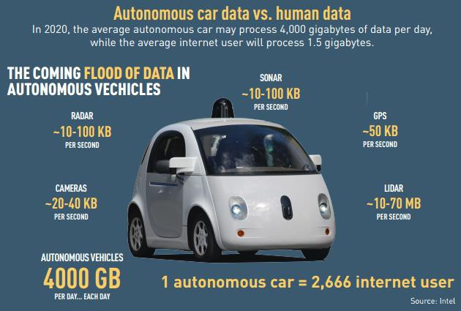

Source: https://www.geonovum.nl/sites/default/files/Self-DrivingVehiclesReport.pdf

Artificial intelligence
CAVs require software which emulates the routines of natural human cognition (processes used to judge, plan, acquire knowledge, or otherwise — “think”)40. This Artificial Intelligence is required to consider information available and make decisions on the path vehicles need to follow. According to Tractica41, both semi- autonomous and the fully autonomous vehicles of the future will rely heavily on AI systems. They forecast that AI hardware, software, and services revenue in the automotive industry will increase from $404 million in 2016 to $14.0 billion by 2025, representing a compound annual growth rate of 48.3% as depicted in Figure 10.

Advancement of AI are closely linked to advancements in machine learning and data mining. To achieve all the benefits of this massive amount of data collected, there will be a need for software that can analyse masses of data collected from monitoring the whereabouts of people and objects, and detect patterns that allow us to understand the behaviour of complex systems42.

Sensors for environmental scanning
CAVs also rely on sensors to obtain a detailed view of its surroundings, including static objects (e.g. road layout) and dynamic objects (e.g. vehicles, pedestrians etc.). Figure 11 describes the sensor technology roadmap and how it connects to the increased levels of the autonomous technology. Research is underway to improve maturity of sensors and the effectiveness in a range of different environments.

40 https://medium.com/@CivilMaps/cognition-for-cars-using-6d-localization-b4a76527a110
41 ‘https://www.tractica.com/newsroom/press-releases/automotive-artificial-intelligence-revenue-to-reach-14- billion-by-2025/
42 https://www.gov.uk/government/uploads/system/uploads/attachment_data/file/300334/06-522-intelligent- infrastructure-overview.pdf

Figure 10: Automotive artificial intelligence total revenue (by segment, 2016-2025)
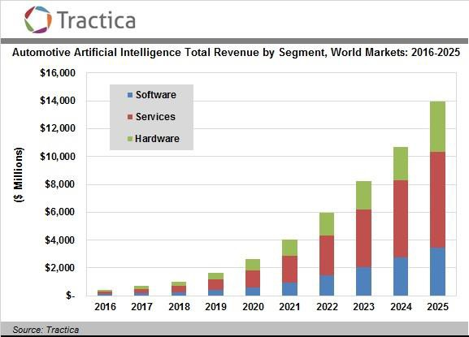

Figure 11: Sensor technology and autonomous functions roadmap
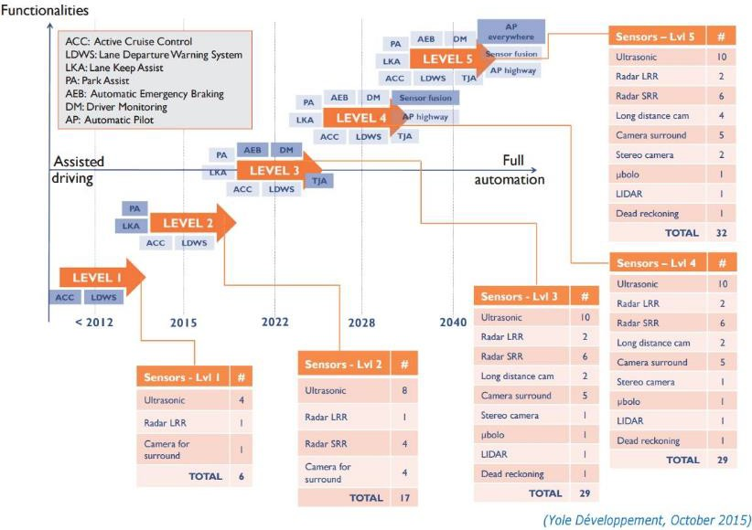

Other technologies
Virtual Reality (VR) and Augmented Reality (AR)
These technologies are still in their infancy but many enterprises are assessing its longer-term impact43. There are two direct impacts of these technologies on CAVs44:

- VR and AR can be used as a Simulated Testing Ground. Virtual Reality Prototyping will provide a safe testing ground for autonomous vehicles, which are yet to be perfected but will be key for the development and acceptance of CAVs.

- The Visual Displays used in VR and AR will improve situational awareness and form an important component of the human-machine interface. New forms of visual displays, combined with aural and haptic feedback, will be designed to improve driver situational awareness and increase safety; combining these with other active systems based on computer vision, such as lane departure and auto-braking, presents the promise of lower accidents, fatality rates, and more.

Cyber protective technologies
Although the shift towards a digital world oﬀers huge opportunities, it also comes with new types of risks and threats: the spread of the ‘Internet of Things’ means the vulnerability to cyberattacks now extends beyond digital assets to physical assets, including critical infrastructure, such as transport systems and communications networks45.

CAVs are likely to become a key target of cyber attackers for a range of motives, from political disruption, terrorist purposes, to commercial espionage. Example of hacking are already happening, e.g. the remote control of a Tesla Model S from a distance of 12 miles away where hackers “interfere with the car’s brakes, door locks, dashboard, computer screen and other electronically controlled features”46.

Developing secure by design systems will be necessary along with implementing appropriate monitoring systems to detect anomalies, analyse any threats, and provide associated mitigations strategies. Not only should vehicles be secure but also associated communication networks. Therefore, the technological advancement in protective technologies (hardware/software) and intrusion detection systems will have a major impact on CAV development.

Blockchain
A blockchain is the technology allowing distributed ledger to be updated by a network of participants (distributed management). There are several applications where blockchain could enable a more efficient and secure CAV operation. At an early stage, blockchain could facilitate the fractional ownership of a vehicle to manage the shares of an asset among several owners. At a more advanced level, the blockchain technology could sustain a product lifecycle management of all its components; having the ability to maintain and service itself to run efficiently, optimised by data.

Social trends

Decrease in car ownership
In western economies, there is some indication that the emerging driving age population do not place as great importance on car ownership as much as previous generations47. Using the United States (US) as an example, some studies suggest that car ownership will decrease. Tony Seba, a Stanford economist, has released a study which made the following claims48:

43 https://centricdigital.com/blog/digital-trends/augmented-and-virtual-reality-trends-for-2017/
44 http://www.roboticstrends.com/article/3_ways_ar_vr_are_improving_autonomous_vehicles
45 http://ec.europa.eu/epsc/sites/epsc/files/strategic_note_issue_24.pdf
46 https://publications.parliament.uk/pa/ld201617/ldselect/ldsctech/115/115.pdf
47 “Mobility as a Service – does it have critical maas?”, Corinne Mulley
48 https://www.forbes.com/sites/quora/2017/06/22/what-will-car-ownership-look-like-in-the- future/#42f81d336b99

- Private car ownership will drop by 80% by 2030 in the US; and,

- Using electric ride-shares will be four to ten times cheaper per mile than buying a new car by 2021.

In Europe, the number of passenger vehicles is expected to decrease slightly by 2030 due to demographic shifts in attitudes towards vehicle ownership and increasing investment in rail transport49.

This decrease in car ownership is expected to have a negative impact if CAVs can be privately owned. However, if CAVs are facilitated as part of a shared fleet, a diminishing attachment to car ownership is likely to increase their use and adoption, particularly in the long term (autonomy level 5).

Public acceptance
Understanding the behaviour and emotions around CAVs is an important step towards deployment – people must trust the technology they are using, feel safe, and want to use/buy new services that CAVs open up50. If this is not the case, due to media covering about security breaches for instance, CAVs might not be able to fully take off. The British Standards Institute outlined three standardization areas which are considered as critical to public acceptance of CAVs and where work should begin promptly:

- Test-track and virtual design verification and validation – standards to support the testing of CAVs, including road, test-track and virtual test scenarios;

- Functional safety in CAV design – standards for addressing functional safety in design of production-level automated systems; and,

- Assessment and approval of CAV systems – standards on safety of holistic connected CAV systems enabling the testing of CAV capabilities in a wider systems context.

Public acceptance in terms of trust of CAVs is expected to be major factor in the long term as it might impact investment from private companies (e.g. reduced investment if they feel the market is too small).

Considering a post 2025 horizon, the desire to drive will also impact CAV development at level 5. Driving is a pleasure for some which vary with culture and this might stay constant over time. According to a US survey51, 43% of respondents said that the impossibility to drive would deter them from purchasing/leasing a vehicle at L5. Moreover, concerns over job protection might be a barrier for CAV development post 2025 if people fear of labour risks due to automation.

Attitudes towards data privacy and sharing
CAVs will generate extensive data on how and when people move, as well as data concerning transport networks and congestion52. The availability of this data is key to the success of CAVs in terms of improving the efficiency of transport networks and understand how people interact with these networks.

Some of this data might be personal (allowing the identification of an individual), and therefore requiring data protection. Given that the data will predominantly concern the vehicle, the meaning of personal data is unclear in the context of CAVs53. This leads to a lack of clarity in terms of data ownership – e.g. will locational data collected by vehicles be owed by car manufacturers or passengers? This is related to the issue of ownership, and whether CAVs will be privately owned, or whether they will be fleet vehicles.

Public attitude towards data privacy is expected to have a major impact on CAV development as the associated data is required to achieve expected benefits. There is an uncertainty in the future around the willingness to

49 http://inrix.com/press-releases/traffic-congestion-to-cost-the-uk-economy-more-than-300-billion-over-the- next-16-years/
50 “CAVs – Introducing the future of mobility”, Atkins White Paper, 2016
51
http://orfe.princeton.edu/~alaink/SmartDrivingCars/PDFs/Kelley+Blue+Book+Future+Autonomous+Vehicle+ Driver+Study+-+FINAL.pdf
52 “CAVs – Introducing the future of mobility”, Atkins White Paper, 2016
53 https://publications.parliament.uk/pa/ld201617/ldselect/ldsctech/115/115.pdf

share personal data. This willingness to share will vary with the type of services passengers get in return, and the culture of operation.

Tendency to share journeys and vehicles
The KiM Netherlands Institute for Transport Policy Analysis has published four scenarios for future traffic and transport systems involving self-driving behaviours54. Those scenarios were based on two main trends – levels of automation and sharing economy. This demonstrates that the attitude towards sharing is considered as a substantial trend impacting how CAVs will look like. KiM defines two types of sharing which can be distinguished: the sharing of a car and the sharing of a ride in a car (with multiple people travelling in one car at the same time).

As the cost of CAVs may prohibit acquisition, CAVs are expected to be enabled by this increasing acceptance of sharing journeys and vehicles. A report from Global Market Insights55 forecasted a growth of 18% CAGR for the global fleet, with the number of members projected to exceed 30million by 2024. Traditional automotive manufacturers are investing in car sharing to enhance their business models, with e.g. General Motors investing in the U.S. based ride-hailing company Lyft, or Ford launching a pilot car-sharing program in London.

Ageing population
In Europe, the percentage of people being older than 65 is expected to increase from 19.2% to 23.9% from 2016 to 203056. This increase in aging population will lead to further need for comfortable and accessible means of transportation, a key benefit of CAVs. Therefore, the aging population is expected to favour the development of CAVs by generating customer demand.

Urbanisation
Urbanisation leads to an increased need for transportation alternatives and efficient transport, as more and more people need to commute on the same transport routes at the same time57. The impact of urbanisation of CAVs is uncertain. There is a challenge of introducing CAVs in complex urban environment with pedestrians and cyclists. This may never be fully addressed and could therefore limit the development of CAVs. Conversely, CAVs can potentially bring benefit in traffic efficiency by optimising the network thanks to the enhanced information on vehicle location. Therefore, CAVs may be seen as a means to improving congestion in cities58. This does not necessarily require autonomous functionality, but instead as a deployment of cooperative-ITS technologies.

Working practices
There is an increased development of advanced technology and more powerful information communication technologies, allowing a greater use of remote working. This means people won't need to travel into an office, especially if it doesn’t suit their needs or choices (e.g. long commute). If businesses become more flexible it is likely that this trend will get significance. Remote working will impact CAV development to a certain extent as it removes the need to travel and reduces travel demand59.

Flexible working, working during weekends and working in multiple locations are likely to alter the options available for the journey to work. A more flexible mobility approach will be required60. Therefore, Mobility as a Service (MaaS) and car rental/sharing could be a preferable option than car ownership as it allows flexibility. This might generate demand for CAVs via Mobility as a Service.

54 “Driver at the wheel?” KiM Netherlands Institute for Transport Policy Analysis
55 https://www.gminsights.com/industry-analysis/carsharing-market
56 http://ec.europa.eu/eurostat/statistics- explained/index.php/File:Population_structure_by_major_age_groups,_EU-28,_2016- 80_(%25_of_total_population).png
57 http://www.centreforcities.org/wp-content/uploads/2015/11/15-11-02-Urban-Demographics.pdf
58 https://ts.catapult.org.uk/wp-content/uploads/2016/07/Mobility-as-a-Service_Exploring-the-Opportunity-for- MaaS-in-the-UK-Web.pdf
59 https://www.rand.org/pubs/research_reports/RR1377.html
60 http://www.sciencedirect.com/science/article/pii/S0966692316304082?via%3Dihub

Shift towards clean transport modes
Various studies, including those undertaken by the European Commission, have attempted to explore the public’s perceptions of the impacts of transport compared with other issues of concern to the general public. The results of these studies show that air pollution is a priority in the view of the public, especially when compared with other concerns (e.g. congestion) that local, national and international bodies can influence61.

There is also an emerging evidence that consumer demand for more informed transport choices is growing62. For example, findings from a study conducted by the Transport Systems Catapult shown that 43% of respondents expect to be provided with transportation options based on their immediate preferences (e.g. routes for good weather, bad weather, most cost efficient, etc.). Favour towards sustainable choice is a consumer preference, with consumers willing to get information about the carbon footprint for their journey for instance. Whether CAVs will be environmental friendly is uncertain as this depends on the evolution of electric vehicles. Therefore, the impact of passengers favouring clean transport modes on CAV development is uncertain.

Economic trends

High technology cost
Varying degrees of connected and autonomous technologies (such as ADAS and cruise control) are market- ready and well embedded within the vehicle fleet. Furthermore, R&D investment into partial and fully autonomous driving has been large, despite the lack of a direct market currently. Therefore, component costs and software challenges will probably dictate the pace of the industry’s state of “technical readiness” for AVs63 in terms of what is available to the consumer.

Ultimately, high technology cost is expected to have a major impact on CAVs as this will prevent widespread use if costs are passed on customers. A potential outcome is that highly autonomous functionality is reserved for those who will gain the most direct economic benefit – fleet operators, for both goods and passenger travel (for example, utilising Mobility as a Service).

Business models
One potential business model for CAVs is Mobility as a Service (MaaS), with several pilots currently being underway internationally. The Center for Automotive Research64 defines Mobility as a Service as a mobility distribution model in which a person satisfies his or her transportation needs over a single interface: in general, multiple transportation options (mass transit, car-sharing, ride-hailing, among others) are provided as an integrated solution. MaaS could enable CAVs by offering it as a transport option, increasing access. If CAVs are used in sharing fleet, MaaS will be used to manage CAV mobility supply65.

Other business models have developed throughout the years, including pay-as-you-go (e.g. pay-per-mile), on- demand services (e.g. Uber) and peer to peer economy. Whilst those business models are expected to have an impact on CAVs, this is difficult to forecast as details on customer offering for CAVs is not clear enough (e.g. purchase vs on-demand, pay-per-mile vs monthly membership).

This is linked not only to the ownership model preferred by users, but also to the ownership model permitted by regulators. People are currently permitted to drive based on demonstrating their fitness, something that can be taken away. Given concerns of cyber security, and of possible failure models for CAVs, it is unclear the extent to which highly automated CAVs will be allowed under private ownership. This is less relevant in the

61
http://www.racfoundation.org/assets/rac_foundation/content/downloadables/racf_ricardo_aea_air_quality_re port_hitchcock_et_al_june_2014.pdf
62 https://ts.catapult.org.uk/wp-content/uploads/2016/07/Mobility-as-a-Service_Exploring-the-Opportunity-for- MaaS-in-the-UK-Web.pdf
63 http://pg.jrj.com.cn/acc/Res/CN_RES/INVEST/2015/9/17/f70472c6-f4ad-4942-8eab-3c01f3c717a7.pdf
64 https://planetm.michiganbusiness.org/globalassets/pdf/future-cities_final-report_30-october-2017.pdf
65 “Mobility as a Service, exploring the opportunity for MaaS in the UK”, Transport System Catapult, 2016

period to 2025, when low-level driver assistance technologies will prevail, but any wider concerns of ownership models may influence adoption of emerging technologies.

Political trends

Investment and funding availability
Governmental bodies have a central role to play in CAVs, both in terms of safety and regulatory requirements, along with ensuring the expected societal benefits of CAVs can be achieved.

Funding from governmental bodies are key to improve countries general capabilities. Governments can support in the development of skills through apprenticeships and national skills strategies, that industries can be equipped with the skills to deal with the new technological challenge66. However, CAV development is mostly market driven so that public funding is expected to have a minor impact.

Allied to the investment in CAV technologies is the investment in infrastructure, both physical and digital. Connectivity in the fleet will lead to increased demand on digital communications infrastructure, particularly if the deployment of 5G networks is required. Furthermore, positioning requirements may necessitate the development of nationwide public available RTK networks or other means of augmenting GNSS. Whilst private companies are able to provide some of these, at the very least a level of regulation and standardisation will be required.

Standardisation
The British Standards Institute highlighted a lack of common standards and consistent policy frameworks as a potential barrier for CAV development. Four areas for standards development have been identified based on impact and feasibility:

- Vehicle-to-Vehicle (V2V) and Vehicle-to-Infrastructure (V2I) communications – standards for applications of V2V/V2I/I2V communications to support deployment, integration of communications technologies and priority message management.

- Traffic and road-space management – standards to enable coordination and integration of CAVs with traffic management systems and wider transport networks by authorities at regional, national and international levels.

- Cyber security – whole CAV system – standards across attacks surfaces to manage resilience of CAV systems.

- Verifying CAV technologies – security of the supply chain – standards to help demonstrate that CAV technology meets minimum desired security guidelines and that there are sufficient safeguards in the supply chain

The organisation mentioned that the “standards landscape was complex, further harmonisation was needed, and that adaptations or new versions of such standards would be needed to fully address design, testing and operation of connected and highly automated vehicles”. Therefore, standardisation is expected to have a major impact CAVs, especially if long periods are required for standard development and agreement across stakeholder.

Regulation
Several regulatory areas are expected to have a major impact on the development of CAVs:

      - Data sharing and availability. As already mentioned before, data sharing and availability will be key for the success of CAVs. To unlock the societal benefits of data sharing it may be that some

66 “Intelligent Mobility Skills Strategy, growing new markets in smarter transport”, Transport System Catapult, 2016
67 “Connected and autonomous vehicles, a UK standards strategy”, British Standard Institute, 2017

limited level of mandatory data sharing is desirable such as that being achieved through the EU’s eCall initiative expected to be implemented in 201868.

      - Respond to social concerns over job protection and labour risks due to automation. Getting the buy-in from governmental bodies is key as they could prohibit CAVs on the road or specific sections of roads, e.g. having CAV corridors. The announcement from the Indian minister Nitin Gadkari that “they won't allow driverless cars in India and any technology taking away jobs”69 is a strong statement, raising barriers for private companies which want to grow in this market.

      - Liability and agreement on responsibility in case of incidents. Insurance is a fundamental piece of the puzzle and key to enabling CAVs to reach the roads, with the issue of ownership being critical to determining whether any personal cover is still warranted70. An agreement in terms of liability will need to be made between different stakeholders, including vehicle manufacturer and software manufacturer in the event of an accident.

68 https://s3-eu-west-1.amazonaws.com/media.ts.catapult/wp- content/uploads/2016/10/06145942/PPCAV.pdf
69 http://www.bbc.co.uk/news/technology-40716296
70 “CAVs – Introducing the future of mobility”, Atkins white paper, 2016

Opportunities for SDFE in the emerging value chain
From the Strategy 2020 SDFE describes its role as:

- to provide the foundation for political decisions through reliable data which can be combined, and to ensure that geo and administrative data create value across the public sector.
- supplies the public sector, citizens and businesses with data, giving them more intelligent and accurate knowledge about society.
- facilitates collaboration across the public sector. This is necessary if we are to deliver the most relevant data about our country and society.
- capacity to understand the data requirements of others is vital in its ability to identify areas where improved use of public data may benefit the entire society – and what is required to achieve this effect.

The analysis of potential roles for SDFE in the emerging value chain for CAV’s are done inside these strategic parameters.

Potential roles – in long term perspective
Previous sections have drawn some key conclusions around the role of geospatial data in the operation of autonomous vehicles, and some of the limitations.

Directly relating to use of geospatial data in relation to CAV’s the analysis has concluded that:

- Geospatial data is important and essential for the operation of connected and autonomous vehicles;
- The quality of geospatial data will impact the effectiveness and the societal benefits that can be expected from CAVs; and,
- Private companies are seeking to provide geospatial data for use in CAVs.

However, there are some important social, political, economic and technological trends that may limit the development of CAVs, and in turn prevent some of wider societal benefits from being realise. This includes:

- Concerns over data privacy and sharing;
- The impact regulation; and,
- A need for standardisation across multiple aspects of connectivity and autonomy.

There are therefore a number of roles that geospatial data agencies, such as SDFE as an enabler, can play in the emerging field of connected and autonomous vehicles:

- As a passive data provider for CAV operations;
- Facilitating and coordinating data; or,
- Through providing a scalable data platform to actively engage in the CAV ecosystem.

As illustrated in the figure below.

Figure 12: Roles in the emerging CAV ecosystem
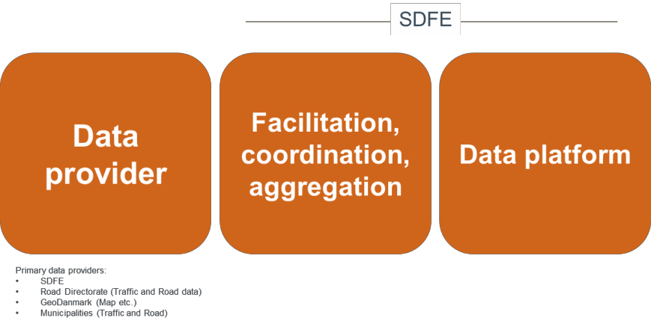

Acting as a passive data provider, an organisation can make data available for the operation of CAVs. This may be directly available to users and OEMs, or it may be the provision of data to support geospatial data providers (such as an inventory of speed limits to be fused with other data). An extension of this is to take a facilitation and coordination role, bringing together multiple actors (such as road authorities, municipalities and infrastructure providers) into a common reference/data model and governance model. This is the model for SDFE to pursuit.

There is also an opportunity to seek to add value to CAV operations through the provision of certain data. For example:

- Providing data on traffic status or road works (such as the Vejdirektoratet product VejMan in order to support dynamic routeing, reducing congestion and providing user benefits; and,
- Providing data on traffic volume, air quality and topography, providing a foundation for analysis and regulation of vehicle emissions.

These two roles are currently commonplace for public organisations. To continue to adopt this role may, through provision/exhibiting access to authoritative datasets from various data providers (agencies and municipalities), present a number of risks that needs to be considered:

- Taking responsibility for high-fidelity, safety-critical data for CAV operations, potentially with liability issues;
- An inability to directly impact operations, with no guarantee of ‘adding value’ through dataset provision.

Whilst collecting, aggregating and pushing data is passive, an alternative approach is to take an active role in the provision and use of geospatial data. Establishing a data platform to support operations can be seen as a means of leading on standards for data quality, on standardisation, and on use for wider benefits. This is likely to include:

- Real-time data provision (Data as a Service);
- A flexible and scalable architecture to respond to new data;
- The ability to ingest, aggregate, filter, model and report data for use in CAV operation;
- The ability to ingest data from CAVs for distribution to interested parties;
- Enforcement of standards;
- Ensuring accuracy, reliability, continuity and integrity; and,
- Actively managing risks to both direct users and wider stakeholders.

Consistency in use is particularly important given the evolving nature of CAV technologies, of their use, and of the variety of stakeholders.

Furthermore, there is a broader need – in a societal perspective, to make use of CAV data beyond the direct operation, and therefore beyond the interests of automotive manufacturers, for better planning, maintenance of infrastructure and performance reporting.

SDFE’s role in the emerging CAV ecosystem (short and mid- term)
As concluded earlier in the analysis (activity 1) there is no immediate or crucial requirement for SDFE or other geospatial data agencies (Road Directorate, GeoDanmark and Municipalities) to provide information for use in autonomous vehicles. However, the same information published as a consolidated data sets could be used in a broader perspective providing support for road and traffic administrations and operations, both on a local and national level for planning, construction, maintenance and managing use of the infrastructure – in a short- term perspective.

The gap-analysis concluded that a lot of the relevant road and traffic data – to a certain extent, exists and are available from central stakeholders:

- SDFE (Addresses, Stednavne, etc.)
- Road Directorate (Traffic and Road data, Road reference (Vejreference))
- GeoDanmark (Map etc. in collaboration between national and local level))
- Municipalities (Traffic and Road data)

The data sets are not integrated, referenced and aligned, and some are not easily available/accessible for public use. To be able to provide (publish) unified and integrated geospatial data for public administrations (short-term) and CAV’s (long-term) it is necessary to consolidate the data sets into a standardized data/reference model supporting geospatial data provision from stakeholders. The figure below illustrates the role as provider of an integrated data service, publishing road and traffic data (both static and dynamic) based on multiple sources of data (road authorities, municipalities and infrastructure providers) for the OEM Map industry to be used by the CAV’s for supplementing the onboard monitoring and scanning technology.

Figure 13: Geospatial data, dynamic traffic data and messaging service in CAV values chain
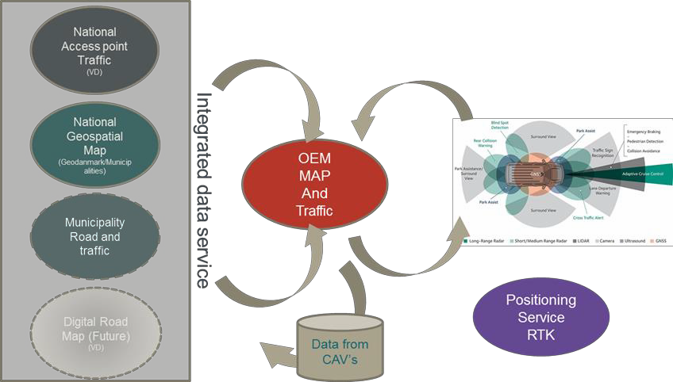

Today SDFE plays an active role as an enabler and provider of services and platforms for access to free public accessible data sets. Using this experience SDFE, could play an active role as enabler of a process towards publishing the geospatial datasets through standardisation, data and reference modelling and developing a governance model in close collaboration with the primary stakeholders (GeoDanmark, Road Directorate and Municipalities).

At EU and international level extensive activities on developing the future standards and regulations for operating CAV’s is undergoing and will influence the development and implementation of operating CAV’s and MaaS. By starting the process of building a centralised publishing service for access to geospatial data from relevant data owners - in time before the CAV’s arrive, could be an efficient instrument for complying to these standards and regulations as they are established. But also to create a working environment for CAV’s in early stages of their dissemination.

The analysis has identified four activities to be addressed as important for building the services platform:

- Access to high quality Static/dynamic data sets for road topography (what do roads look like) and road topology (what can road be used for), road attributes, environment etc. – short-term perspective

- Access to dynamic traffic information (Collision, road work, emergency messaging etc.) (National Access Point) – short-term perspective

- Provision of High Quality Positioning service (possibly through RTK) – mid-term perspective

- Receiver of data from CAV’s – long-term perspective The activities are described in the following sections.

High Quality road topology and topography
As mentioned above the relevant geospatial data are organised in vertically divided systems owned and maintained by different stakeholders, on different platforms and by different governance models.

A future consolidated geospatial service should be built on a common data and reference model, standards and a common governance model to provide coherent access to datasets held by the stakeholders through the publishing service.

Figure 14: Stakeholders - geospatial data
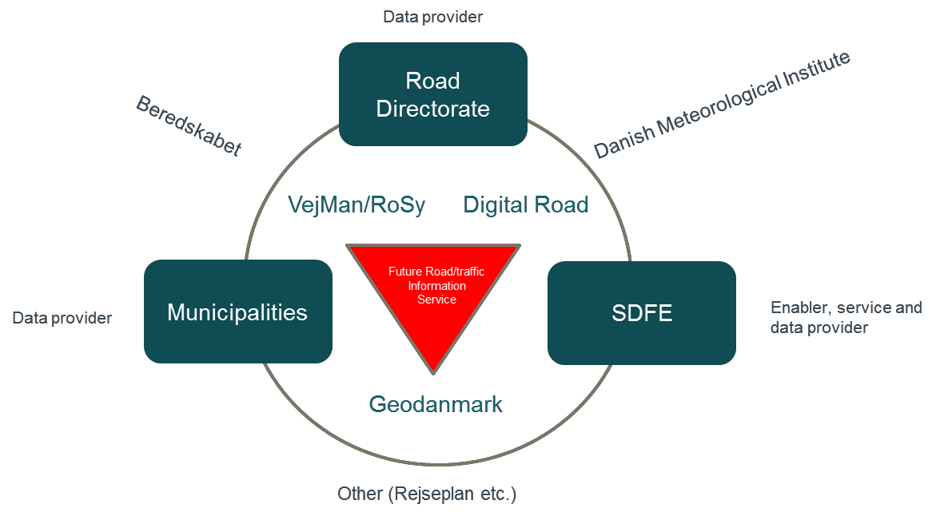
The figure illustrates roles as enabler, service provider, data provider of the primary stakeholders in providing geospatial data through key systems to a public accessible publishing service for road and traffic information.

Dynamic traffic data and messaging service
The Danish NAP (National Access Point for Traffic Information) which is currently under construction is supposed to exhibit static traffic data, dynamic traffic data and road status data for the primary road net. The service is owned and operated by the Road Directorate.

In the future, this should be extended to the secondary road net administrated by municipalities.

By integrating the service into the geospatial service for CAV’s and linking the information to the position of the requester it could provide high quality information for the operations and safety of CAV’s etc. through use of a standardized messaging service. In short-term perspective, the service could enhance and raise the quality of traffic information in Denmark.

High Quality positioning service
One of the important requirements for CAV’s and MaaS is the ability to obtain positional information with a high level of precision and accuracy (cm level) in real time to determine the vehicles position for safe and efficient operation. The use of GNSS in CAVs, and the ability to provide this level of quality, will be influenced through external factors. For example, this could include multipath and particular weather conditions, which may impact precision and accuracy. Augmentation and post-processing techniques are well used in GNSS, but may not be consistently applied across users. The foreseen geospatial service supports data and objects (traffic signs, road layout etc.) registered with high precision and accuracy, and a link to maps and therefore supports operation of the CAV’s. However, if the augmented GNSS signal quality is low, a more consistent and precise positioning service is required. It is important that requirements of precision, accuracy, integrity and availability can be maintained across all aspects of the network (vehicles, infrastructure and control). RTK potentially provides a means of achieving this across a large area.

SDFE together with Danish Technical University Space is undertaking a pilot project (TAPAS) to provide a test bed in area of Aarhus for use of RTK-technology to calculate an accurate position. The test bed will be operating from autumn 2018. The test bed supports all use of positioning services, not just CAVs.

A national Positioning service based on GNSS and RTK-technology will provide a very important service to the CAV’s but will also could be used in a broad perspective in other sectors e.g. construction, agriculture, maritime navigation in coastal areas (harbours etc.). Similar national services are operating in other countries
e.g. Sweden (SWEPOS).

There are two privately operated services in Denmark at this moment based on annual payment of use of the service.

Repository for CAV data
CAV’s constantly collects and broadcast data related to position, speed, action, performance, hindrances etc. Some of these data can be considered personal data and as such be regulated by privacy laws and regulations.
Other data can be considered “Vital” and in “Public Interest” these will be collected by the CAV-manufactures or the MAP-producers and it can be foreseen that sharing these data will be regulated (EU-level) and accessible to public authorities, to business use (payable) etc.

Access to these data will be of immense value to society both in terms of use for improving the safety, mobility and efficiency of transportation, but also in terms of providing Public Authorities with data to further develop, maintain and regulated the infrastructure.

An efficient way of colleting these data will be by building a central repository for collecting, sharing and making the data accessible for relevant authorities.

Benefits of the geospatial infrastructure
The benefits of improving the geospatial infrastructure for connected and autonomous vehicles can be better understood if seen in the perspective of the general development of cooperative intelligent transport systems (C-ITS71). This is because a lot of the benefits are heavily connected to other developments, in this case especially the development and implementation of autonomous vehicles and supporting systems.

- https://ec.europa.eu/transport/sites/transport/files/themes/its/doc/c-its-platform-final-report-january-2016.pdf

Figure 15: Benefits of a geospatial infrastructure platform
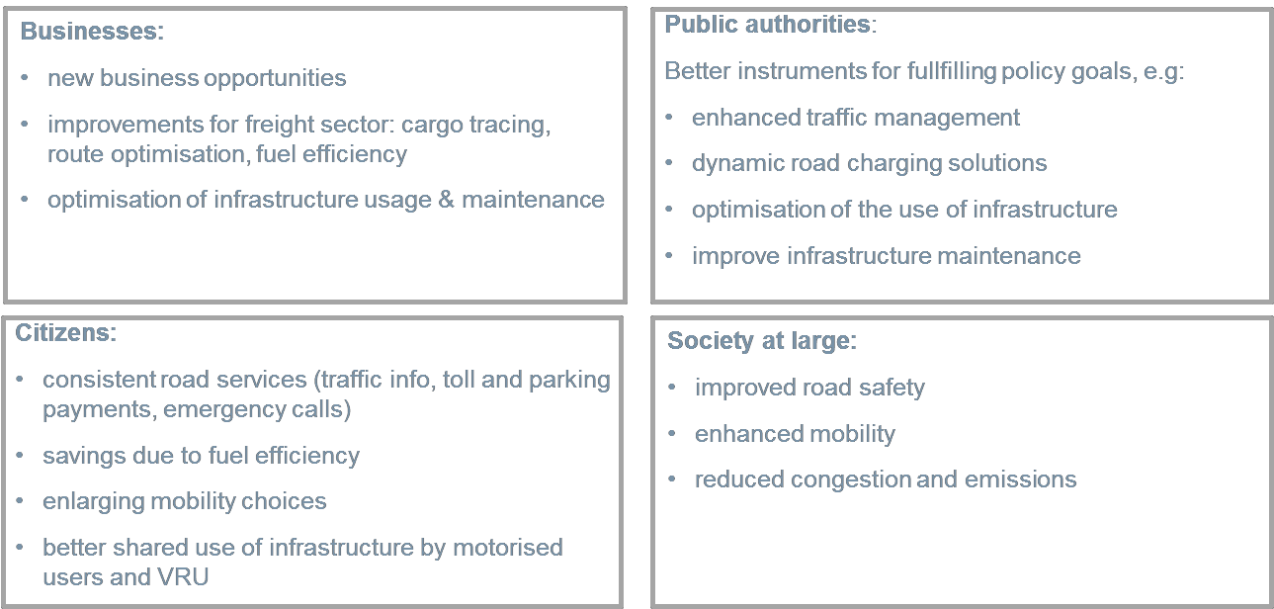
(From C-ITS platform Final Report 2016)

The figure 15 above highlights certain areas with society, business, public authorities and citizens where C- ITS and thereby also its geospatial infrastructure can be beneficial.

The benefits of geospatial data regarding what is mentioned in the figure, arguably relates more to certain aspects with clear geospatial relations such as improved road safety, enhanced traffic management, dynamic road charging solutions, improved infrastructure maintenance and consistent road services. But many, if not all, have an aspect linking it to place and position.

Some benefits are heavily related to the introduction of CAVs and the needed road infrastructure.

One such benefit is increased traffic efficiency. This is achieved through a higher overall transportation speed as there will be fewer interruptions, partially due to more efficient driving, but most of these savings can be achieved through intersection-related services, parking information and smart routing. In relation this, there are benefits such as improved fuel consumption and less polluting emissions both due to the improved transportation time and less idling but also as an intelligent vehicle can optimize fuel consumption.

Other parts lead to benefits such as increased safety. Overall accident and injury rates are predicted to become lower due to introduced technology. Some of the services related to this improvement is things such as a hazardous location warning, in-vehicle speed limits and intersection safety that all have strong ties to geospatial data. The overall safety improvement due to the successful introduction safety related CAV systems, is expected to reduce the number of fatalities and general injuries on a European scale by 7%72.

In addition to the directly related improvements there are also secondary benefits, one such is the possible effect introduction of CAVs can have on cellular and data coverage, which could lead to investment and improvement to the overall cellular network with related benefits.

As such the benefits are largely societal while main investment decisions lie with end-users and road authorities either by buying new and improved vehicles or by improving the infrastructure for it.

This is however not to say there are no potential benefits for road authorities and public institutions.

- https://ec.europa.eu/transport/sites/transport/files/themes/its/doc/c-its-platform-final-report-january-2016.pdf

The road authorities could realise economic benefits due to improved traffic flow and improved use of existing roads could reduce and postpone investments in new infrastructure.

Regarding the geospatial data aspect, a possible benefit as mentioned in figure 16 is also improved infrastructure maintenance, planning and development, that could be made easier and more efficient by a detailed mapping. This improvement is already happening with new road construction where even sub-surface infrastructure such as pipes and wires are mapped in detail and through new system-to-system road reference system (Vejreferencedatabasen). The same is apparent in the option for dynamic road information, by being able to change speeds limits or lane layout to fit what direction rush-our traffic moves at a certain time without having to change physical infrastructure.

As such, by having a consistent detailed geospatial data basis which could be utilized with future cars, could enhance the authority’s ability to manage traffic dynamically both in terms of improving overall efficiency but also in terms of for example enforcing green initiatives or taxing driving in certain areas or cities.

The benefits however do not come quick as the first period will entail investments. The C-ITS deployment could however according to C-ITS report, have a positive benefit/cost ratio of up to 3 to 1 in their scenarios. The significant benefits however, will first start to be noticeable about 5 to 10 years after investments are made but rely on multiple C-ITS related systems to be implemented as the overall benefits improve for each system added.

Appendices

.

Appendix A. Example C-ITS applications

Connectivity based safety
Applications to increase individual safety by informing/warning the road users, or directly interact with a vehicle (braking).

  - Road condition warning (emergency vehicle or motor vehicle approaching, stationary vehicle, collision, roadwork, etc.)
  - Collision avoidance (emergency electronic brakes lights and warnings: lane change/overtaking vehicle/pre-crash/forward collision/vulnerable road users etc.)
  - Driving assistance (curve speed warning, left turn assist, stop sign movement assistance, glare reduction, blind spot, speed limit notification, in-vehicle signage, wrong way warning, traffic signal violation warning, etc.)
  - Weather Response Traffic Information, allowing variable speed limit depending on weather events

Traffic efficiency
Applications to increase the efficiency of the traffic flow and prevent congestion. This includes informing/advising/instructing individual road users and traffic management measures by road operators

  - Decentralized floating car data
  - Intersection management
  - Co-operative adaptive cruise control
  - Co-operative vehicle highway automation system (Platoon)
  - Traffic signal priority request by designated vehicles
  - Traffic light optimal speed advisory
  - Traffic information (including queue) warning and recommended itinerary
  - Limited access warning and detour notification
  - Parking location and availability information

Environment
Applications to reduce the negative effects of traffic flow (GHG emissions, noise, air pollution etc).

  - Eco-approach and departure at signalized intersections
  - Eco-traffic signal timing
  - Eco-traffic signal priority
  - Connected eco-driving
  - Eco-lanes management
  - Eco-speed harmonization
  - Information on fuelling & charging stations for alternative fuel vehicles
  - Low emissions zone management
  - Dynamic eco-routing (Light Vehicle, Transit, Freight)
  - Park & Ride information

Comfort
Applications to enhance the users’ road experience, including information and entertainment but not exclusively.

  - Information such as point of interest notification and map download and update
  - Entertainment such as media downloading
  - Automatic access
  - Control/parking access
  - Local electronic commerce
  - Car rental/sharing assignment/reporting
  - Emergency Call (eCall) and Breakdown Call (bCall)
  - Pay-As-You-Drive (PAYD)
  - Stolen Vehicle alert and Tracking (SVT)

  - Personal data synchronization
  - Telematics, related to insurance

Maintenance
Applications to increase the efficiency of maintenance, whether the beneficiary is the individual users, private companies, or public operators.

  - Remote diagnosis and just in time repair notification
  - Vehicle data collect for product life cycle management
  - Probe-based pavement maintenance
  - Probe-based weather data to recommend treatment plans and weather response plans to snowplough operators

Planning
Applications to enhance local authorities’ understanding of the road network.

  - Vehicle classification-based traffic studies
  - CV-enabled turning movement & intersection analysis
  - CV-enabled Origin-Destination studies
  - Work zone traveller information

Appendix B. Investment stakeholders
This appendix summarises the main stakeholders investing in the CAV industry. Those stakeholders can be classified as governmental bodies, OEMs, and other (e.g. Google, Uber etc.)

Governmental bodies
Governmental bodies have a central role to define the safety and regulatory requirements of CAVs. Furthermore, CAVs are always collecting location, road and traffic data which can be used by government authorities to assess and analyse to assist in urban network planning. The data so derived can also be used to develop new road revenue models. For these purposes major investments across the world are funded by governmental authorities. Main initiatives and ambitions stated by governments are summarised below. This information is sourced from a report published in December 2016 by Michigan Department of Transportation and The Center for Automotive Research73:

- US – The US government has announced a 10-year, nearly $4 billion investment in FY17 budget proposal to test connected vehicle systems in designated corridors throughout the country, and work with industry leaders to ensure a common multistate framework for connected and autonomous vehicles74. The funding of the projects that are currently under the ‘Strategic planning 2015 -2019’ focus on the connectivity element.

- EU – EU has several projects related to autonomous and connected vehicles under different programmes. The most noticeable one is the ‘Vehicle and Road Automation’, a support action funded by the European Union to create a collaboration network of experts and stakeholders working on deployment of automated vehicles and its related infrastructure75.

- UK – UK is still part of the EU, however it is worth to be mentioned by itself as the UK government is heavily investing (more than £250 million) in connected and autonomous vehicles, as demonstrated by the number of projects funded from 2015 till now (50 projects and 6 test beds). The UK government has created the Centre for Connected and Autonomous Vehicles (CCAV) to keep the UK at the forefront of the development of connected and autonomous vehicle technology.

- Australia – In August 2016, Australia published its National Policy Framework for Land Transport Technology, containing policy principles and a 2016-2019 action plan. The Australian government aims to support the deployment of connected and automated vehicle technology through policy leadership, supporting investment in digital infrastructure, providing access to transportation data, creating a supportive regulatory environment, and investing in R&D and trials.

- China - Chinese authorities began getting involved and supporting the development of automated vehicle technology later than their American and European counterparts. They are however making rapid progress with recent activities. In November 2015, Shanghai unveiled a 3.6 km (2 miles) road section for testing self-driving vehicles, the first of its kind in China. Shortly after, similar test areas in the Beijing and Chongqing, and in the provinces of Hebei and Zhejiang were approved by the Ministry of Industry and Information Technology76.

- Japan - In November 2015, Japan’s Prime Minister made public the goal to provide “transport services using unmanned vehicles” and make possible automated driving on expressways by the 2020 Tokyo Olympics and Paralympics. The Japanese government is expecting that the vehicle technology and road infrastructure will be ready for demonstration tests by 201777.

73 http://www.cargroup.org/wp-content/uploads/2017/04/CAV_International_Survey_2017_555402_7.pdf
74 https://www.transportation.gov/briefing-room/secretary-foxx-unveils-president-obama%E2%80%99s-fy17- budget-proposal-nearly-4-billion
75http://www.autonet2030.eu/wp-content/uploads/2016/11/15_2016-10-27-AutoNet-Final-Event-
VRA_CARTREv02.pdf
76 http://www.chinadaily.com.cn/business/motoring/2016-06/13/content_25691027.htm
77 http://vra-net.eu/wp-content/uploads/2016/10/Shinji-Itsubo-National-Institute-for-Land-and-Infrastructure- Management-NILIM.pdf

- Singapore - Singapore has several initiatives intended to create an advanced transportation network in the world.

- South Korea - South Korea is the fifth-largest auto manufacturing country in the world, and thus is a significant stakeholder in the development of connected and automated vehicle technology. In September 2015, South Korea announced that the national government would contribute efforts towards developing and integrated connected and automated transportation system. South Korea permitted testing of automated vehicles on select public roads in 2015, and expanded the scope of available roads in 2016.

- United Arab Emirates - Dubai’s 2030 goal is to make 25% of all trips within the city driverless, as announced in 2016 by Vice President and Prime Minister of the United Arab Emirates.

OEMs
OEMs are investing and acquiring the right technology expertise and also consolidating ventures which integrate hardware and software system. OEMs try also to incorporate the Advanced Driver Assistance System (ADAS) providers or tech providers for the efficient functioning of the autonomous vehicles. Tesla, BMW, Audi, etc., are working on developing their own autonomous Cars.

Other
Software Companies: Substantial opportunities are going to be available for a range of technology providers’ esp. software companies who are involved in application development for example, cloud and IT services, security software and vehicle engineering. For instance, there is an unspoken agreement amongst all the stakeholders that the data so generated by the autonomous vehicles will use cloud as a medium for storage. Transportation agencies will then be able to use this data, use software and analytical tools to understand the data and then implement the findings in designing and developing ‘smart’ roads and an efficient transport system78.

Mobile Service Providers: According to Garter by 2018, 20% of all new vehicles will need to be self-aware to capture systems status, positioning and surroundings in real time. This would lead to a significant increase in data consumption pattern and therefore create potentially attractive revenue models for mobile service providers. Mobile service providers will have to build new capacity, products and services. This shall benefit the telecommunications industry and the Original Equipment Manufacturers (OEMs) to take advantage by selling their products to consumers.

Tech giants: This category refers to companies like Google, Apple etc. which are working in multiple industries at the same time. These companies are heavily investing in CAVs and maps inside the autonomous vehicles as well.

78 https://www.geonovum.nl/sites/default/files/Self-DrivingVehiclesReport.pdf

Appendix C. Geospatial data as a tool

Geospatial data as a tool (Case Study 3)

Title/Country |  | Europe
Objectives | Creation of an innovative method of providing a cooperative intelligent traffic system through V2V communications and processing information from various sources Expected outcomes: delivery of improved traffic management information to drivers and  other stakeholders and delivery of security and safety information to the automotive sector
Stakeholder | Consultancy, University, Research organisation, automotive engineering  Control F1, Infohub, University of Nottingham, Huduma Ltd
Services | Monitor traffic in real time to divert drivers around any obstructions on their route  Identify issues like accident blackspots, road and other infrastructure damage via automated reports from vehicles travelling through the city.  Find and book available parking spaces as well as giving drivers access to other facility information.  Offer journey planning information using dynamic maps updated closed to real-time, automatically to the central systems.  Monitor and receive reports on driver behaviour such as speeding, tailgating and heavy braking and turning.
Technologies | GNSS, dynamic maps, DSRC/ITS-G5 transmitter for V2V communication
Autonomy level | N/A
Timeframe | 2016 - 2018
End user | Driver, OEMs, Journey planning app providers, Insurance companies
Geospatial data use | Underpinning some mentioned services: e.g. location of parking space, issues (accident, infrastructure damage), other facilities.  Improve mapping data through ameliorated V2V connections
Reference | http://www.i-motors.cloud/

Geospatial data as a tool (Case Study 4)

Title/Country |  | Europe
Objectives | Development of an understanding of the public acceptance, legal and insurance blockers to Connected and Autonomous Vehicles  Development of a proven independent test site for Autonomous Vehicles (AV) Development of test cases by social, legal and insurance experts and evaluation using real roads and a fully immersive simulator
Stakeholder | Consultancy, Local authorities, Universities, Insurance, automotive engineering Atkins, BAE Systems (Operations) Ltd, Williams Grand Prix Engineering Ltd. Fusion Processing Ltd, First Bristol Ltd, AXA Insurance Limited, University of West England, University of Bristol, Bristol City Council, South Gloucestershire Council
Timeline | 2015 – 2018
Services | Handover between the driver and the vehicle Effective Vehicle to Vehicle and junctions interaction.
Technologies | On-vehicle sensors
Autonomy level | Levels 3, 4
End user | Driver, Insurance, Local authorities
Geospatial data use | Location of objects in closed vicinity, e.g. road furniture
Reference | https://www.venturer-cars.com/

Geospatial data as a tool (Case Study 5)

Title/Country | Multi-Car Collision Avoidance (MuCCA) | Europe
Objectives | Driver aid that aims to avoid multi-car collisions on motorways. If an accident cannot be avoided, the MuCCA system will attempt to minimise its consequences (both injuries and damage)
Stakeholder | Automotive Engineering, M+E engineering, Automotive consulting, University, Innovation centre, Car manufacturer  IDIADA Automotive Technology UK Ltd, Cranfield University, Cosworth Electronic ltd, Secured by Design ltd, Transport Systems Catapult, Westfield Sportscars ltd.
Timeframe | 2017 - 2020
Services | Development of a novel level 4 collision avoidance system in which neighbouring cars cooperate. This includes the anticipation of the trajectories of nearby non-equipped cars, accounting for their likely human driver behaviour and physical vehicle dynamics.  Development of test environments for automated vehicle systems both virtually (in simulation) and at vehicle level (on a test track) for comprehensive validation and live demonstration.  Identification of key V2V cyber-security requirements relevant for the MuCCA cooperative function.  Development of innovative means to correlate identity of V2V respondents with vehicles "seen" by other sensors.  Development of data-logging tools that can be used in "replay" to refine control strategies.
Technologies | Machine learning/Artificial Intelligence, simulation, sensor systems, vehicle-to-vehicle communications and vehicle control systems.
Autonomy level | Level 4
End user | Drivers
Geospatial data use | Location of objects in closed vicinity, e.g. road furniture
Reference | https://www.gov.uk/government/uploads/system/uploads/attachment_data/file/650444/ccav- research-and-development-projects-2017.pdf

Geospatial data as a tool (Case Study 6)

Title/Country | 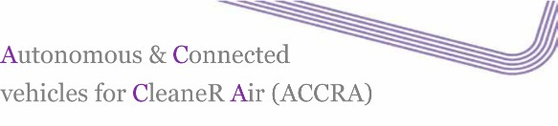 | Europe
Objectives | Development of a system allowing remote control of a vehicle energy management system to ensure it is running in zero emissions (ZE)
Stakeholder | Consulting, Research, Sensor design and analysis, Local authority, Automotive Engineering  Dynniq UK Ltd., Transport Systems Catapult, Cenex, EarthSense, Systems Ltd, Tevva Motors Ltd, Leeds City Council
Timeframe | 2017 – 2018
Services | Monitoring the vehicles’ location and operational state, control the ZE running strategy ensuring ZE through areas of poor Air Quality, respond to pollution violations and modify (on-demand) the ZE strategy of the vehicle via active geo-fencing.
Technologies | Mobile Air Quality sensors
Autonomy level | N/A
End user | Air quality management authority, driver
Geospatial data use | Information on vehicle’s surroundings and weather information
Reference | https://www.gov.uk/government/uploads/system/uploads/attachment_data/file/650444/cc av-research-and-development-projects-2017.pdf

Geospatial data as a tool (Case Study 7)

Title/Country | 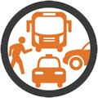  New York City (NYC) DOT Pilot | US
Objectives | Deployment of connected vehicle technology, including in-vehicle pedestrian warnings in large ﬂeets that operate in New York City and an additional V2I/I2V project component that will equip approximately 100 pedestrians  Provision of system capabilities to manage the large ﬂeets and their safety applications Measurement of the system’s performance while preserving privacy for ﬂeet owners’ and participants’ personally identifiable information  Focus on the stability and robustness of the roadside unit (RSU) and onboard unit (OBU) “platforms” to support Over the-Air (OTA) software updates and data collection
Stakeholder | Local authorities, Transportation authorities, Supply chain management NYCDOT Bureau of Traffic Operations, NYCDOT IT Department, New York City Department of Information Technology and Telecommunications, NYCDOT Fleets, Taxi  and Limousine Commission and Taxi Fleets, Metropolitan Transportation Authority (MTA) / New York City, Transit, New York City Department of Sanitation (DSNY), United Parcel Service (UPS), Pedestrians for Accessible and Safe Streets Coalition
Timeframe | 2015 - ongoing
Services | V2I/I2V Safety (Speed Compliance, Curve Speed Compliance, Speed Compliance/Work Zone, Red Light Violation Warning, Oversize Vehicle Compliance, Emergency Communications and Evacuation Information)  V2V Safety (Forward Crash Warning (FCW), Emergency Electronics Brake Lights (EEBL), Blind Spot Warning (BSW), Lane Change Warning/Assist (LCA), Intersection Movement Assist (IMA), Vehicle Turning Right in Front of Bus Warning)  V2I/I2V Pedestrian (Pedestrian in Signalized Crosswalk, Mobile Accessible Pedestrian Signal System (PED-SIG))
Technologies | Short Range Communication (DSRC), 310 signalized intersections for vehicle-to- infrastructure (V2I), RSUs
Autonomy level | N/A (Connectivity focused)
End user | Drivers, Traffic operators, Local authorities
Geospatial data use | Location of street furniture, vehicles (taxis, shared fleet etc.), Itinerary via bus GPS datasets, Taxi GPS trip records
References | https://www.its.dot.gov/pilots/pilots_nycdot.htm

Geospatial data as a tool (Case Study 8)

Title/Country | Driver Assistive Truck Platooning (DATP) | US
Objectives | Evaluation of impacts on surrounding traffic of DATP, in terms of safety and traffic flow Evaluation of impacts of DATP on infrastructure  Evaluation of feasibility of conducting enforcement responsibilities when DATP trucks are operating  Evaluation of administrative impacts of permitting DATP systems and operations
Stakeholder | Research Institutes, University, Truck companies, Engineering  Auburn University, Peloton, Peterbilt Trucks, Meritor WABCO, American Transportation Research Institute (ATA, TMC)
Timeframe | 2013 - 2016
Services | Longitudinal control only V2V communications  Exchanging performance parameters between vehicles  Positioning sufficient to discriminate in-lane communications from out-of-lane communications  Human-machine interfaces  Distinct modes for leading or following
Technologies | Acceleration Control System, Active Braking System, System Control Module, Radar Unit, Display, Camera, Antennas, Platooning Indicator
Autonomy level | N/A
End user | Truck Drivers, Traffic operators, Local authorities
Geospatial data use | Getting information for street furniture, Location of vehicles (Trucks)
Reference | http://vra-net.eu/wp- content/uploads/2014/04/Driver_Assisted_Truck_Platooning_DATP_FHWA-Auburn.pdf

Geospatial data as a tool (Case Study 9)

Title/Country | Autonomous car development company | OEM/US
Objectives | Waymo’s vehicles use sensors and software to detect other roadway users, and objects. Responds to unexpected changes like closed lanes or respond to complex cues at a railroad crossing.  Provide defensively driving, meaning they stay out of blind spots and nudge away from large vehicles.
Stakeholder | Autonomous car development company  Waymo (spin out of Google's parent company, Alphabet Inc)
Timeframe | 2009 – ongoing
Services | Working towards fully self-driving cars
Technologies | On board sensor technologies including LIDAR and camera, GPS
Autonomy level | Level 5 (End goal)
End user | Driver
Geospatial data use | High definition inch-precision map of the area the vehicle is expected to use, including height of traffic lights; geospatial data of direct vehicle surrounding collected from on- board systems
Reference | https://waymo.com/

Geospatial data as a tool (Case Study 10)

Title/Country | OEM - Tesla Autopilot | OEM/US
Objectives | The Tesla Autopilot relies on technology created by Mobileye to generate a digital image of the space around the car.  Using cameras and radar sensors, and some very complex algorithms, the Mobileye black box can recognise the road ahead, choose the optimum path along it, and recognise objects like other cars, cyclists, and road signs.  Tesla’s Autopilot at this stage it is only semi-autonomous.
Stakeholder | OEM  Tesla
Timeframe | 2014 – ongoing
Services | Autosteer: Working with the radar cruise control system, lane cameras and all-round sensors, Autosteer allows driver to let go of the wheel on the motorway or dual carriageway while the car steers itself. The radar cruise control and autonomous braking means the driver won’t crash into the car in front, as an Autopilot-equipped Tesla will brake from 70mph to a standstill if required.  Auto Lane Change: Tesla can’t yet change lanes autonomously to overtake slower traffic, for example. At the moment, if you have Autopilot engaged and want to overtake, you simply turn on the relevant indicator using the column stalk. The car will change lanes when the sensors tell it such a manoeuvre appears safe, but Tesla says the driver still needs to double-check their surroundings before activating a lane change.  Automatic Emergency Steering: With side collision sensors constantly monitoring your progress, the Autopilot system will take evasive action by swerving away from another vehicle that comes too close. As the Tesla swerves, it sounds an alert to tell the driver to take the wheel.  Autopark: In town, the Tesla will recognise parking spaces and parallel park on command.
Technologies | LIDAR Technology, GPS
Autonomy level | Level 3 at the moment (aiming at level 5 soon)
End user | Driver
Geospatial data use | Detailed high-precision mapping data
References | http://www.autoexpress.co.uk/tesla/96682/what-is-tesla-autopilot-everything-you-need-to- know  https://www.tesla.com/en_GB/autopilot http://fortune.com/2015/10/16/how-tesla-autopilot-learns/

Geospatial data as a tool (Case Study 11)

Title/Country | OEM - Audi Piloted Driving | OEM
Objectives | Audi recently deployed a vehicle equipped with its Piloted Driving system. This system:  - Allows a vehicle to accelerate/decelerate, steer and change lanes autonomously  - Work at speeds of up to 70mph and only on highways, as yet does not work in built up areas or with traffic signals but will in the future
Stakeholder | Audi  Automotive engineering
Timeframe | Audi has announced that it will make the system available in the next version of the Audi A8, expected within 2018.
Services | Enhanced safety: Use of technology that helps drivers to bypass obstacles that suddenly appear on the road. Sensor and camera data is used to calculate the best accident prevention strategy. Once again, the assistance system provides support while the person at the wheel remains firmly in the driver’s seat.  Turn assist: Within the system parameters, turn assist monitors oncoming vehicles on the opposite side of the road when the driver is about to turn left. If the system recognizes a critical situation during the turn manoeuvre, it automatically actuates the brakes. The system is enabled as soon as the driver switches on the indicator and the vehicle is traveling at a speed of between around two and ten kilometres per hour.  Traffic jam assist: Between speeds of zero and around 60 kilometres per hour, traffic jam assist gives the driver semi-automatic distance control — for instance, in slow-moving traffic. Within specific system parameters, the system recognizes lane markings as well as vehicles in the same lane, lending assistance in steering, accelerating and braking. At speeds of over around 60 kilometres per hour, Audi active lane assist helps the driver stay in lane.  Predictive efficiency assist: In conjunction with the ‘MMI Navigation’ plus with ‘MMI  touch’, adaptive cruise control harnesses data from predictive efficiency assist to adjust speed in an anticipatory manner. Within the system parameters, it uses information on curve radii, transitions into urban areas and speed limits stored in the navigation system to do so. Data from camera-based road sign recognition technology is also assimilated.  While in addition predictive efficiency assist selectively controls engine thrust and coasting phases, which can make for more fuel saving driving, the control of the vehicle remains firmly in the driver’s hands.
Technologies | Radar and ultrasound sensors coupled with the front camera
Autonomy level | Level 3 (at the moment)
End user | Driver, OEM
Geospatial data use | Use of Navigation system for ‘predictive efficiency assistance’
Reference | http://www.audi.com/en/innovation/piloteddriving/assistance_systems.html

Geospatial data as a tool (Case Study 12)

Title/Country | Autonomous mobility-on-demand programme for Singapore | Singapore
Objectives | Delphi will provide a fleet of fully autonomous vehicles and develop a cloud-based mobility-on-demand software suite. It will also conduct a trial of an urban, point-to-point, low-speed, autonomous, mobility-on-demand service
Stakeholder | Manufacturing company  Delphi Automotive
Timeframe | 2016 – 2019
Services | Facilitate efficient urban and suburban vehicle sharing, autonomous bus or taxi services, logistics and long-distance truck platooning.  Reduce overall traffic congestion and vehicle emissions
Technologies | Cameras, Lidar, Radar, Internal mapping technology (but will eventually look to use an outside vendor), Vehicle agnostic technology (meaning it can be applied in passenger cars, buses, commercial vehicles, purpose-built mobility pods and electric vehicles)
Autonomy level | Levels 4,5
End user | Drivers, Traffic operators, Logistic companies
Geospatial data use | Getting information for street furniture, Location of vehicles (taxis, shared fleet etc.)
References | https://www.autoblog.com/2016/08/01/delphi-autonomous-test-program-singapore/ https://smartcitiesworld.net/transport/transport/autonomous-mobility-on-demand- programme-for-singapore

Appendix D. Activities of mapping
companies

Navmii - http://navmii.com/adas
Navmii uses an Advanced Driver Assistance Systems Solutions for visual recognition, advanced algorithms and deep learning. It provides drivers with additional information and alerts about the driving environment around them.
ADAS Features:
- Dual camera powered computer vision
- Road signs recognition – long range road sign recognition and feedback
- Forward collision warning – additional eye road scanner and collision warnings
- Lane departure warning – lane deviation alerts
- Virtual Bumper – low speed collision warning
- Pedestrian detection – sudden appearance of pedestrians warnings
Civil Maps - https://civilmaps.com/
Civil Maps provides cognition for autonomous vehicles, enabling them to crowdsource continental scale, 3D semantic maps for safe driving. Civil Maps is also developing techniques for localizing a vehicle in six degrees of freedom: the movement axes (x, y, z) and also rotational axes (roll, pitch, yaw).
5D Robotics - http://5drobotics.com/about-us
5D provides position and navigation, as well as obstacle avoidance and guarded motion systems. The company's systems work in any environment, including those without GPS, allowing vehicles to park side by side, indoors, outdoors and in the snow, fog, or rain.
Sanborn - http://www.sanborn.com/highly-automated-driving-maps-for-autonomous-vehicles/
Sanborn’s Advanced Technology group has developed proprietary Mapping technology that leverages Aerial Imagery, Aerial LiDAR data, and Mobile (driven) LiDAR data to create standardized, high-precision 3D base-maps focusing specifically on self-driving vehicle models and markets.
Sanborn HD Maps for Autonomous Driving Feature:
- Accuracy in the 7-10cm absolute ranges.
- Highly detailed inventories of all stationary physical assets related to roadways such as road lanes, road edges, shoulders, dividers, traffic signals, signage, paint markings, poles
- Electronic Horizon Predictive Awareness – autonomous vehicles will know what lies ahead.
- OpenDrive and NDS format compatibility.
- ADASIS v2 standardization.
- Proprietary Geo-Database schematics.
- Integration compatibility with all forms of Municipal Data, Vehicle Supplied Data, and Crowd- Sourced datasets.
- Conflation functionality designed to improve the absolute accuracy of 3rd party Road Data (probe or alternative source) to high-precision standards.
- Online web-based analytics – designed for auto teams to review / discuss vector and point data super-imposed digitally on top of high-resolution imagery.
- Lightweight data size – data is optimized and compressed for onboard CPU systems.
NVIDIA - https://www.nvidia.com/en-us/self-driving-cars/hd-mapping/
NVIDIA provides highly detailed maps for autonomous vehicles. NVIDIA uses localization, structure-from- motion algorithms that enable data from multiple cameras to be converted into detailed 3D mapping information. NVIDIA also combines data from various inertial sensors in the car, along with GPS data and camera that enables precise positioning of key landmarks. LIDAR information can be utilized to create even

richer maps with greater detail. A combination of artificial intelligence and VSLAM (Visual Simultaneous Localization and Mapping) handle all stages of map creation.

Deepmap - https://medium.com/deepmap-blog/your-data-your-map-1f0280eda0c3

  - Handle sensor failures and challenging environmental conditions
  - Connected cars for better navigation systems

Ushr (Subsidiary of Geodigital Insight focused on CAVs) - http://www.ushrauto.com

Provides precise, high-definition mapping technology and software for autonomous vehicles.
Combines 3D maps built on remote sensing and imaging technologies such as LiDAR with industry analytics and location-based work management software.

Swift Nav - https://www.swiftnav.com/

Swift Nav provides an improved GNSS system with high accuracy that enables the next generation of autonomous vehicle applications requiring lane or sub-lane level position

Faraday Future

Faraday Future’s plan for a mapping technology for self-driving: Create a proprietary engine that will utilize its own crowdsourced dynamic map in combination with a static map sourced from a third-party, according to sources familiar with the project. Mapping providers such as HERE, Sanborn, and TomTom are likely candidates to be third-party providers for the static maps used by the engine.

Lvl5 - https://lvl5.ai/

Computer vision software to crowdsource high-accuracy maps for self-driving cars.

PIE Mapping

Provider of digital mapping, data and routing services for CAVs

Novatel - https://www.novatel.com/industries/autonomous-vehicles/#technology

  - High precision Real Time Kinematics (RTK) positioning firmware to provide centimetre level positioning. Features: (Rapid Time to Narrow Lane (TTNL) at variable baseline lengths, Ambiguity fixing out to 40 + km, cm + 1 ppm accuracy, GPS, GLONASS and BeiDou modes)
  - Inertial Measurement Units (IMUs) to provide reliable, continuously available, position, velocity and attitude-even through short periods of time when satellite signals are blocked or unavailable.
  - GNSS satellite clock and orbit correction data to yield robust positioning without the need for nearby base stations.
  - Post-processing for highly accurate post-mission position to maximize the accuracy of the solution by processing previously stored Global Navigation Satellite System (GNSS) and Inertial Measurement Unit (IMU) data forward and reverse in time, and combining the results. The position, velocity and attitude solution can be smoothed and output at the required data rate and in the coordinate frame required. This process also provides the ability to assess the solution reliability and accuracy.

Appendix E. Trends analysis
This table sums up the findings in section 9.2 to 9.5: Transport impact :
    - trip demand – how people live and work
    - Mode choice – how people make choices about transportation

Category | Trend | Transport impact |  | Type of impact |  | Overall effect
 |  | Trip demand | Mode choice | Adoption | Maturity | +/- | Minor/Major | 2025?
Social | Decrease in car ownership |  | X | X |  | Uncertain | Minor
 | Poor public acceptance of CAVs  - Trust/Desire to drive/Job protection |  | X | X |  | Negative | Major
 | Public attitude towards data privacy |  | X | X | X | Positive | Major | X
 | Tendency to share journeys and vehicles |  | X | X |  | Positive | Minor
 | Ageing population | X |  | X |  | Positive | Major
 | Urbanisation growth |  | X |  |  | Uncertain | Minor
 | Working practice  - Remote working/Flexible working | X | X | X |  | Uncertain | Minor
 | Favour towards clean transport modes |  | X | X |  | Uncertain | Minor
Economic | Data availability and sharing |  |  |  | X | Positive | Major | X
 | High technology cost |  | X | X |  | Negative | Major | X
 | Business models | X | X | X |  | Positive | Minor
Political | Investment and funding availability |  | X |  | X | Positive | Minor | X
 | Standardisation |  | X |  | X | Positive | Major | X
 | Regulation  -Data sharing/Social concerns response/Liability |  |  | X | X | Uncertain | Major | X

Technological | Connectivity technologies  -Roadside connectivity/GNSS connectivity |  | X |  | X | Positive | Major | X
 | Automation technologies  -Sensors for environmental scanning/Artificial Intelligence/Computing power |  | X |  | X | Positive | Major | X
 | Other  Cyber protective technology/VR&AR/Blockchain |  | X |  | X | Positive | Major | X

© Atkins Ltd except where stated otherwise.

The Atkins logo, ‘Carbon Critical Design’ and the strapline ‘Plan Design Enable’ are trademarks of Atkins Ltd.

Atkins Geospatial Data for Autonomous Vehicles | Version 1.0 | 2017 83

