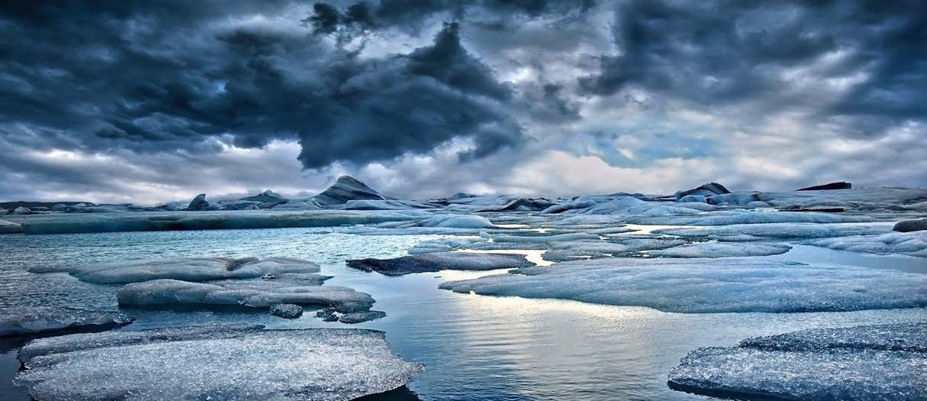

Arctic Spatial Data Infrastructure 2015–2017 BIENNIAL REPORT

June 2017

Message From the Arctic SDI Board Chair

It has been my pleasure to serve as the Chair of the Arctic Spatial Data Infrastructure (SDI) Board concurrently with the U.S. Chairmanship of the Arctic Council for the past 2 years. The Arctic SDI is an invaluable opportunity to increase international collaboration and strengthen relationships among the national mapping agencies of the eight Arctic Council member nations.
This report highlights the successes and accomplishments of the Arctic SDI during the U.S. Chairmanship, acknowledging that they are a result of years of cooperation and effort to identify common goals and opportunities to build on national and regional efforts across all of our countries. Together, we have focused on building the infrastructure as colleagues and partners who face the same challenges in each of our countries. We have created a 5-year Strategic Plan and a governance structure, and our experts have begun to document, track, and work through a suite of strategic activities.
Eight countries coming together around common standards and common goals is critical at this time. The globe is getting smaller. These past few years have been punctuated with humanitarian efforts requiring a multinational response to earthquakes, tsunamis, and famine, and an essential component to these efforts is integrating information to bring data together in realtime. Standards allow data to come together in a way that’s meaningful, authoritative, and accessible in realtime. It’s my hope to continue to bring more datasets together to allow mash-ups to occur based on applications that we have not expected and cannot quite anticipate, limited only by the imagination of the scientists and stakeholders using the data.
The Arctic is undergoing dramatic changes—it’s probably the area on the planet that’s changing the most; in particular, it’s warming rather quickly. The Arctic has a rich diversity of wildlife and resources and is one of the most valuable regions on the planet, which gives us all reason to care about the economic and environmental impacts on this region. The idea behind the Arctic SDI is to bring together data and information—the most authoritative information we have—to aid in our understanding of what’s happening in that environment and allow smart decisions to be made as a result.

Sincerely,

Kevin T. Gallagher
Associate Director, Core Science Systems, U.S. Geological Survey

Table of Contents
Message From the Arctic SDI Board Chair i
Why an Arctic SDI 1
Recognizing Successes and Accomplishments—2015–2017 1
Delivering on the Strategic Plan 2
SDI Manual for the Arctic 2
Outreach 3
Arctic Council 3
International Hydrographic Organization 3
Delivering Authoritative, Harmonized Data 3
Basemap 4
Circumpolar Gazetteer 4
Arctic SDI Geoportal 4
OGC Arctic Spatial Data Pilot 5
Arctic Digital Elevation Model 5
Looking to the Future of Arctic SDI 5

Why an Arctic SDI
Arctic SDI Mapping Agencies
- Natural Resources Canada, Canada Centre for Mapping and Earth Observation
- Agency for Data Supply and Efficiency, Denmark
- National Land Survey of Finland
- National Land Survey of Iceland
- Norwegian Mapping Authority
- Federal Service for State Registration, Cadastre and Mapping of the Russian Federation
- Swedish Mapping, Cadastral and Land Registration Authority
- U.S. Geological Survey
A spatial data infrastructure (SDI) provides tools for data distributors to ensure geospatial data is easier for users to access, validate, and combine with other data. Important datasets are produced and distributed by many stakeholders—in the public and private sector— and most of it can be geographically referenced.

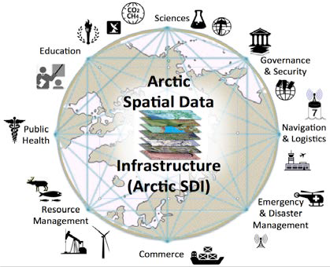

The Arctic Spatial Data Infrastructure initiative
brings together geospatial experts and scientists in a voluntary cooperation between the eight national mapping agencies of the Arctic countries (Canada, Kingdom of Denmark, Finland, Iceland, Norway, Russia, Sweden, and the United States) in direct support of the priorities of the Arctic Council and other important stakeholders.

The Arctic SDI was established to address the need for readily available spatial data in the northern areas of the globe. The national mapping agencies connect ongoing priorities and respective national SDI initiatives with the international and global communities such as the UN-GGIM, ISO, OGC, IHO, and GEO,1 to name a
few.

1United Nations Committee of Experts on Global Geospatial Information Management, International Organization for Standardization, Open Geospatial Consortium, International Hydrographic Organization, and Group on Earth Observations

Building on these international efforts and agreements, the Arctic SDI cooperation embraces the system of systems approach to the access and use of data by working across mapping agencies with stakeholders representing many sectors. It is important to showcase the value of a rich interoperable data environment through the use of standards and information management best practices to break down information silos. The goal of this initiative is to facilitate delivery of data to and from local, national, regional, and global stakeholders.

Recognizing Successes and Accomplishments—2015–2017
In 2007, the concept of a regional spatial data infrastructure for the Arctic was introduced at the GeoNorth I Conference in Yellowknife, Canada, followed by unanimous formal support for the Arctic SDI initiative in 2009 by Arctic Council Senior Arctic Officials (SAO). In 2014, the national mapping agencies signed a memorandum of understanding (MOU) that has led to demonstrable progress toward operationalizing the first elements of the Arctic SDI.

In 2015, the Arctic SDI Board approved a set of governance structures and created the Arctic Spatial Data Infrastructure Strategic Plan 2015- 2020 with an Implementation Plan and Roadmap, which outline strategic activities

necessary for the Arctic SDI to deliver services to support Arctic stakeholders and to facilitate the adoption of common information management best practices.

These strategic activities include iterative dialog with Arctic stakeholders to understand their unique needs for reference and thematic data and to gain insights into the constraints, such as low or no bandwidth in remote environments, and other challenges that impact technology and interoperability.

Other strategic activities focus on improved data sharing through standards and information management best practices that contribute to the availability, accessibility, and usability of data around the world—especially the Arctic. Aligning and documenting priorities has paved the way for notable and significant growth of the Arctic SDI these past 2 years.

Delivering on the Strategic Plan
The Arctic SDI completed a professional SDI evaluation and the developed key performance indicators that will allow us to monitor progress and ensure a healthy infrastructure. To facilitate
common understanding across stakeholders, a suite of communication materials were created, including a Fact Sheet; a video, Introduction to the Arctic SDI; an Arctic SDI Manual (described below); and a redesign of the Arctic SDI website.

Arctic SDI Manual
The newly published SDI Manual for the Arctic provides information and guidance on the planning, management, development, and maintenance of the Arctic SDI to stakeholders. It provides good data management practices, identifies policy and guideline requirements, and demonstrates the value and benefits an SDI provides to enhance efficient monitoring and decision making in the Arctic. The manual addresses the needs of three audiences: (1) high- level strategic decision makers, (2) Arctic data providers and distributors, and (3) the end users of Arctic data.

The SDI manual, and accompanying Glossary of Terms, are “living documents” that will be updated continually to reflect the evolution of SDI components and also the changing information requirements of the Arctic stakeholders.

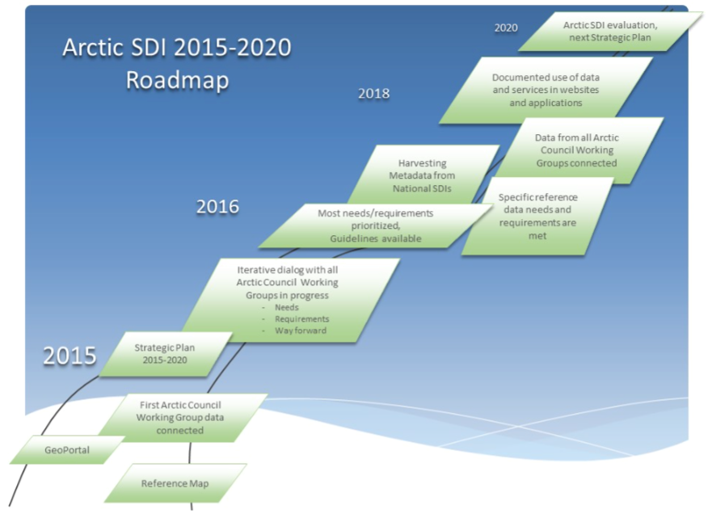

Outreach

Arctic Council
In September 2015, the Arctic SDI was invited to develop and facilitate a breakout session, titled Standardized Geospatial Data Management and Sharing, at the Joint Arctic Council Working Group Meeting held in Tromsø, Norway. Several key messages were highlighted in the Joint Meeting report to the Arctic Council SAOs as important items for the Arctic Council to build on. These include the importance of standards, data management, and interoperability coupled with the need for geospatial experts, identification of common goals across the Arctic Council Working Groups, and establishment of crosscutting expert groups to address geospatial data management.

We highlighted our collaborations at various venues, including a presentation at the October 2016 Arctic Council SAO meeting and several other venues, an intervention on the floor of the UN-GGIM, and a poster presentation at the April 2017 International Conference on Arctic Science: Bringing Knowledge to Action. The Arctic SDI provides twice annual reports to the Arctic
Council SAOs through the Conservation of Arctic Flora and Fauna Working Group (CAFF) and outreach and collaboration has resulted in integration of CAFF data and the dynamic delivery of embedded maps on their website.
International Hydrographic Organization (IHO)
In September 2016, the IHO Arctic Region Hydrographic Commission (IHO/ARHC) formalized the Arctic Regional Marine Spatial Data Infrastructure Working Group (ARMSDIWG). As a result of early outreach efforts, the documentation for the ARMSDIWG stated, “the ARHC is clearly positioned to have a working group to communicate, connect, and create a Marine Dimension to the greater SDI for the region,” and “establish communication channels …[with] NMAs to promote sharing of SDI information and find areas for collaboration.”

International representatives of the Arctic SDI and IHO/ARHC met in Copenhagen in April 2017, laying the foundation for a partnership that will foster opportunities to bring authoritative Arctic land and water reference data together and help ensure we don't build information silos.

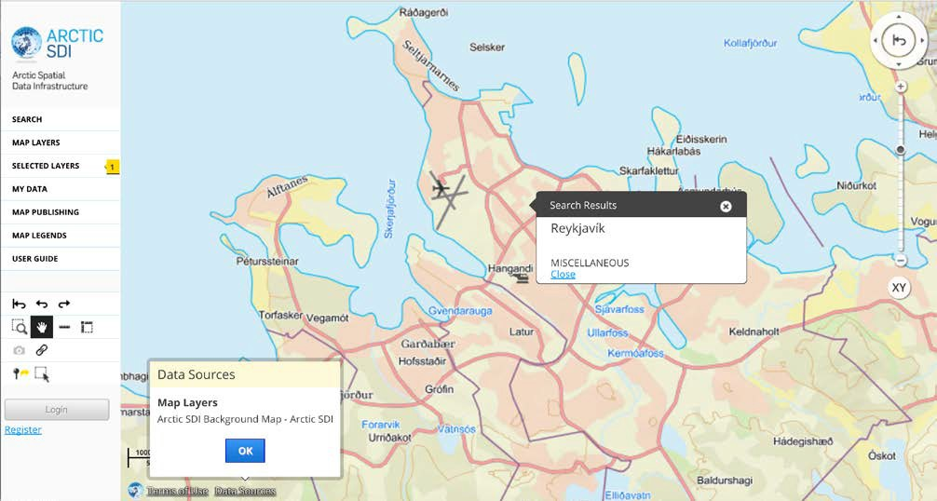
Circumpolar Gazetteer highlighting Reykjavik, Iceland, on the Arctic SDI Basemap

Delivering Authoritative, Harmonized Data
The Arctic SDI has released two harmonized data products, with more in development. Additionally, these data will be available via Web Services for reuse to deliver common, authoritative data layers for data visualization.

Basemap
The Arctic SDI harmonized basemap is a topographic map rendered using data delivered from each country’s national SDIs, featuring a newly adopted common cartographic specification. The result is a unified topographic view over the entire Arctic with details such as elevation contours, rivers and lakes, and other geographic features.

Circumpolar Gazetteer
The Arctic SDI continues to enhance a circumpolar gazetteer based on official place name data provided by each country. The service allows users to search for places and “drill down” to a specific location.

Arctic SDI Geoportal
The Arctic SDI Geoportal, launched in 2014, is based on the open source platform Oskari developed by Finland and is built for browsing, visualizing, analyzing, and sharing distributed geographic information. The Geoportal adheres
to Open Data principles leveraging distributed spatial data infrastructures and making extensive use of services based on Open Geospatial Consortium standards. The Geoportal uses ISO standard 19115 Topic Categories and search to provide access to thematic and reference data layers.

Key functionalities include the ability to search for metadata, place names, and coordinates; a map marker tool; a map legend display; and a set of additional map analysis tools and icons. Documentation is provided in the form of a user guide and a quick start guide. New functionalities of the Geoportal include the animation of temporal data and that registered users can save map views and generate embedded, interactive maps for delivery on any website.

Geoportal users can combine map layers to visualize the phenomena of their choice and choose from a variety of tools to be added on the map. The fully functional map client can then be embedded on any website with context-related information by copying and pasting the map’s URL onto any web page. If any data source gets updated, the latest data is readily available on the embedded map with no user intervention.

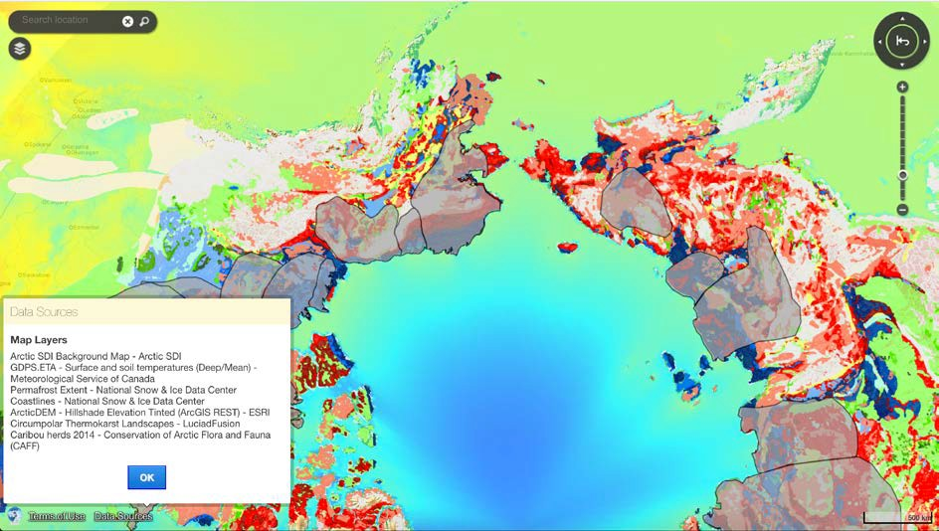
Example of an embedded map generated using the Arctic SDI Geoportal for the Arctic Spatial Data Pilot

Embedded maps: A powerful tool for disseminating the information from SDIs without needing programming skills.

OGC Arctic Spatial Data Pilot
To advance Arctic SDI strategic objectives to test interoperability of standards, increase the inventory of available Arctic data, and demonstrate the diverse, rich, and valuable potential of providing geospatial data using standards, the U.S. Geological Survey and Natural Resources Canada co-sponsored an Open Geospatial Consortium (OGC) Pilot.

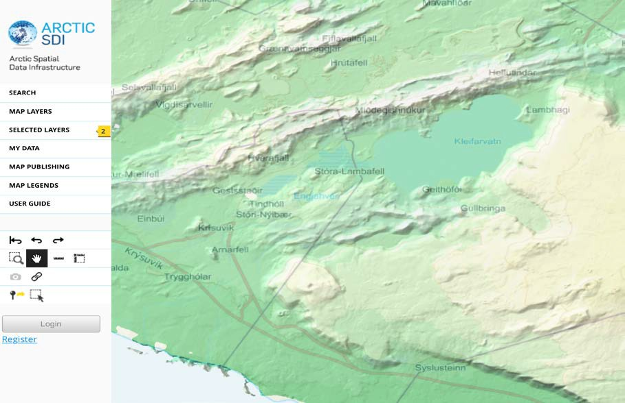The Arctic Spatial Data Pilot demonstrated how, through standards, a wide variety of data from distributed sources could be used across multiple tools to analyze and visualize data and highlight areas of interest. Further, that costs for collecting and using data can be significantly reduced and decision making is enhanced when consistent methods are used to share geographic data. Participants generated videos to demonstrate the power of data to tell stories around scenarios developed with stakeholders,
Arctic SDI Geoportal displaying Arctic DEM layered with Arctic SDI Basemap south of Reykjavik, Iceland
arctic-sdi.org
5
Arctic SDI 2015–2017 Biennial Report
including the Inuit Circumpolar Council (Alaska) and CAFF.

The final demonstration, held in March 2017, showcased data intensive scenarios including sea ice evolution, caribou migration analysis, effects of new shipping routes, food security and landslide susceptibility mapping. Videos and the Final Engineering Report, which will be evaluated by Arctic SDI to inform ongoing strategic priorities, are on-line.

Arctic Digital Elevation Model
In support of a 2015 U.S. Arctic Council initiative to investigate development of a Pan-Arctic Digital Elevation Map, elevation experts from the Arctic SDI mapping agencies came together to evaluate an ongoing United States-led effort to develop an ArcticDEM product. The digital surface model being developed through the University of Minnesota Polar Geospatial Center (PGC) and funded by the National Science Foundation is being produced using stereo- paired satellite imagery licensed through the National Geospatial-Intelligence Agency and then automatically processed using open source software and supercomputing.

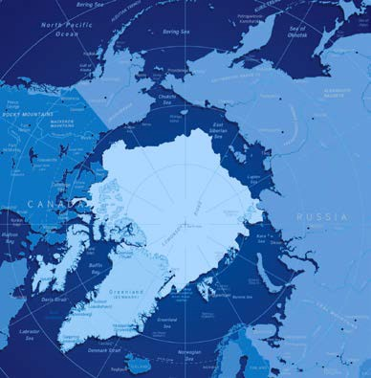The Arctic SDI organized two international workshops and provided bilateral contributions of mapping agency data and expert evaluations on pre-release versions of the initial product based on local knowledge that led to enhanced algorithms. The Arctic SDI Board released a statement recommending that the Arctic Council endorse this as a first generation product. Development of this dataset is aligned with the Arctic SDI strategic goals by providing, for the first time, an informative reference layer of 2- meter-resolution elevation data for the entire Arctic.

website: arctic-sdi.org
When released, the Arctic DEM will be a huge first step and offer a significant advancement in the availability of coherent Arctic elevation data to serve the Arctic science community.

Looking to the Future of Arctic SDI

As Finland takes on the Chairmanship of the Arctic SDI in 2017 the Board will continue to look to the future and search for opportunities to increase the visibility of the international cooperation and efforts to enhance delivery of distributed, standardized, regional data and accessibility of tools for visualization and analysis of that data. The goal of the Arctic SDI is to build an Arctic spatial data infrastructure that will serve local and global stakeholders and ensure that scientists, resource managers, decision makers, and citizens can discover, access, combine, and use trusted data to conduct research, make informed decisions, and respond to issues and emergencies in a changing Arctic.
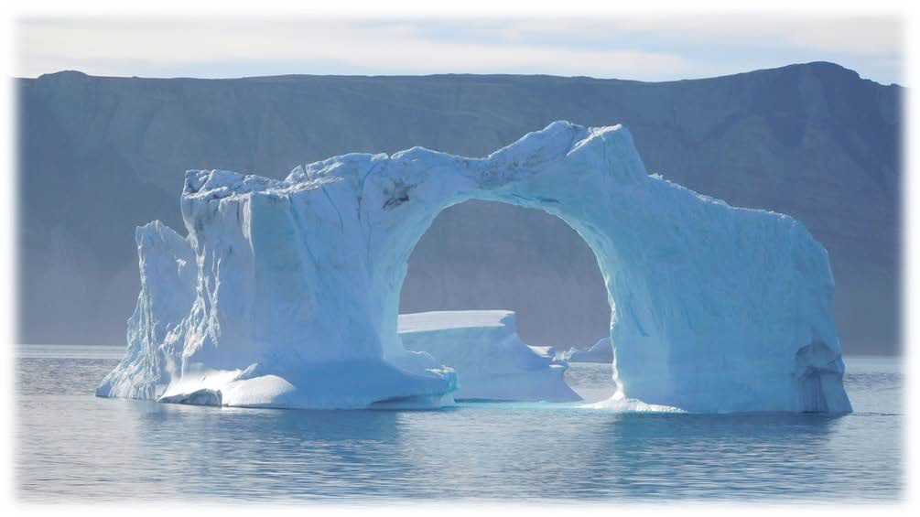

arctic-sdi.org
6 Arctic SDI 2015–2017 Biennial Report

